**LINUX**

ABHIRAMI KANNAN

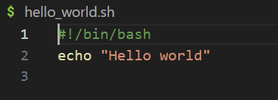

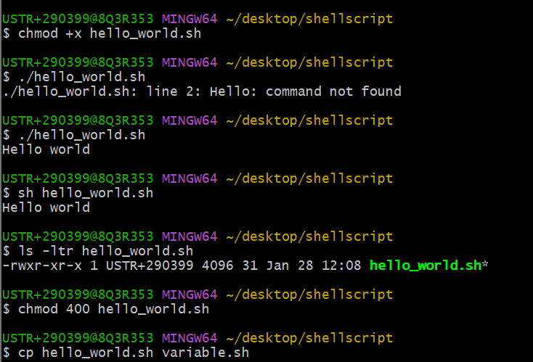

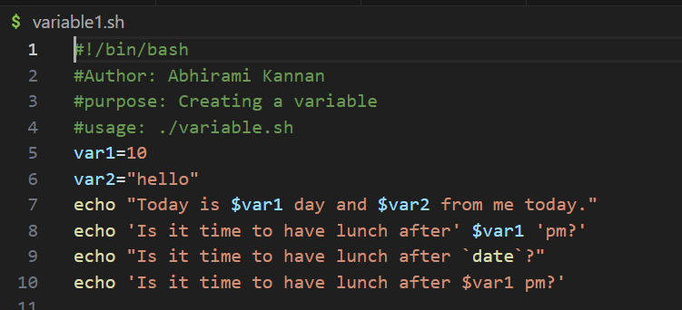

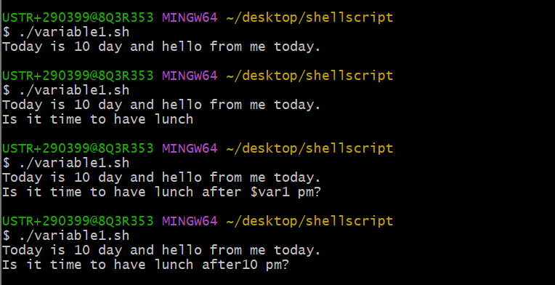

#!/bin/bash

#Author: Abhirami Kannan

#purpose: Read the input

#usage: ./inputvariable.sh

file=$1

if [ -f $file ]; then

echo "file access $file"

else

echo "file doesnt exist"

fi

#!/bin/bash

#Author: Abhirami Kannan

#purpose: Read the input

#usage: ./inputvariable.sh

file=$1

if [ -f "$file" ]; then

echo "file access $file"

else

echo "file doesnt exist"

fi

file=$1

if [[ -f $file ]]; then

echo "file access $file"

else

echo "file doesnt exist"

fi

$ ./if_square_bracket.sh "file with.sh"

file access file with.sh

file access file with.sh

FOR

#!/bin/bash

#Author: Abhirami Kannan

#purpose: Learning for loop

#usage: ./for.sh

#fruit ->variable

fruits=("apple" "banana" "cherry" "jackfruit")

for fruit in "${fruits[@]}"; do

echo "i like to eat $fruit"

done

$ ./for.sh

i like to eat apple

i like to eat banana

i like to eat cherry

i like to eat jackfruit

fruits=("apple" "banana" "cherry" "jackfruit")

for i in "${!fruits[@]}"; do

echo "fruit ate $i is ${fruits[$i]}"

done

fruit ate 0 is apple

fruit ate 1 is banana

fruit ate 2 is cherry

fruit ate 3 is jackfruit

fruits=("apple" "banana" "cherry" "jackfruit") #array created here

for i in "${!fruits[@]}"; do

if((i%2==0)); then #condition for even

echo "i like this fruit ${fruits[$i]}"

else

echo "i dont like this fruit ${fruits[$i]}"

fi

done

i like this fruit apple

i dont like this fruit banana

i like this fruit cherry

i dont like this fruit jackfruit

echo "pls enter the number"

read -r num

echo "$num"

#usage:./multiplication_while.sh

echo "pls enter the number"

read -r num

echo "multiplication table of $num"

counter=1

while [ $counter -le 10 ]

do

    mult=`expr $num \* $counter`

    echo "$num * $counter = $mult"

    counter=`expr $counter + 1`

    done

pls enter the number

12

multiplication table of 12

12 * 1 = 12

12 * 2 = 24

12 * 3 = 36

12 * 4 = 48

12 * 5 = 60

12 * 6 = 72

12 * 7 = 84

12 * 8 = 96

12 * 9 = 108

12 * 10 = 120

Also add unit test case in your case study

Test driven development