UST EXAM

1. Github repo: https://github.com/wolf3766/spring-boot-hello-world.git
2. Dockerhub image link: <https://hub.docker.com/repository/docker/skc3766/java-image>
3. Yaml files used: deployment.yaml,service.yaml
4. Screenshots:

* Build the image successfully

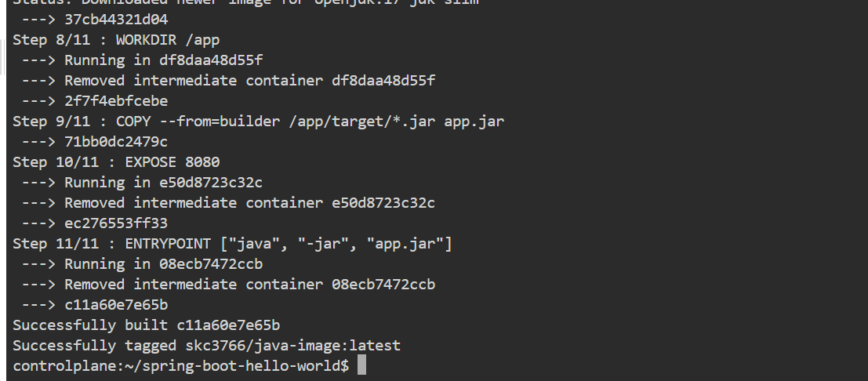

* Pushed into dockerhub successfully.

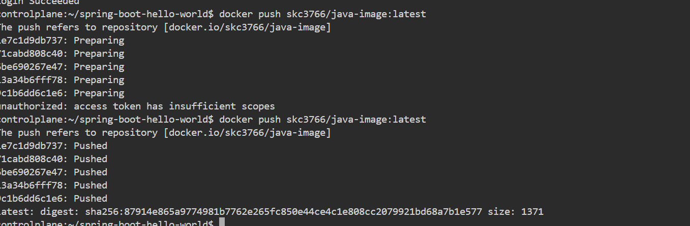

* Created a deployment using deployment.yaml

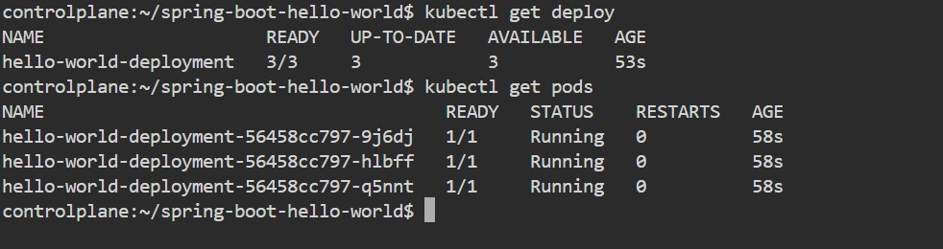

* Created a service using service.yaml

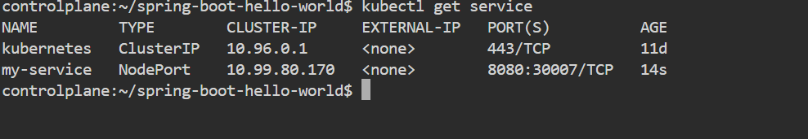

* Curl done using clusterip because no public ip provided.



* Scaled the deployment as replicas=3 and scaled back to replicas=1

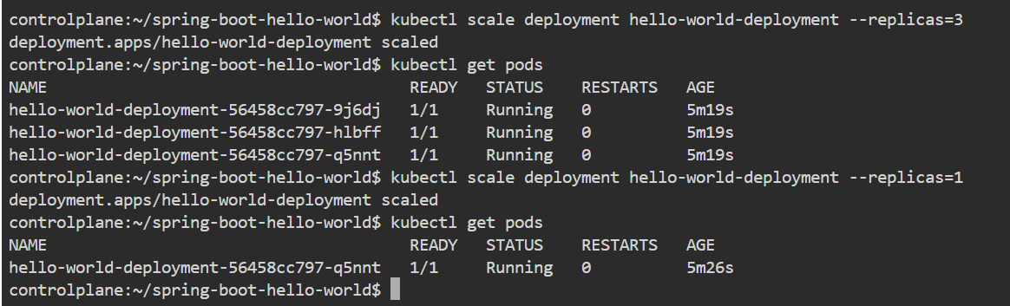

* Added the yaml files(deployment.yaml,Dockerfile,service.yaml) into github.

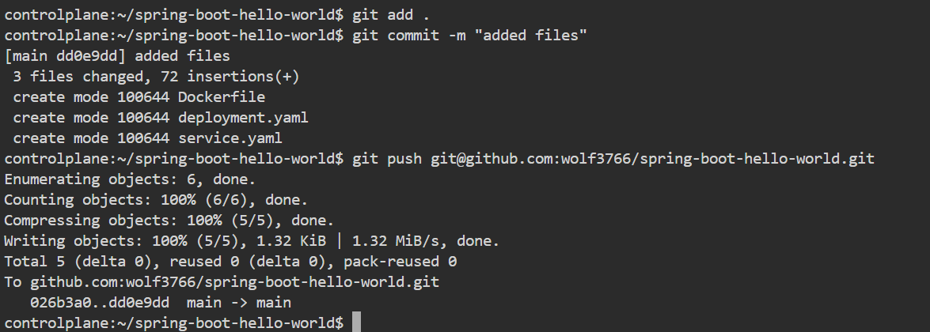

* Deployment.yaml

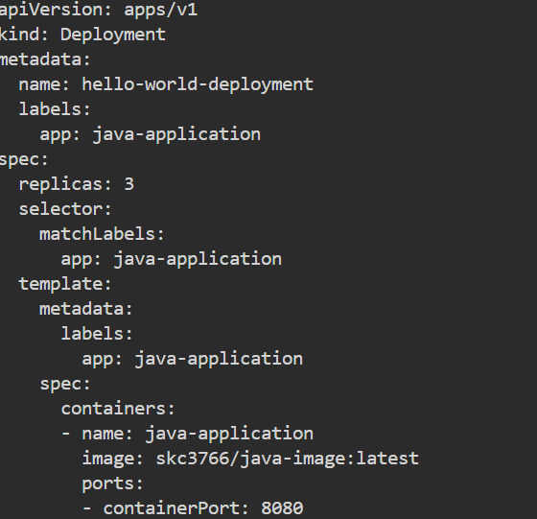

* Service.yaml

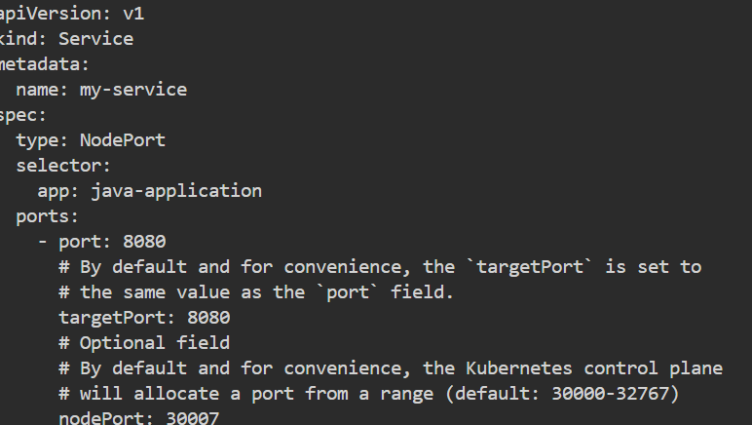

* Dockerfile