Lab: [Grafana Alerting - Route alerts using dynamic labels](http://www.grafana.com/tutorials/alerting-get-started-pt5/) tutorial.

Link: <https://grafana.com/tutorials/alerting-get-started-pt6/?pg=tutorials&plcmt=results>

**Docker-compose build** : command which builds images for every services given in docker-compose.yaml

**docker-compose up -d** : build the missing images, starts the container -> from docker-compose.yaml

**Use case of this lab**: monitoring and alerting for system health with Prometheus and Grafana.

**Grafana login** :  [http://localhost:3000](https://94bef85a1d69-10-244-4-8-3000.papa.r.killercoda.com/)

1. Login
2. Create a time series panel

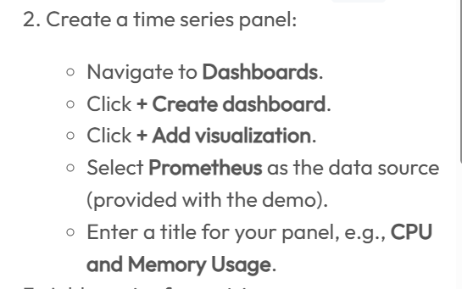

1. Add querry ->select Prometheus->add title-> give querry-> run the querry -> will see a graph

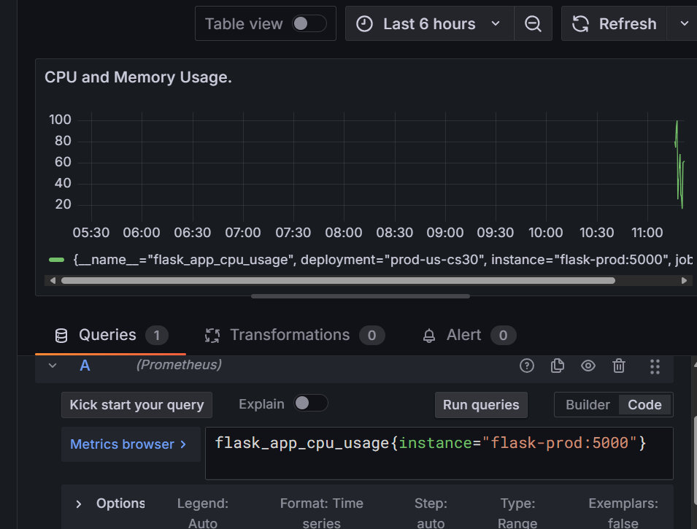

Querry: flask_app_cpu_usage{instance="flask-prod:5000"}

1. Again add querry for memory usage = flask_app_memory_usage{instance="flask-prod:5000"}

Run querry:

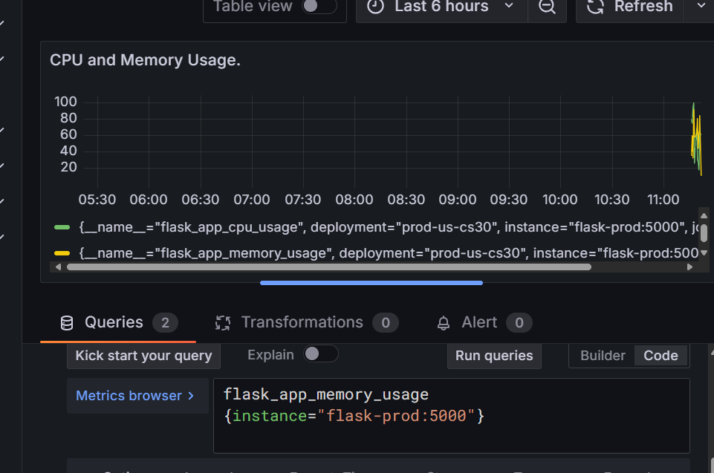

Saved the dashboard. So time series panel ready.

1. Create alert rules:
   1. Create alert rule for cpu usage: **Alerting > Alert rules > new alert rule** from the Grafana sidebar.

Querry: flask_app_cpu_usage{instance="flask-prod:5000"}

* Condition: Enter 75 as the value for **WHEN QUERY IS ABOVE** to set the threshold for the alert.

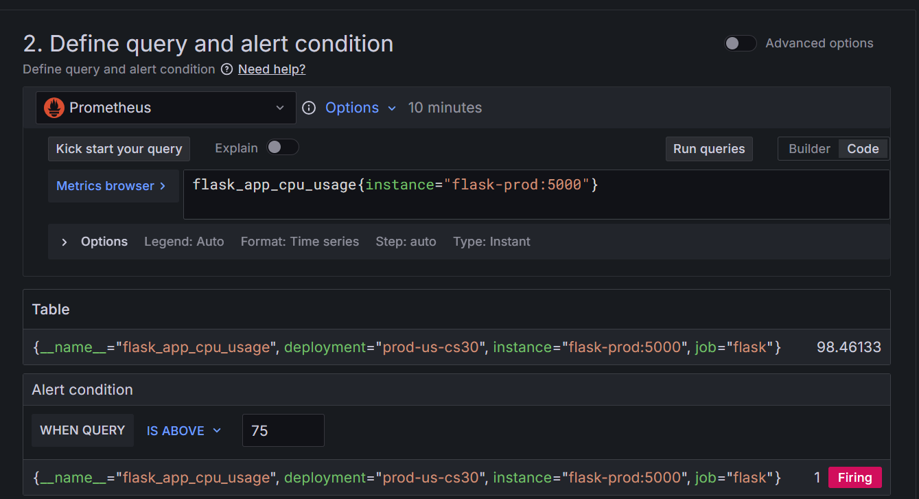

* 1. New folder : This folder contains our alert rules.

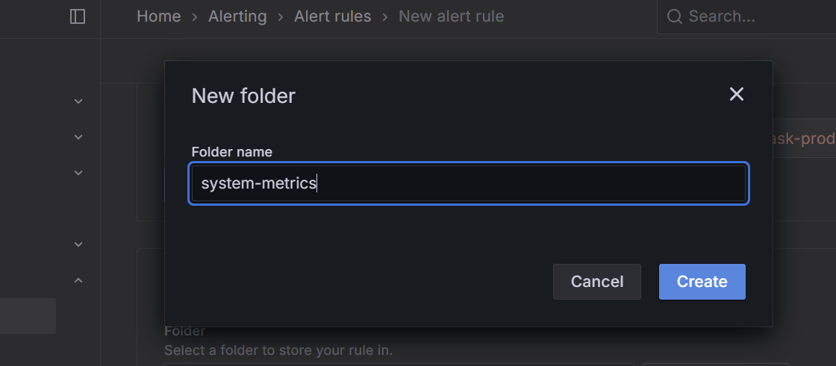

Evaluation group: evaluation interval =1m

Pending period and keep firing for

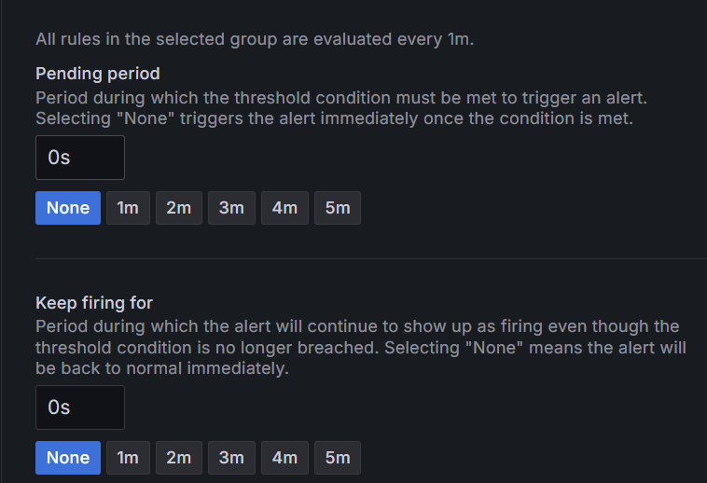

**Pending period** is how long the alert system waits after a condition becomes true before actually firing the alert. If you set it to **0 seconds**, the alert will trigger **immediately** once the condition is met.

Keep firing for = 0s. This controls how long the alert stays active after the condition goes back to normal. If you set it to **0 seconds**, the alert stops **right away** when the condition is no longer true.

* 1. Configure notifications:

Created contact point

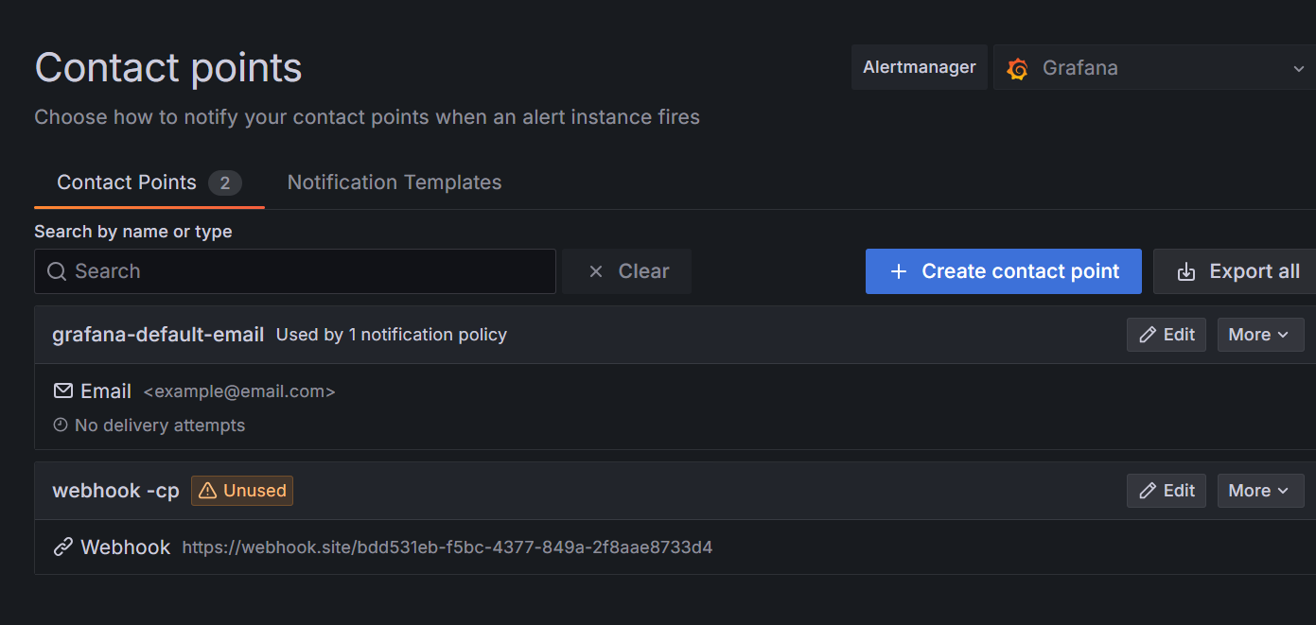

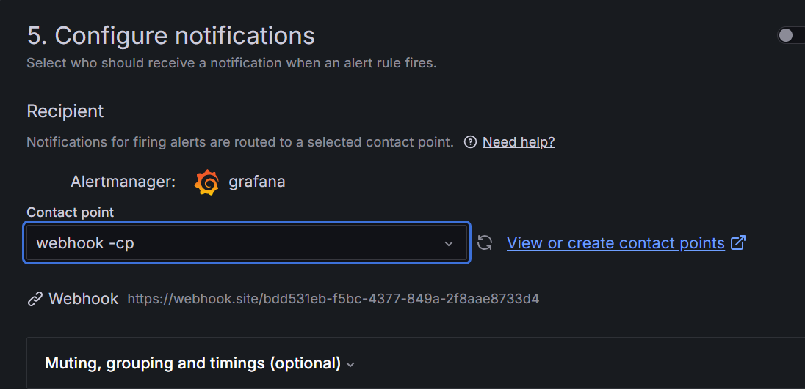

Link of public webhook: [(12) Webhook.site - Test, transform and automate Web requests and emails](https://webhook.site/#!/view/bdd531eb-f5bc-4377-849a-2f8aae8733d4/11955a5c-b9a4-4009-8da5-96559297431c/1)

Copy the url from this and give to sent the notifications.

* 1. Configure notification messages:

Link alert rule to visualisation

Link: [Create and link alert rules to panels | Grafana documentation](https://grafana.com/docs/grafana/latest/alerting/alerting-rules/link-alert-rules-to-panels/#link-alert-rules-to-panels)

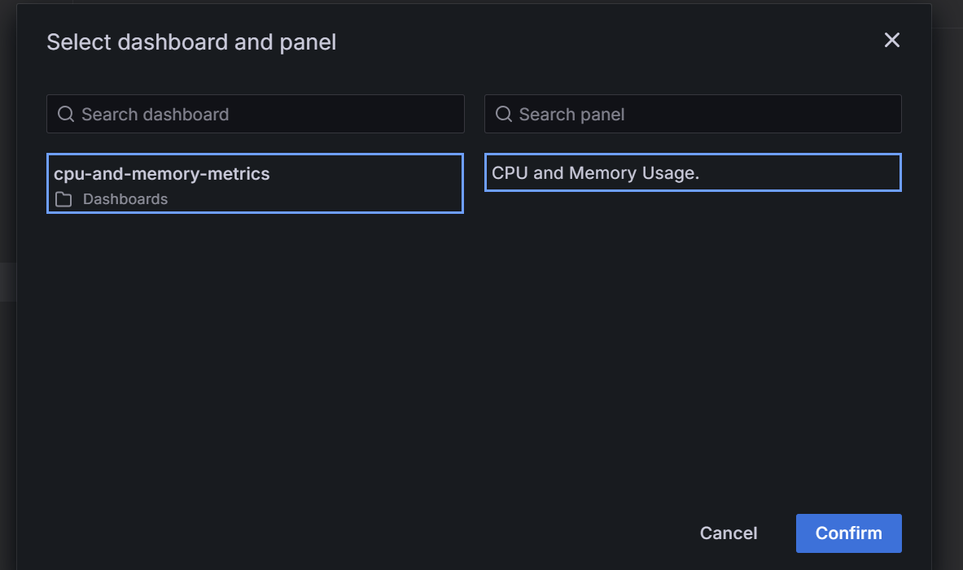

Successfully linked alert rule to ur visualization.

Adding another rule:

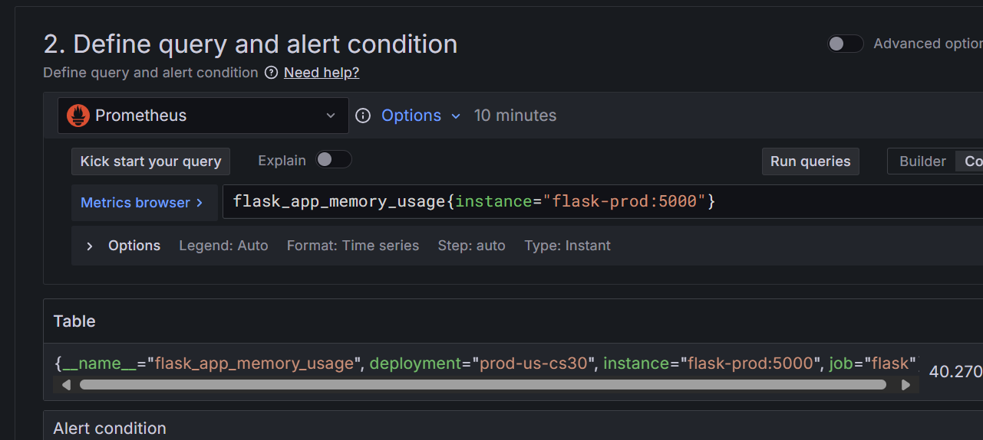

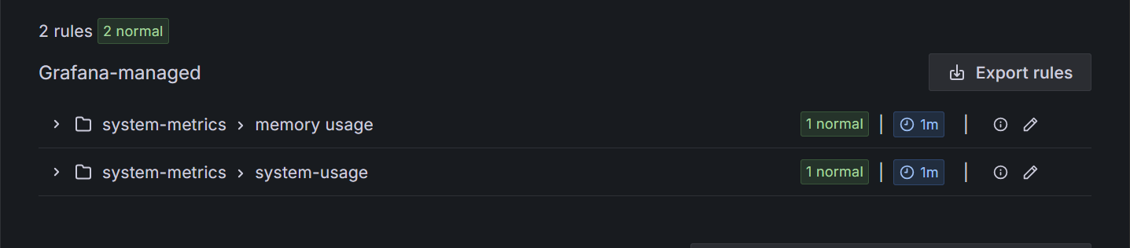

Dashboard:

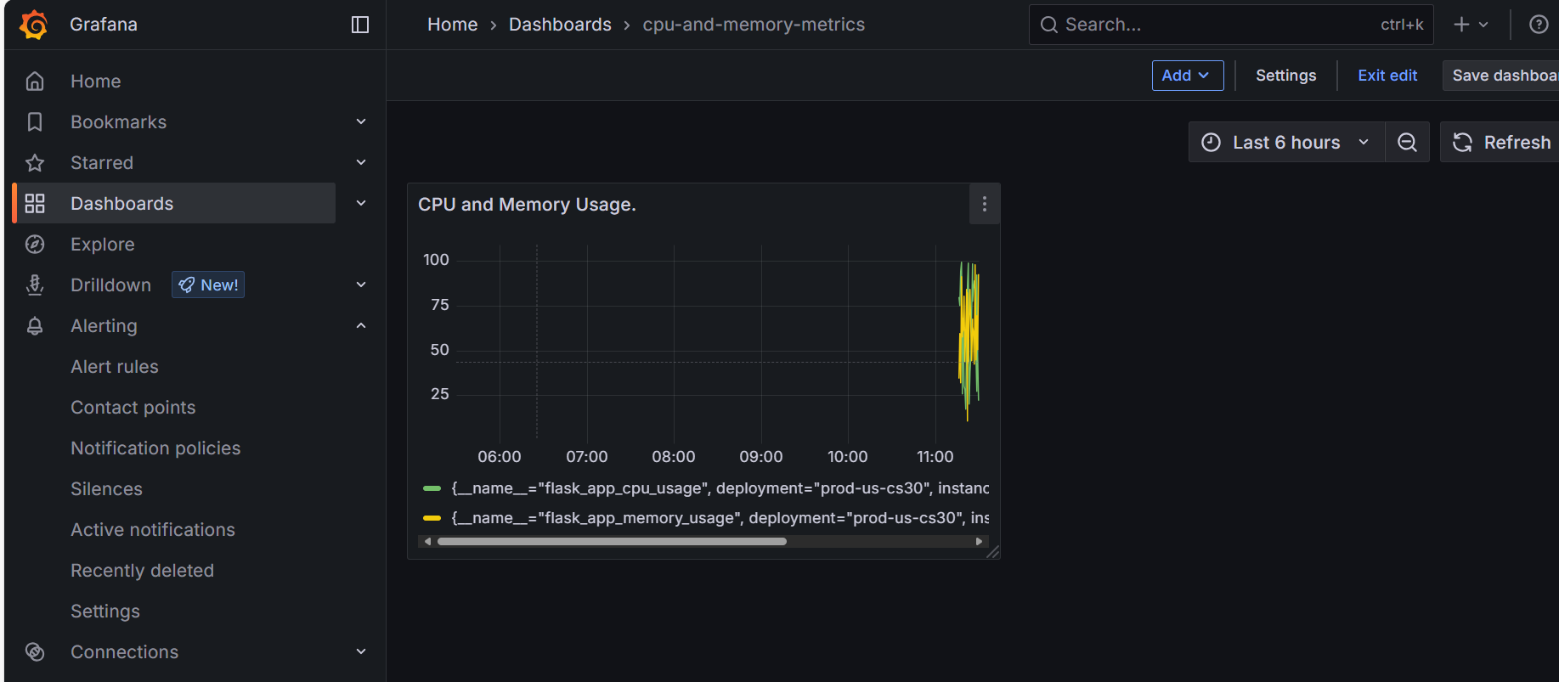

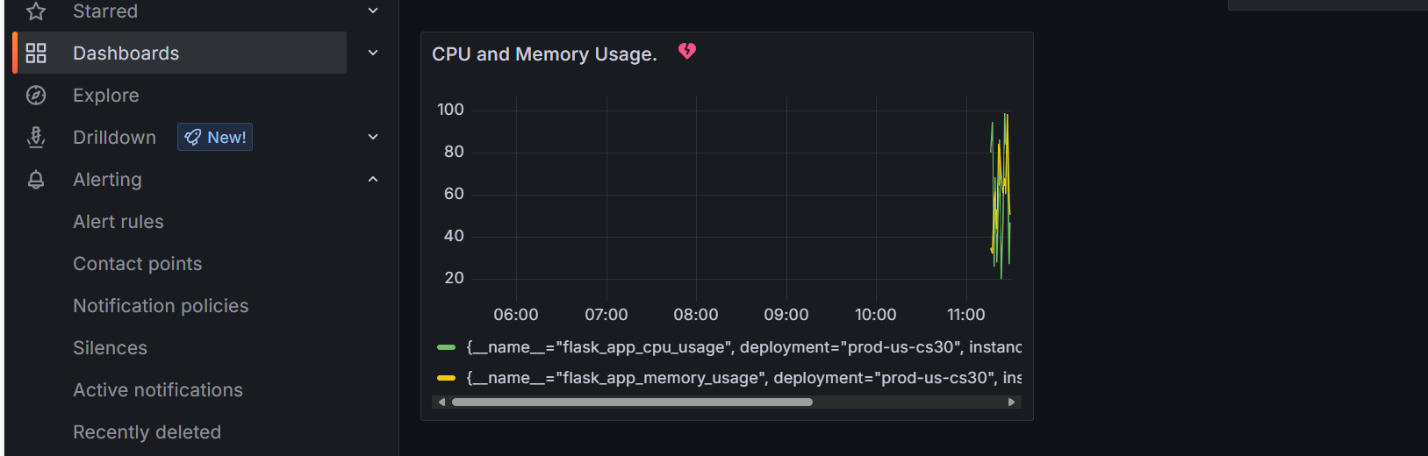

* I have done again because I was not sure about what I have done.. and how everything works.. was confused because I have done somethg wrong.

* Condition changed 0 to 75

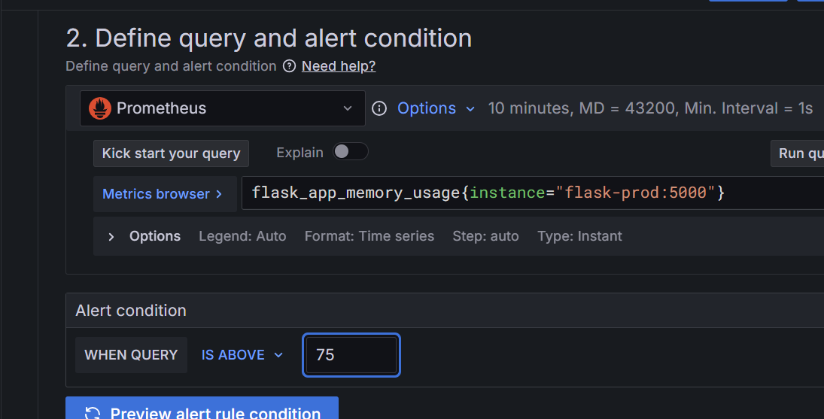

* Final output:

* The output will vary according to the usage and which exceeds the threshold already setted