Alerting lab 2: <https://grafana.com/tutorials/alerting-get-started-pt4/?pg=tutorials&plcmt=results>

Goal: Templating in both labels and annotations

Template labels and annotations

1. Login to Grafana-> link : [http://localhost:3000](https://ceaf22146203-10-244-6-3-3000.papa.r.killercoda.com/)
2. Create an alert rule which includes summary and description annotation
3. Alerting ->alert rules->manage alert rules-> add rule

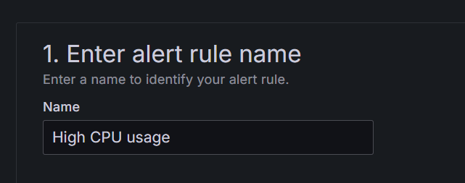

* 1. **Datasource**-> testdata
  2. **Scenario** -> csv content

This dataset simulates a data source returning multiple time series, with each time series generating a separate alert instance.

* 1. When above 75

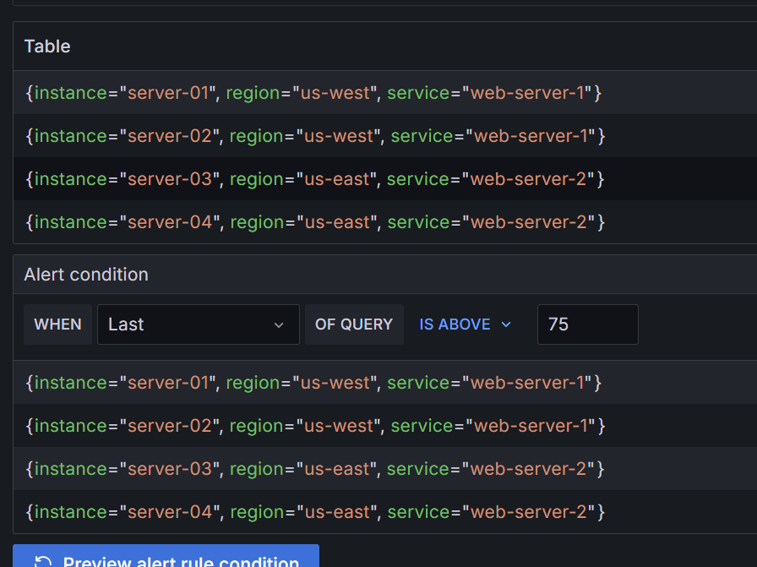

* 1. Created folder and evaluation metrices
  2. Created contact point-> webhook

* 1. Configure summary annotation

{{- "\n" -}}

Instance: {{ index $labels "instance" }}

{{- "\t" -}} Usage: {{ index $values "A"}}%{{- "\n" -}}

* 1. Save rules and exit

 Template notifications

1. Alerting ->contact points ->notification templates ->add
2. Add example -> select -Print firing and resolved alerts

Template:

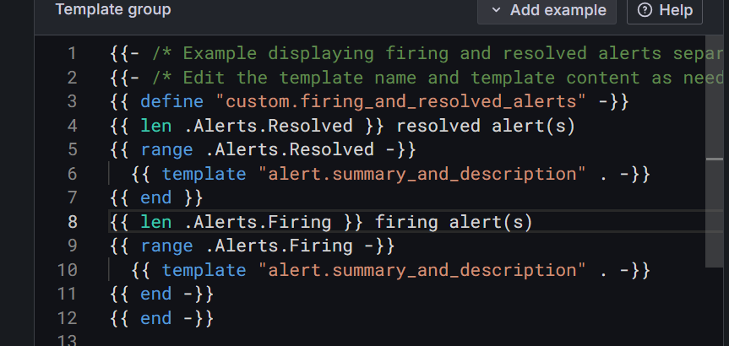

• One part shows **resolved alerts** (how many, and their details).

• Another part shows **firing alerts** (how many, and their details).

• The alert.summary_and_description bit pulls the **summary and description** you set earlier for each alert.

Edit payload->existing->select the alert rule

Alert rules-> view->instances