TASK: how to do the authentication with infinity datasource api calls

Task:

* You want to pull **JSON data** from an API URL using **POST method**.
* The API is **protected by a token** (like a Bearer Token).
* You’re using **Infinity Data Source plugin** in Grafana.
* The API requires the token in the **Authorization header**.

So the url given by some others, it requires an authentication access token to access the api end point.

SOLUTION:

Lets take an public api end point

Url: <https://postman-echo.com/post>

HTTP Headers: key and value

Key: Authorization

Value: Bearer TEST_TOKEN_EXAMPLE123

Body content:

{

"message": "Hello, Abhirami"

}

raws/root selector:

Data

Screenshots:

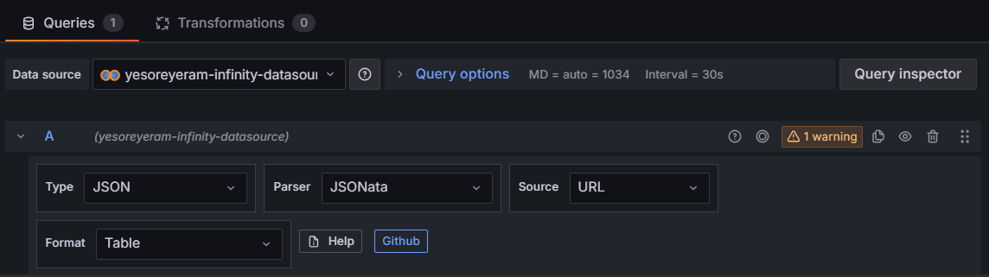

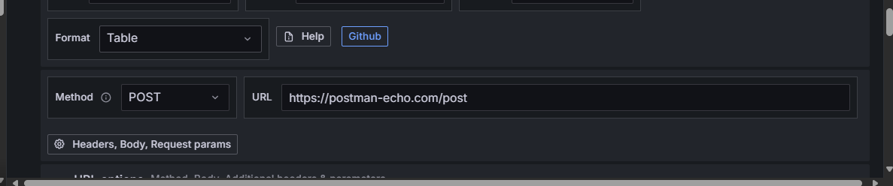

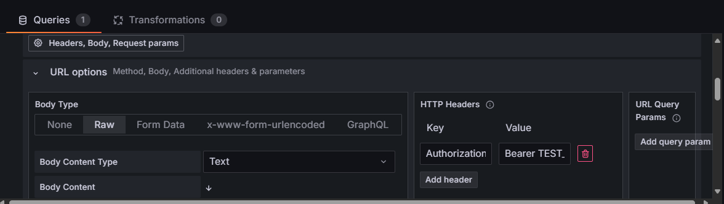

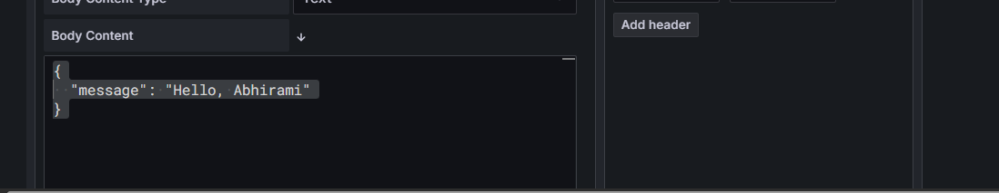

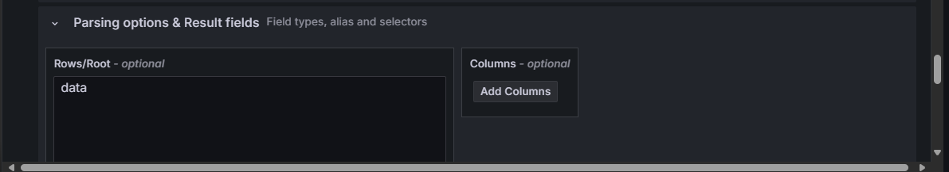

OUTPUT:

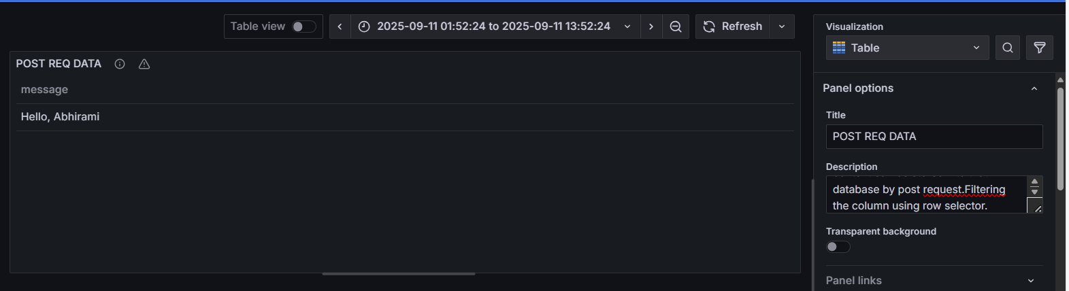

DOUBTS:

Here we used a public test api end point. (Only designed to return back the req we sent not for storing).

It does not store the data in the body into a database.

Because here there is no database. It just returns the body back to us what we sent …to see the grafana is extracting the data.

POST req : Normally the data in the body can be stored into the database when we use post req.

Q. So if we use a real API end point, is it storing into the database?

Depends upon the API implementation.

1. Sometimes api designed to store data in the database
2. Sometimes Api designed to Process and returns data(Without saving..sent parameters)
3. **Row Selector** in Grafana is only used to tell where to pick the data from the API response → It does not affect storage.

Q. What is HTTP header?

An **HTTP Header** is additional information you send along with an HTTP request or receive in a response.

Key and values are imp.

For authentication the key must be Authorization

Value : data passed(TOKEN)

Q. if we didnt give row selector as data?

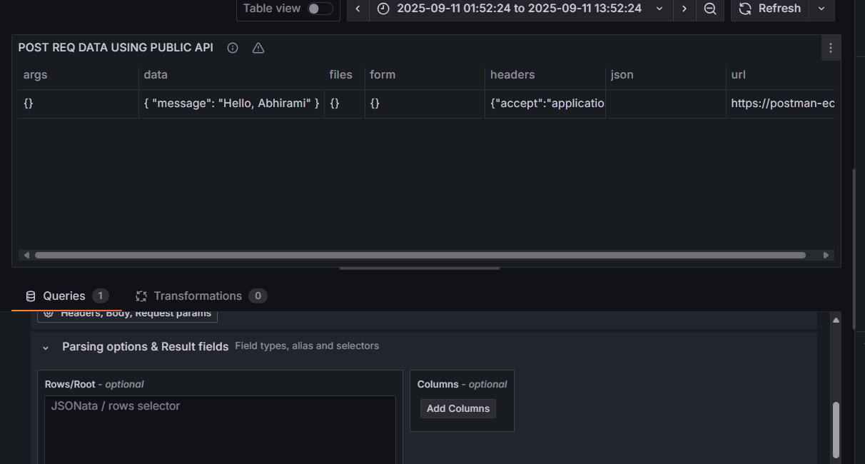

Q. if we give row selector as headers?

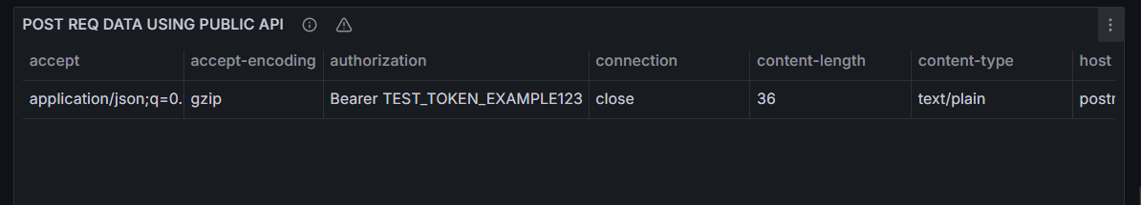

2. Another practical:

Website Url : [REST API - ready to use](https://restful-api.dev/)

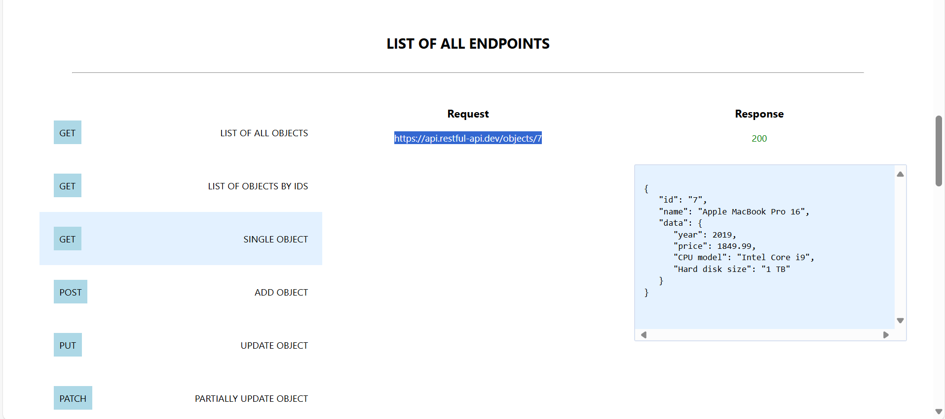

POST url: <https://api.restful-api.dev/objects>

Body:

{

"name": "Apple MacBook Pro 16",

"data": {

"year": 2019,

"price": 1849.99,

"CPU model": "Intel Core i9",

"Hard disk size": "1 TB"

}

}

Row selector: Data

Visualization type: Table.

SCREENSHOTS:

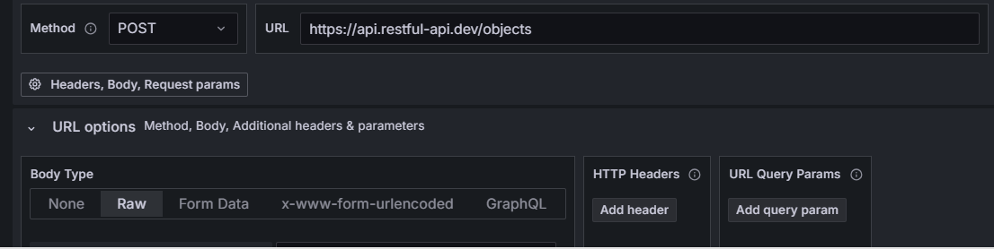

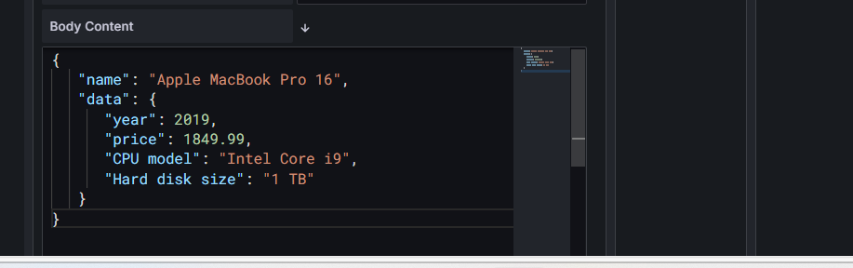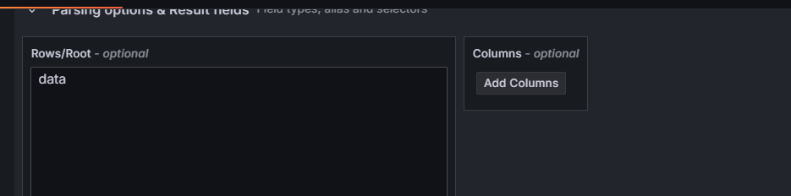

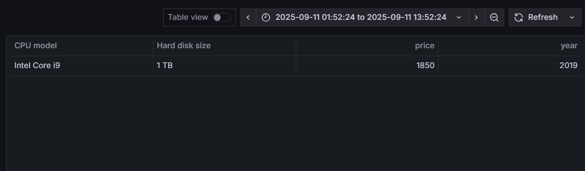

3. Try GET request From same website:

Website: [REST API - ready to use](https://restful-api.dev/)

Get req : <https://api.restful-api.dev/objects/7>

Body: No body

Row selector: data

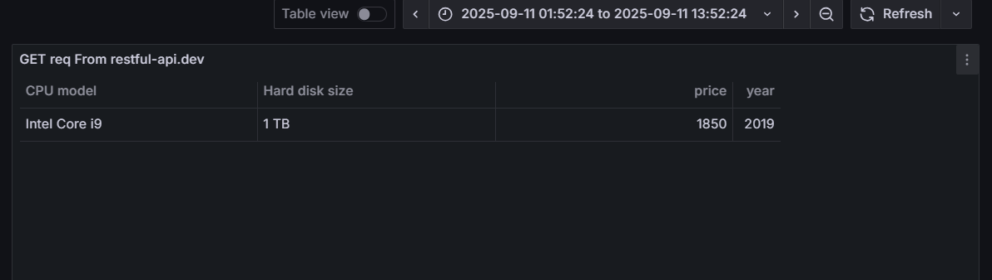

4. Get req to list all data

Url : <https://api.restful-api.dev/objects>

Row selector: data

Visualization type : table

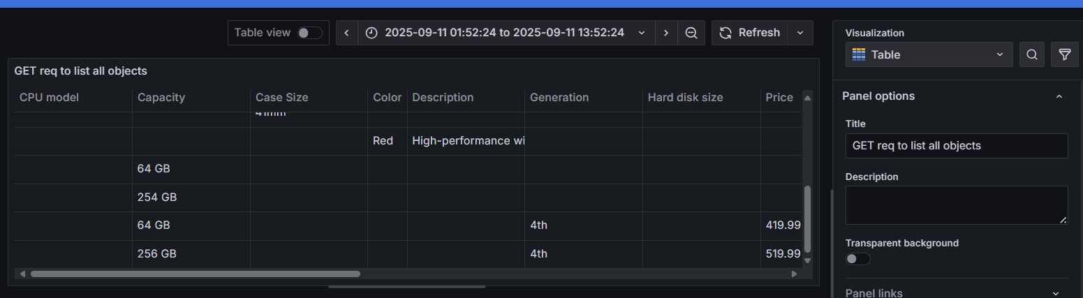

5. Get req - List of objects by ids

Url: <https://api.restful-api.dev/objects?id=3&id=5&id=10>

Visualization type: table

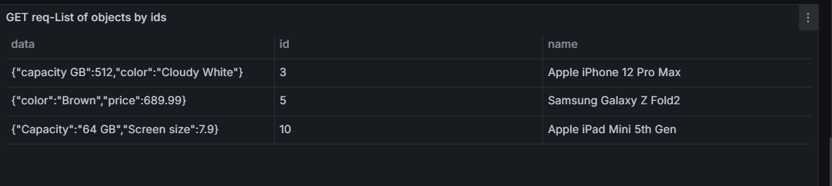

6. Created a text panel:

<div style="color: black; background-color: lightblue; padding: 10px; text-align: center;">

<h1>GET AND POST API REQUESTS</h1>

</div>

7. Dashboard:

