15/9/25

**TASK:** Creating a Security Related Dashboard In Splunk.

Also include drill down feature.

Csv data:

timestamp,incident_id,incident_type,severity,status,vulnerability_id,vuln_type,vuln_severity,vuln_status,compliance_area,compliance_status,user_id,login_success,login_time,alert_id,alert_type,alert_severity

2025-09-10T10:00:00Z,INC001,Malware,High,Open,VULN001,SQL Injection,Critical,Open,PCI-DSS,Non-Compliant,user001,True,2025-09-10T09:55:00Z,ALERT001,Unauthorized Access,High

2025-09-10T11:00:00Z,INC002,Phishing,Medium,Resolved,VULN002,Cross-site Scripting,Medium,Resolved,ISO27001,Compliant,user002,False,2025-09-10T10:58:00Z,ALERT002,Brute Force Attempt,Critical

2025-09-10T12:00:00Z,INC003,Data Leak,High,Open,VULN003,Unpatched Software,Critical,Open,GDPR,Non-Compliant,user003,True,2025-09-10T11:59:00Z,ALERT003,Privilege Escalation,Medium

2025-09-10T13:00:00Z,INC004,Malware,Low,Open,VULN004,Weak Password Policy,Low,Open,NIST,Compliant,user004,True,2025-09-10T12:59:00Z,ALERT004,Malware Behavior,High

2025-09-10T14:00:00Z,INC005,Phishing,Critical,Resolved,VULN005,Open Ports,Critical,Resolved,PCI-DSS,Compliant,user005,False,2025-09-10T13:55:00Z,ALERT005,Data Exfiltration,Critical

SOLUTION:

1. Uploading the csv data
   1. Settings -> add data -> uploading the csv data.
   2. index=main(i have selected)

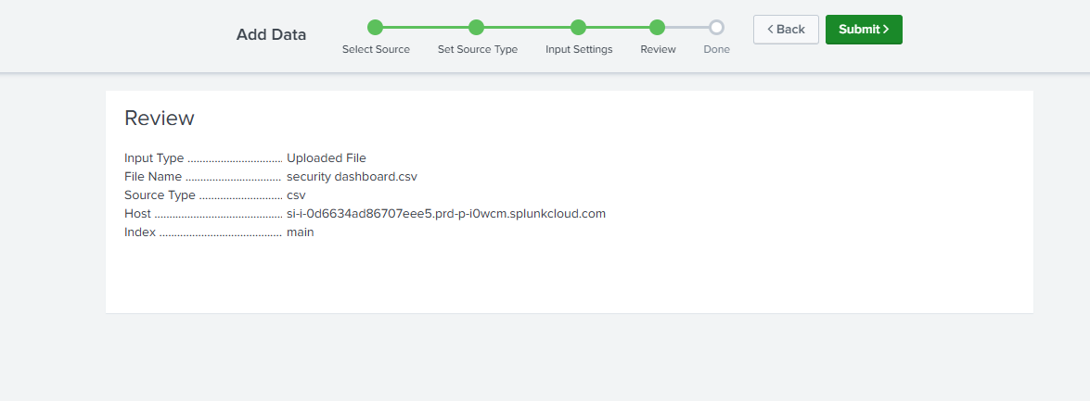

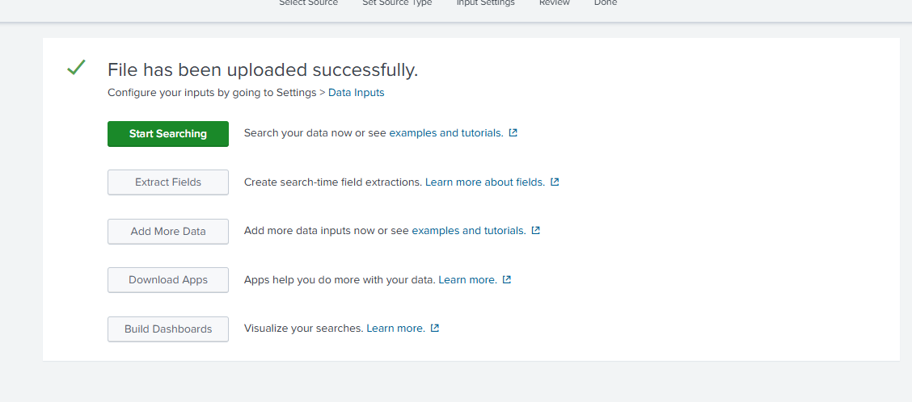

1. Dashboard studio-> grid
2. **Panel 1: Incident Severity vs Status Overview**
   1. Spl query:

source="security dashboard.csv" index="main"

| stats count by severity, status

* 1. Visualization type: bar chart
     1. In the right side -> edit ->general -> visualization type.

1. **Panel 2: Vulnerability Status Breakdown**
2. Spl query:

source="security dashboard.csv" index="main"

| stats count by severity, status

1. Visualization type: bar chart

5. **Panel 3: Compliance Status Summary**

source="security dashboard.csv" index="main"

| stats count by compliance_area, compliance_status

Visualization type: Bar chart

6. **Panel 4 – Login Success Rate**

source="security dashboard.csv" index="main"

| stats count by login_success

Visualization type: pie chart

7. **Panel 5 –** **Alerts by Severity**

source="security dashboard.csv" index="main"

| stats count by alert_severity

Visualization Type: Bar chart.

8. **Panel 6 – Open Critical Incidents (Table)**

source="security dashboard.csv" index="main" (severity="Critical" OR severity="High") status="Open"

| table timestamp, incident_id, incident_type, severity, status, user_id

Visualization Type: table

DASHBOARD:

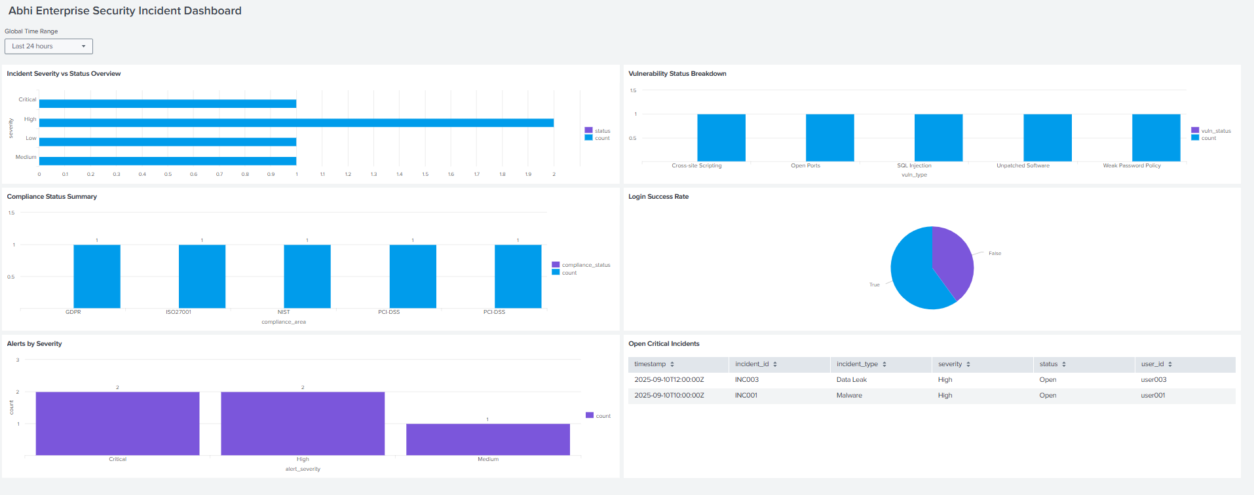

9. Creating drill down

Click a panel

Edit

Bottom u can see interactions (+)

Click the + symbol

There u can see some options:

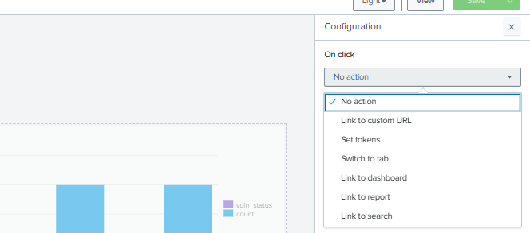

* Click **link to search**
* Custom
* Spl query:

source="security dashboard.csv" index="main"

severity="$click.severity$" status="$click.status$"

source="security dashboard.csv" index="main"

severity="High" status="Open’"

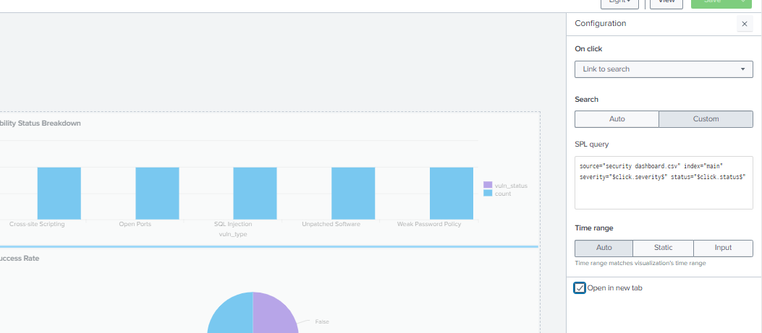

NOT WORKED

10. When i used this query it shows no results. So i changed the values into high and Open to check hardcoded values shows output/not.

So when i click on the High it is opening a new tab and giving results.

11. Understood it is because of not setting up tokens. So in interactions -> set tokens -> added the tokens.After that again go to the link to search query and edit it to previous one and try. Still i didnt got the output( Got no results).

12. Again i added the token: didnt worked

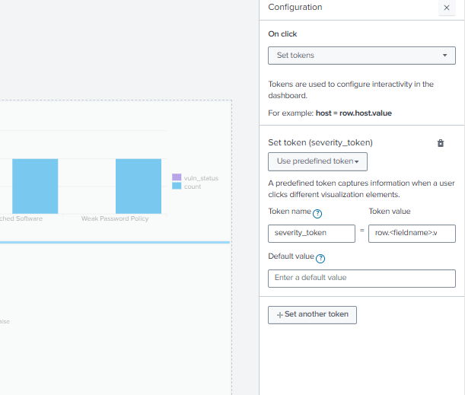

13. Tried with Auto than giving custom queries.

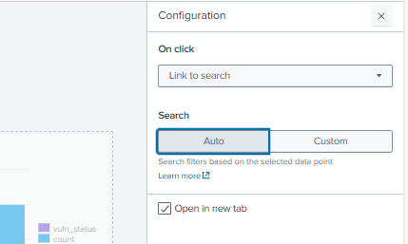

Auto it worked.Token was not needed for Auto.

14. When i click on Critical:

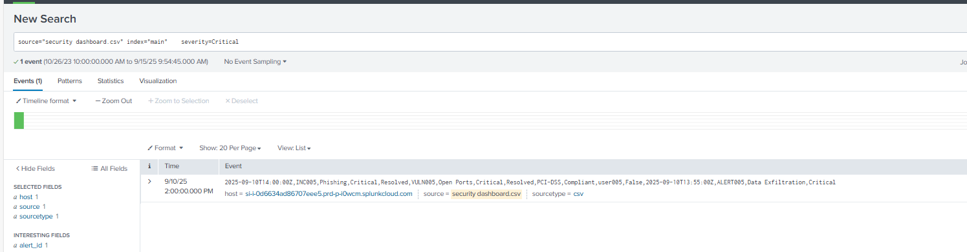

15. When i click on high:

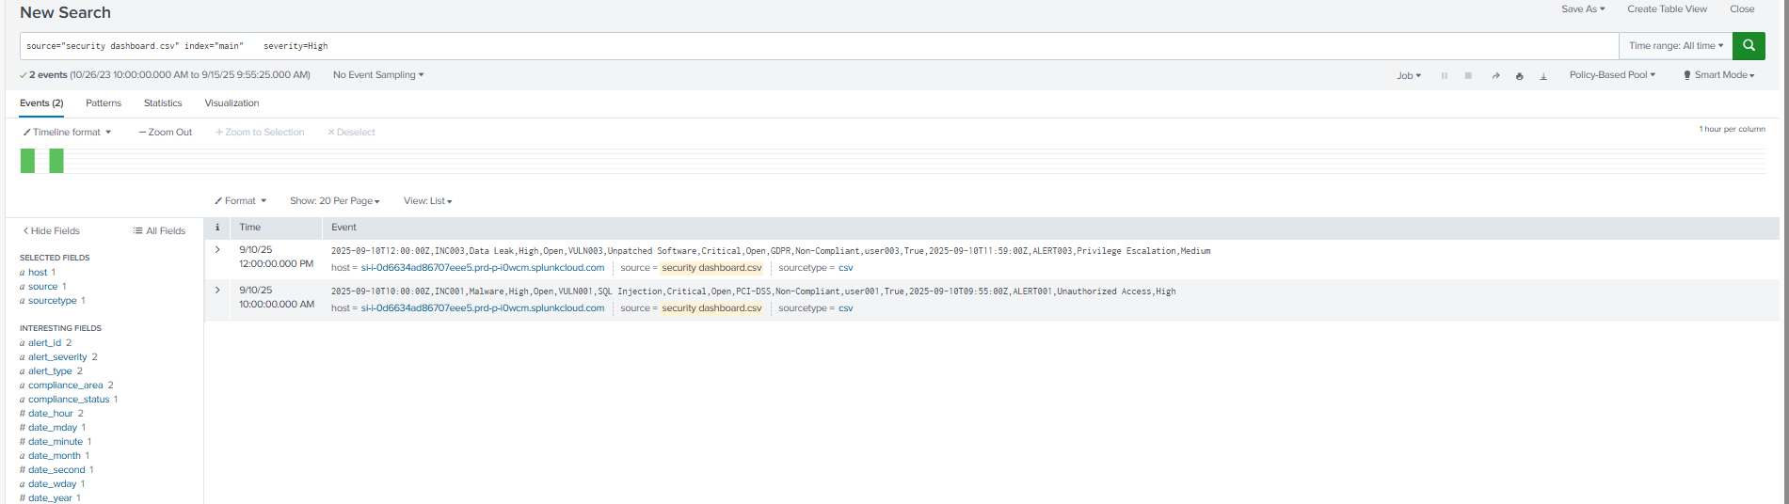

16. When i click on Low:

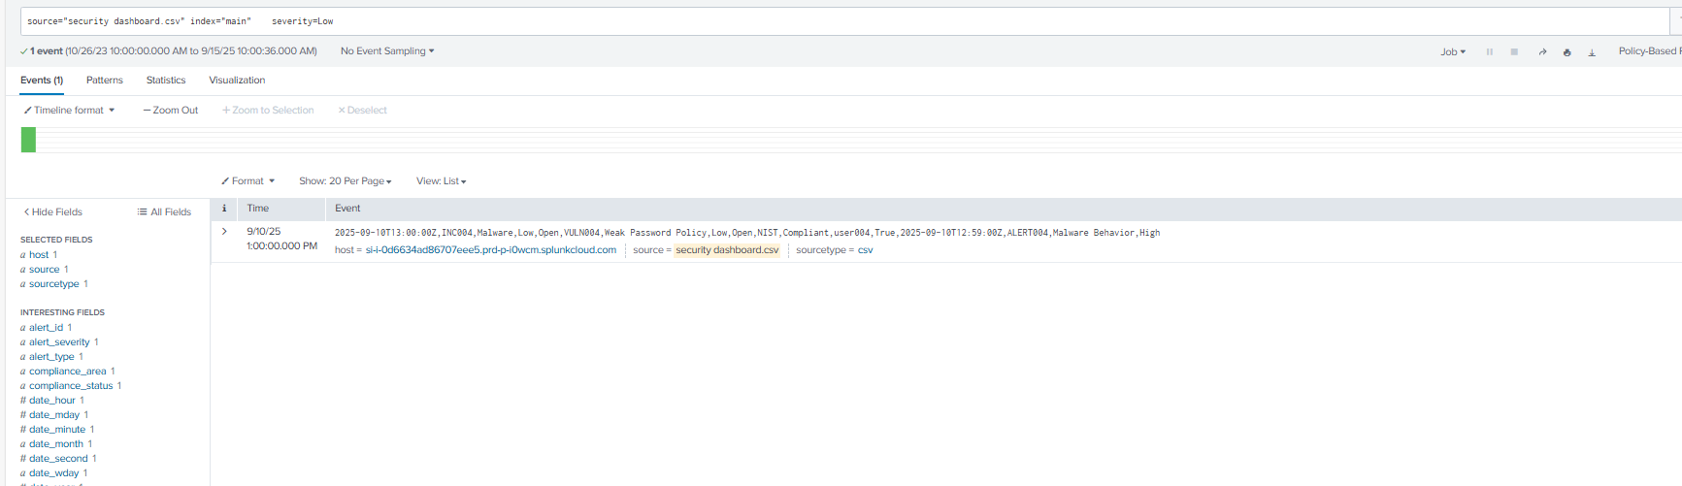

17. When i click on Medium:

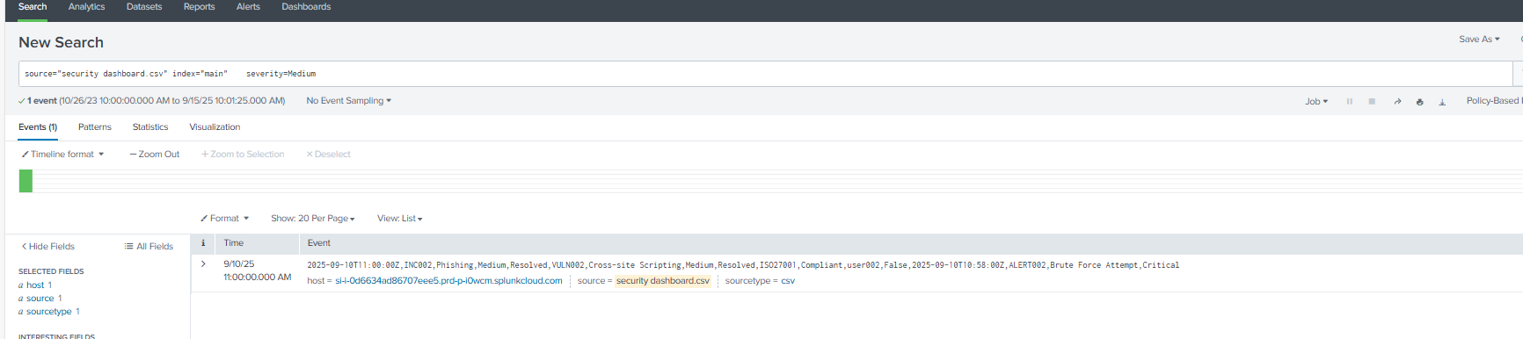

18. Configured drill down for panel2:

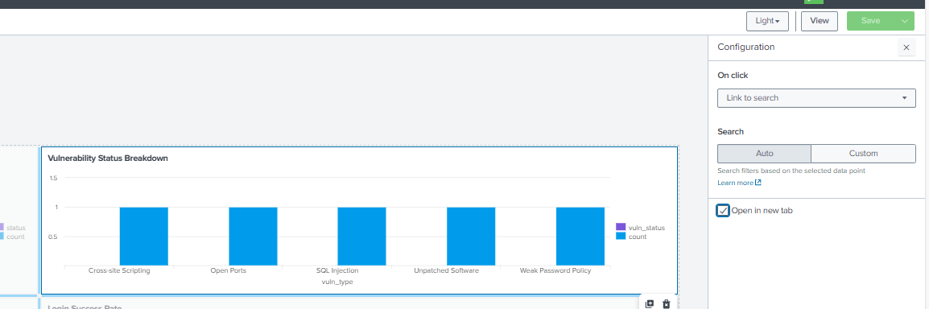

19. Configured Auto drill down -link to search to all panels.

20. Added a heading as Enterprice security related panels.

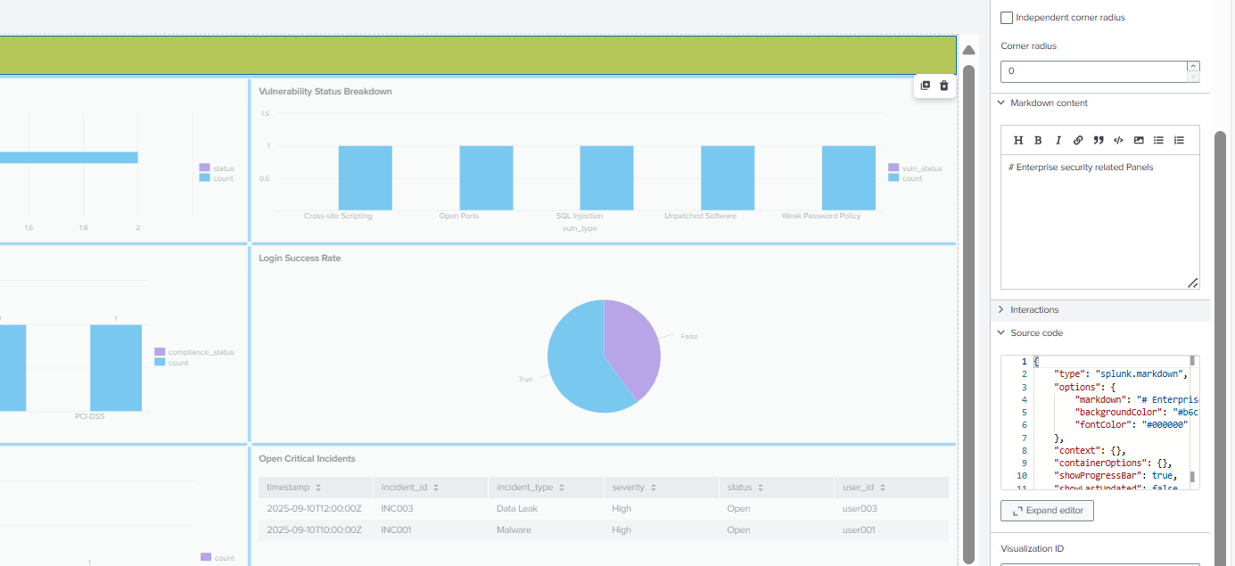

21. Dashboard:

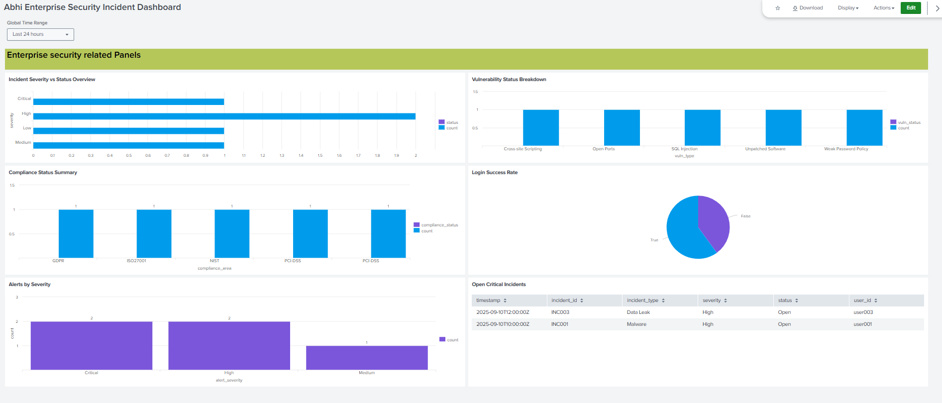

22. Json: Actions -> Export json:

[UST-Observability/Json_backup_files/2_Splunk_security_dashboard2.json at main · Abhiramikannan/UST-Observability](https://github.com/Abhiramikannan/UST-Observability/blob/main/Json_backup_files/2_Splunk_security_dashboard2.json)

Also this option have json code: before ?

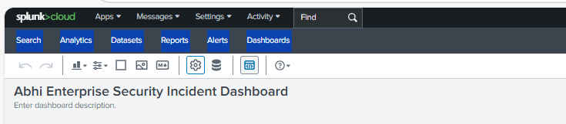

23. TRIED DRILL DOWN BY GIVING TOKEN IN CLASSIC DASHBOARD:

Add inputs:

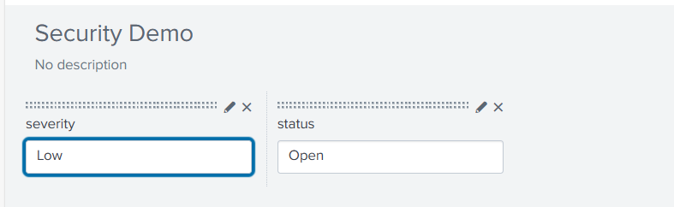

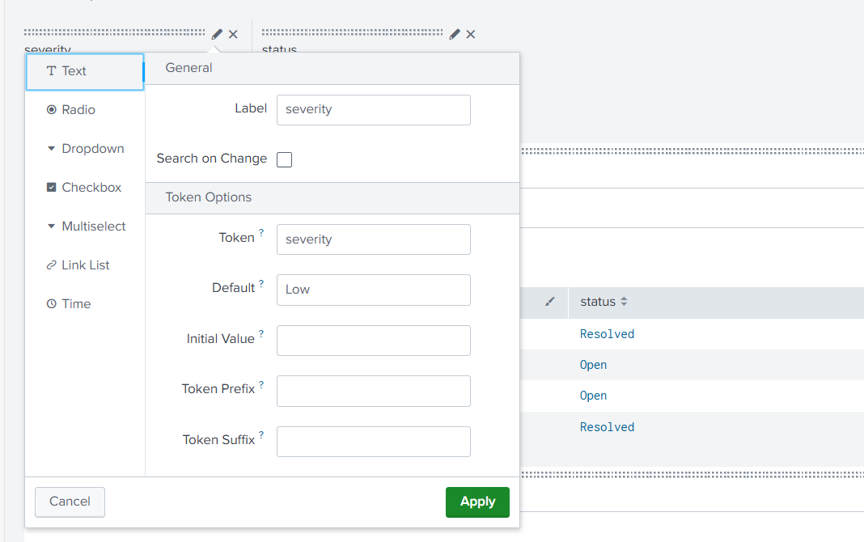

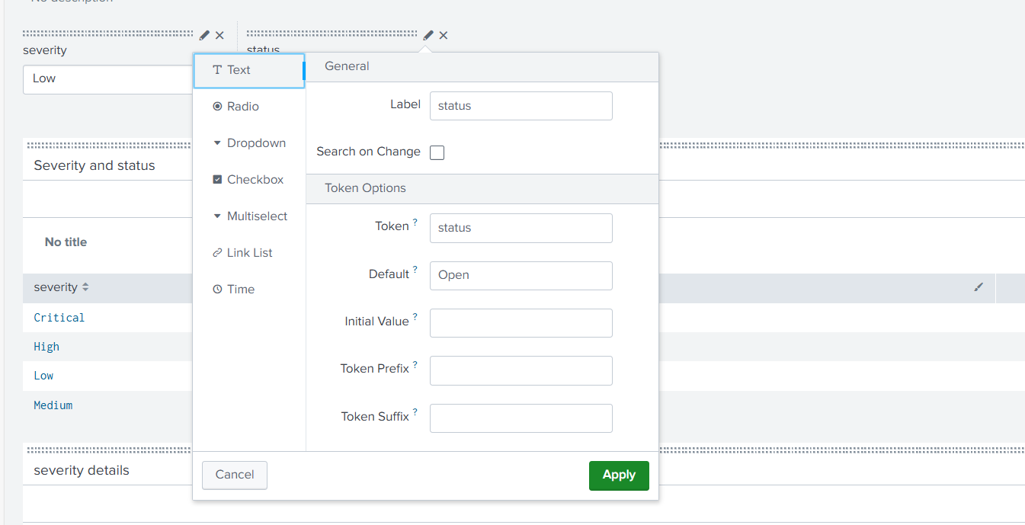

Selected the table we wanted to do drill down and gave token.

$row.severity$

$row.status$

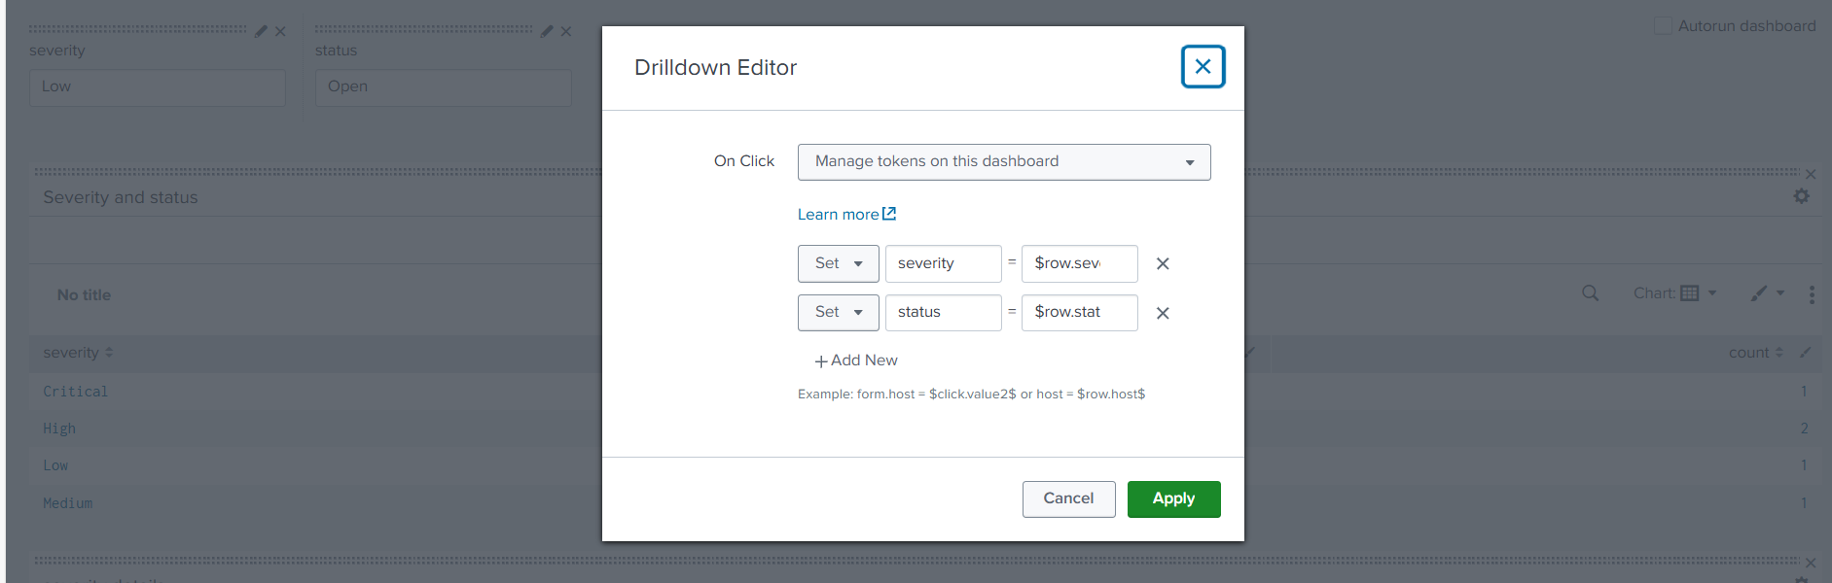

* Searched a spl in search which is fetching the proper details or not and edited the query by giving token:

source="security dashboard.csv" index="main" | search severity="$severity$" status="$status$" | table timestamp, incident_id, incident_type, severity, status

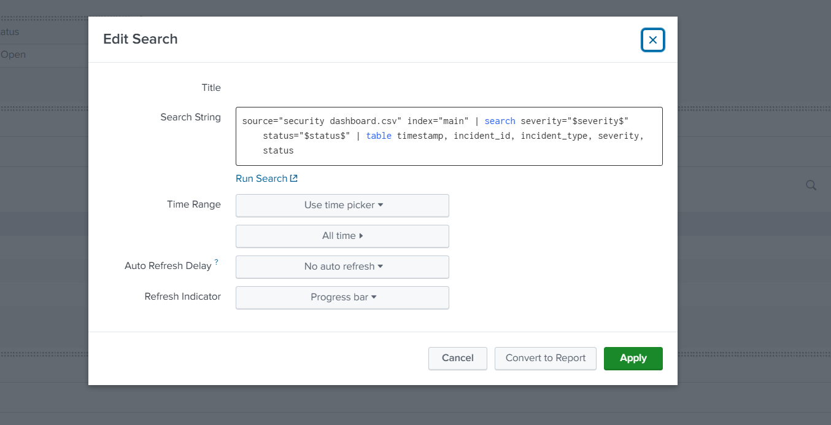

* When i select the critical,high,low,....it will display in the bottom panel where i added the query and token.

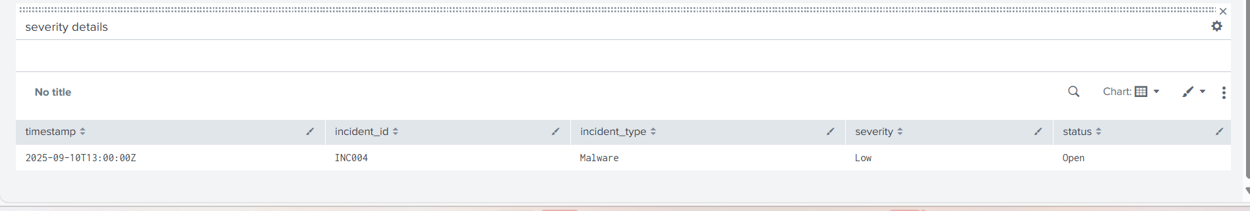

* Because of adding input on the top .. it will display defaulty everytime this severity details panel with the data of previous image i pasted here..

**If i click on critical:**

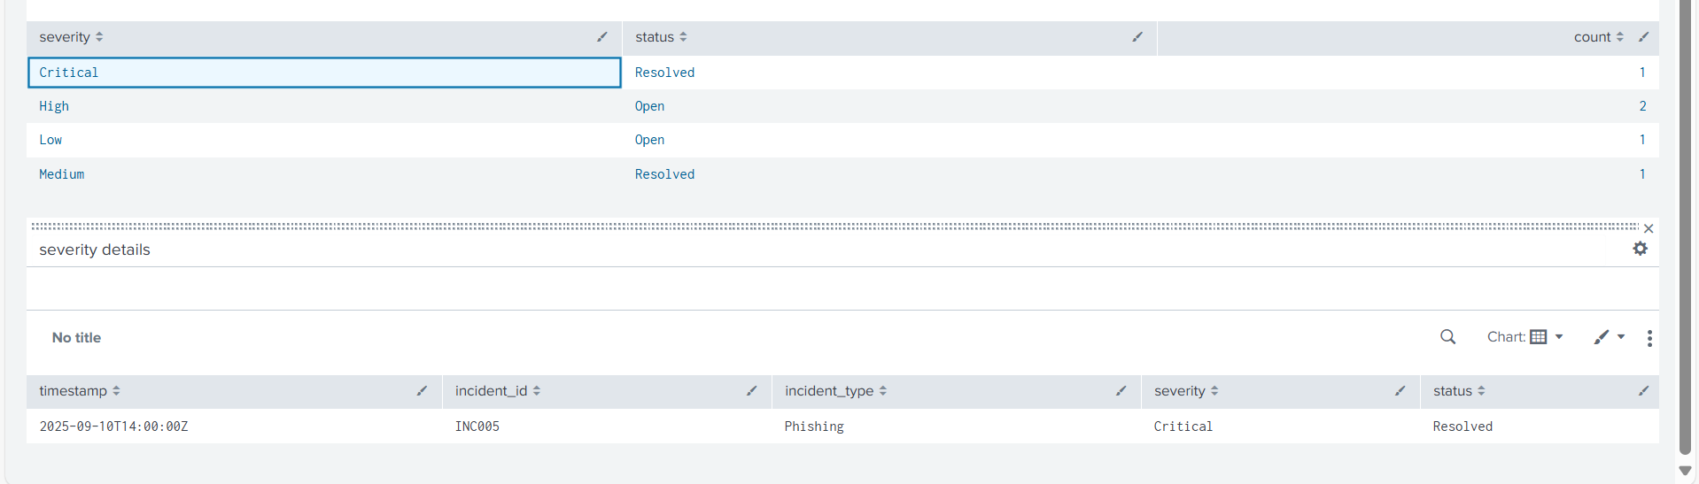

If i click on high:

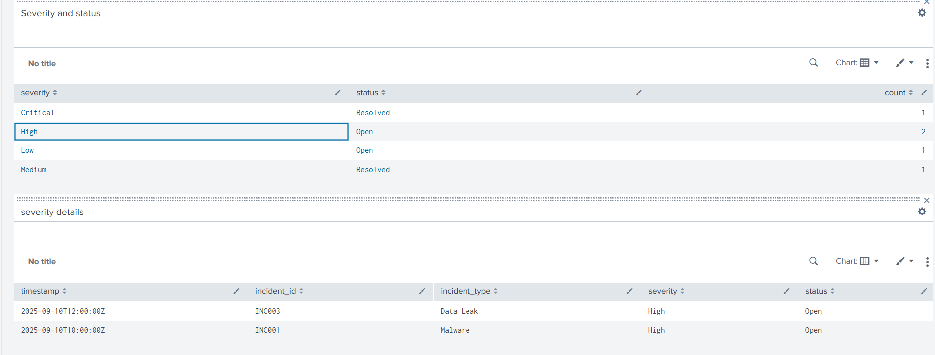

If i click on low:

