TASK:

 Log data from Otel are sending to Splunk, please check for last 24hrs with **index="otel"** and **analyse the log and work on the dashboards**.

[Wallet Manager](https://cryptowallet.sflabs.ustpace.com/) - Crypto wallet web app to generate the logs.  
  
  
Actually we need to do: **analyse the log and work on the dashboards**TASK: Create dashboard of crypto wallet dashboard.

SOLUTION:

1. To see all events of wallet:

index="otel" wallet

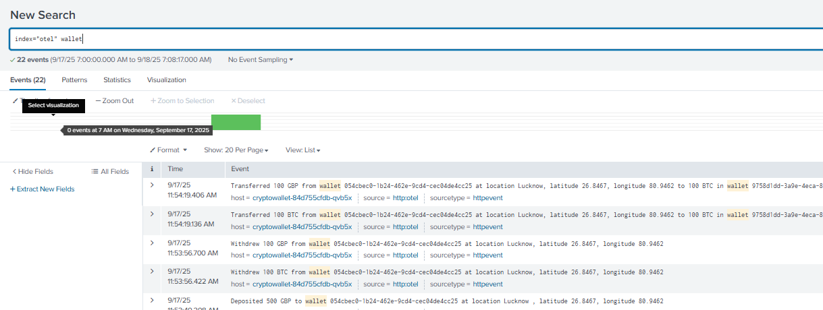

22 events listed.

**SPL: It shows the details of deposit:**

index="otel" wallet earliest=-24h latest=now | search "Deposited" | rex "Deposited\s+(?<amount>\d+)\s+(?<currency>\w+)\s+to wallet\s+(?<wallet_id>[a-z0-9-]+)" | rex "at location\s+(?<location>[^,]+),\s*latitude\s+(?<lat>[\d\.]+),\s*longitude\s+(?<lon>[\d\.]+)" | table _time wallet_id amount currency location lat lon | sort -_time

**SPL: It shows the details of Transfer:**

index="otel" wallet earliest=-24h latest=now

| search "Transferred"

| rex "Transferred\s+(?<amount_from>\d+)\s+(?<currency_from>\w+)\s+from wallet\s+(?<wallet_from>[a-z0-9-]+).*to\s+(?<amount_to>\d+)\s+(?<currency_to>\w+)\s+in wallet\s+(?<wallet_to>[a-z0-9-]+)"

| rex "from wallet\s+[a-z0-9-]+\s+at location\s+(?<location_from>[^,]+),\s*latitude\s+(?<lat_from>[\d\.]+),\s*longitude\s+(?<lon_from>[\d\.]+)"

| rex "in wallet\s+[a-z0-9-]+\s+at location\s+(?<location_to>[^,]+),\s*latitude\s+(?<lat_to>[\d\.]+),\s*longitude\s+(?<lon_to>[\d\.]+)"

| table _time wallet_from wallet_to amount_from currency_from amount_to currency_to location_from lat_from lon_from location_to lat_to lon_to

| sort -_time

**SPL: it shows the details of Withdrawel:**

index="otel" wallet earliest=-24h latest=now | search "Withdrew" | rex "Withdrew\s+(?<amount>\d+)\s+(?<currency>\w+)\s+from wallet\s+(?<wallet_id>[a-z0-9-]+)" | rex "at location\s+(?<location>[^,]+),\s*latitude\s+(?<lat>[\d\.]+),\s*longitude\s+(?<lon>[\d\.]+)" | table _time wallet_id amount currency location lat lon | sort -_time

**IMP:**

Lost all data so changed the time range of every panels to yesterday and also removed this from every querry.

* ( earliest=-24h latest=now) = remove this

**PANELS CREATION:**

1. Panel 1: Total events(stat)

Spl:

index=otel host="cryptowallet-84d755cfdb-qvb5x" earliest=-24h latest=now

| stats count AS "Total Events"

Drilldown:  
details = events

1. Panel 2: Total wallet created(stat)

Spl:

index="otel" earliest=-24h latest=now "Created wallet"

| stats count as "Total Wallets Created"

Drilldown:

details = wallets_created

1. Panel 3: Total wallet deleted(stat)

Spl:

index=otel host="cryptowallet-84d755cfdb-qvb5x" earliest=-24h latest=now "Deleted wallet" | stats count as "Total Wallets Deleted"

drilldown:  
details= wallets_deleted

1. Panel 4: Total errors (wallet not found)(stat)

Spl:

index="otel" wallet earliest=-24h latest=now

| rex "Wallet with ID (?<wallet_id>[a-z0-9-]+) not found"

| where isnotnull(wallet_id)

| stats count as total_wallet_errors

Drilldown:

details=error  
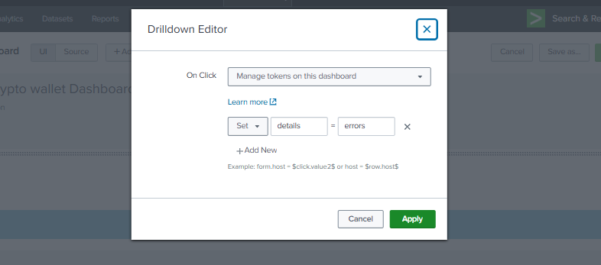

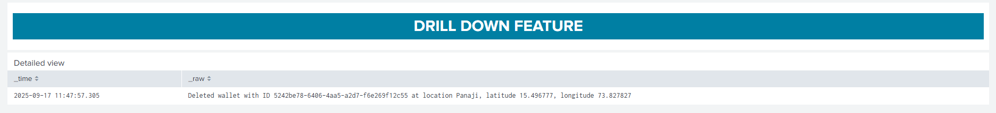

1. Panel 5: error %

Spl:

index=otel host="cryptowallet-84d755cfdb-qvb5x" earliest=-24h latest=now

| eval is_error=if(like(_raw,"%not found%"),1,0)

| stats count as total_events sum(is_error) as total_errors

| eval error_percentage = round((total_errors/total_events)*100,2)

| fields error_percentage

Drilldown:

details=error

1. Panel 6: failed Operations

Spl:

index=otel host="cryptowallet-84d755cfdb-qvb5x" earliest=-24h latest=now "not found"

| stats count AS "Failed Operations"

Drilldown:

details=error

1. Panel 7: Total no of deposits

Spl:

index="otel" wallet earliest=-24h latest=now

| where like(_raw, "Deposited%")

| stats count as total_deposits

Drilldown:

details=deposits

1. Panel 8: Total number of withdrawals

Spl:

index="otel" wallet earliest=-24h latest=now

| where like(_raw, "Withdrew%")

| stats count as total_withdrawals

Drilldown:

details= withdrawals

1. Panel 9: Total number of Transfers

Spl:

index="otel" wallet earliest=-24h latest=now

| where like(_raw, "Transferred%")

| stats count as total_transfers

Drilldown:

details= transfers

1. Panel 10: Total number of Transactions

Spl:

index="otel" wallet earliest=-24h latest=now

| eval is_transaction=if(like(_raw,"Deposited%") OR like(_raw,"Withdrew%") OR like(_raw,"Transferred%"), 1, 0)

| stats sum(is_transaction) as total_transactions

Drilldown:

details= "Deposited" OR "Withdrew" OR "Transferred"

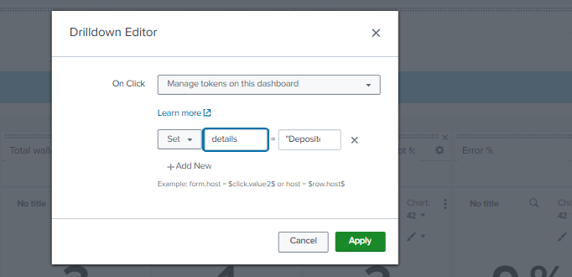

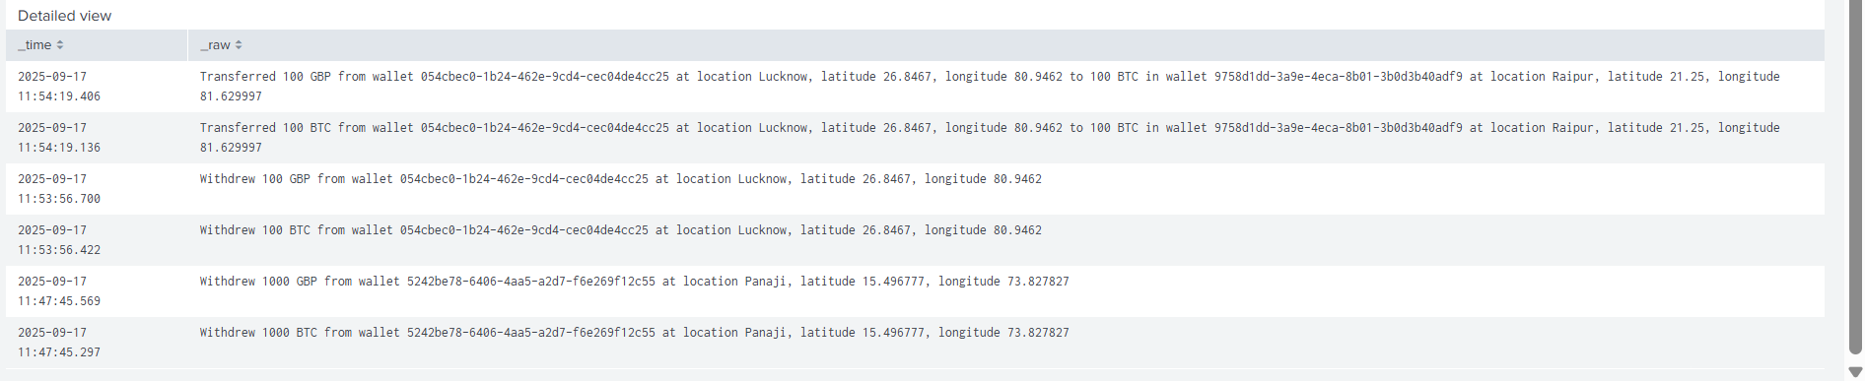

1. Panel 11: Transaction by Location and type (Choropleth Map)

Spl:

index="otel" wallet earliest=-24h latest=now

| rex "at location\s+(?<location>[^,]+),\s*latitude\s+(?<lat>[\d\.]+),\s*longitude\s+(?<lon>[\d\.]+)"

| eval type=case(

match(_raw,"Deposited"),"Deposit",

match(_raw,"Withdrew"),"Withdrawal",

match(_raw,"Transferred"),"Transfer"

)

| stats count by location lat lon type

1. Panel 12: Number of transaction per currency(column chart)

Spl:

index="otel" wallet earliest=-24h latest=now

| eval type=case(

match(_raw,"Deposited"),"Deposit",

match(_raw,"Withdrew"),"Withdrawal",

match(_raw,"Transferred"),"Transfer"

)

| rex field=_raw "Deposited\s+\d+\s+(?<deposit_currency>\w+)"

| rex field=_raw "Withdrew\s+\d+\s+(?<withdraw_currency>\w+)"

| rex field=_raw "Transferred\s+\d+\s+(?<transfer_currency_from>\w+).*to\s+\d+\s+(?<transfer_currency_to>\w+)"

| eval currency=coalesce(deposit_currency, withdraw_currency, transfer_currency_from)

| stats count as transactions by currency

| sort -transactions

1. Panel 13: Deposit per currency (column chart)

Spl:

index="otel" wallet earliest=-24h latest=now

| where like(_raw, "Deposited%")

| eval currency=mvindex(split(_raw," "),2)

| stats count as deposits by currency

1. Panel 14: withdrawal per currency(column chart)

Spl:

index="otel" wallet earliest=-24h latest=now

| where like(_raw, "Withdrew%")

| eval currency=mvindex(split(_raw," "),2)

| stats count as withdrawals by currency

1. Panel 15: Outgoing transfer per currency (column chart)

Spl:

index="otel" wallet earliest=-24h latest=now

| where like(_raw, "Transferred%")

| eval currency=mvindex(split(_raw," "),2)

| stats count as outgoing_transfers by currency

1. Panel 16: Number of deposit per wallet (column chart)

Spl:

index="otel" wallet earliest=-24h latest=now

| where like(_raw, "Deposited%")

| eval wallet_id=mvindex(split(_raw," "),6)

| stats count as deposits by wallet_id

| sort -deposits

1. Panel 17: number of withdrawels per wallet

Spl:

index="otel" wallet earliest=-24h latest=now

| where like(_raw, "Withdrew%")

| eval wallet_id=mvindex(split(_raw," "),6)

| stats count as withdrawals by wallet_id

| sort -withdrawals

1. Panel 18: number of transfers per wallet

Spl:

index="otel" wallet earliest=-24h latest=now

| where like(_raw, "Transferred%")

| eval wallet_from=mvindex(split(_raw," "),6)

| eval wallet_to=mvindex(split(_raw," "),13)

| stats count as transfers by wallet_from

| sort -transfers

1. Table 19: Detailed view (table)->DRILLDOWN

Spl:

index=otel host="cryptowallet-84d755cfdb-qvb5x" earliest=-24h latest=now

| eval category=case(

match(_raw,"Created wallet"),"wallets_created",

match(_raw,"Deleted wallet"),"wallets_deleted",

match(_raw,"Deposited"),"deposits",

match(_raw,"Withdrew"),"withdrawals",

match(_raw,"Transferred"),"transfers",

like(_raw,"%not found%"),"errors",

true(),"events")

| search category=$details$

| table _time _raw

**TITLE:**

1. CRYPTO WALLET DASHBOARD

<row>

<panel>

<html>

<h1 style="text-align: center; color: black; background-color:#94D2EC; padding: 15px; font-size: 30px;">CRYPTO WALLET DASHBOARD</h1>

</html>

</panel>

</row>

1. DRILL DOWN FEATURE

<row>

<panel>

<html>

<h1 style="text-align: center; color: white; background-color: #007FA3; padding: 15px; font-size: 30px;"> DRILL DOWN FEATURE</h1>

</html>

</panel>

</row>

PROBLEM: NO DATA

1. Removed the latest and 24 hr from all the querries and changed to yesterday.( earliest=-24h latest=now)

Eg:

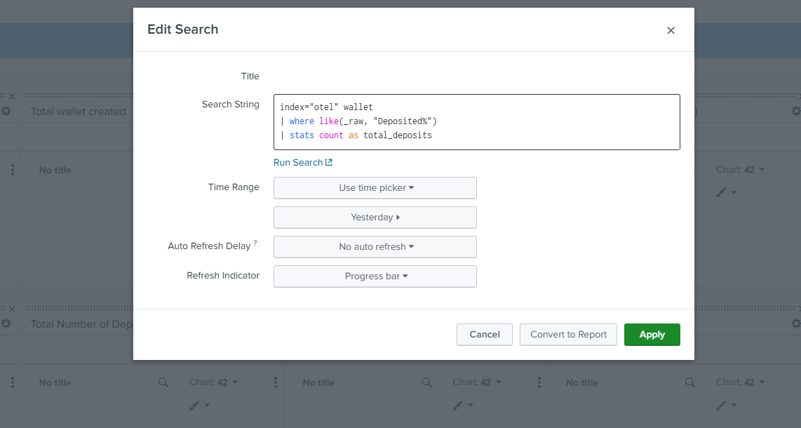

DASHBOARD:

ALERT:

Don’t forget to keep time range as yesterday.

Spl:   
index=otel host="cryptowallet-84d755cfdb-qvb5x" "not found"

