DYNATRACE - Tool

Q. what is Dynatrace?
Dynatrace is an APM (Application Performance Monitoring) platform that tracks the performance, infrastructure health, and user experience of applications — helping teams detect issues early and optimize overall system performance.

Q. Why we are creating token in Dynatrace?
A Dynatrace token is used for authentication and API access, enabling integrations (like OpenTelemetry, Jenkins, or monitoring agents) to send or retrieve data safely. Not exposing login credentials.
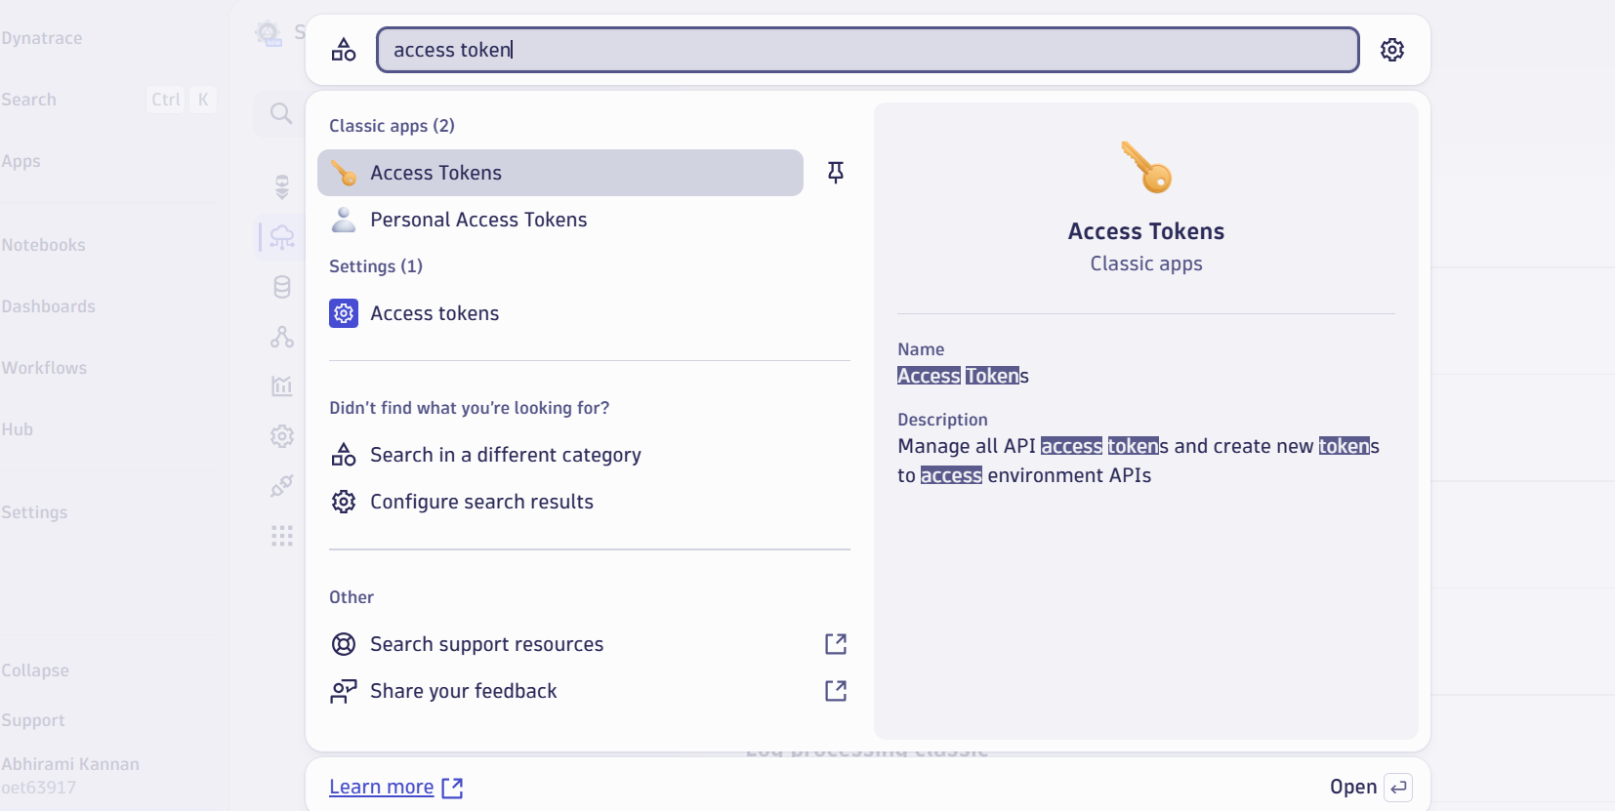

Q. For creating token I referred a documentation and searched for 3 things and added that .
Link: Running OpenTelemetry demo app Astronomy Shop with Dynatrace
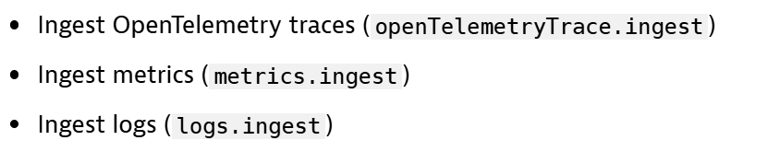

Q. After creating token find end point. Y? From where you find and why?
After creating a token, you need the endpoint so that external tools (like OpenTelemetry, Prometheus, or Jenkins) know where to send or receive data from Dynatrace. It tells them the exact Dynatrace environment URL for API communication.

TASK: Merin added some data and asked us to check for logs,metrices and traces. Also create dashboards in Dynatrace.

Q. where u can see traces in Dynatrace?
Services-> u can see the list of services there as 14 -> click there.. the page goes to explorer and u can see the list of services -> select 1 (frontend) -> u can see the traces.
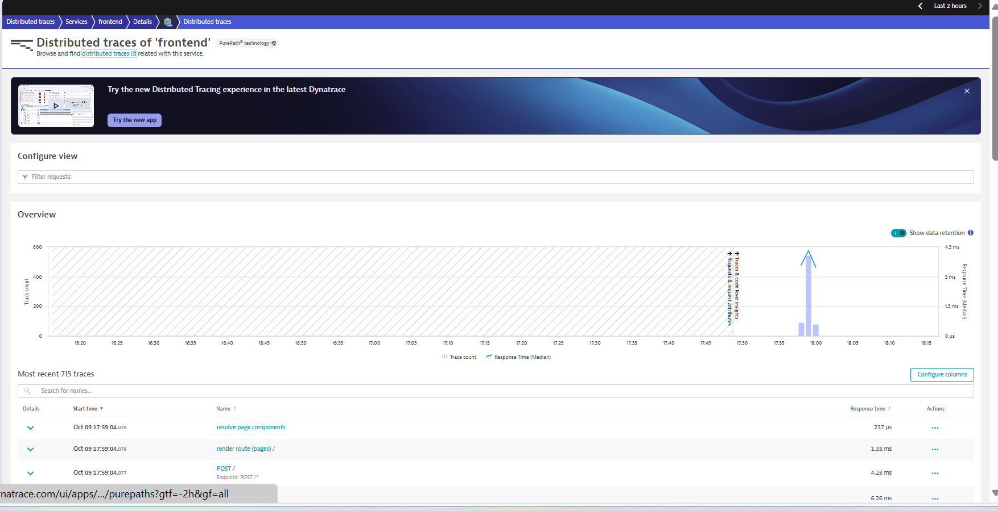

Q. where u can see logs and metrics?
Apps -> logs -> u can see logs.
Apps -> metrics classic -> u can see metrics
Q. Types of Dashboards in Dynatrace?
1. Dashboard
2. Dashboard classic
When we select pin to dashboard it redirect to classic dashboard
Open with can redirects to dashboards.

Q. How to create dashboard using metrics data?
1. I want to create panels for some req (Traffics)
2. search requests in search bar
3. u will find some request texted metrics
4. select one and open to dashboard and adjust this

Dashboard:
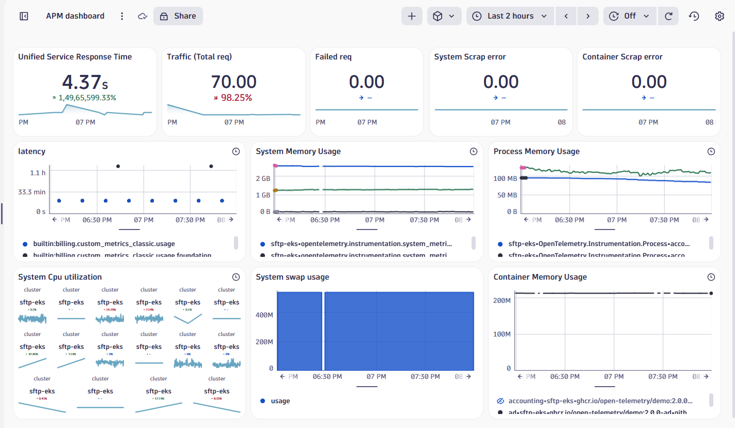

NO DATA ISSUE:
- Unified service failure count
- Service health -> affected no…
- builtin:service.request.failure_count
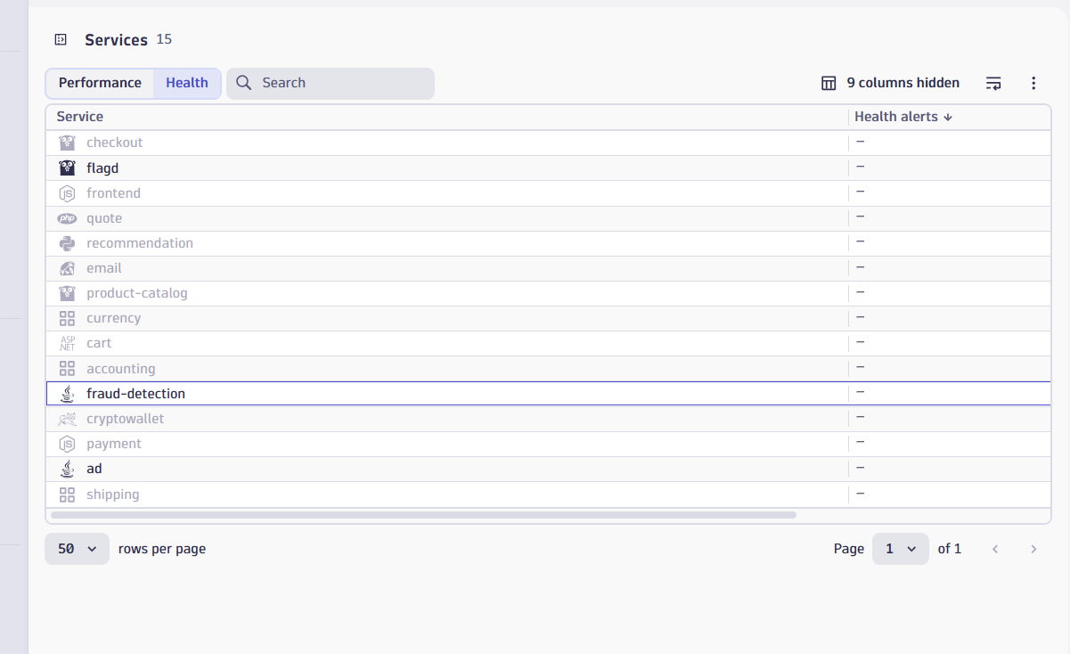

DOUBT:
- when I search on logs : status =error . I can see some data , in metric when I search error.. less no of data . y?

Dashboard:
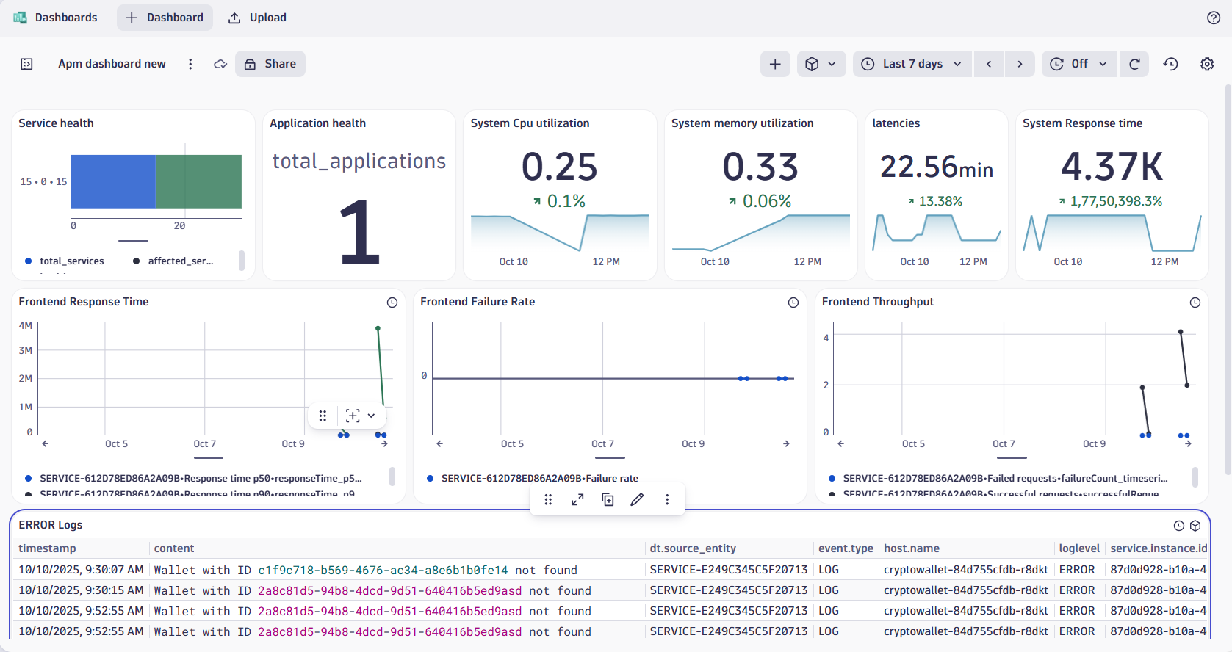
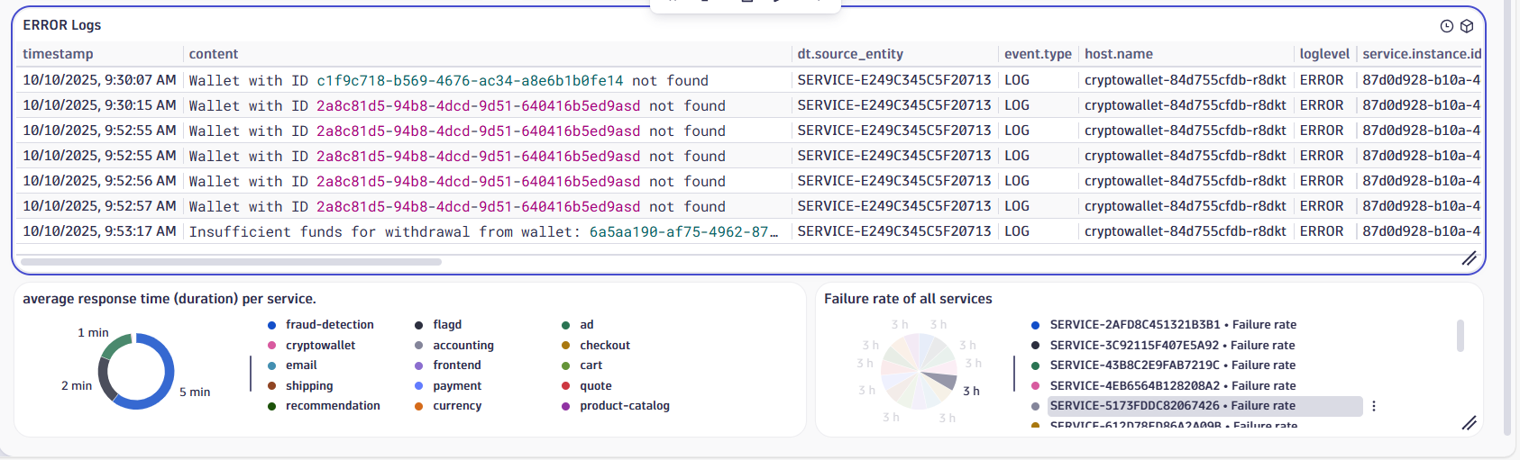

Q. Why Dynatrace is used for dashboards
Dynatrace is used to get a complete picture of an application's and system's performance.
It uses OneAgent to automatically collect data from every part of the application — including frontend, backend, database, and infrastructure — and provides deep insights with AI-powered analysis.
It also uses AI (Davis AI) to find problems and their exact root causes, which saves a lot of time compared to tools like Grafana or Prometheus that need manual setup and only show graphs.

13/10/25
Newrelic vdo link: New Relic final demo video.mp4
Task: Create similar dashboard in Dynatrace.

Q. How to add and create SLO in ur dashboard?

- Creating SLO
  - Apps -> SLO -> service performance
    - Application latency SLO
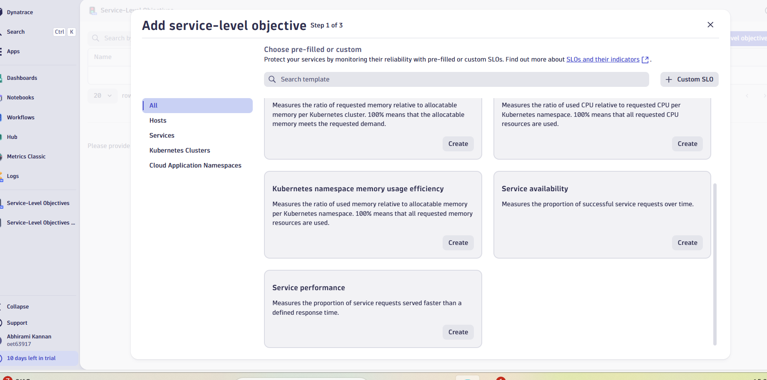
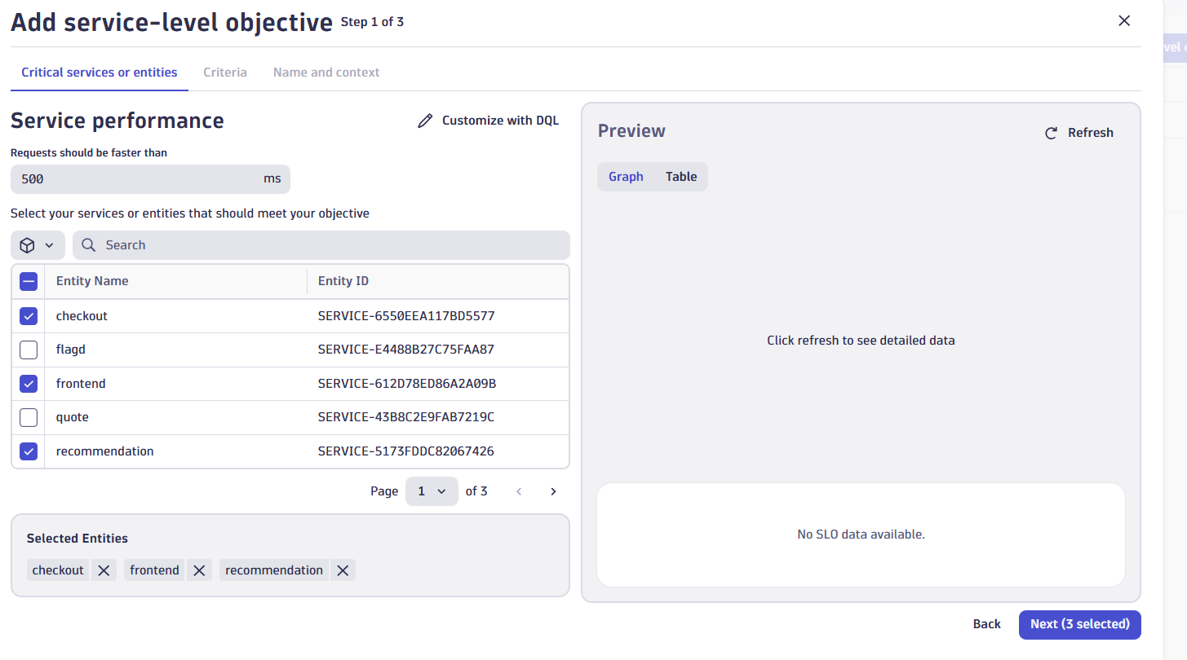
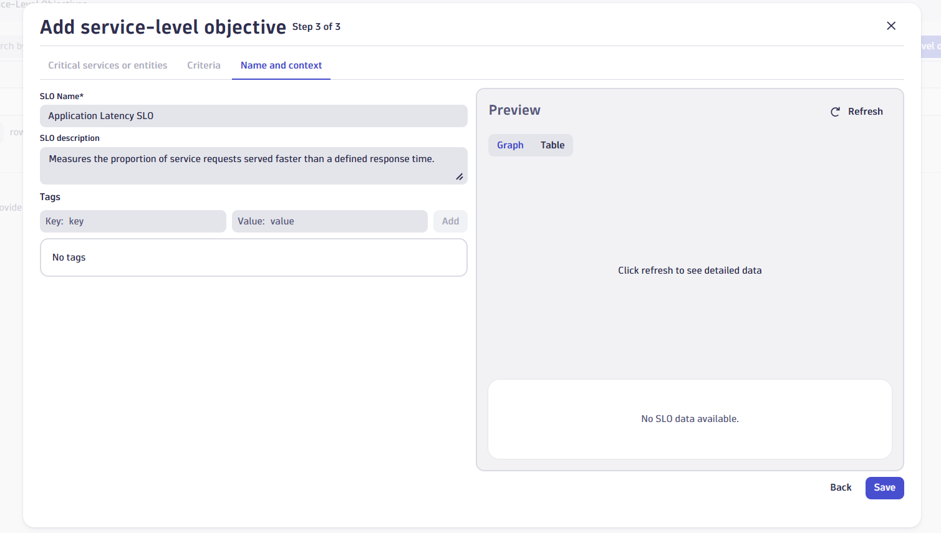
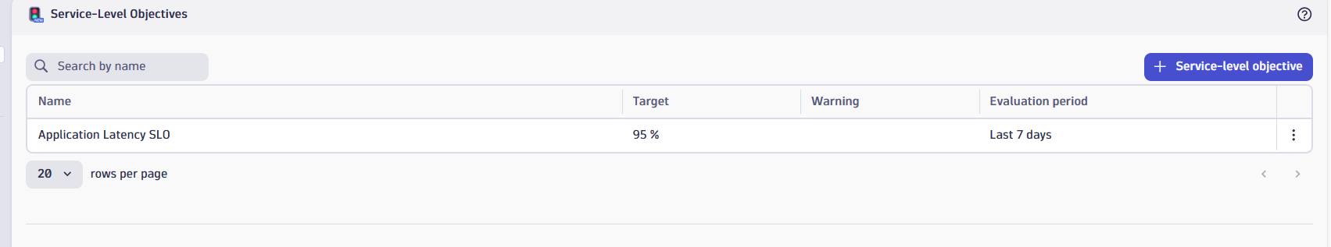

  - Creating the Error SLO (Target 99.95% Success)
    - use the Service-level availability template.
    - Select Entities -> same as latency
    - Target: Set the target to 99.95 %.
    - Name : Application Error SLO
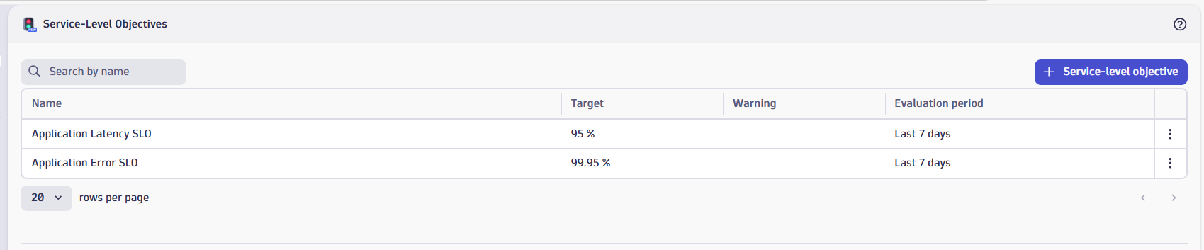

- App error rate:
  - Req failed count/ Total service req * 100
  - Search -> calculated service metrics->
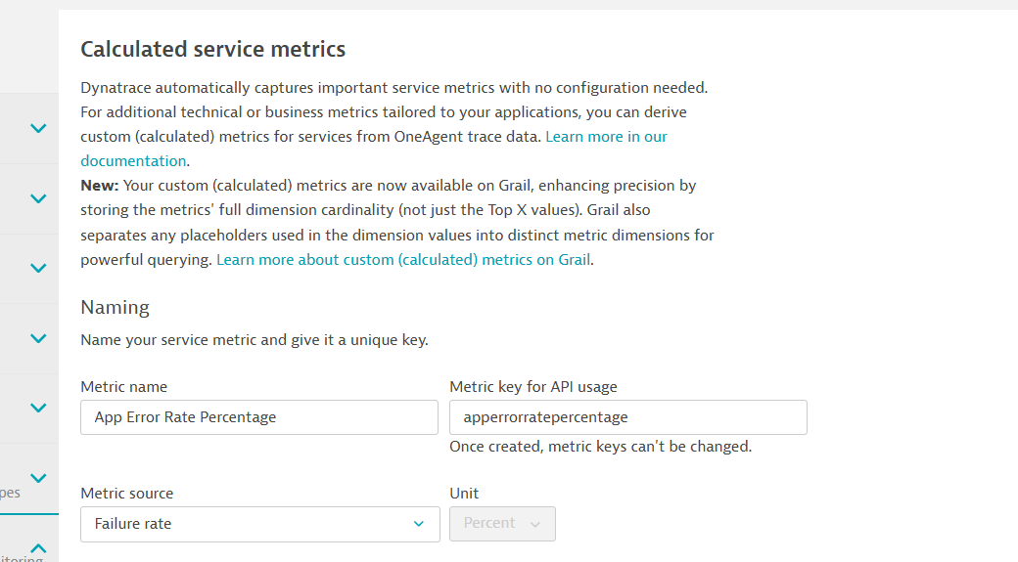
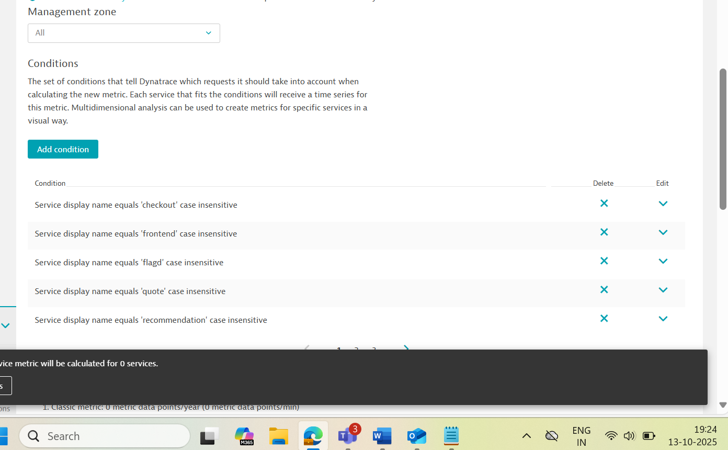

Didn’t worked.
DQL querry to find error rate of each service:
timeseries {
failedRequests = sum(dt.service.request.failure_count, default: 0),
totalRequests = sum(dt.service.request.count, default: 0)
},
by: { dt.entity.service }
| fieldsAdd errorRate = arrayAvg(failedRequests) / arrayAvg(totalRequests) * 100
| fields timeframe, interval, entityName(dt.entity.service), errorRate

DQL for error rate of app:
timeseries {
failedRequests = sum(dt.service.request.failure_count, default: 0),
totalRequests = sum(dt.service.request.count, default: 0)
}
| fieldsAdd errorRate = arrayAvg(failedRequests) / arrayAvg(totalRequests) * 100
| fields timeframe, interval, errorRate

Dql for service failure count: Taken from metric
timeseries { failure_count = sum(dt.service.request.failure_count, scalar: true), failure_count.trend_line = sum(dt.service.request.failure_count) }

DQl for service req count: Taken from metric
timeseries { count = sum(dt.service.request.count, scalar: true), count.trend_line = sum(dt.service.request.count) }

- P95 Time=The fastest response time of the slowest 5% of requests.
  - Search response to get the metric name:
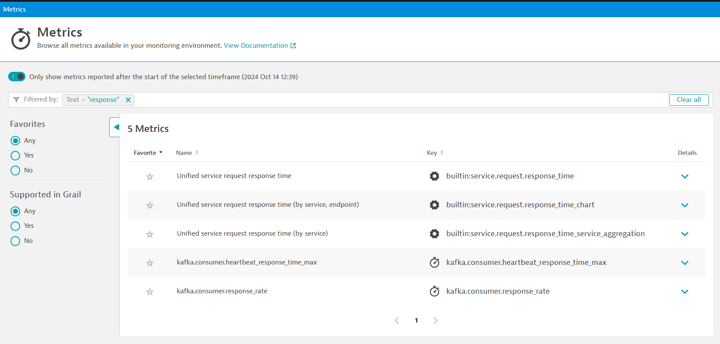

  - Response time taken from metrics:
    - timeseries { response_time = percentile(dt.service.request.response_time, 50, scalar: true), response_time.trend_line = percentile(dt.service.request.response_time, 50) }
  - For 95 percentile of App:
timeseries {
p95_response_time = percentile(dt.service.request.response_time, 95, scalar: true),
p95_response_time_trend = percentile(dt.service.request.response_time, 95)
}
- Total details:
timeseries totalRequests = sum(dt.service.request.count),
failedRequests = sum(dt.service.request.failure_count),
p99ResponseTime = percentile(dt.service.request.response_time, 99), // Added P99
p95ResponseTime = percentile(dt.service.request.response_time, 95),
p50ResponseTime = percentile(dt.service.request.response_time, 50), // Added P50 (Average/Median)
by: { dt.entity.service }
| fieldsAdd serviceName = entityName(dt.entity.service)
| fieldsAdd errorRate = arrayAvg(failedRequests) / arrayAvg(totalRequests) * 100
| fields serviceName,
errorRate,
totalRequests = arraySum(totalRequests), // Changed to arraySum for total requests in time frame
p50ResponseTime = arrayAvg(p50ResponseTime),
p95ResponseTime = arrayAvg(p95ResponseTime),
p99ResponseTime = arrayAvg(p99ResponseTime)
| sort errorRate desc
| limit 20
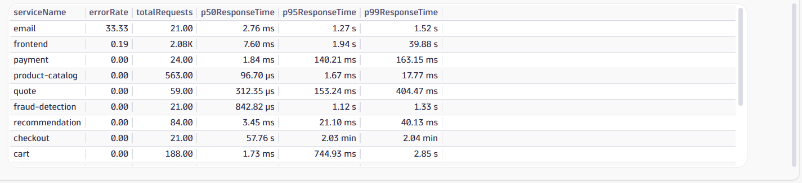

- I want a table which displays service name, error slo, latency slo
  - To check the services with the traffic (No of req) = RAW TRAFFIC
timeseries total = sum(dt.service.request.count), failures = sum(dt.service.request.failure_count)
, by: { dt.entity.service }
| fieldsAdd error_slo = if(condition: total > 0, then: 100 * ((total - failures) / total), else: 0)
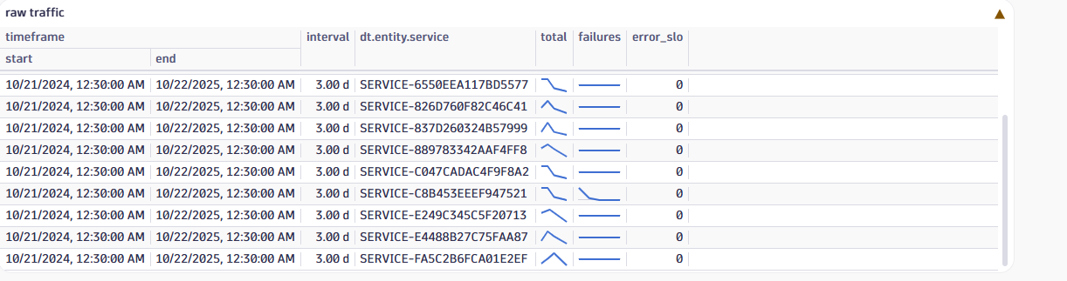

There is no traffic that’s y 0 .
  - Table dql querry:
timeseries
avgRespTime = avg(dt.service.request.response_time),
total = sum(dt.service.request.count),
failures = sum(dt.service.request.failure_count)
, by: { dt.entity.service }

| fieldsAdd
total = coalesce(total, 0),
failures = coalesce(failures, 0),
latency_slo = if(condition: isNull(avgRespTime), then: null, else: if(condition: avgRespTime > 500000, then: 0, else: 100)),
error_slo = if(condition: total > 0, then: 100 * ((total - failures) / total), else: 0),
service_name = entityName(dt.entity.service)
| fields service_name, latency_slo, error_slo
Table:
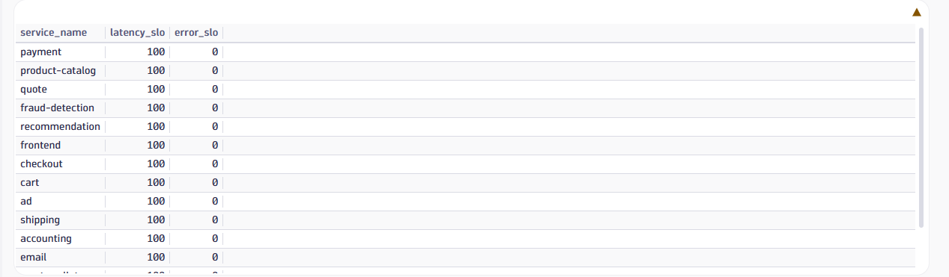
Latency SLO is showing 100 for each service because the average response time for all of them is below your defined threshold of 500 milliseconds. This means every service is meeting the latency target, so the SLO is marked as fully compliant (100%).
Error SLO is showing 0 because of no traffic. Your error SLO is showing 0 because the number of failed requests (failures) is equal to the total number of requests (total) — meaning 100% of requests failed, resulting in 0% success.

Q. why error slo is 0 ?
Saying no failure count that’s y. But when I checked the metrics I saw some failure graph.
I made that as a panel: 11 req failed
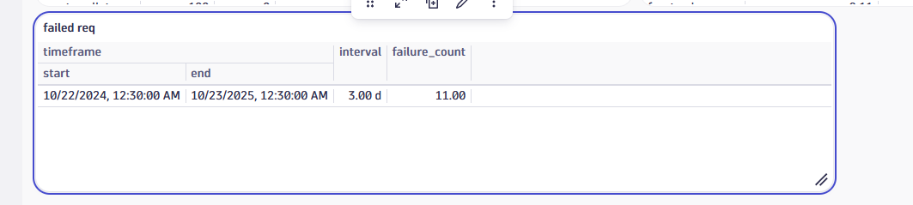

I changed querry of slo compliance table:
timeseries
avgRespTime = avg(dt.service.request.response_time),
total = sum(dt.service.request.count),
failures = sum(dt.service.request.failure_count)
, by: { dt.entity.service }

| fieldsAdd
service_name = entityName(dt.entity.service),
total_sum = arraySum(total),
failures_sum = arraySum(failures),
avgRespTime_ms = arrayAvg(avgRespTime) / 1000

| fieldsAdd
latency_slo = if(condition: isNull(avgRespTime_ms), then: null, else: if(condition: avgRespTime_ms > 500, then: 0, else: 100)),
error_slo = if(condition: total_sum > 0, then: 100 * ((total_sum - failures_sum) / total_sum), else: 0)

| fields service_name, latency_slo, error_slo

Table:
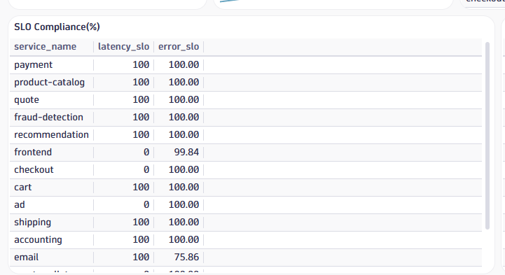

- Table view of services overview
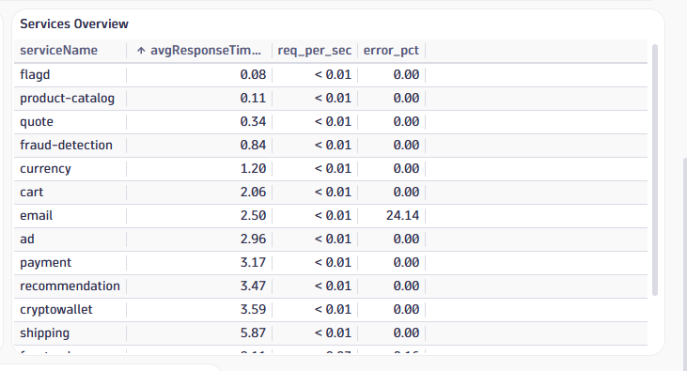

Querry:
timeseries
totalRequests = sum(dt.service.request.count),
failedRequests = sum(dt.service.request.failure_count),
p50ResponseTime = percentile(dt.service.request.response_time, 50)
, by: { dt.entity.service }

| fieldsAdd
serviceName = entityName(dt.entity.service),
avgResponseTime_ms = arrayAvg(p50ResponseTime) / 1000,
totalRequests_sum = arraySum(totalRequests),
failedRequests_avg = arrayAvg(failedRequests),
totalRequests_avg = arrayAvg(totalRequests)

| fieldsAdd
req_per_sec = totalRequests_sum / 86400, // Replace with your actual timeframe in seconds
error_pct = if(condition: totalRequests_avg > 0, then: failedRequests_avg / totalRequests_avg * 100, else: 0)

| fields serviceName, avgResponseTime_ms, req_per_sec, error_pct
| sort error_pct desc
| limit 20

FEATURE I need to Implement:
When i click on the service name of first level 0 dashboard it show the detail of that service in level 1 dashboard.

LEVEL 1 dashboard:
The panels I want:
error slo target panel,error sli compliance over time,latency slo target,latency sli compliance overtime,error count per service, error rate per service,error per trace, trace count per service,duration in ms per service,duration per trace (ms) these much panels i want in level 1

- Adding variable:
  - Click variable
  - Type serviceName
  - Set default
I want exactly like this picture:
I got this using a dql but still a triangle symbol I can see.
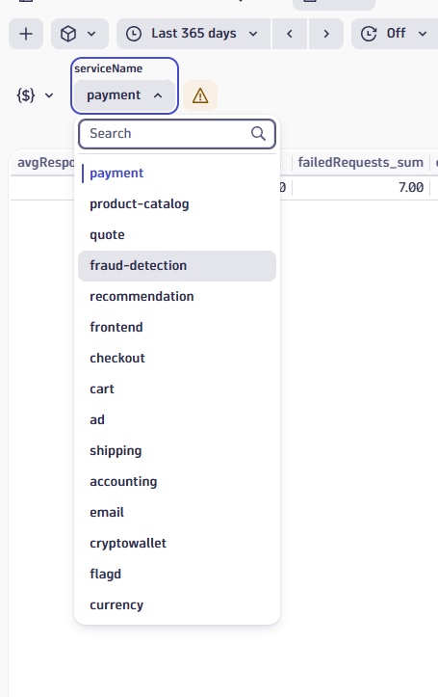

DQL:
timeseries {
dummy = sum(dt.service.request.count, default: 0)
},
by: { dt.entity.service }
| fieldsAdd serviceName = entityName(dt.entity.service)
| fields serviceName

ISSUE:
This variable is not referenced. To use it, add it to a query, code, title, or markdown.
Copy "$serviceName"

Copy this and use in the panels. Then only this will work.

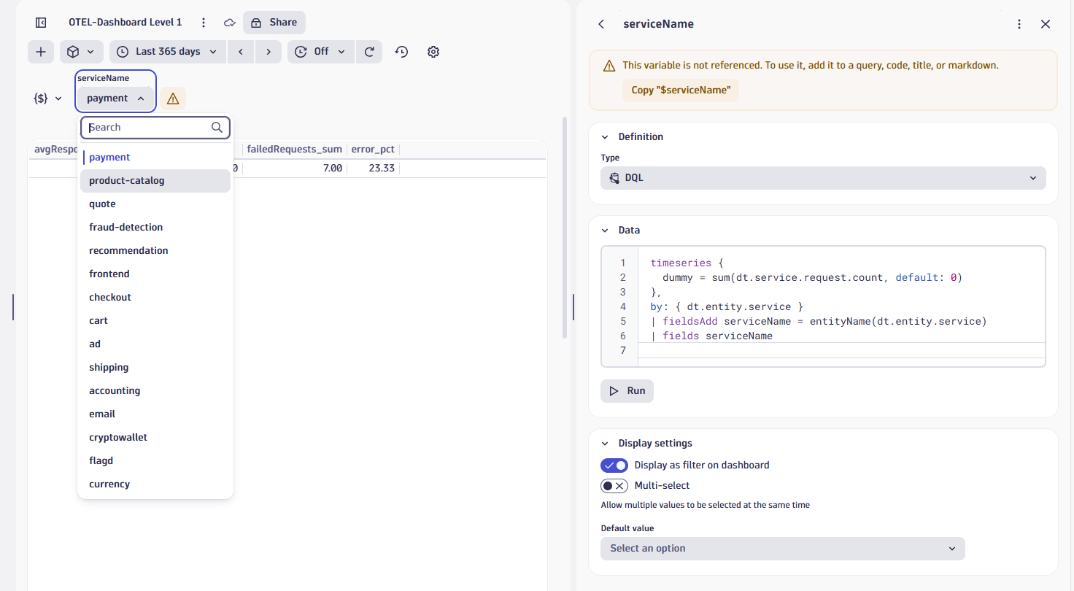

SOLN:
This is because we haven’t used this variable anywhere…we should use this variable in level 1 dashboard.

- Some working dql:
  - Service count:
timeseries {
dummy = count(dt.service.request.count)
},
by: { dt.entity.service }

  - What the service name contains?
timeseries {
dummy = count(dt.service.request.count)
},
by: { dt.entity.service }
| fieldsAdd readableName = entityName(dt.entity.service)
| fields readableName, dt.entity.service

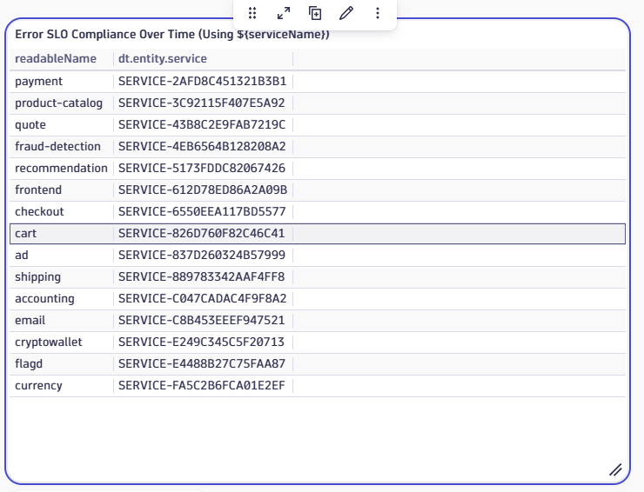

- Hardcoded panel for error sli compliance over time:
timeseries {
totalRequests = sum(dt.service.request.count, default: 0),
failedRequests = sum(dt.service.request.failure_count, default: 0)
},
by: { dt.entity.service }
| fieldsAdd readableName = entityName(dt.entity.service)
| filter readableName == "frontend"
| fieldsAdd errorSLI = if(
condition: arrayAvg(totalRequests) > 0,
then: 100 * ((arrayAvg(totalRequests) - arrayAvg(failedRequests)) / arrayAvg(totalRequests)),
else: 100
)
| fields timeframe, interval, errorSLI

- Panel for error sli Compliance over time of particular service using variable serviceName:
timeseries {
totalRequests = sum(dt.service.request.count, default: 0),
failedRequests = sum(dt.service.request.failure_count, default: 0)
},
by: { dt.entity.service }
| fieldsAdd readableName = lower(trim(entityName(dt.entity.service)))
| filter readableName == lower(trim($serviceName))
| fieldsAdd errorSLI = if(
condition: arrayAvg(totalRequests) > 0,
then: 100 * ((arrayAvg(totalRequests) - arrayAvg(failedRequests)) / arrayAvg(totalRequests)),
else: 100
)
| fields timeframe, interval, errorSLI

- Latency sli compliance over time of particular service:
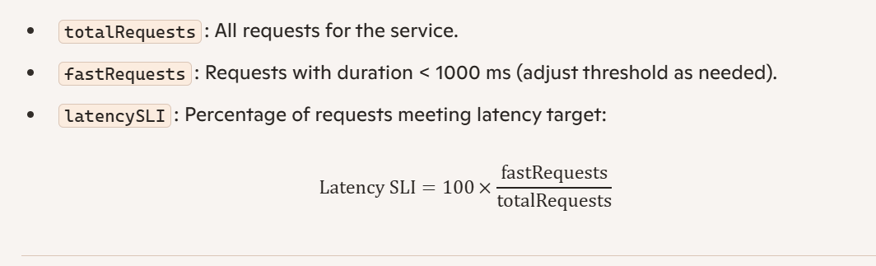

- I gave the latency working querry to chatgpt and chatgpt gave a querry and the querry is working:

timeseries {
latencies = avg(dt.sfm.server.metrics.latencies, scalar: true),
latencies.trend_line = avg(dt.sfm.server.metrics.latencies)
},
filter: { dt.system.bucket == "dt_system_metrics" }

- From this it confirms that this querry works because dt.sfm.server.metrics.latencies is not a metric in the global metric namespace. It only exists inside the “system metrics bucket” object (dt_system_metrics). That means it can’t be directly fetched like normal metrics (fetch builtin:* or fetch dt.service.*).
Instead, it’s a field inside a dataset you must access using fetch dt.system.bucket (the same bucket used in your working query).
- Issues: NO RECORDS
  - Because dt.sfm.server.metrics.latencies exists only inside the system metrics bucket (dt_system_metrics).
  - It is not tied to services. That means there is no dt.entity.service field inside this metric.
  - That’s why filtering by $serviceName returns nothing — the system metrics bucket does not know about your services.
  - you cannot calculate latency SLI per service using dt.sfm.server.metrics.latencies, because it’s a system-level metric, not a service-level metric.

