POWERBI

Watch a video: https://youtu.be/9tF1IrfLflg?si=yaQSfy9MiLskm-TH
- What is powerbi?
- Dasboard visualization tool.
- U can create reports,Graphs,charts and Interactive visuals.
- If the visualization is column chart. How to set up x and y axis?
Dragging the data into x and y axis accordingly .
- To change colour of chart visualization:
  - Visualization -> Format ur visuals -> columns -> change colour
- Interaction Feature in powerbi:
When u click on Australia it shows the boxes shipped in Australia region highlighted. You can see on the below image.
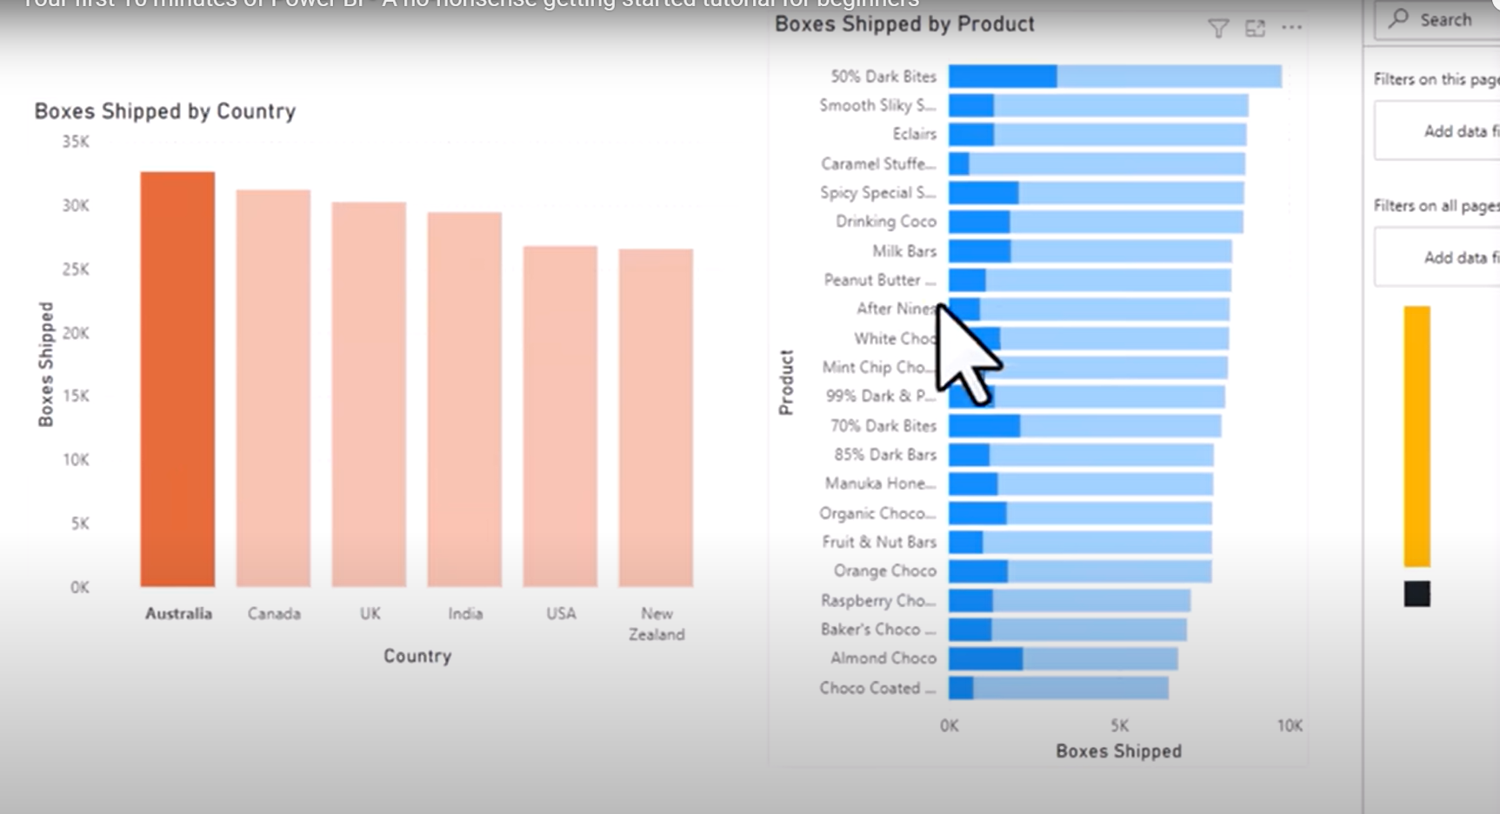
- To take u back again to without highlighting -> click on the same box.
- Date is a special type of data in power bi:
  - Creates a hierarchy like year, quarter
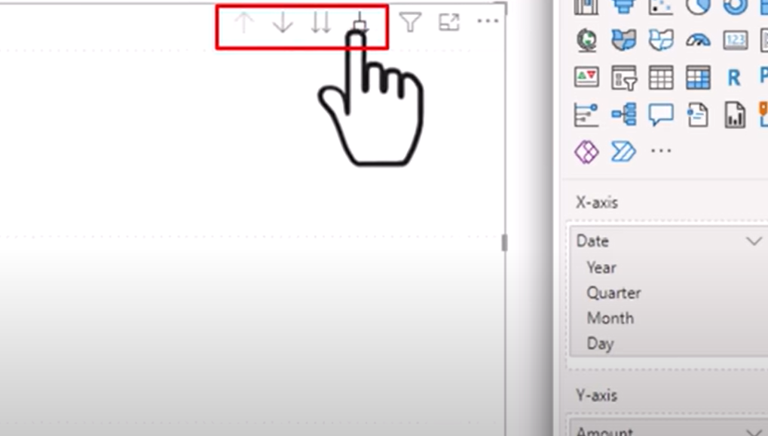

  - Will give u a single value summing up. So click the arrow in the above picture 2,3 times u can see quarterly and monthly visualization as line graph.
  - When someone asks why the amount decreased suddenly in the line chart: Just click the point and analyse: Explain the decrease.
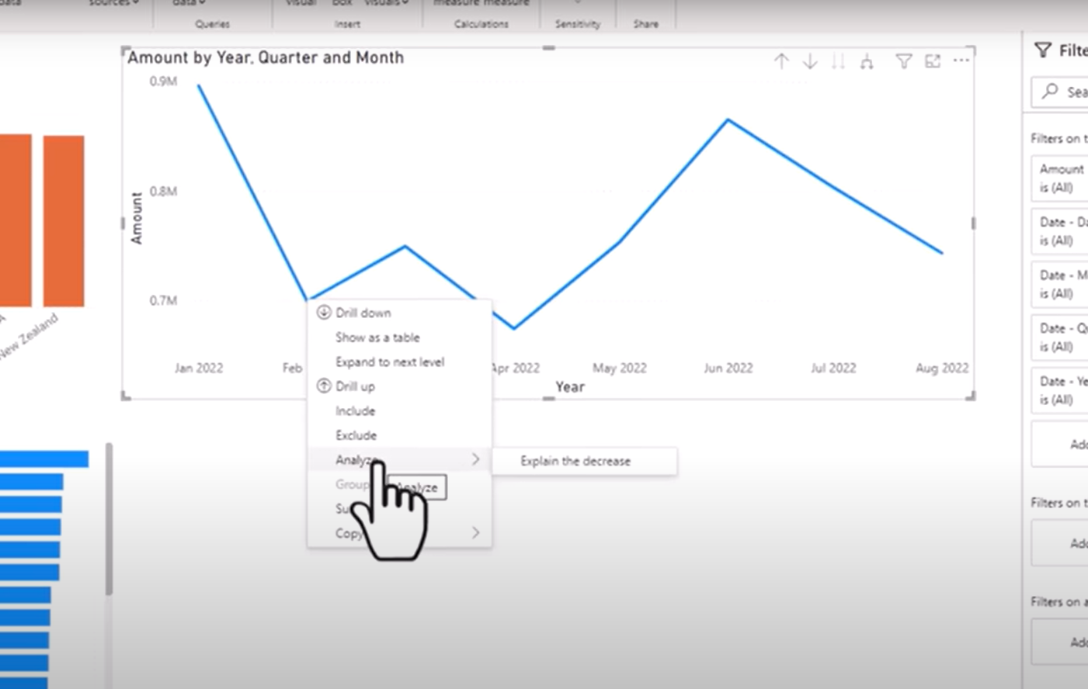

  - Click the + button to add it to ur dashboard:
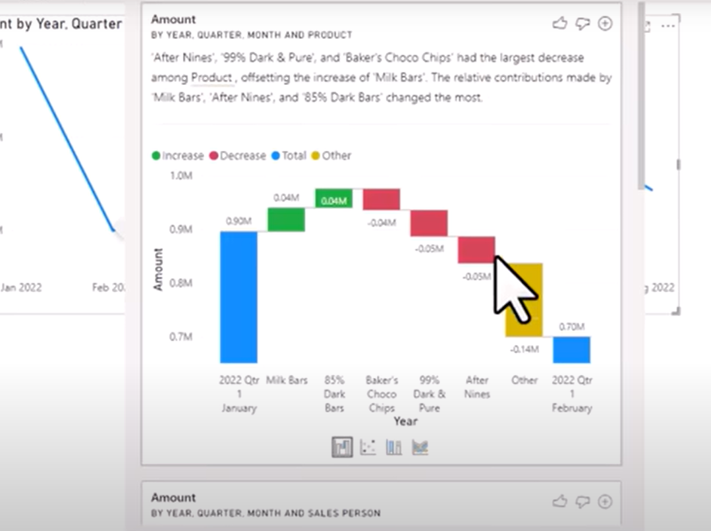

TASKS:
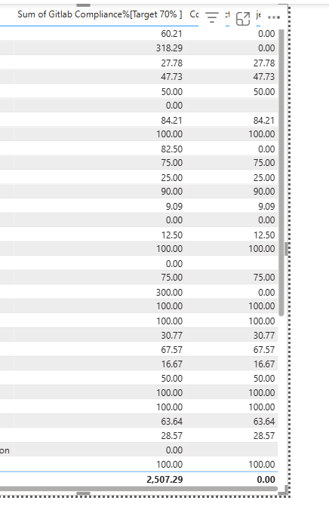
ERROR RESOLVING:
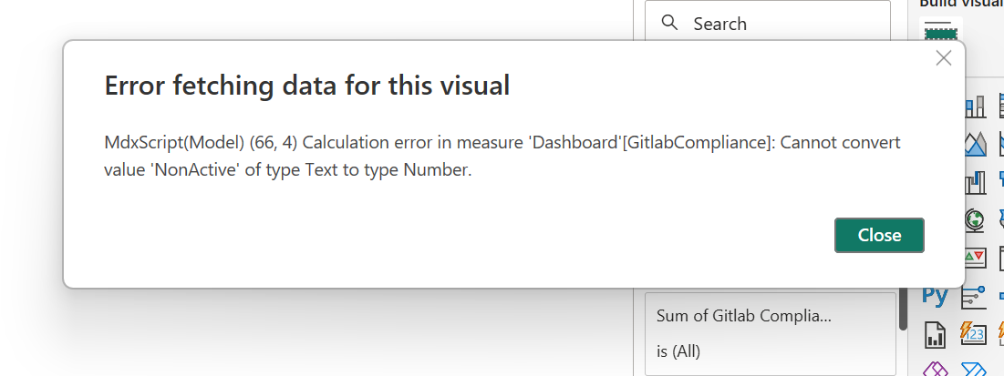
Transform data -> Select Column ->Near Home -> change Data type to Whole number -> Replace error -> -1
ERROR:
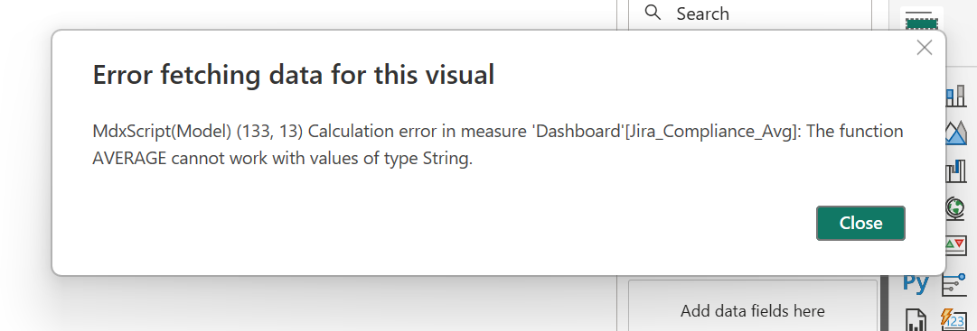
Transform data -> Decimal number -> right click on column-> replace errors -> 0.
Q. why I gave 0 here?
There is no such value 0 on this table that’s y.
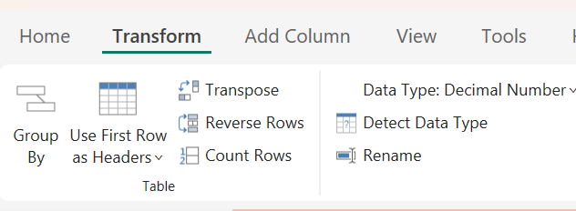
ERROR:
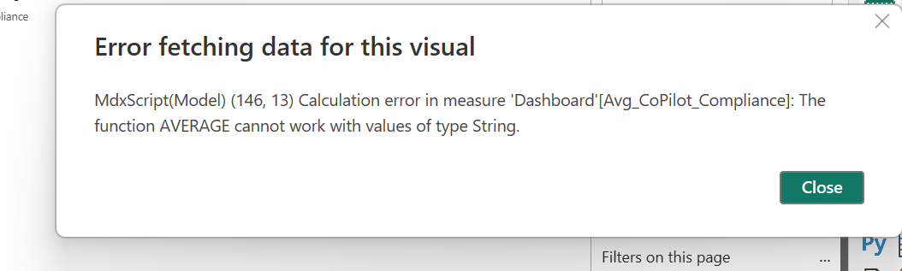
ans:
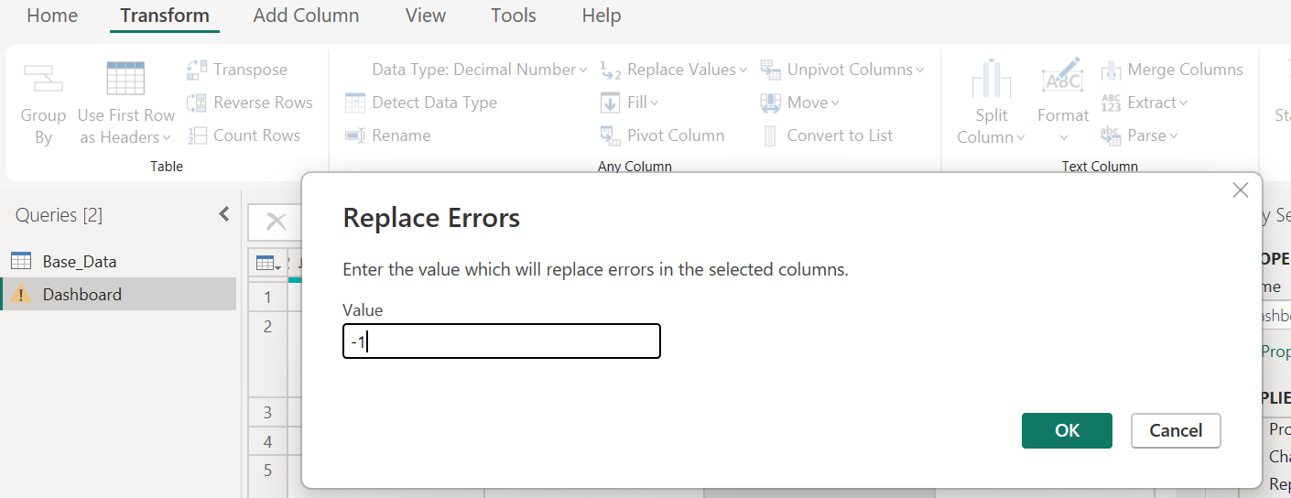
transform -> change type -> Decimal (Because we have decimal number in column)
Also rightclick -> replace errors -> -1(Because we already have 0 as a value in that column.. so -1 gave).
Error:
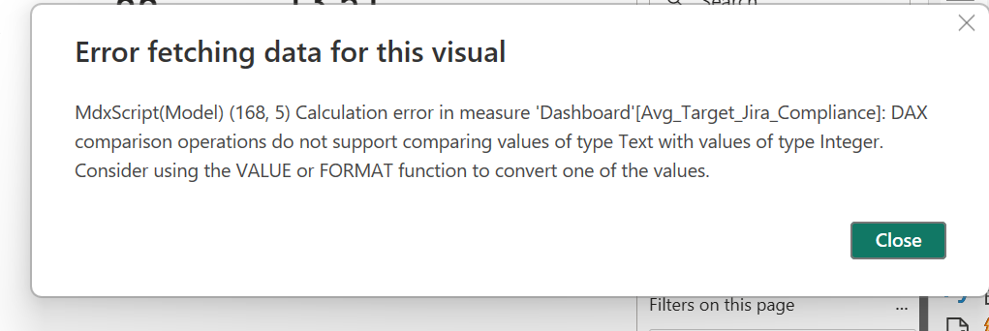
Soln:
change type to decimal and replace error as -1 (because already 0 is there)
Q. why the error came?
because error text is there in that column.
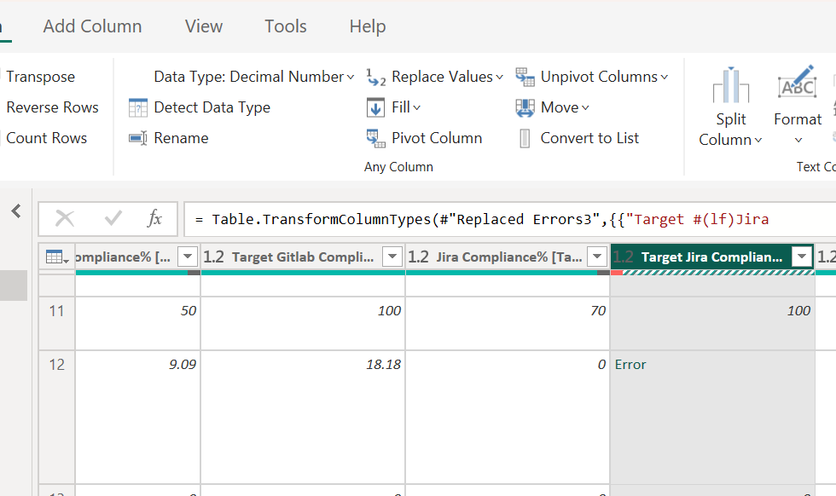
IMP:
- If u want count -> Drag to values.

TASK: CREATE A DASHBOARD IN POWERBI
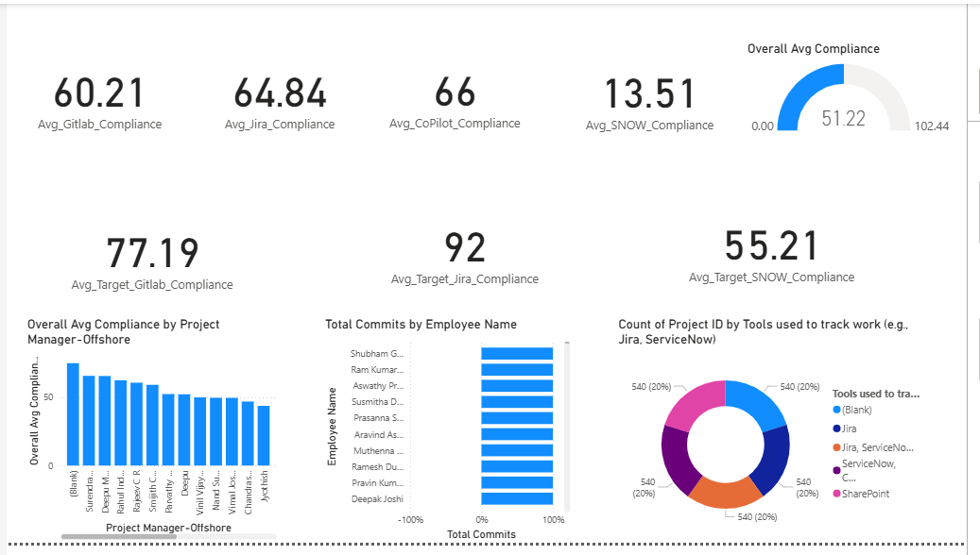
measures
Avg_Gitlab_Compliance =
CALCULATE(
AVERAGE('Dashboard'[Gitlab Compliance%[Target 70% ]]]),
'Dashboard'[IS - 1 IT] = "Y",
'Dashboard'[NTW #] > 0
)
Avg_Jira_Compliance =
FORMAT(
CALCULATE(
AVERAGE('Dashboard'[Jira Compliance%[Target 70%]]]),
'Dashboard'[IS - 1 IT] = "Y",
'Dashboard'[NTW #] > 0
),
"0.00"
)

Avg_CoPilot_Compliance =
CALCULATE(
AVERAGE('Dashboard'[CoPilot Complaince%[Target 100%]]]),
'Dashboard'[IS - 1 IT] = "Y",
'Dashboard'[NTW #] > 0
)
Avg_SNOW_Compliance =
CALCULATE(
AVERAGE('Dashboard'[ SNOW Complaince%]),
'Dashboard'[IS - 1 IT] = "Y",
'Dashboard'[ SNOW Complaince%] > 0
)
Avg_Target_Gitlab_Compliance =
CALCULATE(
AVERAGE('Dashboard'[TargetGitlab Compliance%]),
'Dashboard'[IS - 1 IT] = "Y",
'Dashboard'[NTW #] > 0,
'Dashboard'[TargetGitlab Compliance%] > 0
)
Avg_Target_Jira_Compliance =
CALCULATE(
AVERAGE('Dashboard'[Target Jira Compliance%]),
'Dashboard'[IS - 1 IT] = "Y",
'Dashboard'[NTW #] > 0,
'Dashboard'[Target Jira Compliance%] > 0
)
Avg_Target_SNOW_Compliance =
CALCULATE(
AVERAGE('Dashboard'[Target SNOW Complaince %]),
'Dashboard'[IS - 1 IT] = "Y",
VALUE('Dashboard'[Target SNOW Complaince %]) > 0
)
Overall Avg Compliance =
VAR Gitlab = IFERROR(VALUE([Avg_Gitlab_Compliance]), 0)
VAR Jira = IFERROR(VALUE([Avg_Jira_Compliance]), 0)
VAR SNOW = IFERROR(VALUE([Avg_SNOW_Compliance]), 0)
VAR CoPilot = IFERROR(VALUE([Avg_CoPilot_Compliance]), 0)

RETURN
DIVIDE(
( Gitlab + Jira + SNOW + CoPilot ),
4,
0
)

