**1)   Write a program to check if a number is positive, negative or zero**

**PROGRAM**

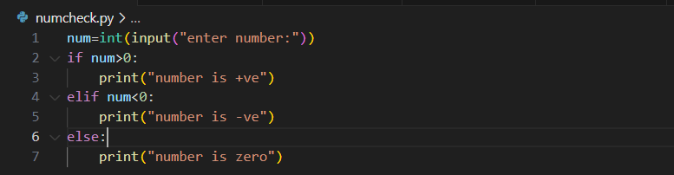

**OUTPUT**

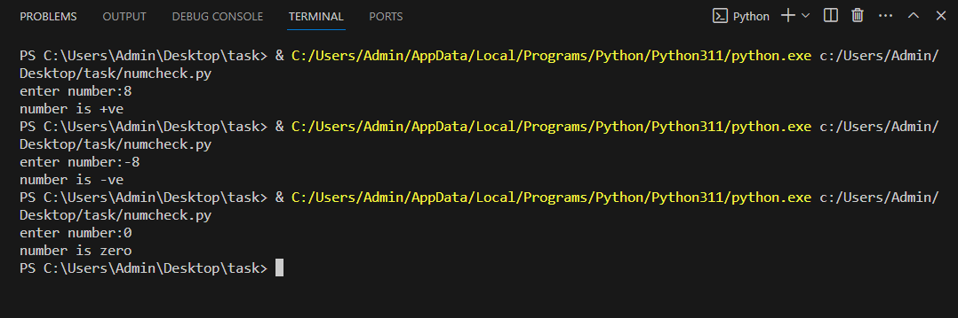

**2) Write a program to check if a person is eligible for voting or not.  
    conditions – age greater than or equal to 18 the person is eligible.**

**age less than 18 not eligible for voting**

**PROGRAM**

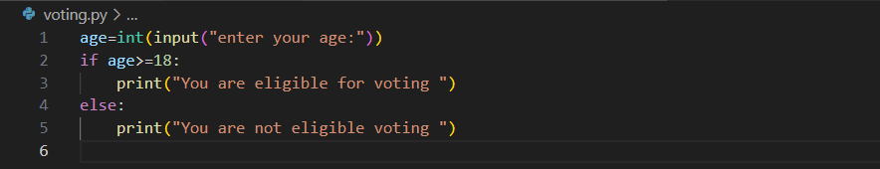

**OUTPUT**

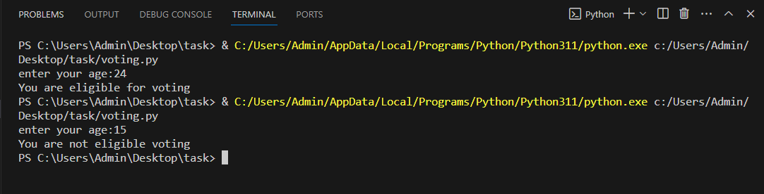

**3) Write a program to check the given number is odd or even**

**PROGRAM**

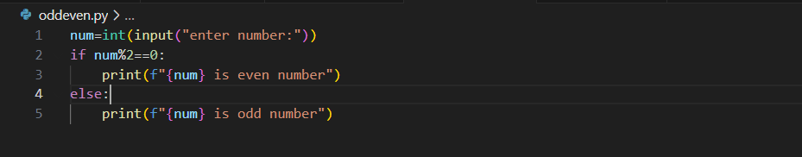

**OUTPUT**

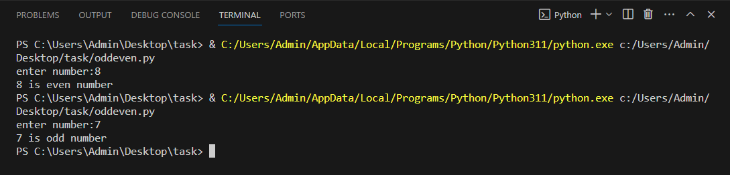

**4) Write a program for grade classification based on percentage  
         conditions**

**percentage = 90  
                  grade A  
         percentage in between 80-90  
                  grade B  
         percentage in between 70-80  
                  grade C  
         percentage less than 70  
                  fail**

**PROGRAM**

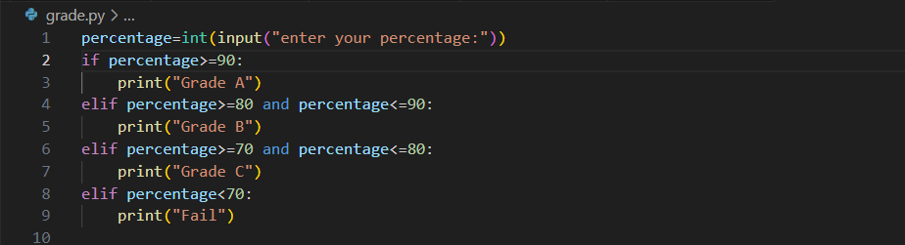

**OUTPUT**

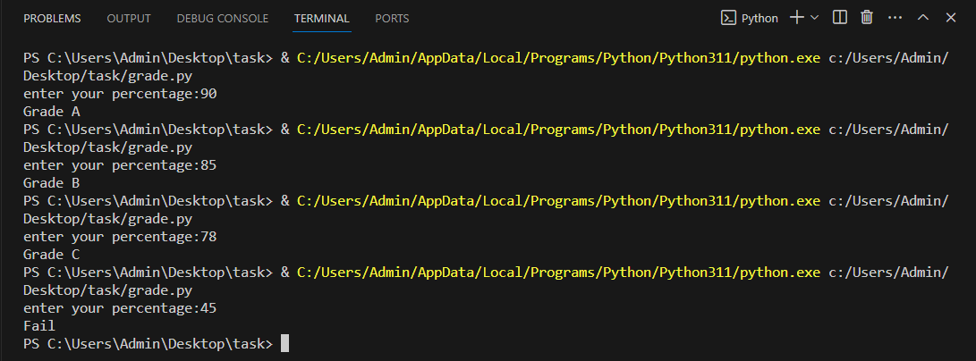

**5) Write a program to check the given year is a leap year or not**

**PROGRAM**

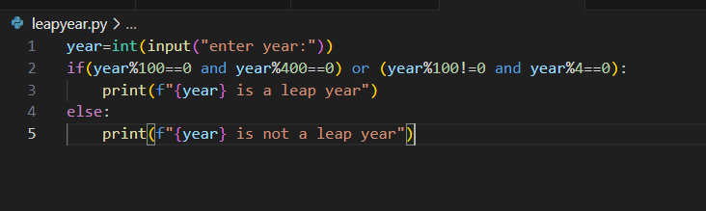

**OUTPUT**

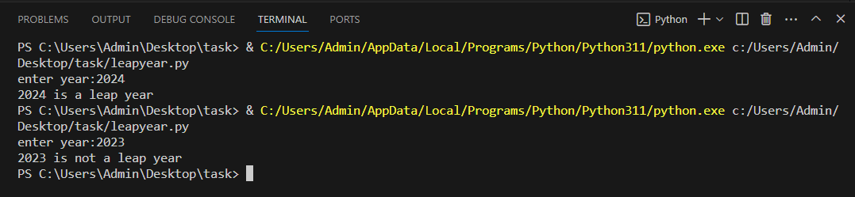

**6) Write a program to determine largest of three numbers.**

**PROGRAM**

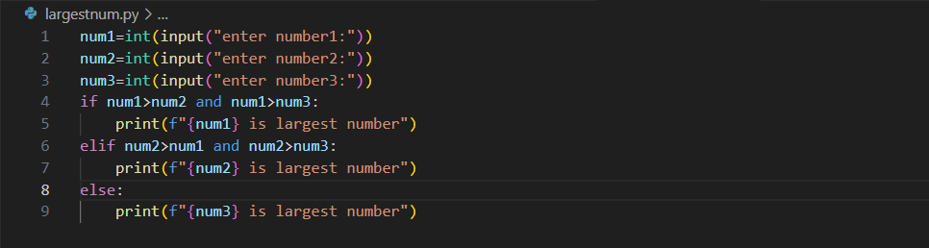

**OUTPUT**

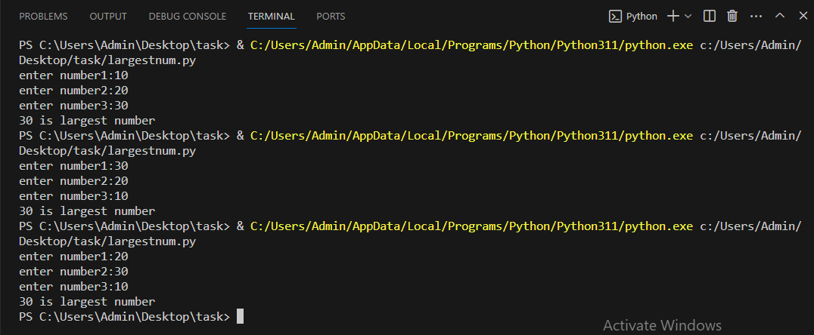

**7) Write program for a simple calculator.**

**PROGRAM**

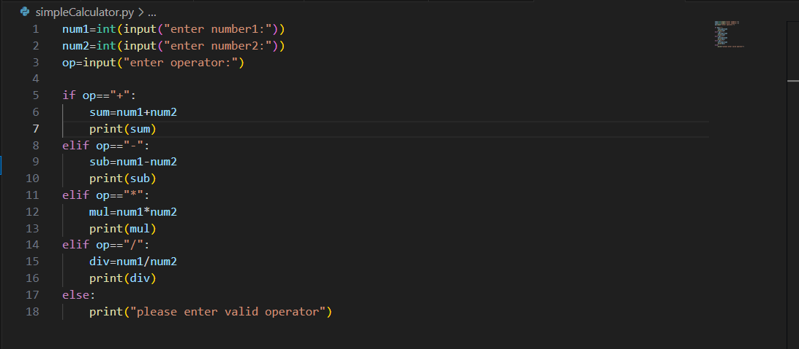

**OUTPUT**

