**TASK 2**

**1) Python program to print all the even numbers within a given range.**

**PROGRAM**

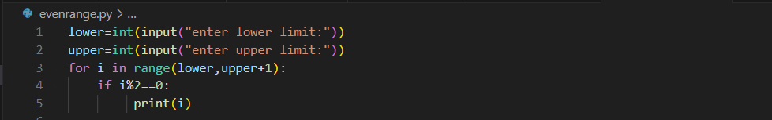

**OUTPUT**

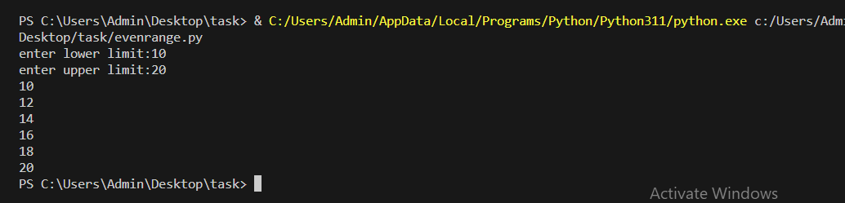

**2) Python program to calculate the sum of odd numbers within the given range.**

**PROGRAM**

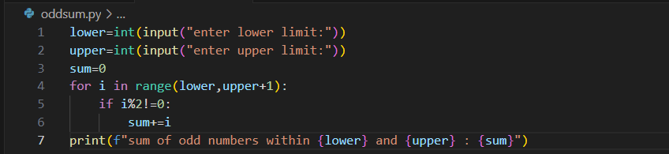

**OUTPUT**

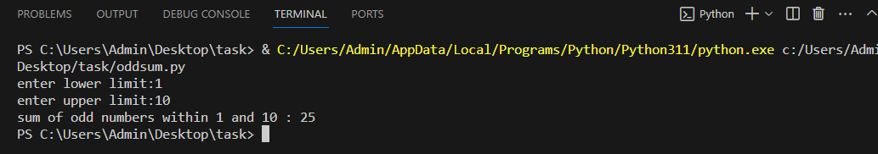

**3)  Python program to check if the given string is a palindrome or not.**

**PROGRAM**

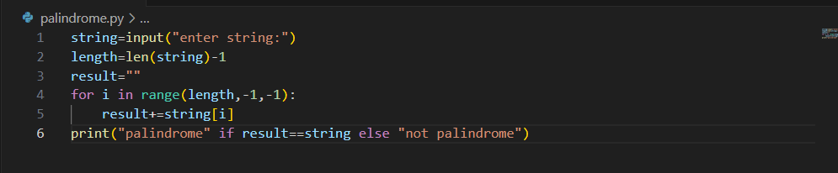

**OUTPUT**

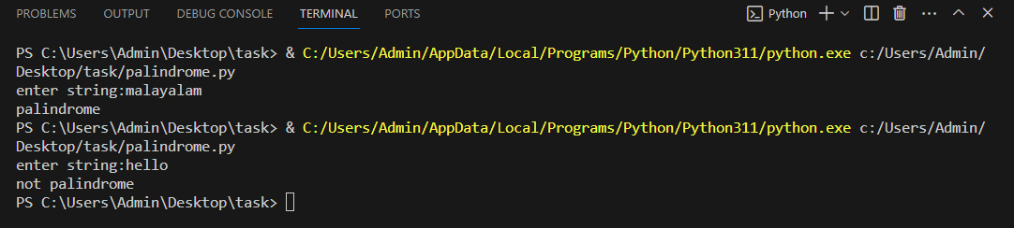

**4) Python program to check if a given number is an Armstrong number.**

**PROGRAM**

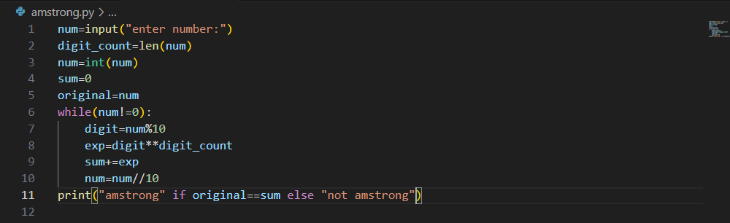

**OUTPUT**

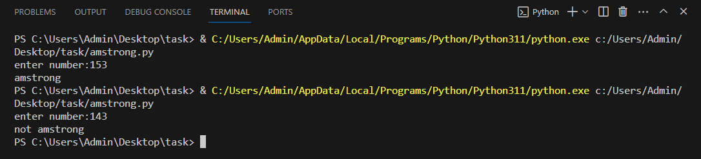

**5) Python program to get the Fibonacci series between 0 to 50.**

**PROGRAM**

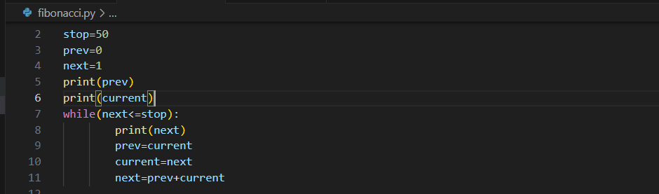

**OUTPUT**

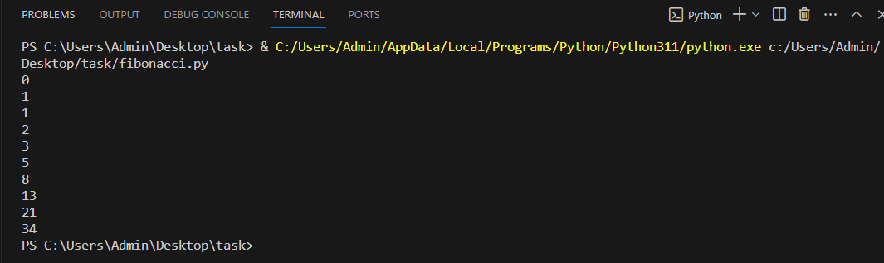

**6) Python program to check given number is prime or not.**

**PROGRAM**

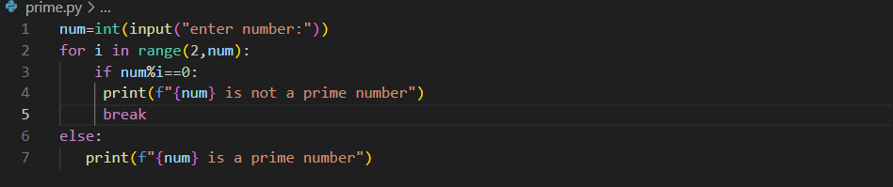

**OUTPUT**

