**TASK 4**

**1. Write a program to print the pattern given below.**

**\***

**\* \***

**\* * \***

**\* * * \***

**\* * * * \***

**PROGRAM**

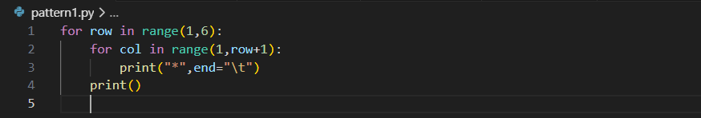

**OUTPUT**

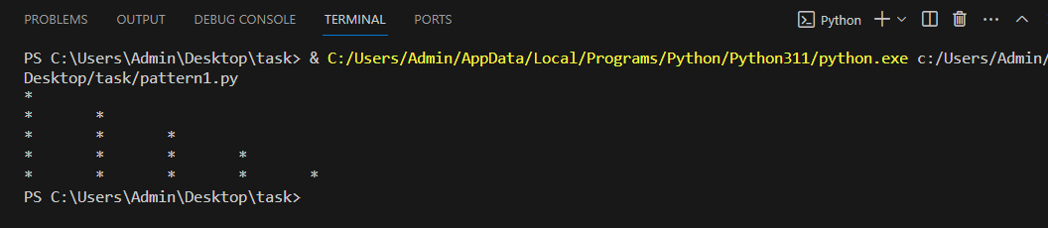

**2 .Write a program to print the pattern given below.  
  
1   
1 2   
1 2 3  
1 2 3 4   
1 2 3 4 5**

**PROGRAM**

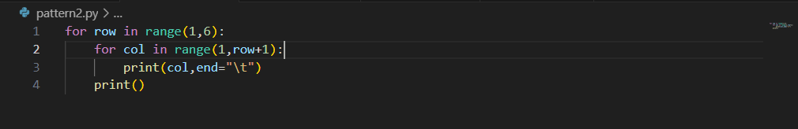

**OUTPUT**

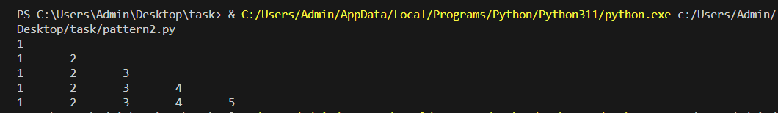

**3. Write a program to print the pattern given below    
  
\***

**\*\***

**\*\*\***

**\*\*\*\***

**\*\*\*\*\***

**\*\*\*\***

**\*\*\***

**\*\***

**\***

**PROGRAM**

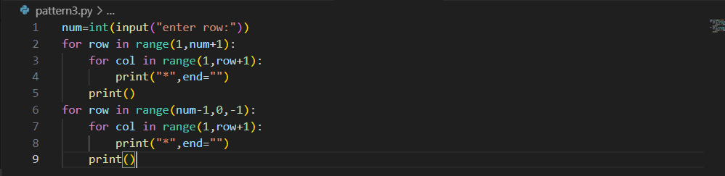

**OUTPUT**

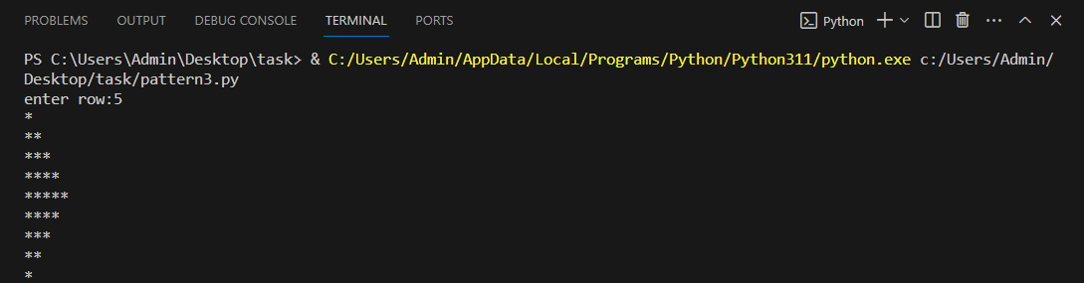

**4. Write a Python program to create the multiplication table (from 1 to 10) of a number.**

**PROGRAM**

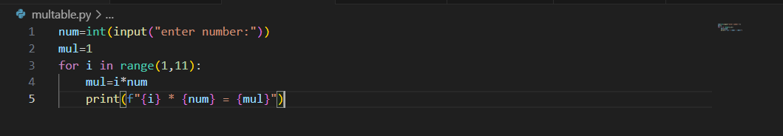

**OUTPUT**

