**TASK 5**

**1) WRITE A PROGRAM TO REVERSE A GIVEN STRING.**

**PROGRAM**

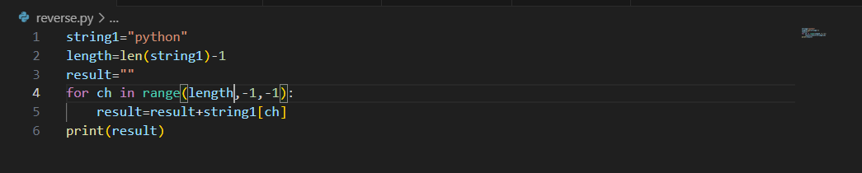

**OUTPUT**

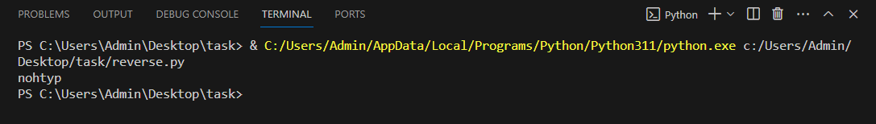

**2) WRITE A PROGRAM IN PYTHON TO PRINT THE CHARACTERS PRESENT AT EVEN INDEX AND ODD INDEX SEPERATELY FOR THE GIVEN STRING.**

**PROGRAM**

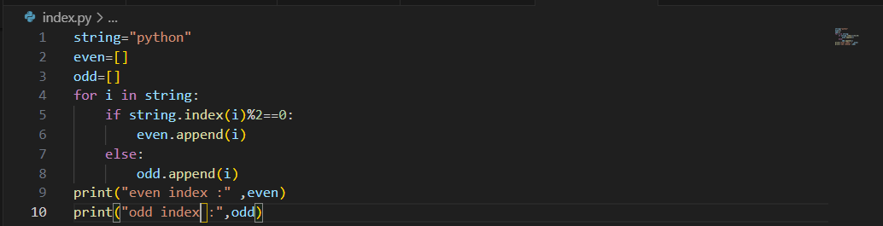

**OUTPUT**

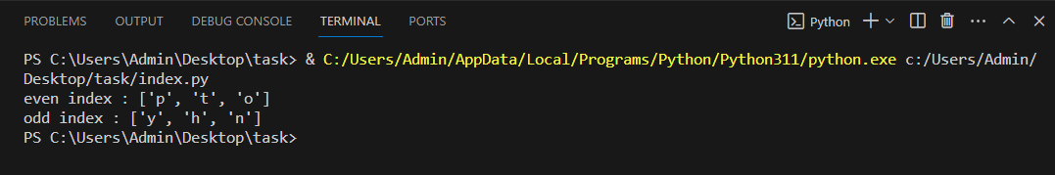

**3) PROGRAM TO MERGE STRING ALTERNATELY USING PYTHON.**

**PROGRAM**

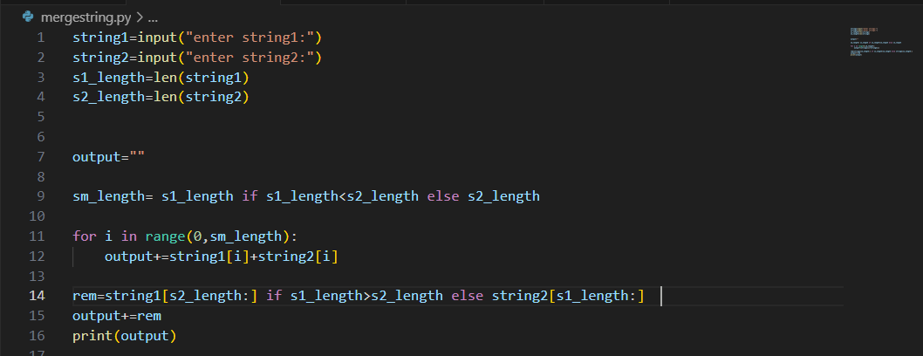

**OUTPUT**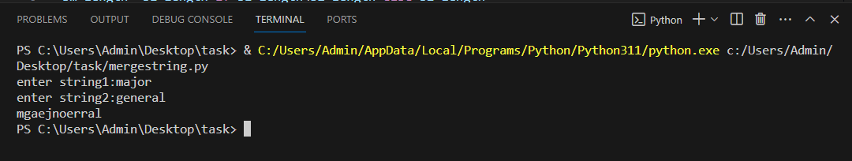

**4) PROGRAM TO SORT CHARACTERS OFTHE STRINGS, FIRST SYMBOL FOLLOWED BY DIGITS.**

**PROGRAM**

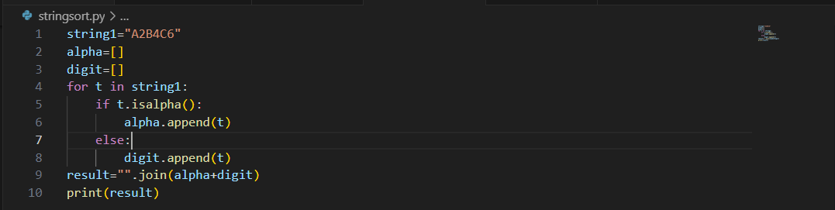

**OUTPUT**

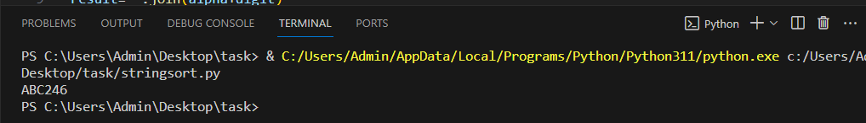

**5) PROGRAM TO FIND THE NUMBER OF OCCURANCES OF EACH VOWELS PRESENT IN THE GIVEN STRING.**

**PROGRAM**

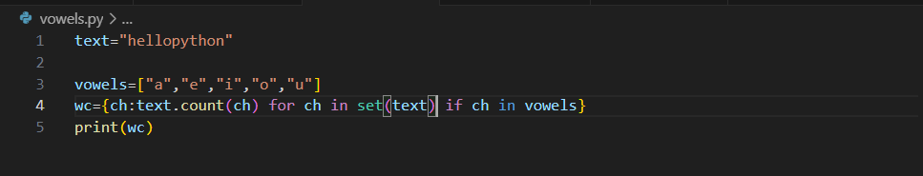

**OUTPUT**

