**TASK 6**

**1. Python Program to Find Factorial of Number Using Recursion.**

**PROGRAM**

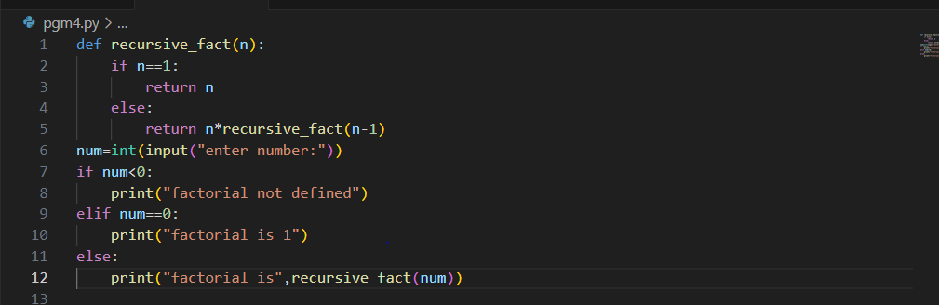

**OUTPUT**

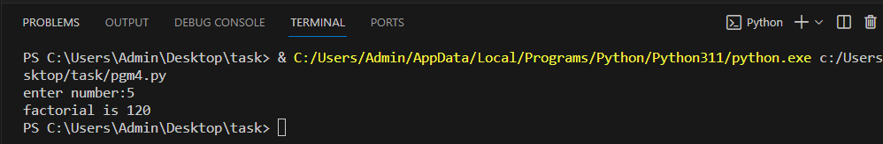

**2. Python program to check if the given number is a Disarium Number.**

**PROGRAM**

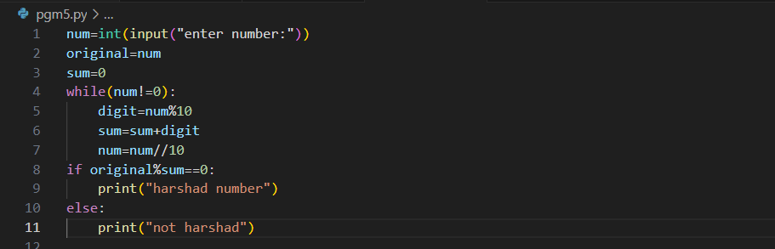

**OUTPUT**

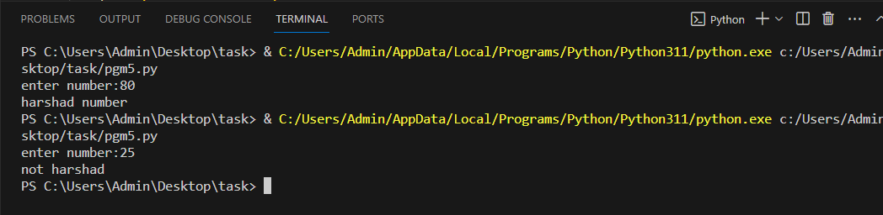

**3. Python program to determine whether the given number is a Harshad Number.**

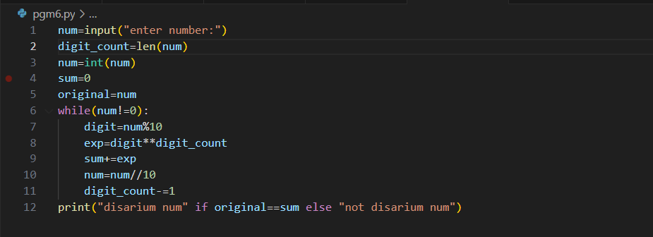

**OUTPUT**

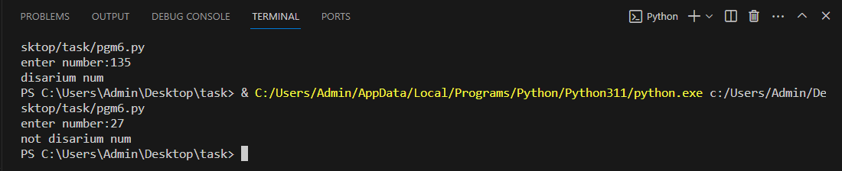

**4. Python program to check the number of digits present in an integer.**

**PROGRAM**

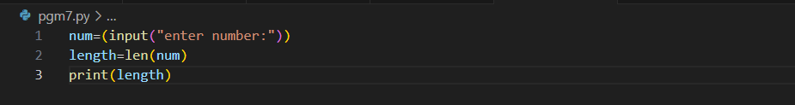

**OUTPUT**

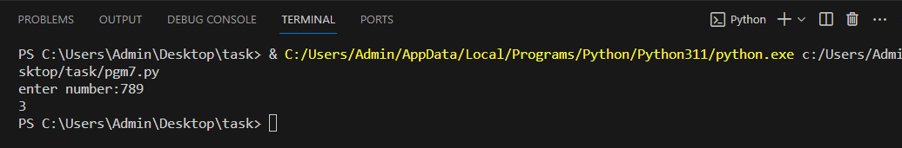

**5. How to count the number of upper and lowercase letters in a string.**

**PROGRAM**

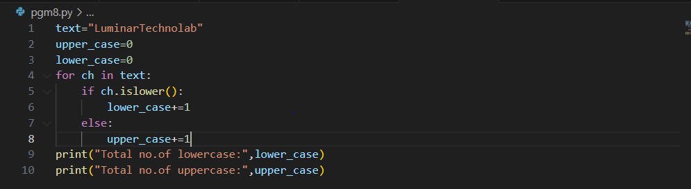

**OUTPUT**

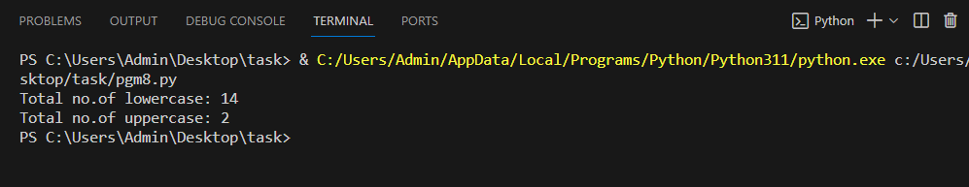

**6. Write a program to count words in string.**

**PROGRAM**

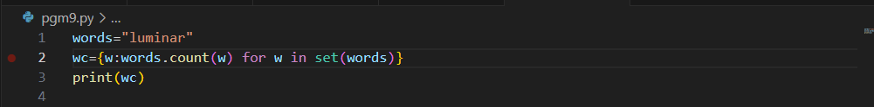

**OUTPUT**

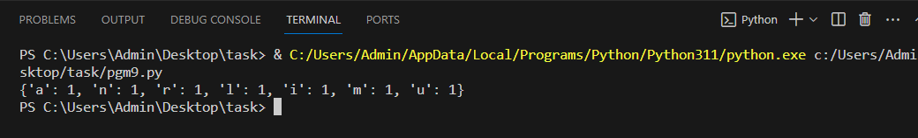

**7. Write the program to find the lists consist of at least one common element.**

**PROGRAM**

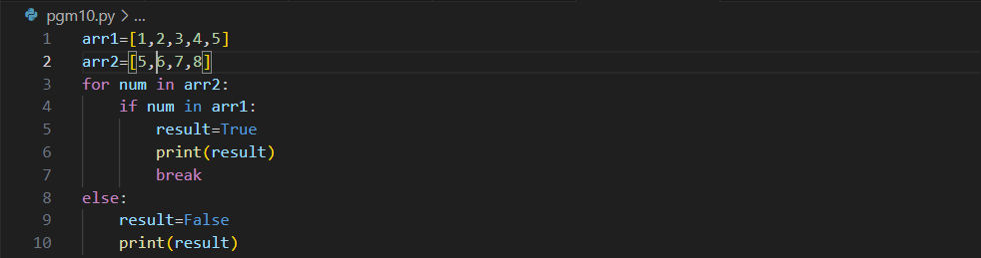

**OUTPUT**

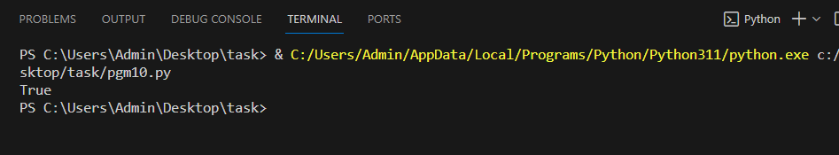

**8. Python program to print the duplicate elements of an array.**

**PROGRAM**

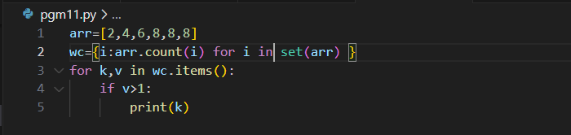

**OUTPUT**

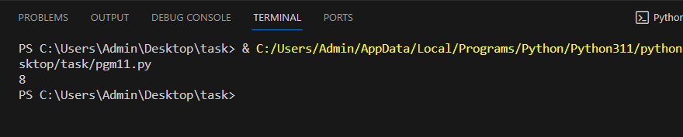

**9. Python program to print the elements of an array present on even position.**

**PROGRAM**

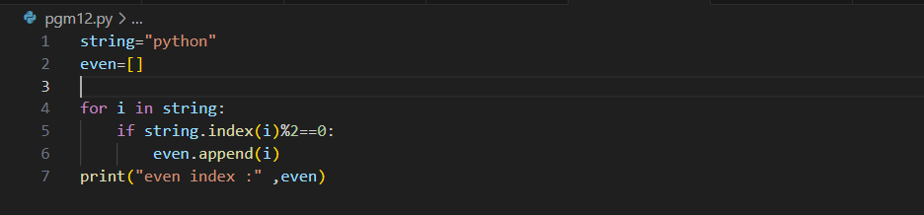

**OUTPUT**

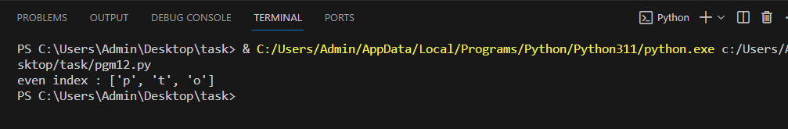

**10. Python program to print the elements of an array present on odd position.**

**PROGRAM**

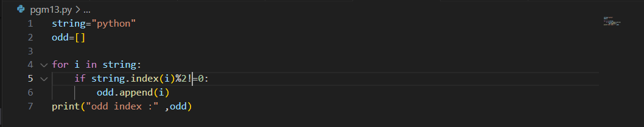

**OUTPUT**

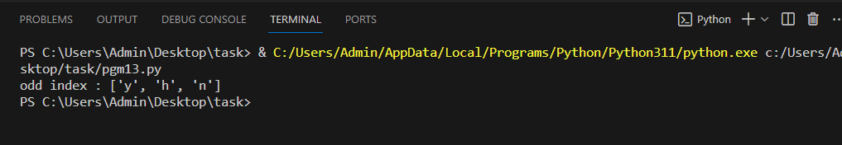

**11. Python program to print the largest element in an array.**

**PROGRAM**

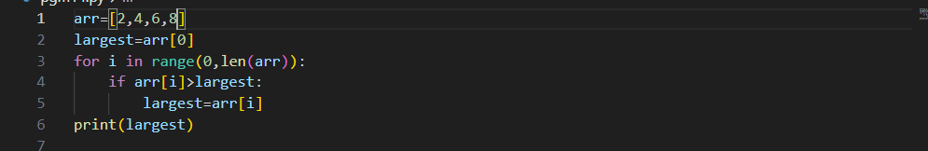

**OUTPUT**

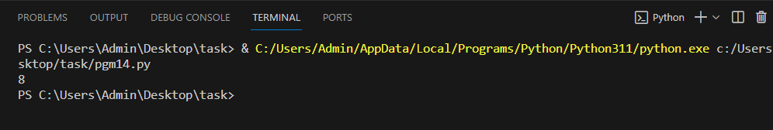

**12. Python program to print the smallest element in an array.**

**PROGRAM**

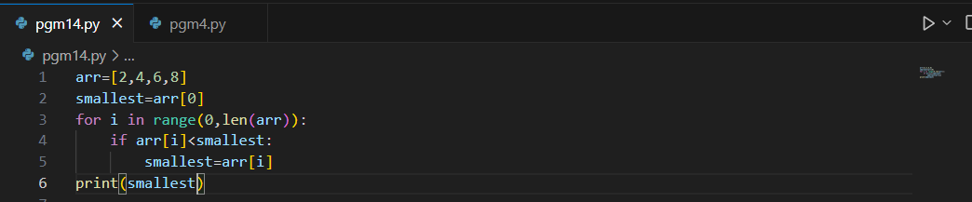

**OUTPUT**

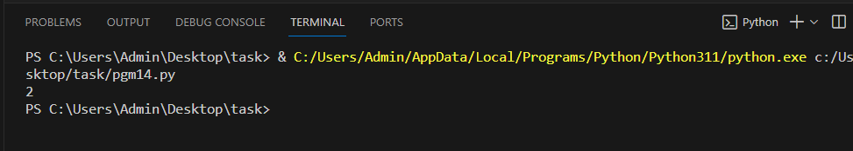

**13. Python program to print the number of elements present in an array.**

**PROGRAM**

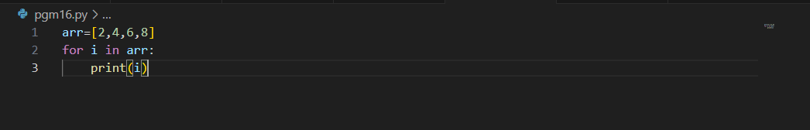

**OUTPUT**

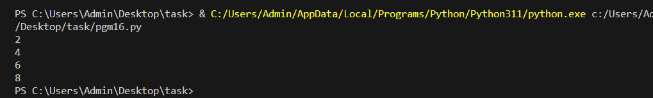

**14. Python program to print the sum of all elements in an array.**

**PROGRAM**

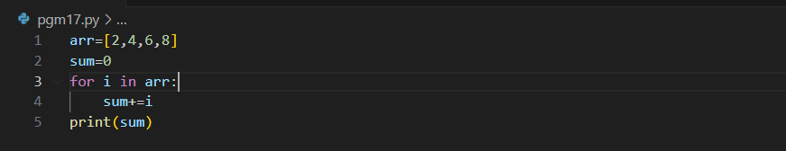

**OUTPUT**

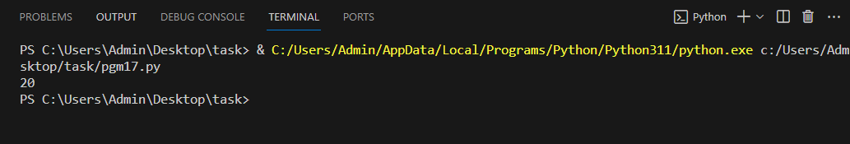

**15. Python Program to Find Armstrong Number in an Interval.**

**PROGRAM**

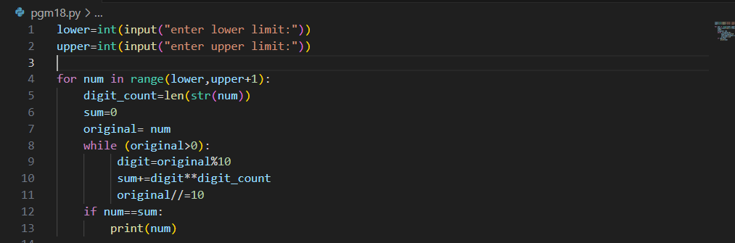

**OUTPUT**

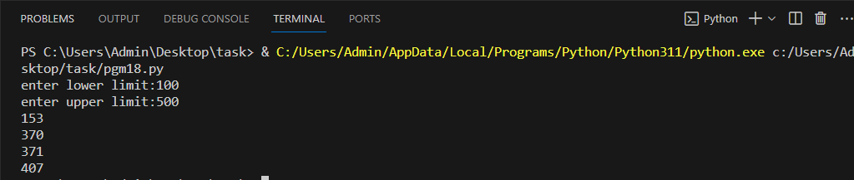

**16. Program to Check Armstrong Numbers in Python.**

**PROGRAM**

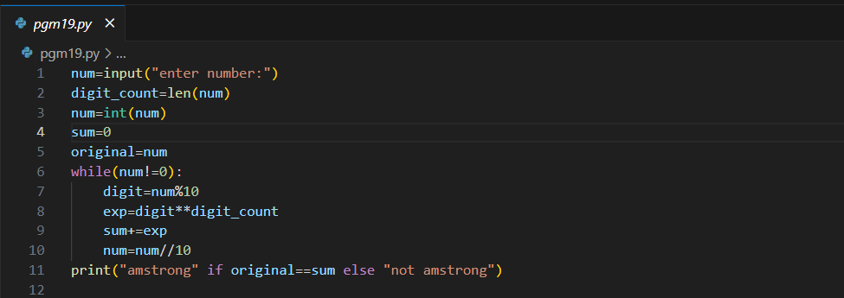

**OUTPUT**

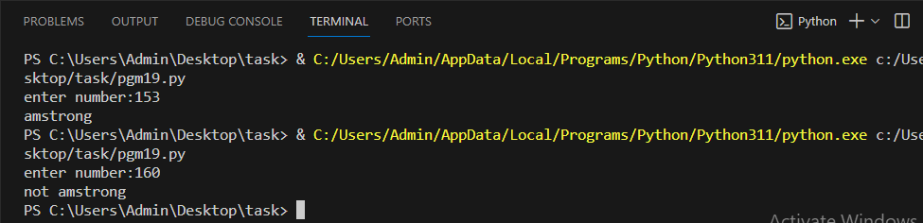

**17. Write a Python program to check if a list is empty or not.**

**PROGRAM**

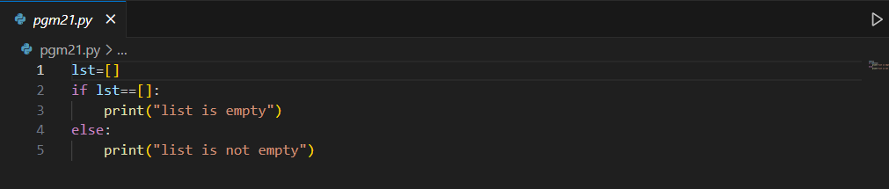

**OUTPUT**

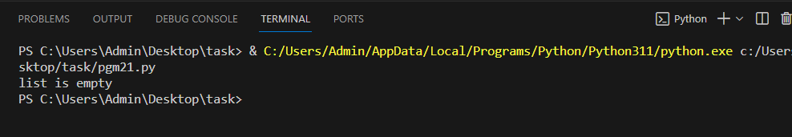

**18. Write a Python program to multiply all the items in a list.**

**PROGRAM**

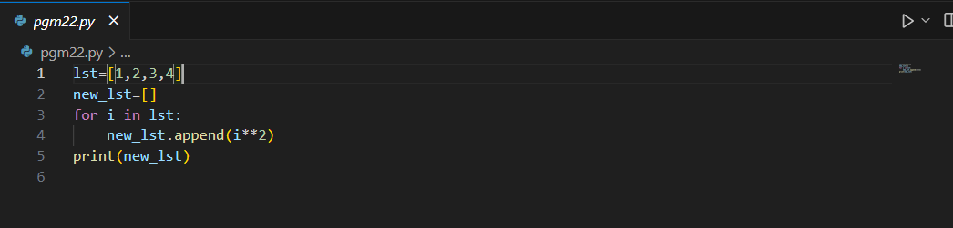

**OUTPUT**

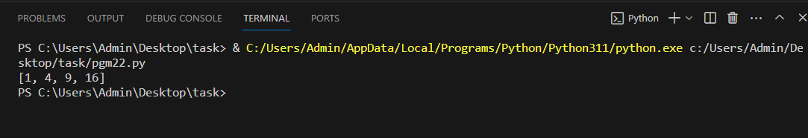

**19. Write a Python program to clone or copy a list.**

**PROGRAM**

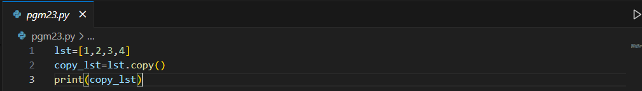

**OUTPUT**

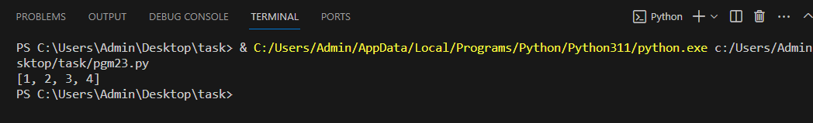

**20. Write a Python program to print the numbers of a specified list after removing even numbers from it.**

**PROGRAM**

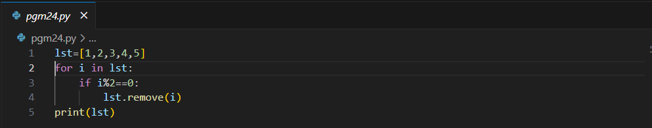

**OUTPUT**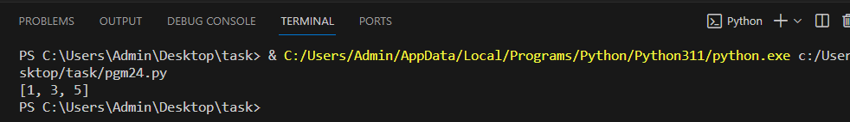

**21. Write a Python program to shuffle and print a specified list.**

**PROGRAM**

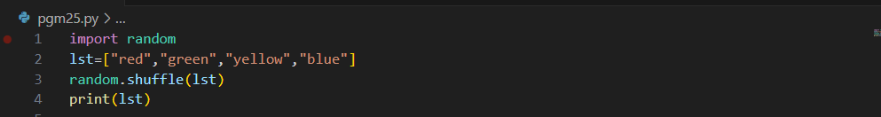

**OUTPUT**

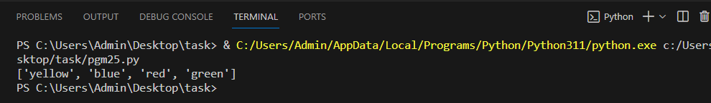

**22. Write a Python program to check whether the n-th element exists in a given list.**

**PROGRAM**

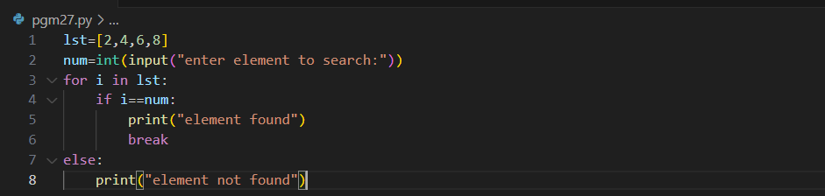

**OUTPUT**

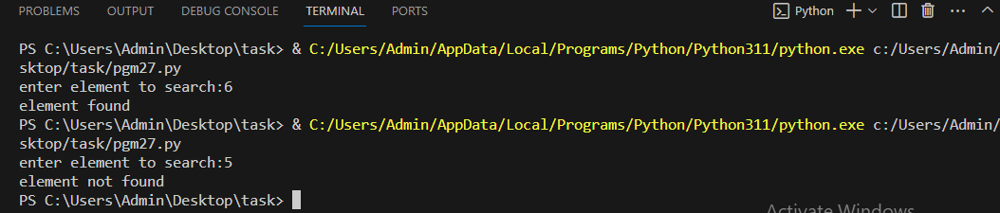

**23. Write a Python function to find the maximum of three numbers.**

**PROGRAM**

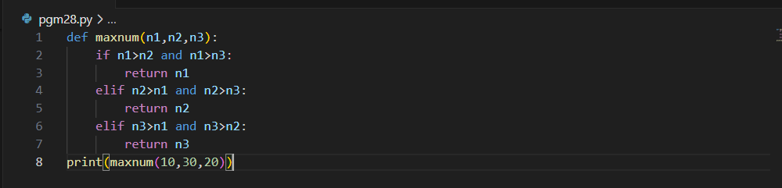

**OUTPUT**

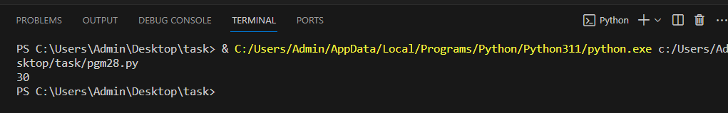

**24. Write a Python function that accepts a string and counts the number of upper- and lower-case letters.**

**PROGRAM**

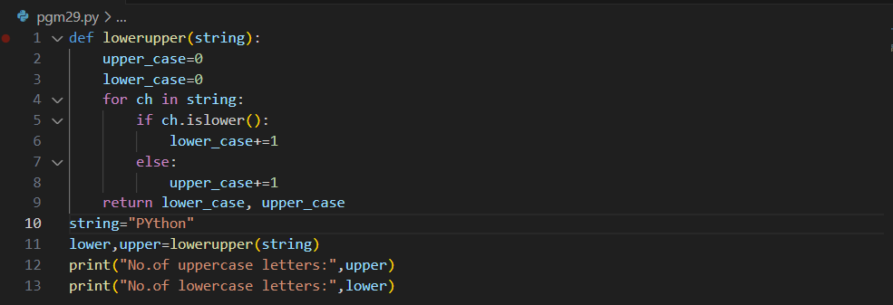

**OUTPUT**

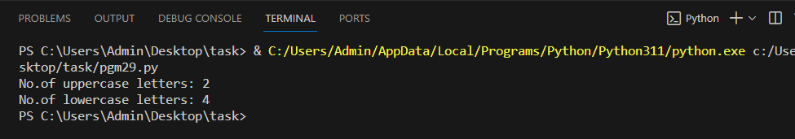

**25. Write a Python program to reverse the order of the items in the array.**

**PROGRAM**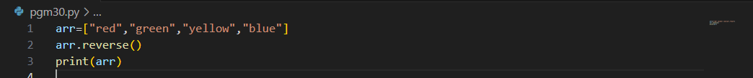

**OUTPUT**

