**Install GIT & make sure it is added into PATH.**

**Use GIT as local VCS. Steps to follow:**

1. **Create a directory ‘project_dir’ & cd to ‘project_dir’.**

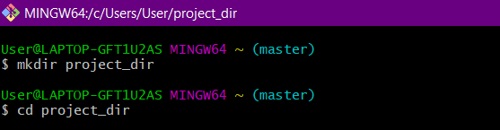

1. **Initialize git version database. (git init)**

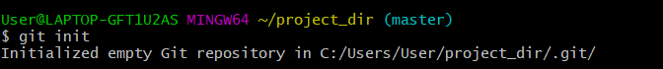

1. **Create a new file index.html.**

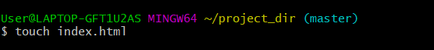

1. **Check the git status. You should find index.html as untracked file.**

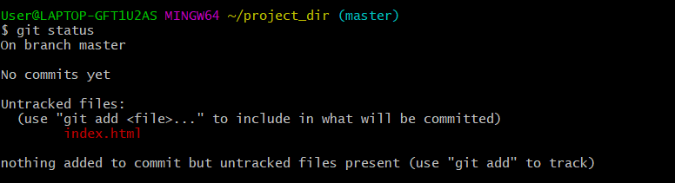

1. **Stage the index.html file.**

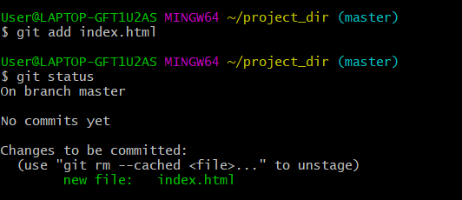

**6.Commit index.html**

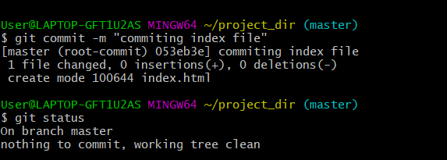

**7.Make few changes in index.html & create a new file info.txt file.**

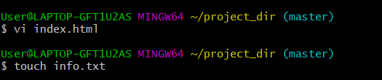

**8.Check git status. You should find index.html & info.txt as untracked files.**

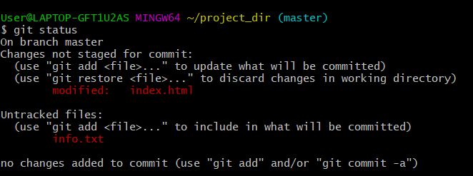

**9.Configure GIT to ignore all txt files.**

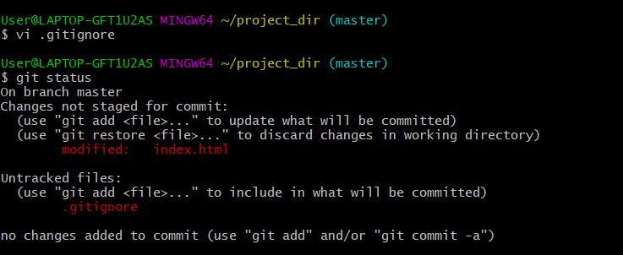

**10.Again check the git status. You should find only index.html as untracked file.**

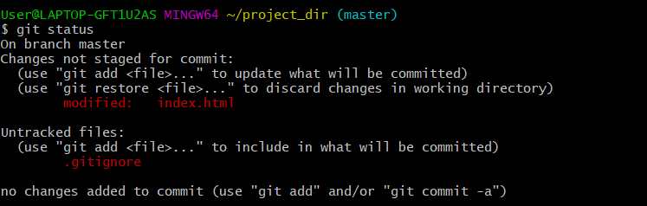

**11.State & commit index.html**

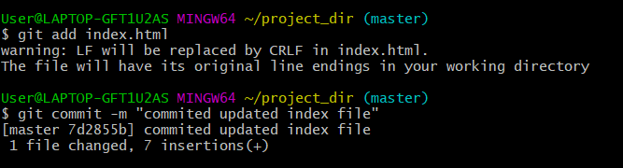

**12.Log all your comments so far.**

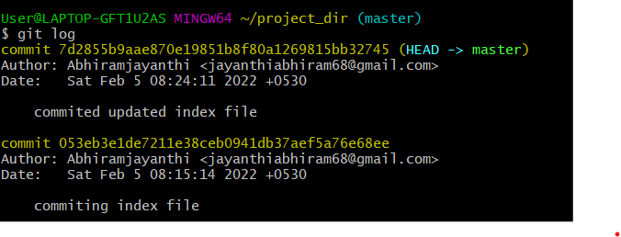

**13.Make some changes in index.html.**

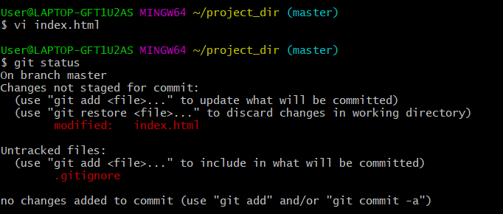

**14.Revert the change made in the previous step using git command.**

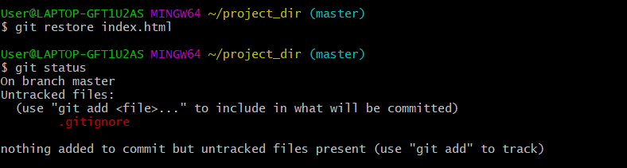

**15.Again change index.html.**

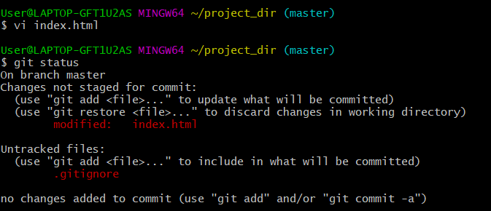

**16.Stage index.html**

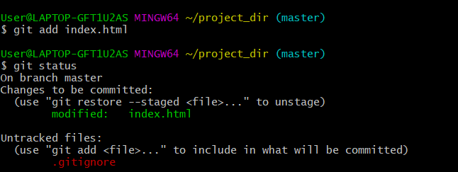

**17.Revert back the last stage.**

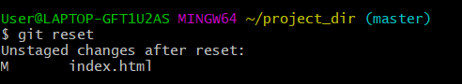

**18.Rename ‘add’ command to ‘my-add’.**



**19.Using my_add command Stage index.html again & commit the changes.**

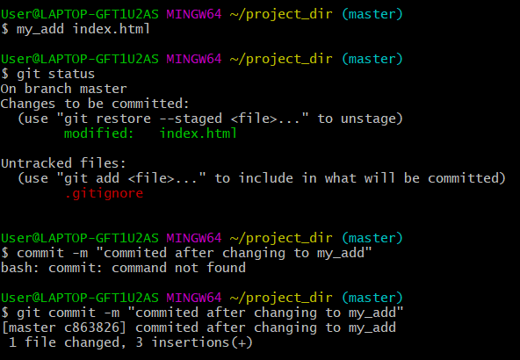

**20.Revert the last commit.**

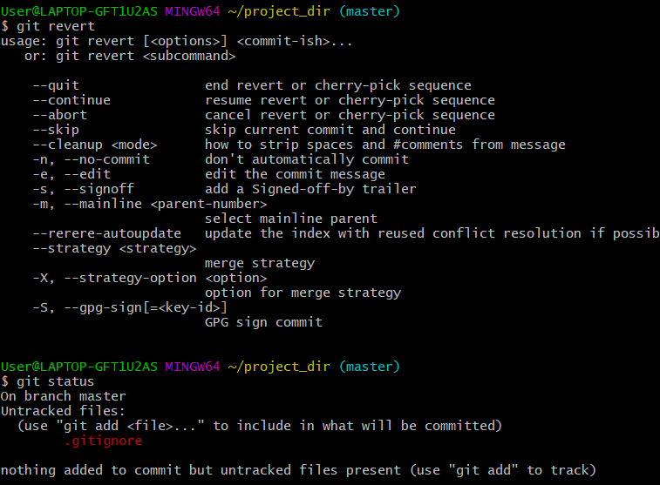

**GIT Branching**

**Objective: Commit HTML, CSS & JavaScript assignments into GIT.**

**SECTION-1 (HTML assignments) - Steps to follow:**

**21. First take a backup of your assignments & projects. This is required because due to incorrect GIT operation you may lose your files.**

**22. Create an empty directory ‘Assignments’ & cd to ‘Assignments’.**

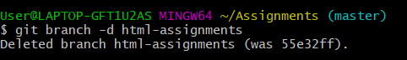

**23. Create a file README.txt inside ‘Assignments’ & write few lines about the contents of ‘Assignments’ folder.**

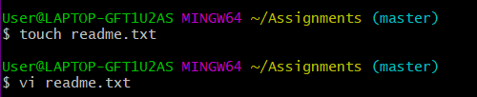

**24. Commit README.txt file.**

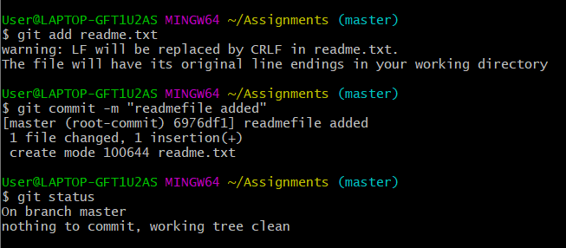

**25. Now create a new branch ‘html-assignments’.**



**26. Switch to ‘html-assignments’ branch.**

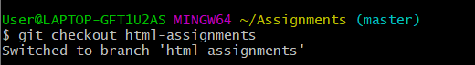

**27. Copy all HTML assignments inside ‘Assignments’ folder.**

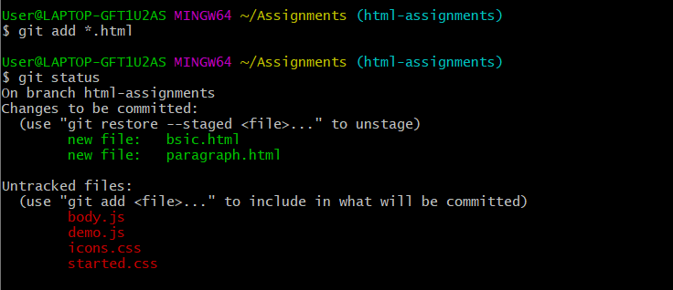

**28. Commit HTML assignments into ‘html-assignments’ branch.**

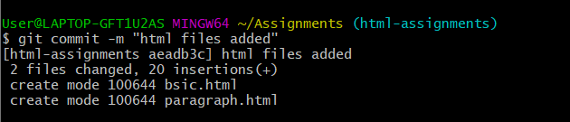

**29. Make minor changes into few files belonging to ‘html-assignments’ branch.**

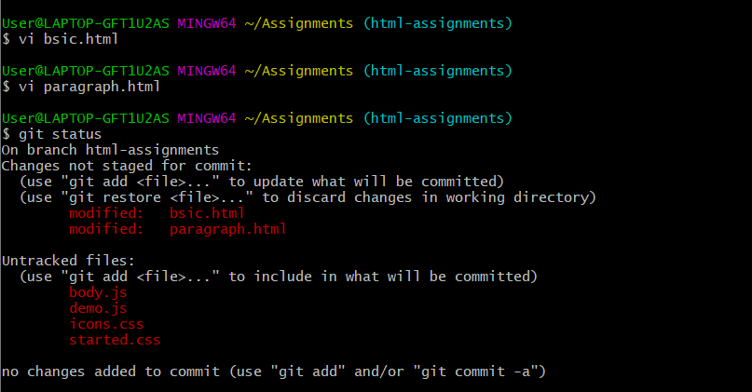

**30. Commit those changed files.**

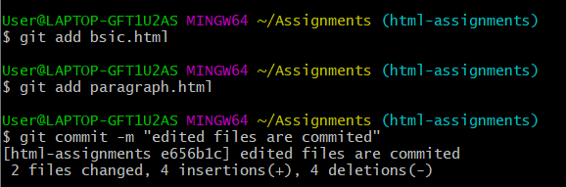

**31. Switch to master branch.**

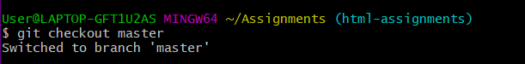

**32. Make minor changes into README.txt file & commit those changes into master.**



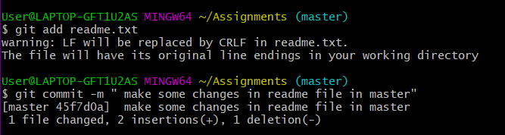

**33. Again switch to ‘html-assignments’ branch.**

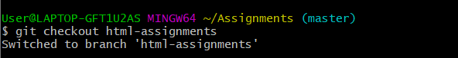

**34. Make minor changes into few files belonging to ‘html-assignments’ branch.**

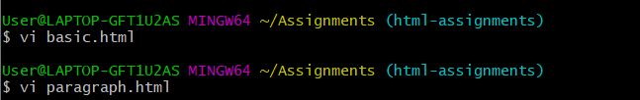

**35. Commit those changes.**

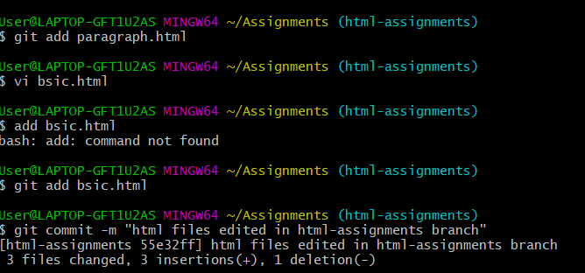

**36. Switch to master.**

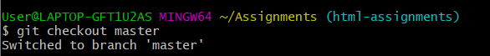

**37. Merge ‘html-assignments’ branch into master. Confirm all html assignments are shown in master.**

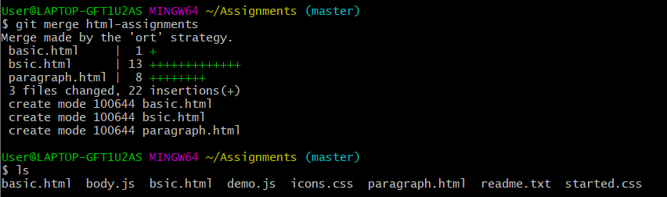

**38. Finally delete the ‘html-assignments’ branch**



**SECTION-2 - (CSS assignments) Steps to follow:**

1. **Create a new branch ‘css-assignments’.**



1. **Switch to ‘css-assignments’ branch.**

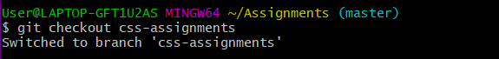

1. **Copy all CSS assignments inside ‘Assignments’ folder.**

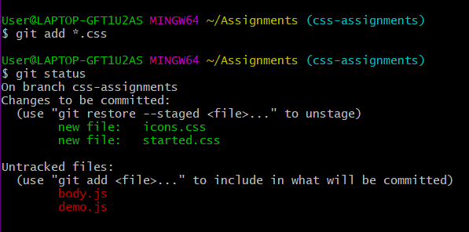

1. **Commit CSS assignments into ‘css-assignments’ branch.**

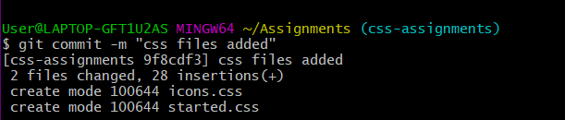

1. **Make minor changes into README.txt file on line 1 belonging to ‘css-assignments’ branch.**



1. **Commit those changed files.**

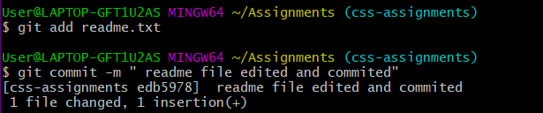

1. **Switch to master branch.**

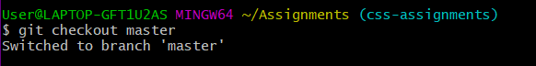

1. **Make minor changes into README.txt file on line 3 & commit those changes into master.**

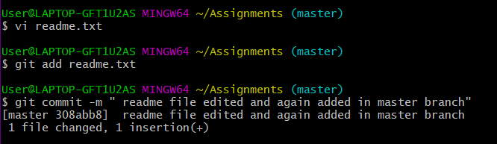

1. **Again switch to ‘css-assignments’ branch.**

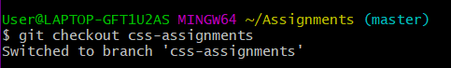

1. **Make minor changes into few files belonging to ‘css-assignments’ branch.**

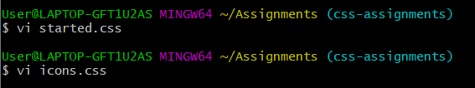

1. **Commit those changes.**

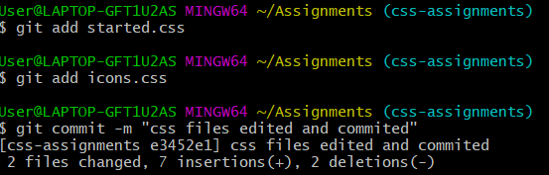

1. **Switch to master.**



1. **Merge ‘css-assignments’ branch into master. Confirm all css assignments are shown in master.**

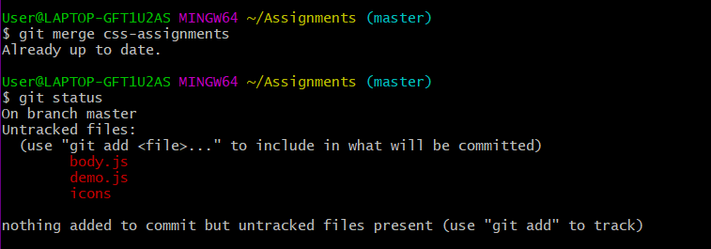

1. **Finally delete the ‘css-assignments’ branch**

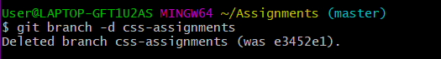

**SECTION-3 - (JavaScript assignments) Steps to follow:**

1. **Create a new branch ‘js-assignments’.**



1. **Switch to ‘js-assignments’ branch.**

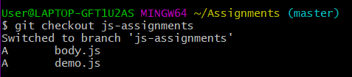

1. **Copy all JavaScript assignments inside ‘Assignments’ folder.**



1. **Commit JavaScript assignments into ‘js-assignments’ branch.**

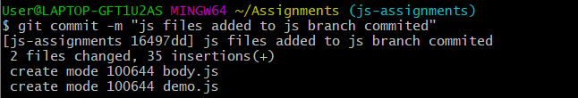

1. **Make minor changes into README.txt file on line 1 belonging to ‘js-assignments’ branch.**



1. **Commit those changed files.**

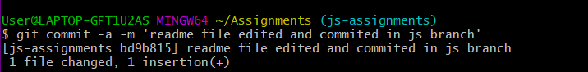

1. **Switch to master branch.**

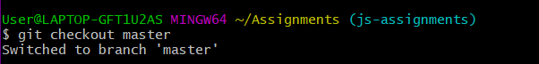

1. **Make minor changes into README.txt file on line 1 & commit those changes into master.**

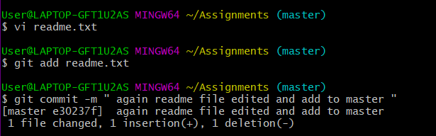

1. **Again switch to ‘js-assignments’ branch.**



1. **Make minor changes into few files belonging to ‘js-assignments’ branch.**

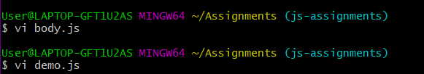

1. **Commit those changes.**

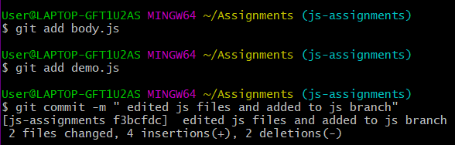

1. **Switch to master.**

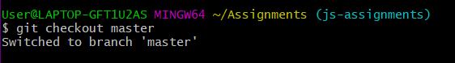

1. **Merge ‘js-assignments’ branch into master. Confirm all JavaScript assignments are shown in master.**

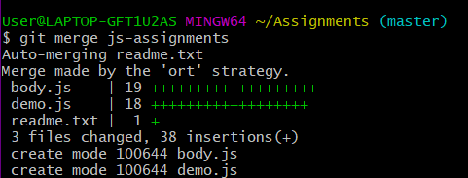

1. **Finally delete the ‘js-assignments’ branch.**

