Sales Compensation Foundations
A beginner-friendly guide with correct calculations and practical examples

1) What Is Sales Compensation?
Sales compensation is how a company pays sales employees for both (a) doing their role and (b) achieving results.
- Base pay: fixed salary paid regularly (weekly/monthly).
- Variable pay: performance-linked earnings such as commission and bonuses.

2) Why Companies Use Sales Compensation
- Motivation: reward outcomes, not only activity.
- Alignment: connect seller behavior to company goals (growth, renewals, margins).
- Fairness: define clear rules so payout is predictable and transparent.

3) Core Building Blocks
- Quota/Target: expected sales result for a time period.
- Attainment: actual results divided by quota.
- Commission Rate: percentage used to calculate variable pay.
- Accelerator: higher commission rate after crossing quota.
- Credit Split: shared deal credit when multiple roles contribute.
- Payout Formula: base salary + variable pay components.

4) How It Functions (Simple Process)
- Step 1: Plan is designed (quota, rates, bonus rules, payout timing).
- Step 2: Deals are closed and credited to reps.
- Step 3: Attainment is calculated against quota.
- Step 4: Commission is calculated using plan rules (flat or tiered).
- Step 5: Bonus/accelerator adjustments are applied.
- Step 6: Final payout is audited and paid.

5) Example A: Basic Monthly Plan (Flat Rate)
Item | Value
Base salary | $3,500.00
Sales closed | $48,000.00
Commission rate | 5.00%
Commission earned | $2,400.00 = $48,000.00 x 5.00%
Bonus rule | $400.00 (because sales >= $45,000.00)
Total monthly pay | $6,300.00
Check: Total Pay = Base + Commission + Bonus = $3,500.00 + $2,400.00 + $400.00 = $6,300.00

6) Example B: Tiered Quarterly Plan (More Complex)
Plan rules: 4% for 0-80% of quota, 6% for 80-100%, and 9% above 100%. Bonus = $2,000 if attainment is at least 120%.
Tier | Sales in Tier | Rate | Commission
0%-80% of quota | $240,000.00 | 4.00% | $9,600.00
80%-100% of quota | $60,000.00 | 6.00% | $3,600.00
Above 100% | $70,000.00 | 9.00% | $6,300.00
Metric |  | Value
Quarterly quota |  | $300,000.00
Quarterly sales |  | $370,000.00
Attainment |  | 123.33%
Total commission |  | $19,500.00
Performance bonus |  | $2,000.00
Quarterly base salary |  | $12,000.00
Final quarterly pay |  | $33,500.00
Check: Final Pay = Base + (Tier1 + Tier2 + Tier3 Commission) + Bonus = $12,000.00 + ($9,600.00 + $3,600.00 + $6,300.00) + $2,000.00 = $33,500.00

7) Example C: Split Credit on One Deal
Role | Deal Credit % | Credited Revenue | Commission Rate | Variable Pay
Account Executive | 70.00% | $70,000.00 | 8.00% | $5,600.00
Sales Engineer | 30.00% | $30,000.00 | 2.00% | $600.00
This shows how one deal can be shared fairly across roles. It prevents overpaying one role and underpaying another.

8) Common Mistakes to Avoid
- Using unclear definitions for quota and attainment.
- Changing rates mid-period without clear communication.
- Ignoring split-credit rules for team selling.
- Not auditing payouts before payroll.
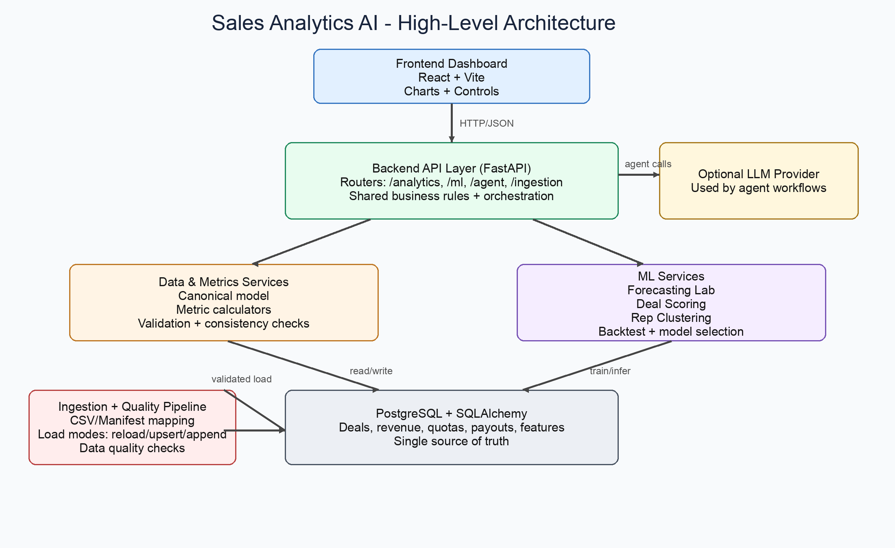
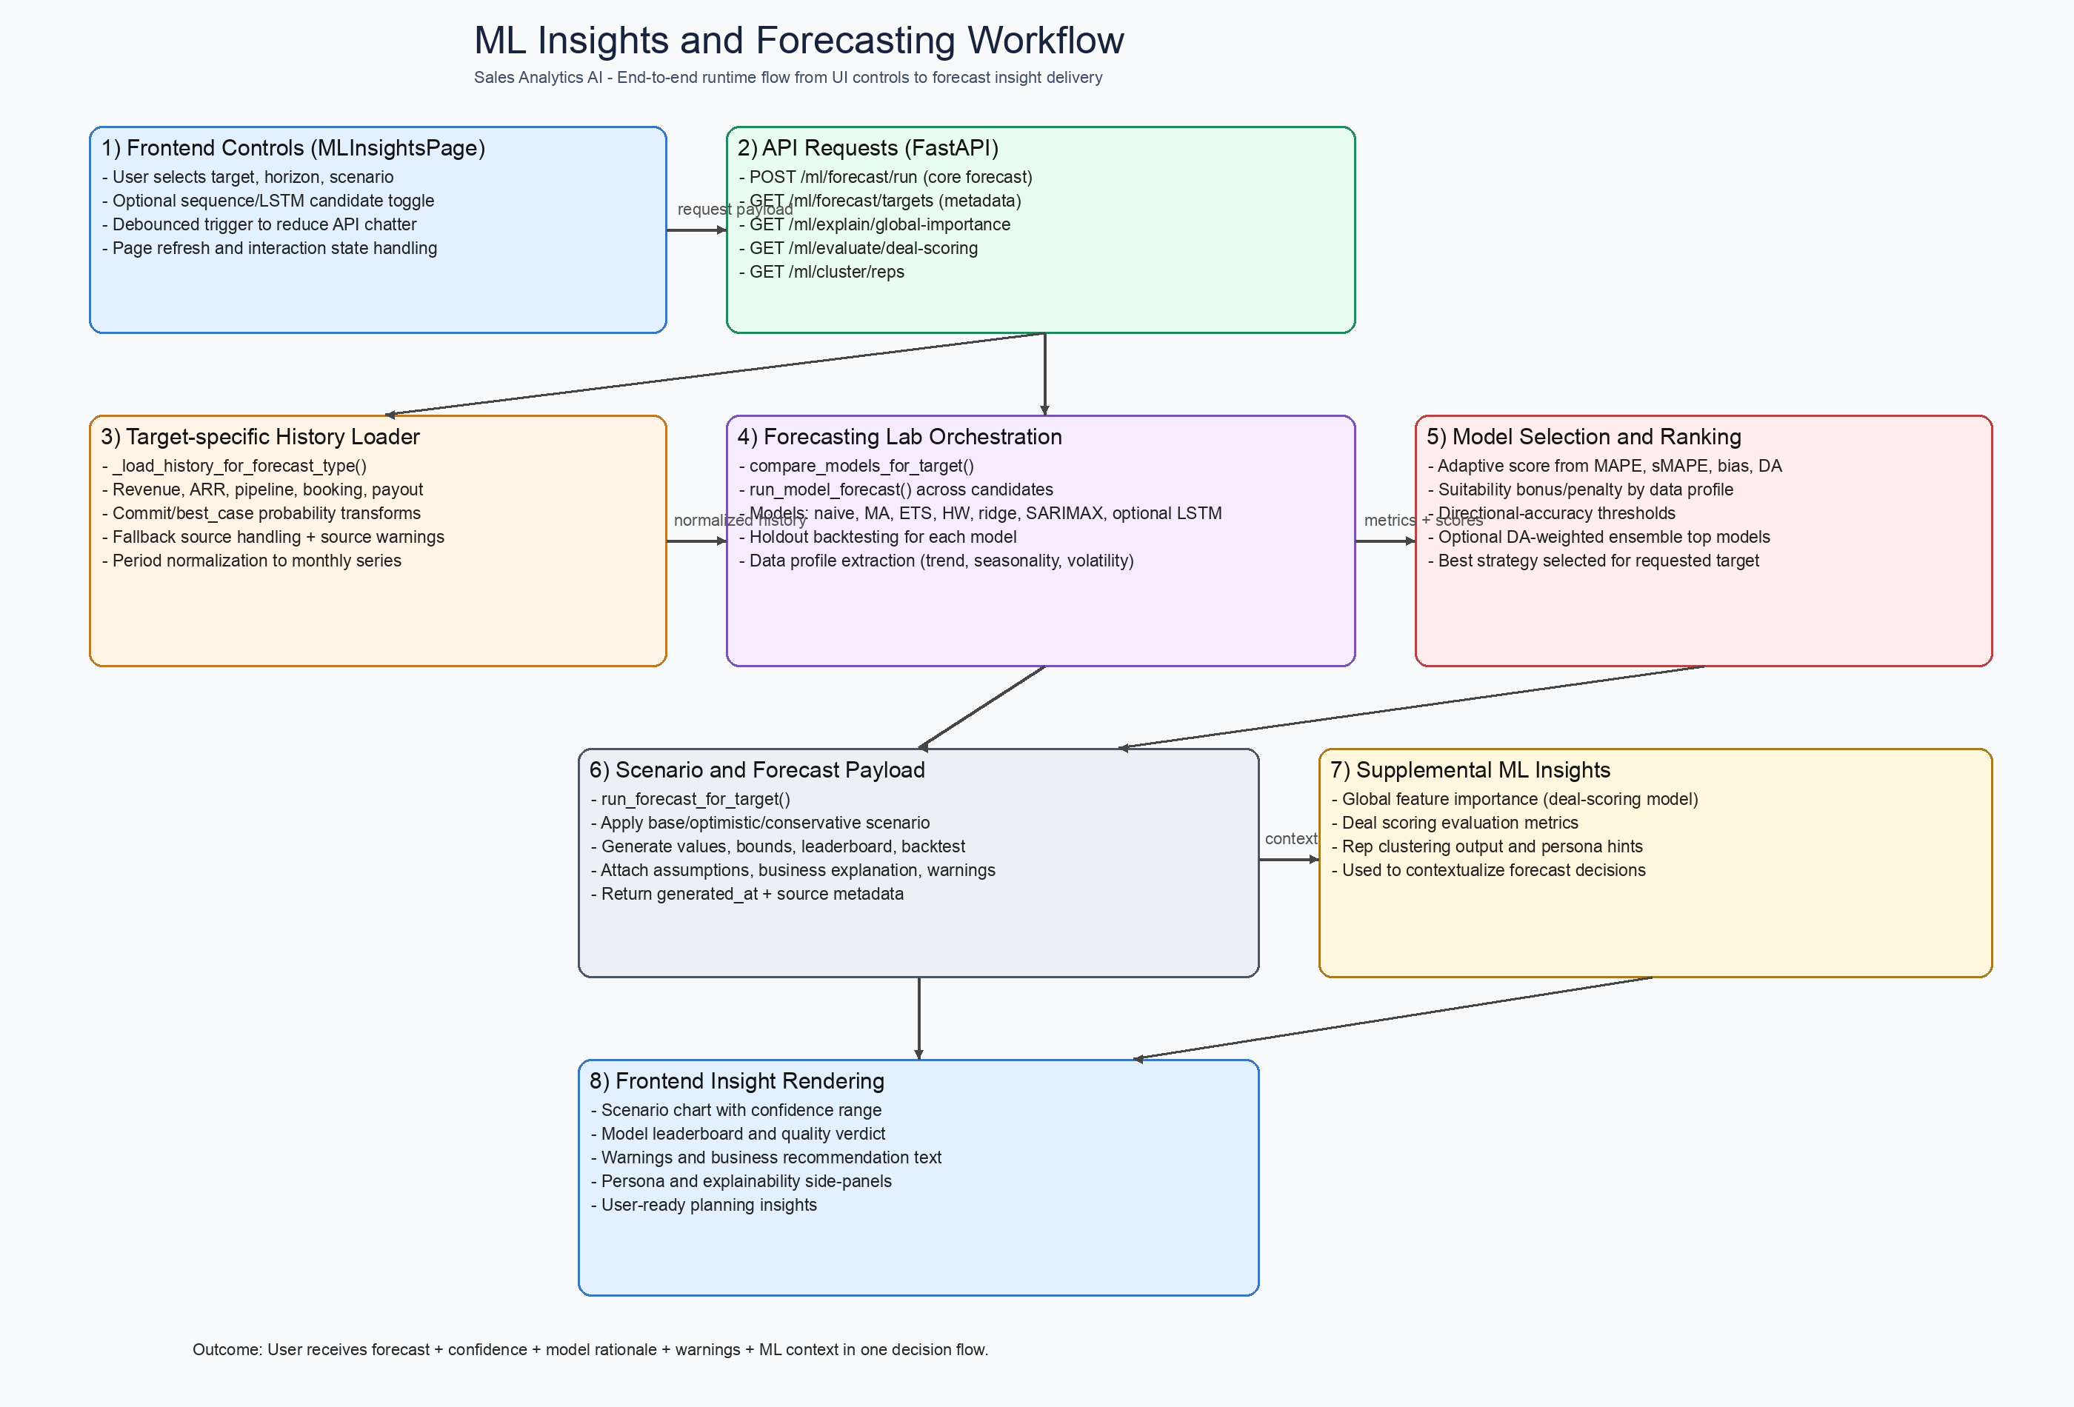

Appendix: Low-Level Project Design
This low-level diagram maps key modules and file-level responsibilities across frontend, API routers, service logic, and persistence.
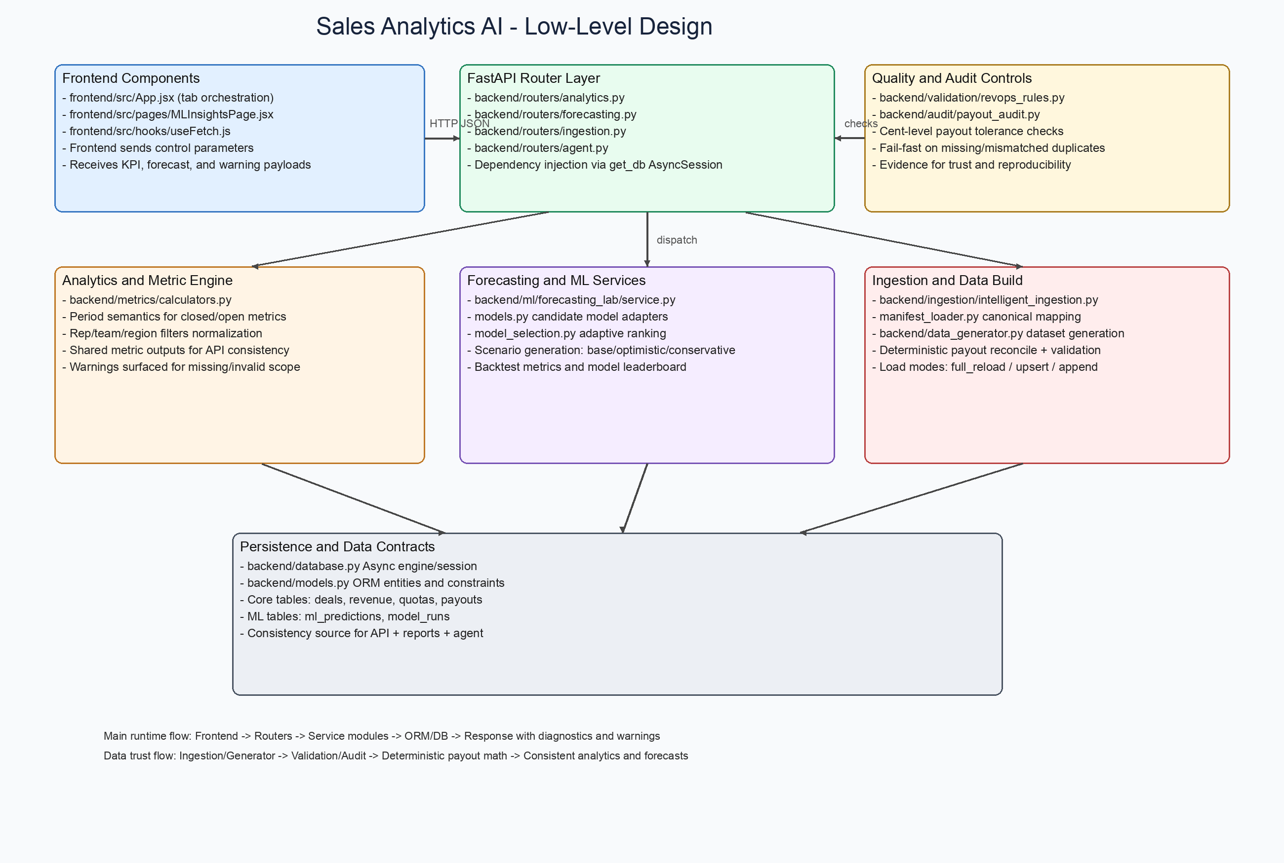
Figure: Low-level architecture and data-flow responsibilities

