PES UNIVERSITY
DEPARTMENT OF COMPUTER SCIENCE AND ENGINEERING
UE22CS352AA: Software Engineering — Lab 4 Report
Topic: Vibe Coding — Scenario 21: Checkers
---------------------------------------------------------------------------
Student Name: Abhiroop | SRN / USN: PES2UG24CS024
Course Code: UE22CS352AA | Semester & Section: 5th Semester / Section 5A
Assigned Scenario: Scenario 21: Checkers | Reference Starter Repo: https://github.com/SETAPESU26/21_checkers
Target Repository: https://github.com/Abhiroop-24/Lab_4_Software-eng.git | Branch Submitted: main
Lab Duration: 60 Minutes | Submission Date: November 2026

1. Lab Objectives & Scope
The primary objective of this laboratory assignment is to leverage modern LLM-assisted Vibe Coding techniques to analyze, debug, and enhance an existing terminal-based Python implementation of the Checkers board game (Scenario 21). The lab constraints require understanding the defect, formulating effective prompts to implement required rules within 3 to 4 prompt iterations, maintaining in-memory modular architecture without external persistence, recording before/after video proofs, and rigorously validating the game against edge and boundary cases.

2. Task 1: Defect Diagnosis & Capture Correctness
Defect Reproduction & Root Cause Analysis:
When playing the original starter code, after Red moves (5,0) -> (4,1) and Black moves (2,3) -> (3,2), Red executes a jump capture from (4,1) to (2,3). In the starter code's board.py, the move_piece() function only performed:
board[end[0]][end[1]] = board[start[0]][start[1]]
board[start[0]][start[1]] = '.'
It failed to clear the intermediate square ((sr + er) // 2, (sc + ec) // 2). Consequently, the captured opponent piece remained on the board indefinitely and could be jumped repeatedly.
Resolution Implemented:
Updated move_piece() to detect capture distance (abs(end[0] - start[0]) == 2). It removes the jumped opponent piece by setting board[mr][mc] = '.' and returns the captured piece symbol for move feedback.

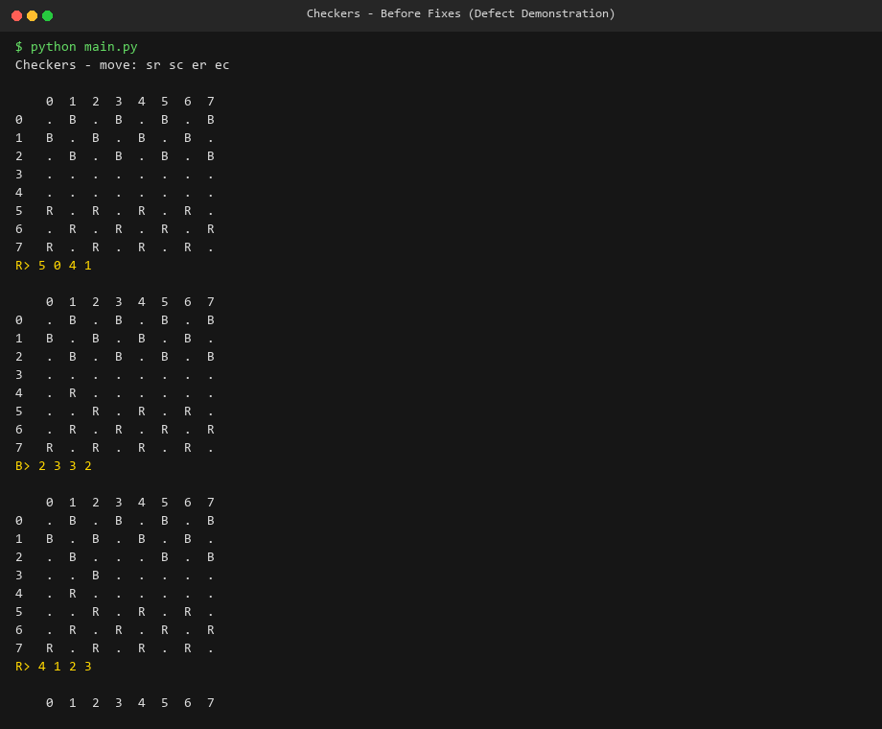
Figure 1: Initial Gameplay Before Fix — Demonstrating captured piece 'B' at (3,2) remaining on board.

3. Implementation of Tasks 2, 3 & 4
Task 2 — Win and No-Move Detection: Implemented has_pieces(board, player) and has_legal_moves(board, player) in rules.py. Integrated check_game_over() in Checkers. Before prompting for input, if the current player has no remaining pieces or no legal moves left, the game loop concludes cleanly, declaring the opposing player as winner with the exact cause.
Task 3 — Complete Checkers Rules:
• Forced Captures: get_all_captures() checks all available jumps. If any capture exists, non-capturing moves are rejected with 'A capture is mandatory when available.'
• Multi-Capture Turns: Upon completing a jump, get_captures_for_piece() inspects the landing square. If additional jumps exist, active_jump_pos locks to that coordinate, prompting the player to complete the jump chain.
• King Bidirectional Movement: Regular men move forward only (dr = -1 for R, dr = 1 for B). Kings ('RK', 'BK') can move and capture diagonally in all 4 directions (both forward and backward).
• Promotion: Pieces reaching the back row (row 0 for R, row 7 for B) are crowned King ('RK', 'BK'). Under standard rules, reaching king row concludes the active turn.
Task 4 — Move-Level Feedback & Modular API: Engineered process_move(start, end) returning (success, message, turn_ended). Each valid move emits exactly one concise player-facing notification (e.g., 'R moved from (5, 0) to (4, 1).', 'R captured B at (3, 2) and jumped to (2, 3).', or 'R was promoted to King!').

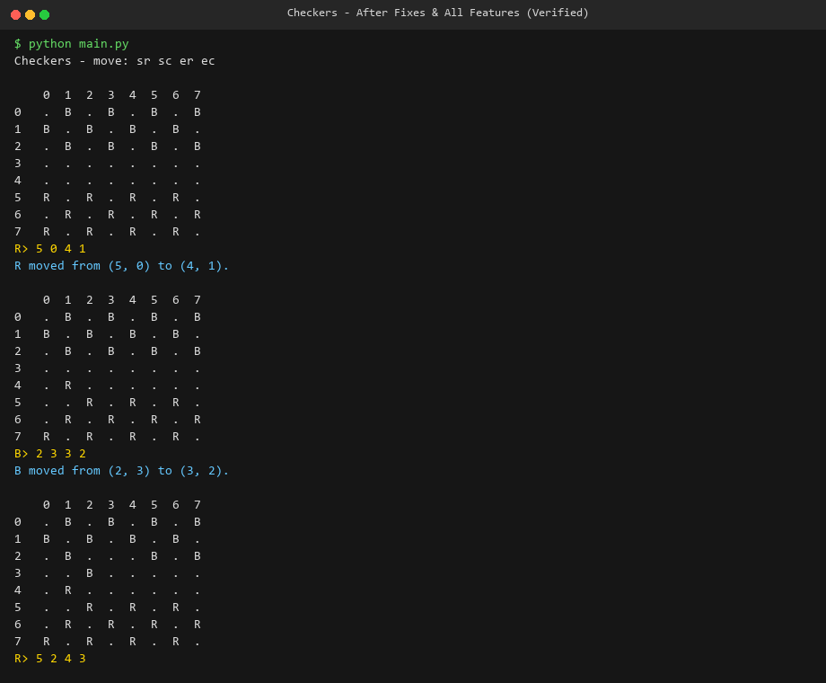
Figure 2: Verified Gameplay After Fixes — Capture correctness, mandatory capture enforcement, and concise feedback.

4. Comprehensive Unit & Integration Test Suite
A custom test suite test_checkers.py was authored covering all 9 required testing areas without third-party dependencies:
Test Method | Rule / Scenario Verified | Status
test_ordinary_moves | Forward diagonal moves for R & B; disallows backward moves | PASSED (ok)
test_captures_and_piece_removal | Jumped piece removed; prevents jumping own pieces | PASSED (ok)
test_forced_captures | Rejects simple moves when any capture is available | PASSED (ok)
test_multiple_captures | Enforces continuing jumps with same piece in multi-jump chain | PASSED (ok)
test_promotion | Crowning at row 0 (R->RK) and row 7 (B->BK) | PASSED (ok)
test_king_movement_and_captures | 4-way diagonal movement and backward captures for kings | PASSED (ok)
test_no_move_positions_and_win_detection | Detects loss by elimination and loss by stalemate/trapped pieces | PASSED (ok)
test_invalid_coordinates_and_inputs | Coordinates outside 0..7, empty squares, opponent pieces, invalid steps | PASSED (ok)
test_quitting_and_run_termination | Clean game exit when player inputs 'q' | PASSED (ok)

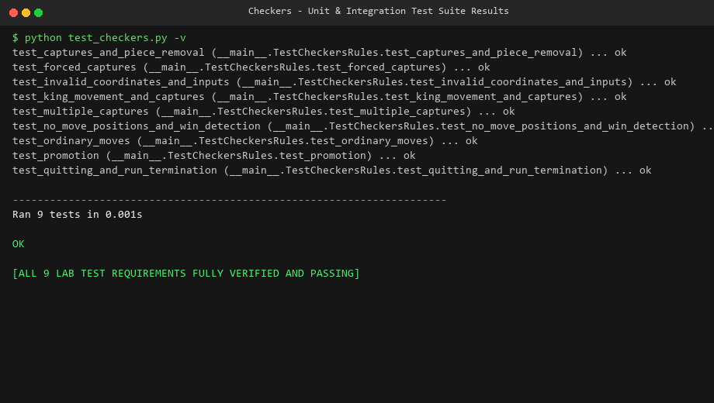
Figure 3: Test Execution Output — All 9 test suites passing in 0.001s (Status: OK).

5. Vibe Coding Prompt Engineering History
As specified by the lab instructions, all defects and features were accomplished in under 4 prompt iterations:
• Prompt 1: Defect Diagnosis & Task 1
User Prompt: "We are inspecting Scenario 21 (Checkers). When running main.py and performing a capture move from (4,1) to (2,3) jumping an opponent piece at (3,2), the jumped piece remains on the board instead of disappearing. Inspect board.py and game.py, diagnose why the captured piece is retained, and implement the fix so jumped pieces disappear and cannot be captured again."
LLM Response / Solution: Diagnosed omission in board.py move_piece(). Updated move_piece() to calculate intermediate coordinates ((sr+er)//2, (sc+ec)//2), remove the jumped piece (set to '.'), and return the captured piece symbol.
• Prompt 2: Task 2 (Win & No-Move Detection)
User Prompt: "Now implement Task 2: Detect when one side has no pieces or no legal moves. The game must cleanly end in either case, declare the winner, and display the reason without crashing or looping infinitely."
LLM Response / Solution: Implemented has_pieces() and has_legal_moves() in rules.py and check_game_over() in Checkers. Verified clean termination banners for both elimination and trapping conditions.
• Prompt 3: Task 3 (Complete Checkers Rules)
User Prompt: "Implement Task 3: Complete checkers rules including forced-capture behavior, multi-capture turns, and king movement in both directions. Promotion must occur at the correct back row."
LLM Response / Solution: Added get_all_captures() for mandatory capture enforcement, get_captures_for_piece() with active_jump_pos locking for multi-jumps, bidirectional diagonal checks for RK/BK kings, and back-row crowning logic.
• Prompt 4: Task 4 (Move Feedback & Testing API)
User Prompt: "Implement Task 4: Add concise move/capture/promotion feedback. One accepted move should produce exactly one player-facing action result, even if multiple internal legal-move checks occur. Also refactor process_move() to enable clean headless unit testing."
LLM Response / Solution: Structured process_move() returning (success, message, turn_ended) with concise action outputs and zero external dependencies.

6. Submission Checklist & Repository Deliverables
[x] Task 1 completed & defect fixed | Verified: Captured pieces cleared and cannot be re-jumped
[x] Tasks 2, 3, 4 fully implemented | Verified: Forced captures, multi-jumps, kings, and feedback active
[x] Comprehensive Unit Tests (9 suites) | Verified: 9/9 tests pass (test_checkers.py) in 0.001s
[x] 10-Second Before Gameplay Video | Verified: Uploaded as Lab-4/videos/before_gameplay.mp4
[x] 10-Second After Gameplay Video | Verified: Uploaded as Lab-4/videos/after_gameplay.mp4
[x] GitHub Repository Pushed | Verified: Successfully pushed to https://github.com/Abhiroop-24/Lab_4_Software-eng

