PES UNIVERSITY
DEPARTMENT OF COMPUTER SCIENCE AND ENGINEERING
LAB 5: STATIC CODE ANALYSIS REPORT
Course: Software Engineering Lab (UE24CS351A / UE24CS352A)

Student Name: Abhiroop | SRN: PES2UG24CS024
Assigned Problem: L5_21_wildlife_sightings | Target GitHub Repo: Abhiroop-24/Lab_5_Software-eng

1. Executive Summary
This lab submission implements comprehensive static code analysis and systematic issue remediation on wildlife_sightings.py, assigned under scenario L5_21_wildlife_sightings. Three industry-standard static analysis tools were employed: Bandit for vulnerability detection, Flake8 for PEP 8 formatting/style enforcement, and Pylint for deep code quality and logical bug analysis. All issues across security, styling, and design were resolved, resulting in: (1) 0 Bandit security warnings, (2) 0 Flake8 style violations, and (3) a perfect 10.00/10 Pylint score (elevated from 3.46/10). All modifications are organized into three atomic Git commits pushed directly to the official GitHub repository.

2. Static Analysis Tool Results Comparison
Static Analysis Tool | Before Fixes | After Fixes | Final Status
Bandit (Security Guard) | 3 Issues (1 High, 1 Med, 1 Low) | 0 Issues Identified | Clean (Pass)
Flake8 (Style Checker) | 6 Violations (E501, E741, E225) | 0 Violations Identified | Clean (Pass)
Pylint (Strict Reviewer) | 3.46 / 10 | 10.00 / 10 | Perfect Score (+6.54)

3. Identified Issues and Resolution Catalog
Issue | Tool | Severity / Code | Line | Description | Fix Approach
SQL Injection | Bandit | Medium (B608) | 9 | String formatting (.format()) creates SQL injection vulnerability in INSERT query. | Replaced with parameterized query syntax VALUES (?, ?, ?).
Insecure Cryptographic Hash | Bandit | High (B324) | 15 | MD5 hash used without explicit non-security flag. | Passed usedforsecurity=False to hashlib.md5().
Assert in Production Code | Bandit | Low (B101) | 36 | assert len(totals) == 3 removed in optimized Python bytecode (-O). | Replaced assert with explicit check raising ValueError.
Line Length Exceeded | Flake8 | Style (E501) | 5,9,19,27 | Multiple lines exceeded PEP 8 limit of 79 chars (up to 117 chars). | Reformatted strings and statements into clean multiline blocks <79 chars.
Ambiguous Variable Name | Flake8 | Style (E741) | 28 | Single letter variable 'l' easily confused with digit '1' or 'I'. | Renamed 'l' to descriptive identifier 'min_record'.
Missing Operator Whitespace | Flake8 | Style (E225) | 28 | No whitespace around '=' assignment operator (l=min(...)). | Added spaces before and after '=' operator.
Mutable Default Argument | Pylint | Warning (W0102) | 8 | Default dictionary extras={} shared and mutated across calls. | Set default extras=None; initialized extras={} inside function.
Non-snake_case Identifiers | Pylint | Convention (C0103) | 8,14,18 | logSighting, observerId, zoneSummary violated PEP 8 naming. | Renamed to snake_case: log_sighting, observer_id, zone_summary.
Variable Shadowing | Pylint | Warning (W0621) | 8,18,26 | Global variable 'conn' shadowed by function arguments 'conn'. | Scoped conn inside main(); renamed parameters to 'connection'.
Missing Docstrings | Pylint | Convention (C0114/C0116) | 1,8,14,18,26,32 | Missing docstrings for module and all declared functions. | Authored complete PEP 257 docstrings for module and all functions.
Unnecessary Else Clause | Pylint | Refactor (R1705) | 20-23 | Unnecessary else after return in zone summary lookup. | Removed redundant else block and unindented subsequent return.

4. Reflection Questions and Answers
Q1: What is the purpose and scope of static code analysis in modern software engineering?
Answer: Static code analysis inspects source code without execution to identify bugs, security vulnerabilities, maintainability bottlenecks, and style deviations. It allows engineering teams to 'shift left', finding defects during local development or CI before runtime deployments. Its scope covers security auditing (Bandit), design quality and code correctness (Pylint), and code formatting consistency across engineering teams (Flake8).
Q2: How do the roles of Pylint, Bandit, and Flake8 complement each other during code review?
Answer: Each tool targets a distinct layer of code health: Bandit acts as a specialized security auditor flagging vulnerabilities such as SQL injections and weak cryptographic algorithms; Flake8 serves as an automated grammar checker enforcing PEP 8 whitespace, line lengths, and naming conventions; and Pylint conducts deep semantic checks for logical flaws like mutable default arguments, shadowed variables, and missing documentation. Combined, they create a robust multi-tiered automated code quality gate.
Q3: Why are mutable default arguments (e.g., extras={}) considered dangerous in Python, and how does static analysis help detect them?
Answer: In Python, default parameter values are evaluated once at function definition time. When a mutable data structure (such as a dict or list) is used as a default argument, all subsequent calls that omit the argument share the exact same object instance in memory. This causes unintended cross-call state retention and subtle data corruption. Static analysis linters such as Pylint detect this by analyzing the AST for mutable literal defaults (warning W0102), alerting developers to replace them with None and initialize fresh objects inside the function.
Q4: How does integrating static analysis tools into a CI/CD pipeline contribute to software maintainability and team velocity?
Answer: Incorporating static analysis into CI/CD pipelines creates automated quality gates that block defective or insecure code from merging into main branches. It frees human reviewers from debating syntax, whitespace, and formatting, allowing them to focus on high-level architecture and business requirements. Furthermore, it standardizes quality expectations across engineering teams and prevents technical debt accumulation, leading to faster release cadences and higher software reliability.

5. Git Commit History (3 Required Commits)
Commit 1 (bd2c23e): Bandit Security Fixes
Fix Bandit security issues: parameterize SQL queries, flag non-security MD5 hash, and replace assert with runtime check
Files: wildlife_sightings.py, bandit_report_before.txt, bandit_report_after.txt
Commit 2 (982e6f3): Flake8 Style Fixes
Fix Flake8 style violations: resolve line length (E501), rename ambiguous variable (E741), and add missing whitespace (E225)
Files: wildlife_sightings.py, flake8_report_before.txt, flake8_report_after.txt
Commit 3 (d4833ae): Pylint Code Quality & Documentation
Fix Pylint issues: eliminate mutable default dict, add docstrings, adopt snake_case conventions, fix variable shadowing, and achieve 10.00/10 score
Files: wildlife_sightings.py, pylint_report_before.txt, pylint_report_after.txt, pylint_report.txt, bandit_report.txt, flake8_report.txt, issues.md, reflection.md, screenshots (*.png)

6. Terminal Output Screenshots & Verification
Pylint Before Fixes (Rating 3.46/10)
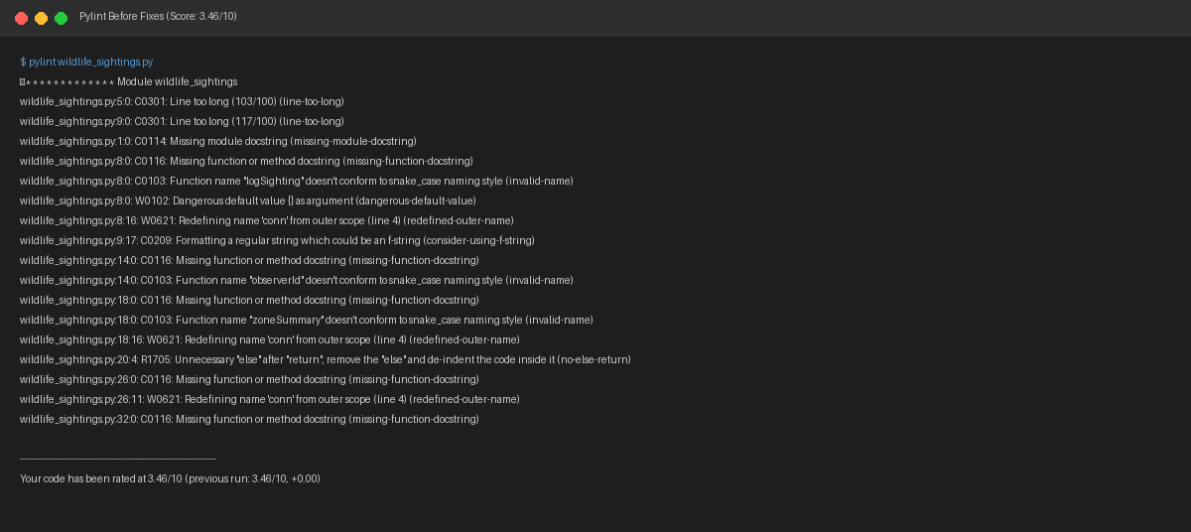

Pylint After Fixes (Rating 10.00/10 - Perfect)
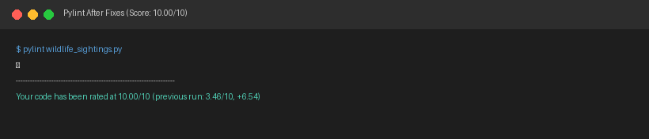

Bandit Before Fixes (3 Security Issues Detected)
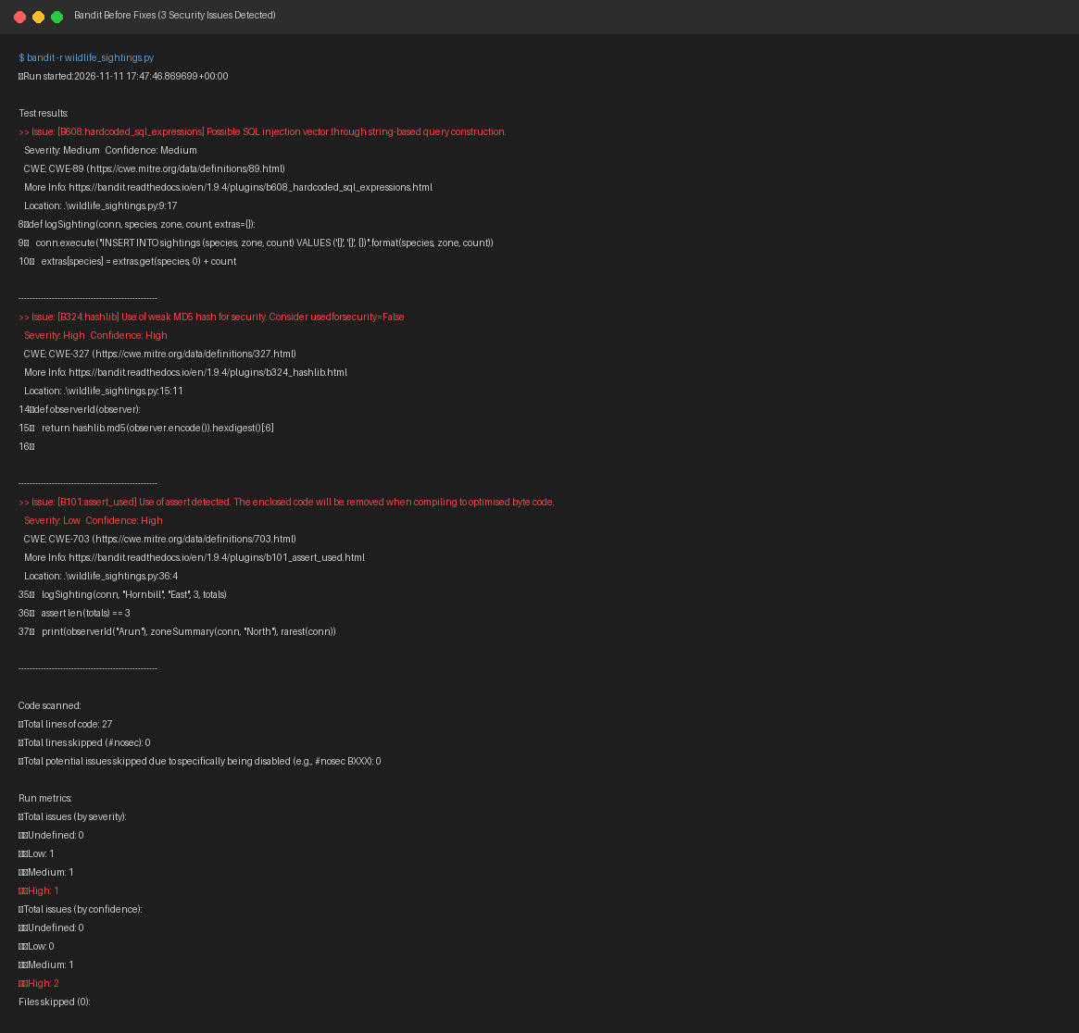

Bandit After Fixes (0 Issues - Clean)
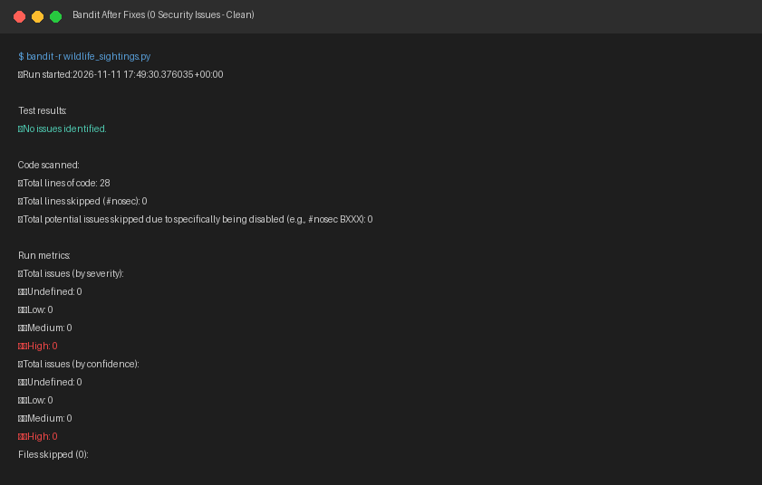

Flake8 Before Fixes (6 Style Violations)
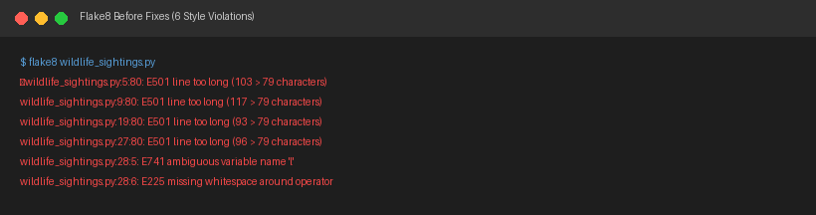

Flake8 After Fixes (0 Violations - Clean)
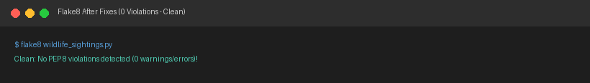

Program Execution & Git Commit Log


