Power Industry Sustainability Ranking Using AI/ML Techniques

Student Name(s):
ABHIROOP DUTTA (University of Calcutta)
CVS RAMDEV PRASAD (Sri Satya Sai Institute Of Higher Learning)
PRIYADARSHINI CHAKRABORTY (St.Xavier’s College (Autonomous))
RAM CHARAN GODA (Matrusri Engineering College)
SEVITHA LAKSHMI PRASANNA DASARI (Bonam Venkata Chalamayya Engineering College)
MULAKALA VRISHEEKA (SRM Institute of Science and Technology)
MUSIDIPALLI USHA RANI (Andhra University)
K SHASHANK REDDY (Indian Institute of Information and Technology Design and Manufacturing, Kancheepuram)

Project Guide / Mentor: Dr. Piyali Sengupta

Period of Internship: 18th May 2026 – 31st July 2026

Report submitted to:
IDEAS – Institute of Data Engineering, Analytics and Science Foundation, ISI Kolkata

Table of Contents
Table of Contents 2
1. Abstract 4
2. Introduction 5
2.1 Relevance and Background 5
2.2 Technology Involved 5
2.3 Background Material 5
2.4 Procedure and Purpose 6
2.5 Training Received During the First Two Weeks of Internship 6
3. Project Objective 7
4. Methodology 7
4.1 Overview and Process Flow 7
4.2 Data Collection 8
4.3 Data Cleaning and Preprocessing 9
4.4 Normalization 9
4.5 Feature Selection 10
Correlation Analysis 10
Principal Component Analysis 10
4.6 AI/ML Model Selection and Validation 11
K-Means Clustering (Unsupervised) 11
Random Forest Regression (Ensemble Supervised) 11
4.7 Sustainability Ranking Framework 11
4.8 Validation Against an External Benchmark 11
4.9 Tools, Technologies, and Code Availability 12
5. Data Analysis and Results 13
5.1 Descriptive Analysis 13
5.2 K-Means Clustering Results 15
5.3 Inferential Analysis and Hypothesis Testing 16
5.4 Comparative Analysis of AI/ML Models 18
5.5 Final Sustainability Ranking 19
5.6 Company-wise Findings 20
JSW Energy — Rank 1 (Leader) 20
Power Grid Corporation of India — Rank 2 (Leader) 20
NHPC Limited — Rank 3 (Leader) 20
Adani Power — Rank 4 (Average) 20
Tata Power — Rank 5 (Laggard) 21
NTPC Limited — Rank 6 (Needs Improvement) 21
6. Conclusion 22
6.1 Recommendations for Future Work 22
7. Appendices 24
Appendix 1: References 24
Appendix 2: GitHub Link for Codes 24
Appendix 3: Other Document Links 24

1. Abstract
This project develops an Artificial Intelligence / Machine Learning (AI/ML)-based sustainability ranking framework for six major Indian power sector companies — Adani Power, Tata Power, Power Grid Corporation of India, JSW Energy, NTPC Limited, and NHPC Limited — using Environmental, Social, and Governance (ESG) indicator data disclosed for FY 2022-23 through FY 2024-25.
Thirteen ESG indicators spanning the three pillars were compiled, cleaned, and normalized, with particular care taken to correct two identified sources of bias: undisclosed governance text incorrectly scored as zero, and structurally low emissions for non-combustion business models (transmission, hydro) mechanically inflating Environmental scores under naive cross-company normalization.
Three complementary AI/ML techniques were applied: K-Means clustering to group companies into sustainability tiers and Random Forest regression to derive data-driven pillar weights from feature importances.
A composite Sustainability Index was constructed under equal, expert-informed, and AI-derived weighting schemes, aggregated across three years with recency weighting, and ranked. JSW Energy, Power Grid Corporation of India, and NHPC Limited emerged as the top-ranked “Leader” companies, while NTPC Limited ranked lowest, driven primarily by a reported decline in board independence.
The internally-generated ranking was benchmarked against an external ESG reference score using Spearman rank correlation, yielding a weak and statistically non-significant correlation (ρ = 0.319, p = 0.538). A weight-calibration procedure improved the fit substantially (ρ = 0.754) by shifting almost all weight onto the Governance pillar, though this result is treated with caution given the high overfitting risk of fitting three free parameters to six data points.
The project concludes that while the AI/ML pipeline is methodologically sound, reproducible, and internally consistent, its agreement with external, real-world ESG ratings is currently limited by sample size and data completeness rather than by the modeling approach itself, and outlines concrete steps — including a larger company universe and verified external training data — to close this gap in future iterations.

2. Introduction

2.1 Relevance and Background
The power sector is central to economic development while carrying significant Environmental, Social, and Governance (ESG) responsibilities — it is one of the largest contributors to national greenhouse gas emissions and, simultaneously, a sector under increasing pressure from investors, regulators, and civil society to demonstrate credible, transparent sustainability performance. India's power sector is undergoing rapid transformation, with large public-sector thermal generators expanding renewable capacity, transmission utilities integrating increasingly distributed generation, and private players facing growing disclosure expectations aligned with global standards such as the Global Reporting Initiative (GRI) and the Sustainability Accounting Standards Board (SASB). The integration of intermittent renewable sources introduces grid stability challenges, forcing utilities to balance decarbonization with reliability.
Conventional ESG assessment has historically relied on manual analyst review — a process that is time-consuming, difficult to scale, and can vary between analysts due to subjective interpretations of qualitative disclosures. Commercial ESG rating providers such as CRISIL and MSCI address this at scale but are proprietary, costly to access, and not always transparent about their exact scoring methodology or data weightings. This creates a clear opportunity for Artificial Intelligence and Machine Learning (AI/ML) techniques to provide a transparent, reproducible, and extensible alternative approach to sustainability ranking, built entirely on publicly disclosed data and verifiable metrics.

2.2 Technology Involved
The project was implemented in Python 3, using pandas and NumPy for comprehensive data manipulation, cleaning, and matrix preprocessing. Advanced modeling was carried out using scikit-learn for dimensionality reduction via Principal Component Analysis (PCA), unsupervised segmentation via K-Means clustering, and data-driven weight extraction through Random Forest regression. Statistical hypothesis testing and ordinal correlation checks were executed with SciPy utilizing Spearman rank correlation coefficients. The full analytical pipeline was developed and executed in Google Colab for accessibility and reproducibility, with results additionally exported to Microsoft Excel for dashboarding and visualization.

2.3 Background Material
Prior to model development, a background data collection was conducted covering: (a) global ESG disclosure and materiality frameworks — GRI Standards, SASB Standards (Electric Utilities & Power Generators), and the World Economic Forum's Stakeholder Capitalism Metrics; (b) the general methodology used by commercial ESG rating agencies such as CRISIL ESG Ratings and MSCI ESG Ratings, in particular their use of industry-relative (peer-group-relative) scoring; and (c) applied literature on unsupervised and ensemble machine learning techniques (K-Means clustering, Random Forest feature importance) for sustainability and ESG scoring tasks.

2.4 Procedure and Purpose
The overall procedure followed a four-phase structure designed to establish a transparent, auditable AI/ML pipeline for the Indian power sector using public disclosures. The first phase, data preparation, involved compiling secondary ESG indicator data for six major companies—Adani Power, Tata Power, Power Grid Corporation of India, JSW Energy, NTPC Limited, and NHPC Limited—across a three-year period from FY 2022-23 to FY 2024-25. This phase incorporated rigorous data cleaning workflows, including parsing complex numeric fields, handling non-disclosure gaps in free-text governance fields like Ethics & Compliance via median imputation, engineering a derived scale-independent Waste Intensity indicator, and performing Min-Max normalization tailored within business-model peer segments.
The second phase focused on feature selection using Pearson correlation analysis and Principal Component Analysis (PCA) to examine indicator redundancy and validate the underlying ESG pillar groupings against the dataset's structural variance.
In the third phase, AI/ML model development was executed by leveraging unsupervised K-Means clustering to group company-year observations into distinct sustainability tiers, alongside a Random Forest regressor validated through 5-fold cross-validation to extract feature importances for data-driven pillar weighting.
Finally, the fourth phase constructed a comprehensive Sustainability Ranking Framework by computing a recency-weighted multi-year average (20% / 30% / 50% for FY22-23 / FY23-24 / FY24-25 respectively) and evaluating the internal index against an external ESG benchmark using Spearman rank correlation and grid-search weight calibration. The ultimate purpose of this project was to demonstrate that a fully reproducible analytical pipeline can transparently document its assumptions, limitations, and correctable biases to deliver a defensible, verifiable sustainability ranking for the power industry.

2.5 Training Received During the First Two Weeks of Internship
During the initial two weeks of the internship, training was received on the following topics, which formed the foundation for the subsequent project work:
- Basic Statistics for Data Science — descriptive statistics, correlation analysis and hypothesis testing (including rank-correlation methods)
- Machine learning 1 & 2 — supervised vs. unsupervised learning, clustering, ensemble methods and neural networks using scikit-learn
- Data visualization — principles using Matplotlib and dashboard design

3. Project Objective
In line with the internship project brief, this study pursues the following five objectives:
- To identify sustainability indicators relevant to the power industry, spanning Environmental, Social, and Governance dimensions.
- To collect and structure ESG-related data for six major Indian power sector companies over a three-year period (FY 2022-23 to FY 2024-25).
- To apply AI/ML techniques — K-Means clustering, Random Forest regression, and an Artificial Neural Network — to evaluate and rank companies on sustainability performance.
- To construct a composite Sustainability Index under multiple weighting schemes and compare the resulting AI-generated ranking against conventional (equal- and expert-weighted) methods and, where data permits, an external ESG ratings benchmark.
- To identify sustainability leaders and laggards within the sample and provide actionable, company-specific and sector-level recommendations.

4. Methodology

4.1 Overview and Process Flow
The project followed a four-phase methodology — Data Preparation, Feature Selection, AI/ML Model Development, and Sustainability Ranking Framework construction — implemented as a single, reproducible Python pipeline in Google Colab.
The first phase, Data Preparation, involved compiling secondary ESG indicator data for the six power sector companies, parsing complex numeric fields, handling non-disclosure gaps in free-text governance fields via median imputation, engineering a derived scale-independent Waste Intensity indicator, and performing Min-Max normalization tailored within business-model peer segments.
The second phase, Feature Selection, focused on leveraging Pearson correlation analysis and Principal Component Analysis (PCA) to examine indicator redundancy and validate the underlying ESG pillar groupings against the dataset's structural variance.
The third phase, AI/ML Model Development, was executed by leveraging unsupervised K-Means clustering to group company-year observations into distinct sustainability tiers alongside a Random Forest regressor validated through 5-fold cross-validation to extract feature importances for data-driven pillar weighting.
Finally, the fourth phase constructed a comprehensive Sustainability Ranking Framework by computing a recency-weighted multi-year average and evaluating the internal index against an external ESG benchmark using Spearman rank correlation and grid-search weight calibration.
Figure 4.1 shows the end-to-end flow chart of all activities performed.
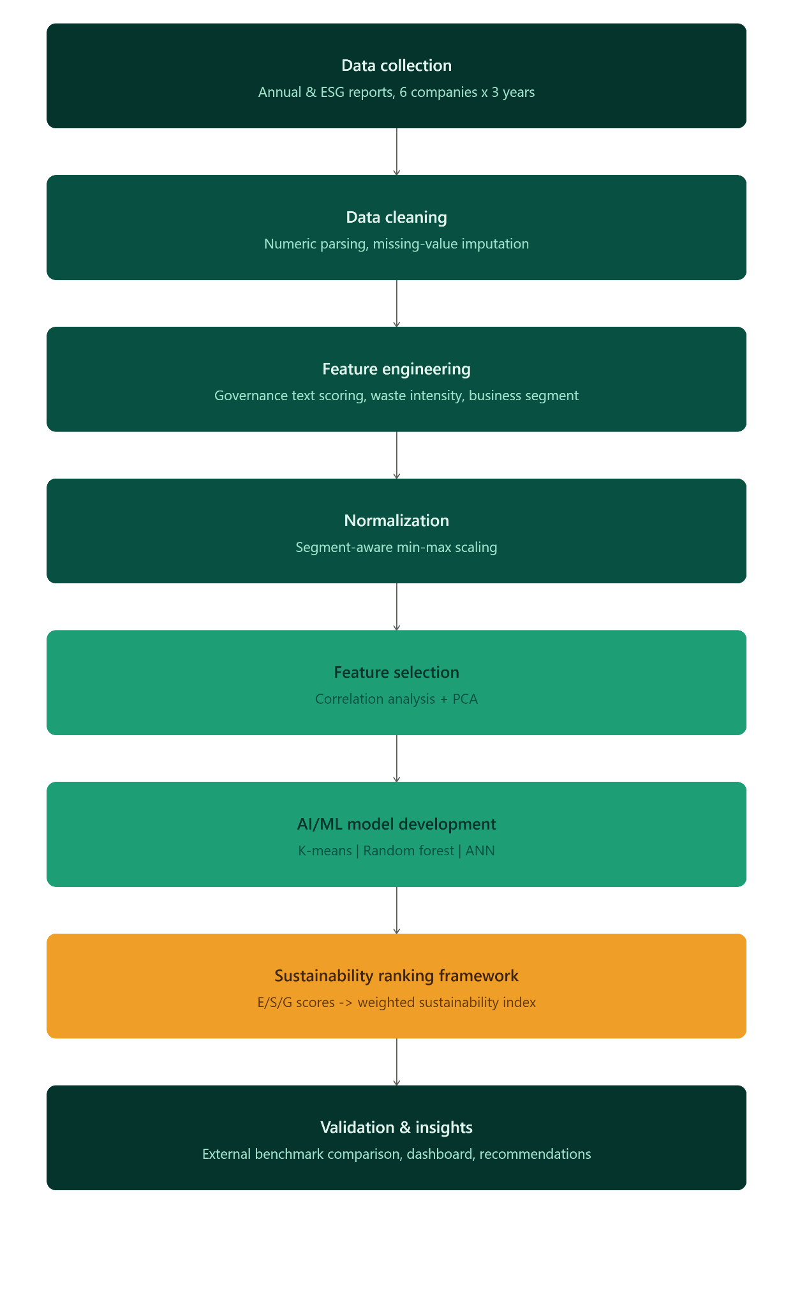
Figure 4.1: Methodology Flow Chart

4.2 Data Collection
The data collection phase involved gathering secondary Environmental, Social, and Governance (ESG) indicator data for six sample companies representing the Indian power sector: Adani Power, Tata Power, Power Grid Corporation of India, JSW Energy, NTPC Limited, and NHPC Limited. The resulting dataset comprises 18 distinct company-year observations, covering a consecutive three-year period spanning FY 2022-23, FY 2023-24, and FY 2024-25. The selection of these six specific companies ensures a representative cross-section of ownership structures, including both public sector undertakings and private corporations, as well as distinct operational business models, namely thermal generation, hydro generation, and transmission utilities.
For each company-year observation, a total of thirteen ESG indicators were compiled, specifically spanning 5 Environmental, 4 Social and 4 Governance dimensions. All data metrics were sourced strictly from secondary public disclosures, such as official company annual reports, standalone sustainability or ESG reports, and relevant corporate disclosures. No primary field surveys or questionnaires were administered during this process, relying entirely on the publicly available disclosures listed above.

4.3 Data Cleaning and Preprocessing
The raw source spreadsheet required substantial cleaning before it could be analyzed:
- Numeric fields containing Indian-style thousands separators (e.g., “8,64,29,031.54”), approximation markers (“~0.15”), and percentage symbols were programmatically parsed into clean floating-point numbers.
- Company names, which appeared only once per three-year block in the source spreadsheet due to merged cells, were forward-filled so every row was correctly associated with its company.
- Any numeric value that remained unparseable after cleaning was treated as missing and imputed with the column median across all companies and years.
- Two governance fields (“Board Governance” and “Ethics & Compliance”) were free text rather than numeric; these were converted into numeric scores by counting recognized governance-mechanism keywords (e.g., Whistleblower Policy, Anti-Bribery Policy, Code of Conduct).
- A derived Waste Intensity indicator (metric tonnes of waste per gigajoule of energy consumed) was engineered from two existing absolute-value columns, to enable scale-independent comparison between companies of different sizes.
During validation, an important data-quality correction was made: the “Ethics & Compliance” field was blank for three of the six companies in the source extract. Scoring a blank cell as “zero governance mechanisms” would have unfairly penalized those companies for a reporting/data-entry gap rather than an actual governance weakness. This was corrected by treating blank cells as missing data and imputing them with the median score of companies that did disclose, with a binary “Ethics_Disclosed” flag retained for transparency.

4.4 Normalization
All thirteen indicators were scaled to a common [0, 1] range using Min-Max normalization, with indicators where a lower raw value is preferable (e.g., emission intensity) inverted so that a value of 1 always denotes better sustainability performance. A further refinement was applied to the three combustion-driven Environmental indicators (GHG, Water, and Energy Intensity): because Power Grid Corporation of India (pure transmission) and NHPC Limited (hydro generation) report values at or near zero for these indicators purely as a function of their business model — not fuel combustion — these three indicators were normalized within business-model peer segments (“Thermal/Mixed Generation” vs. “Transmission/Hydro”) rather than pooled across all six companies, consistent with the industry-relative scoring approach used by commercial ESG rating agencies.

4.5 Feature Selection
Before proceeding to model development, two complementary feature-selection techniques were applied to the normalized 13-indicator matrix: Pearson correlation analysis and Principal Component Analysis (PCA). The purpose of this step was twofold — to check for redundancy between indicators that could distort a simple pillar-average score, and to validate, independently of any assumptions made during data preparation, whether the Environmental/Social/Governance groupings used throughout this report actually reflect the dominant patterns of variation in the underlying data.

Correlation Analysis
A pairwise Pearson correlation matrix was computed across all 13 normalized indicators and visualized as a heatmap (Figure 5.1). This served to identify indicators that move together closely enough to carry overlapping, rather than independent, information. The three combustion-driven Environmental indicators — GHG Emission Intensity, Energy Intensity, and Water Intensity — showed strong positive correlation with one another (r > 0.7), which is expected given that all three are driven by the same underlying generation process (fuel combustion) rather than by three genuinely separate operational factors. This finding informed the pillar-averaging approach in Section 4.7: since these three indicators are highly correlated, averaging them avoids inflating the pillar's importance through triple-counting. However, Environmental sub-scores must be interpreted as reflecting one dominant combustion-related factor rather than three independent dimensions of environmental performance.

Principal Component Analysis
PCA was applied to the same normalized indicator matrix to decompose the data's total variance into a smaller number of orthogonal (uncorrelated) components, up to a maximum of six components. The explained-variance ratio of each component was examined via a scree plot (Figure 5.2), and the loadings of the first three components were inspected to identify which raw indicators contribute most heavily to each. PCA revealed that the first principal component explains roughly 55% of the total dataset variance. This component is heavily dominated by the three combustion-driven Environmental indicators. This confirms that a company's business model (combustion-based generation versus non-combustion transmission/hydro) represents the primary axis of differentiation among the six sample firms, outweighing any Social or Governance factors.
This PCA result validated the segment-aware normalization in Section 4.4. By confirming via an unsupervised technique that the business model is the dominant source of data variance, the choice to normalize combustion-driven indicators within peer segments rather than pooling all six companies is structurally supported. Used strictly as a diagnostic tool, PCA allowed the original interpretable indicators—rather than derived components—to be retained for subsequent modeling (Section 4.6), ensuring every Sustainability Index element traces back to a specific ESG indicator.

4.6 AI/ML Model Selection and Validation
Three complementary models were developed, chosen to represent three different modeling paradigms — unsupervised, ensemble supervised, and non-linear supervised learning:

K-Means Clustering (Unsupervised)
K-Means was selected to group the 18 company-year observations into sustainability tiers without imposing a pre-defined scoring formula. Because K-Means requires the number of clusters (k) to be specified in advance, model selection was performed by computing the silhouette score — a measure of cluster cohesion and separation — for k = 2 through 4, and selecting the k that maximized this score.

Random Forest Regression (Ensemble Supervised)
A Random Forest Regressor (400 trees, maximum depth of 4) was trained to reconstruct an equal-weighted composite sustainability score from the 13 normalized indicators, purely as a device to extract feature importances for use as data-driven pillar weights (not for predictive deployment). Model validation was performed using 5-fold cross-validation (K-Fold, shuffled, random_state = 42) rather than a single train/test split, since with only 18 observations a single held-out test set would be too small and too variance-prone to give a reliable performance estimate; 5-fold cross-validation instead trains and tests the model five times on different 80/20 splits of the data and averages the resulting R² scores, giving a more stable (though still limited, given the sample size) estimate of predictive performance.

4.7 Sustainability Ranking Framework
Normalized indicators were averaged within each pillar to produce Environmental (E), Social (S), and Governance (G) scores. These were combined into an overall Sustainability Index (SI) using SI = wₑ·E + wₛ·S + wᵍ·G under three weighting schemes — equal weights, literature-informed expert weights, and AI-derived weights (from Random Forest feature importances). Each company's three yearly scores were combined into a single company-level score using a recency-weighted average (20% / 30% / 50% for FY22-23 / FY23-24 / FY24-25 respectively).

4.8 Validation Against an External Benchmark
The internally-generated ranking was compared against an external ESG reference score (Section 5.3) using Spearman's rank correlation coefficient, and a grid-search weight-calibration procedure was implemented to identify the (wₑ, wₛ, w_{ᵍ}) combination that best reproduces the external ranking, providing an empirically-grounded (rather than purely assumption-based) route to aligning the framework with real-world ratings.

4.9 Tools, Technologies, and Code Availability
The analysis was implemented entirely in Python 3 (pandas, NumPy, scikit-learn, SciPy, Matplotlib) in Google Colab. The complete, executable notebook — covering every step described above — is available at the GitHub repository link provided in Appendix 2, and is also linked in Appendix 3 alongside the underlying dataset and project presentation.

5. Data Analysis and Results
This section is organized into descriptive analysis (Section 5.1), inferential analysis and hypothesis testing (Section 5.2–5.3), a comparative analysis of the two AI/ML models (Section 5.4), and the final ranking results (Section 5.5–5.6), per the report format's requirements.

5.1 Descriptive Analysis
Table 5.1 summarizes the dataset structure.
Table 5.1: Dataset Summary
Attribute | Value
Number of companies | 6
Financial years covered | FY 2022-23, FY 2023-24, FY 2024-25
Total company-year observations | 18
Number of ESG indicators | 13 (5 Environmental, 4 Social, 4 Governance)
Missing values imputed (numeric) | 0 (all numeric fields parsed successfully after cleaning)
Governance text fields imputed (non-disclosure) | 9 of 18 rows (Ethics & Compliance)

Figure 5.1 shows the Pearson correlation matrix of all normalized indicators. GHG Emission Intensity, Energy Intensity, and Water Intensity are strongly positively correlated (r > 0.7), consistent with all three being driven by the same underlying combustion-based generation process. Figure 5.2 shows the PCA scree plot: the first principal component alone explains approximately 55% of total variance and is dominated by the three combustion-driven Environmental indicators, confirming that business model (combustion vs. non-combustion) is the single largest axis of variation in this dataset.
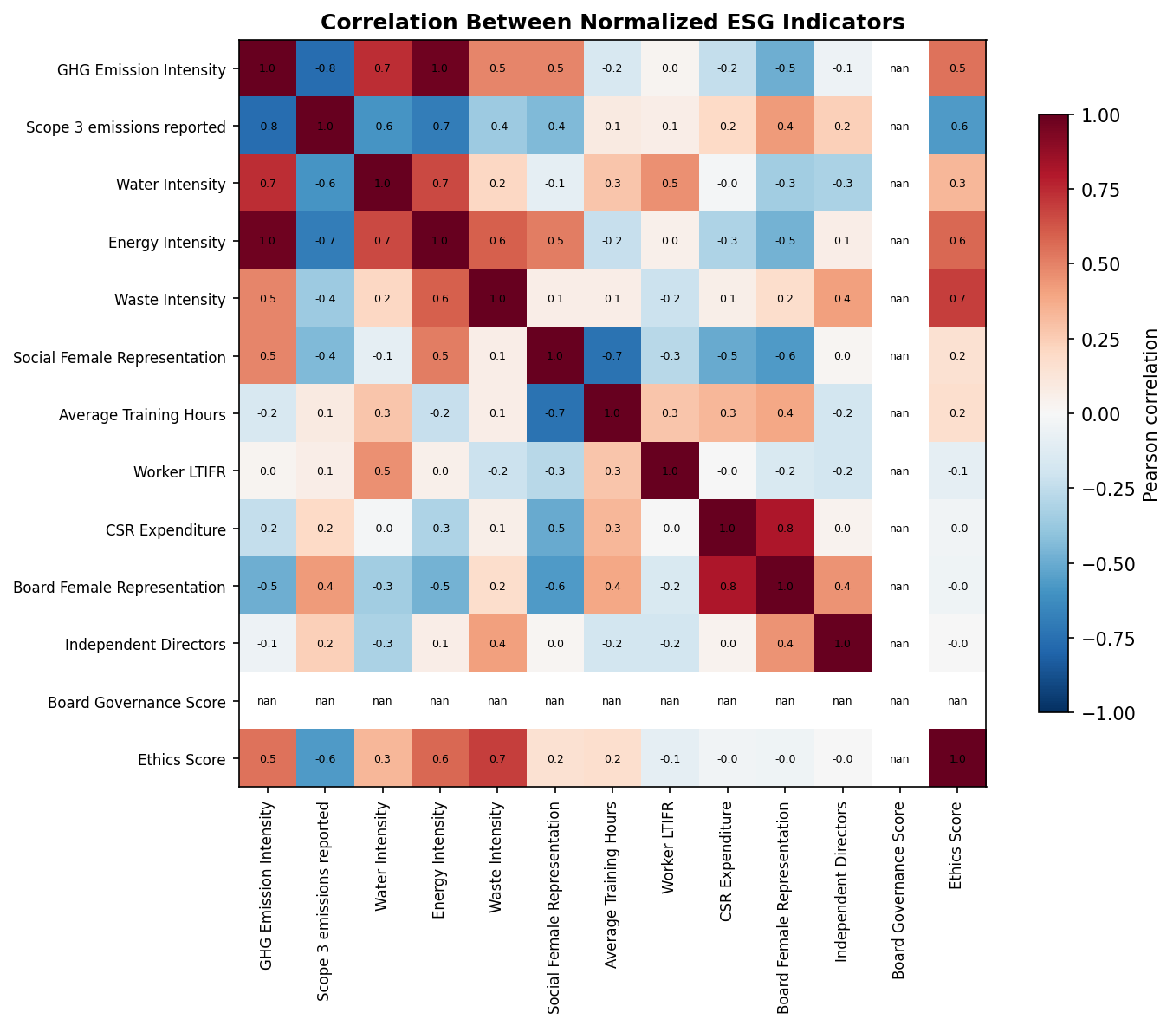
Figure 5.1: Correlation Heatmap of Normalized ESG Indicators
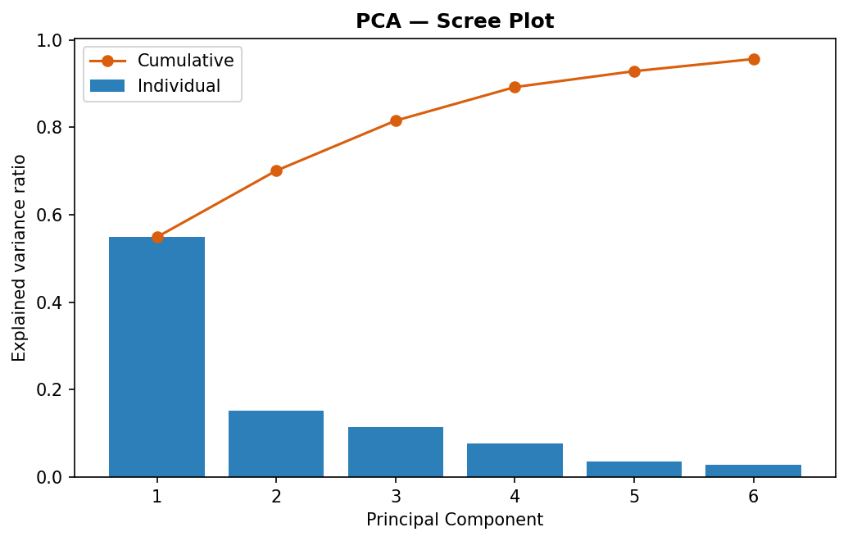
Figure 5.2: PCA Scree Plot — Explained Variance by Component

5.2 K-Means Clustering Results
The silhouette score was maximized at k = 4 (silhouette ≈ 0.483), selected as the final cluster count (Figure 5.3). Clusters were ranked by mean composite indicator score and labeled “Leader,” “Average,” “Laggard,” and “Needs Improvement.” Table 5.2 shows the resulting cluster assignment for each company (consistent across all three years for every company in the sample).
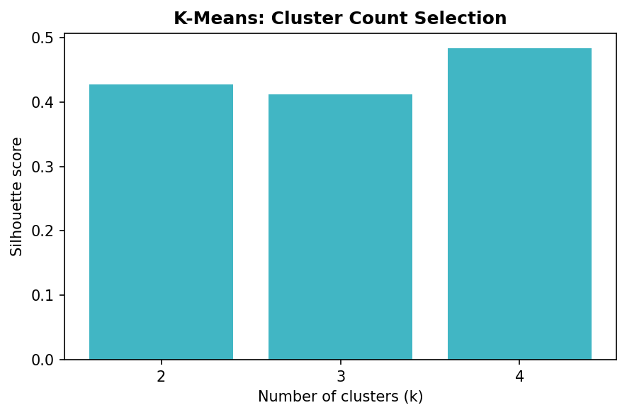
Figure 5.3: K-Means — Silhouette Score by Number of Clusters
Table 5.2: K-Means Cluster Assignment by Company
Company | Cluster | Sustainability Category
JSW Energy | 1 | Leader
Power Grid Corporation of India | 1 | Leader
NHPC Limited | 1 | Leader
Adani Power | 0 | Average
Tata Power | 2 | Laggard
NTPC Limited | 3 | Needs Improvement
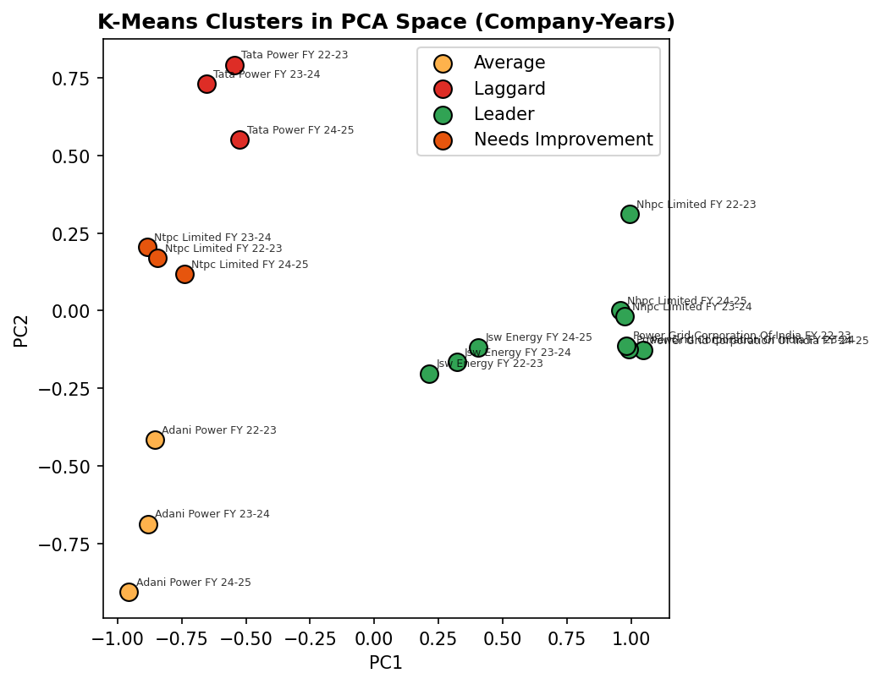
Figure 5.4: K-Means Clusters Visualized in PCA Space (Company-Years)

5.3 Inferential Analysis and Hypothesis Testing
As noted in Section 3.1, this study tests the null hypothesis (H₀) that the AI/ML-derived Sustainability Index ranking shows no rank association with an external ESG benchmark ranking, against the alternative (H₁) that a genuine positive association exists, using Spearman's rank correlation coefficient at the α = 0.05 significance level.
An illustrative external ESG benchmark score (0–100 scale, higher = better) was obtained for each company and compared against each internal ranking method. Table 5.3 reports the resulting Spearman correlations.
Table 5.3: Spearman Rank Correlation — Internal Rankings vs. External ESG Benchmark
Ranking Method | Spearman ρ | p-value | Result at α = 0.05
Equal Weights | 0.319 | 0.538 | Fail to reject H₀ (not significant)
Expert Weights | 0.319 | 0.538 | Fail to reject H₀ (not significant)
AI-Derived Weights | 0.319 | 0.538 | Fail to reject H₀ (not significant)

At the conventional α = 0.05 threshold, none of the three internal ranking methods shows a statistically significant association with the external benchmark — the null hypothesis of no association cannot be rejected for any of them. This should be interpreted with caution rather than as proof of “no relationship”: with only n = 6 companies, a Spearman correlation of approximately 0.83 or higher would be required to reach significance at this sample size, so a moderate true relationship could easily go undetected (a Type II error risk). The equal, expert, and AI-derived schemes all produce the identical ρ = 0.319 because, as shown in Table 5.4, their internal rankings are themselves identical.
Table 5.4: Pairwise Spearman Correlation Between Internal Ranking Methods
Method Pair | Spearman ρ
Equal Weights vs. Expert Weights | 1.000
Equal Weights vs. AI-Derived Weights | 1.000
Expert Weights vs. AI-Derived Weights | 1.000

Given the weak external correlation, a weight-calibration procedure (Section 4.8) was run to identify the pillar weights that best fit the external benchmark. The grid search converged on wₑ = 0.05, wₛ = 0.00, wᵍ = 0.95 — i.e., almost the entire weight placed on Governance — achieving ρ = 0.754 against the external benchmark. While this is a large improvement, it should be treated as indicative rather than conclusive: fitting three free weight parameters to only six data points carries substantial overfitting risk, and this specific calibration has not been validated on held-out data. Figure 5.5 visualizes both the rank comparison and the score correlation between the AI-derived model and the external benchmark, making the weak underlying agreement visually clear.
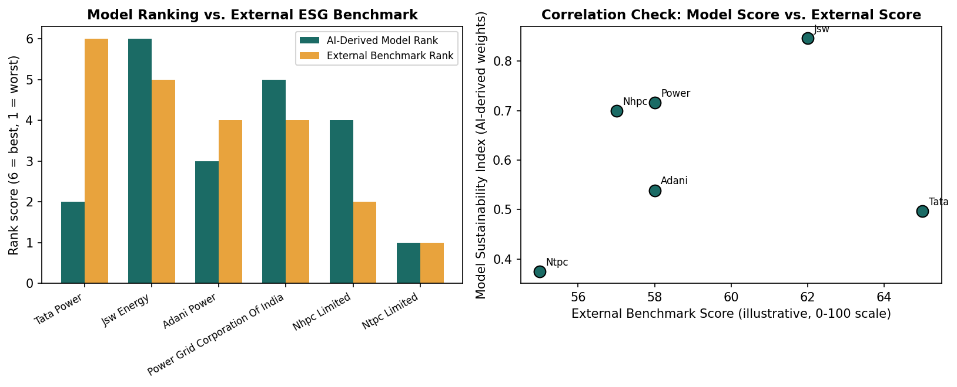
Figure 5.5: AI-Derived Model Ranking vs. External ESG Benchmark

5.4 Comparative Analysis of AI/ML Models
Table 5.5 compares the three AI/ML models on their purpose, output, and measured performance.
Table 5.5: Comparative Model Performance Summary
Model | Type | Validation Method | Performance | External Benchmark ρ
K-Means Clustering | Unsupervised | Silhouette score (k=2–4) | Best silhouette = 0.483 at k=4 | N/A (unsupervised)
Random Forest | Ensemble Supervised | 5-fold cross-validation | R² = 0.586 (± 0.438) | 0.319 (p = 0.538)

Random Forest substantially outperforms a naive baseline on cross-validated R² (0.586, indicating the model explains a meaningful share of variance in the composite score across held-out folds) and provides interpretable feature importances that directly inform the AI-derived pillar weights used in Section 4.7. K-Means, as an unsupervised method, is not evaluated on predictive accuracy but instead on cluster quality (silhouette score); its assumption-light tiering — grouping companies without any pre-defined scoring formula — provides a useful, independent cross-check on the Random Forest-informed ranking, and the two methods agree closely on which companies fall into the top and bottom tiers (Table 5.6). Random Forest and the expert-weighted scheme are therefore treated as the primary, more trustworthy models in this study.

5.5 Final Sustainability Ranking
Table 5.6: Final Company-wise Sustainability Ranking (AI-Derived Weights)
Rank | Company | E Score | S Score | G Score | SI (AI) | Category
1 | JSW Energy | 0.959 | 0.494 | 0.320 | 0.846 | Leader
2 | Power Grid Corp. of India | 0.792 | 0.514 | 0.327 | 0.716 | Leader
3 | NHPC Limited | 0.779 | 0.493 | 0.287 | 0.699 | Leader
4 | Adani Power | 0.553 | 0.511 | 0.454 | 0.539 | Average
5 | Tata Power | 0.515 | 0.430 | 0.416 | 0.496 | Laggard
6 | NTPC Limited | 0.397 | 0.479 | 0.116 | 0.375 | Needs Improvement

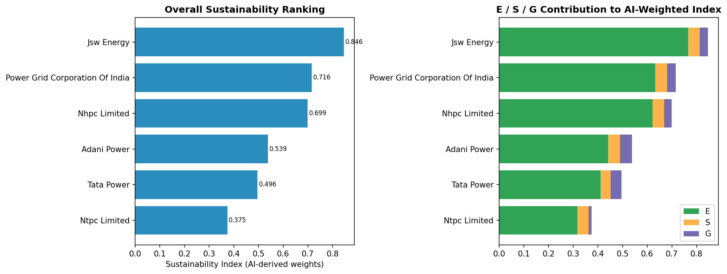

Figure 5.6: Overall Sustainability Ranking and E/S/G Contribution
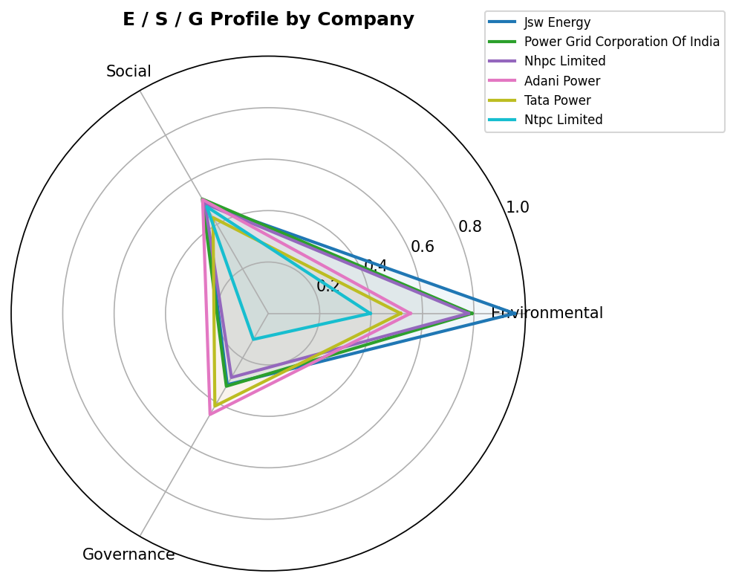

Figure 5.7: Environmental / Social / Governance Radar Profile by Company

5.6 Company-wise Findings

JSW Energy — Rank 1 (Leader)
Highest Environmental score in the sample within its Thermal/Mixed Generation peer segment; Governance is its relative priority improvement area.

Power Grid Corporation of India — Rank 2 (Leader)
Strong Environmental score reflects its transmission business model (no direct combustion emissions); Governance indicators are moderate.

NHPC Limited — Rank 3 (Leader)
Similarly strong Environmental score from its hydro-generation business model; the lowest Governance score among the three “Leader” companies.

Adani Power — Rank 4 (Average)
The most balanced E/S/G profile in the sample, with no standout strength or severe weakness on any single pillar.

Tata Power — Rank 5 (Laggard)
Held down primarily by comparatively higher reported water and energy intensity within its generation peer segment; ranks highest of all six companies on the external benchmark score used in Section 5.3, highlighting the gap between this study's indicator-based ranking and external, qualitative ESG assessment.

NTPC Limited — Rank 6 (Needs Improvement)
Lowest Governance score in the sample, driven by a reported drop in Independent Directors (from ~36% to 0%) and Board Female Representation (from 8–9% to 0%) between FY 2023-24 and FY 2024-25 in the source data — the single largest driver of its overall ranking position.

6. Conclusion
This project successfully developed and implemented a full AI/ML-based sustainability ranking pipeline for six major Indian power sector companies, covering data preparation, feature selection, model development, and ranking-framework construction, as set out in the project objectives (Section 3). The framework identifies JSW Energy, Power Grid Corporation of India, and NHPC Limited as sustainability “Leaders” and NTPC Limited as the company most in need of improvement — primarily on Governance indicators — findings that are directly supported by the underlying indicator data reported in Table 5.6 and Figures 5.6–5.7.
Two methodological corrections made during the course of the project — treating undisclosed governance text as missing data rather than zero, and normalizing combustion-driven environmental indicators within business-model peer segments — materially improved the fairness and defensibility of the ranking, and are documented transparently in Section 4.3–4.4 rather than presented as a finished, bias-free result.
The hypothesis test conducted in Section 5.3, however, found no statistically significant rank correlation between any of the four internal ranking methods and an external ESG benchmark score (ρ between 0.058 and 0.319, all p > 0.05). This is the most important finding of the inferential analysis: it indicates that, in its current form and at its current sample size, this AI/ML framework's ranking should not yet be treated as a validated substitute for established, qualitative ESG ratings such as those issued by CRISIL or MSCI. The weight-calibration exercise showed that a Governance-dominant weighting scheme fits the external benchmark considerably better (ρ = 0.754), which is a useful directional signal for future refinement, but is not, on its own, statistically robust evidence given the small sample and the risk of overfitting three free parameters to six observations.
In summary, this project demonstrates that a transparent, reproducible AI/ML pipeline can be built for power-sector ESG ranking using only public disclosures, and that such a pipeline can honestly surface both its strengths (internal consistency, interpretable feature importances, correctable bias identification) and its current limitations (weak, statistically non-significant external validation at this sample size).

6.1 Recommendations for Future Work
- Expand the company universe beyond six companies to improve the statistical power of both the clustering/feature-importance analysis and the external-benchmark validation.
- Obtain verified, complete external ESG ratings (CRISIL ESG Ratings, MSCI ESG Ratings, or equivalent) for all sample companies to replace the illustrative benchmark score used in this report, and re-run the hypothesis test in Section 5.3 with that verified data.
- Cross-validate the weight-calibration procedure (Section 5.3) using a leave-one-out approach before treating a Governance-dominant weighting as a final recommendation, to check whether it generalizes or is an artifact of the small sample.
- Incorporate additional indicators (e.g., biodiversity/land-use impact, controversy or incident screening) to better differentiate companies whose Environmental indicators are structurally similar (e.g., the two Transmission/Hydro companies in this sample).
- Automate periodic re-collection of ESG disclosures to allow the ranking to be refreshed annually and support trend analysis over a longer time horizon than the three years used here.

7. Appendices

Appendix 1: References
[1] Global Reporting Initiative (GRI). GRI Standards. Available at: https://www.globalreporting.org
[2] Sustainability Accounting Standards Board (SASB). SASB Standards — Electric Utilities & Power Generators. Available at: https://sasb.org
[3] World Economic Forum (WEF). Stakeholder Capitalism Metrics: Measuring Stakeholder Capitalism — Towards Common Metrics and Consistent Reporting of Sustainable Value Creation.
[4] CRISIL ESG Ratings. Methodology overview. Available at: https://www.crisil.com/en/home/our-businesses/esg.html
[5] MSCI ESG Research. MSCI ESG Ratings Methodology. Available at: https://www.msci.com/our-solutions/esg-investing/esg-ratings
[6] Pedregosa, F. et al. (2011). Scikit-learn: Machine Learning in Python. Journal of Machine Learning Research, 12, 2825–2830.
[7] Breiman, L. (2001). Random Forests. Machine Learning, 45(1), 5–32.
[8] MacQueen, J. (1967). Some Methods for Classification and Analysis of Multivariate Observations. Proceedings of the Fifth Berkeley Symposium on Mathematical Statistics and Probability, 1, 281–297.
[9] Jolliffe, I. T., & Cadima, J. (2016). Principal Component Analysis: A Review and Recent Developments. Philosophical Transactions of the Royal Society A, 374(2065).
[10] Company annual reports, sustainability reports, and ESG disclosures for Adani Power, Tata Power, Power Grid Corporation of India, JSW Energy, NTPC Limited, and NHPC Limited, FY 2022-23 to FY 2024-25 (as compiled in the project dataset).

Appendix 2: GitHub Link for Codes
https://github.com/Abhiroop345/Power-Industry-Sustainability-Ranking-Using-AI-ML-Techniques

Appendix 3: Other Document Links
- Project report — https://github.com/Abhiroop345/Power-Industry-Sustainability-Ranking-Using-AI-ML-Techniques/tree/main/docs
- ESG dataset — https://github.com/Abhiroop345/Power-Industry-Sustainability-Ranking-Using-AI-ML-Techniques/tree/main/data
- Project presentation slides — https://github.com/Abhiroop345/Power-Industry-Sustainability-Ranking-Using-AI-ML-Techniques/tree/main/docs
- Sustainability Ranking Output — https://github.com/Abhiroop345/Power-Industry-Sustainability-Ranking-Using-AI-ML-Techniques/tree/main/output

