DIGITAL IR Transmitter Module (SKU:DFR0095)

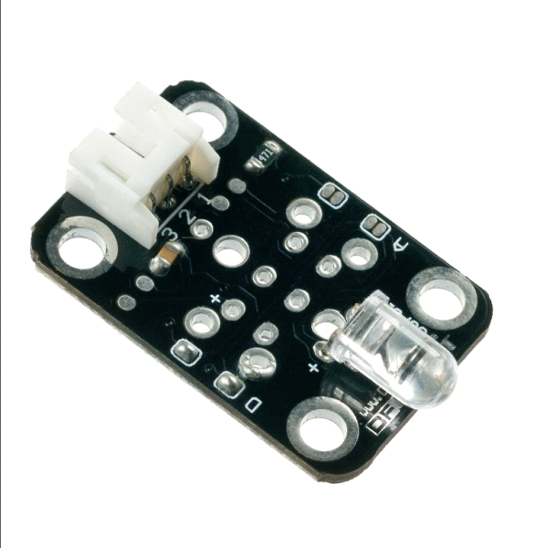
Contents :
1 Introduction
2 Specification
3 Wiring Diagram
4 Applications
5 Sample Code
Introduction
DIGITAL IR Transmitter Module (SKU:DFR0095)

IR Transmitter Module is designed for IR communication which is widely used for operating the television device wirelessly from a short line-of-sight distance. The remote control is usually contracted to remote.

Since infrared (IR) remote controls use light, they require line of sight to operate the destination device. The signal can, however, be reflected by mirrors, just like any other light source.

If operation is required where no line of sight is possible, for instance when controlling equipment in another room or installed in a cabinet, many brands of IR extenders are available for this on the market. Most of these have an IR receiver, picking up the IR signal and relaying it via radio waves to the remote part, which has an IR transmitter mimicking the original IR control.

Infrared receivers also tend to have a more or less limited operating angle, which mainly depends on the optical characteristics of the phototransistor. However, it’s easy to increase the operating angle using a matte transparent object in front of the receiver.
Specification

Power Supply:5V
Interface:Digital
Modulate Frequency:38Khz
Module interface socket:JST PH2.0

Wiring Diagram
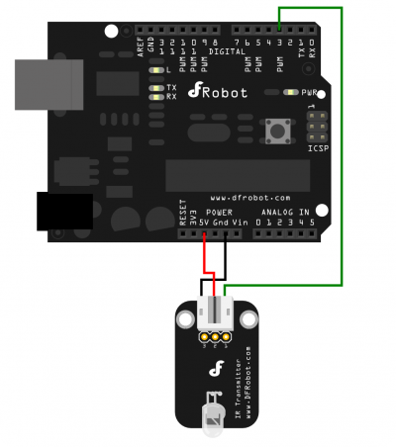

Applications

Remote control
TV control
Air conditioning control

Sample Code : sketch with libraries
FEATURES
• Very low supply current
• Photo detector and preamplifier in one
package
• Internal filter for PCM frequency
• Improved shielding against EMI
• Supply voltage: 2.5 V to 5.5 V
• Improved immunity against ambient light
• Insensitive to supply voltage ripple and noise
• Compliant to RoHS Directive 2011/65/EU and in
accordance to WEEE 2002/96/EC
Note
**
Please see document “Vishay Material Category Policy”:
www.vishay.com/doc?99902
DESCRIPTION
The TSOP12.. series are miniaturized receivers for infrared
remote control systems. A PIN diode and a preamplifier are
assembled on a lead frame, the epoxy package acts as an
IR filter.
The demodulated output signal
can be directly decoded by
a microprocessor. The TSOP12.. is compatible with all
common IR remote control data formats.
This component has not be
en qualified according to
automotive specifications.

Sample Code1：
#include <IRremote.h>
IRsend irsend;

void setup()
{
Serial.begin(9600);
pinMode(3, OUTPUT);
}

void loop()
{
digitalWrite(3, HIGH);
delay(300);
digitalWrite(3, LOW);
delay(300);
irsend.sendNEC(0x807F18E7, 32);
Serial.print("SendIR: ");
}

Sample Code2：
#include "main.h"

void xmitCodeElement(uint16_t ontime, uint16_t offtime, uint8_t PWM_code );
void flashslowLEDx( uint8_t num_blinks );
void quickflashLEDx( uint8_t x );
void tvbgone_sleep( void );
void delay_ten_us(uint16_t us);
void quickflashLED( void );
uint8_t read_bits(uint8_t count);

#define putstring_nl(s) Serial.println(s)
#define putstring(s) Serial.print(s)
#define putnum_ud(n) Serial.print(n, DEC)
#define putnum_uh(n) Serial.print(n, HEX)

/*
This project transmits a bunch of TV POWER codes, one right after the other,
with a pause in between each. (To have a visible indication that it is
transmitting, it also pulses a visible LED once each time a POWER code is
transmitted.) That is all TV-B-Gone does. The tricky part of TV-B-Gone
was collecting all of the POWER codes, and getting rid of the duplicates and
near-duplicates (because if there is a duplicate, then one POWER code will
turn a TV off, and the duplicate will turn it on again (which we certainly
do not want). I have compiled the most popular codes with the
duplicates eliminated, both for North America (which is the same as Asia, as
far as POWER codes are concerned -- even though much of Asia USES PAL video)
and for Europe (which works for Australia, New Zealand, the Middle East, and
other parts of the world that use PAL video).

Before creating a TV-B-Gone Kit, I originally started this project by hacking
the MiniPOV kit. This presents a limitation, based on the size of
the Atmel ATtiny2313 internal flash memory, which is 2KB. With 2KB we can only
fit about 7 POWER codes into the firmware's database of POWER codes. However,
the more codes the better! Which is why we chose the ATtiny85 for the
TV-B-Gone Kit.

This version of the firmware has the most popular 100+ POWER codes for
North America and 100+ POWER codes for Europe. You can select which region
to use by soldering a 10K pulldown resistor.
This project is a good example of how to use the AVR chip timers.
The hardware for this project uses an Arduino:
Connect an IR LED to pin 3.
Connect a visible LED to pin 13 (or use builtin LED in some Arduinos).
Connect a pushbutton between pin 1 and ground.
Pin 0 is floating for North America, or wired to ground for Europe.

extern PGM_P *NApowerCodes[] PROGMEM;
extern PGM_P *EUpowerCodes[] PROGMEM;
extern uint8_t num_NAcodes, num_EUcodes;

/* This function is the 'workhorse' of transmitting IR codes.
Given the on and off times, it turns on the PWM output on and off
to generate one 'pair' from a long code. Each code has ~50 pairs! */
void xmitCodeElement(uint16_t ontime, uint16_t offtime, uint8_t PWM_code )
{
TCNT2 = 0;
if(PWM_code) {
pinMode(IRLED, OUTPUT);
// Fast PWM, setting top limit, divide by 8
// Output to pin 3
TCCR2A = _BV(COM2A0) | _BV(COM2B1) | _BV(WGM21) | _BV(WGM20);
TCCR2B = _BV(WGM22) | _BV(CS21);
}
else {
// However some codes dont use PWM in which case we just turn the IR
// LED on for the period of time.
digitalWrite(IRLED, HIGH);
}

// Now we wait, allowing the PWM hardware to pulse out the carrier
// frequency for the specified 'on' time
delay_ten_us(ontime);

// Now we have to turn it off so disable the PWM output
TCCR2A = 0;
TCCR2B = 0;
// And make sure that the IR LED is off too (since the PWM may have
// been stopped while the LED is on!)
digitalWrite(IRLED, LOW);

// Now we wait for the specified 'off' time
delay_ten_us(offtime);
}

/* This is kind of a strange but very useful helper function
Because we are using compression, we index to the timer table
not with a full 8-bit byte (which is wasteful) but 2 or 3 bits.
Once code_ptr is set up to point to the right part of memory,
this function will let us read 'count' bits at a time which
it does by reading a byte into 'bits_r' and then buffering it. */

uint8_t bitsleft_r = 0;
uint8_t bits_r=0;
PGM_P code_ptr;

// we cant read more than 8 bits at a time so dont try!
uint8_t read_bits(uint8_t count)
{
uint8_t i;
uint8_t tmp=0;

// we need to read back count bytes
for (i=0; i<count; i++) {
// check if the 8-bit buffer we have has run out
if (bitsleft_r == 0) {
// in which case we read a new byte in
bits_r = pgm_read_byte(code_ptr++);
// and reset the buffer size (8 bites in a byte)
bitsleft_r = 8;
}
// remove one bit
bitsleft_r--;
// and shift it off of the end of 'bits_r'
tmp |= (((bits_r >> (bitsleft_r)) & 1) << (count-1-i));
}
// return the selected bits in the LSB part of tmp
return tmp;
}

/*
The C compiler creates code that will transfer all constants into RAM when
the microcontroller resets. Since this firmware has a table (powerCodes)
that is too large to transfer into RAM, the C compiler needs to be told to
keep it in program memory space. This is accomplished by the macro PROGMEM
(this is used in the definition for powerCodes). Since the C compiler assumes
that constants are in RAM, rather than in program memory, when accessing
powerCodes, we need to use the pgm_read_word() and pgm_read_byte macros, and
we need to use powerCodes as an address. This is done with PGM_P, defined
below.
For example, when we start a new powerCode, we first point to it with the
following statement:
PGM_P thecode_p = pgm_read_word(powerCodes+i);
The next read from the powerCode is a byte that indicates the carrier
frequency, read as follows:
const uint8_t freq = pgm_read_byte(code_ptr++);
After that is a byte that tells us how many 'onTime/offTime' pairs we have:
const uint8_t numpairs = pgm_read_byte(code_ptr++);
The next byte tells us the compression method. Since we are going to use a
timing table to keep track of how to pulse the LED, and the tables are
pretty short (usually only 4-8 entries), we can index into the table with only
2 to 4 bits. Once we know the bit-packing-size we can decode the pairs
const uint8_t bitcompression = pgm_read_byte(code_ptr++);
Subsequent reads from the powerCode are n bits (same as the packing size)
that index into another table in ROM that actually stores the on/off times
const PGM_P time_ptr = (PGM_P)pgm_read_word(code_ptr);
*/

uint16_t ontime, offtime;
uint8_t i,j, Loop;
uint8_t region = US; // by default our code is U

void setup() {
Serial.begin(9600);

TCCR2A = 0;
TCCR2B = 0;

digitalWrite(LED, LOW);
digitalWrite(IRLED, LOW);
pinMode(LED, OUTPUT);
pinMode(IRLED, OUTPUT);
pinMode(REGIONSWITCH, INPUT);
pinMode(TRIGGER, INPUT);
digitalWrite(REGIONSWITCH, HIGH); //Pull-up
digitalWrite(TRIGGER, HIGH);

delay_ten_us(5000); // Let everything settle for a bit

// determine region
if (digitalRead(REGIONSWITCH)) {
region = US; // US
DEBUGP(putstring_nl("US"));
}
else {
region = EU;
DEBUGP(putstring_nl("EU"));
}

// Tell the user what region we're in - 3 is US 4 is EU
quickflashLEDx(3+region);

// Indicate how big our database is
DEBUGP(putstring("\n\rNA Codesize: ");
putnum_ud(num_NAcodes);
);
DEBUGP(putstring("\n\rEU Codesize: ");
putnum_ud(num_EUcodes);
);
}

void sendAllCodes() {
// We may have different number of codes in either database
if (region == US) {
j = num_NAcodes;
}
else {
j = num_EUcodes;
}

// for every POWER code in our collection
for (i=0 ; i < j; i++) {
PGM_P data_ptr;

// print out the code # we are about to transmit
DEBUGP(putstring("\n\r\n\rCode #: ");
putnum_ud(i));

// point to next POWER code, from the right database
if (region == US) {
data_ptr = (PGM_P)pgm_read_word(NApowerCodes+i);
}
else {
data_ptr = (PGM_P)pgm_read_word(EUpowerCodes+i);
}

// print out the address in ROM memory we're reading
DEBUGP(putstring("\n\rAddr: ");
putnum_uh((uint16_t)data_ptr));

// Read the carrier frequency from the first byte of code structure
const uint8_t freq = pgm_read_byte(data_ptr++);
// set OCR for Timer1 to output this POWER code's carrier frequency
OCR2A = freq;
OCR2B = freq / 3; // 33% duty cycle

// Print out the frequency of the carrier and the PWM settings
DEBUGP(putstring("\n\rOCR1: ");
putnum_ud(freq);
);
DEBUGP(uint16_t x = (freq+1) * 2;
putstring("\n\rFreq: ");
putnum_ud(F_CPU/x);
);

// Get the number of pairs, the second byte from the code struct
const uint8_t numpairs = pgm_read_byte(data_ptr++);
DEBUGP(putstring("\n\rOn/off pairs: ");
putnum_ud(numpairs));

// Get the number of bits we use to index into the timer table
// This is the third byte of the structure
const uint8_t bitcompression = pgm_read_byte(data_ptr++);
DEBUGP(putstring("\n\rCompression: ");
putnum_ud(bitcompression);
putstring("\n\r"));

// Get pointer (address in memory) to pulse-times table
// The address is 16-bits (2 byte, 1 word)
PGM_P time_ptr = (PGM_P)pgm_read_word(data_ptr);
data_ptr+=2;
code_ptr = (PGM_P)pgm_read_word(data_ptr);

// Transmit all codeElements for this POWER code
// (a codeElement is an onTime and an offTime)
// transmitting onTime means pulsing the IR emitters at the carrier
// frequency for the length of time specified in onTime
// transmitting offTime means no output from the IR emitters for the
// length of time specified in offTime

#if 0

// print out all of the pulse pairs
for (uint8_t k=0; k<numpairs; k++) {
uint8_t ti;
ti = (read_bits(bitcompression)) * 4;
// read the onTime and offTime from the program memory
ontime = pgm_read_word(time_ptr+ti);
offtime = pgm_read_word(time_ptr+ti+2);
DEBUGP(putstring("\n\rti = ");
putnum_ud(ti>>2);
putstring("\tPair = ");
putnum_ud(ontime));
DEBUGP(putstring("\t");
putnum_ud(offtime));
}
continue;
#endif

// For EACH pair in this code....
cli();
for (uint8_t k=0; k<numpairs; k++) {
uint16_t ti;

// Read the next 'n' bits as indicated by the compression variable
// The multiply by 4 because there are 2 timing numbers per pair
// and each timing number is one word long, so 4 bytes total!
ti = (read_bits(bitcompression)) * 4;

// read the onTime and offTime from the program memory
ontime = pgm_read_word(time_ptr+ti); // read word 1 - ontime
offtime = pgm_read_word(time_ptr+ti+2); // read word 2 - offtime
// transmit this codeElement (ontime and offtime)
xmitCodeElement(ontime, offtime, (freq!=0));
}
sei();

//Flush remaining bits, so that next code starts
//with a fresh set of 8 bits.
bitsleft_r=0;

// delay 250 milliseconds before transmitting next POWER code
//delay_ten_us(25000);
delay_ten_us(10000);

// visible indication that a code has been output.
quickflashLED();
}
while (Loop == 1);

// flash the visible LED on PB0 4 times to indicate that we're done
delay_ten_us(65500); // wait maxtime
delay_ten_us(65500); // wait maxtime
quickflashLEDx(4);

}

void loop() {
if (digitalRead(TRIGGER) == 0) {
sendAllCodes();
}
}

/****************************** LED AND DELAY FUNCTIONS ********/

// This function delays the specified number of 10 microseconds
// it is 'hardcoded' and is calibrated by adjusting DELAY_CNT
// in main.h Unless you are changing the crystal from 8mhz, dont
// mess with this.
void delay_ten_us(uint16_t us) {
uint8_t timer;
while (us != 0) {
// for 8MHz we want to delay 80 cycles per 10 microseconds
// this code is tweaked to give about that amount.
for (timer=0; timer <= DELAY_CNT; timer++) {
NOP;
NOP;
}
NOP;
us--;
}
}

// This function quickly pulses the visible LED (connected to PB0, pin 5)
// This will indicate to the user that a code is being transmitted
void quickflashLED( void ) {
digitalWrite(LED, HIGH);
delay_ten_us(3000); // 30 millisec delay
digitalWrite(LED, LOW);
}

// This function just flashes the visible LED a couple times, used to
// tell the user what region is selected
void quickflashLEDx( uint8_t x ) {
quickflashLED();
while(--x) {
delay_ten_us(15000); // 150 millisec delay between flahes
quickflashLED();
}
}

