IR Receiver Modules For Remote Control Systems

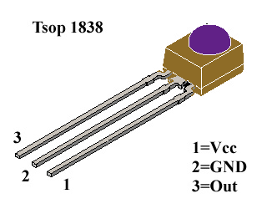

FEATURES

• Very low supply current

• Photo detector and preamplifier in one

package

• Internal filter for PCM frequency

• Improved shielding against EMI

• Supply voltage: 2.5 V to 5.5 V

• Improved immunity against ambient light

• Insensitive to supply voltage ripple and noise

• Compliant to RoHS Directive 2011/65/EU and in

accordance to WEEE 2002/96/EC

Note

\*\*

BLOCK DIAGRAM :

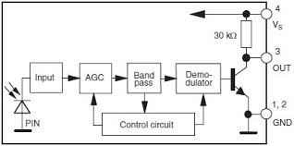

DESCRIPTION

The TSOP12.. series are miniaturized receivers for infrared

remote control systems. A PIN diode and a preamplifier are

assembled on a lead frame, the epoxy package acts as an

IR filter.

The demodulated output signal

can be directly decoded by

a microprocessor. The TSOP12.. is compatible with all

common IR remote control data formats.

This component has not be

en qualified according to

automotive specifications.

APPLICATION CIRCUIT :

