Snapshots:

-Map:

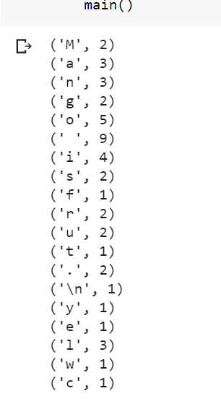

-Split:

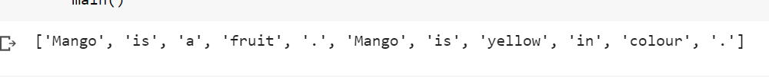

-Mapped pairs:



-Shuffled pairs:



-Reduced pairs:

