Bronze Layer:
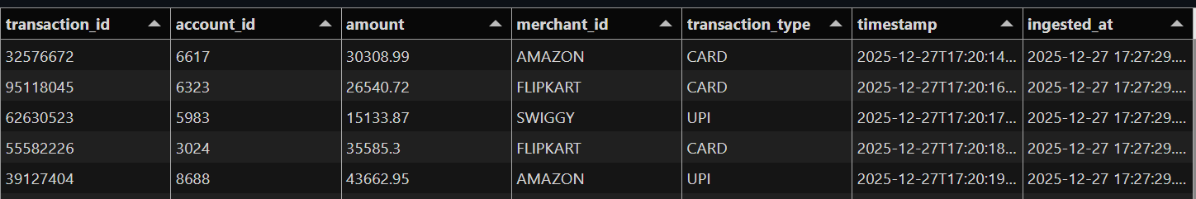

Silver Layer:

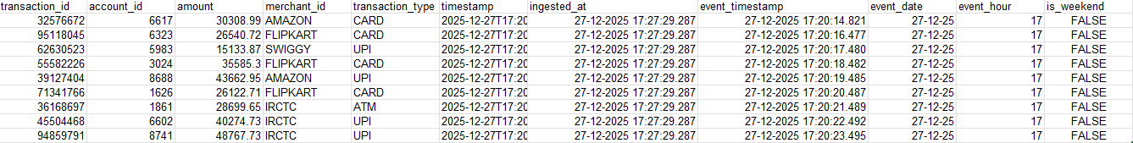

Gold Layer:
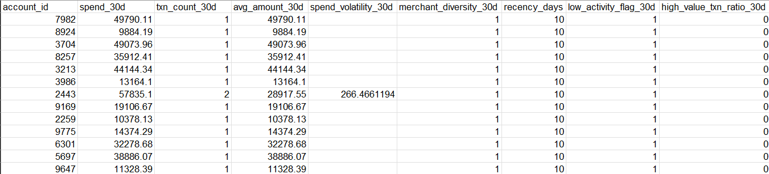

Features
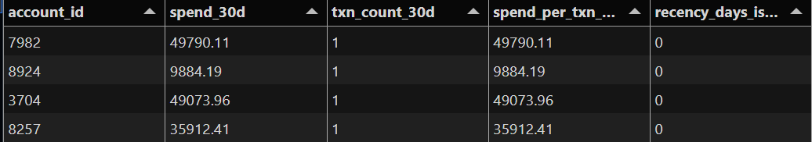
Label Generation Table:
