A/B Testing Analysis

The analysis shows that overall effect of UI change is good as we can see from the bar plot. The daily average time is average time spent on the website by a user. The plot below show’s male users and unknown’s users are loving the Quora already (as compared to females) and this new UI acted as catalyst for their time spent on Quora.

Suggestion: From the plot I can say that we have to do research that why female users are less enagaged

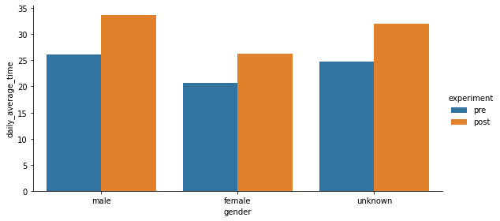

This is a plot of control group and we can see that female and unknown contributors are not loving the old UI.

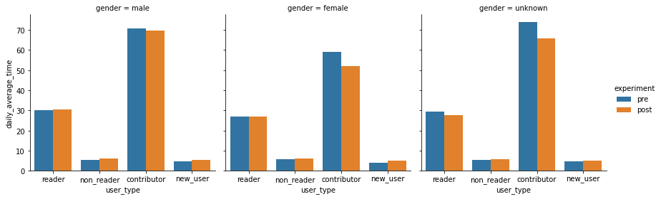

The plot below is of treatment group and here we can see that every type of user is loving the new UI. Most of users are spending more time on website.

In this case I have suggestion that we should push this to production as it is not having any bad effect on any type of users.

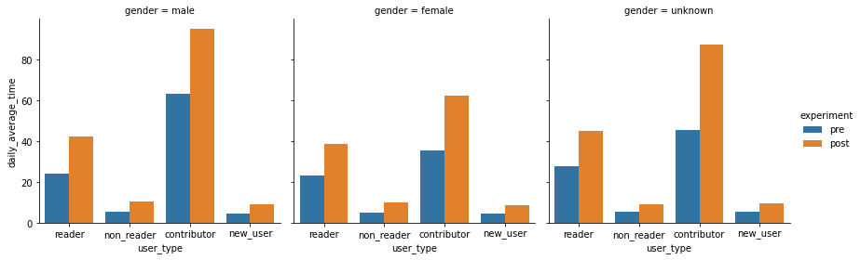

The treatment group had very less active mean time as compared to control and from t-test I found that they were not looking from same distribution. So I have suggestion that selection of control and treatment group can be more randomized so that we can have control and treatment group from same distribution at the start of experiment.