Dudam Bhanu Prakash

S00455011

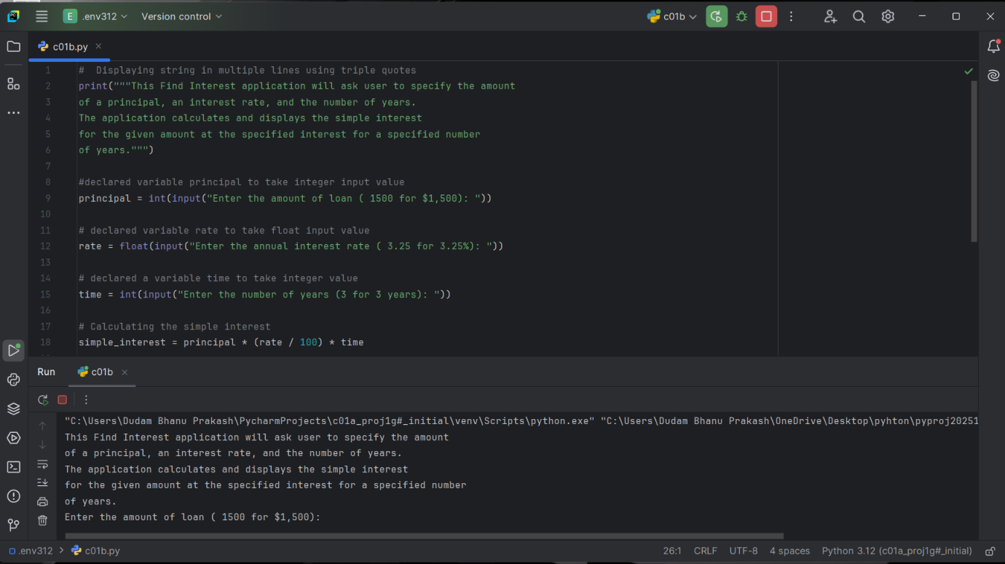

Successful execution of the code

Code:

# Displaying string in multiple lines using triple quotes  
print("""This Find Interest application will ask user to specify the amount   
of a principal, an interest rate, and the number of years.  
The application calculates and displays the simple interest   
for the given amount at the specified interest for a specified number   
of years.""")  
#declared variable principal to take integer input value  
principal = int(input("Enter the amount of loan ( 1500 for $1,500): "))  
# declared variable rate to take float input value  
rate = float(input("Enter the annual interest rate ( 3.25 for 3.25%): "))  
# declared a variable time to take integer value  
time = int(input("Enter the number of years (3 for 3 years): "))  
# Calculating the simple interest  
simple_interest = principal * (rate / 100) * time  
# Displaying the result  
print(f"\nThe simple interest on a loan of ${principal} at {rate}% yearly interest rate for {time} years is ${simple_interest:.2f}.")  
  
#Calculating the compounded monthly interest  
compounded_interest = principal * (1 + (rate / 100) / 12) ** (12 * time)  
print(f"The monthly compounded interest on a loan of ${principal} at {rate}% yearly interest rate for {time} years is ${compounded_interest:.2f}.")