Test Plan

Project Name : Homestay

Tables of Content

1. Introduction

2. Objective

3. Scope

4. Testable Feature

5. Testing Approach

6. Role/Responsibility

7. Test Schedule

8. Test Deleveriable

9. Entry and Exit criteria

10. Tools

11. Risk and Mitigation plan

12. Approvals

1. Introduction .

This test plan outlines the strategy for testing the homestay website built for Mr. Chirag's house located on the outskirts of Nainital. The website aims to facilitate seamless interaction between guests, caretakers, and the house owner by providing an intuitive platform for booking and managing homestay services. The primary focus of the test plan is to ensure the website's functionality, usability, security, and performance meet the expectations of all stakeholders.

2. Objective

The aim of this document is to give an overview of the testing approach, strategies, and scope for the HomeStay web application. This document includes details like scope of the project, objectives, test schedule and resource allocations, test deliverables and Reports. The primary objective of this test plan is to verify that the homestay website operates flawlessly under real-world conditions.

3. Scope

**In-Scope:** All features of the app except for the payment gateway.

* Guest Module
* Caretaker Module
* House Owner Module

**Out-of-Scope:** Payment gateway integration and functionality.

* Third-Party Service Issues
* Non-English Language Support

4. Testable Feature

1. Sign up
2. Login
3. Register with Social account (google, facebook.. etc)
4. Forget password
5. Profile section
6. Homestay Availability info
7. Booking Info
8. Manage Bookings
9. Update Booking Information
10. Checkout Process
11. View Bookings Overview

5. Testing Approach:

* Testing Types - Functional Testing

- Compatibility Testing

Testing Methodologies :-

* Black-box Testing
* White-box Testing
* Regression Testing
* User Acceptance Testing (UAT)

Testing Environment :-

* UAT
* Pre-Prod

Operating System

* Windows 10 and above
* Browsers: [Chrome and firefox]
* Testing Tools: [Manual Testing, jira, microsoft teams, Mind Map, salesforce]

6. Roles/Responsibilities

| **Name** | **Role** | **Responsible** |
| --- | --- | --- |
| Abhisek | Test Engineer | * Understand customer requirements * Write Test scenarios & Test cases * Executing the Test cases. * Performing root cause analysis * identify underlying issues. * Defect tracking and reporting. |

7. Test Schedule

| Task | Time Duration |
| --- | --- |
| Test plan | 18 Nov 24 |
| Test Scenario | 1 Day |
| Test cases creation | 1 Day |
| Test cases Execution | 1 Day |
| Summary report submission | 19 Nov 24 |

8. Test Deliverables

The following are to be delivered to the client:

| **Deliverables** | **Description** | **Responsible**  **Owner** | **Target**  **Completion**  **Date** |
| --- | --- | --- | --- |
| Test Plan | Outlines the testing approach, strategies, and scope for the Home Stay web application. | Masai - HomeStay | 19 Nov 2024 |
| Test Cases | Test Cases created for both functional testing and compatibility testing | Masai - HomeStay | 19 Nov 2024 |
| Defect Reports | Detailed description of the defects identified in different versions of application. | Masai - HomeStay | 19 Nov 2024 |

9. Entry and Exit Criteria

The below are the entry and exit criteria for every phase of Software Testing Life

Cycle:

**Requirement Analysis :**

**Entry Criteria:**

Once the testing team receives the Requirements documents and uses documents of the project. Includes what functions need to be tested and how the software should behave.

**Exit Criteria:**

The testing team should thoroughly explore and understand each requirement listed in the documents.Any doubts or uncertainties regarding the requirements should be addressed and clarified to ensure that the testing team has a clear understanding of what needs to be tested and how it should behave.

**Test Planning**

**Entry Criteria:**

Testable Requirements derived from the given Requirements documents.Test Plan

document includes the Test Strategy, which provides a high-level overview of

how testing will be conducted.

**Exit Criteria:**

Test Plan is signed-off by the Client (HomeStay)

**Test Designing**

**Entry Criteria:**

The Test Plan document needs to be reviewed and approved by the client and then

Test Plan Document is signed-off by the Client

**Exit Criteria:**

Test Scenarios and Test Cases Documents are prepared, they need to be reviewed

and signed-off by the Client.

**Test Execution**

**Entry Criteria:**

Test Scenarios and Test Cases document needs to be reviewed and approved by the

client and documents are signed-off by the Client.Application is ready for further

Testing.

**Exit Criteria:**

Test Case Reports, Defect Reports are ready

**Test Closure**

**Entry Criteria:**

Test Case Reports, Defect Reports are ready

**Exit Criteria:**

Test Summary Reports, it overviews of the entire testing process

10. Tools

The following are the list of Tools we will be using in this Project:

* X mind map Tool
* Jira - Project management tool
* HomeStay - Test Management
* Microsoft Teams - Collaboration
* Manual Testing - Web App Testing

11. Risks and Mitigation plans:

The following are the list of risks possible and the ways to mitigate them:

| Risk | Mitigation plans |
| --- | --- |
| Fault of QA Testers | Backup Resource Planning |
| No detailed Requirements available | Subject matter experts available for deep understanding of functionalities |
| Test data is incomplete, invalid, or unavailable. | Identify and prepare test data requirements during the test planning phase. |

12. Approvals

HomeStay will send different types of documents for Client Approval like below:

Approval from Project Manager

Approval from Product Owner

Approval from QA Lead

Testing will only continue to the next steps once these approvals are done

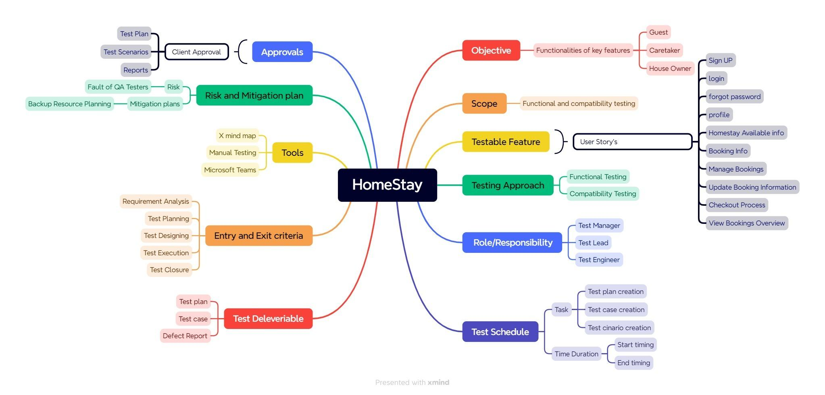

-+-+-+-+-+-+ **End** +-+-+-+-+-+-