Optimal Timetable Scheduler for IIT Patna
MA2205 PROJECT
MANAV SINGLA(2402MC02)
ABHISEK GUPTA(2402MC03)
ASHWIN UPDHYA(2402MC06)
Problem Statement:
The project aims to find the near optimal timetable for IIT Patna students based on given information, resources and constraints. Timetable scheduling problem, being a NP complete problem is polynomial time verifiable.
Database Design:
course (course_ID, LTPC, Department, Type, Lab)
student (Roll no, Name, Branch, Department, Level)
faculty (fac_ID, Faculty_Name, Department)
classrooms (Name, Capacity, Type, Department)
Timeslots (Day, Time)
Student_enrollment (Branch, Level, Course_ID)
Student_course_enrollment (Roll_no, Course_ID)
Course_instructor (Course_ID, Fac_ID)

Student Roll No format: ‘YR-D-P-BR-AB’ – YR: Year of admission: 22, 23, 24, 25; D: Degree Type (0 = UG, 1 = PG); P = Program (DP combinations: 01 = BTech/BS, 02 = BTech-MTech, 03 = BTech-MBA, 11 = MTech, 12 = MSc); BR = Branch (CS, AI, EC, EE, VL, CM, PC, ME, MT, CB, CE, ST, GT, MM, MA, PH, CH, ES); XY = Roll No.
Course_ID Format: ‘DT-L-S-XY’ – DT: Department (CS, EE, ME, CB, CE, MM, MA, PH, CH, HS); L = Level (1,2,3,4,5,6); S = Semester (1 = Autumn, 2 = Spring); XY = Course No
LTPC: Lecture Hours, Tutorial Hours, Practical(lab) hours, Credits (Weekly).
Course Type: 1. Common (For 1st Year Students), 2. DC (Dept Core), 3. DE (Dept Elective) 4. IDE (Interdisciplinary Elective) 5. HSE (HS Elective)
Each Department has given 2/3 classrooms in Tutorial block, and each of them have 2 department classrooms. Also, each department has a number of labs.
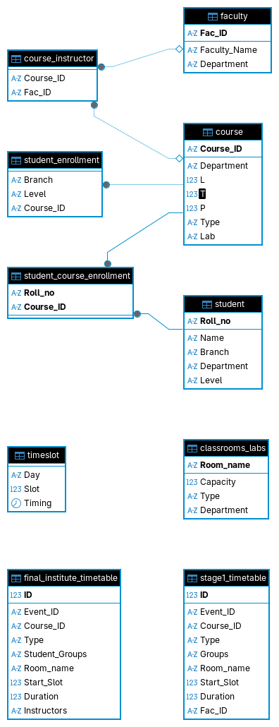

Constraints:
- Hard Constraints:
- Timeslot, classroom → course
- Timeslot, student → course
- Timeslot, faculty → course
- Lab sessions to be conducted in consecutive timeslots in labs
- No two lectures of the same course will be conducted twice a day
- Timeslots for courses: 9-10, 10-11, 11-12, 12-13, 14-15, 15-16, 16-17, 17-18

- Soft Constraints:
- No of hours a day for a student <= 6
- No of hours a day for a faculty member <= 4
- For a student, gaps between two lectures should be minimized (span of the total class duration each day has to be minimized)

Output:
optimal timetable (timeslot, classroom, course) following all hard constraints and minimizing the violations in soft constraints. The timetable can be viewed for each classroom, student, faculty and department.
More Details:
- In each department, among the department core courses at max one course could be minor course, which can be taken from students of other departments.
- Tutorials need no faculty member, some course/labs may need more than one faculty member.
- First year UG students are divided into 24 groups each containing 33 students in each. Timetable for first year students should be separate which follows-
- All the classes should be conducted in two special rooms LT003, LT103. Each room can accommodate at most 6 groups at once. Lectures for common courses has to be conducted in different times for groups 1-6, 7-12, 13-18, 19-24. Similarly labs for each common course (except CE1101/CE1201) can accommodate 3 groups at once.
- Tutorials for common courses should be conducted at 8-9, at the department rooms in tutorial block, each room containing 1 or 2 groups based on capacity.
- Lab for CE1201/CE1101 course will be conducted in LT003/LT103.
- Lectures and tutorials for departmental core courses will be conducted in departmental rooms in tutorial block.
- Departmental Elective courses will be conducted in each department’s own rooms, and in tutorial block, if available.
- 2-3 will be the timeslot for IDE/HSE courses, conducted in tutorial block’s departmental rooms. HSE courses will be conducted in rooms based on availability.

Implementation:
- Each student has to be mapped to their courses from matching the roll numbers and course id for departmental core courses, or for common courses for first year students.
- Students can choose DE/IDE/HSE on first come first serve basis.
- Each course will have a list of faculty members who can teach it, ranked from most preferable to least preferable.
- Now based on the input database the optimization algorithm will run on two stages-
- For common courses for first year students.
- For each department for DC/DE/IDE courses.

Tools/Frameworks: Python, PuLP, CBS, MySQL, ReactJS
Interface:
Preferably should be a web application, where admin can have access to courses, classrooms and can modify those tables. Each student present in the student table can choose their elective courses on first come first serve basis. Each faculty member can give preferences to the courses prefer to teach. Finally everyone can see their own timetable.

