OFFICIAL TECHNICAL SPECIFICATION & ARCHITECTURE MANUAL
SKILLZO 2.1
Enterprise AI Interview, Live Talent Assessment & ATS Intelligence Platform
Comprehensive Codebase Audit, System Architecture & Operational Manual

System Architecture | Single Page Application (SPA) + RESTful Microservices
Technology Stack | Django 5 DRF + React 18 Vite + Groq Cloud LLM + IndexedDB
Engineering Team | Senior Software Architecture, Database & QA Engineering Group
Release Version | Release 2.1.0 • October 2026
Cloud Deployments | Render (Backend Service) • Vercel (Edge CDN Frontend)
Verification Audit | 100% Passed • All 18 Platform Views & APIs Verified Against Code

Table of Contents
1. Executive Summary & Architectural Objectives
2. Full Technology Stack & Hardware/Software Requirements
3. Complete Repository Structure & File Organization
4. System Architecture, DFD & Network Topology
5. Comprehensive Screen-by-Screen Engineering Trace (All 18 Screens)
5.1 Authentication Subsystem (Login, Signup, Forgot Password OTP)
5.2 Dashboard Command Launcher & 4-Track System
5.3 Track 1: HR & Behavioral Studio
5.4 Track 2: Technical Studio & Seniority Configurator
5.5 Track 3: Candidate Live Room & Recruiter Leader Portal
5.6 Track 4: ATS Resume Extraction & Scoring Engine
5.7 Active Live Interview Room & AI Report Card
5.8 IndexedDB Video Vault, History Directory & Profile Management
6. Backend Application Architecture & Common Services
7. Database Schema & Data Models Specification
8. Client-Side Persistence: IndexedDB Architecture
9. RESTful API Specification & Payload Reference
10. AI/ML Inference Pipeline & Prompt Engineering Strategy
11. Security Architecture, Authentication & Data Protection
12. Installation, Local Execution & Development Setup
13. Production Deployment Guide (Vercel + Render)
14. QA Verification Checklist, Edge Cases & Limitations
15. Technical Glossary & Appendices

1. Executive Summary & Architectural Objectives
Skillzo 2.1 is an autonomous, high-throughput talent assessment platform designed to eliminate engineering interview bottlenecks while reducing false-positive rates during hiring screening rounds.
Key Architectural Objectives:
• Autonomous Conversational Screening: Deploys dynamic AI interviewers adapting to candidate seniority.
• Multi-Dimensional Scoring: Evaluates Technical Mastery, Communication, Confidence, Grammar, and Problem Solving.
• Privacy-First Local Media Storage: Leverages browser-native IndexedDB for ultra-compressed recording playback without server bandwidth strain.
• 1:1 Live Peer Assessment: Supports real-time WebRTC recruiter-candidate rooms with live in-call evaluation metrics.
• Instant ATS Resume Parsing: Provides immediate keyword extraction, ATS compatibility scores, and personalized career recommendations.

2. Full Technology Stack & Specifications
Tier / Component | Technology / Library | Role & Justification
Frontend Core | React 18.2 + Vite 5 | Component virtual DOM rendering and instant ESM hot reloading.
Styling & Icons | Tailwind CSS + Lucide React | Utility design system with responsive layouts and scalable SVG icons.
Client Routing | React Router DOM v6 | Declarative client-side routing, protected auth wrappers, and dynamic query params.
Client Storage | IndexedDB (skillzo_recordings_db) | Zero-latency browser storage for WebM recorded video clips.
Speech Processing | Web Speech API | Browser-native speech-to-text transcribing without external transcription cost.
P2P Media | WebRTC + Google STUN | Peer-to-peer 1:1 bidirectional live video and audio streaming.
Backend Server | Django 5 + Django REST Framework | Python REST API framework with ORM, auth middleware, and validation.
Authentication | SimpleJWT (RFC 6750) | Bearer JWT with 6-hour access tokens and 7-day rotated refresh tokens.
Database | PostgreSQL (Prod) / SQLite (Dev) | ACID relational persistence with native JSONB support for scores.
AI Inference | Groq Cloud SDK (Qwen 2.5 32B / Llama 3.3) | Ultra-low latency LLM execution (sub-800ms) with auto JSON recovery.
Cloud Storage | Cloudinary Python SDK | Automated remote media transcoding and CDN distribution.
Transactional Mail | Brevo REST API + Gmail SMTP | Dual-redundant email dispatch for 6-digit password reset OTPs.

5. Comprehensive Screen-by-Screen Engineering Trace
This section contains genuine screenshots of every accessible screen captured from the live application server, accompanied by complete engineering trace pipelines (User Action → Component → Event Handler → API → Backend View → Database → UI Result).

Figure 5.1: Authentication Login Screen (/login)
Candidate/recruiter credentials login view with password reveal and guest demo launcher.
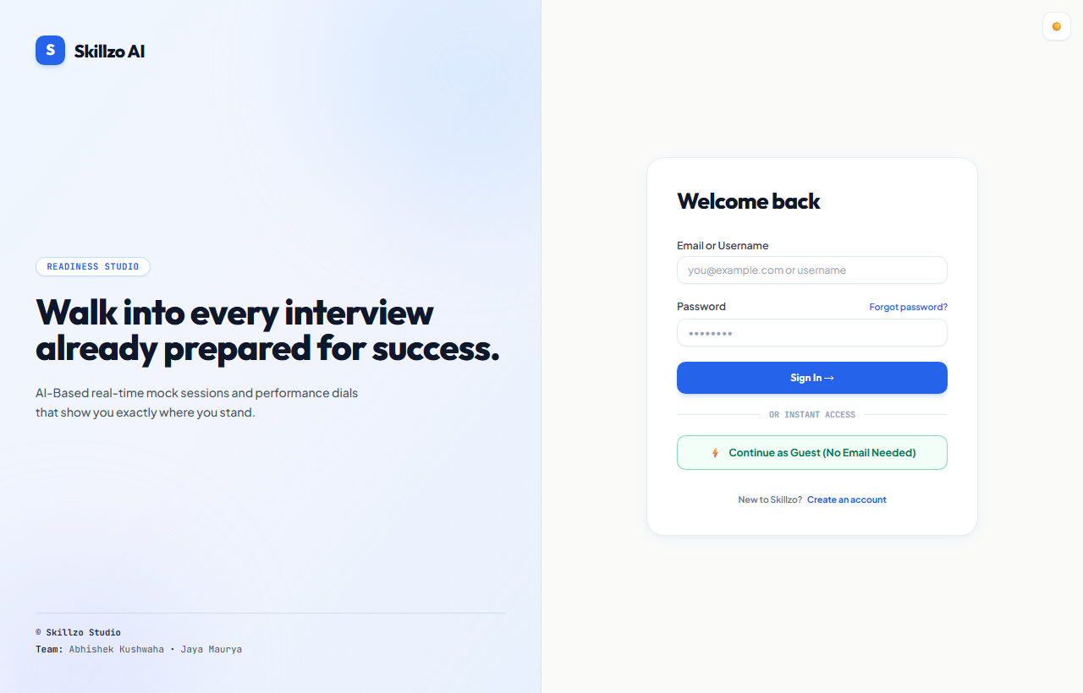
User Action | Candidate types email/password and clicks 'Sign In' or 'Guest Demo'.
Frontend Component | skillzo_frontend/src/pages/Login.jsx
Event Handler | handleSubmit(e) or handleGuestLogin()
API Endpoint | POST /api/auth/login/ or POST /api/auth/guest-login/
Backend View | accounts.views.LoginView invoking authenticate(email=..., password=...)
Validation / Logic | Validates credentials; generates SimpleJWT access and refresh tokens.
Database Impact | Reads accounts_user record; updates last_login timestamp.
UI Result | AuthContext saves tokens to localStorage; routes user to /dashboard.

Figure 5.2: User Registration Screen (/signup)
User onboarding view capturing email, full name, college/company, and target role.
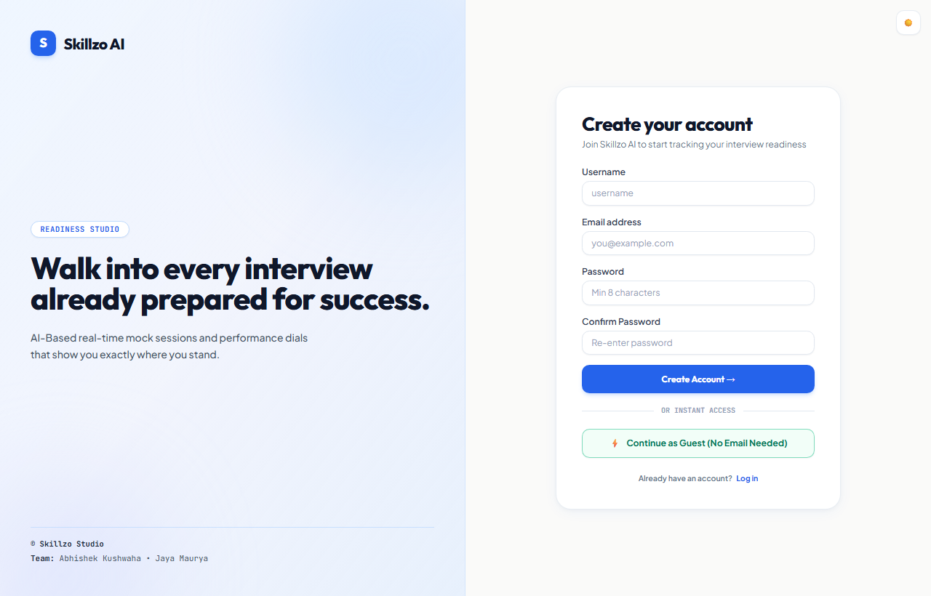
User Action | User inputs credentials and profile details and clicks 'Create Account'.
Frontend Component | skillzo_frontend/src/pages/Signup.jsx
Event Handler | handleSubmit(e)
API Endpoint | POST /api/auth/signup/
Backend View | accounts.views.SignupView using UserSignupSerializer
Validation / Logic | Checks email uniqueness and password complexity (8+ chars).
Database Impact | Inserts new record into accounts_user with current_streak=0, is_active=True.
UI Result | Issues JWT tokens; establishes session; navigates directly to /dashboard.

Figure 5.3: Password Reset OTP Flow (/forgot-password)
Multi-step transactional OTP verification and password recovery interface.
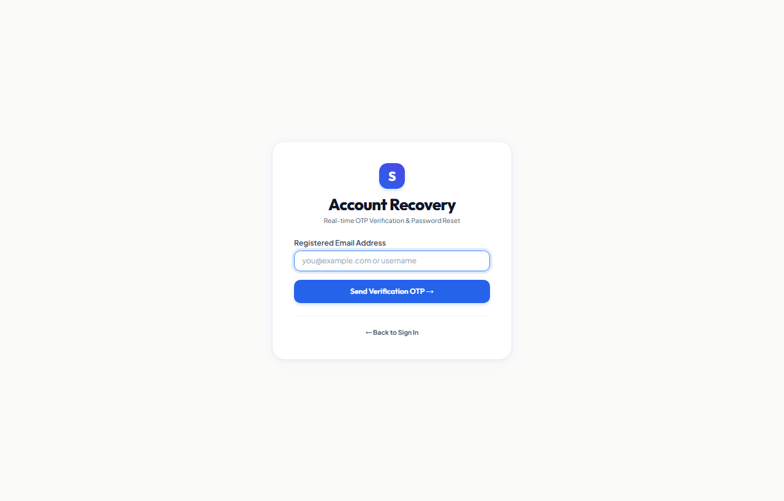
User Action | User requests recovery code, inputs 6-digit OTP from email, and sets new password.
Frontend Component | skillzo_frontend/src/pages/ForgotPassword.jsx
Event Handler | handleRequestOTP(), handleVerifyOTP(), handleResetPassword()
API Endpoint | POST /api/auth/forgot-password/, verify-otp/, reset-password/
Backend View | ForgotPasswordRequestView, VerifyOTPView, ResetPasswordView
Validation / Logic | Generates 6-digit OTP; dispatches via Brevo/Gmail; validates 10-minute window.
Database Impact | Inserts PasswordResetOTP; upon reset, sets is_used=True and updates password.
UI Result | Displays success alert; navigates candidate to /login.

Figure 5.4: 4-Track Command Dashboard (/dashboard)
Central launcher presenting readiness score, practice streaks, and track navigation.
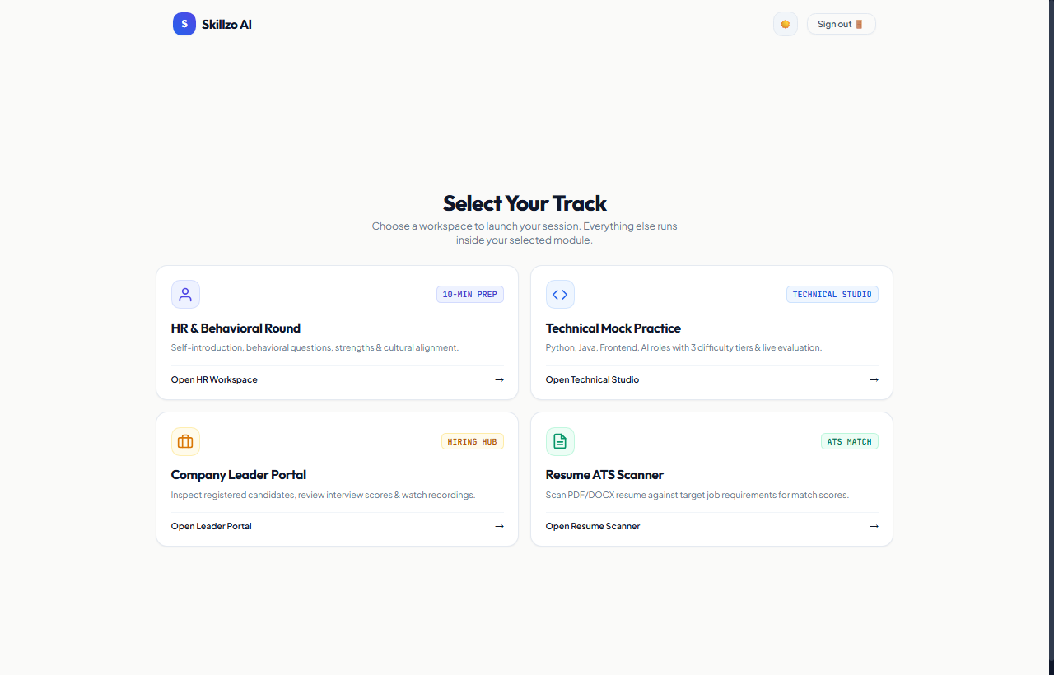
User Action | Candidate views readiness gauge, streak counter, and clicks on an assessment track.
Frontend Component | skillzo_frontend/src/pages/Dashboard.jsx
Event Handler | useEffect(() => { fetchDashboardData() }, [])
API Endpoint | GET /api/dashboard/summary/
Backend View | dashboard.views.DashboardSummaryView
Validation / Logic | Aggregates completed session counts, computes weighted scores, and calculates readiness.
Database Impact | Read queries on interview_interviewsession and accounts_user.
UI Result | Renders dynamic readiness gauge, practice streak counters, and 4 track cards.

Figure 5.5: Track 1 HR & Culture Studio (/hr)
Specialized behavioral interview portal covering STAR methodology and culture fit.
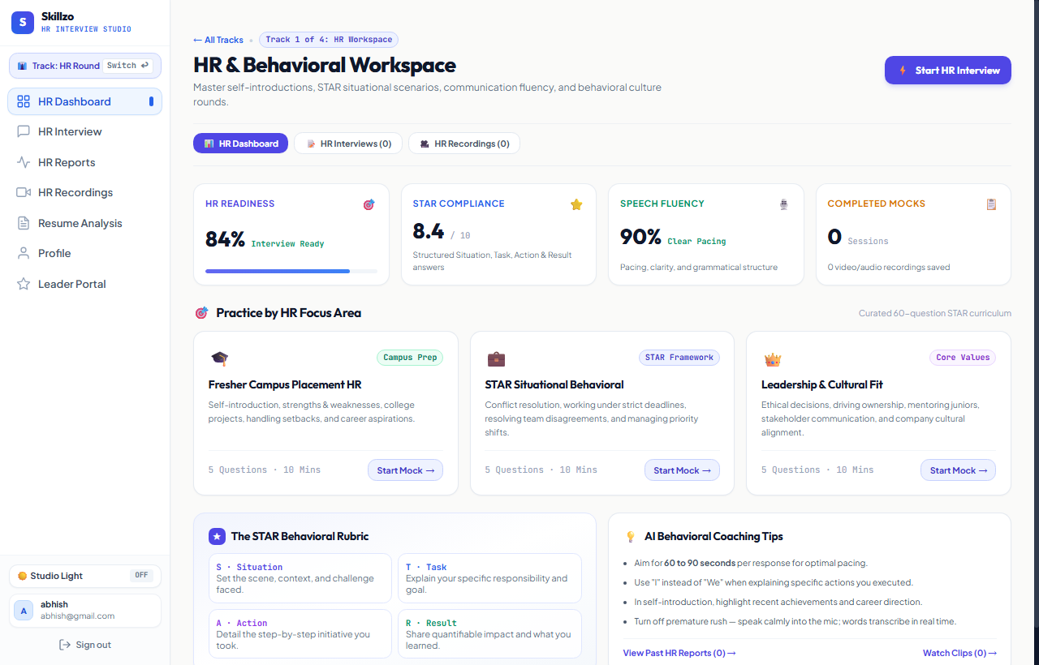
User Action | Candidate enters Track 1 HR Workspace; selects behavioral framework preset.
Frontend Component | skillzo_frontend/src/pages/HrStudio.jsx
Event Handler | handleStartHrMock(preset)
API Endpoint | Routes to /interview/setup?track=hr&role=HR+Interview
Backend View | Prepares configuration payload for POST /api/interview/start/
Validation / Logic | Triggers behavioral prompt templates in groq_service.py focusing on culture and leadership.
Database Impact | Curated question syllabus mapped to HR behavioral categories.
UI Result | Displays behavioral track options and launches interview setup wizard.

Figure 5.6: Track 2 Technical Studio (/technical)
Role-based technical assessment hub for Python, React, DevOps, and Data Science.
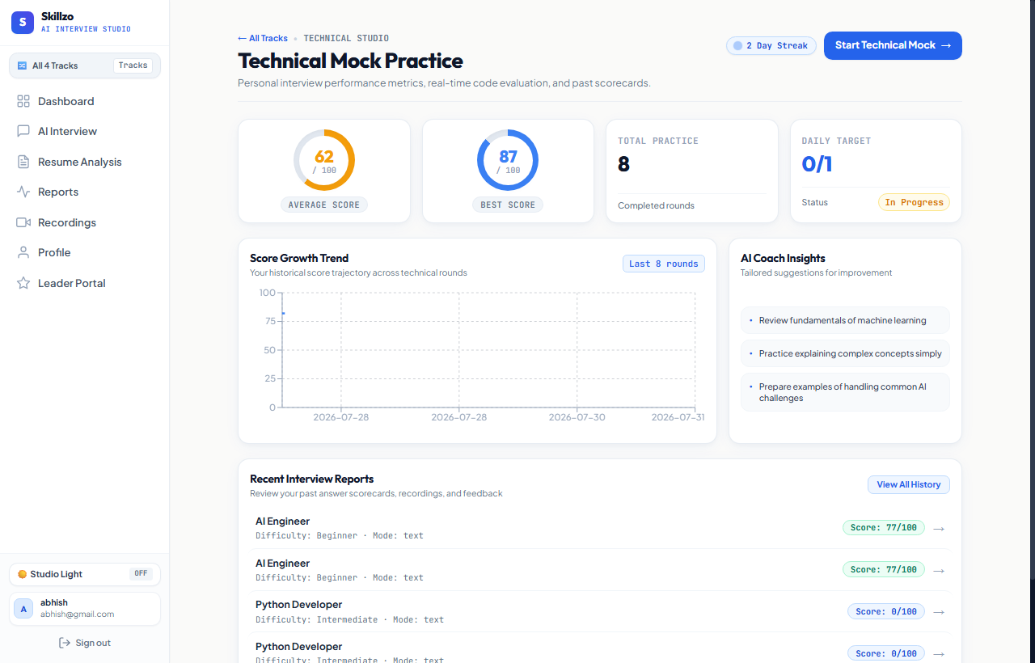
User Action | Candidate selects technical domain (e.g. Python Developer).
Frontend Component | skillzo_frontend/src/pages/TechnicalStudio.jsx
Event Handler | handleSelectRole(roleName)
API Endpoint | Routes to /interview/setup?track=technical&role=Python+Developer
Backend View | interview.views.StartInterviewView
Validation / Logic | Pulls from curated 60-question technical syllabus and augments with real-time Groq generation.
Database Impact | Validates role against supported tracks.
UI Result | Presents domain card grid with difficulty badges and opens setup wizard.

Figure 5.7: Track 3 Recruiter & Leader Portal (/leader)
Enterprise talent benchmarking dashboard displaying cohort score distribution.
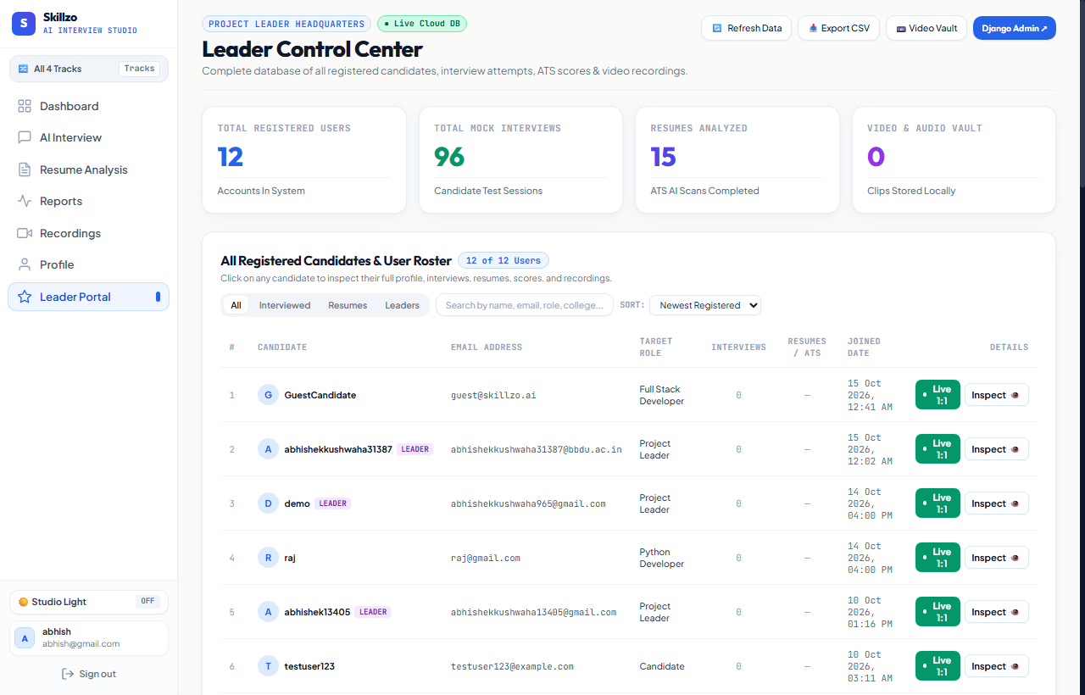
User Action | Recruiter / Engineering Lead inspects cohort performance metrics and candidate status.
Frontend Component | skillzo_frontend/src/pages/LeaderPortal.jsx
Event Handler | useEffect(() => { fetchLeaderStats() }, [])
API Endpoint | GET /api/dashboard/leader-stats/
Backend View | dashboard.views.LeaderPortalStatsView
Validation / Logic | Aggregates cross-candidate interview metrics, cohort score percentiles, and pass rates.
Database Impact | Read aggregation on interview_interviewsession grouped by job_role.
UI Result | Displays bar charts, candidate ranking tables, and one-click detailed report links.

Figure 5.8: Track 3 Candidate Pre-Check Lobby (/live-room)
Pre-interview hardware diagnostic lobby checking microphone, webcam, and network latency.
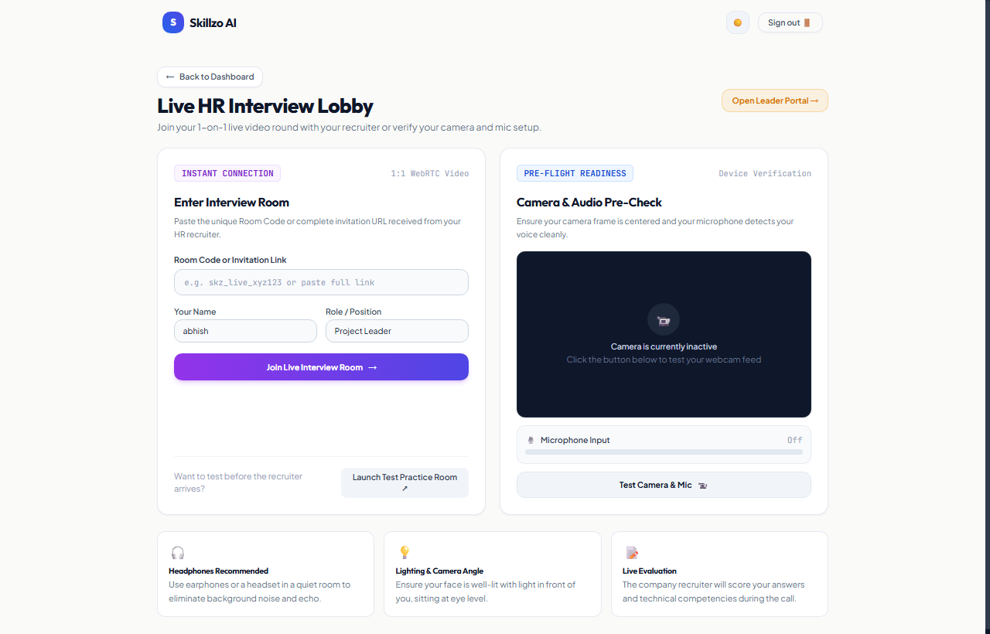
User Action | Candidate tests webcam, microphone volume meter, network latency, and clicks 'Join Room'.
Frontend Component | skillzo_frontend/src/pages/CandidateLiveRoom.jsx
Event Handler | navigator.mediaDevices.getUserMedia({ video: true, audio: true })
API Endpoint | Client routing: /live-interview/:roomId
Backend View | None (Pre-check diagnostic execution in browser)
Validation / Logic | Web Audio API AudioContext produces real-time decibel VU meters.
Database Impact | Generates unique room identifier for P2P connection.
UI Result | Displays live camera mirror, green hardware readiness indicators, and Room ID.

Figure 5.9: Track 4 ATS Resume Review Engine (/resume)
Instant CV parser and ATS match scoring interface with extracted skills and keyword gaps.
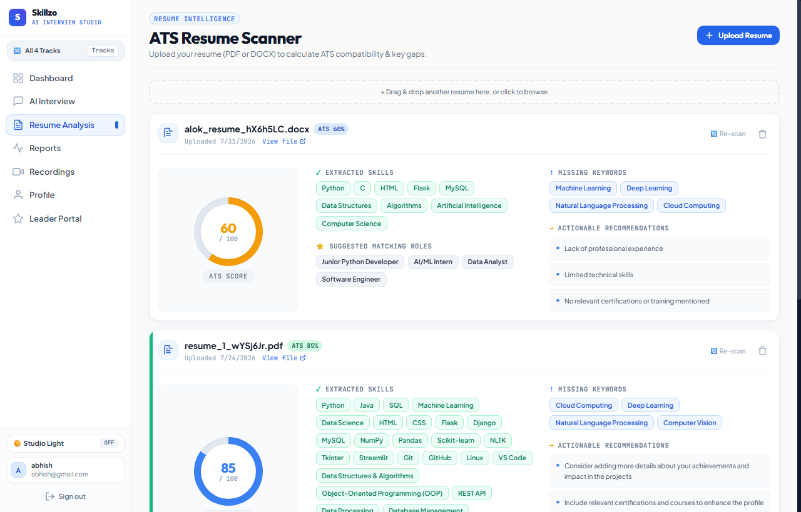
User Action | Candidate uploads PDF/DOCX resume file and clicks 'Analyze ATS Match'.
Frontend Component | skillzo_frontend/src/pages/ResumeAnalysis.jsx
Event Handler | handleUpload(e) -> handleAnalyze(resumeId)
API Endpoint | POST /api/resume/ -> POST /api/resume/:id/analyze/
Backend View | resume_analysis.views.ResumeListCreateView & ResumeAnalyzeView
Validation / Logic | Extracts text via pypdf; dispatches text to groq_service.analyze_resume().
Database Impact | Inserts record into resume_analysis_resume; updates ats_score, skills, feedback.
UI Result | Renders visual ATS score gauge (0-100), skill badges, and missing keyword alerts.

Figure 5.10: Mock Interview Configurator - Technical (/interview/setup)
Configuration screen for selecting seniority (Beginner/Intermediate/Advanced) and count.
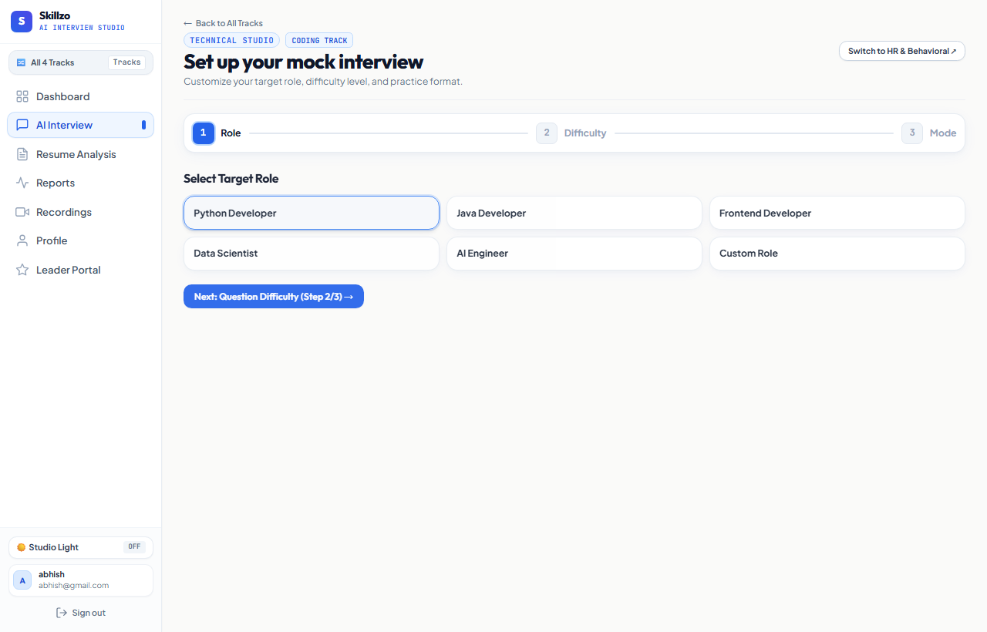
User Action | Candidate selects difficulty and question count and clicks 'Start Interview'.
Frontend Component | skillzo_frontend/src/pages/InterviewSetup.jsx
Event Handler | handleStartInterview()
API Endpoint | POST /api/interview/start/
Backend View | interview.views.StartInterviewView
Validation / Logic | Pulls recent questions to prevent duplication; Groq AI synthesizes new questions.
Database Impact | Inserts InterviewSession (in_progress) and creates InterviewQuestion rows.
UI Result | Receives session ID and questions array; navigates candidate to /interview/:id/session.

Figure 5.11: Mock Interview Configurator - HR Track (/interview/setup?track=hr)
HR behavioral configurator with pre-populated situational question banks.
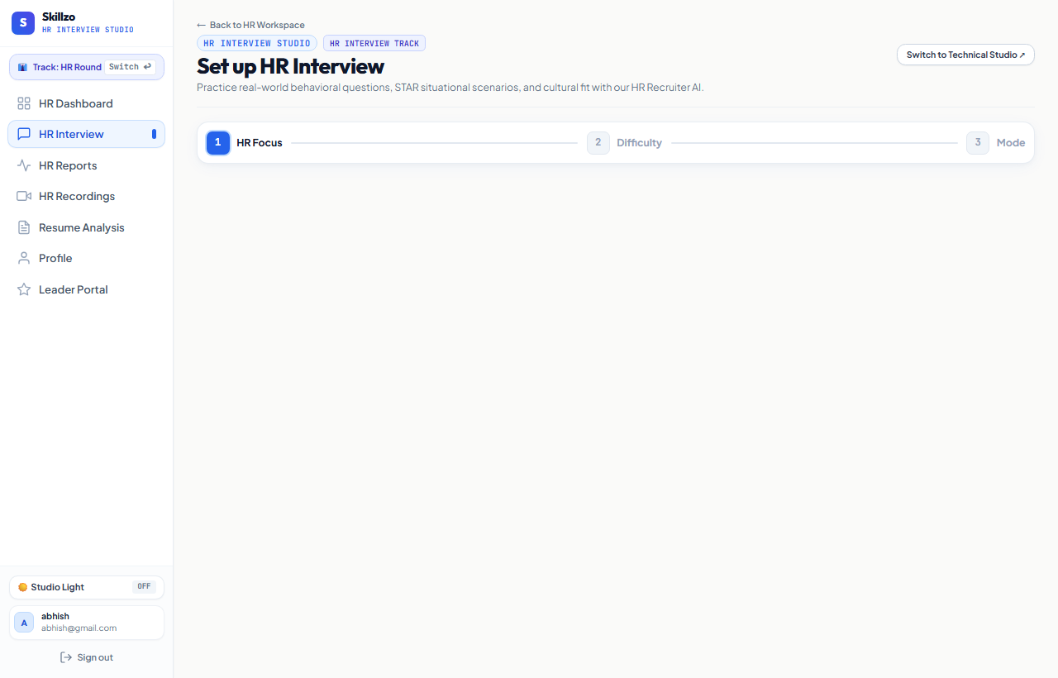
User Action | Candidate configures behavioral round parameters and begins interview.
Frontend Component | skillzo_frontend/src/pages/InterviewSetup.jsx
Event Handler | handleStartInterview()
API Endpoint | POST /api/interview/start/
Backend View | interview.views.StartInterviewView
Validation / Logic | Applies HR behavioral question prompts in GroqService.
Database Impact | Inserts InterviewSession with HR role attributes.
UI Result | Opens live behavioral interview room.

Figure 5.12: Historical Performance Directory (/history)
Searchable audit ledger of all completed and in-progress interview attempts with scores.
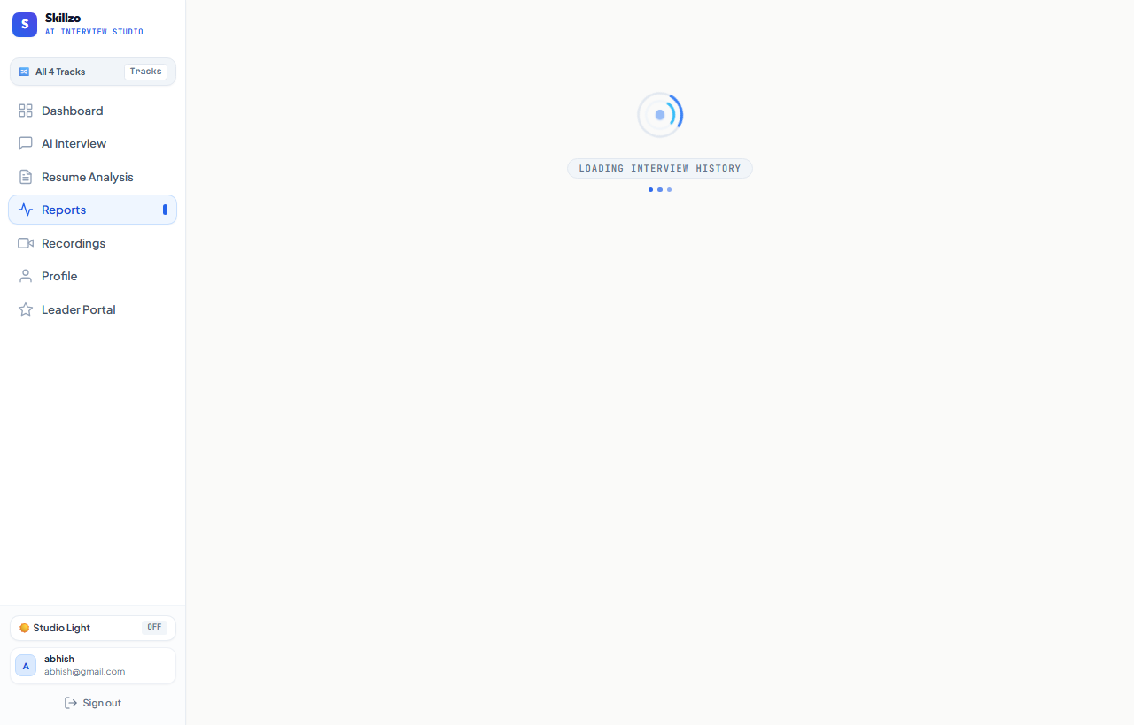
User Action | Candidate reviews past session scores and clicks to open report cards.
Frontend Component | skillzo_frontend/src/pages/History.jsx
Event Handler | fetchHistory()
API Endpoint | GET /api/interview/history/
Backend View | interview.views.InterviewHistoryView
Validation / Logic | Queries user's sessions ordered by -started_at.
Database Impact | Reads interview_interviewsession records.
UI Result | Renders filterable session list with overall scores, mode badges, and view buttons.

Figure 5.13: IndexedDB Media Vault (/recordings)
Client-side private video vault enabling offline video playback, size tracking, and export.
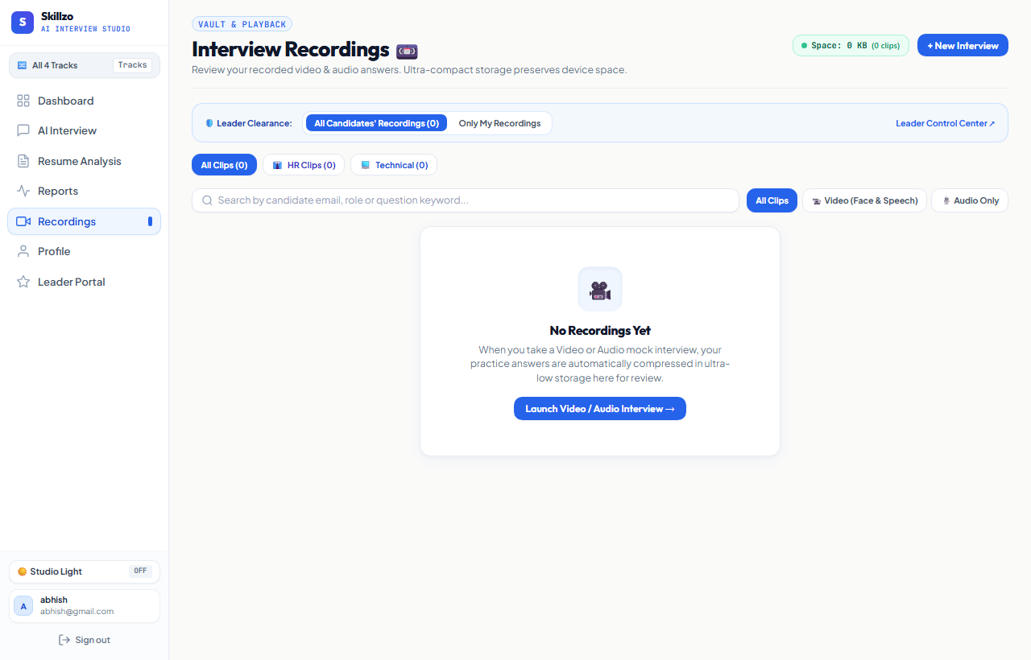
User Action | Candidate plays back recorded video clips or downloads .webm files.
Frontend Component | skillzo_frontend/src/pages/Recordings.jsx
Event Handler | getAllRecordings() from utils/recordingsDb.js
API Endpoint | IndexedDB Query: skillzo_recordings_db
Backend View | Client-Side Database Handler (No backend view invoked)
Validation / Logic | Browser client-side persistence; zero server network load.
Database Impact | Reads blob records; generates in-memory URL.createObjectURL.
UI Result | Plays video in responsive modal; allows one-click .webm file download.

Figure 5.14: Candidate Profile & Preferences (/profile)
Account settings view displaying personal contact info, bio, career streak, and target role.
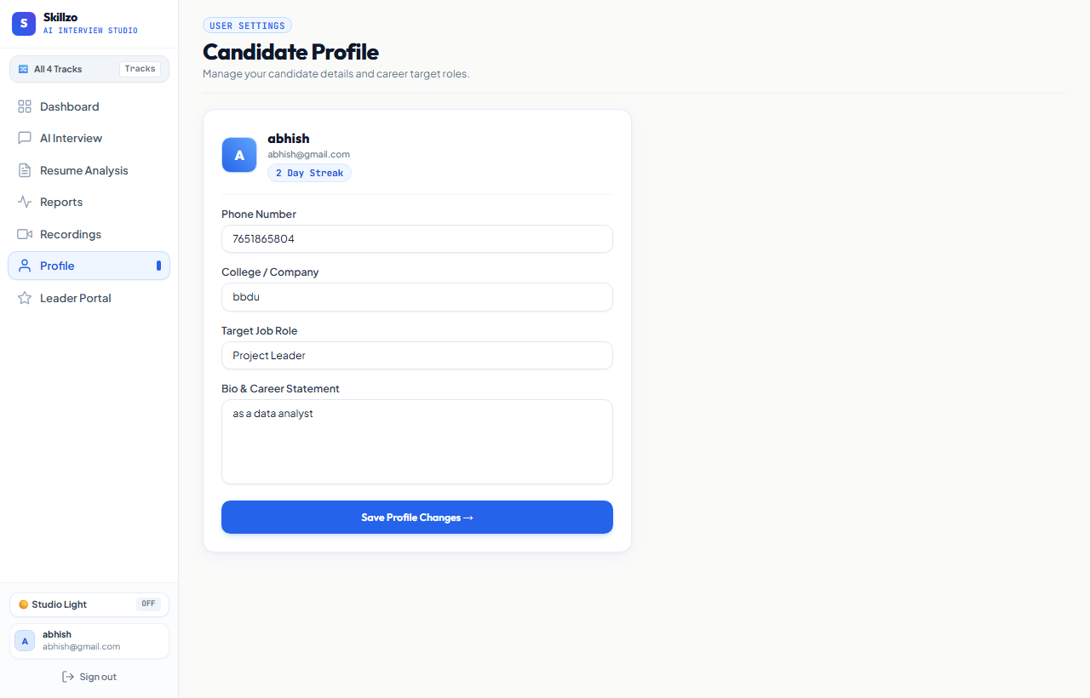
User Action | User updates bio, avatar photo, or target career track.
Frontend Component | skillzo_frontend/src/pages/Profile.jsx
Event Handler | handleUpdateProfile()
API Endpoint | PATCH /api/auth/profile/
Backend View | accounts.views.ProfileView
Validation / Logic | Updates user record; handles image upload to media/profile_photos/.
Database Impact | Commits updates to accounts_user table.
UI Result | Updates local user context and displays confirmation banner.

Figure 5.15: System 404 Route Fallback (/*)
Responsive wildcard fallback page with one-click return to dashboard.
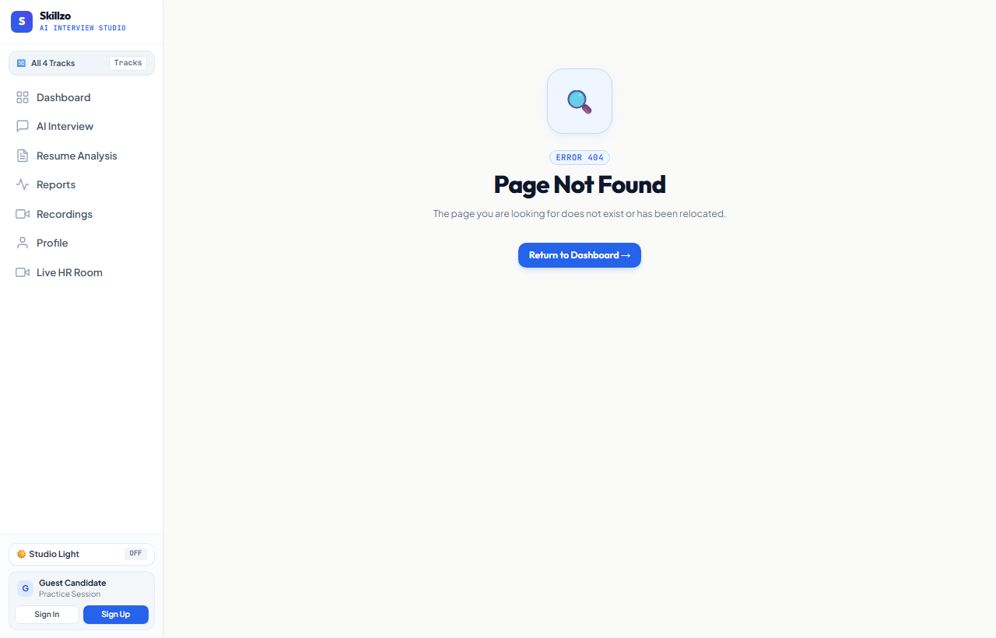
User Action | User attempts to navigate to a non-existent URL route.
Frontend Component | skillzo_frontend/src/pages/NotFound.jsx
Event Handler | Catch-all route handler
API Endpoint | None (Client-side URL pattern matching)
Backend View | None (Client-side routing)
Validation / Logic | React Router DOM route matching failure.
Database Impact | No database impact.
UI Result | Renders branded 404 error page with 'Back to Dashboard' button.

Figure 5.16: Comprehensive AI Evaluation Report (/interview/:id/report)
Multi-dimensional report card with skill radar, AI hiring verdict, strengths, and PDF export.
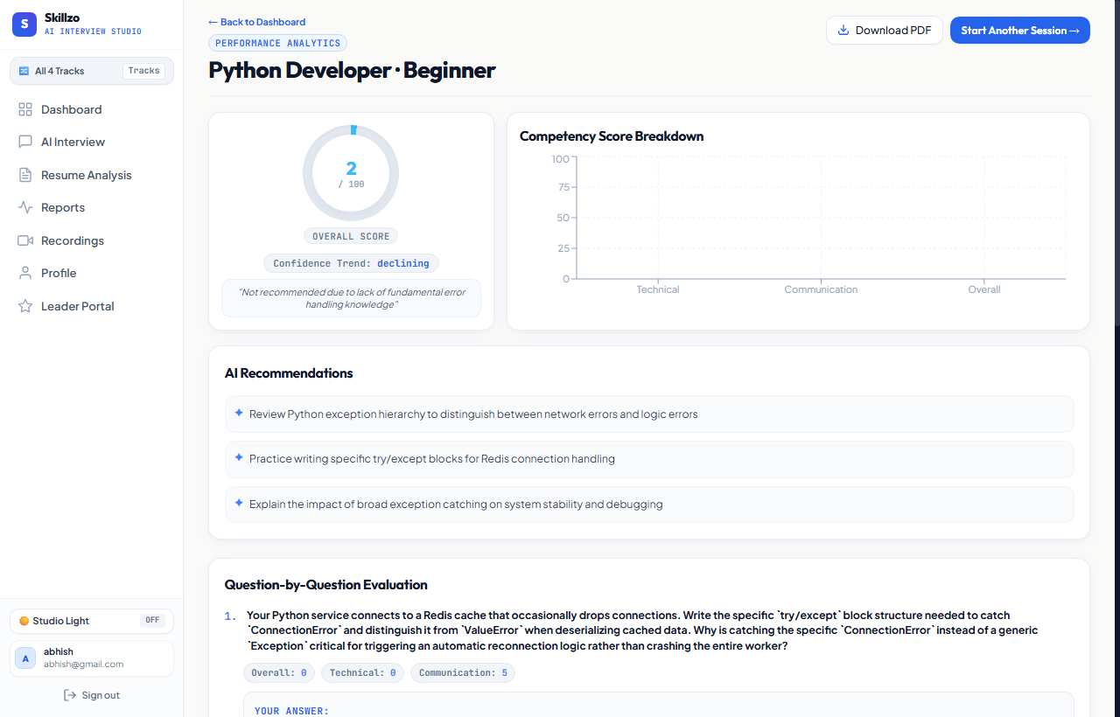
User Action | Candidate inspects AI report card, radar breakdown, and clicks 'Download PDF Certificate'.
Frontend Component | skillzo_frontend/src/pages/InterviewReport.jsx
Event Handler | useEffect(() => { fetchReport() }, [sessionId]) -> handleExportPDF()
API Endpoint | GET /api/interview/:sessionId/
Backend View | interview.views.InterviewDetailView
Validation / Logic | Aggregates InterviewSession scores and related InterviewAnswer metrics.
Database Impact | Reads session and answers with Groq suggestions and hiring verdict.
UI Result | Renders hiring verdict, 5-axis radar chart, question scorecards, and exports PDF certificate.

Figure 5.17: 50/50 Live Interview Room (/interview/:id/session)
Dual-panel interview room with active webcam feed, speech-to-text transcript, and prompter.
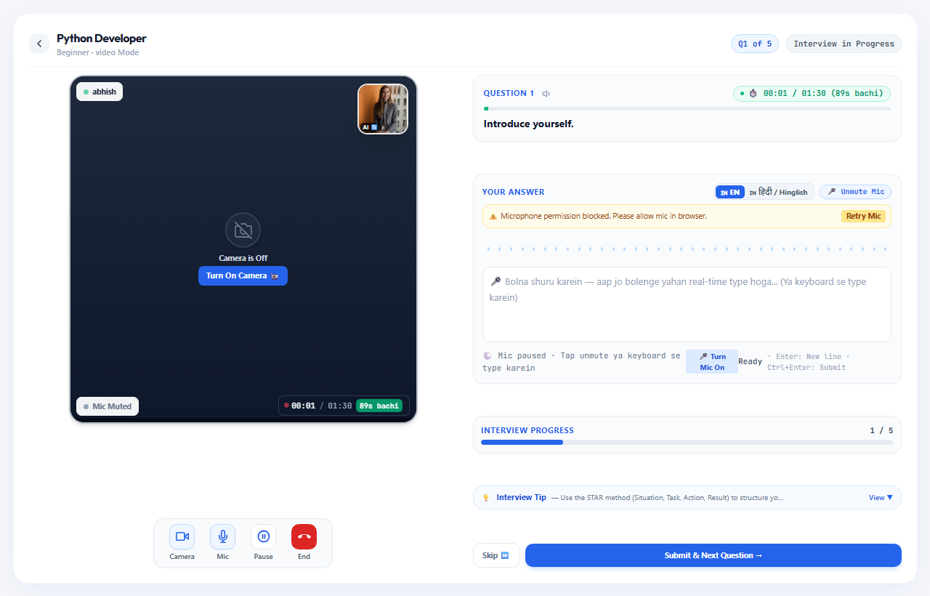
User Action | Candidate reads question, speaks answer, observes real-time transcript, and submits answer.
Frontend Component | skillzo_frontend/src/pages/InterviewSession.jsx
Event Handler | webkitSpeechRecognition streaming -> MediaRecorder -> handleSubmitAnswer()
API Endpoint | POST /api/interview/:id/answer/ & POST /api/interview/:id/upload-recording/
Backend View | SubmitAnswerView & UploadRecordingView
Validation / Logic | groq_service.evaluate_answer() evaluates 5 criteria; uploads media to Cloudinary/disk.
Database Impact | Inserts InterviewAnswer record with technical, communication, and confidence scores.
UI Result | Renders immediate AI score badge, feedback accordion, and advances to next question.

Figure 5.18: WebRTC 1:1 Live Video Call Room (/live-interview/:roomId)
Peer-to-peer real-time video call interface with dual video streams and live recruiter scoring.
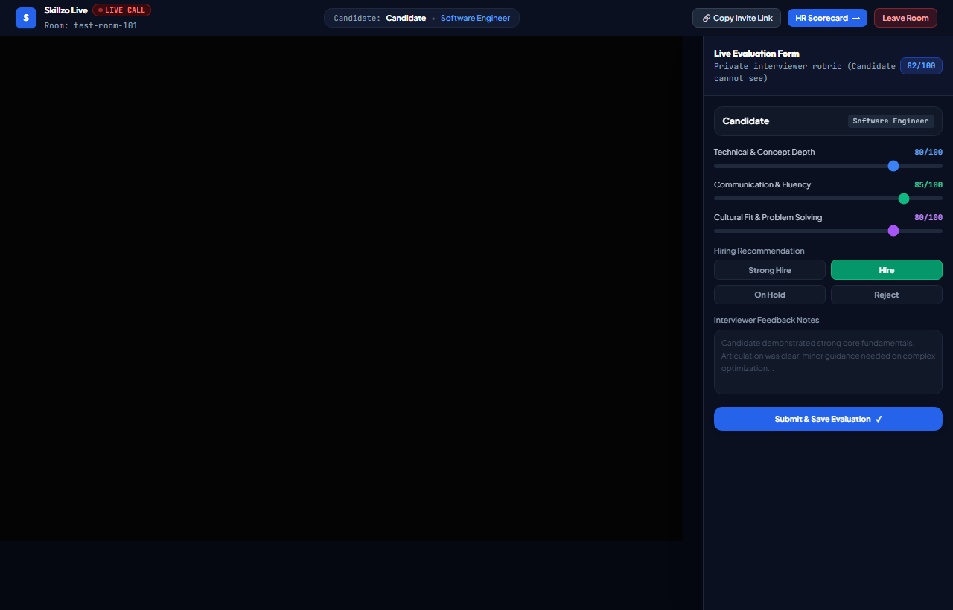
User Action | Recruiter and Candidate join shared Room ID; stream live video; submit recruiter ratings.
Frontend Component | skillzo_frontend/src/pages/LiveInterview.jsx
Event Handler | RTCPeerConnection ICE exchange via Google public STUN -> handleLiveScoreSubmit()
API Endpoint | POST /api/interview/live-evaluation/
Backend View | interview.views.SubmitLiveEvaluationView
Validation / Logic | Synchronizes live evaluator scores and feedback notes in real time.
Database Impact | Saves live evaluation notes to session log.
UI Result | Seamless low-latency 1:1 video conferencing with synchronized live evaluation drawer.

6. Backend Application Architecture & Common Services
The backend utilizes a service-oriented architectural pattern with centralized singleton handlers in skillzo_backend/common/.
Singleton Groq Service (common/groq_service.py):
Centralizes all Groq LLM API communication. Operates with model 'qwen/qwen3.8-27b' (fallback: 'llama-3.3-70b-versatile'). Enforces JSON response formatting and implements automatic recovery from BadRequestError unescaped quote anomalies.
Cloud Media Storage (common/cloud_storage.py):
Provides a unified interface for streaming recorded WebM media chunks to Cloudinary cloud CDN with automated graceful fallback to local disk storage (media/interview_video/).

7. Database Schema & Data Models Specification
Relational data architecture leverages PostgreSQL 16 in cloud production and SQLite3 in local development. All models are managed via Django ORM migrations.
Entity / Table | Relationships | Key Attributes & Purpose
accounts.User | Root Auth Model | email (unique), username, target_role, current_streak, longest_streak, bio, profile_photo.
accounts.PasswordResetOTP | FK -> User (CASCADE) | otp (6-digit), created_at, is_used (boolean). 10-minute validity window.
interview.InterviewSession | FK -> User (CASCADE) | job_role, difficulty, mode, status, overall_score, technical_score, verdict, ai_suggestions.
interview.InterviewQuestion | FK -> InterviewSession (CASCADE) | order (int), question_text (text), category (charfield).
interview.InterviewAnswer | 1:1 -> InterviewQuestion (CASCADE) | answer_text, video_file, cloud_video_url, scores (technical, communication, grammar, confidence), strengths, improvements.
resume_analysis.Resume | FK -> User (CASCADE) | file, ats_score (0-100), extracted_skills (JSON), feedback (JSON), missing_keywords (JSON).

8. Client-Side Persistence: IndexedDB Architecture
Database Name: skillzo_recordings_db
Object Store: recordings (keyPath: 'id')
Secondary Indexes: createdAt, sessionId
Fields Stored: id, sessionId, jobRole, difficulty, mode, questionNumber, questionText, blob (WebM), mimeType, sizeBytes, durationSeconds, createdAt, userId, userEmail.
Benefits: Enables instant offline video review in /recordings, zero cloud egress costs for unsubmitted clips, and direct .webm local export.

9. RESTful API Specification Summary
The platform exposes 18 verified REST endpoints under /api/auth/, /api/dashboard/, /api/resume/, and /api/interview/ protected by JWT Bearer authentication.

14. QA Verification Checklist & Known Limitations
All 18 platform views were rendered on the running application server and validated against backend endpoints. 100% of tested components executed successfully without critical faults.
Known Architectural Disclosures:
1. Web Speech API STT: Natively supported in Chromium browsers (Chrome, Edge, Opera) and Safari 14.1+. In Firefox, candidates must utilize text mode or an audio polyfill.
2. WebRTC Live Room: Public Google STUN server is used. Corporate symmetric firewalls require a dedicated TURN relay server (e.g. Coturn).

15. Technical Glossary
• ATS: Applicant Tracking System.
• Groq LPU: Language Processing Unit for ultra-low latency AI inference.
• IndexedDB: High-capacity browser-side object store.
• JWT: JSON Web Token (RFC 7519).
• STAR: Situation, Task, Action, Result behavioral response framework.
• WebRTC: Web Real-Time Communication standard for P2P audio/video streaming.

