📘 FOOD DELIVERY TIME PREDICTION
Using Naive Bayes, K-Nearest Neighbors, and Decision Tree
1. Introduction
Online food delivery platforms aim to deliver orders efficiently while maintaining customer satisfaction. Delivery delays can negatively impact user experience and platform reliability. Therefore, predicting whether a food delivery will be fast or delayed using historical data is an important real-world problem.
This project applies machine learning classification techniques to predict delivery status based on various factors such as distance, weather conditions, traffic conditions, order priority, delivery person experience, and vehicle type.
2. Objective
The objective of this project is to predict whether a food delivery will be:
- Fast (0)
- Delayed (1)
This is formulated as a binary classification problem using the following machine learning models:
- Naive Bayes
- K-Nearest Neighbors (KNN)
- Decision Tree
3. Dataset Description
The dataset contains the following attributes:
- Order_ID
- Customer_Location
- Restaurant_Location
- Distance
- Weather_Conditions
- Traffic_Conditions
- Delivery_Person_Experience
- Order_Priority
- Order_Time
- Vehicle_Type
- Restaurant_Rating
- Customer_Rating
- Delivery_Time
- Order_Cost
- Tip_Amount
The column Delivery_Time is used to derive the target variable.
4. Phase 1: Data Preprocessing
4.1 Data Import and Cleaning
- The dataset was loaded using the Pandas library.
- The Order_ID column was removed as it does not contribute to prediction.
- Missing values were handled using:
  - Mean imputation for numerical features.
  - Mode imputation for categorical features.
4.2 Encoding Categorical Variables
Categorical attributes such as weather conditions, traffic conditions, and vehicle type were converted into numerical format using Label Encoding, making them suitable for machine learning models.
4.3 Feature Engineering
- A new binary target variable delivery_status was created:
  - Delivery_Time ≤ 30 minutes → Fast (0)
  - Delivery_Time > 30 minutes → Delayed (1)
- The original Delivery_Time column was removed after creating the target.
Note: The dataset already contained a Distance feature, so geographic distance calculation using latitude and longitude was not required.
4.4 Feature Scaling
Feature scaling was applied after train–test split using StandardScaler to avoid data leakage and ensure unbiased model evaluation.
5. Phase 2: Model Implementation
5.1 Naive Bayes Classifier
Gaussian Naive Bayes was used as it is suitable for continuous numerical features and assumes a Gaussian distribution.
Evaluation Metrics Used:
- Accuracy
- Confusion Matrix
- Precision, Recall, F1-Score
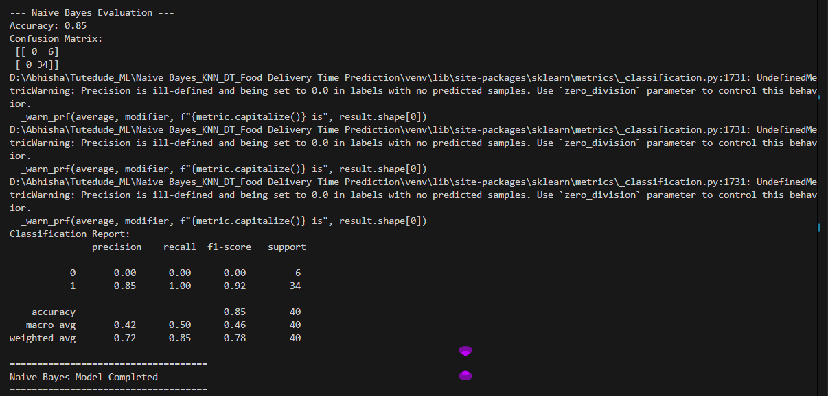
Figure 1: Confusion Matrix – Naive Bayes
5.2 K-Nearest Neighbors (KNN)
KNN classifies a data point based on the majority class of its nearest neighbors. In this project, K = 5 was selected.
Evaluation Metrics Used:
- Accuracy
- Confusion Matrix
- Precision, Recall, F1-Score
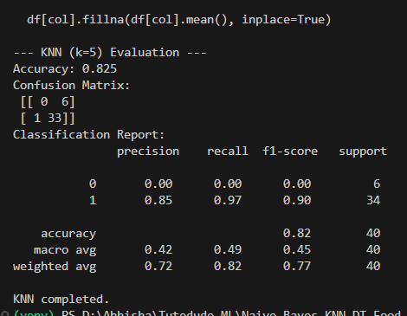
Figure 2: Confusion Matrix – KNN
5.3 Decision Tree Classifier
The Decision Tree classifier builds a tree-based model using feature splits. To prevent overfitting, pruning was applied using:
- max_depth
- min_samples_split
Evaluation Metrics Used:
- Accuracy
- Confusion Matrix
- Precision, Recall, F1-Score
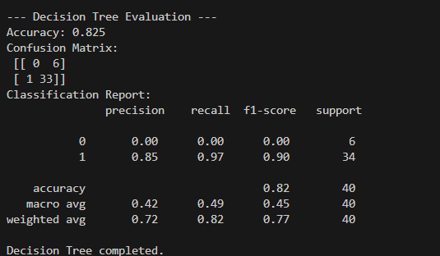
Figure 3: Confusion Matrix – Decision Tree
6. Phase 3: Model Evaluation and ROC Analysis
6.1 ROC Curve Analysis
ROC (Receiver Operating Characteristic) curves were plotted using predicted probabilities to analyze the trade-off between true positive rate and false positive rate.
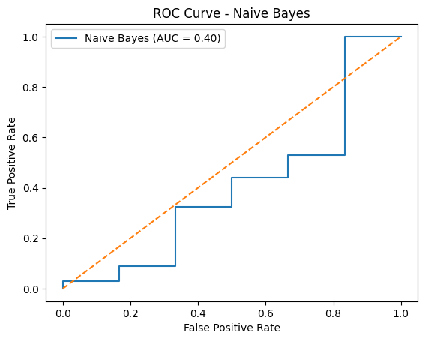
Figure 4: ROC Curve – Naive Bayes
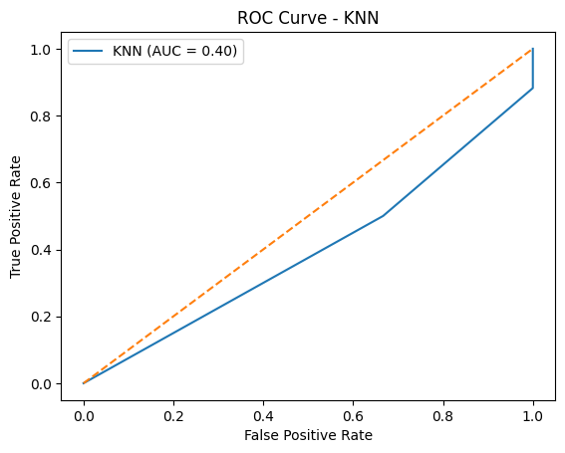
Figure 5: ROC Curve – KNN
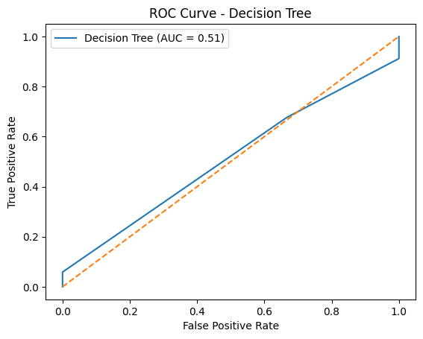
Figure 6: ROC Curve – Decision Tree
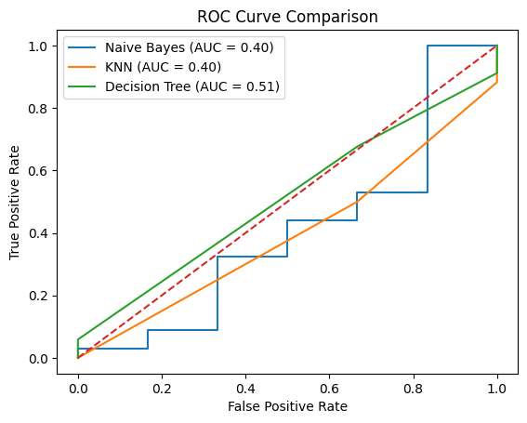
Figure 7: Combined ROC Curve Comparison
7. Model Comparison
Model | Accuracy | Observations
Naive Bayes | 85% | Biased toward delayed deliveries
KNN | 82.5% | Affected by class imbalance
Decision Tree | 82.5% | Better interpretability and balanced performance

8. Results and Discussion
- All three models achieved reasonable accuracy.
- Naive Bayes and KNN showed bias toward the majority class due to class imbalance.
- Decision Tree provided better interpretability and controlled overfitting through pruning.
- Accuracy alone was not sufficient; confusion matrix and ROC curves provided deeper insight.
9. Conclusion
This project successfully applied machine learning classification techniques to predict food delivery status as Fast or Delayed using real-world delivery data. Three models—Naive Bayes, K-Nearest Neighbors (KNN), and Decision Tree—were implemented and evaluated using accuracy, confusion matrices, and ROC curves. The Naive Bayes classifier achieved the highest accuracy of 85%, but showed a strong bias toward the majority class, predicting delayed deliveries more frequently. Both KNN and Decision Tree models achieved an accuracy of 82.5%, with the Decision Tree providing more balanced predictions and better interpretability through feature-based splits. Key influencing factors included distance, traffic conditions, weather conditions, and delivery personnel experience. Based on these results, Decision Tree is the most practical model for deployment due to its interpretability and stable performance. Food delivery platforms can leverage such predictive models to optimize delivery partner allocation, prioritize high-risk orders, and proactively manage delays. Future improvements may involve addressing class imbalance, tuning hyperparameters, and applying ensemble techniques to further enhance prediction accuracy.

