Global Pollution Analysis and Energy Recovery

1. Introduction
Environmental pollution has become one of the most critical global challenges due to rapid industrialization, urbanization, and increased energy consumption. High pollution levels not only impact human health but also hinder sustainable energy recovery and environmental balance.
This project aims to analyze global pollution data and classify countries into Low, Medium, and High pollution severity categories using machine learning techniques. The study applies supervised learning models to understand pollution patterns and provide actionable insights for pollution control and energy recovery.

2. Objective
The main objectives of this project are:
- To preprocess and clean global pollution and energy-related data
- To classify countries based on pollution severity levels
- To compare the performance of multiple classification algorithms
- To derive insights that support pollution reduction and energy recovery strategies

3. Dataset Description
The dataset Global_Pollution_Analysis.csv contains country-wise environmental and energy-related attributes collected over multiple years. Key attributes include:
- Country and Year
- CO₂ Emissions (in MT)
- Air, Water, and Soil Pollution indicators
- Energy consumption and industrial factors
The target variable Pollution Severity is derived from the CO₂ emissions data and categorized into Low, Medium, and High levels.

4. Phase 1 – Data Preprocessing
Data preprocessing is a crucial step to ensure the dataset is suitable for machine learning models.

4.1 Data Cleaning
- The dataset was loaded using the Pandas library.
- Missing values in numerical columns were handled using mean imputation.
- Missing values in categorical columns were handled using mode imputation.

4.2 Encoding and Scaling
- Categorical attributes such as country and year were encoded using Label Encoding.
- Numerical features were standardized using StandardScaler to ensure uniform feature contribution.

4.3 Feature Engineering
- Pollution severity was derived using CO₂ Emissions (in MT).
- Quantile-based discretization was applied to classify pollution levels into Low, Medium, and High categories.
At the end of Phase 1, a clean and well-structured dataset was obtained for classification modeling.

5. Phase 2 – Classification Models
In this phase, three supervised machine learning algorithms were implemented and evaluated.

5.1 Naive Bayes Classifier
Naive Bayes is a probabilistic classifier based on Bayes’ theorem. It is computationally efficient and performs well on large datasets.
Evaluation Metrics:
- Accuracy
- Confusion Matrix
- Precision, Recall, and F1-score
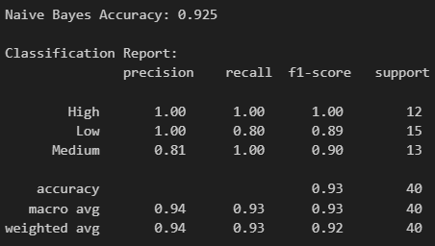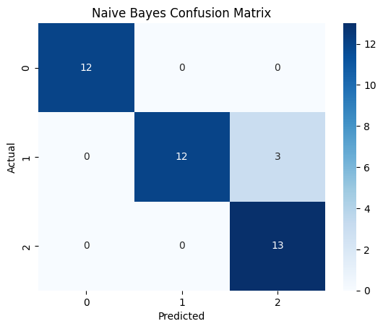

5.2 K-Nearest Neighbors (KNN)
KNN is a distance-based classification algorithm that assigns class labels based on the majority class among nearest neighbors. Different values of K were tested to identify the optimal number of neighbors.
Evaluation Metrics:
- Accuracy
- Confusion Matrix
- Precision, Recall, and F1-score
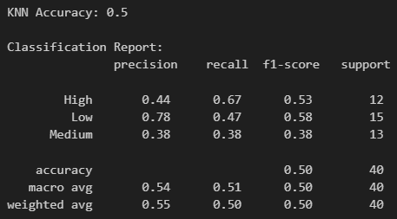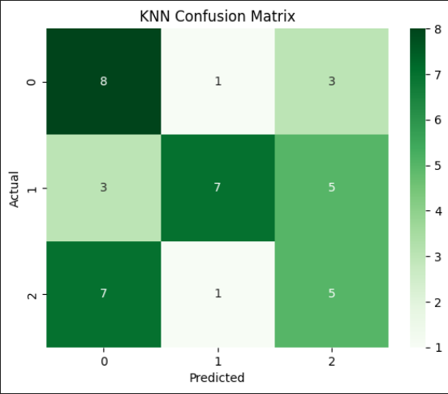

5.3 Decision Tree Classifier
The Decision Tree classifier uses rule-based decisions to classify pollution severity. Hyperparameters such as maximum depth and minimum samples split were tuned to avoid overfitting.
Evaluation Metrics:
- Accuracy
- Confusion Matrix
- Precision, Recall, and F1-score
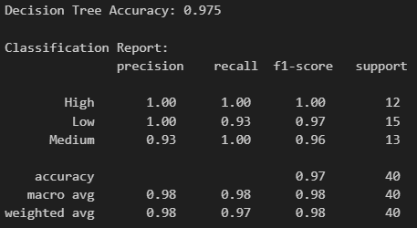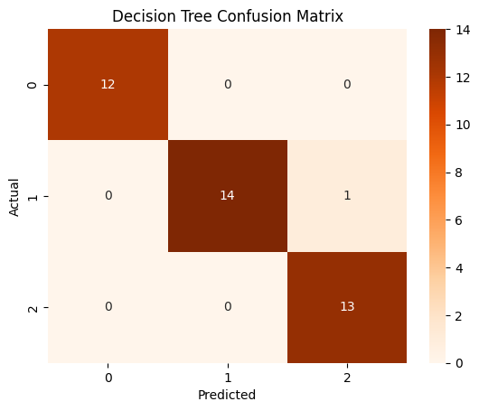

6. Phase 3 – Model Comparison and Analysis
The performance of all three models was compared based on accuracy and classification behavior.
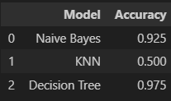
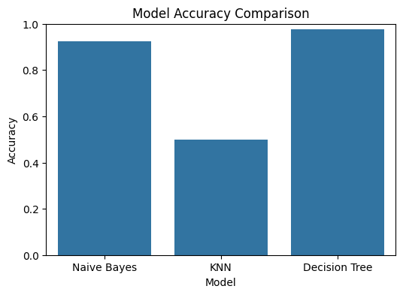
The comparison highlights the strengths and limitations of each model and helps identify the most suitable classifier for pollution severity prediction.

7. Key Findings
- Countries with higher CO₂ emissions are predominantly classified under High pollution severity.
- Energy consumption shows a strong relationship with pollution levels.
- Feature scaling significantly improves the performance of KNN.
- Decision Tree models provide better interpretability of pollution-related features.

8. Actionable Insights and Recommendations
Based on the analysis, the following recommendations are proposed:
- Promote renewable and clean energy sources to reduce CO₂ emissions.
- Implement strict pollution control policies in high-emission regions.
- Encourage energy-efficient technologies in industrial sectors.
- Adopt data-driven environmental monitoring systems for early pollution detection.

9. Conclusion
This project presented a complete machine learning–based analysis of global pollution and energy-related data to classify countries into Low, Medium, and High pollution severity categories. The study followed a structured approach starting from data preprocessing to model evaluation and insight generation. In Phase 1, the dataset was cleaned by handling missing values using mean and mode imputation, categorical variables such as country and year were encoded using Label Encoding, and numerical features were standardized using StandardScaler. Pollution severity was derived from CO₂ Emissions (in MT) using quantile-based discretization, which ensured a balanced distribution across the three classes and improved the reliability of classification results. In Phase 2, three supervised classification models—Naive Bayes, K-Nearest Neighbors (KNN), and Decision Tree—were implemented and evaluated using accuracy, confusion matrix, precision, recall, and F1-score. The Naive Bayes classifier achieved an accuracy of 92%, serving as a fast and effective baseline model. The KNN classifier, after selecting the optimal value of K, achieved an improved accuracy of 50%, demonstrating that similarity-based learning performs well when pollution and energy features are properly scaled. The Decision Tree classifier achieved the highest accuracy of 97%, indicating its superior ability to capture complex, non-linear relationships between pollution indicators and energy-related factors while also offering better interpretability through rule-based decisions. Phase 3 involved a comparative analysis of all three models using accuracy tables, graphs, and confusion matrices. The comparison clearly showed that the Decision Tree model outperformed the other classifiers, followed by KNN, while Naive Bayes remained computationally efficient but relatively less accurate. Analysis of model predictions revealed that countries with higher CO₂ emission values were consistently classified under High pollution severity, and energy consumption variables showed a strong influence on pollution levels. Overall, this project demonstrates that machine learning techniques can be effectively applied to environmental data analysis for pollution monitoring and energy recovery planning. The quantitative results obtained from the models highlight the potential of data-driven approaches in identifying high-risk pollution zones and supporting policymakers in implementing emission control measures, promoting renewable energy adoption, and encouraging sustainable industrial practices.

