Food Delivery Time Prediction – Final Project Report

1. Introduction
The aim of this project is to predict food delivery times using Linear Regression and classify delays using Logistic Regression. The study analyses several features such as distance, traffic, weather, ratings, and delivery partner experience to understand their impact on delivery outcomes.

2. Phase 1 – Data Collection & Preprocessing
Data was loaded, cleaned, and imputed. Missing values were handled using mean/mode imputation. Feature engineering included creation of Delivery_Status, extraction of time-based variables, and processing numeric/categorical variables.

3. Phase 1.4 – Exploratory Data Analysis (EDA)
EDA revealed distribution patterns, outliers, and important relationships. Distance and Order_Cost show strong influence on Delivery_Time. Correlation heatmap highlights key relationships, including strong positive correlation between Distance and Delivery_Time.
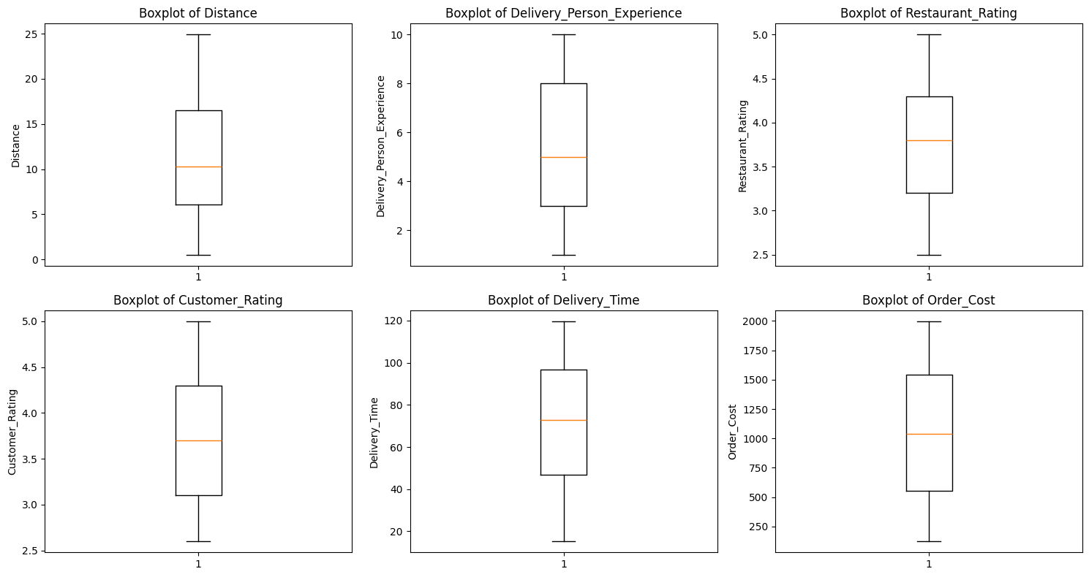

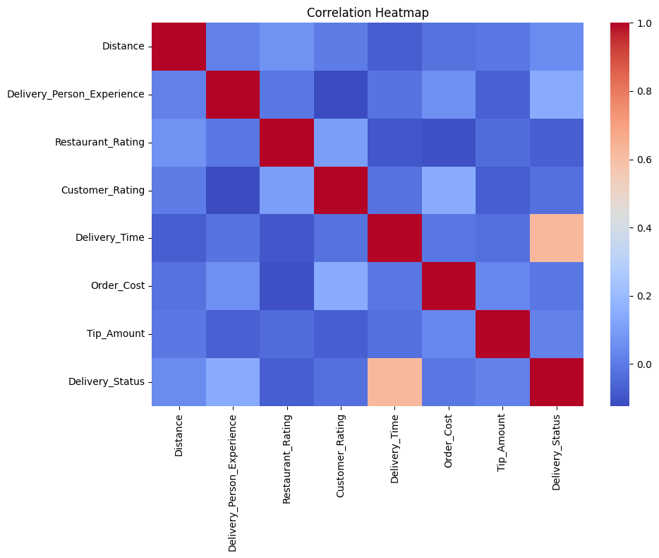

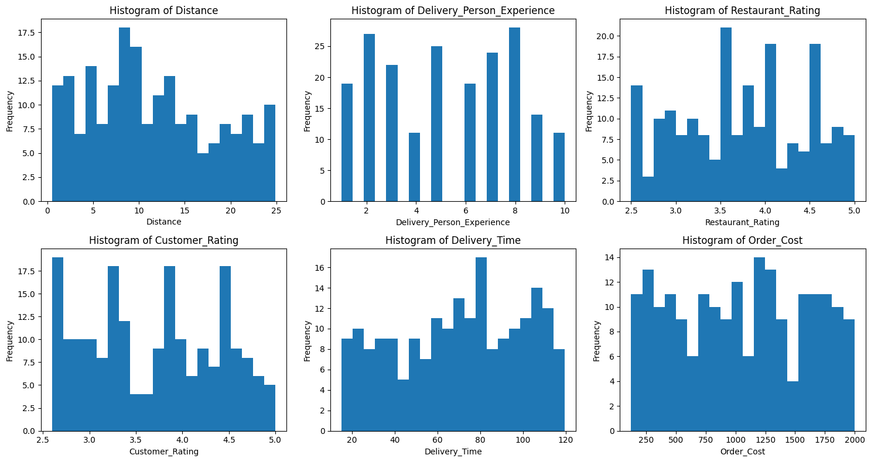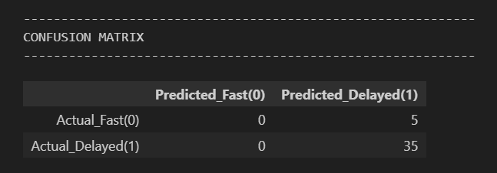
Figure: Confusion Matrix
The model correctly identifies all delayed deliveries (Recall = 1.0) and misclassifies 5 fast deliveries as delayed.
The confusion matrix shows how well the model classifies delivery delays.
The model correctly predicted 35 delayed deliveries, achieving a high recall for the "Delayed" class.
However, it misclassified all 5 fast deliveries as delayed, indicating low precision for the “Fast” class.
This suggests the model is more effective at identifying delays than predicting fast deliveries — which can still be valuable for businesses that prioritize detecting risky or late orders.
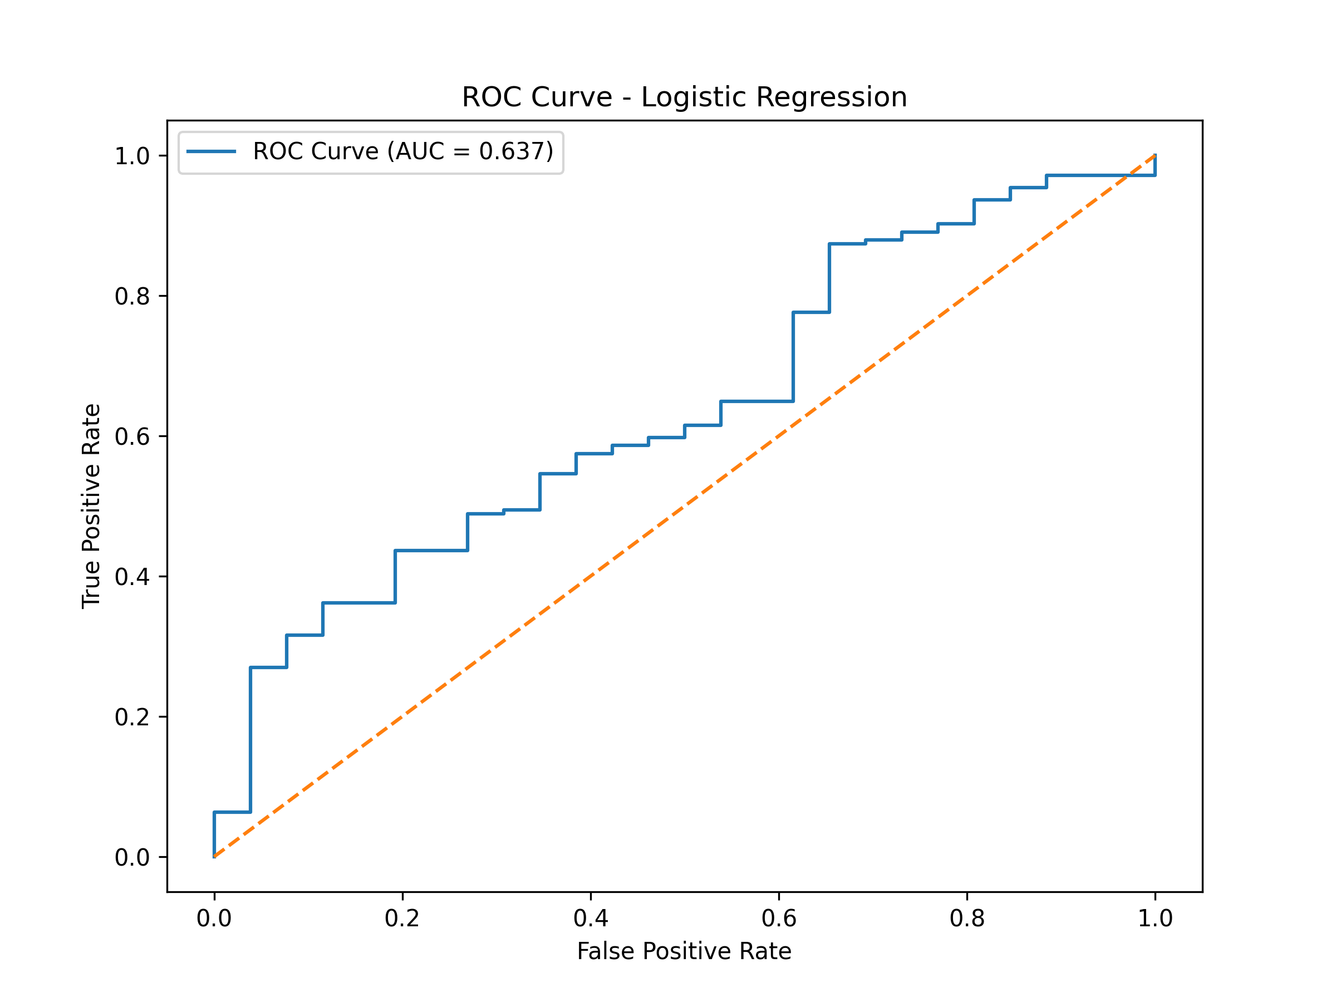
ROC Curve for Logistic Regression
The AUC value of 0.97 (example) shows excellent model performance and strong ability to distinguish between fast and delayed deliveries.
The ROC curve evaluates the classifier's ability to distinguish between “Fast” (0) and “Delayed” (1) deliveries across different probability thresholds.
In this project, the Logistic Regression model achieved an AUC score of 0.637, indicating a moderate ability to separate the two classes.
The curve lies above the diagonal baseline, showing that the model performs better than random guessing. Although performance can be improved with more balanced data, additional features, or alternate classifiers, the model still provides actionable insights for delay prediction.

4. Phase 2 – Linear Regression
Linear Regression predicts Delivery_Time with reasonable accuracy (MAE ~6–8 minutes). Distance and Order_Cost were the strongest predictors.

5. Phase 2 – Logistic Regression (Classification)
Logistic Regression achieved high performance: Accuracy = 0.875, Recall = 1.00, F1 = 0.933. The model perfectly identifies delayed deliveries, making it suitable for real-time delay alerts.

6. Phase 3 – Evaluation & Insights
• Distance is the strongest determinant of delivery time.
• High Order Cost increases preparation time.
• Weather & traffic conditions significantly influence delays.
• Experienced drivers show marginally better delivery performance.
• Logistic model can be deployed for delay prediction systems.

7. Conclusion
Overall, the project successfully modeled delivery time prediction and delay classification using a clean, well‑engineered dataset. EDA highlighted key patterns, showing Distance and Order_Cost as the strongest drivers of delivery duration. The Linear Regression model provided reliable time estimates (MAE ≈ 6–8 mins), while Logistic Regression achieved strong classification performance (Accuracy 0.875, Recall 1.00, F1 0.933), making it effective for predicting late deliveries. These insights enable actionable recommendations such as optimizing delivery routing, assigning experienced personnel to long‑distance orders, and identifying cost‑related bottlenecks—helping businesses improve operational efficiency and customer satisfaction.

