**GitHub Link:**

**SQL Installation**

Was facing error in establishing the connection initially. So, I uninstalled the Workbench, removed it from the registry and then re-installed it. For re-installation, followed the steps given in the MYSQL Installation pdf. Then, created a new schema – dblabs1

**SQL QUERIES**

1. **Check how many directors are present in iMDB.**

**Query**: Select count(*) from imdb.directors;

**Output:**

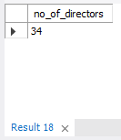

1. **Check how many movies are released post-year 2000**

**Query:** select count(*) as no_of_movies from imdb.movies where year > 2000;

**Explanation:**

**Output**

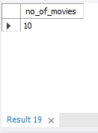

1. **Find the list of genres of movies directed by Andrew Adamson**

**Query:**

select genre from imdb.movies_genres as mg where mg.movie_id = (select movie_id from imdb.movies_directors where director_id = (select id from imdb.directors where first_name = "Andrew" and last_name = "Adamson"));

**Explanation:**

select * from imdb.movies_genres;

select id from imdb.directors where first_name = "Andrew" and last_name = "Adamson";

select movie_id from imdb.movies_directors where director_id = (select id from imdb.directors where first_name = "Andrew" and last_name = "Adamson");

select genre from imdb.movies_genres as mg where mg.movie_id = (select movie_id from imdb.movies_directors where director_id = (select id from imdb.directors where first_name = "Andrew" and last_name = "Adamson"));

**Output**

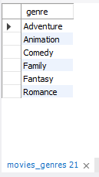

1. **List of directors whose movies are ranked between 7 to 8 ranking.**

**Query**

select CONCAT(first_name,'',last_name) as Directors from imdb.directors where id IN (select director_id from imdb.movies_directors where movie_id IN (select id from imdb.movies as m where m.rank BETWEEN 7 AND 8));

**Explanation**

select id from imdb.movies as m where m.rank BETWEEN 7 AND 8;

select director_id from imdb.movies_directors where movie_id IN (select id from imdb.movies as m where m.rank BETWEEN 7 AND 8);

select CONCAT(first_name,'',last_name) as Directors from imdb.directors where id IN (select director_id from imdb.movies_directors where movie_id IN (select id from imdb.movies as m where m.rank BETWEEN 7 AND 8));

**Output – 20 results**

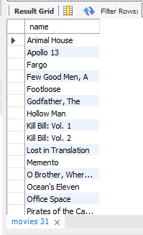

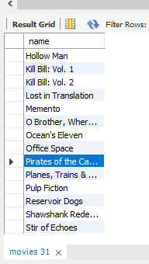

1. **Find the role of Julliet Akinyi in Lost in Translation movie**

**Query**

SELECT role from imdb.roles where actor_id = (SELECT id from imdb.actors where first_name = "Julliet" and last_name = "Akinyi") AND movie_id = (select id from imdb.movies where name = "Lost in Translation");

**Explanation**

SELECT id from imdb.actors where first_name = "Julliet" and last_name = "Akinyi";

select id from imdb.movies where name = "Lost in Translation";

SELECT * from imdb.roles where actor_id = (SELECT id from imdb.actors where first_name = "Julliet" and last_name = "Akinyi") AND movie_id = (select id from imdb.movies where name = "Lost in Translation");

SELECT role from imdb.roles where actor_id = (SELECT id from imdb.actors where first_name = "Julliet" and last_name = "Akinyi") AND movie_id = (select id from imdb.movies where name = "Lost in Translation");

**Output**

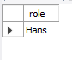

1. **List of the movies that contain the letter ‘o' in any position**

**Query:** select name from imdb.movies where name LIKE "%o%";

**Output:**

