Forest Fire Risk Prediction Using Machine Learning
Project Report
Dataset Extended Algerian Forest Fires Dataset
September 2026

Abstract
This project develops a machine-learning classifier that estimates forest fire risk from weather and fire-weather observations. The Extended Algerian Forest Fires dataset is cleaned and analysed before Logistic Regression, Decision Tree, and Random Forest models are trained. Random Forest is selected as the final model because it achieves the strongest held-out test performance. An interactive form inside Jupyter Notebook allows a user to enter seven conditions and receive a fire-risk class with an estimated probability.

Problem Statement
Forest fires can damage ecosystems, wildlife, property, and human life. Temperature, relative humidity, wind speed, rainfall, and vegetation dryness affect the chance that a fire will start or spread. The objective of this mini project is to classify a set of observed conditions as Fire or Not Fire. The result is an educational risk estimate that can support understanding of weather related fire danger.

Dataset
The project uses the Extended Algerian Forest Fires dataset. The source data contains 1,215 records collected across Algerian regions and includes dates, weather observations, Canadian Fire Weather Index components, a fire class, and a region label. One record with an incomplete date is removed during preprocessing, leaving 1,214 records for analysis and training.
Column | Description
DATE | Observation date used to derive year, month, and day.
Temperature | Temperature in degrees Celsius.
RH | Relative humidity percentage.
Ws | Wind speed in kilometres per hour.
Rain | Rainfall in millimetres.
FFMC | Fine Fuel Moisture Code for the dryness of fine surface fuel.
DMC | Duff Moisture Code for moisture in medium-depth organic material.
DC | Drought Code for longer-term dryness.
ISI | Initial Spread Index, related to the potential initial rate of spread.
BUI | Buildup Index, representing available fuel.
FWI | Fire Weather Index, an overall fire-danger index.
Classes | Original target label: fire or not fire.
Region | Algerian region associated with the observation.

Data Preparation
Column names are cleaned and the final source column is renamed Region because it stores regional labels. Fire class labels are trimmed, converted to lowercase, and encoded as a numerical target where 0 means Not Fire and 1 means Fire. Dates are converted to datetime values, with Year, Month, and Day extracted. Weather and fire-index fields are converted to numeric values. Incomplete records are removed after the missing-value check.
The final model uses seven features: Temperature, RH, Ws, Rain, FFMC, DMC, and ISI. FWI is not used as a model input because it is an overall index derived from related conditions and can make the prediction less interpretable for this educational risk-prediction task.

Exploratory Analysis
The notebook includes a class distribution chart, temperature and humidity box plots, and a correlation heatmap. The heatmap shows that fire occurrence is positively associated with FFMC, ISI, and temperature, while relative humidity has a negative association. Highly related fire-index variables such as DMC, DC, and BUI are not all used together in the selected feature set, reducing redundant information.
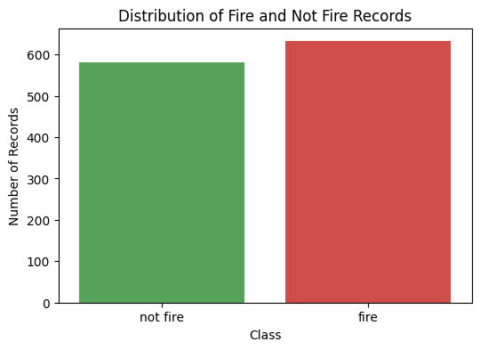
Figure 1 Distribution of Fire and Not Fire Records
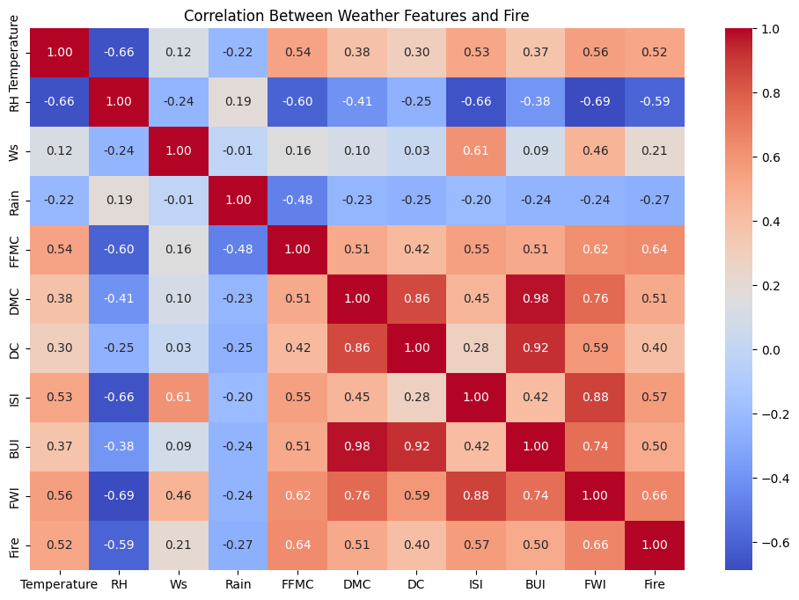
Figure 2 Correlation Between Weather Features and Fire

Model Development
The dataset is split into 80 percent training data and 20 percent testing data using stratified sampling so that both groups preserve the Fire and Not Fire class proportions. StandardScaler is fitted only on the training data and then applied to both training and test features. Three classification models are trained: Logistic Regression, Decision Tree, and Random Forest.

Model Evaluation
Model quality is assessed using accuracy, precision, recall, F1-score, a classification report, and a confusion matrix. Recall is important because it measures the proportion of actual fire cases that the model correctly identifies. F1-score balances precision and recall.
Model | Accuracy | Fire Precision | Fire Recall | Fire F1 Score
Logistic Regression | 0.87 | 0.86 | 0.90 | 0.88
Decision Tree | 0.87 | 0.89 | 0.86 | 0.88
Random Forest | 0.91 | 0.93 | 0.90 | 0.91

Random Forest is selected as the final model because it achieves the highest accuracy and Fire F1-score. The notebook also displays a confusion matrix and feature-importance chart to make the final result easier to interpret.
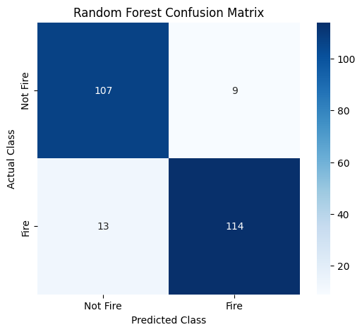
Figure 3 Random Forest Confusion Matrix
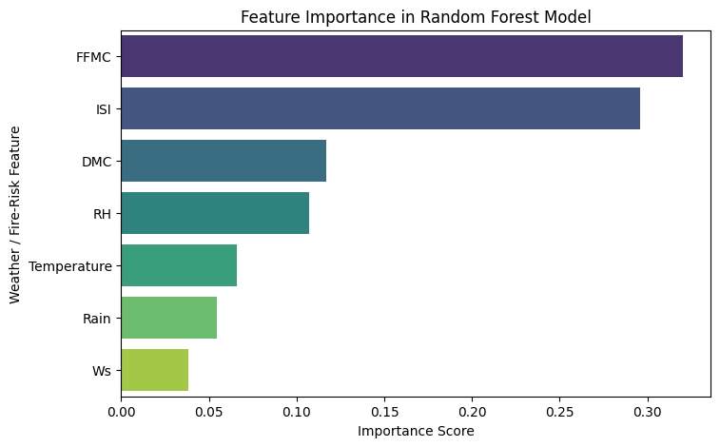
Figure 4 Random Forest Feature Importance

Interactive Prediction Interface
The final notebook uses ipywidgets to present input fields for Temperature, Relative Humidity, Wind Speed, Rainfall, FFMC, DMC, and ISI. When the user selects Predict Fire Risk, the interface applies the same scaler used during training and returns either High Fire Risk or Low Fire Risk together with the estimated probability of fire.
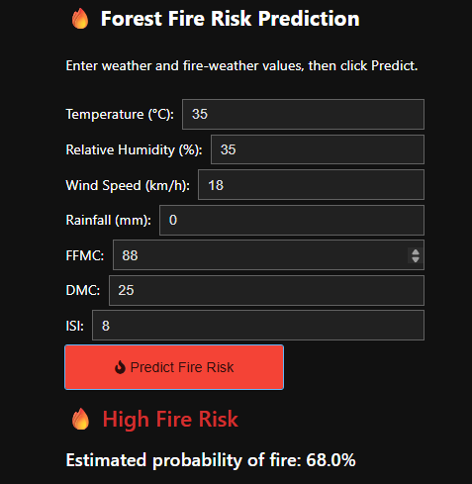
Figure 5 Interactive Notebook Prediction Interface Showing High Fire Risk

Conclusion
The mini project demonstrates a complete machine-learning workflow for forest fire risk classification: data loading, cleaning, analysis, feature selection, model training, evaluation, and interactive prediction. Random Forest gives the strongest result on the held-out test set, with approximately 91 percent accuracy. The model is useful for learning and demonstration, but it is not a real-time emergency warning system and must not be used as the sole basis for public-safety decisions.

References
Abid, F. The extended Algerian forest fires dataset. Mendeley Data. https://data.mendeley.com/datasets/8rkd9cdgs5/1
Python libraries used: Pandas, NumPy, Matplotlib, Seaborn, scikit-learn, Joblib, and Ipywidgets.

