MINOR PROJECT| WRITEUP

**Active Disturbance Rejection Control of Permanent Magnet Synchronous Motor**

Implementing Active Disturbance Rejection Control (ADRC) Algorithm for closed-loop speed control system for Permanent Magnet Synchronous Motors (PMSM)

Department of Electrical Engineering

Maulana Azad National Institute of Technology Bhopal, India

**Aviral Upadhyay 191113269**

**Abhishek Agarwal 191113017**

**Akshat Jain 191113019**

**Anubhav Sharma 191113069**

**Harsh Garg 191113239**

**Abstract: The paper research variation of motor control strategy using simulink implementation with the focus on PMSM control using FOC control which is the most popular technique in the present. It involves PID control which is a linear strategy and thus suffers from certain drawbacks. We attempt to get rid of those by trying to simulate a new and rising control technique known as ADRC, or Active Disturbance Rejection Control, a non-linear technique. We proceed step by step, understanding basic motor models and control blocks in depth and establishing basic difference between the scalar and vector control and exploring the increased complexity but better results of AC control strategy. Since ADRC needs a lot of research to implement successfully, and it is a totally new concept, we have skipped its full implementation for now with a short discussion on the methodology which could have been adopted, given sufficient time.**

***Keywords – BLDC, Back EMF profile, PMSM, PWM, SVPWM, Simulink***

**1. LITERATURE REVIEW**

**Introduction:**

With the rapid development of the world textile industry, the research on industrial sewing machines have been focused on higher precision, more energy-saving, lower cost, higher speed, multiple-function, more intelligence. In order to achieve all these performance indexes, the main problem is to develop an effective servo system. And the PMSM based servo systems have attracted more and more researchers, for which has several inherent advantages compared with other types electric machinery, such as high power density, high power factor, high torque to current ratio, high efficiency, low inertia, rugged construction, easy for maintenance and so on[11].

The PID control is one of the early developed control strategies. Due to its simple algorithm, good robustness and reliability, it has been widely used to design position, speed and electric current loop controller in industrial sewing machine servo system. And classic PID control based, such as increment PI control, fuzzy PID control, Neural PID control , multi-segment PI control are also adopted[12,13]. However, the classical control strategies have some disadvantages, such as, large overshoot, long adjustment time and so on. It is difficult for the PMSM servo system to realize high precision control. PMSM servo system is a typical non-linear time-variant control system. Many intelligent control methods such as fuzzy control, self-adaptive control, neural network control, sliding mode variable structure control, genetic algorithm control are adopted to solve the problems.

Many scholars have done a lot of meaningful researches on these control methods [5,6]. But it still has some difficult to realize. The ADRC can not only arrange the transient process, but also estimate and compensate the total disturbances on the system, which can highly improve the performance of the PMSM servo system. In this paper, ADRC is used as a speed loop regulator in the industrial sewing machine servo control system[7,8]. Simulation results indicated that, compared with conventional PID control servo system, the proposed control method has better dynamic performance, and stronger robustness to the system disturbance.

**Motor Control:**

Electric motors, regardless of their type, have a controller of some type.The simplest example of a motor control mechanism is a regular switch that connects a motor to its power source. This switch can be a manual controller, or a relay connected to an automatic sensor for starting and stopping a motor.Depending, on the applications of a motor, controllers may offer different features. They help the motor start in low-voltage conditions, allow multiple-speed or reverse control operations, protect from over current and overload faults, and perform a wide range of other functions. Some complex motor control devices also help in effectively controlling the speed as well as torque of the motor(s) and might also be a part of a closed loop control system responsible for the exact positioning of the motor driven machine.

They have several essential functions which include: automatically or manually starting as well as stopping the operation of an electric motor, setting forward or reversing the course of rotation, selecting and regulating the speed of rotation, controlling or regulating the torque, as well as protecting the motor against several degrees of electrical overloads and faults. [1]

**PID Controller:**

PID controllers are widely used, low level controllers used in systems that require some form of control. PID stands for Proportional, Integral and Differential controllers. It consists of these three parts which contribute to achieving optimal control of our systems.

The P controller: it applies measured input proportional to the error (i.e. deviation of the actual output from required output) to the system.

The PI controller consists of a Proportional part and an Integral part. The Integral part continuously gathers the errors in our system over time and feeds a force that makes up for it back into the system.

In certain systems, using a P only controller or a PI doesn’t help achieve the needed tracking or stability. In some cases, they produce an undesirable overshoot which needs to be eliminated. The I part of a controller has a contributory effect on the magnitude of the P part but the D part has a counteractive effect on it making it really good for controlling overshoots. It however increases the settling time.

The D part stands for the derivative term and is calculated by multiplying the rate of change of the error term by K, the derivative gain.[2][3]

**PMSM Motor Control:**

The permanent magnet synchronous motors are one of the types of AC synchronous motors, where the field is excited by permanent magnets that generate sinusoidal back EMF. It contains a rotor and stator same as that of an induction motor, but a permanent magnet is used as a rotor to create a magnetic field. Hence there is no need to wound field winding on the rotor.

The advantages of permanent magnet synchronous motor include:

* provides higher efficiency at high speeds
* available in small sizes at different packages
* maintenance and installation is very easy than an induction motor
* capable of maintaining full torque at low speeds.
* high efficiency and reliability
* gives smooth torque and dynamic performance

Figure, Advantages of PMSM Motor over other motors[4]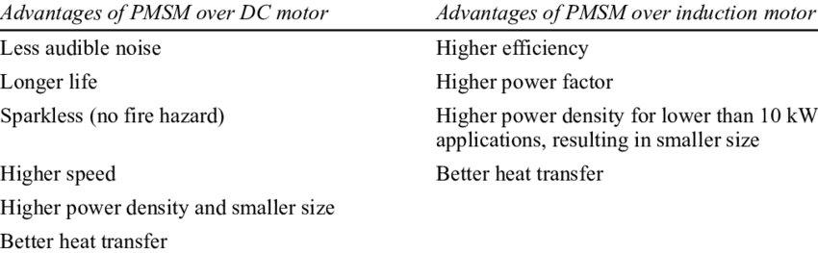

**ADRC Technique:**

Active disturbance rejection control (ADRC) follows on from the PID. It is a type of nonlinear robust control method that is based on extending the system model with an additional and fictitious state variable, representing everything that the user does not include in the mathematical model.[5][6]

The ADRC can not only arrange the transient process, but also estimate and compensate the total disturbances on the system, which can highly improved the performance of the PMSM servo system.

ADRC compared with conventional PID control servo system, the proposed control method has better dynamic performance, and stronger robustness to the system disturbance.

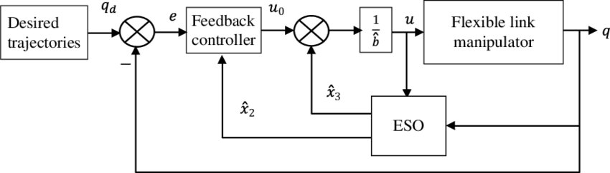

Figure. Block Diagram of ADRC Technique[7]

This disturbance rejection feature allows user to treat the considered system with a simpler model, since the negative effects of modelling uncertainty are compensated in real time.The success of PID control is error feedback. ADRC uses nonlinear state error feedback, so call it Nonlinear PID. In linearization system, people can also use weighted state errors as feedback.[8][9]

ADRC has been shown to give better control performance than PID control [Tian and Gao, 2009]. However, most of the reported applications of ADRC are in the area of motion control.[Tian and Gao, 2009][10]

**Major Contributions:**

BLDC and PMSMs have a lot in common, but control algorithm of BLDC is simple to understand. M. Poovizhi[14] and others verified the mathematical modelling of BLDC based on the Simulink based simulation of closed loop control, the diagram of which is recreated below:

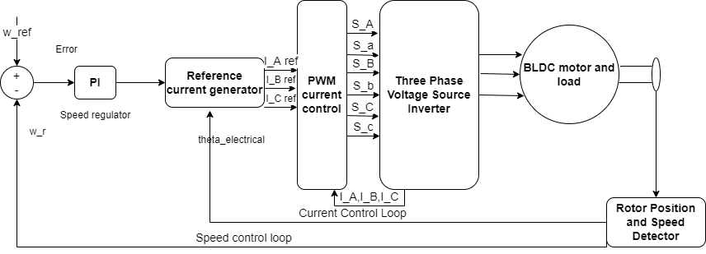

Many other variations of BLDC control revolving around PID have been successfully implemented in Simulink such as adaptive fuzzy logic PID controller [15].

ADRC, otherwise complex, has been implemented successfully for Simulink simulations of BLDC motor control [4] [16]. In a comparative study of disturbance observer-based control (DOBC) and ADRC [16], it is noted that DOBC is simpler and gives slightly better result than ADRC, however both are way better than PID techniques.

Here we can observe that in DOBC and ADRC, the settling time t_s is shorter but the percentage of overshoot is larger as compared to the conventional method.

PMSM control requires concept of generalized theory of machine to bring the complexity down to the level of BLDC, using Clarke/Park transform which makes FOC implementation possible, as done in [5]. Further, ADRC has been researched extensively for PMSM in [6], and simulation and implementation of both these techniques in Simulink are focus of our project.

**2. MOTIVATION**

Electric motors are found in electrical appliances, changes in the industry, process control, cars and everywhere. Permanent magnetic motors synchronous motors (PMSM) are specialized types of brushless motors that offer advantages such as high efficiency, high torque ratio, high performance at both high and low operating speeds, and low maintenance of other motors. Controlling algorithms are important challenges in the automotive control industry. The speed control of PSMS motors is usually achieved by employing Proportional-Integral (PI) controls. However, in some applications such as treadmills, electric vehicles, etc. due to sudden and normal load variations, makes the use of PI controls inappropriate. The Active Disturbance Rejection Control (ADRC) algorithm is an appropriate strategy as it provides better flexible performance in any sudden changes in load.

**3. METHODOLOGY AND PROBLEM FORMULATION**

The aim of this project is to work with Motor Control Blockset ™ to use Active Disturbance Rejection Control (ADRC) for PMSM vehicles using MATLAB® and Simulink®. In the Motor Control Blockset, there are reliable examples of traffic control via PI. Use Active Disturbance Rejection Control (ADRC) to control the engine to avoid interruptions and compare the performance of the controller with a standard PI control for sudden loading. You can target applications such as a treadmill or electric car where sudden changes in load are expected.The required steps to be implemented are as follows:

1. Firstly, to understand the basic building blocks it is required to implement different subsystems such as three phase VSI (inverter) and commutation logic separately in simulink and ultimately use them in the model.
2. Understand the similarities between BLDC and PMSM such that the implementation of FOC in PMSM after application of generalized theory (i.e. Clarke/Park transform) can be easily done by matching the procedure and even using the common blocks of BLDC, but also establish the key difference, i.e. the shape of back-emf via open circuit simulation of both the machines.
3. Implement closed-loop PID control of BLDC, and thereafter field oriented control of PMSM.
4. Understand and discuss major changes in the implementation between field oriented control and ADRC with respect to PMSM motor.
5. Comparing the performance of the ADRC controller with the PI controller. It can be seen how distractions are best handled in the ADRC compared to the PI control.

**4. SIMULATION RESULTS AND DISCUSSION**

Back- emf profile of BLDC and PMSM: It is the key differentiator between BLDC and PMSM, being trapezoidal in shape for BLDC and sinusoidal in shape for PMSM[1]. The simulations establishing these facts within the BLDC and PMSM blocks included in the Simscape library are as shown:

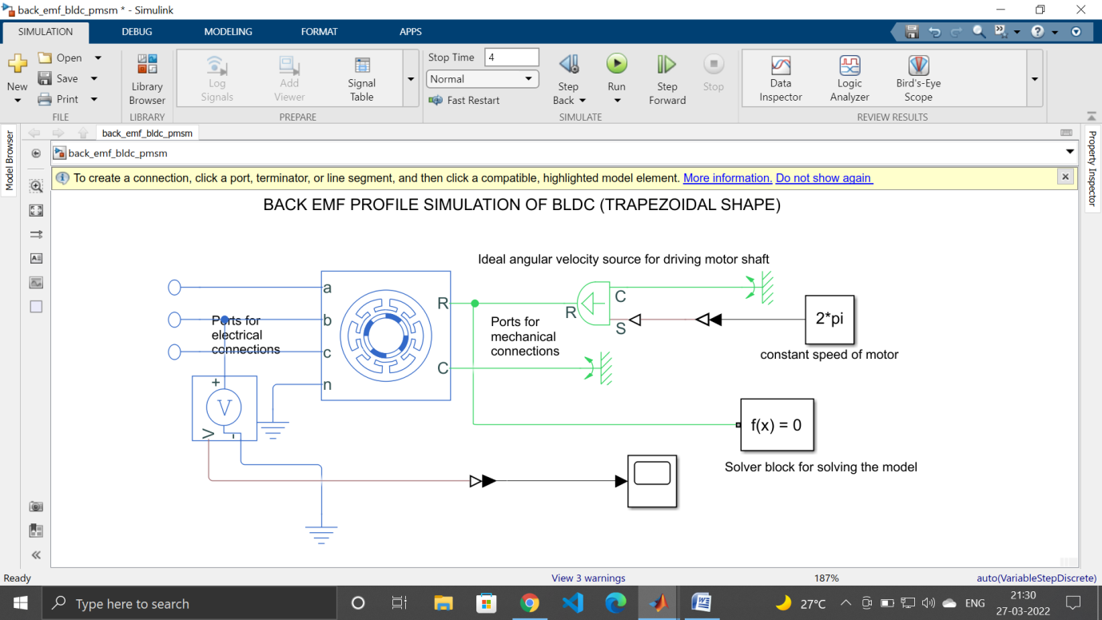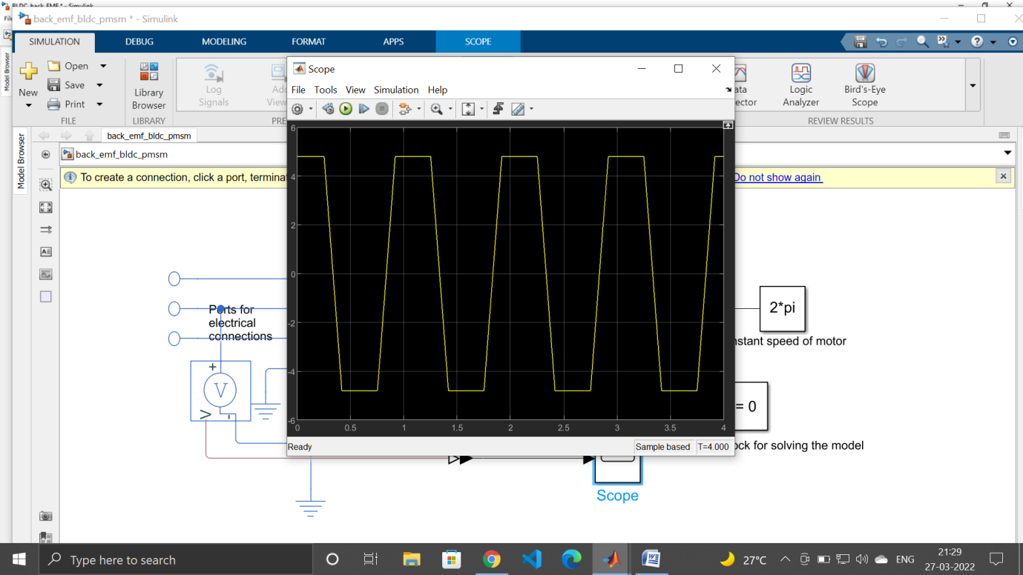

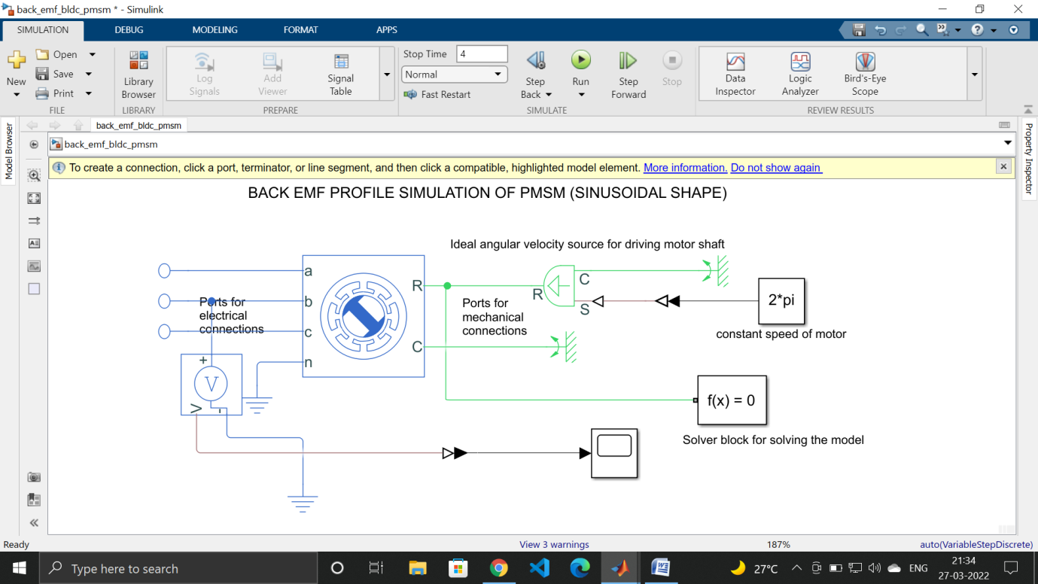

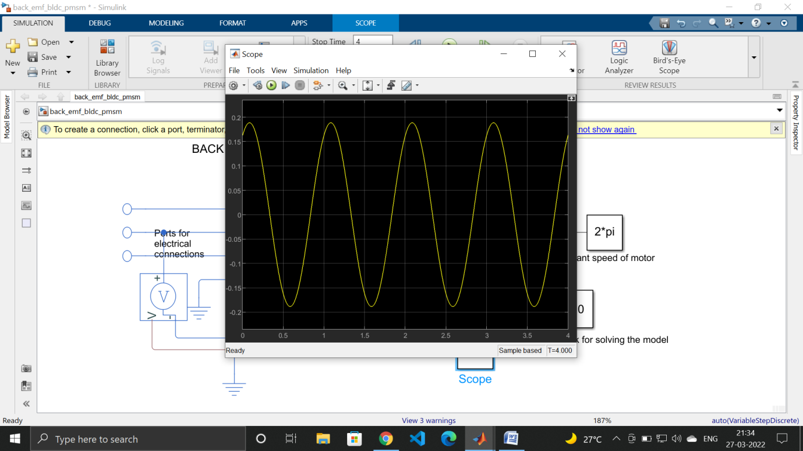

Apart from this one difference, BLDC and PMSM are very similar as they both have a permanent magnet rotor, three-phase winding, both rotate at synchronous speed and they both offer position control [17].

Three-Phase Inverter Model and commutation logic–In BLDC, we need to provide correct commutation logic so that when the rotor is in a particular sector, the correct combination of up and down switches are on which will allow the BLDC to rotate smoothly. Therefore, proper modelling of three phase inverter and PWM control signals is necessary. Although these blocks are available as readymade subsystems in simulink , we still implemented to learn the basic modelling skills and have conceptual clarity. Screenshots are attached below:

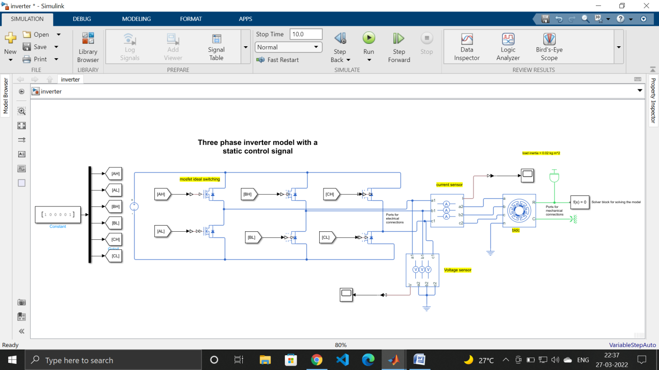

The six step commutation logic simulation diagram to be used in closed loop control is as shown below.

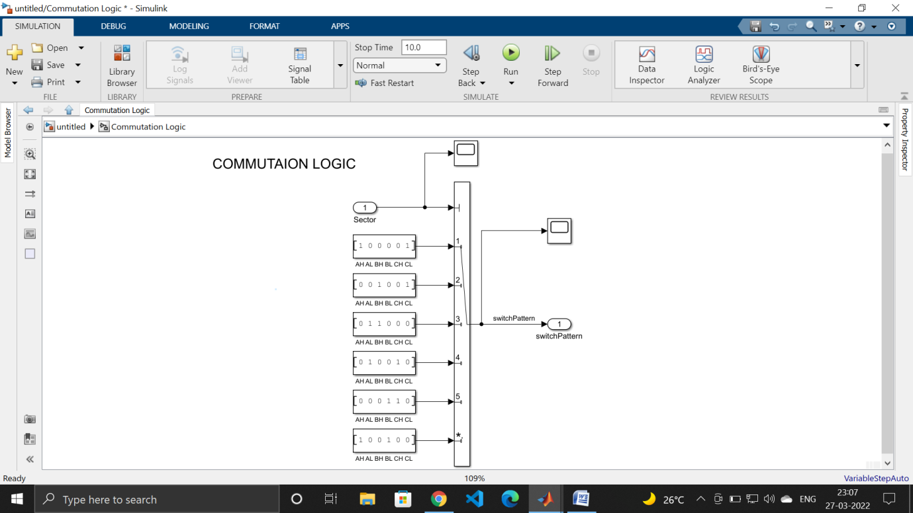

Final BLDC Motor model using PID control is as shown. It is a product of assembly of all the basic building blocks as subsystem and implementing closed loop circuitry discussed earlier.

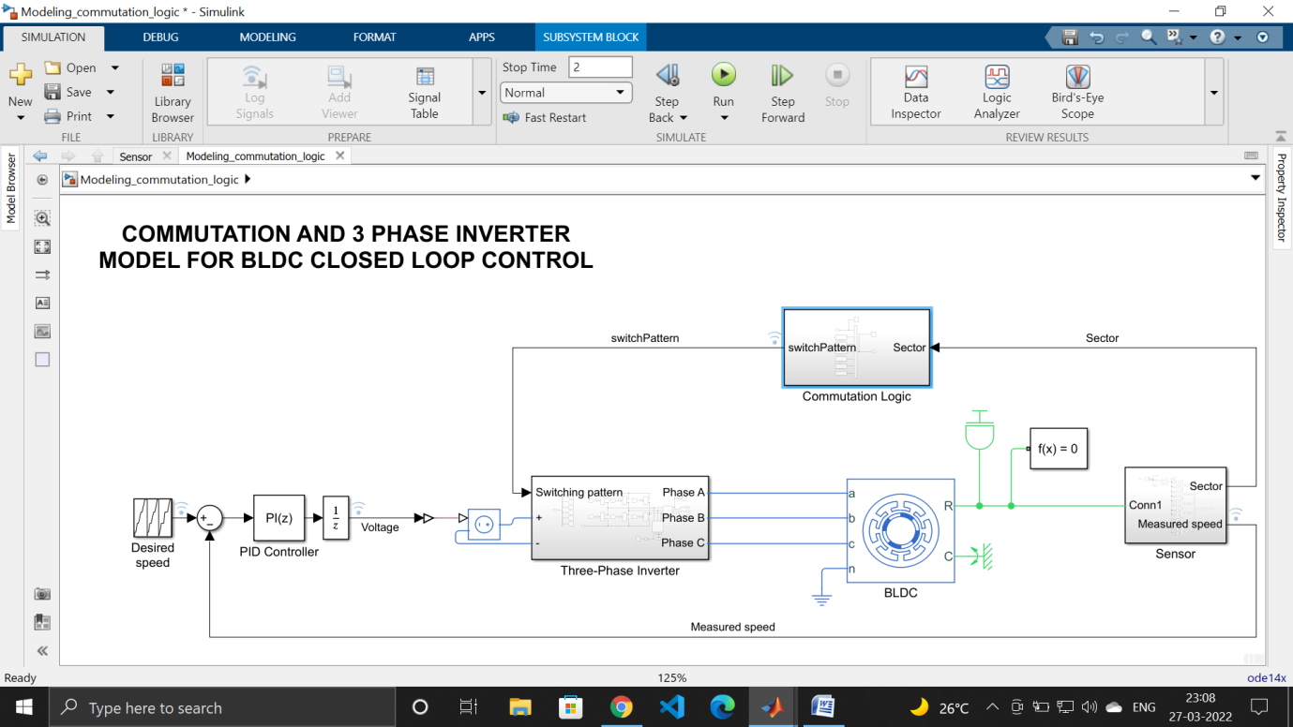

The brief working of this control is as follows – The hall sensor observes the sector in which the rotor of motor is rotating and it feeds that data to six step commutation logic designed above, which decides the exact control signal to be given to the switches of the inverter, which subsequently turns on that particular phase of the BLDC. For synchronous speed maintenance closed loop PID control is employed.

Here, we have not discussed PWM, which is an important aspect of BLDC control, and also directly parallels the SVPWM in FOC control of PMSM, but we reserve our focus on both of these topics while doing PMSM simulations.

The simulation result is as shown. The desired speed follows the reference speed due to excellent PID control. The voltage achieves a constant DC value after a short duration.

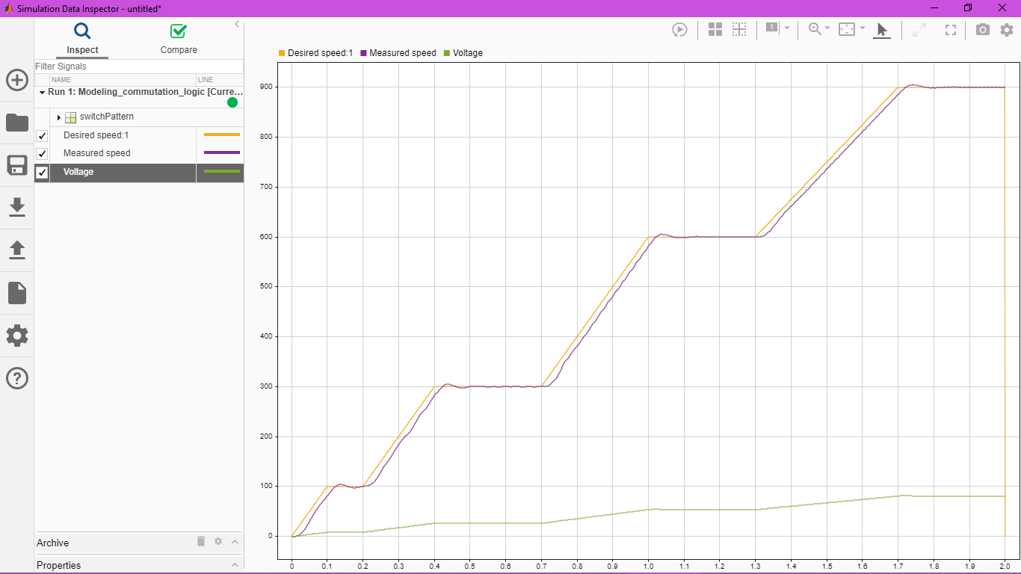

Field Oriented Control of PMSM – The trapezoidal control of BLDC suffers from many disadvantage, the major one of which is the torque and speed ripple produced in the motor response due to discrete nature of commutation logic employed and subsequent static switching for one sector. Also, this logic only allows the alignment of stator and rotor fields within a range of 60 to 120 degrees, but exactly 90 degrees is required for maximum torque. FOC takes care of all these shortcomings at a price of increased complexity. In FOC, we:

1. measure rotor angular position (contrast to BLDC, in which we only need to know the sector of rotor)
2. Align stator field perpendicular to rotor field all the times using PI controllers.
3. Three phase stator current phasor are resolved into two perpendicular stationary current vectors using Clarke/Park transform.
4. The direct axis current is made zero and quadrature axis current is maximized using 2 PI controllers.

The implementation of fourth point in Simulink is as shown.

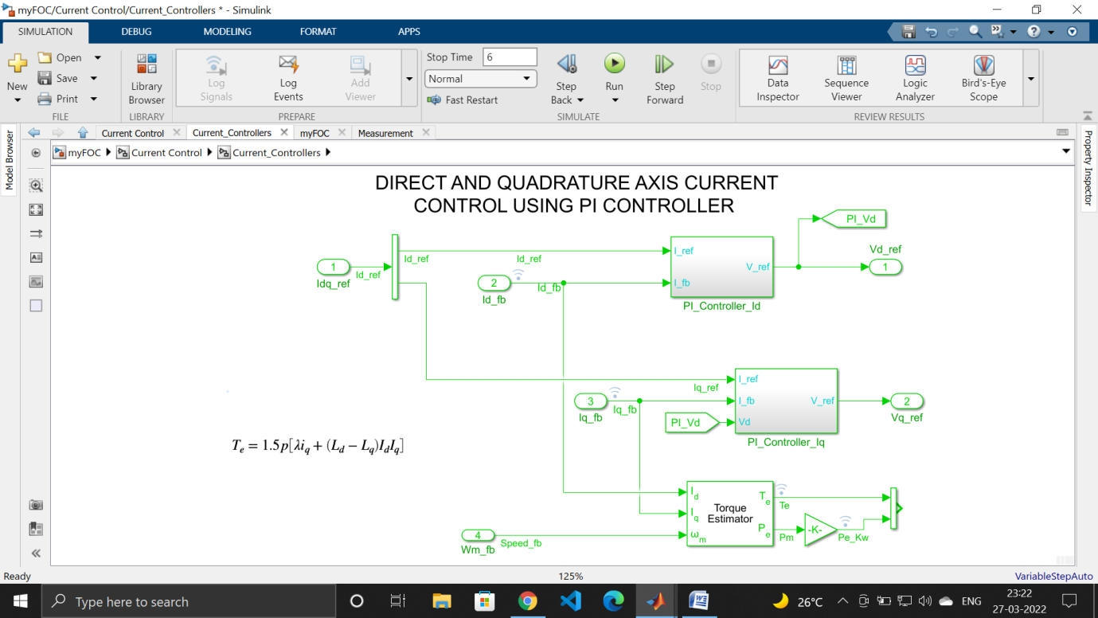

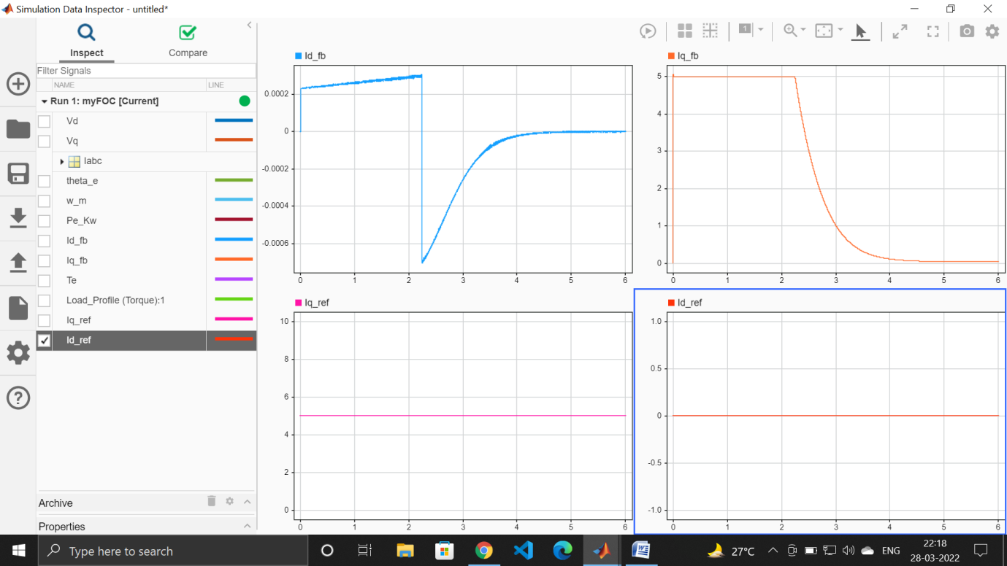

As we can see, I_d is made zero in the steady state, and I_q is made to reach the rated value.

The superset of current control depicting implementation of Clarke and Park transform is as shown:

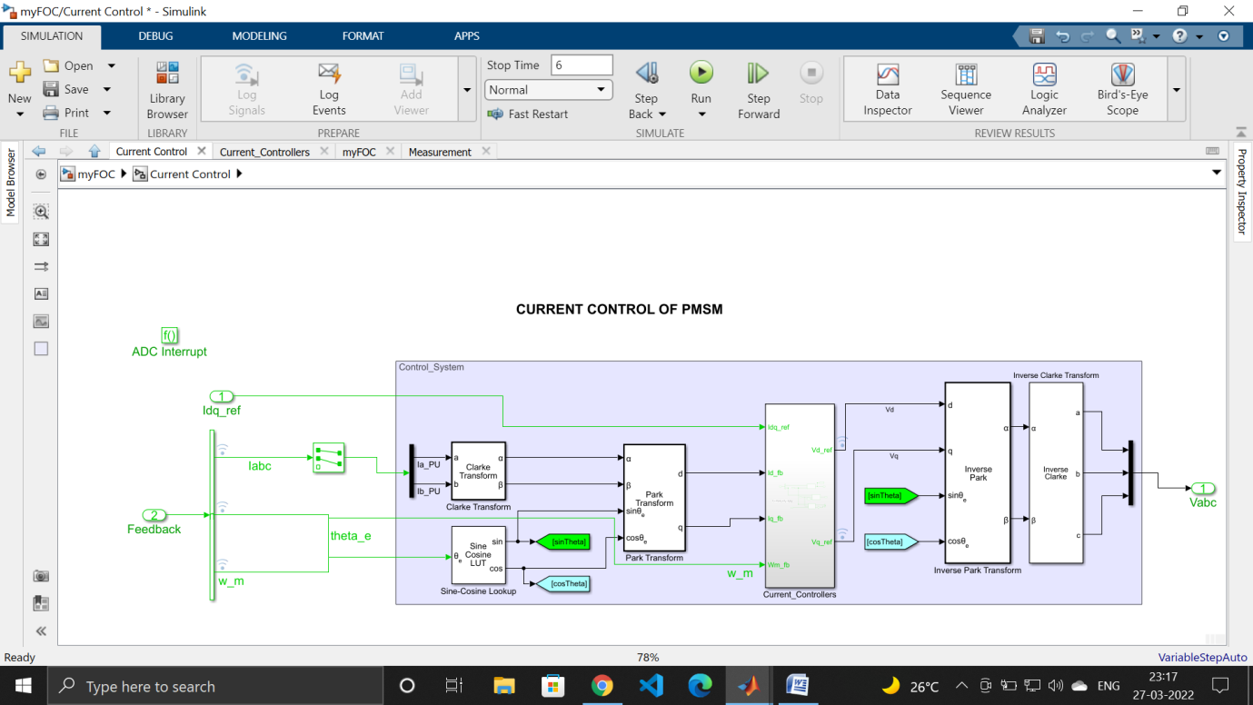

To carry the further simulations, we use an in-built PMSM block as a mathematical model for PMSM. The transient and steady state equations are shown .

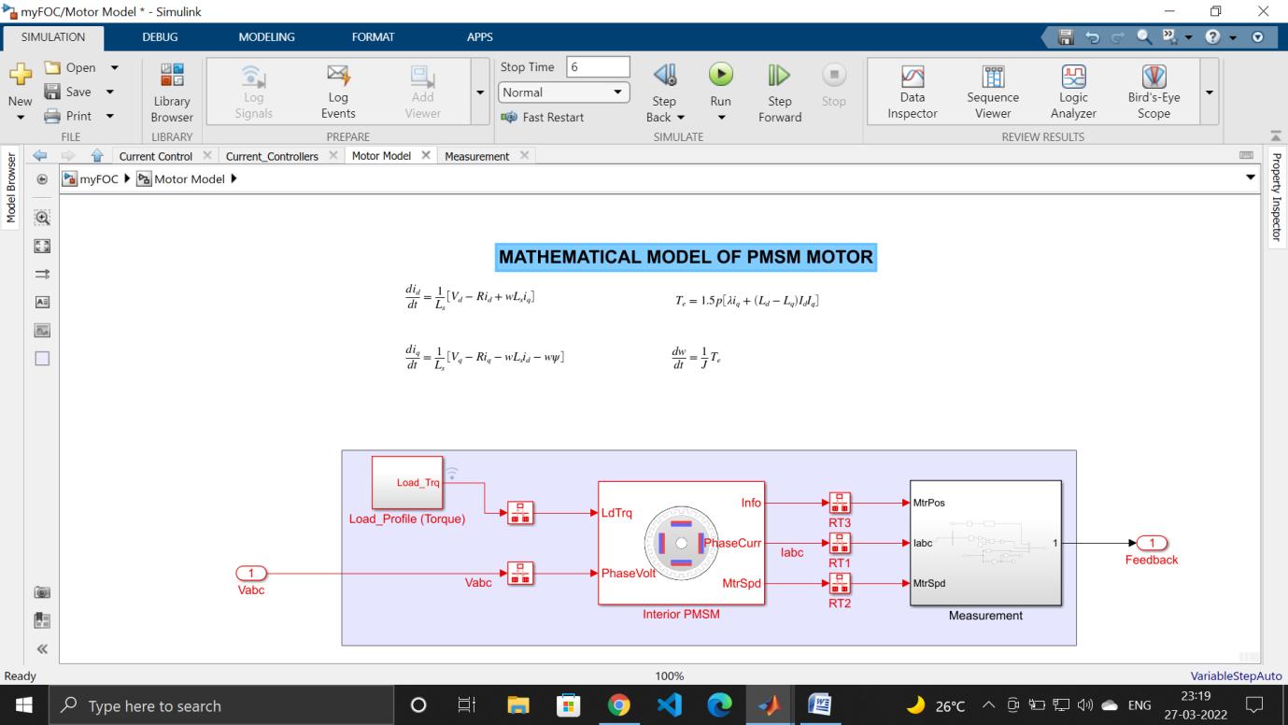

The ultimate superset involving current control and motor control is as shown:

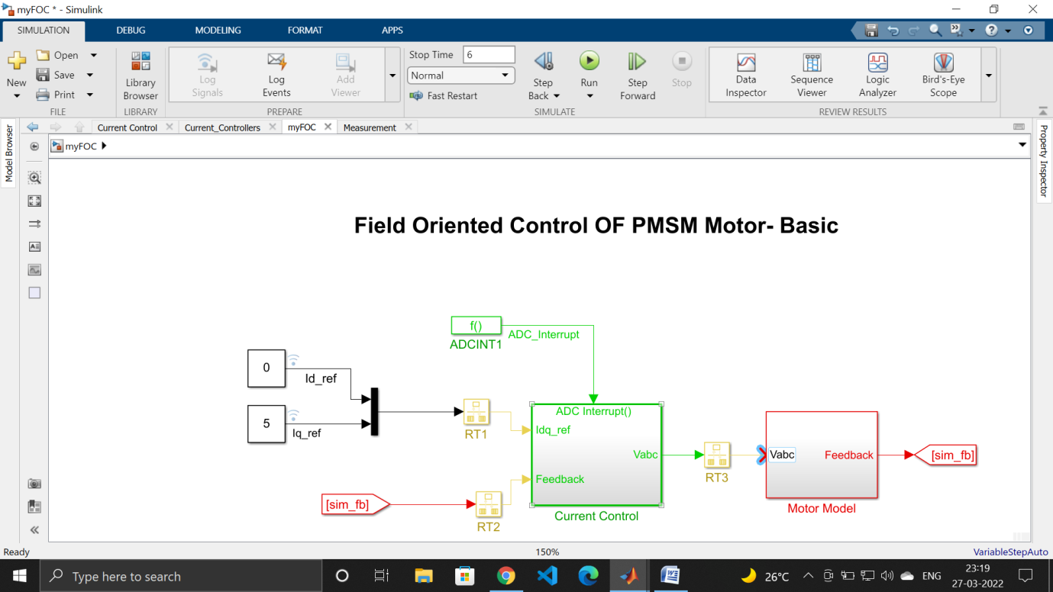

The simulation results showing V_q, w_m and T_e are shown below:

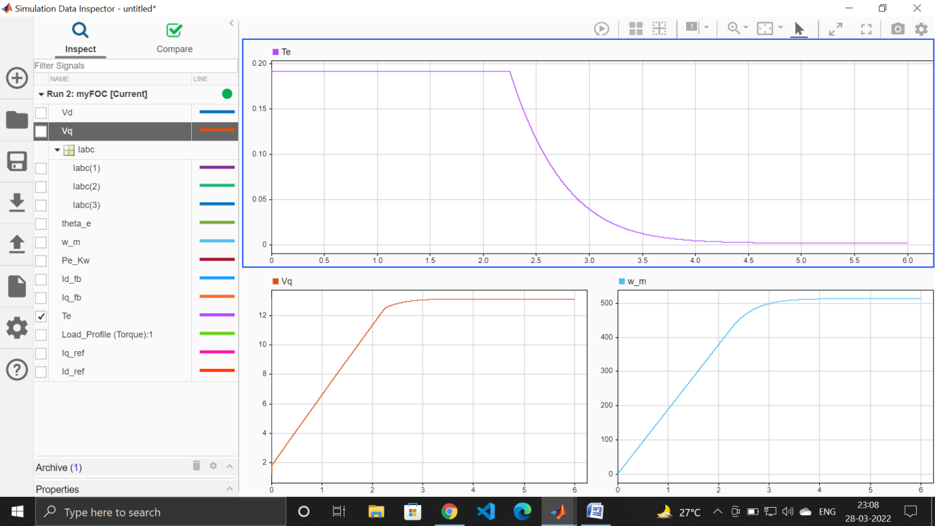

As we can see, motor speed is directly proportional to and follows quadrature axis voltage smoothly and without any ripple, as was not the case with BLDC.

The ADRC model for PMSM is implemented with exactly the same algorithm as that of FOC with one main change: the quadrature axis current which is to be maximized is passed through inbuilt ADRC block imported from ADRC toolbox downloaded from MATLAB add-ons:

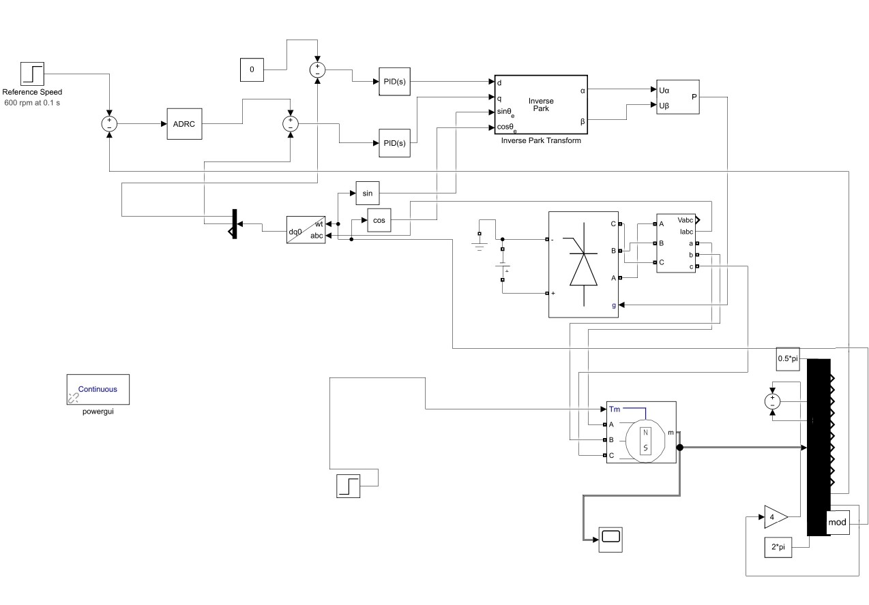

**5. PROJECT VARIATION**

We will be exploring control algorithms other than ADRC like reinforcement learning, Model predictive control etc. and comparing its performance in disturbance rejection to a conventional PI controller in future.

**References**

[1] CACT Archived 2015-04-12 at the Wayback Machine, Center for Advanced Control Technologies, Cleveland State University, USA

[2] Z Gao, Cleveland State University, U.S.A.; Bao-Zhu Guo, University of the Witwatersrand, South Africa, “*Active Disturbance Rejection Control*”, 2014 IFAC World Congress.

[3] G Herbst*, A Simulative Study on Active Disturbance Rejection Control (ADRC) as a Control Tool for Practitioners*.

[4]D Lin; W Luo; Hao Zhang, “*Active disturbance rejection controller of BLDCM in electric vehicle*”, 2011 International Conference on Electrical Machines and Systems.

[5] AMishra, P Agarwal, S.P. Srivastava ;“*A comprehensive analysis and implementation of vector control of permanent magnet synchronous motor*”, researchgate.net

[6] Y Guo; Biao Tang; J Gong; Tao S; “*Research on Speed Control System of PMSM Based on Active Disturbance Rejection Control”;* IEEE 2020

[7] Tiago P. Nascimento, Martin Saska; *Position and attitude control of multi-rotor aerial vehicles*: A survey in Annual Reviews in Control, 2019

[8]R Fareh,MAlShabi*;“Robust Active Disturbance Rejection Control For Flexible Link Manipulator”;* researchgate.net

[9], Han J. From PID to active disturbance rejection control[J]. IEEE transactions on Industrial Electronics, 2009, 56(3): 900-906.

[10] Guo, Bao-Zhu, and Zhi-Liang Zhao. "On convergence of tracking differentiator." International Journal of Control 84.4 (2011): 693-701.

[11]ADRC-Based Speed Control for Permanent Magnet Synchronous Machine Drives Using Sliding-Mode Extended State Observer.

[12]Isa, S.N.M.; Ibrahim, Z.; Patkar, F. “Comparative study of fuzzy logic speed controller in vector controlled PMSM drive: minimum number of fuzzy rule-base”,proceeding of the CITISIA , 25-26 July, 2009, pp.112 – 118

[13]Eung-SeopAn, et. al “System identification and two DOF PID controller design for an industrial sewing machine”, IndustrialElectronics Society, 2003. IECON’03. The 29th Annual Conference of the IEEE, Vol. 2, Nov. 2003, pp. 1557-1563

[14]Poovizhi, M., et al. "Investigation of mathematical modelling of brushless dc motor (BLDC) drives by using MATLAB-SIMULINK." *2017 International Conference on Power and Embedded Drive Control (ICPEDC)*.IEEE, 2017.

[15] Krishnan, P. Hari, and M. Arjun. "Control of BLDC motor based on adaptive fuzzy logic PID controller." *2014 International Conference on Green Computing Communication and Electrical Engineering (ICGCCEE)*.IEEE, 2014.

[16]H. V. Nguyen, T. Vo-Duy and M. C. Ta, "Comparative Study of Disturbance Observer-Based Control and Active Disturbance Rejection Control in Brushless DC Motor Drives," 2019 IEEE

[17] S. Sakunthala, R. Kiranmayi and P. N. Mandadi, "A study on industrial motor drives: Comparison and applications of PMSM and BLDC motor drives," 2017 International Conference on Energy, Communication, Data Analytics and Soft Computing (ICECDS), 2017, pp. 537-540, doi: 10.1109/ICECDS.2017.8390224.