**\* Instructions for using StdConn.java file, which is basically single threaded file sharing method :**

1>first of all the application asks the ip on which it is running

that can be found in network settings.

2>Then the application asks for the place where you want to store all the incoming files.

any folder can be given here with complete location and forward slashes.

3>At any time you want to send file write "send" on console.

then the application will ask for receiver's IP and the file that is to be send. here file must be

specified with complete path and forward slashes.

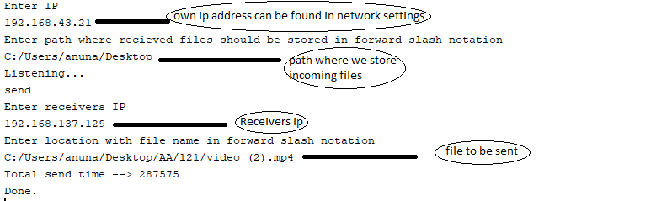Example input:

**\* Instructions for using MultithreadSend.java file and MultithreadReceive.java, which is multi threaded file sharing method :**

MultithreadSend.java must be run on senders computer

MultithreadReceive.java must be run on receiver computer.

1. Open hotspot of the computer you want to perform the role of Receiver

2. connect to hotspot from other computer (the Sender)

3. turn off window firewalls, as it may prevent from establishing connection.

4. open command prompt, compile and run the MultithreadApp.java program

a. it will give two option to either become a sender or receiver

b. if sender option is chosen, then it will ask you to select a file you want to share

c. and also ask whether you want to manually enter receiver ip or let the code automatically try to detect receiver address.

5. open command prompt in the other computer, compile and run the MultithreadApp.java program

a. choose the receiver option and process will start listening for some incoming socket request

6. after sharing gets complete, file will be saved in the same directory where MultithreadApp.java program is stored

7. also the console will show ---> total time taken to send the file