System.setProperty("webdriver.chrome.driver",/chromedriver.exe");

WebDriver driver = new ChromDriver;

driver.switchTo().alert().accept(); //ok

driver.switchTO()alert().dismiss(); //cancel

id

class

name

xpath

cssname

tagname

linktext

partiallinktext

To handle windows based popup

Auto it

Power shell

robot class

getWindowhandle

** Take screen shot

File File = ((TakesScreenshot)driver)

.getScreenshotAs(OutputType.FILE);

FileUtils.copyFile(File,

new File("image location"

+ FileName + ".jpeg"));

Acceptence testing

black box

White box

Load testing

Stress testing

What is Performance Testing?

Performance testing is the general name for tests that check how the system behaves and performs.

Software performance testing examines responsiveness, stability, scalability, reliability, speed,

and resource usage of your software and infrastructure.

What is Load Testing

Load testing is a type of performance in Load testing we check

how the system behaves when multiple users are trying to engage with it at the same time.

isme ek limit tak end user hote hai

What is Stress Testing?

A stress test is a type of performance test that checks the upper limits of your system by testing it under extreme loads

isme koi limit nahi hoti hai

What is Functional Testing?

Functional testing is a type of testing which verifies that each function of the software application operates in conformance with the requirement specification.

This testing mainly involves black box testing, and it is not concerned about the source code of the application.

Every functionality of the system is tested by providing appropriate input, verifying the output and comparing the actual results with the expected results.

This testing involves checking of User Interface, APIs, Database, security, client/ server applications and functionality of the Application Under Test.

The testing can be done either manually or using automation

What is Non-Functional Testing?

Non-functional testing is a type of testing to check non-functional aspects (performance, usability, reliability, etc.) of a software application.

It is explicitly designed to test the readiness of a system as per nonfunctional parameters which are never addressed by functional testing.

Key Difference Between Functional Testing and Non Functional Testing

1 Functional testing verifies each function/feature of the software whereas Non Functional testing verifies non-functional aspects like performance, usability, reliability, etc.

2 Functional testing can be done manually whereas Non Functional testing is hard to perform manually.

3 Functional testing is based on customer’s requirements whereas Non Functional testing is based on customer’s expectations.

4 Functional testing has a goal to validate software actions whereas Non Functional testing has a goal to validate the performance of the software.

5 A Functional Testing example is to check the login functionality whereas a Non Functional testing example is to check the dashboard should load in 2 seconds.

6 Functional describes what the product does whereas Non Functional describes how the product works.

7 Functional testing is performed before the non-functional testing.

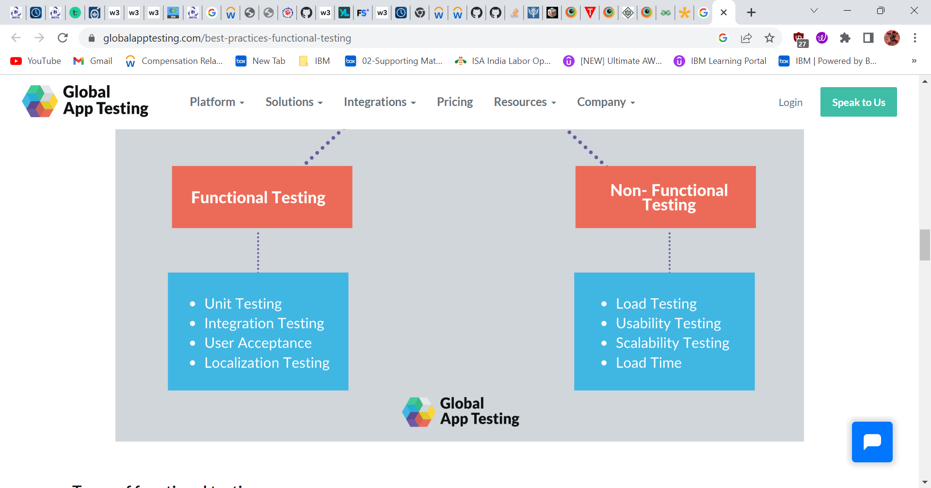

What is integration testing

Integration testing is the second level of the software testing process comes after unit testing. In this testing, units or individual components of the software are tested in a group. The focus of the integration testing level is to expose defects at the time of interaction between integrated components or units.

The goal of integration testing is to check the correctness of communication among all the modules. Once all the components or modules are working independently, then we need to check the data flow between the dependent modules is known as **integration testing**.

Parallel Testing using TestNG and Selenium

[TestNG](https://www.browserstack.com/guide/testng-framework-with-selenium-automation) is a testing framework for Java that helps to organize tests in a structured way and enhances maintainability and readability to the scripts. TestNG has made it easier for automation testers owing to its large feature set. One of which is parallel testing or parallel execution. TestNG provides an auto-defined XML file, where one can set the parallel attribute to method/tests/classes and by using the concept of multi-threading of Java, one can set the number of threads, one wants to create for parallel execution. Below is the structure for defining this attribute in the TestNG XML:

<suite name="Parallel_Testing" parallel="methods" thread-count="2">

The parallel attribute can be extended for multiple values, as below:

* **Methods**: Helps run methods in separate threads
* **Tests**: Help to run all methods belonging to the same tag in the same thread
* **Classes**: Helps to run all methods belonging to a class in a single thread
* **Instances**: Helps run all methods in the same instance in the same thread

WebDriver

1.It is an interface which perform action on

2.Ex:open,close,get,navigate,maximize.

WebElement

1.It is an interface which perform action on browser. Elements of browser

2.Ex:dropdown,radiobutton,checkbox,table.

driver. Manage().window().maximize() ;

## What is XPath Contains?

**XPath contains** is a function within Xpath expression which is used to search for the web elements that contain a particular text. We can extract all the elements that match the given text value using the XPath contains() function throughout the webpage. Contains in XPath has ability to find the element with partial text.

**Example – contains text**  
Here we are searching an anchor .contains text as ‘SAP M’.

"//h4/a[contains(text(),'SAP M')]"

