SQL

There are four different types of JOINs in SQL:

* **(INNER) JOIN:** Retrieves records that have matching values in both tables involved in the join. This is the widely used join for queries.

**SELECT** *

**FROM** Table_A

**JOIN** Table_B;

**SELECT** *

**FROM** Table_A

**INNER** **JOIN** Table_B;

* **LEFT (OUTER) JOIN:**Retrieves all the records/rows from the left and the matched records/rows from the right table.

**SELECT** *

**FROM** Table_A A

**LEFT** **JOIN** Table_B B

**ON** A.col = B.col;

* **RIGHT (OUTER) JOIN:**Retrieves all the records/rows from the right and the matched records/rows from the left table.

**SELECT** *

**FROM** Table_A A

**RIGHT** **JOIN** Table_B B

**ON** A.col = B.col;

* **FULL (OUTER) JOIN:**Retrieves all the records where there is a match in either the left or right table.

**SELECT** *

**FROM** Table_A A

**FULL** **JOIN** Table_B B

**ON** A.col = B.col;

**What is a Self-Join?**

A**self JOIN** is a case of regular join where a table is joined to itself based on some relation between its own column(s). Self-join uses the INNER JOIN or LEFT JOIN clause and a table alias is used to assign different names to the table within the query.

**SELECT** A.emp_id **AS** "Emp_ID",A.emp_name **AS** "Employee",

B.emp_id **AS** "Sup_ID",B.emp_name **AS** "Supervisor"

**FROM** employee A, employee B

**WHERE** A.emp_sup = B.emp_id;

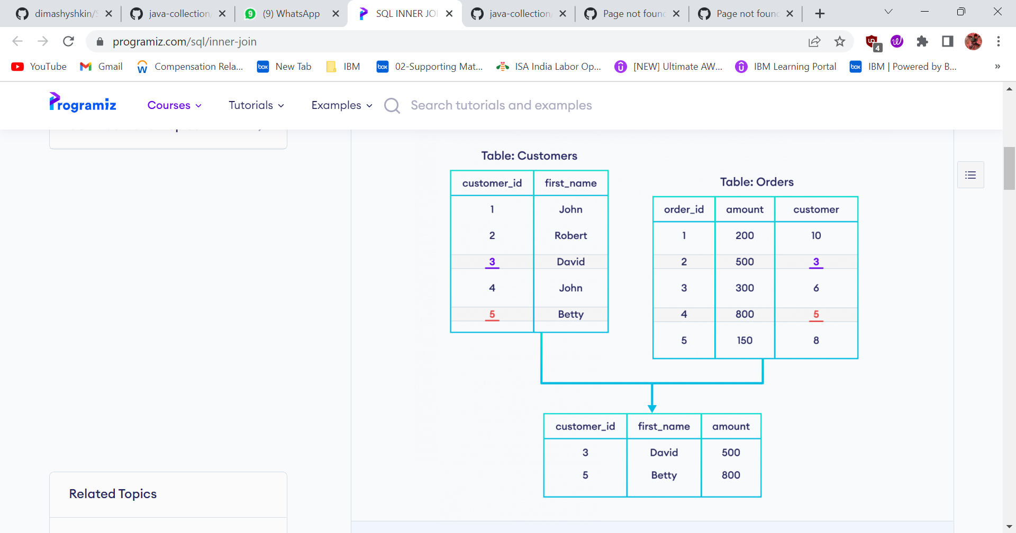

Inner join Query

Select Customer.customer_id ,Customer.first_name ,Orders.amount

Frome Customer

Inner join Orders

On Customer.customer_id = Orders.customer

ON – ON Clause can be used to join columns that have different name

We use ON clause to specify a join condition

Left Outer join

Select *

From Customers

Left join Orders

ON Customers.customer_id = Orders.customer

SELECT Customers.customer_id, Customers.first_name, Orders.amount

FROM Customers

LEFT JOIN Orders

ON Customers.customer_id = Orders.customer

WHERE Orders.amount >= 500;

Right Outer join

SELECT Customers.customer_id, Customers.first_name, Orders.amount

FROM Customers

RIGHT JOIN Orders

ON Customers.customer_id = Orders.customer

WHERE Orders.amount >= 500;