**Assignment - 3**

Name : Abhishek satapure

1. **Searching Algorithm**
2. Binary search:

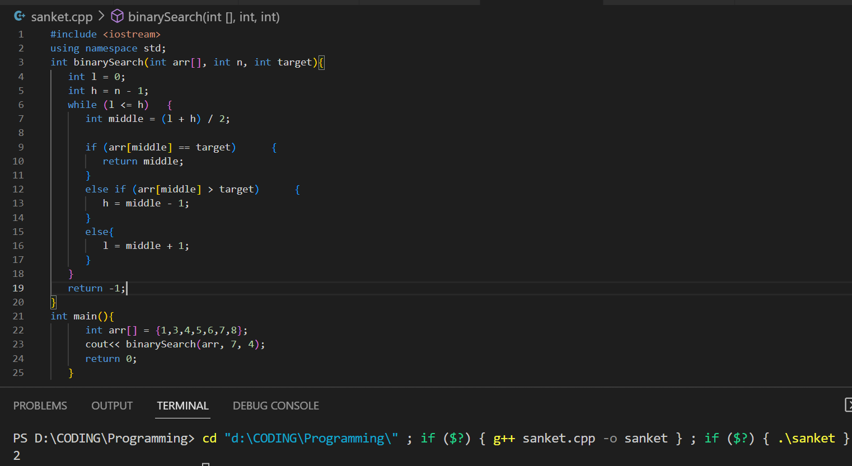

1. Linear search

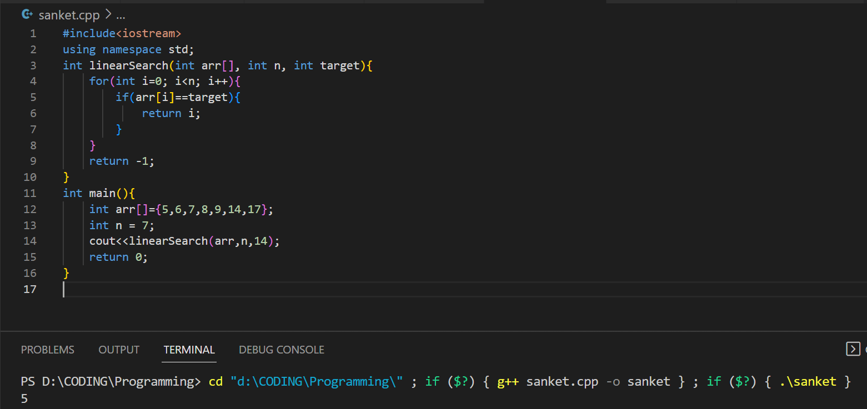

1. Recursive Search:

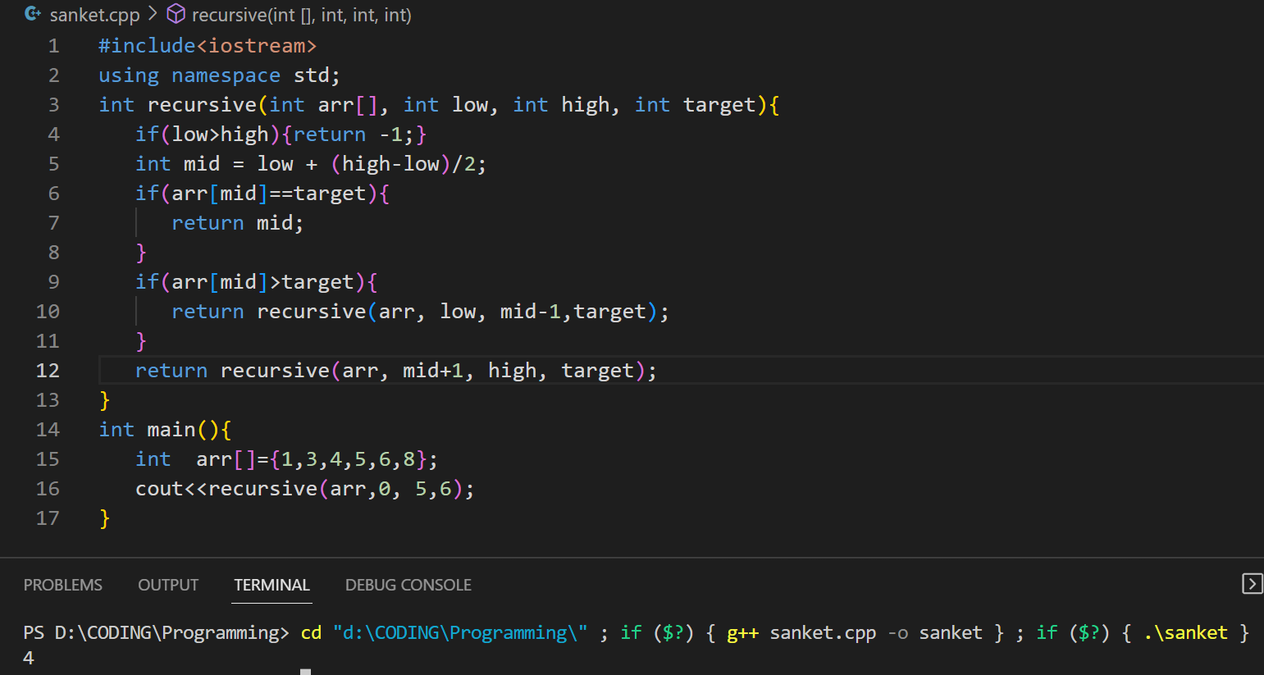

1. Sorting Algorithm:
2. Insertion sort:

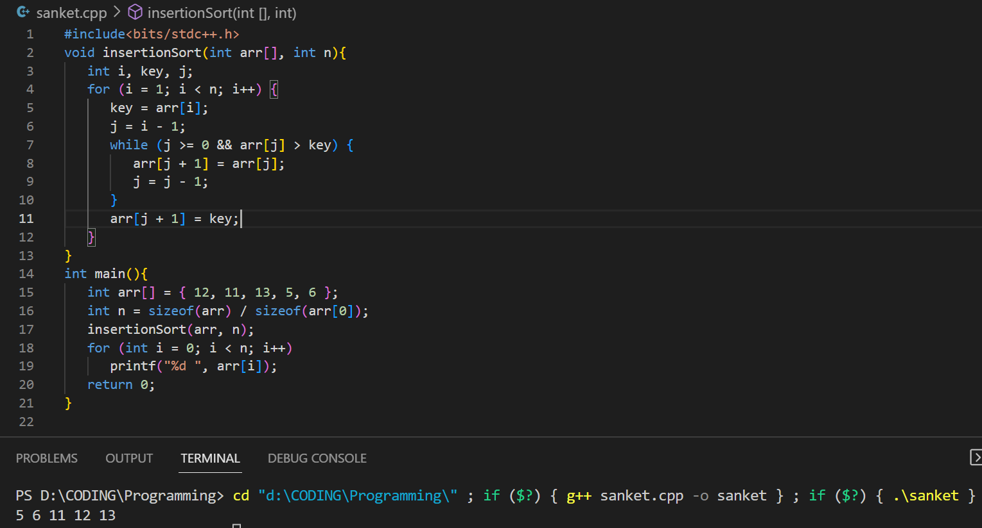

1. Selection sort:

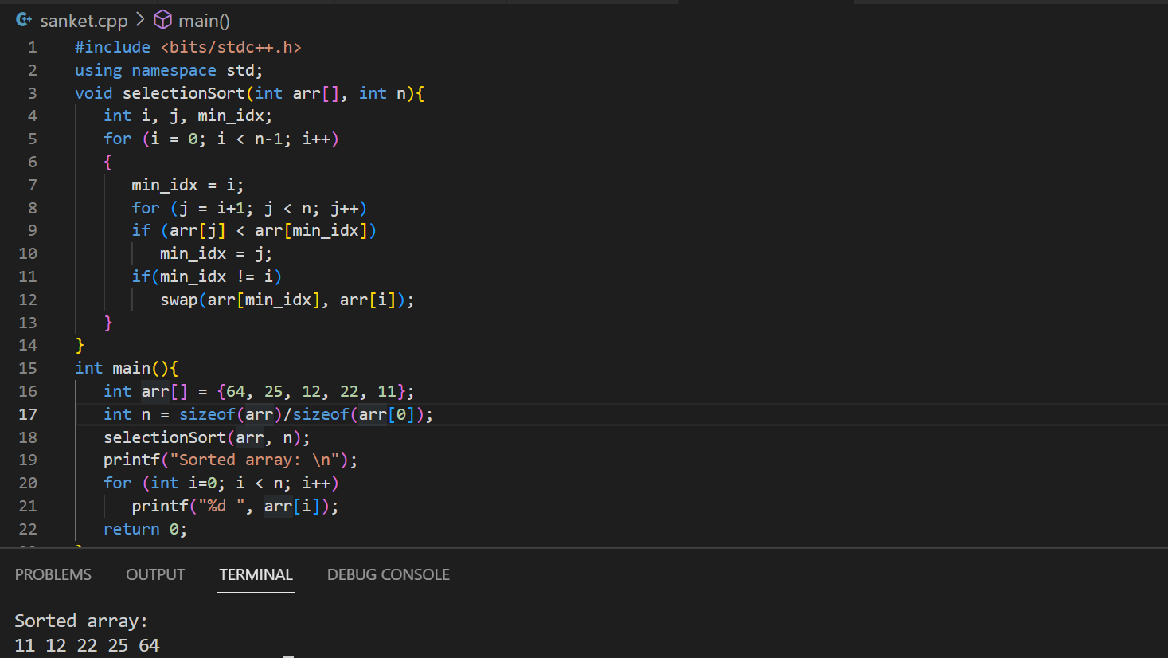

1. Bubble Sort:

