[](https://www.instagram.com/unknown_account835/)[](https://www.facebook.com/profile.php?id=100063712182245)

Name: Abhishek Adhikari

Class: Foundation Group 37A

Email: [adhikaryabhishek209@gmail.com](mailto:adhikaryabhishek209@gmail.com?subject=Contacting%20you%20from%20the%20project)

Submitted to Rikesh Maharjan

Linux Grasshopper Journey Documentation 3

1. Getting Started: 3

1.1 History 3

1.2 Choosing a Linux Distribution 3

1.3 Debian 4

1.4 Red Hat Enterprise Linux 5

1.5 Ubuntu 5

1.6 Fedora 6

1.7 Linux Mint 7

1.8 Gentoo 7

1.9 Arch Linux 8

1.10 openSUSE 9

2. Command Line: 9

2.1 The Shell 9

2.2 pwd (Print Working Directory) 10

2.3 cd (Change Directory) 11

2.4 ls (List Directories) 11

2.5 touch 12

2.6 file 13

2.7 cat 13

2.8 less 14

2.9 history 15

2.10 cp (Copy) 15

2.11 mv (Move) 16

2.12 mkdir (Make Directory) 17

2.13 rm (Remove) 17

2.14 find 18

2.15 help 19

2.16 man 19

2.17 whatis 20

2.18 alias 21

2.19 exit 21

3. User Management 22

3.1 Users and Groups 22

3.2 root 23

3.3 /etc/passwd 24

3.4 /etc/shadow 25

3.5 /etc/group 26

3.6 User Management Tools 27

4. References 28

# Linux Fundamental Examination

## Setting up the terminal:

Visual: The terminal screen shows the command.

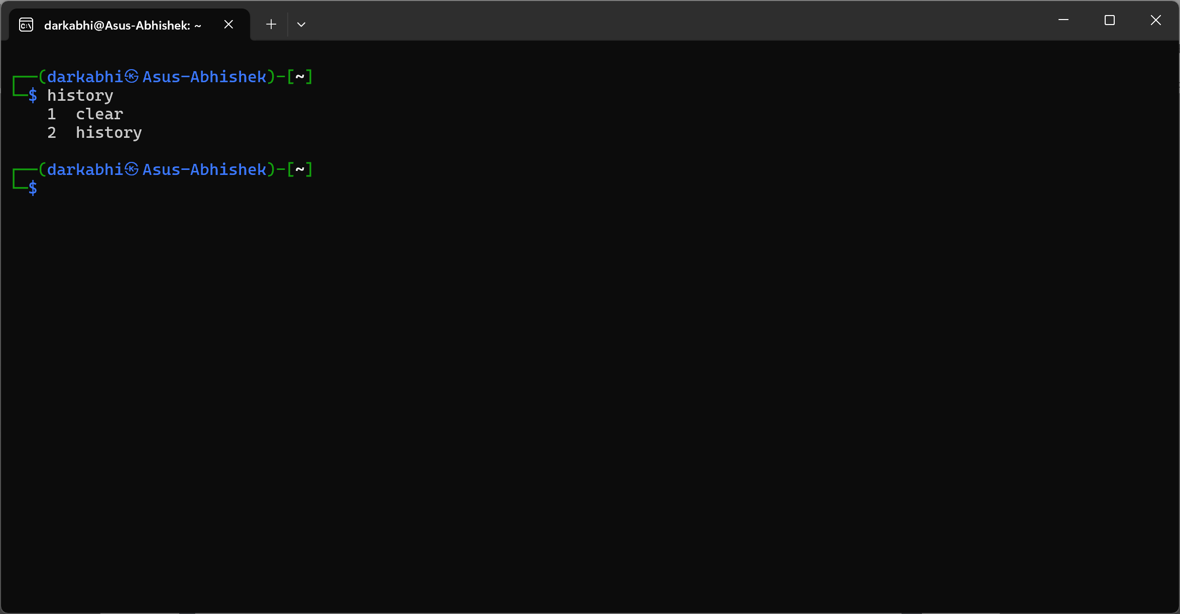

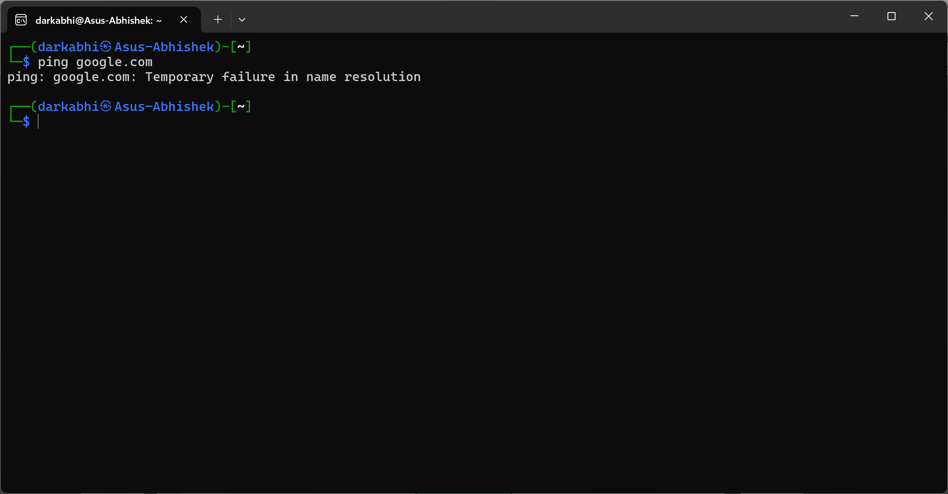

## Create a directory:

### a) What does cut command do with examples?

The ` cut ` command is used to extract sections from each line of files or input data.

* **Example 1:** Extracting characters from position 2 to 8

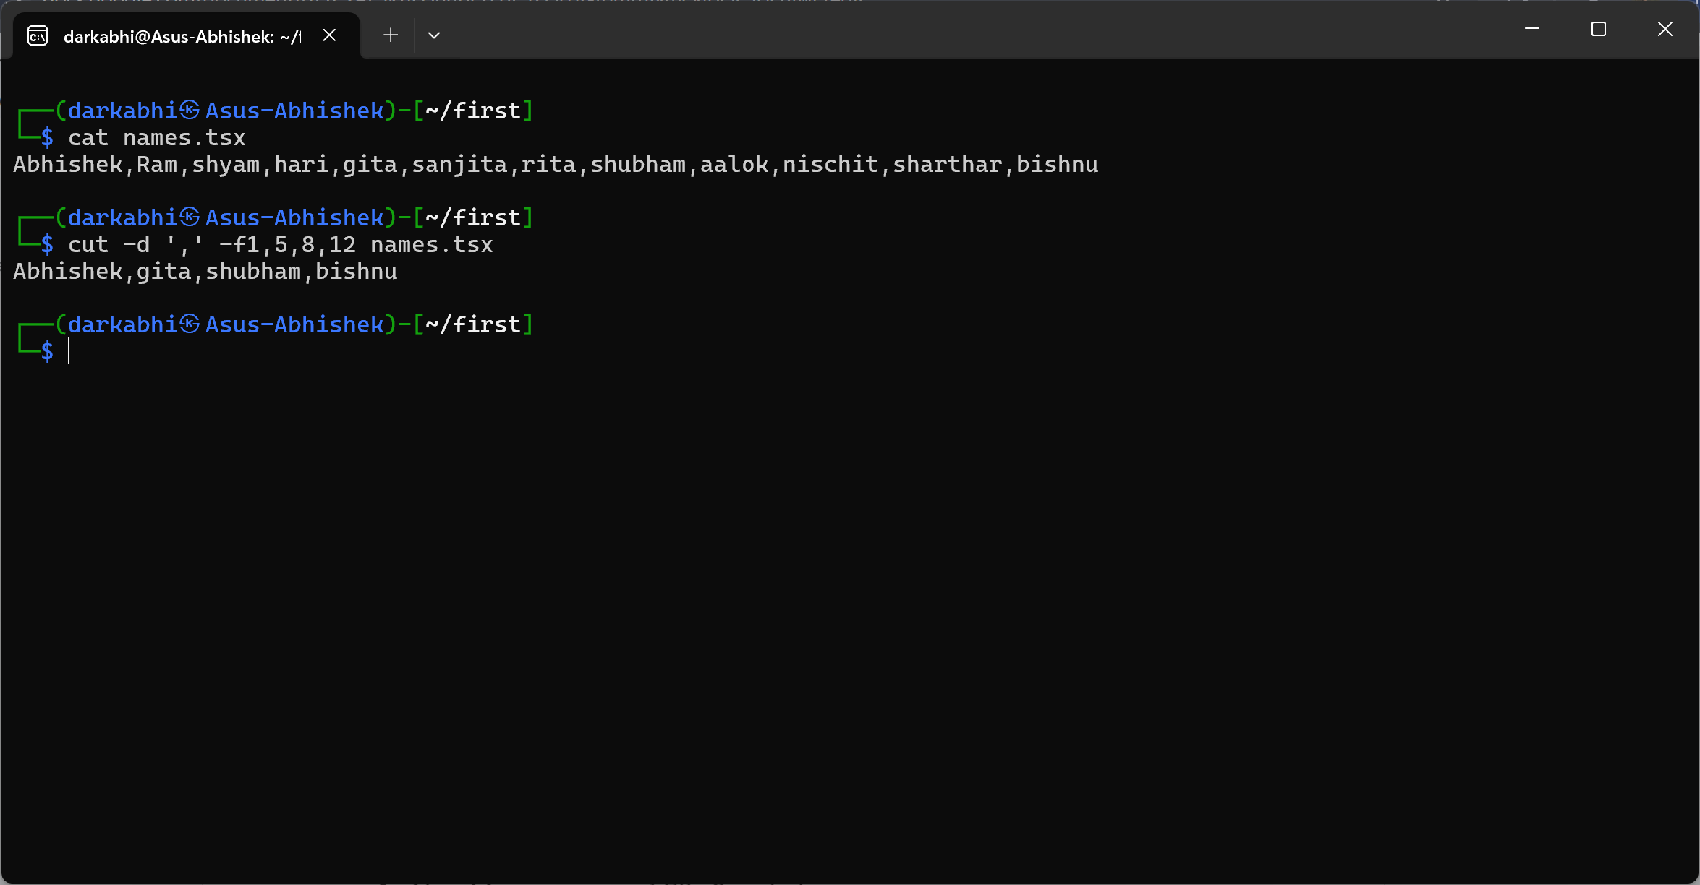

* **Example 2:** Extracting characters from position 2 to 8

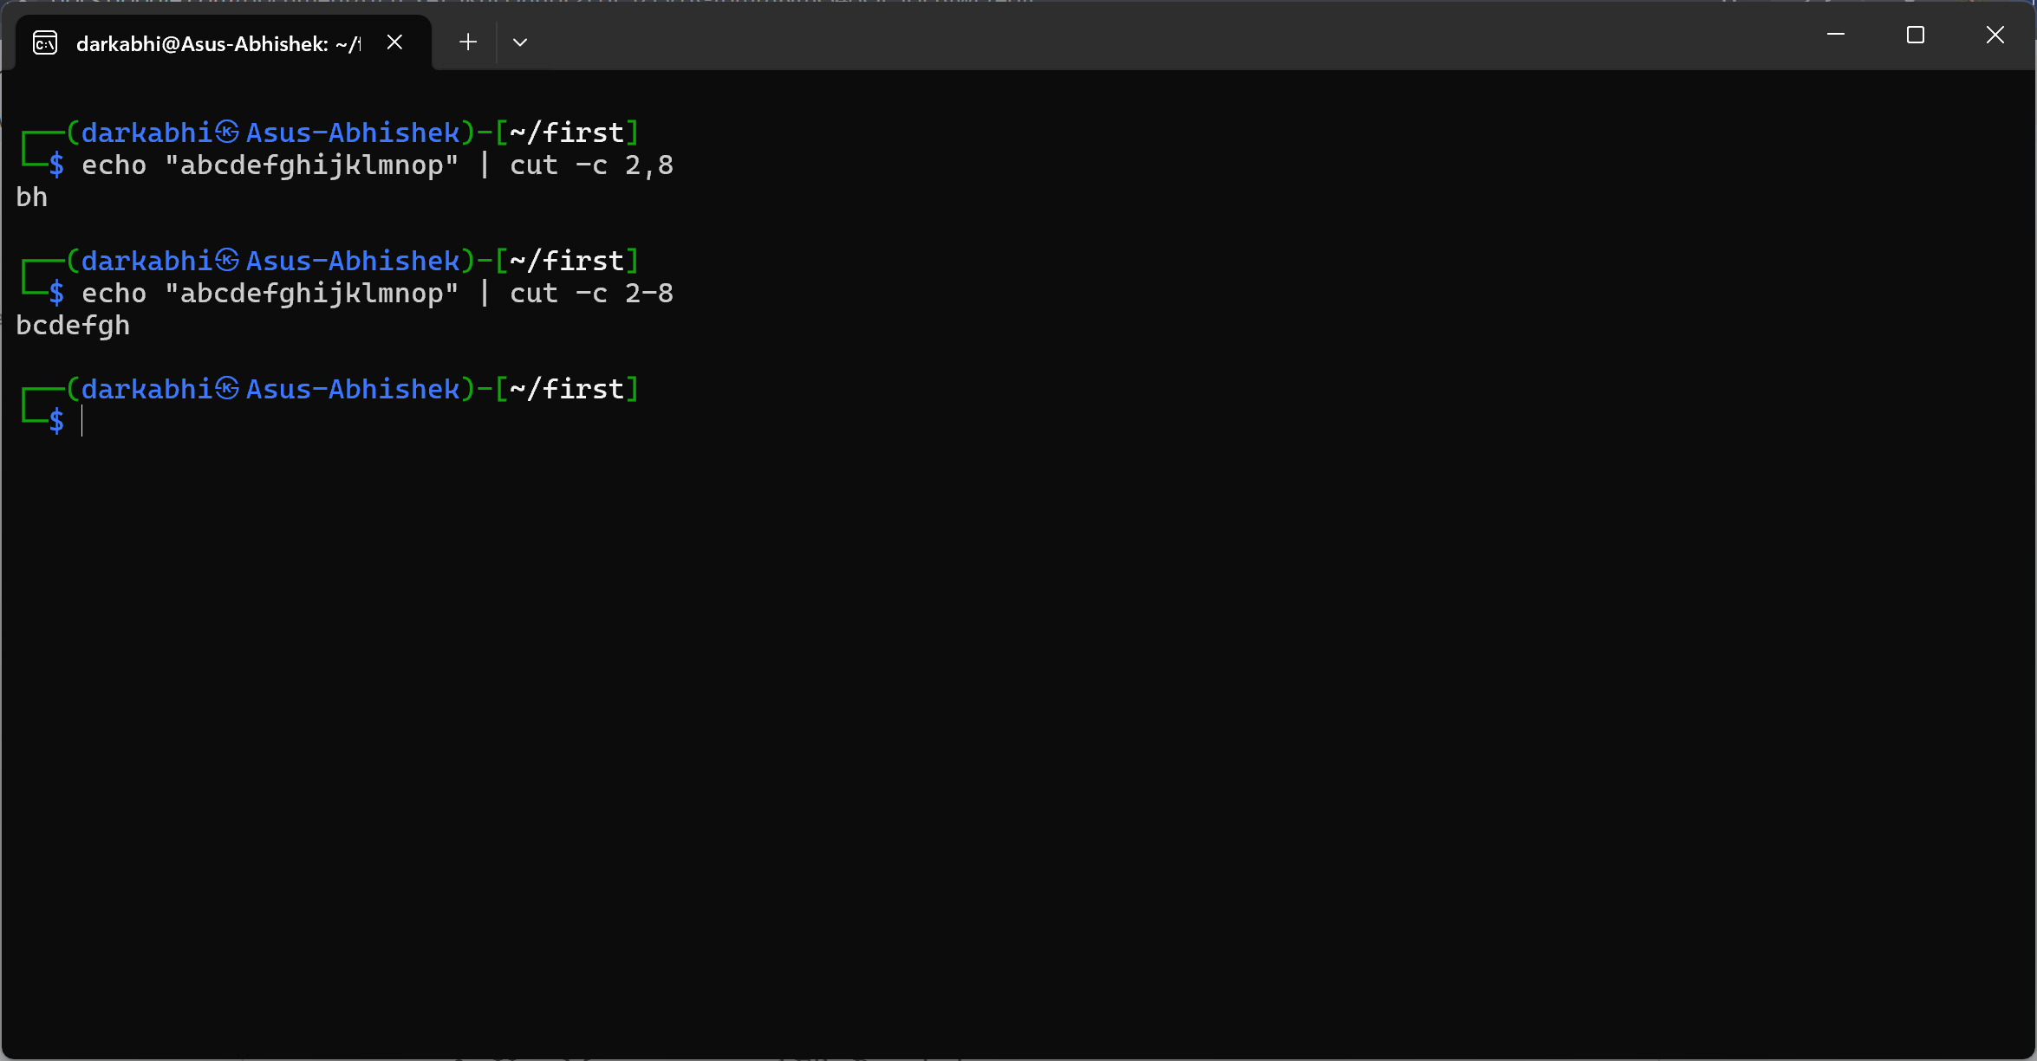

### b) What do grep and find commands do?

The ` grep ` command is used to search for patterns within files.

* **Example 1:** Search for a string in all files within a directory:

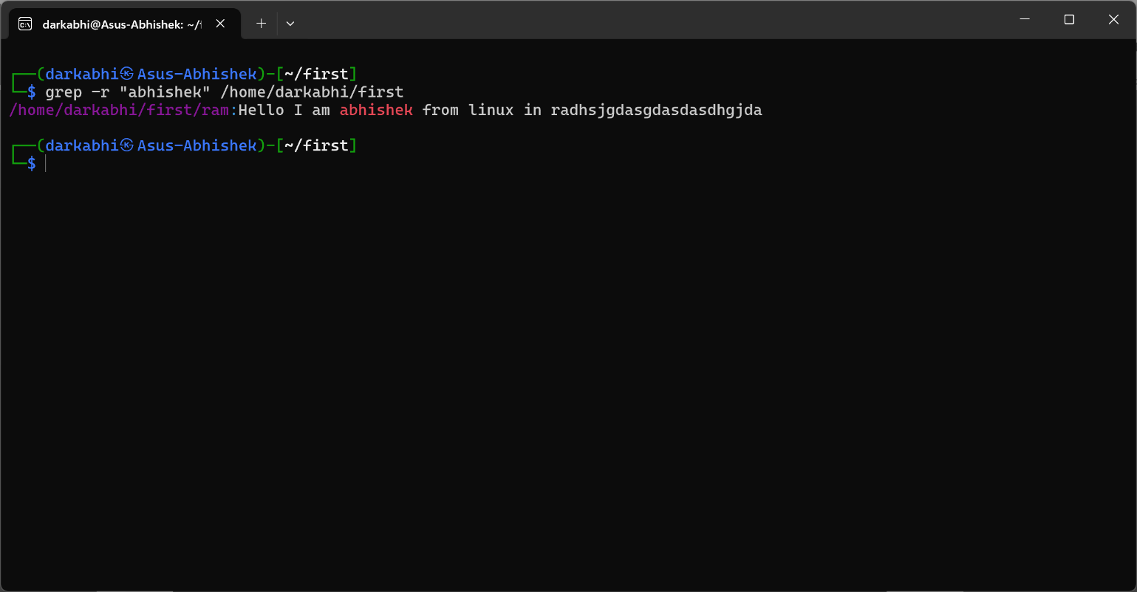

The ` find ` command is used to search for and directories in a directory.

* **Example 1:** Find all .tsx files in the /home/darkabhi directory:

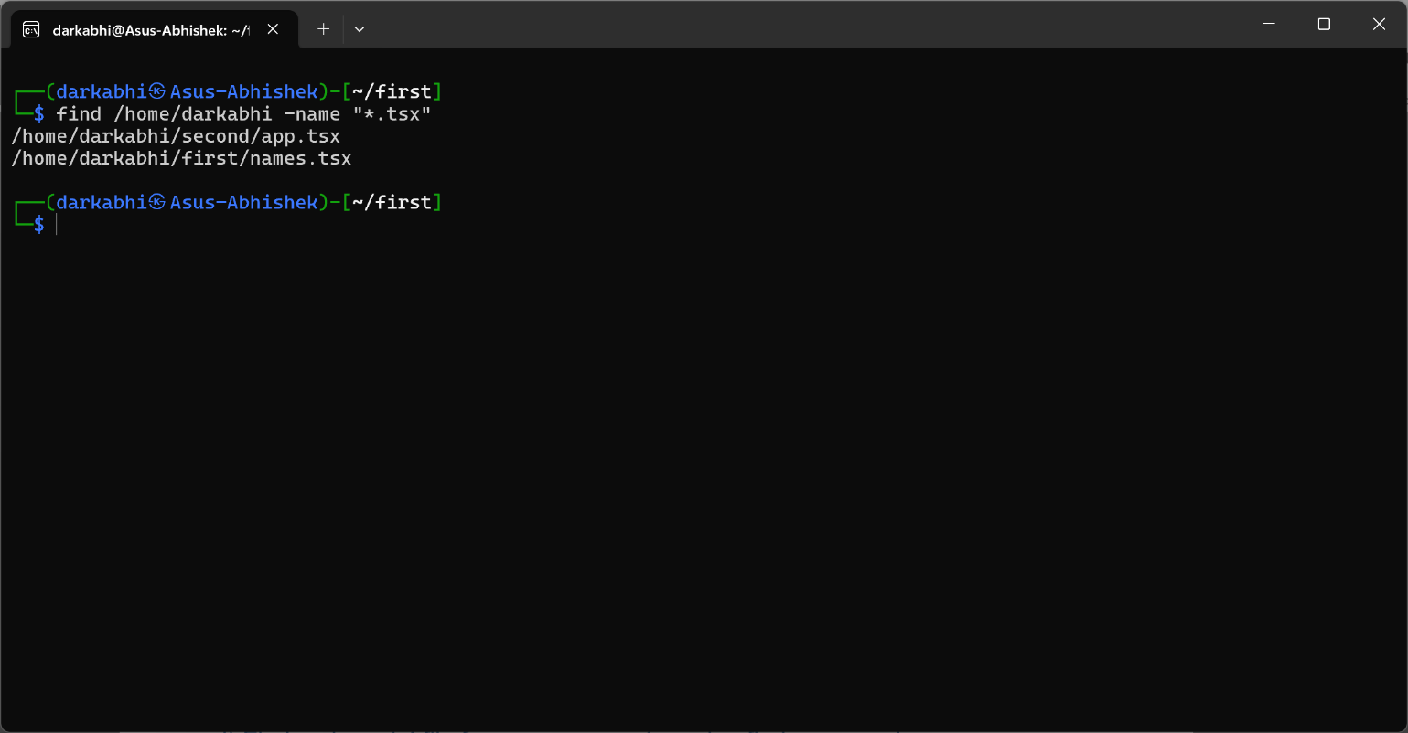

* **Example 2:** Find files modified in the last 7 days:

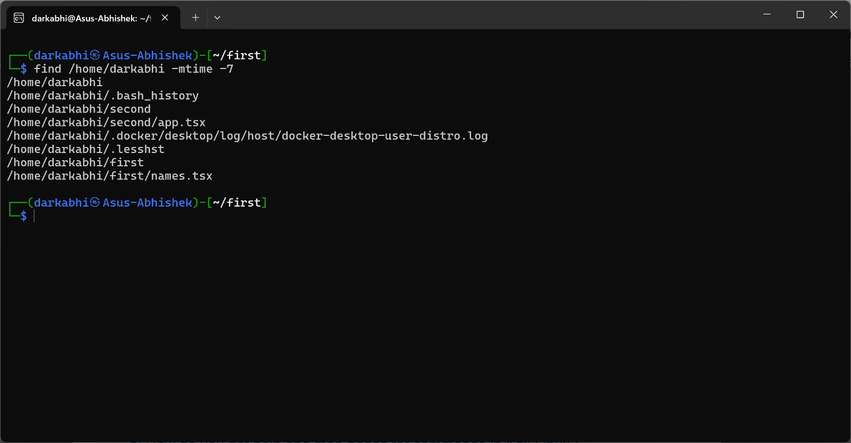

### c) How do you get help and man pages for commands in Kali Linux?

The ` man ` command is to get help and man pages for commands:

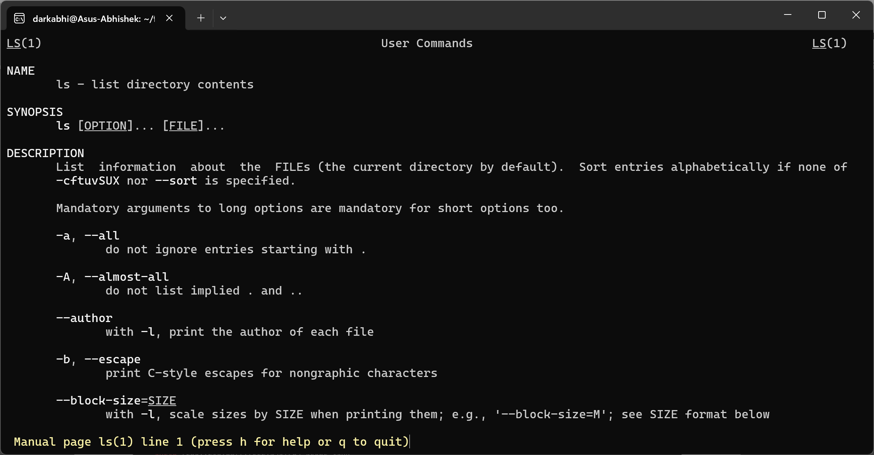

### d) Find rockyou.txt file from your computer using find command

* Visual: The terminal screen shows the command.

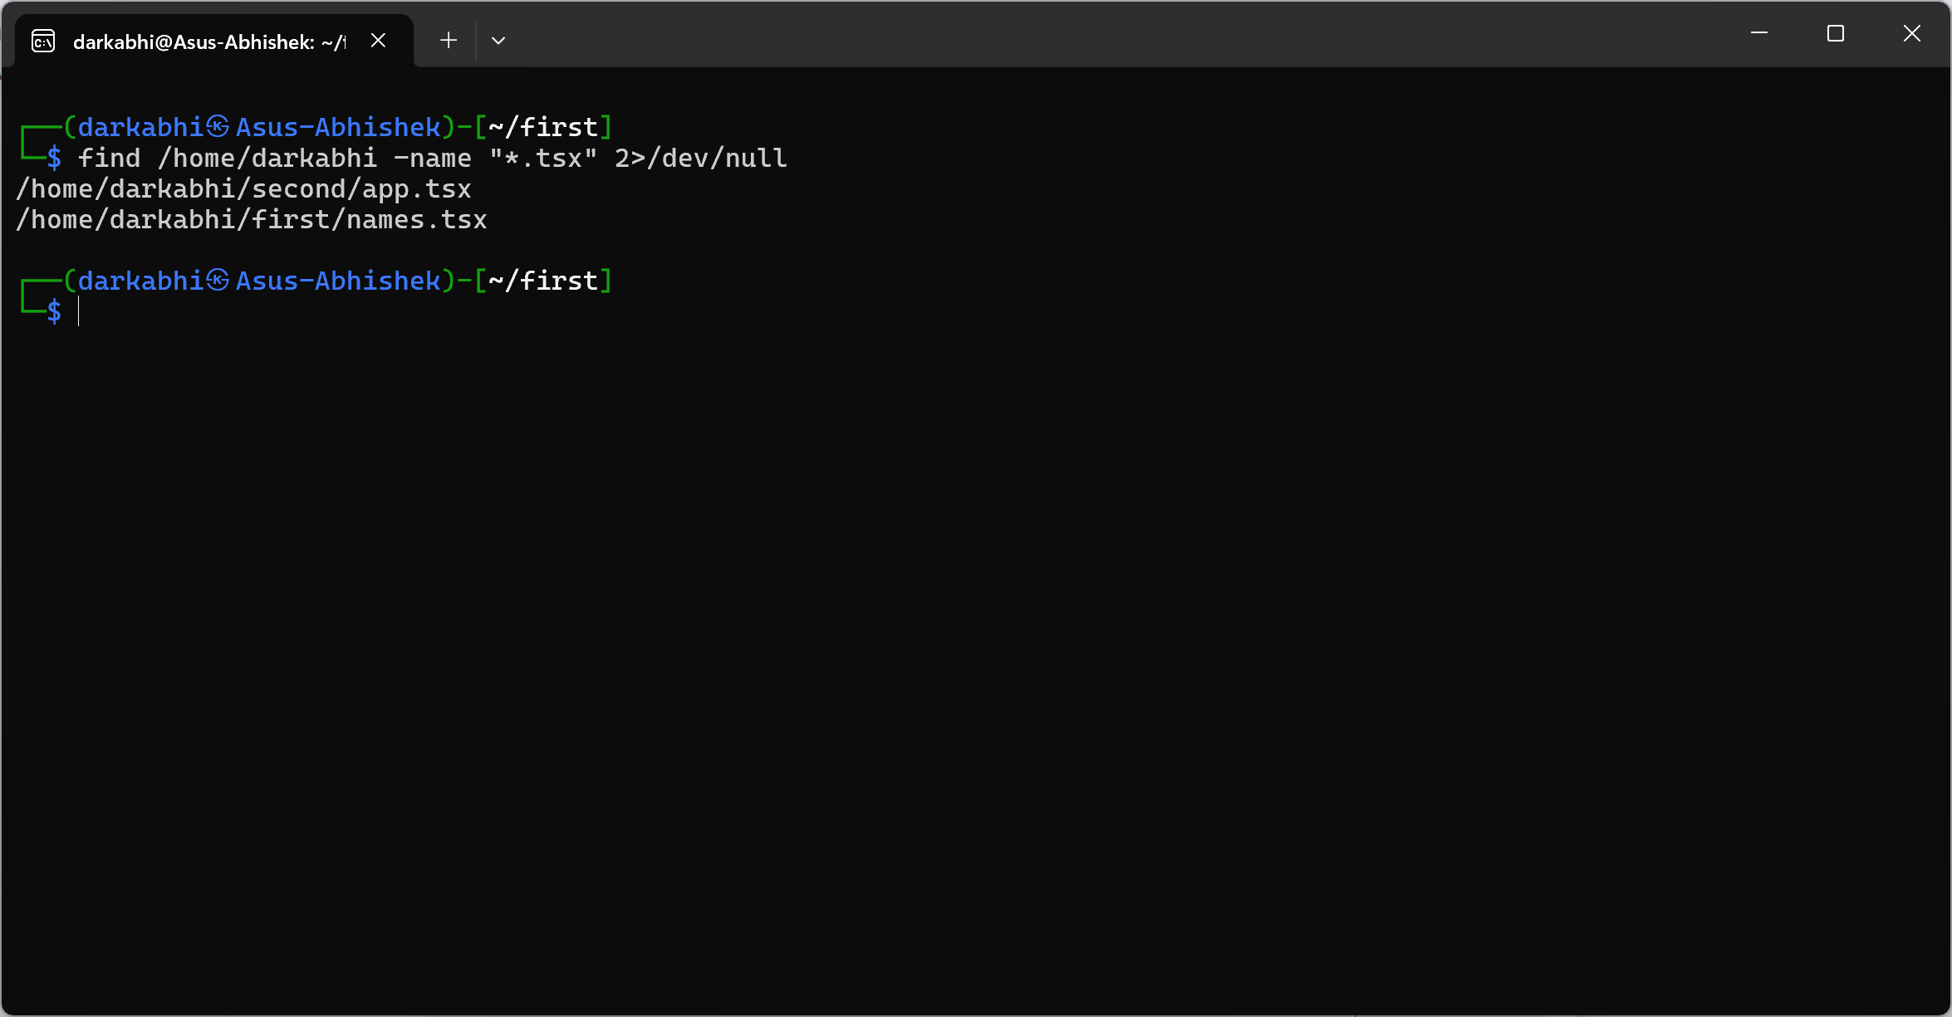

### e) Get an Ipv6 only from your devices using cut command

To get only the IPv6 address:

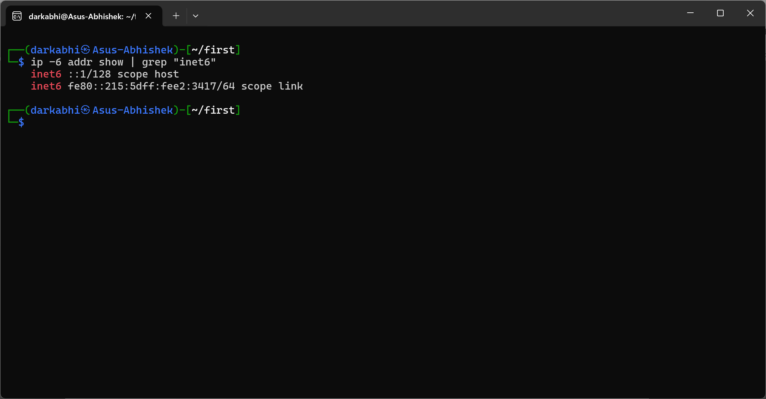

## Standard Redirection:

### a) Display the contents of a text file 'data.log' onto the terminal.

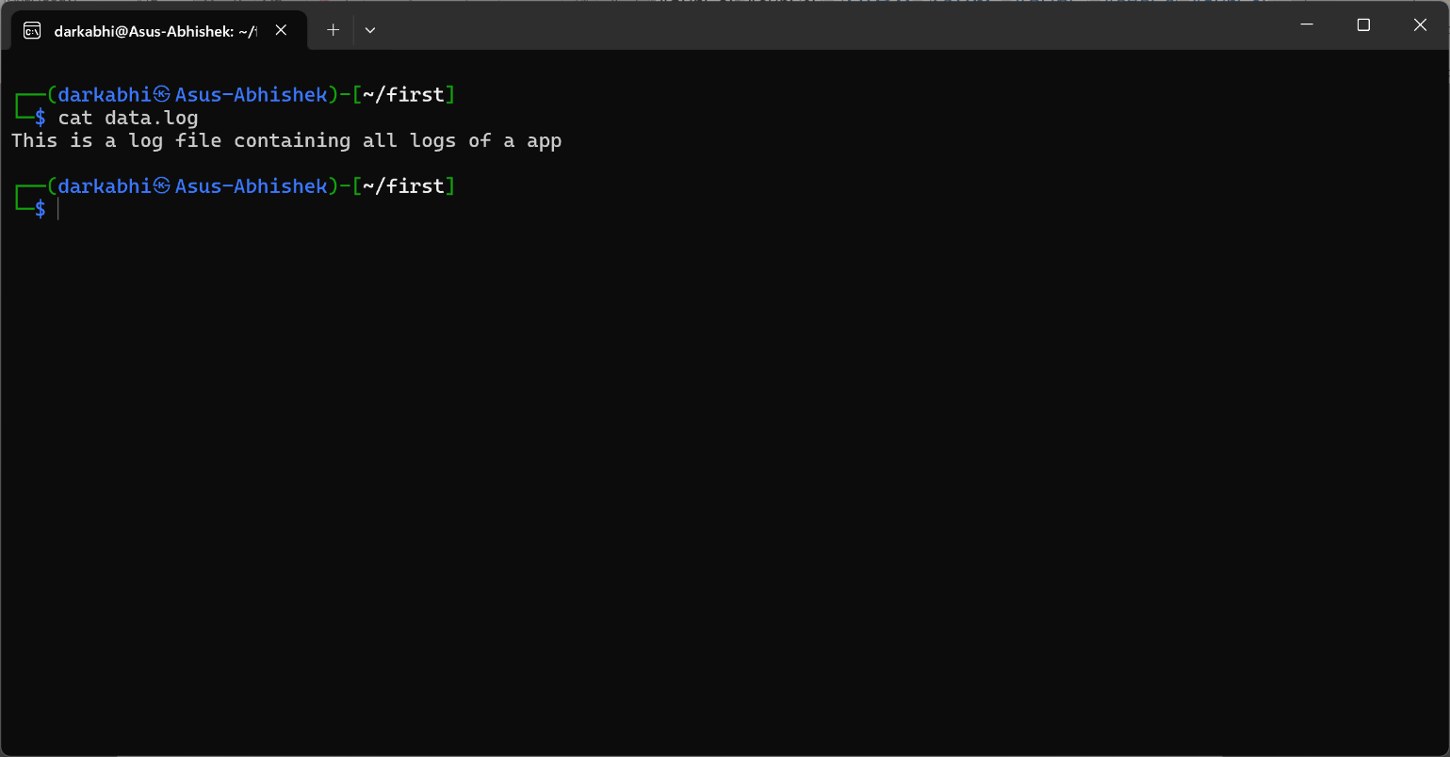

### b) Redirect the output to a new file 'backup.log' in /tmp folder

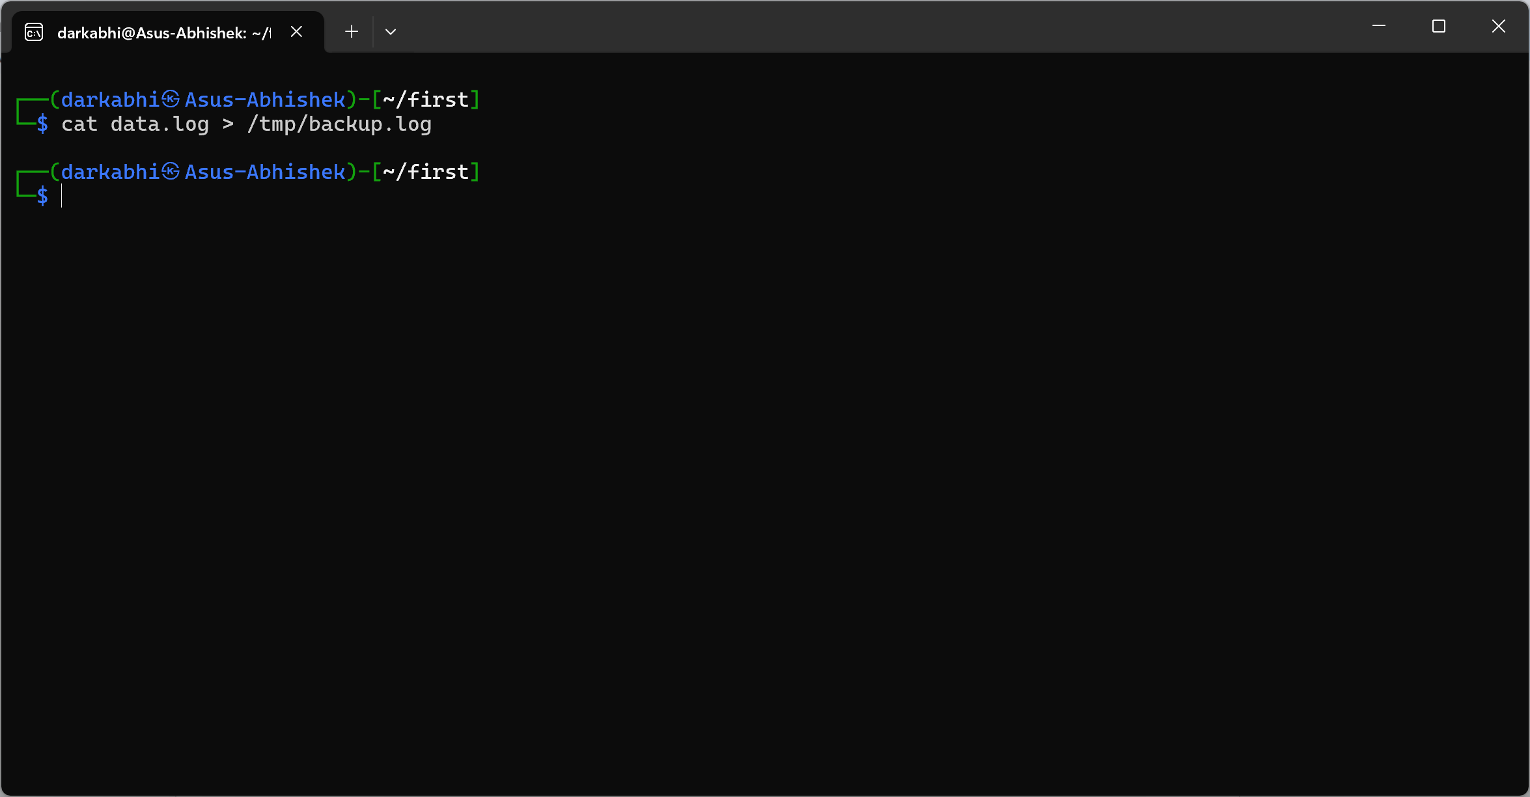

### c) Verify 'backup.log' contains same data as 'data.log' using diff.

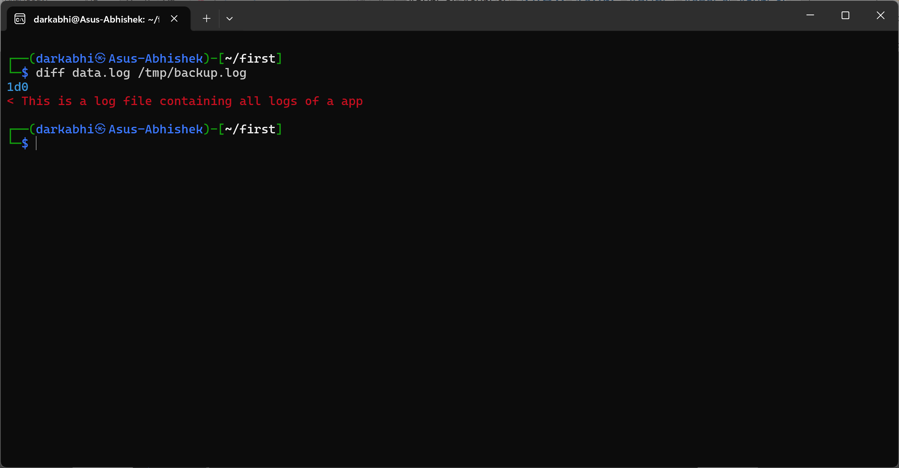

## User Management and File Permissions:

### a) Create a user named "BATCH37" with a unique password and add it to the 'Ethical' group.

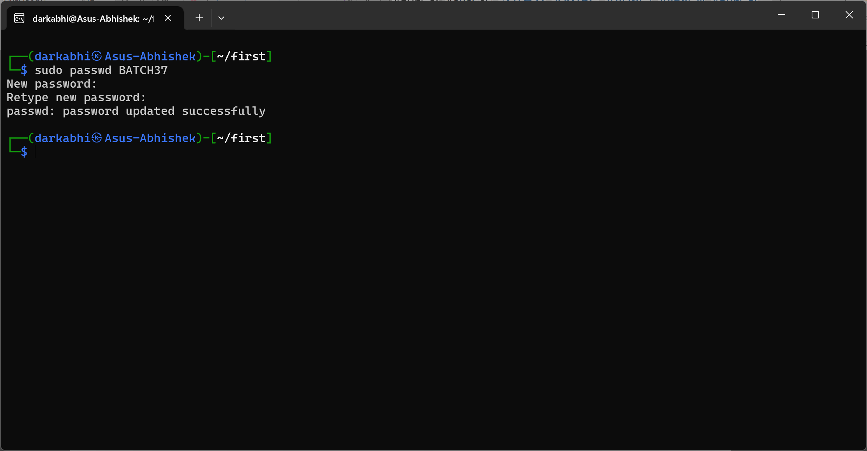

### b) Change the username from "BATCH35" to "STD30".

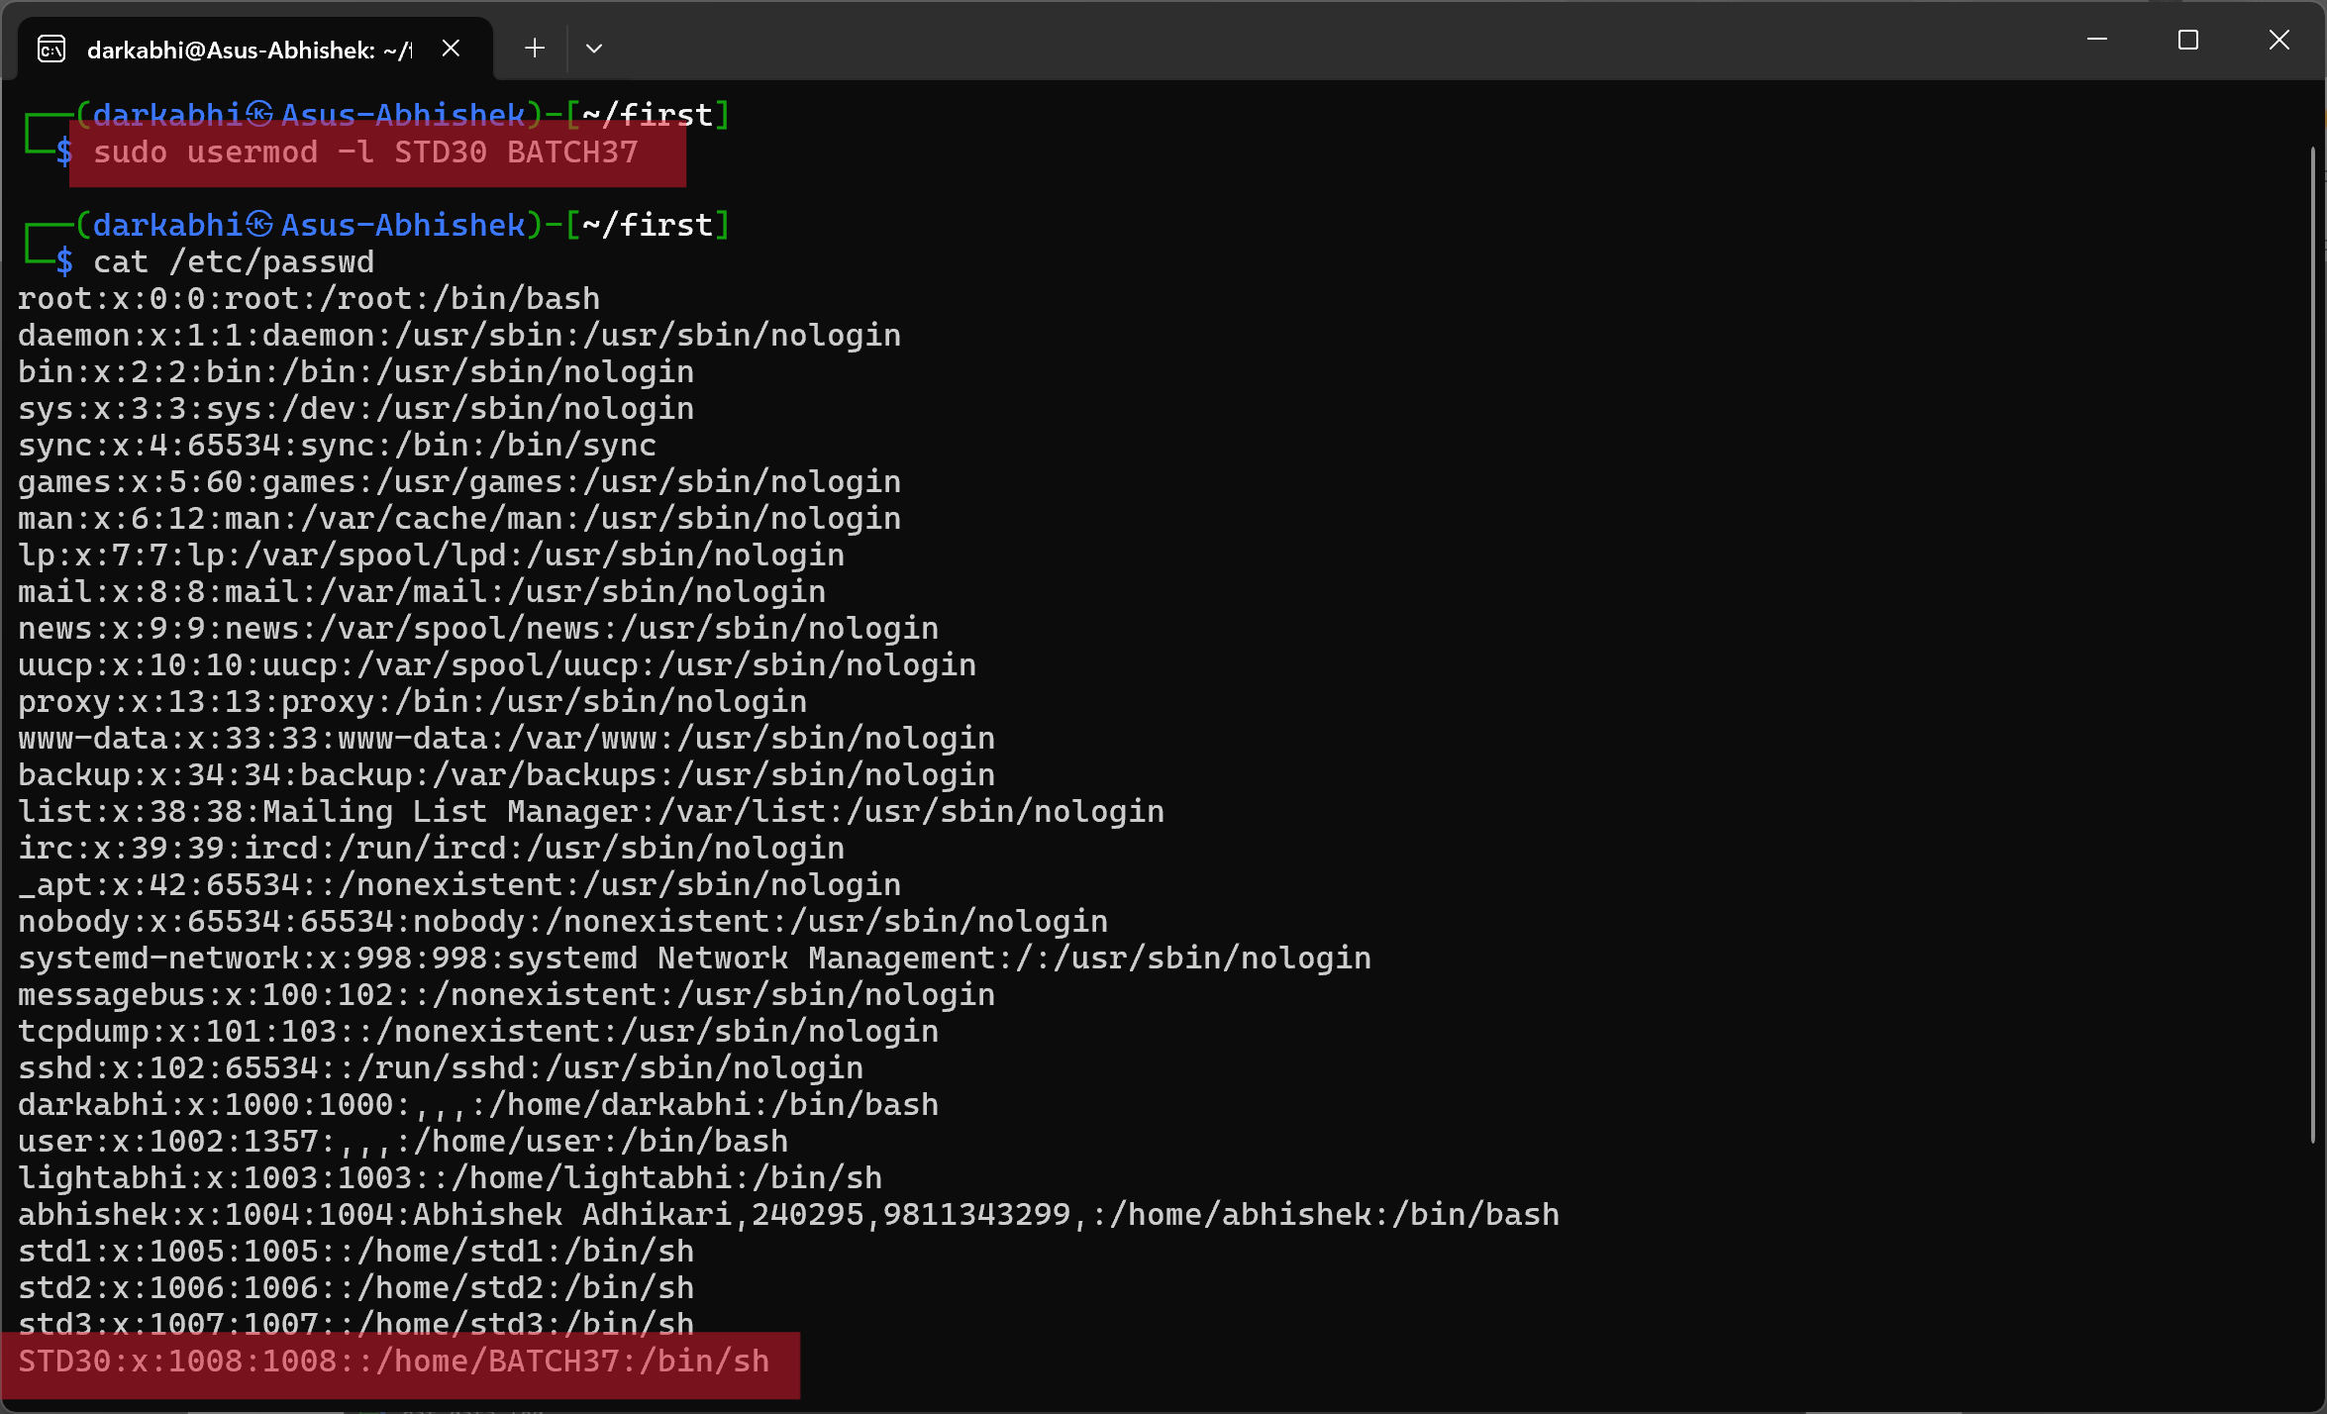

sudo userdel -r STD30

### c) Create a file named "Ethical30.txt" in the user's home directory and append "Hello Ethical 36" and delete the user.

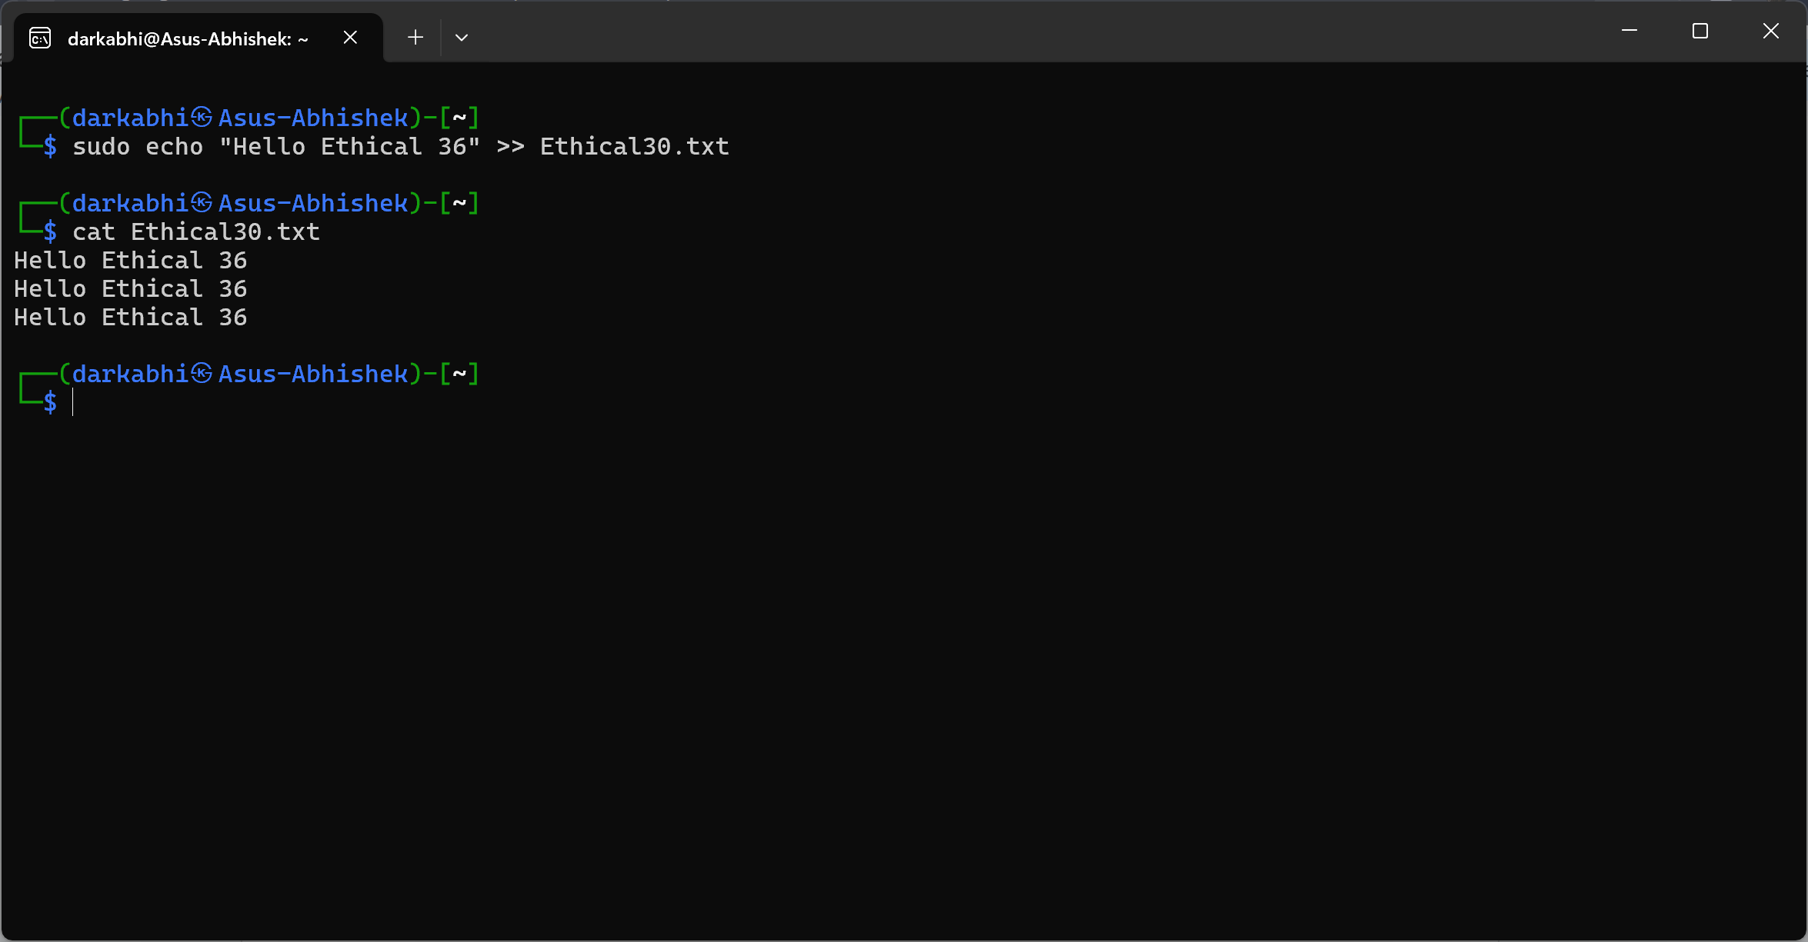

### d) Find rockyou.txt file from your computer using find command

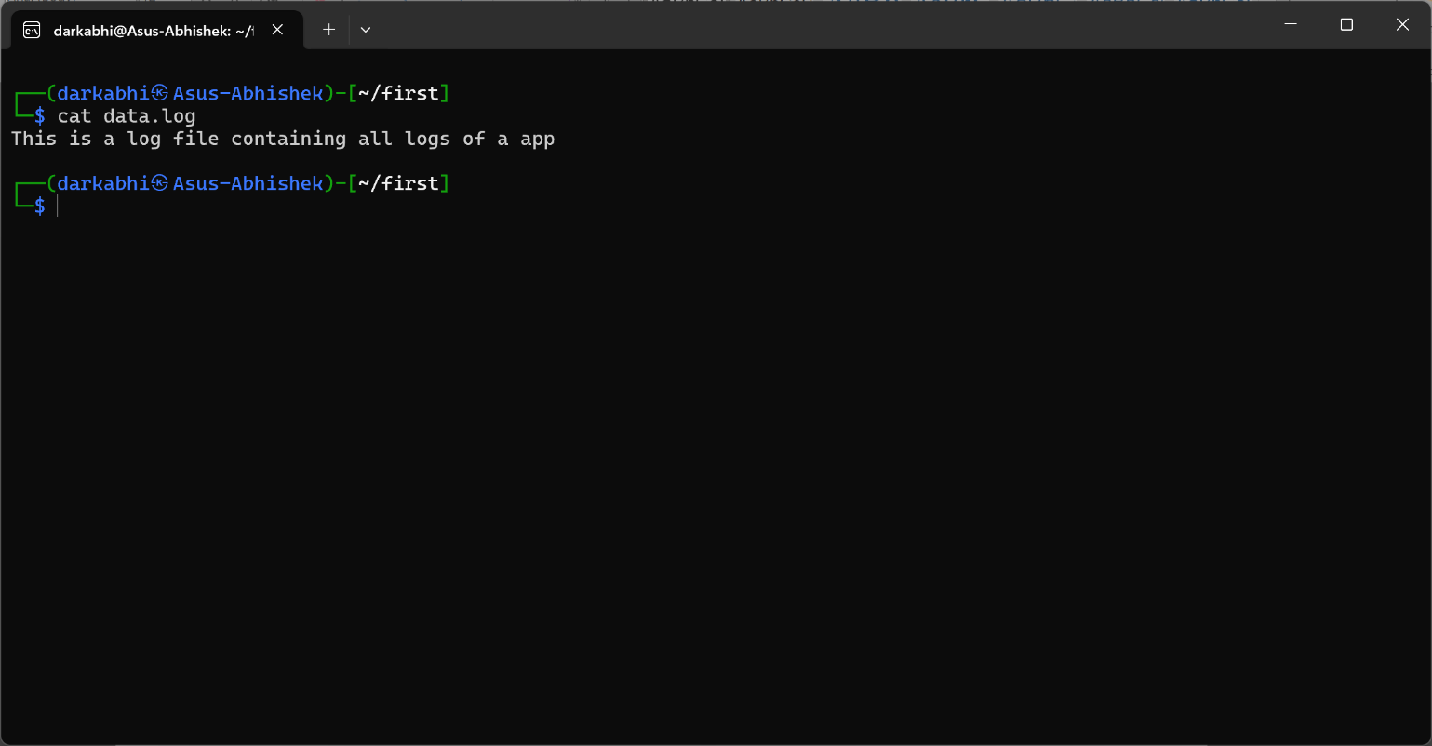

### e) Get an Ipv6 only from your devices using cut command

* Visual: The terminal screen shows the command.
* **What is Virtualization, why companies need it, and name 2 software providing virtualization platforms [3]**:
  + **Virtualization**: Virtualization is the process of creating virtual versions of physical hardware, such as servers, storage devices, and network resources. It allows multiple virtual machines (VMs) to run on a single physical machine, enabling better utilization of resources.
  + **Why companies need it**: Companies use virtualization to reduce hardware costs, improve scalability, enhance disaster recovery options, and simplify management.
  + **Two software platforms**:
    - VMware
    - VirtualBox
* **How can we install Kali Linux in VirtualBox or VMware if we have (kali.ova, kali.vdi, kali.iso)? [2]**:
  + For .ova file:
    - Open VirtualBox/VMware and import the .ova file using the "Import Appliance" option.
  + For .vdi file:
    - Create a new virtual machine and use the .vdi as the hard disk.
  + For .iso file:
    - Create a new virtual machine and mount the .iso as the installation disk, then follow the installation prompts.

**5. Text Editor**

* **How do you enter insert mode in Vim? [1]**:
  + Press i in command mode.
* **What command would you use in Vim to save your changes and exit the editor? [1]**:
  + :wq
* **In Vim, how would you delete an entire line of text? [1]**:
  + Press dd in command mode.
* **How do you save a file in Nano? [1]**:
  + Press Ctrl + O and then Enter.
* **Write “I am noob” in hacker.txt file using echo command [1]**:

bash

Copy code

echo "I am noob" > hacker.txt