

**Linux fu**

**2024**

Submitted to:

Rikesh Maharjan

This project is completed as part of Task 1 for Linux Fundamentals, covering basic Linux commands and its architecture.

**About**

~ Abhishek Adhikari



Table of Contents

**1.List all files and directories** **in your current directory, including hidden ones.**4

**2. Display the current working directory.**4

**3. Create a new directory.**5

**4. Navigate into the new directory.**5

**5. Create two empty files inside new directory.**6

**6. List files in new directory, and display file sizes in human readable format.**6

**7. Display detailed information about the file.**7

**8. Go back one directory level (back to your home directory).**7

**9. Write the content inside new file.**8

**10. Copy the contents of one file into another file.**8

**11. Inside the new directory, create a subdirectory.**9

**12. List all files within the new directory and its subdirectories, showing full paths for each file.**9/10

**13. Remove the file from inside the new directory.**11

**14. Using a single command, delete the entire directory and everything inside it.**11

**15. Get comprehensive help on the mkdir command.**12

1. List all files and directories in your current directory, including hidden ones.

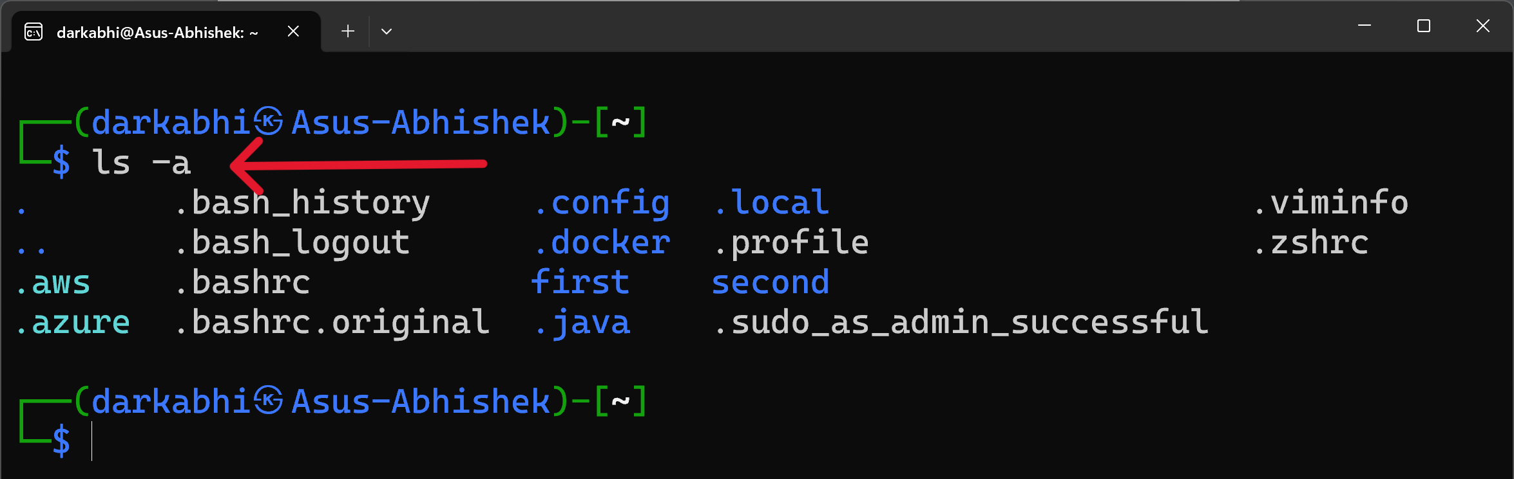

COMMAND: ls -a

The **ls -a** command lists all files and directories in the current directory, including hidden files (those starting with a dot remember not with double dot). The **-a** flag provides and includes hidden files.

2. Display the current working directory path.

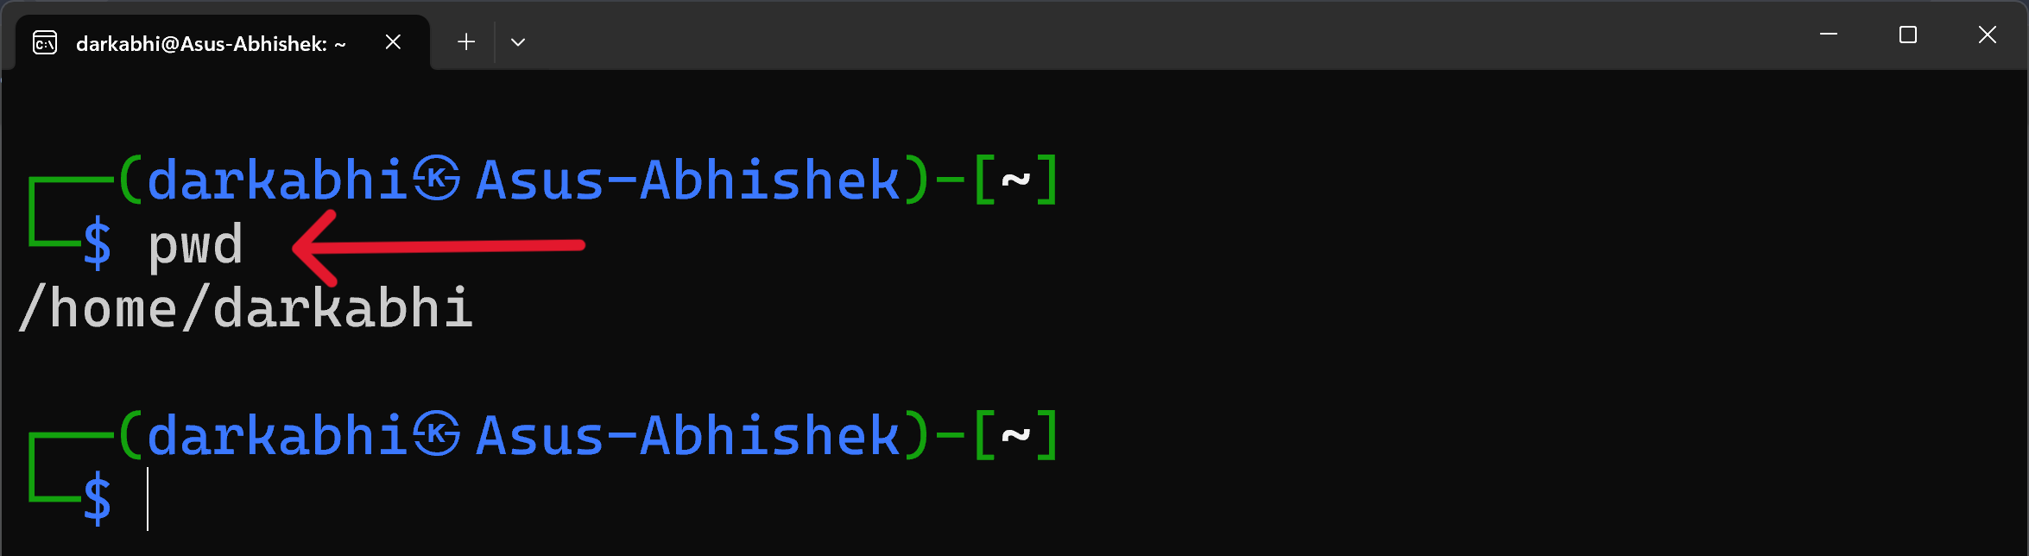

COMMAND: pwd

The **pwd (print working directory)** command outputs the full path of the current directory you are working in. This helps confirm your current location in the file system.

3. Create a new directory named “test_project”.

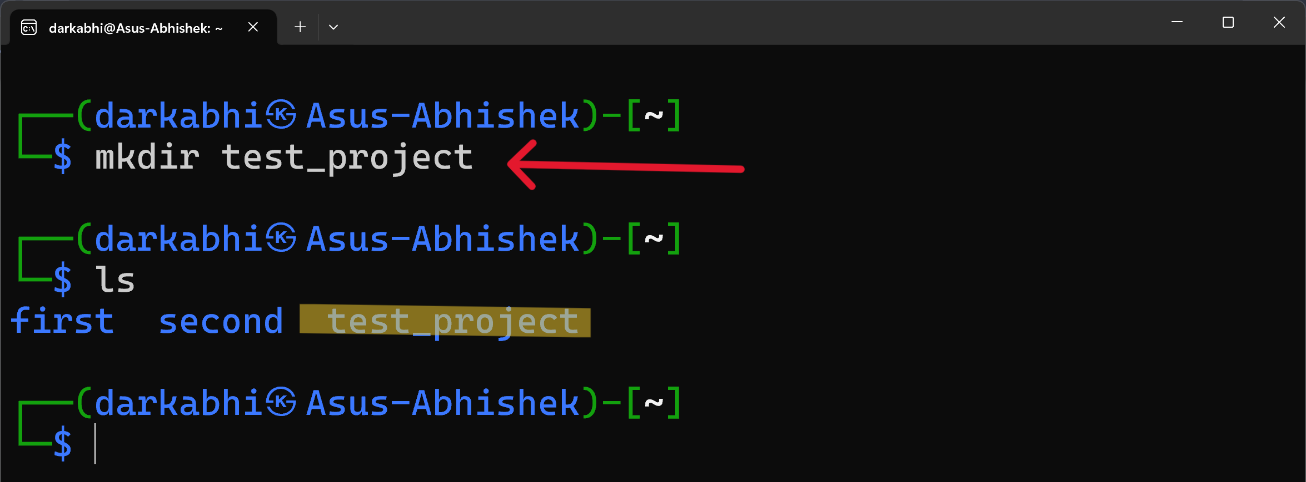

COMMAND: mkdir FOLDER_NAME

The **mkdir** command creates a new directory (i.e. folder). Here, it creates a directory named **“test_project”** in the current location. Also after creation **“test_project”** is highlighted with yellow color.

4. Navigate into the “test_project” directory you just created.

image

COMMAND: cd FOLDER_NAME

The **cd (change directory)** command is used to move into a specified directory. This command moves you into the newly created **“test_project”** directory.

5. Create two empty files inside “test_project” named “notes.txt” and “ideas.txt”.

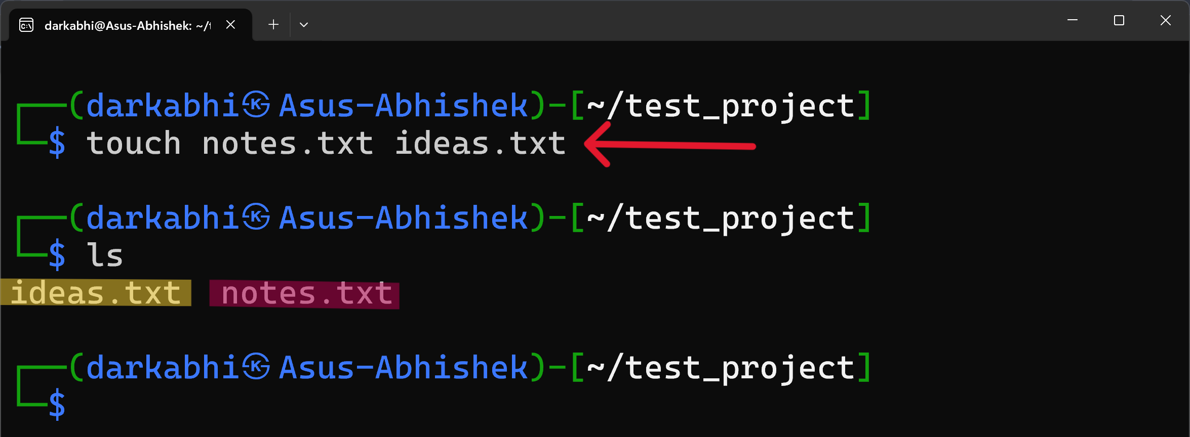

COMMAND: touch FILE_NAME

The **touch** command creates empty files or updates the timestamps of existing files. Here, it creates two new files named **“notes.txt”** and **“ideas.txt”** inside the **“test_project”** directory.

6. List files in “test_project”, displaying file sizes in human-readable format (e.g., KB, MB).

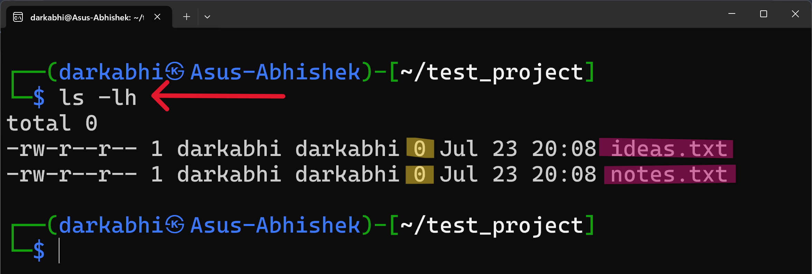

COMMAND: ls -lh

The **ls -lh** command lists files and directories with detailed information, displaying file sizes in a human-readable format (e.g., KB, MB). The -h flag makes the file sizes easier to understand.

7. Display detailed information (permissions, owner, size, etc.) about the file “ideas.txt”.

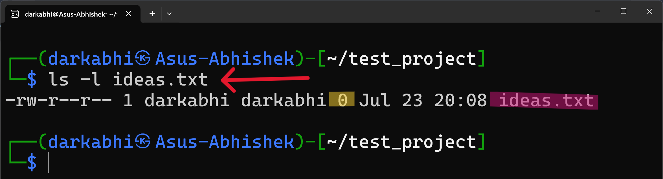

COMMAND: ls -l FILE_NAME

The ls -l command provides detailed information about files and directories. When used with a specific file, like **“ideas.txt”,** it shows details such as permissions, owner, **size**, and modification date.

8. Go back one directory level (back to your home directory).

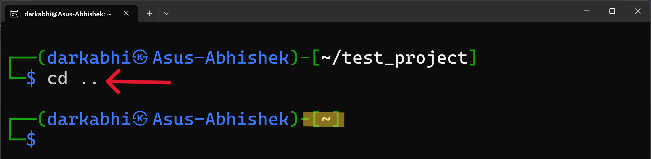

COMMAND: cd PATH

The **cd ..** command navigates up one level in the directory structure, taking you back to the parent directory.

9. Write the phrase “Project Plan” into the file “notes.txt” (located inside “test_project”).

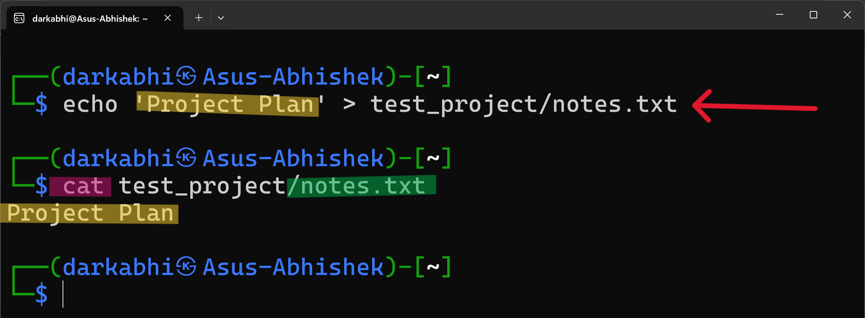

COMMAND: echo CONTENT > FILE_NAME

The echo command outputs the specified text. The **>** symbol redirects this output into the file **“notes.txt”**, overwriting its contents with **“Project Plan”**.

10. Copy the contents of “notes.txt” into “ideas.txt” (both files still inside “test_project”).

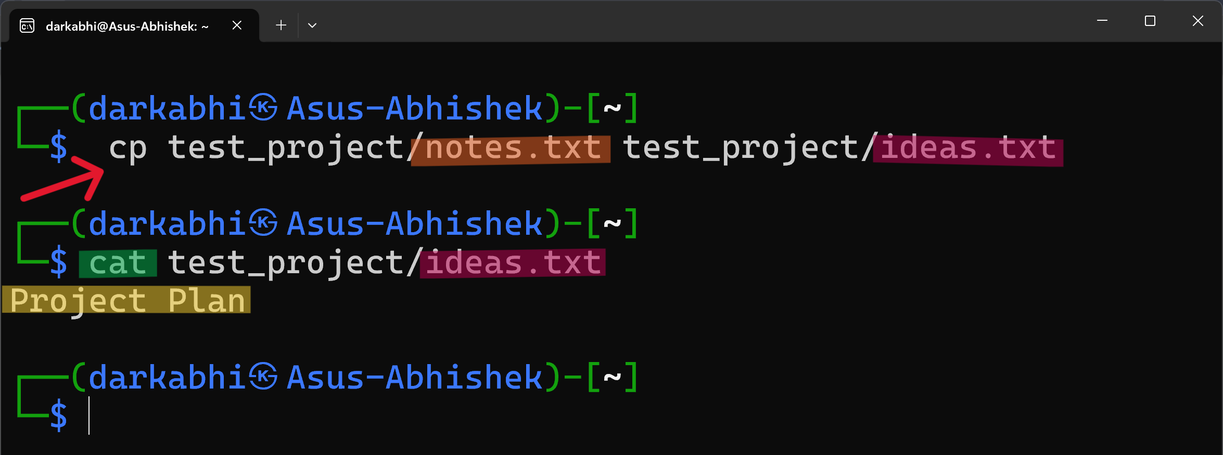

COMMAND: cp FILE_TO_COPY WHERE_TO_COPY

The cp command copies files or directories. Here, it copies the contents of **“notes.txt”** into **“ideas.txt”**, overwriting any existing content in **“ideas.txt”**.

11. Inside the “test_project” directory, create a subdirectory called “images”.

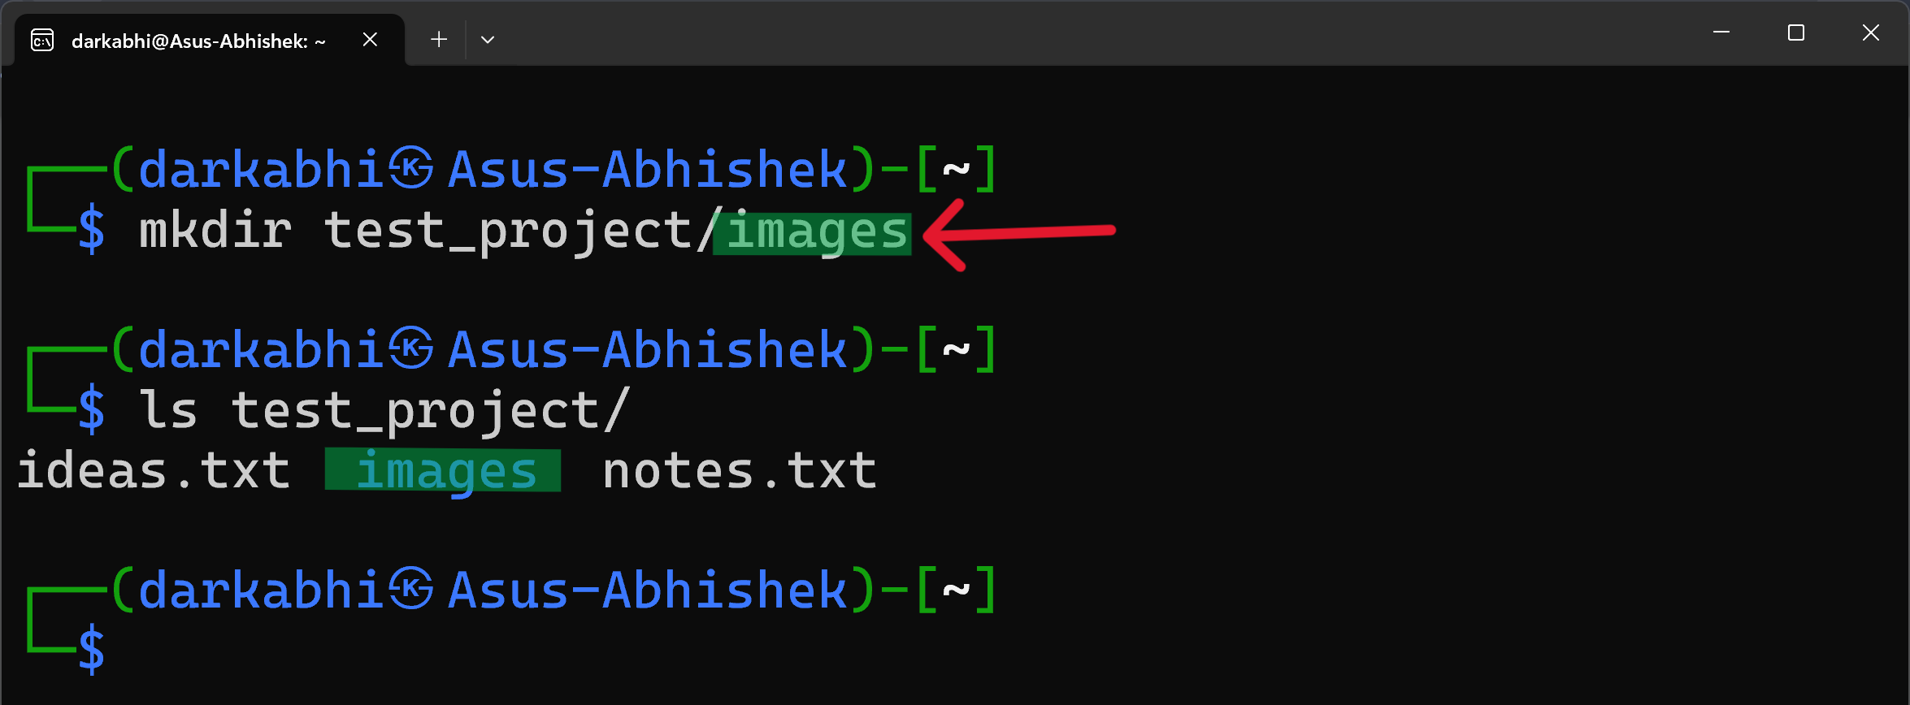

COMMAND: mkdir FOLDER_NAME

The **mkdir** command creates a new directory. Here, it creates a subdirectory named **“images”** inside the **“test_project”** directory.

12. List all files within the “test_project” directory and its subdirectories, showing full paths for each file.

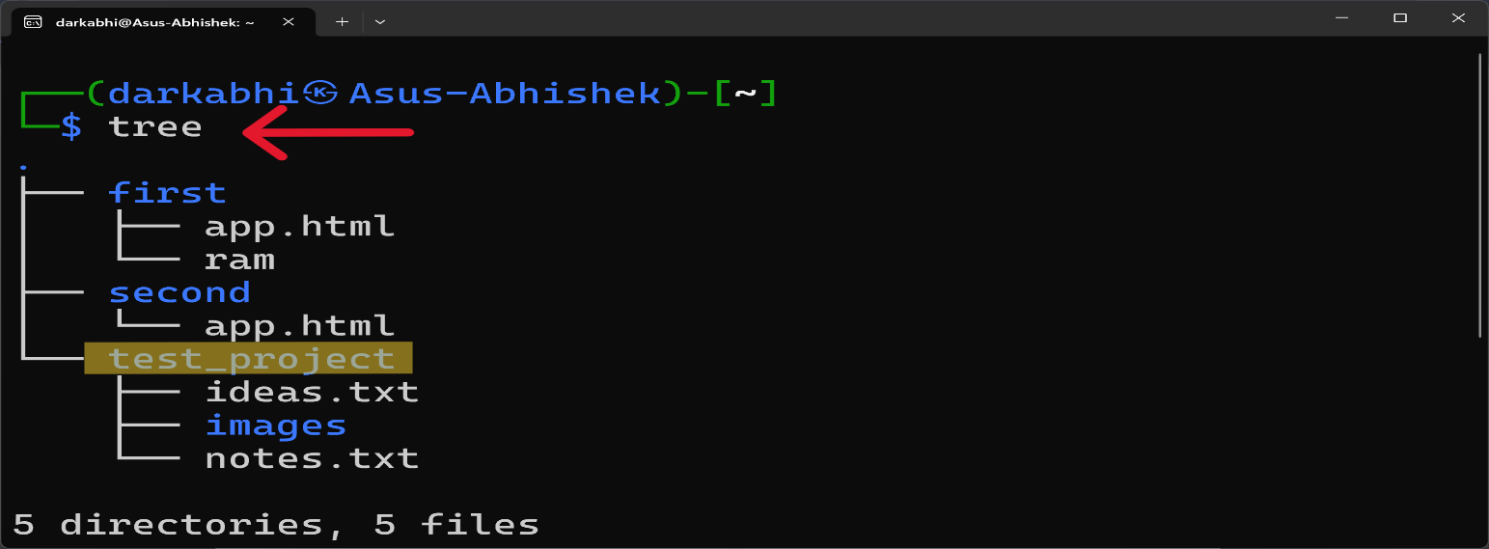

COMMAND: tree

The **tree** command displays the directory structure of a path or of the disk in a **tree-like format**. It lists all files and directories, showing their full paths.

**OR**

image

COMMAND: find FILE_NAME

The **find** command **searches for files** and directories within a specified directory. Here, find **test_project** lists all files and directories within the **"test_project"** directory, showing their full paths.

13. Remove the file “notes.txt” from inside the “test_project” directory.

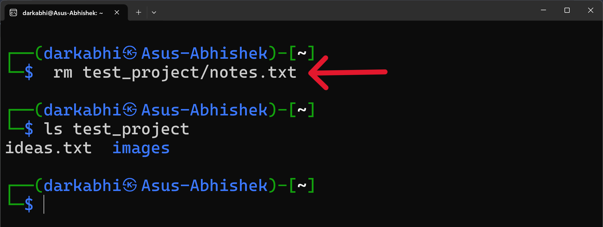

COMMAND: rm FILE_NAME

The **rm (remove)** command deletes files. Here, it removes the file **“notes.txt”** from the **“test_project”** directory.

14. Using a single command, delete the entire “test_project” directory and everything inside it.

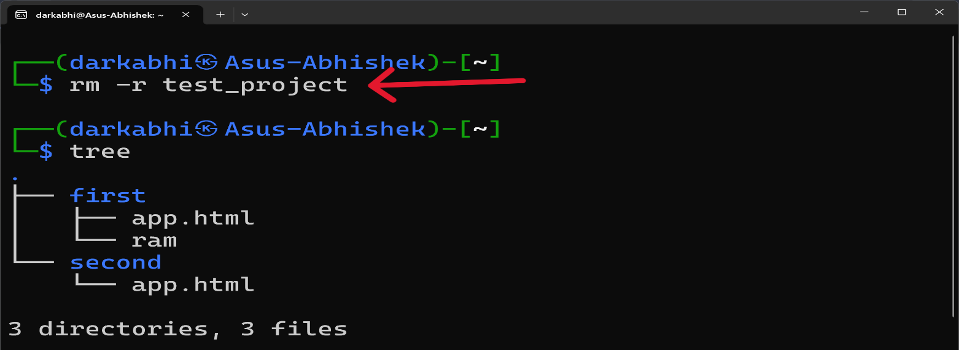

COMMAND: rm -r FOLDER_NAME

The **rm -r** command recursively deletes a directory and all its contents. Here, it removes the **“test_project”** directory and everything within it.

15. Get comprehensive help on the mkdir command.

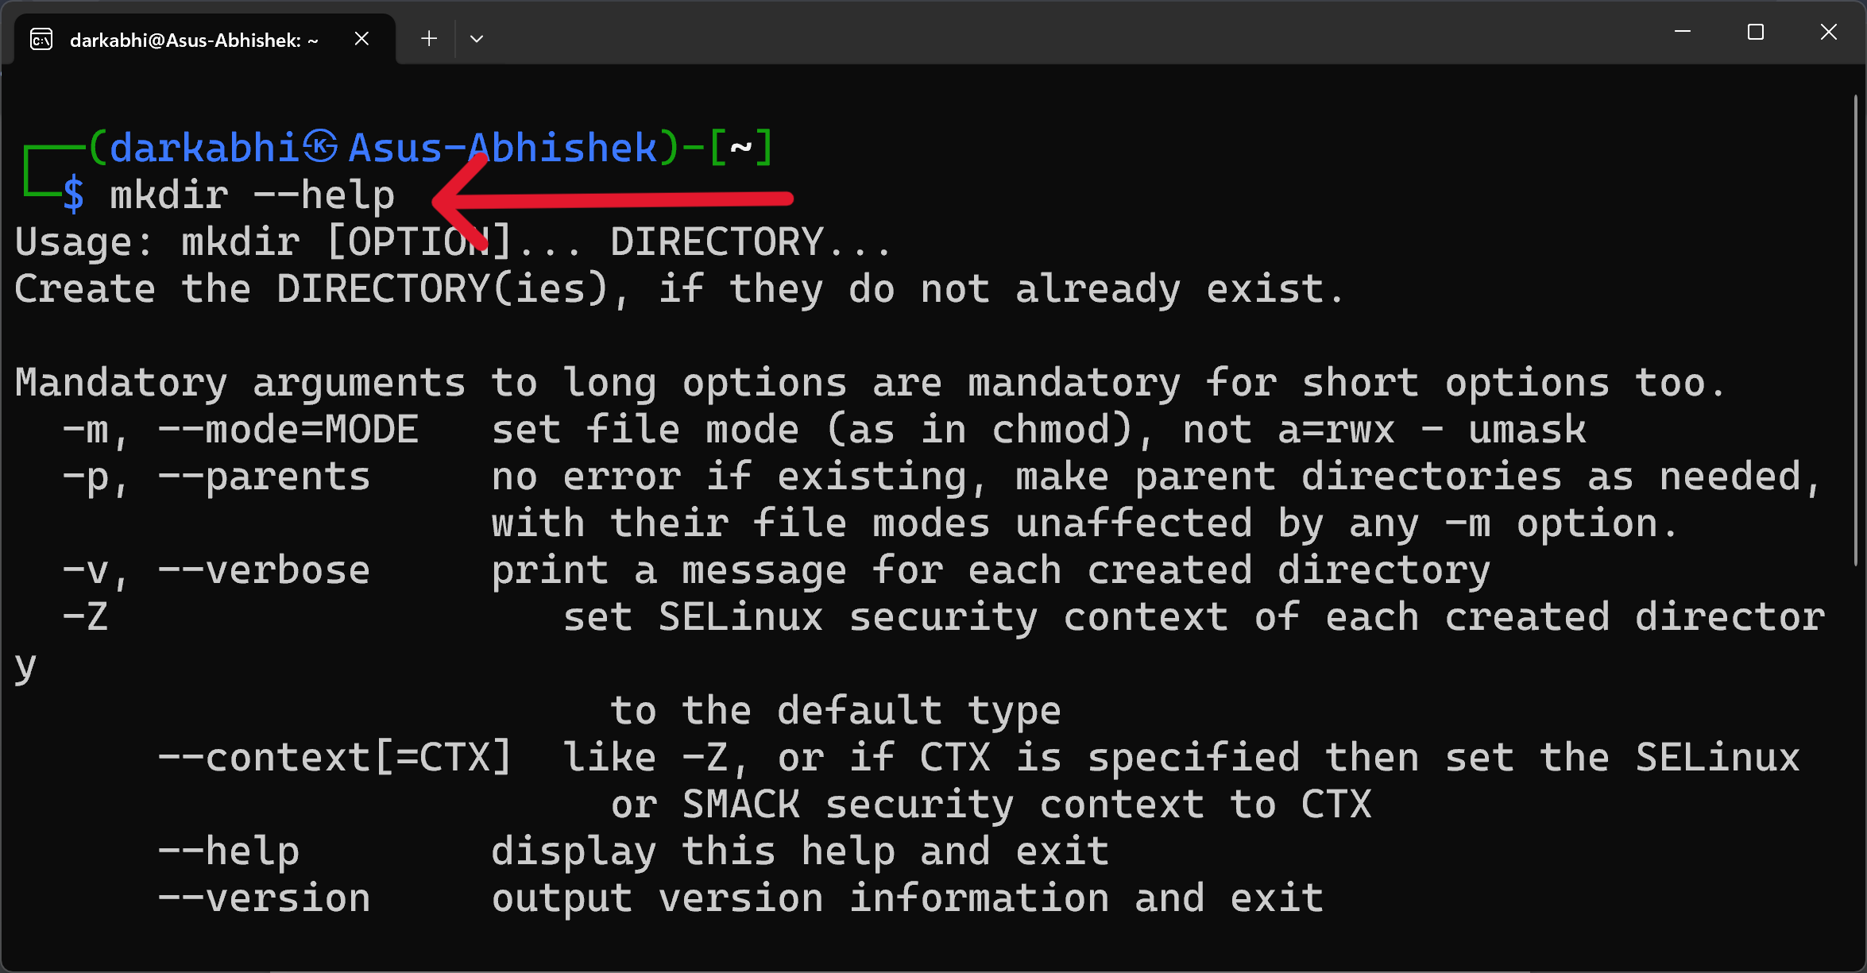

COMMAND: mkdir --help

The **mkdir --help** command provides a summary of the usage, options, and arguments for the mkdir command. It is a quick reference for understanding how to create directories and use various options.

BIBILOGRAPY

1. ***GNU Core Utilities Documentation*** *"GNU Core Utilities: Basic File, Shell, and Text Manipulation Utilities." GNU Project. Accessed July 2024.* [*https://www.gnu.org/software/coreutils/manual/coreutils.html*](https://www.gnu.org/software/coreutils/manual/coreutils.html)
2. ***The Linux Command Line*** *William Shotts. "The Linux Command Line: A Complete Introduction." No Starch Press, 2012.*
3. ***Ubuntu Documentation*** *"Ubuntu Man page: mkdir - Make directories." Canonical Ltd. Accessed July 2024.* [*https://manpages.ubuntu.com/manpages/focal/man1/mkdir.1.html*](https://manpages.ubuntu.com/manpages/focal/man1/mkdir.1.html)
4. ***Linux Handson Guide***

*Machtelt Garrels. “Introduction to Linux and File Handling” 1.27 Edition*

[*https://tldp.org/LDP/intro-linux/html/sect_03_03.html*](https://tldp.org/LDP/intro-linux/html/sect_03_03.html)