[](https://www.instagram.com/unknown_account835/)[](https://www.facebook.com/profile.php?id=100063712182245)

Name: Abhishek Adhikari

Class: Foundation Group 37A

Email: [adhikaryabhishek209@gmail.com](mailto:adhikaryabhishek209@gmail.com?subject=Contacting%20you%20from%20the%20project)

Submitted to Rikesh Maharjan

Linux Grasshopper Journey Documentation 3

1. Getting Started: 3

1.1 History 3

1.2 Choosing a Linux Distribution 3

1.3 Debian 4

1.4 Red Hat Enterprise Linux 5

1.5 Ubuntu 5

1.6 Fedora 6

1.7 Linux Mint 7

1.8 Gentoo 7

1.9 Arch Linux 8

1.10 openSUSE 9

2. Command Line: 9

2.1 The Shell 9

2.2 pwd (Print Working Directory) 10

2.3 cd (Change Directory) 11

2.4 ls (List Directories) 11

2.5 touch 12

2.6 file 13

2.7 cat 13

2.8 less 14

2.9 history 15

2.10 cp (Copy) 15

2.11 mv (Move) 16

2.12 mkdir (Make Directory) 17

2.13 rm (Remove) 17

2.14 find 18

2.15 help 19

2.16 man 19

2.17 whatis 20

2.18 alias 21

2.19 exit 21

3. User Management 22

3.1 Users and Groups 22

3.2 root 23

3.3 /etc/passwd 24

3.4 /etc/shadow 25

3.5 /etc/group 26

3.6 User Management Tools 27

4. References 28

# Linux Grasshopper Journey Documentation

## Getting Started:

### 1.1 History

* Visual: The terminal screen shows the command.

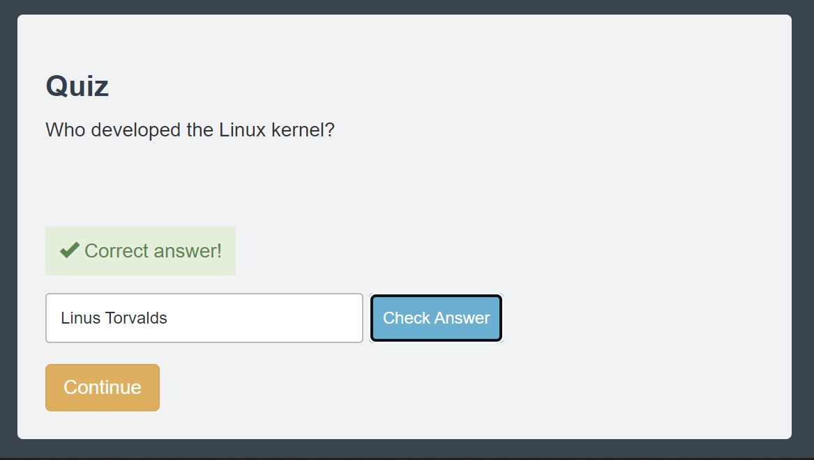

### 1.2 Choosing a Linux Distribution

* Visual: The terminal screen shows the command.

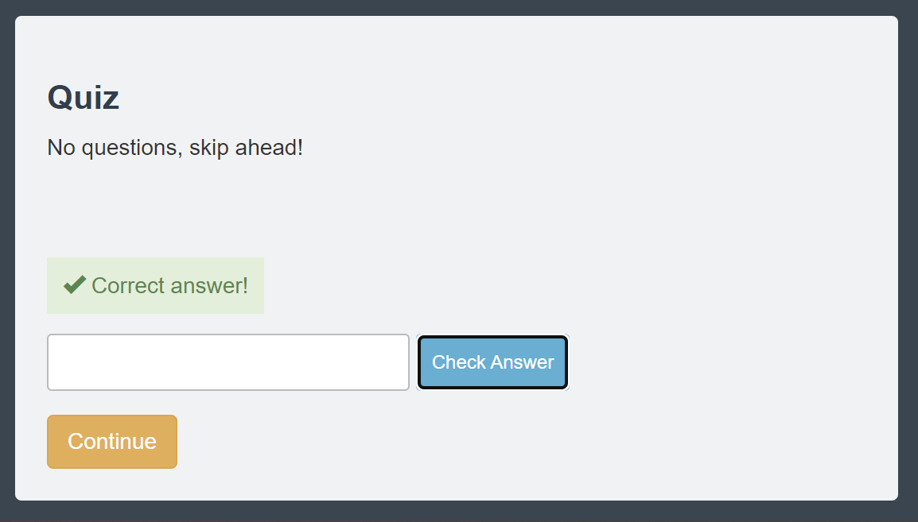

### 1.3 Debian

* Visual: The terminal screen shows the command.

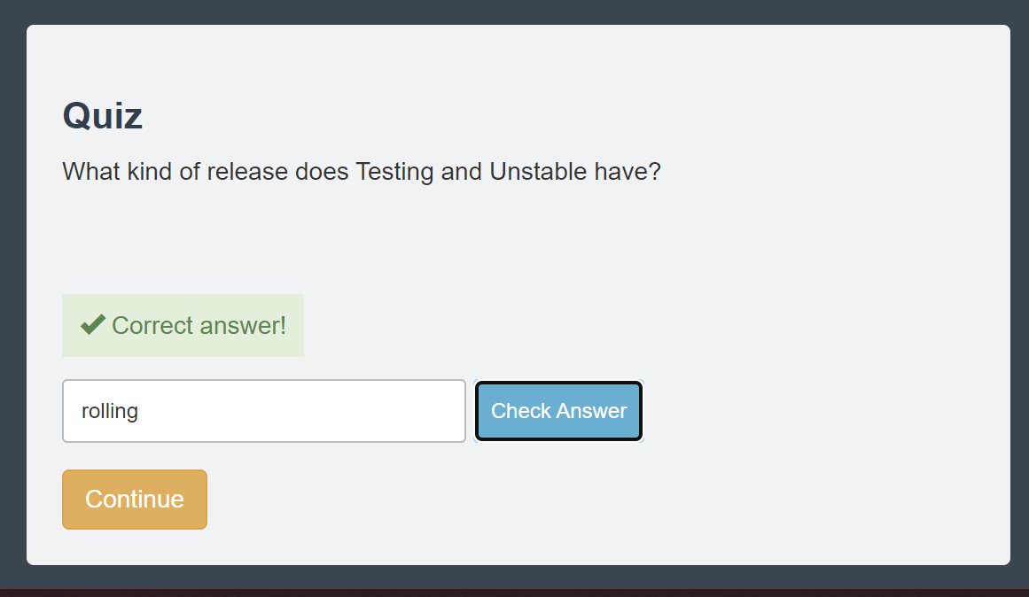

### 1.4 Red Hat Enterprise Linux

* Visual: The terminal screen shows the command.

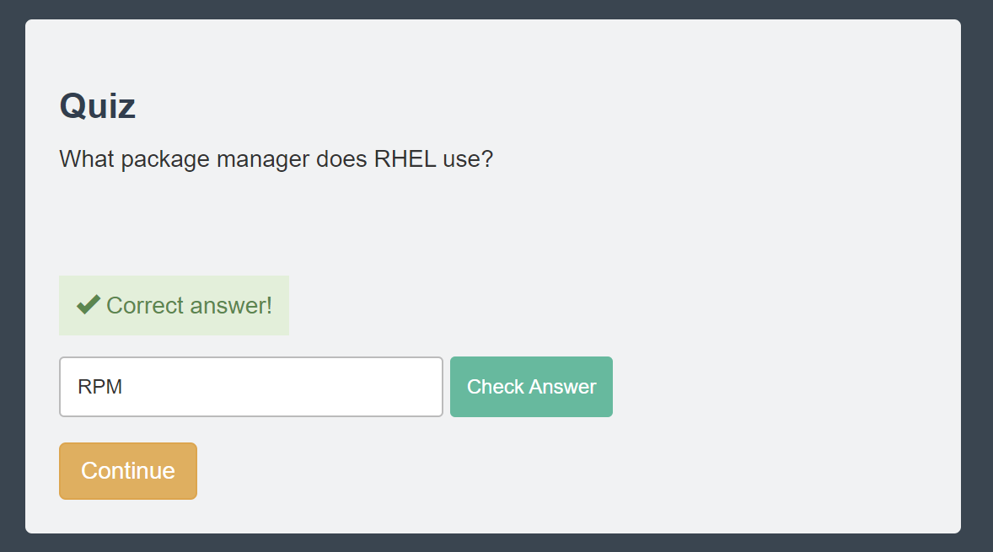

### 1.5 Ubuntu

* Visual: The terminal screen shows the command.

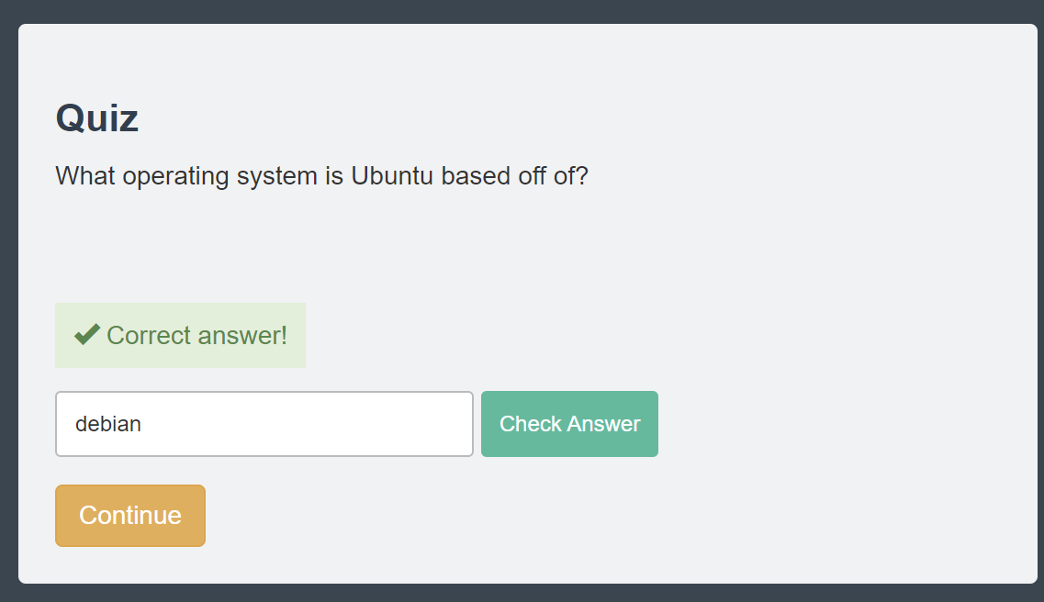

### 1.6 Fedora

* Visual: The terminal screen shows the command.

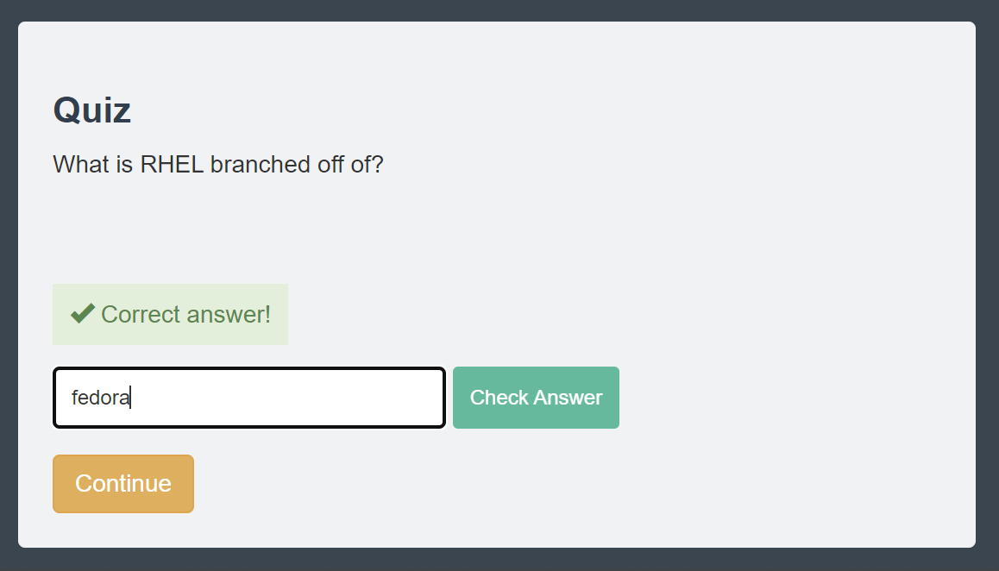

### 1.7 Linux Mint

* Visual: The terminal screen shows the command.

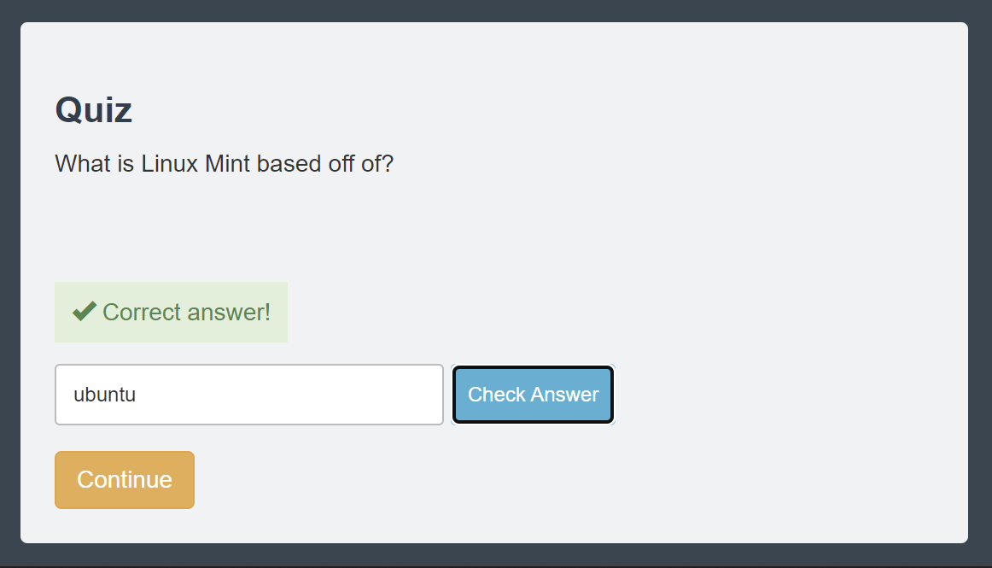

### 1.8 Gentoo

* Visual: The terminal screen shows the command.

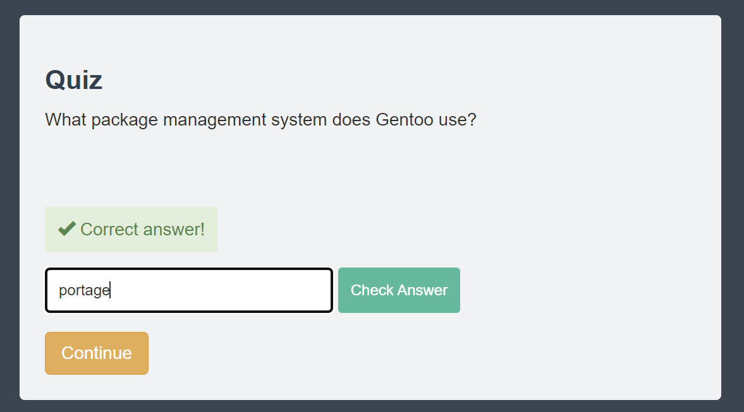

### 1.9 Arch Linux

* Visual: The terminal screen shows the command.

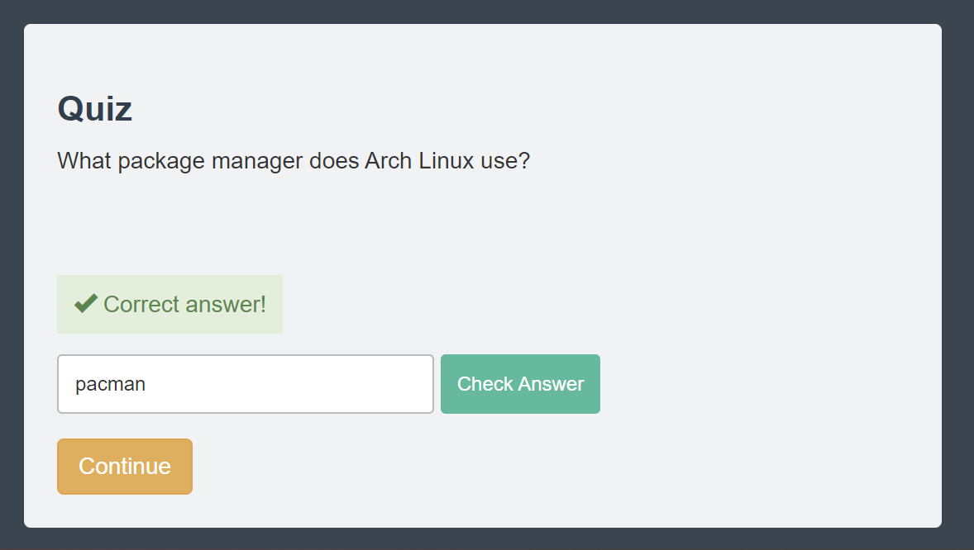

### 1.10 openSUSE

* Visual: The terminal screen shows the command.



## Command Line:

### 2.1 The Shell

* Visual: The terminal screen shows the command.

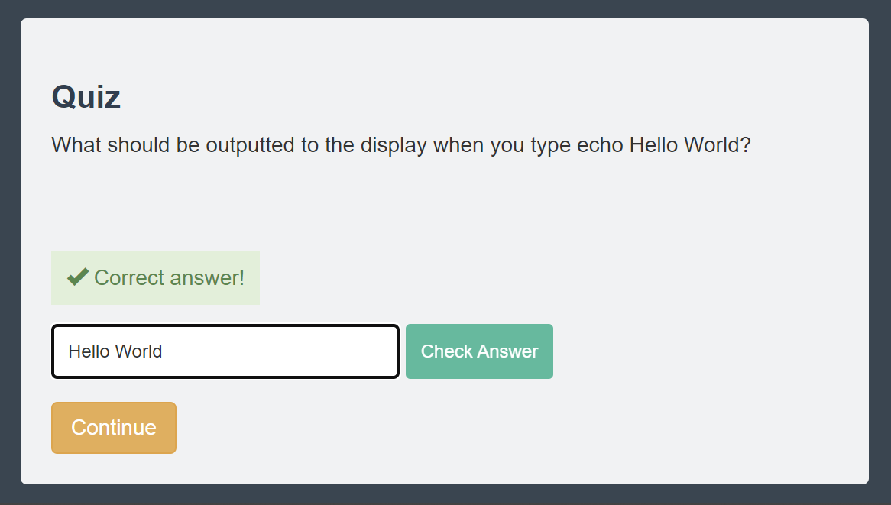

### 2.2 pwd (Print Working Directory)

* Visual: The terminal screen shows the command.

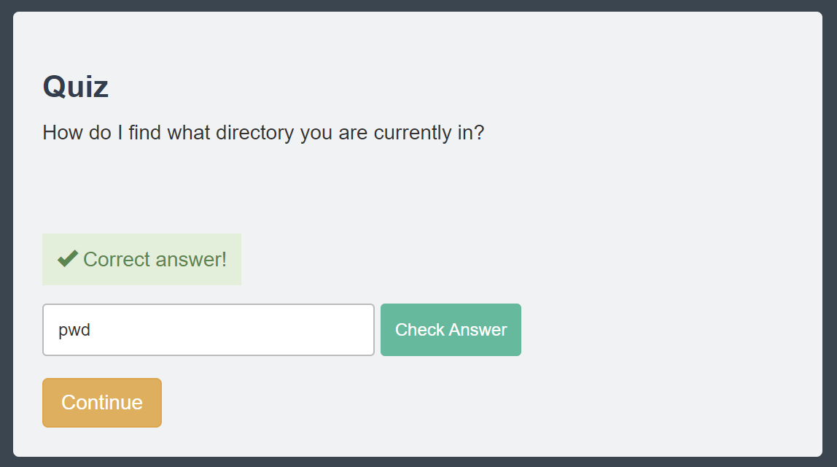

### 2.3 cd (Change Directory)

* Visual: The terminal screen shows the command.

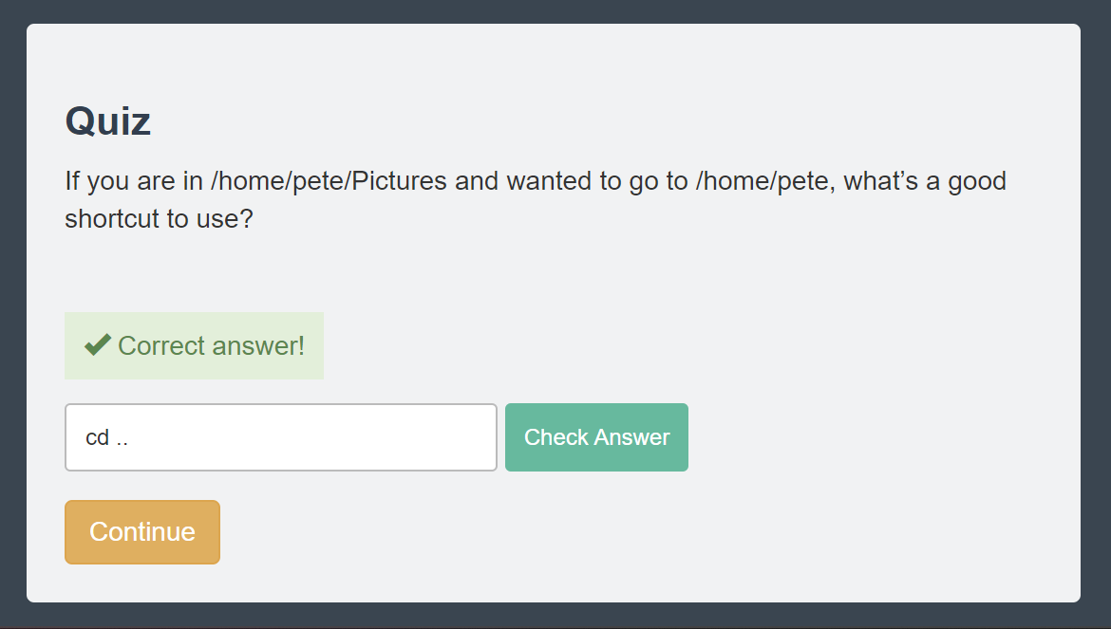

### 2.4 ls (List Directories)

* Visual: The terminal screen shows the command.

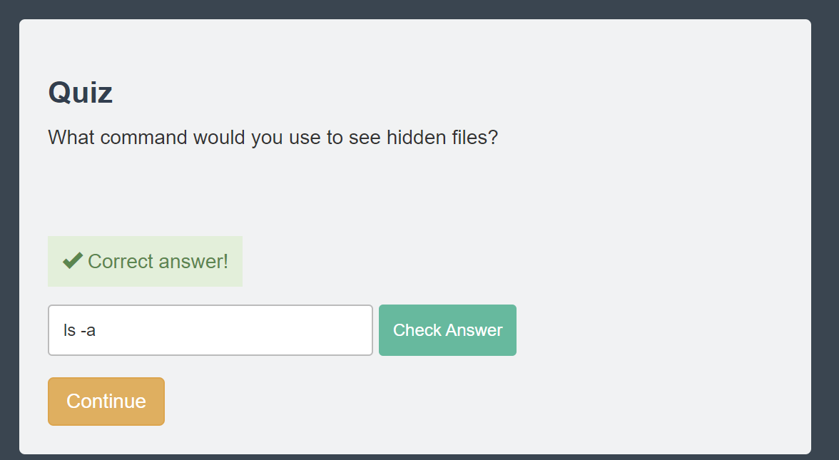

### 2.5 touch

* Visual: The terminal screen shows the command.

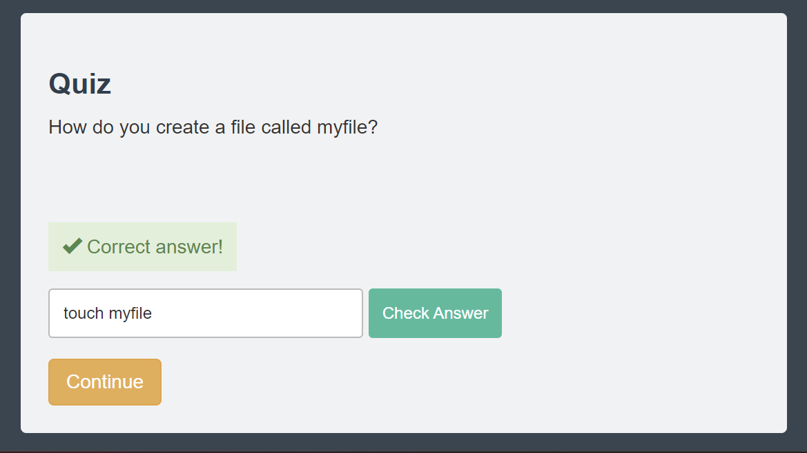

### 2.6 file

* Visual: The terminal screen shows the command.

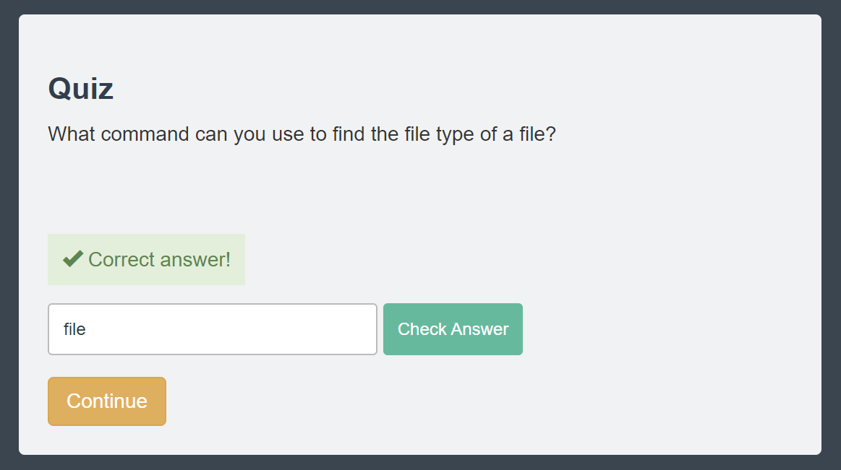

### 2.7 cat

* Visual: The terminal screen shows the command.

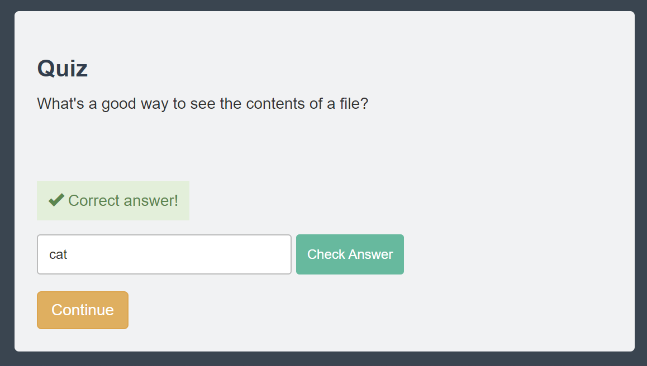

### 2.8 less

* Visual: The terminal screen shows the command.

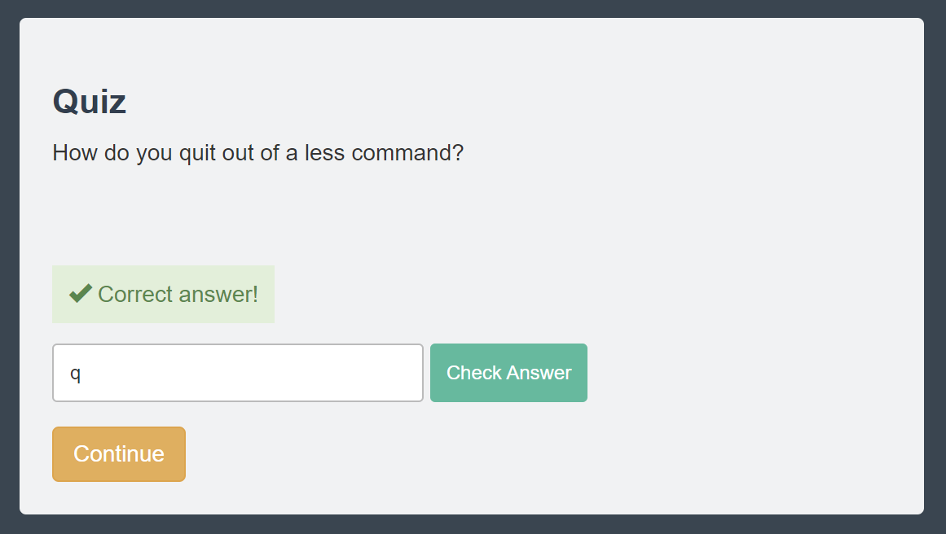

### 2.9 history

* Visual: The terminal screen shows the command.

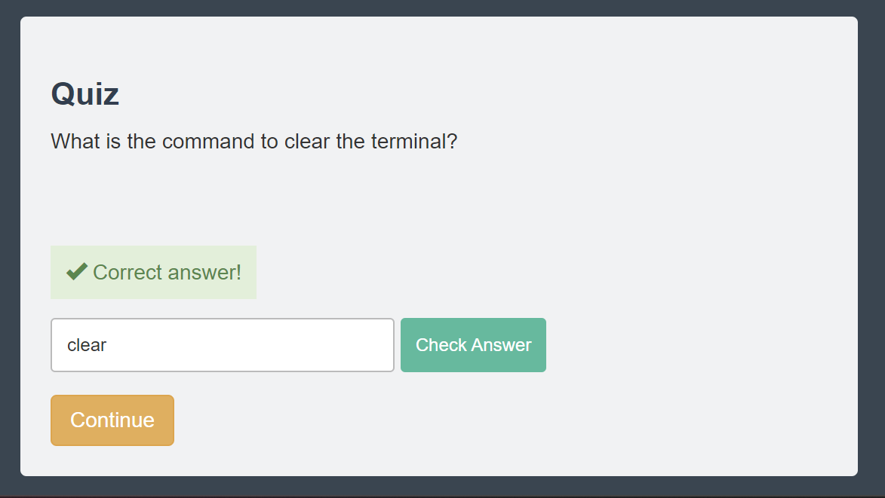

### 2.10 cp (Copy)

* Visual: The terminal screen shows the command.

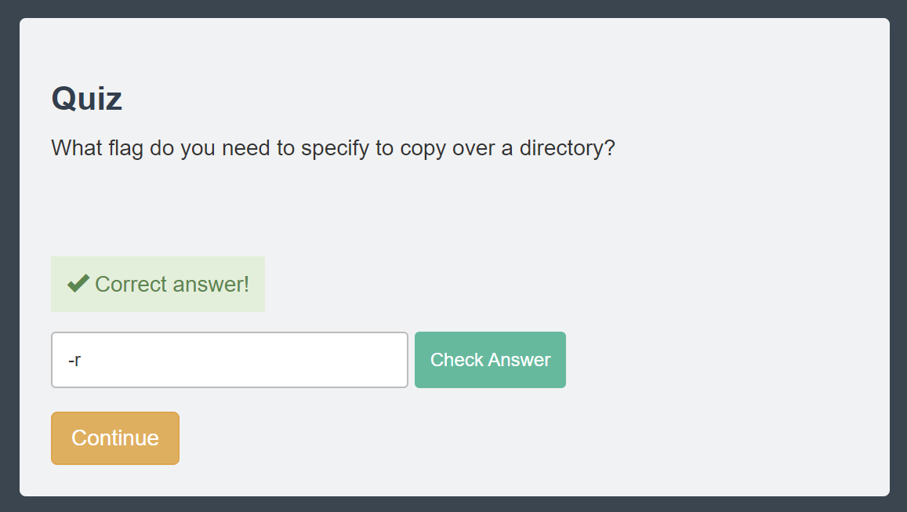

### 2.11 mv (Move)

* Visual: The terminal screen shows the command.

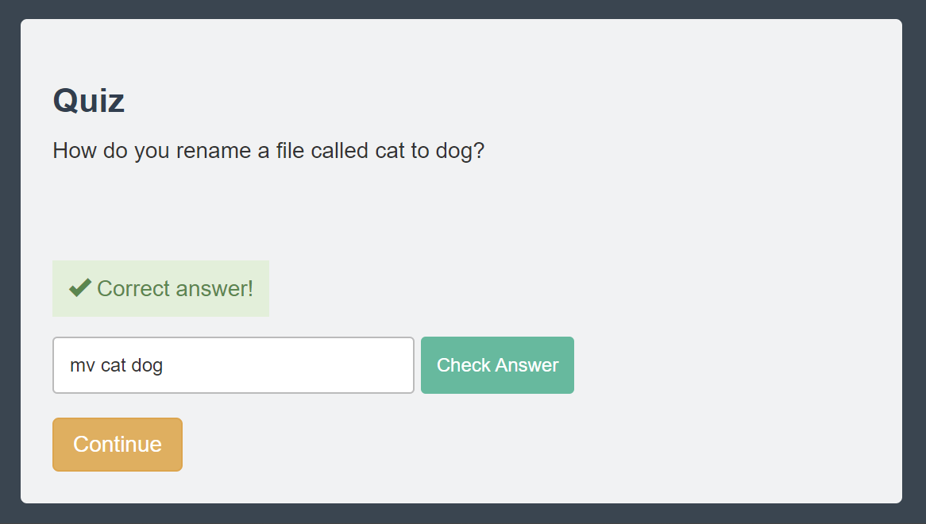

### 2.12 mkdir (Make Directory)

* Visual: The terminal screen shows the command.

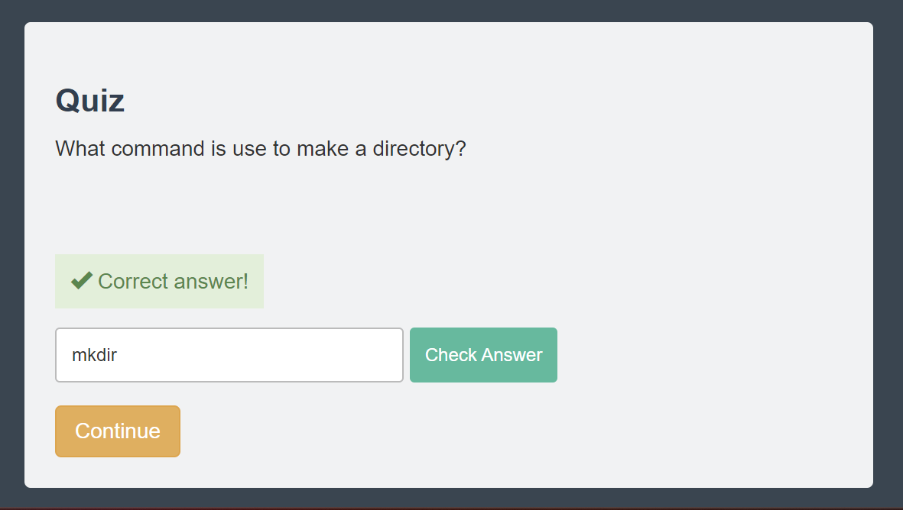

### 2.13 rm (Remove)

* Visual: The terminal screen shows the command.

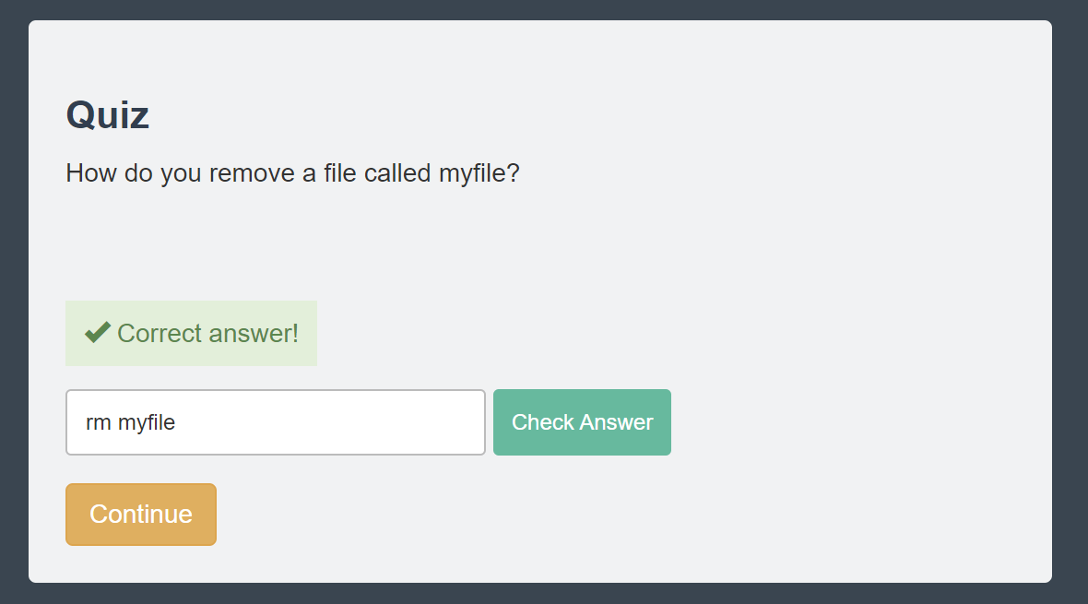

### 2.14 find

* Visual: The terminal screen shows the command.

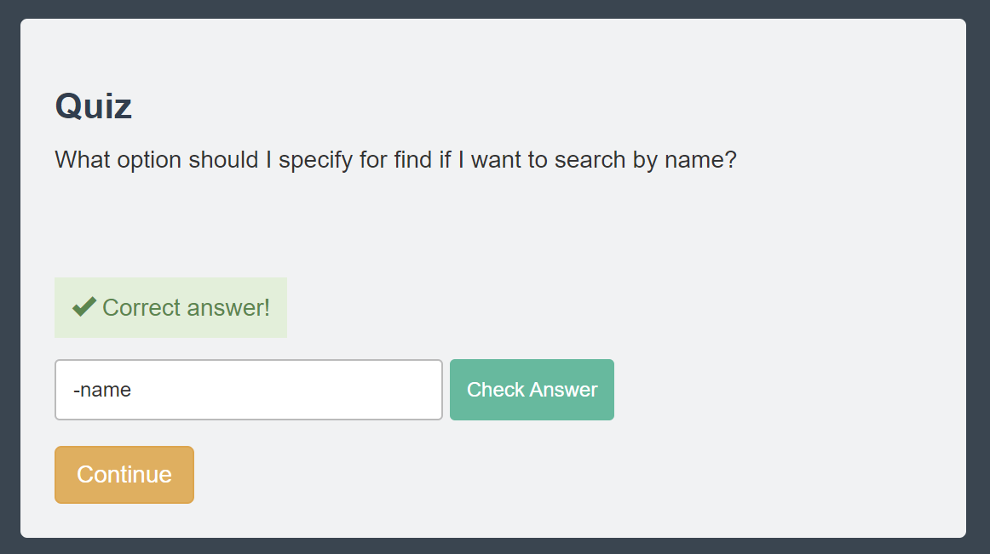

### 2.15 help

* Visual: The terminal screen shows the command.

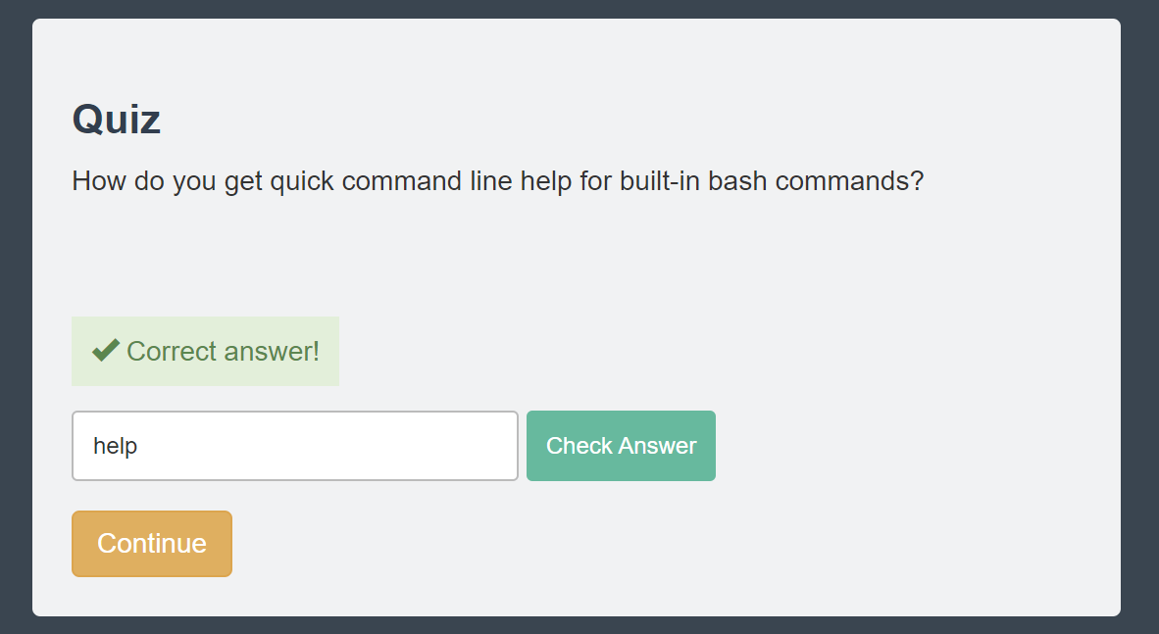

### 2.16 man

* Visual: The terminal screen shows the command.

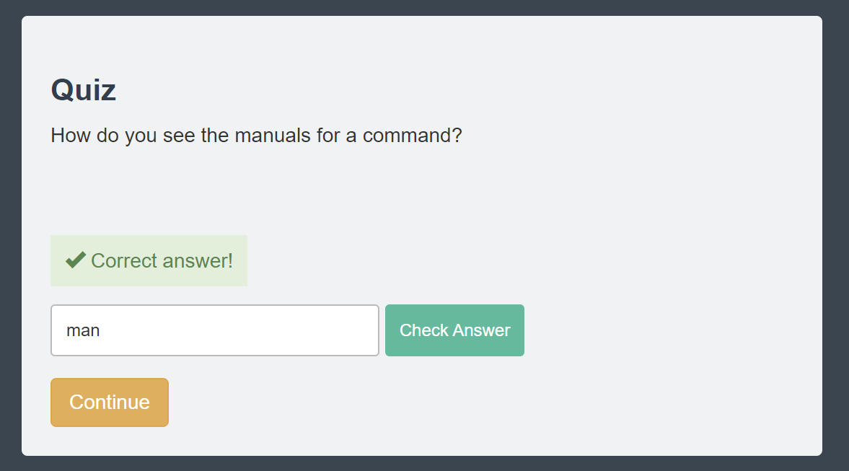

### 2.17 whatis

* Visual: The terminal screen shows the command.

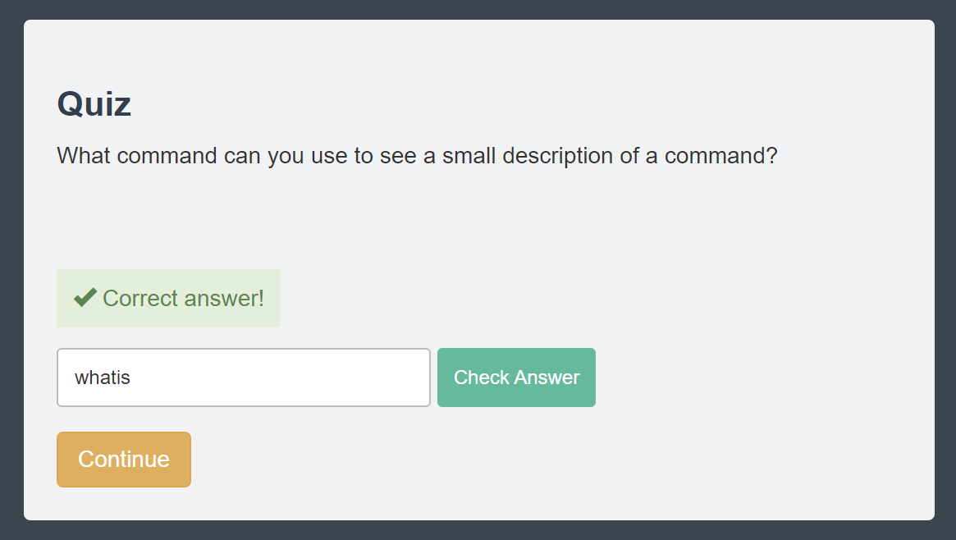

### 2.18 alias

* Visual: The terminal screen shows the command.

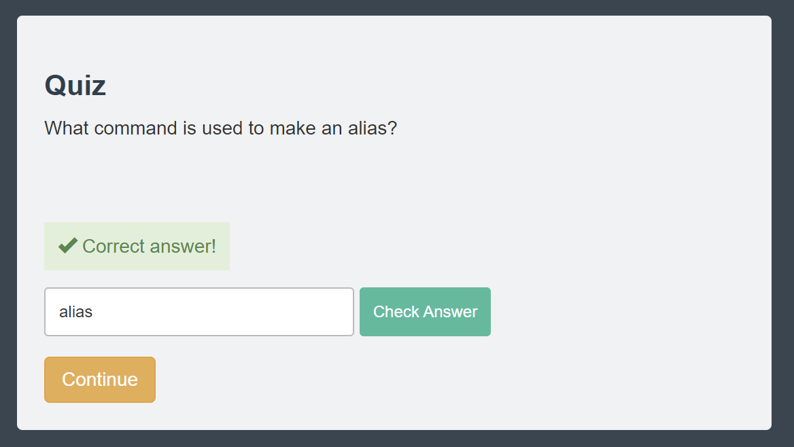

### 2.19 exit

* Visual: The terminal screen shows the command.

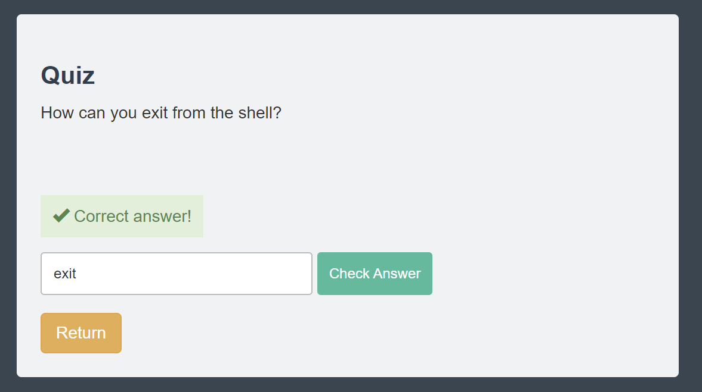

## User Management

### 3.1 Users and Groups

* Visual: The terminal screen shows the command.

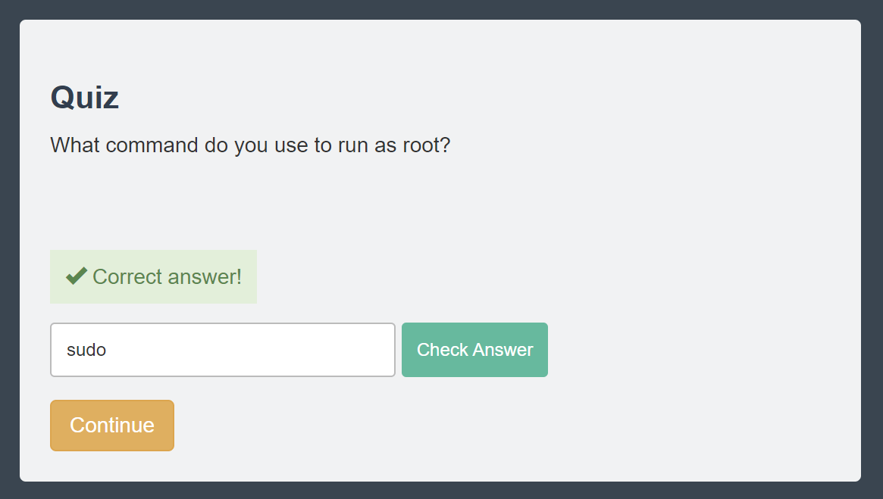

### 3.2 root

* Visual: The terminal screen shows the command.

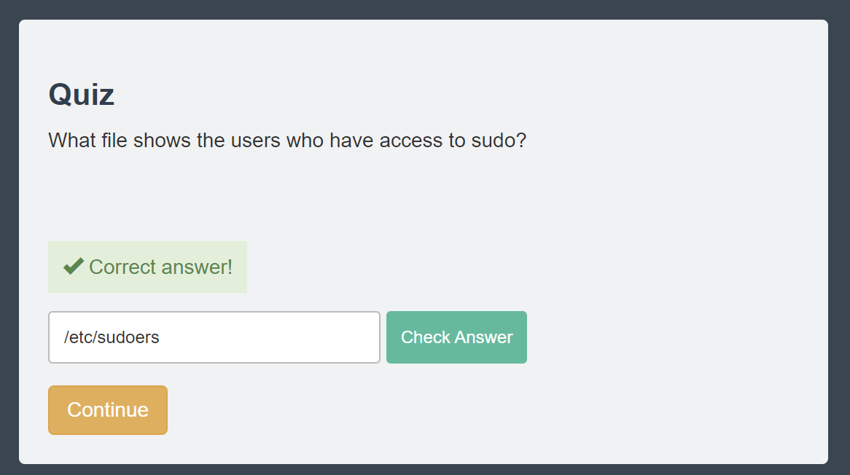

### 3.3 /etc/passwd

* Visual: The terminal screen shows the command.

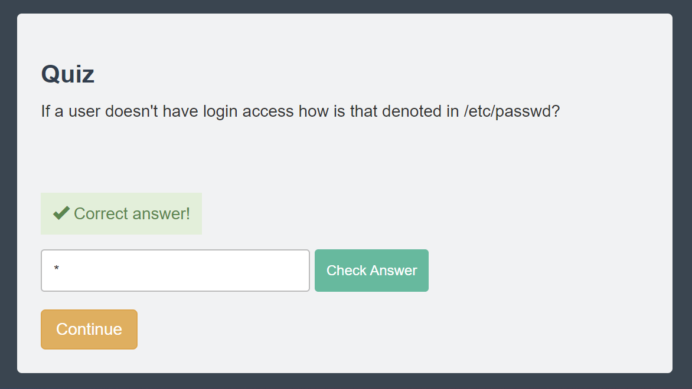

### 3.4 /etc/shadow

* Visual: The terminal screen shows the command.

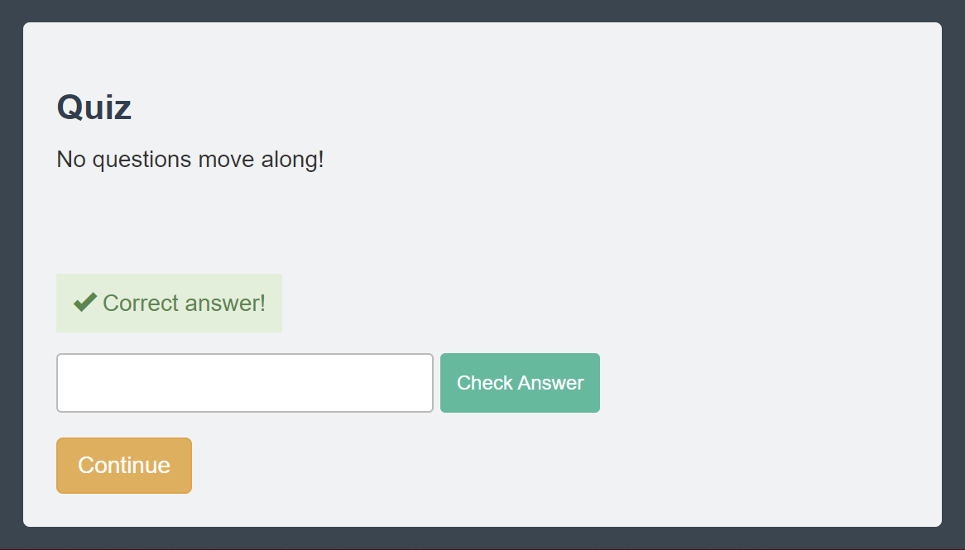

### 3.5 /etc/group

* Visual: The terminal screen shows the command.

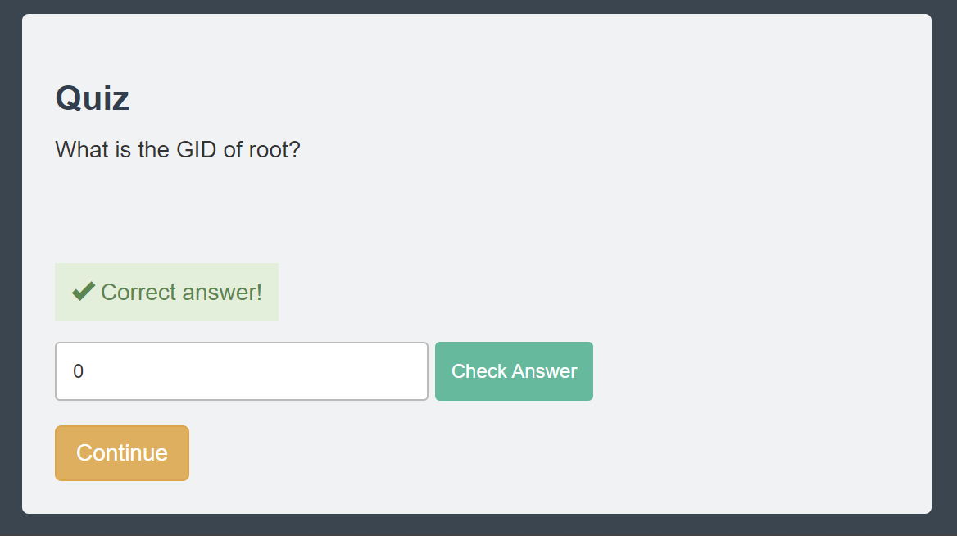

### 3.6 User Management Tools

* Visual: The terminal screen shows the command.

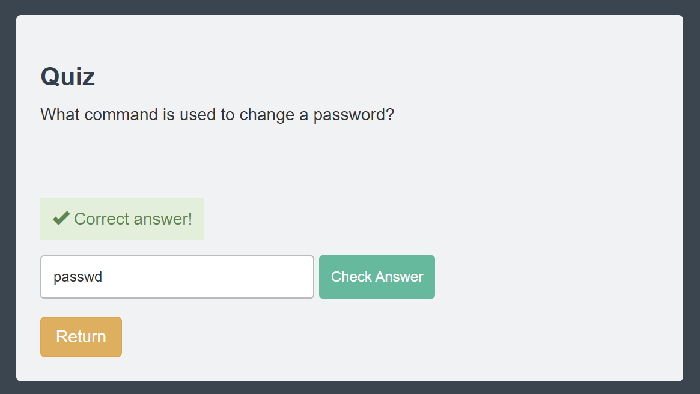

## References

**Official Ubuntu Documentation: User Management**

* [Link: https://ubuntu.com/server/docs/administration-users](https://ubuntu.com/server/docs/administration-users)
* <https://manpages.ubuntu.com/manpages/focal/man1>
* [https://l](https://manpages.ubuntu.com/manpages/focal/man1/mkdir.1.html)inuxjourney.com

**Linux man Pages**

* Commands were referenced through the built-in manual (man) pages in Linux.

**The Linux Command Line by William E. Shotts, Jr.**

* A comprehensive guide for understanding Linux commands and system administration tasks.