

MA in Public Policy and Governance [2025-27]

School of Public Policy and Governance

Advanced Training in Large-scale Survey - NSS, NFHS and PLFS

Submitted by
Abhishek Anand Sinha (H2025PPG001)
Anoushka Purohit (H2025PPG002)
Durga Sreedevi PR (H2025PPG005)
Chaitanya Dandale (H2025PPG003)

Tata Institute of Social Sciences, Hyderabad

Analyse the probability of getting access to good houses by socio-religious groups in India through logistic regression and suggest relevant public policies

Introduction
Housing is an indispensable part of human well-being. The UN Human Rights Declaration of 1948 recognises adequate housing to be
“Everyone has the right to a standard of living adequate for the health and well-being of himself and his family, including food, clothing, housing, and the medical care and necessary social services… (Article 25.1).”
(UN Assembly 1948)
As per the World Cities Report 2025, nearly 1 billion people, or nearly one-eighth of the world’s population, live in inadequate housing with poor amenities and infrastructure. This shows a profound failure of the development. It is recognised as a fundamental human right. In India, this right is further solidified under Article 21 of the Constitution, which guarantees the Right to Life and Personal Liberty, which is further interpreted by the Supreme Court to include the Right to Adequate Housing as an indispensable component of a dignified life. It places the onus on the state to address the structural and socio-religious inequalities that constrain adequate housing. The principle of 'Leaving No One Behind' in National Urban Policies strengthens institutional partnerships for sustainable urbanization, as emphasized by UN-Habitat's framework for India.
This study analyses the probability of accessing good houses by various socio-religious groups, with a limitation in mind that there can be response bias, considering the NSSO 76th round as our database.
METHODOLOGY
The statistical methods used in understanding the social determinants include logistic regression, cross-tabulation, and descriptive statistics.
Socio-religious determinants for access to Good Housing
- Gender
- Religion
- Social Groups
- Sector
- MPCE (Average Monthly Per Capita Expenditure)
  - log(income)=log(MPCE), as the dataset doesn’t take into account the income of the household
- Highest Education Level
- Tenurial Status of Dwelling
- Good_House (Binary dependent)
The p-value remains constant below 0.05, which is 0.00, signalling that the there is a high statistical significance to this model.
Assumptions:
- Binary Dependent Variable : which is satisfied by your variable Good_House (Good House =1, Not Good House = 0).
- Independent of Observations: Selection and characteristics of one household should not influence those of another.
- Logistic regression is a large sample approximation, meaning it generally requires a relatively large sample size to produce reliable results. No. of Observations = 466,426.

Logistic Regression Analysis: Structural Condition
The results of logistic regression show the odds of households owning good or non-good housing, based on the unit-level household information like social groups, religion, the Highest level of education, and the sex of household members. We have separately run logistic regression analysis with the following combinations: -

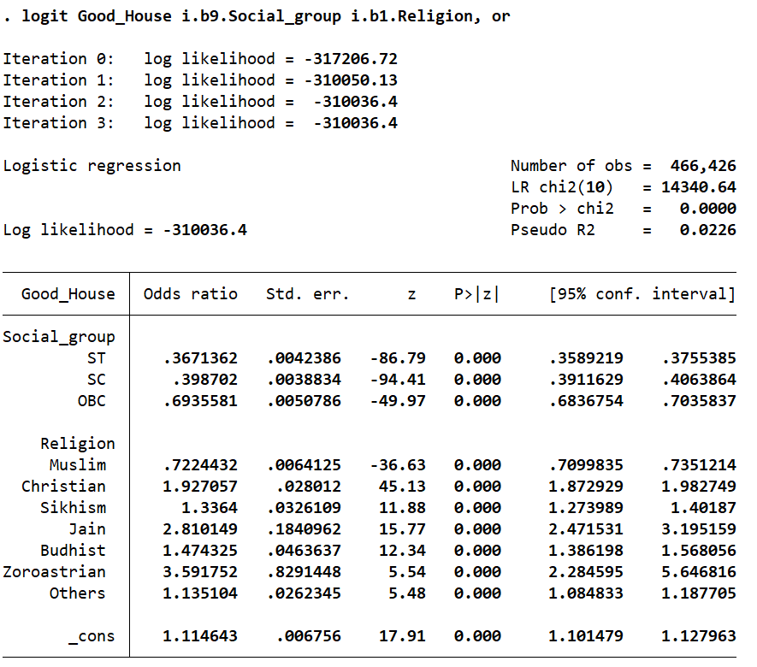Table 1.0, Results of Logistic regression
Table 1.0 shows the relationship between the ‘Social group’ and the ‘Condition of Structure’ across the sectors of Rural and Urban. These are weighted values and try to represent the actuals.
The logistics regression table is showing the assumption of getting good houses as per the social group and the religious group.
- Dependent variable: Good_House (binary)
- Independent variable: Social_group and Religion
- Output reported as odds ratios
Number of Observation – 466,426
Here the reference category for the social group is others.
Schedule Tribe:
Odds ratio - .3671362
Interpretation – the odds ratio is lower than 1 for the ST category, which is signalling that the ST group has 74% (1 - .3671362 = .74) lower odds of being in the “Good_House” category when compared to the reference group “other”.
The confidence interval shows that only .3589219 to .3755385 due to the largest sample size and it is indicating that 95 percent of confidence in the odd ratio will lie between .3589219 to .3755385. so this shows that this is statistically significant and negative.
So from this we can understand that the ST group has negative association with getting good and quality house structure when compared to the social group Others.
One of the main reasons for this is their geographic isolation in "Scheduled Areas" where access to formal construction supply chains is limited. Furthermore, greater reliance on forest-based livelihoods and communal land tenure makes it difficult for households to secure formal housing loans that require individual property titles as collateral.
Schedule Caste:
Odds ratio - .398702
Interpretation – the odds ratio is lower than 1 for the SC category. Which is signalling that the SC group has 61% ( 1 - .398702 = .61) lower odds of being in the “Good_House” category when compared to the reference group “others”.
The confidence interval shows that only .3911629 to .4063864 due to the largest sample size and it is indicating that 95 percent of confidence in the odd ratio will lie between .3911629 to .4063864. so, this is showing that this is statistically significant and negative.
So, from this we can understand that, the SC group has negatively associated with getting good and quality house structure when compared to the social group Others.
One of the main reasons for this is the persistent legacy of residential segregation and the historical denial of land ownership, which has prevented the accumulation of intergenerational housing assets. This "capital deficit" is compounded by discriminatory barriers in urban rental markets, forcing SC households into low-cost, structurally inferior dwellings on the outskirts of economic hubs.
Other backward classes
Odds ratio - .6935581
Interpretation – the odds ratio is lower than 1 for the OBC category. Which is signalling that the OBC group has 31% ( 1 - . 6935581 = .31) lower odds of being in the “Good_House” category when compared to the reference group “others”.
The confidence interval shows that only .3911629 to .4063864 due to the largest sample size and it is indicating that 95 percent of confidence in the odd ratio will lie between .6836754 to .7035839. so, this is showing that this is statistically significant and negative.
So, from this we can understand that, the OBC group has negatively associated with getting good and quality house structure when compared to the social group Others.
One of the main reasons for this is that while OBCs have better land-holding status than SCs or STs, they often face a "middle-income trap" where their earnings are insufficient to upgrade semi-pucca structures to full pucca houses without government assistance. Additionally, the lack of secure, non-agricultural income in rural areas limits their ability to invest in expensive "Good" structural components, such as reinforced concrete (RCC) roofing.
Here the reference category is for the religion group is Hinduism
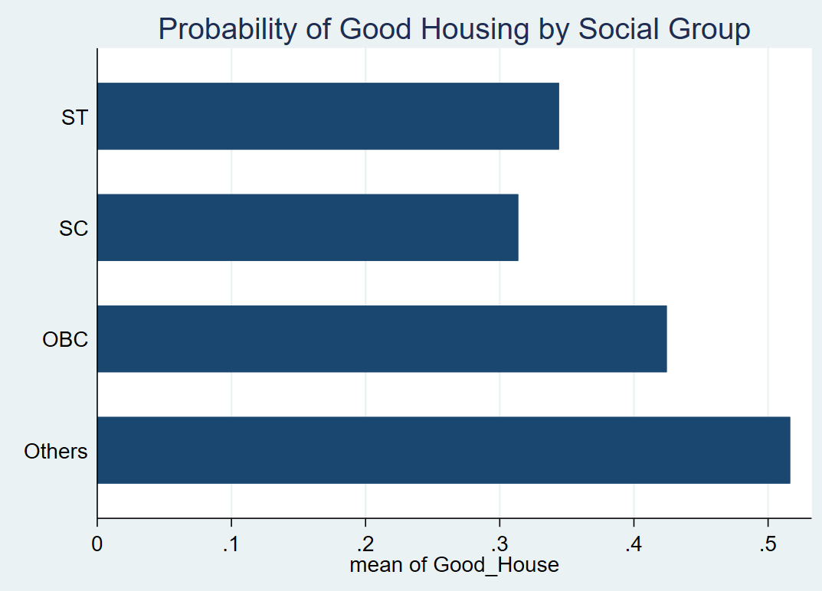
Muslim
Odds ratio - .7224432
Interpretation – the odds ratio is lower than 1 for the Muslim category. Which is signalling that the Muslim group has 28% (1 -.7224432 = .28) lower odds of being in the “Good_House” category when compared to the reference group Hindu.
The confidence interval shows that only .7099835 to .7351214 due to the largest sample size and it is indicating that 95 percent of confidence in the odd ratio will lie between .7099835 to .7351214. so, this is showing that this is statistically significant and negative.
So, from this we can understand that, the Muslim group has negatively associated with getting good and quality house structure when compared to the religion Hindu.
One of the main reasons for this is the high degree of urban residential segregation and "ghettoization," where minority communities are often concentrated in neglected neighbourhoods with poor municipal oversight. This spatial exclusion limits their access to formal housing markets and high-quality infrastructure, while systemic discrimination in the rental sector further restricts their ability to move into "Good" quality housing even when they possess the necessary financial resources.
When analysing the logistics table for getting the good structure house and religious group we can understand other than Muslim, every other religious groups like Christian (92%), Sikhs (33%), Jain (181%), Buddhist (47%), Zoroastrian (259%) and other (13%) has higher odds ratio which is signalling that this group has more chances of getting good houses when comparing to the reference group Hindu. So, comparing this we can understand from this logistical regression table that, Muslims are facing stronger problem with accessing the good house.

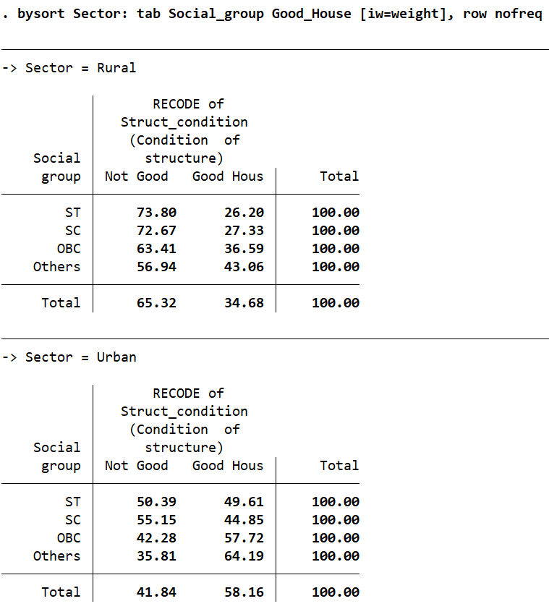
Table 1.1, Condition of Structure of Housing across different Social Groups in India, 2018.
The two-way cross tabulation offers the understanding of the ‘Condition of Structure’ of houses can be broadly categorized into the following two sub-sections -
Rural-Urban disparity: Housing in the ‘Urban’ areas are observed to have higher proportion of houses with ‘Good’ status of condition (58.16 %) compared to the other variable mentioning ‘Not Good’ status of condition (41.84 %) (the variables of ‘satisfactory’ and ‘bad’ are merged together). However, this picture still represents the lack of quality housing in the cities even after a range of focus on the urban affordable housing schemes such as the Pradhan Mantri Awas Yojana (Urban) along with others for both urban and rural areas.
In the ‘Rural’ areas, the housing which is ‘Not Good’ status is at 65.32% and ‘Good’ is at 34.68%. This comes from the point that in the rural areas we find the ‘social complexities’ playing a huge role in the facilitation of this reality. As discussed below with the group-wise disparities across rural and urban sectors.
Social group disparities: Throughout the sector – rural and urban, it is observed that the ‘Scheduled Tribe (ST)’ and ‘Scheduled Caste (SC)’ households have the lowest percentages of 'Good’ housing structures. It is notable to note that the ‘Others’ category which excludes the ‘Other Backward Classes (OBC)’ is having ‘highest’ percentage of “Good” houses. Reflecting the control of the dominant categories over the access to good quality houses. Below the category of ‘Others’ we find the ‘OBC’ households. Thus, this reflects towards the revisiting of the policies for both Urban and Rural areas.
The table shows the relation of the ‘Religion’ with the ‘Condition of Structure’ divided across the sectors of Rural and Urban. These are weighted values and try to represent the actuals.
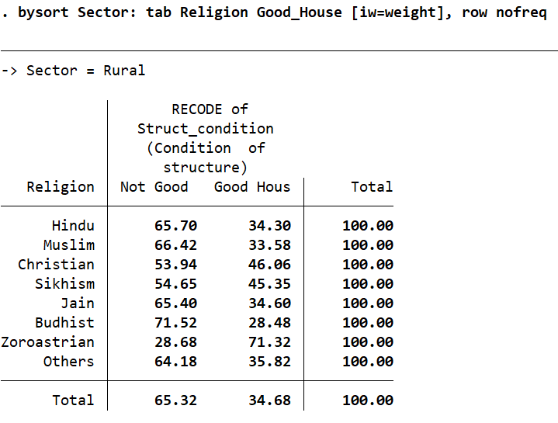
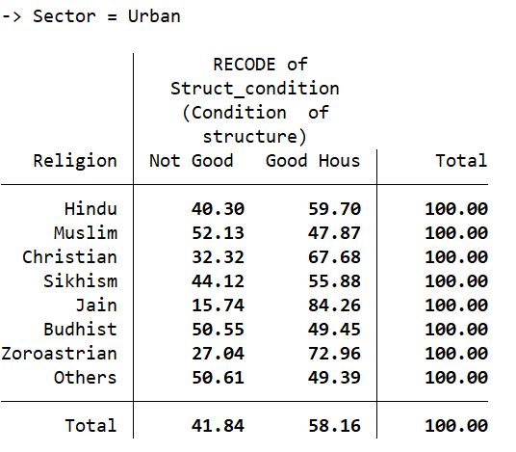
Table 1.2. Condition of Structure of Housing across different Religion Groups in India, 2018.
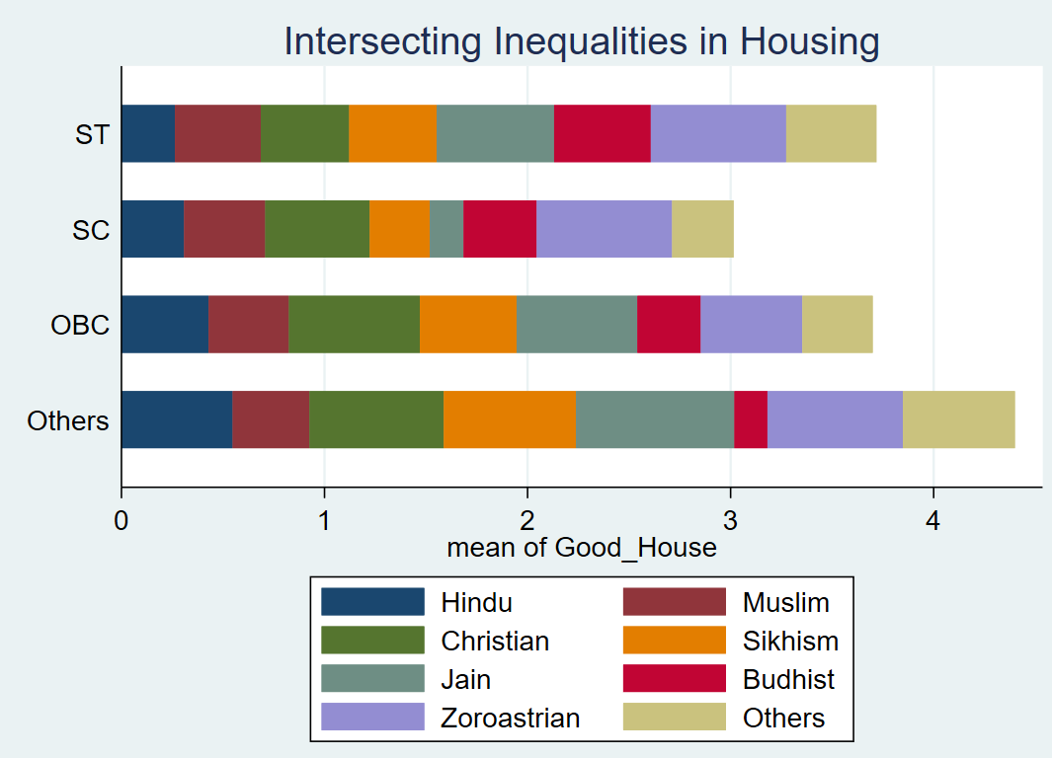
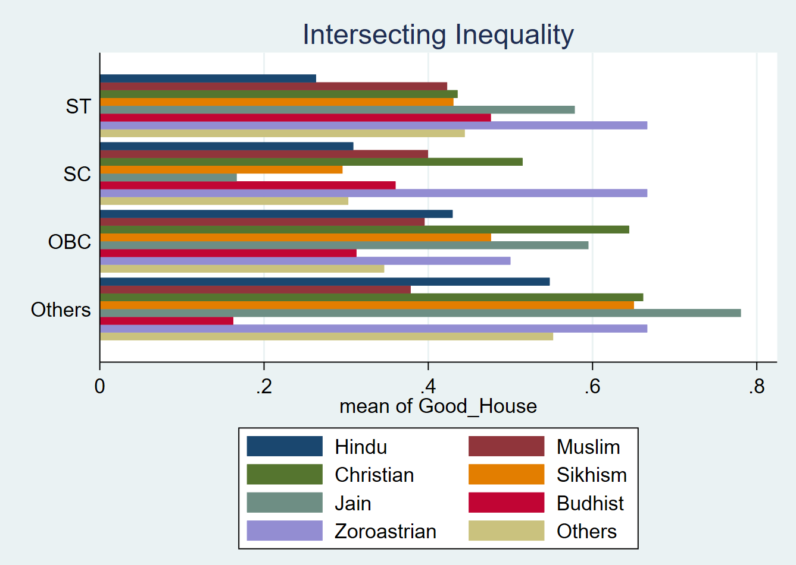
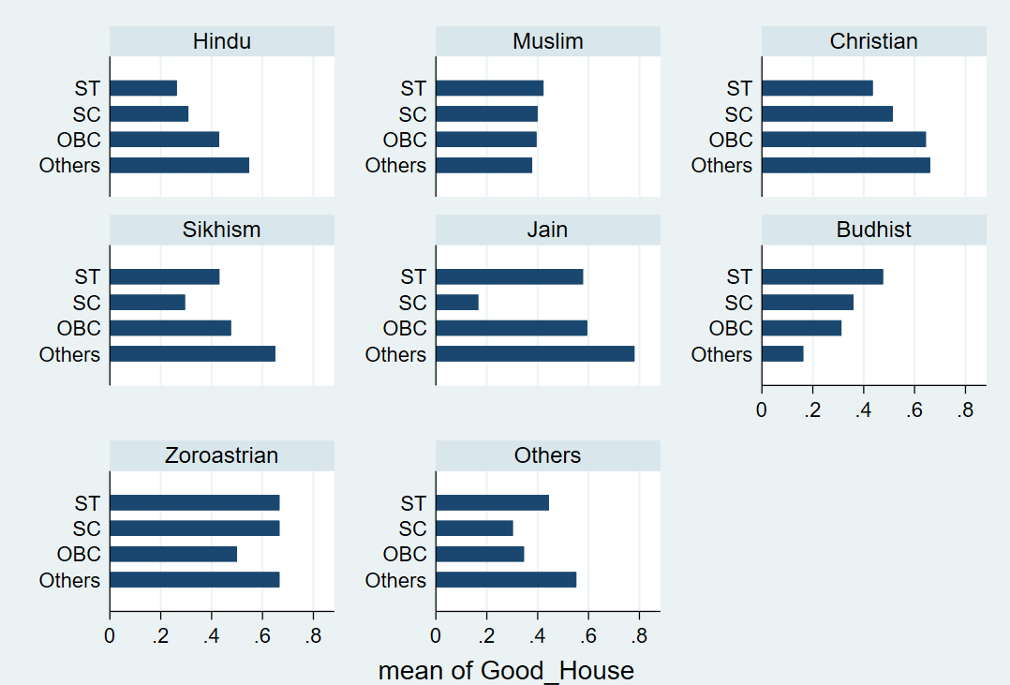
Graph 1.2: Intersectional Inequalities in housing
It can be observed that across all the ‘religions’ in the ‘Urban’ areas (58.16%) the structural conditions are better than ‘Rural’ areas (34.68%). We can understand the variable of Religion by understanding the ‘Better off’ religion categories and the ‘Vulnerable’ religion categories.
Better Off: Here, the ‘Zoroastrians’ have maintained a higher proportion of “Good” housing in both Rural (71.32 %) and Urban (72.96 %) areas. Notably, the percentage of ‘Jains’ having better structural condition of housing differs starkly between Urban (84.26 %) than the Rural (34.60 %) areas.
Vulnerable: The categories of ‘Buddhists’ recorded the ‘lowest’ percentage of ‘Good housing’ in the ‘Rural areas’ (28.48%) with the ‘Urban areas’ (50.55 % of ‘Not Good’) making them worse off in both the cases. The ‘Muslims’ are shown to have the highest ‘precarity’ in ‘Urban areas’ (52.13% ‘Not Good’). The only major group besides the ‘Others’ and ‘Buddhists’ to exceed the 50% mark for poor urban housing. Meanwhile, the ‘Hindus’, ‘Jains’ and then ‘Christians’ have shown to have more or less better housing conditions with ‘45%’ in Rural areas and ’55%’ in Urban areas. Though, the Christians have more ‘Not Good’ houses in Rural areas. Through this we find a similarity with the ‘Social Group’ analysis, as to how we see there is a disparity between the religions is a composite of the precarities shown by the ‘social groups.
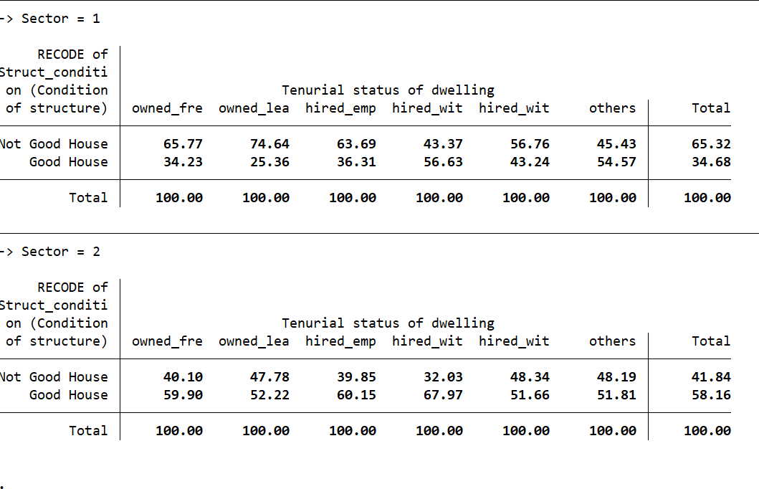
Table 1.3. Condition of Structure of Housing across Gender, 2018.

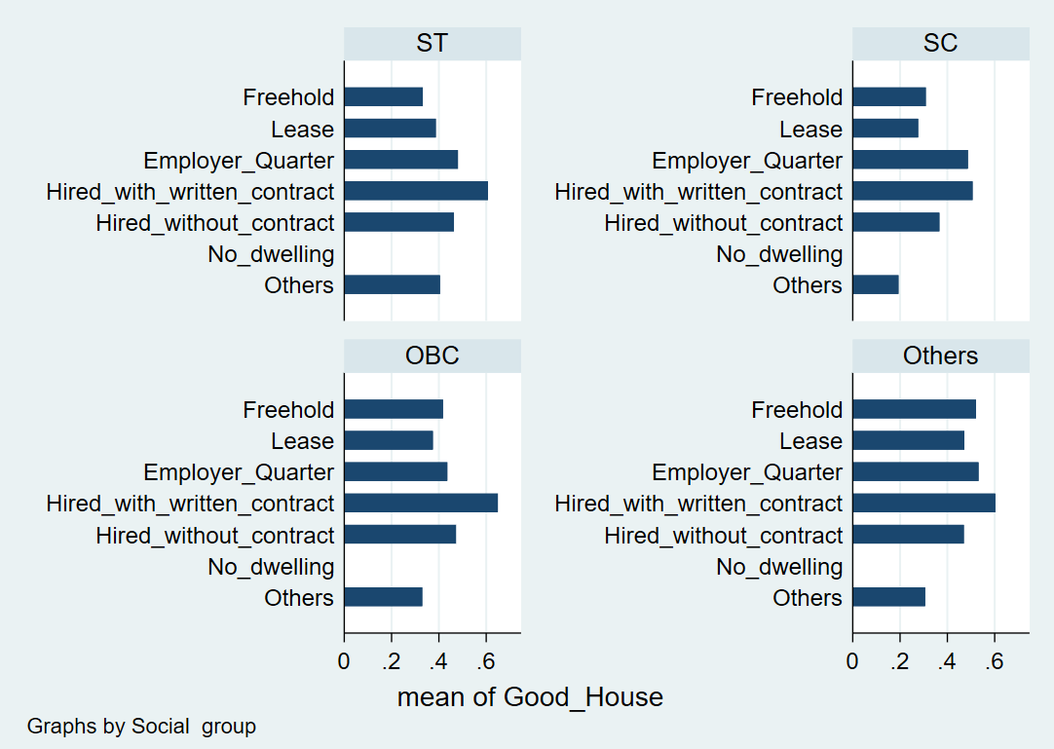
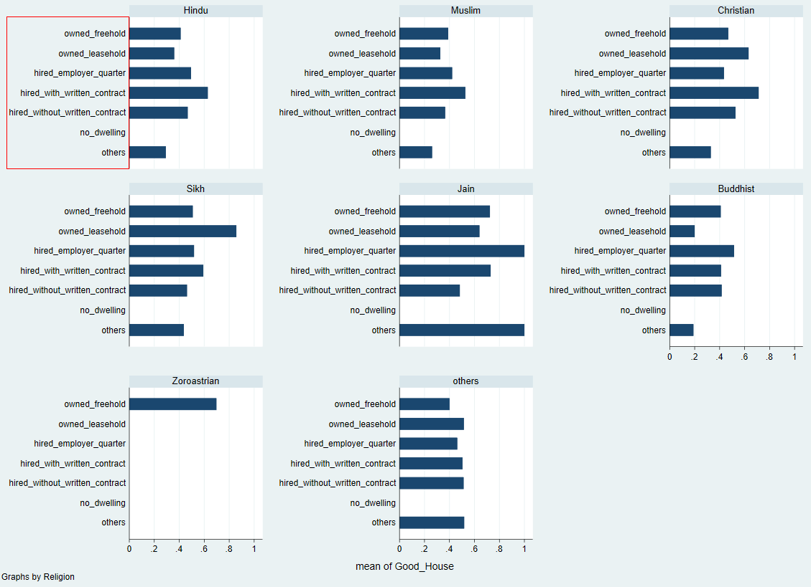
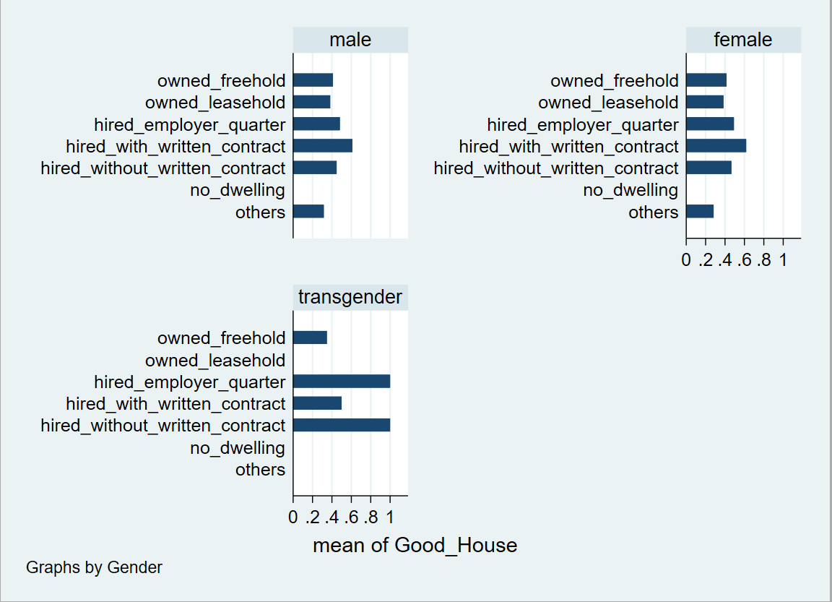
Graph 1.3. Condition of Structure of Housing across Gender, 2018.
The table shows the relation of the ‘Gender’ with the ‘Condition of Structure’ divided across the sectors of Rural and Urban. These are weighted values and try to represent the actuals.
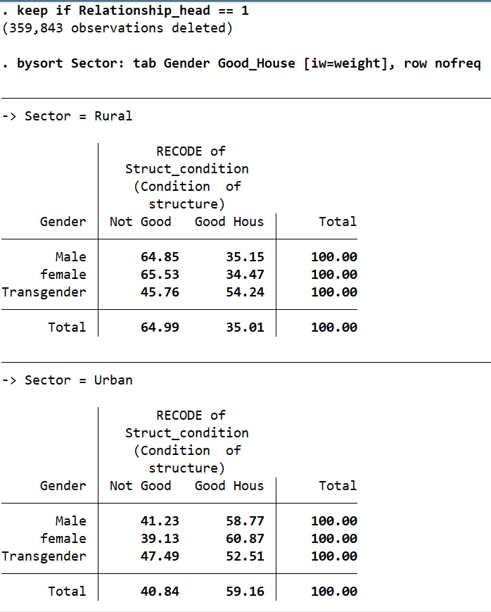
Table 1.4 Condition of Structure of Housing across Gender, 2018.
The ‘Gender’ variable is calculated on a person level, while the ‘Condition of Structure’ is a ‘household-level’ variable. However, to better understand the extent of ‘Female-Headed Households’ in the country. Here, the categories are given as ‘Male’, ‘Female’ and ‘Transgender’. This has been cross-tabulated with the ‘Urban’ and ‘Rural’ sectors.
Across the ‘Urban’ areas we find that for all ‘genders’ the households are significantly having ‘Good’ houses (59.16%) compared to ‘Rural areas’ (35.01%). Thus, we find that approximately 65% of both male and female-headed households live in structures classified as ‘Not Good’, interestingly for the ‘Transgender’ individuals there is better structural conditions (54.24%) as compared to the other groups.
Further analysis can be done of the three categories –

Sector | Male Head (Good) | Female Head (Good) | Transgender Head (Good)
Rural | 35.15% | 34.47% | 54.24%
Urban | 58.77% | 60.87% | 52.51%

Male vs Female Heads
In Rural areas, the male-headed households have a marginal difference of (0.68%) from the female-headed households under the ‘Good’ housing conditions.
In urban areas, female-headed households have better housing conditions at 60.87% compared to 58.77% for males.
Transgender Heads
The interesting case of transgender refers to better ‘Rural’ households as compared to other genders in the sector. In the ‘Urban’ areas, there is a similar picture, but with a slight decrease in housing quality. This can be attributed to the Ministry of Social Justice and Empowerment. Although the societal barriers still linger on.

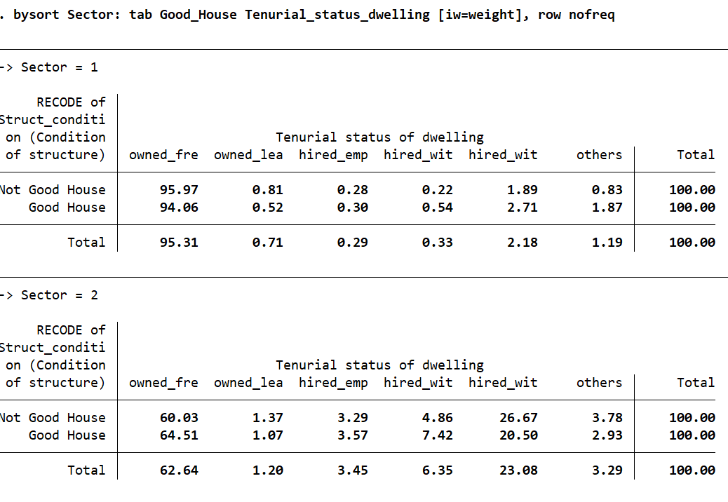
Table 1.5. Mean Condition of Structure of Housing across different Religion, Social Groups and Tenurial Dwelling Status in India, 2018.

Graph 1.5. Mean Condition of Structure of Housing across different Religion, Social Groups and Tenurial Dwelling Status in India, 2018.
Both the graphs below show the relation of the mean of the ‘Condition of Structure’ and ‘Religion’, ‘Social group’ and ‘Tenurial status of Dwelling’. This has been interpreted with the with the divided across the sectors of Rural and Urban. These are weighted values and try to represent the actuals.
It is observed that there is a ‘marginalization’ in the housing market of India. By observing the additional variable of ‘Tenurial status of Dwelling’, it showcases the ‘Scheduled Tribes (ST)’ and ‘Scheduled Castes (SC)’ having an increased of not having access to ‘Good’ houses, with 74 % and 61 %, respectively. This compared to the Forward castes category represented by the ‘Others’. This is due to the historical factors stemming from lack of land ownership, geographic isolation and disputes in the land boundaries. There is a trend of intergenerational accumulation of the housing capital.
In the ‘Social’ and ‘Religious’ grouping of ‘Other Backward Classes (OBC)’ and ‘Muslims’, having intersectional convergence of having ‘31 %’ and ‘28 %’ lower odds of ensuring a ‘Good’ house for them. There are constraints caused due to active discrimination and ghettoization in urban and rural property markets. This represents that the ‘Housing quality’ in India is a not merely function of a household’s income, but there is a historical role of caste and social barriers.
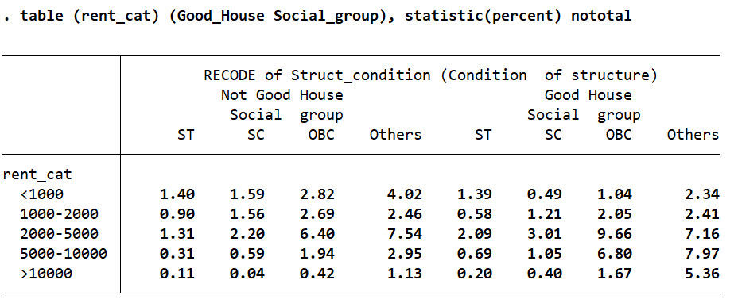
Table 1.6. Mean Condition of Structure of Housing across different Religion, Social Groups and Tenurial Dwelling Status in India, 2018.

Limitations
The perception of what kind of structure is a ‘ good structure’ depends on individual to individual. The Pradhan Mantri Awas Yojana (PMAY) is a major policy initiative of the Government of India to address homelessness and provide adequate housing. But it has had several limitations.
- Landless agricultural workers, who disproportionately belong to the Scheduled Caste (SC) and the Scheduled Tribe (ST) communities, often struggle to get benefits. The quota only extends to the EWS category (35%), making it a caste-blind policy
- While PMAY-G, for instance, mandates a 60% earmarking of targets for SC/STs, the final selection is verified by Gram Sabhas. Reports indicate that local, dominant-caste politics (especially OBCs ) can lead to the exclusion of deserving marginalised sections.
- There is a problem with the exclusion criteria, such as owning a refrigerator or a motorized two-wheeler can disqualify poor families from marginalized communities who might have acquired these items through other welfare schemes or small loans, yet still live in inadequate housing conditions.
- Implementation Gaps in Urban Areas: PMAY-Urban (PMAY-U) faces challenges in reaching slum dwellers through its In-Situ Slum Redevelopment (ISSR) vertical, with implementation reaching only a small percentage of intended beneficiaries, disproportionately affecting marginalized groups living in informal settlements.
- Marginalized, often illiterate beneficiaries face difficulty in providing the necessary "proper title documents" for land, which are required for self-construction (Beneficiary-Led Construction) benefits.
- Addressing urban limitations requires resolving regulatory bottlenecks, ensuring land availability, and promoting participatory planning mechanisms to better execute In-Situ Slum Redevelopment (ISSR)
Despite these limitations, PMAY-G and PMAY-U do include provisions for prioritizing Scheduled Castes (SC), Scheduled Tribes (ST), and other disadvantaged groups, including widows and persons with disabilities. However, the efficacy of this targeting is frequently reduced by the administrative and social hurdles mentioned above.
Policy Recommendations
1. Group specific policies
Beyond the general public policies which focus on the basic amenities, it is important to generate specific public policies which are focusing on the housing and basic amenities to promote inclusiveness and reduce the disparities between different social and religious groups.
2. Infrastructure and living standards
Mandatory Convergence for basic amenities
Along with policies for Building house (Pradhan Mathri Awas Yojana), linking the grants fro the housing schemes for the essential service like the Swatchh Bharath Mission for toilets, Ujjwala Yojana For the clean cooking fuel and the programs for the electrifying the house will help to improve the quality of houses along with the structural conditions.]
3. Strategic and community led development
Prioritized Earmarking for the SC/ST and Religious minorities – it is about the importance of setting aside specific portions of resources exclusively for a specific group before distributing for the rest. Because SC/ST and Muslim communities are facing greater amounts of marginalization in the access to the good house, this type of resource allocation will ensure, in every village, the benefits will not be captured by the influential groups.
4. Incentivizing incremental/ enhancement housing – congestion in the houses are one of the primary reasons for the low quality houses. Policies which are focusing on building more room to the existing houses rather than building new houses will be a solution for this problem, though the behaviour of the people will be a risk for the implementation of this policy, because living in congestion is accepted as the norm between the people especially in slum areas.
REFERENCES
Agarwala, P., Sachdev, M., Sambyal, S. S., Panda, A., Haldar, R., & United Nations Human Settlements Programme (UN-Habitat). (2023). India Country Report 2023-27. In R. Haldar & A. Viswanath (Eds.), India Country Report 2023-27 [Report]. https://unhabitat.org/sites/default/files/2023/06/10._india_country_report_2023.pdf
Das, K. (2025, June 26). Roti, kapda, but no makaan? The disappearing dream of affordable housing. India Today. https://www.indiatoday.in/business/personal-finance/story/affordable-housing-crisis-india-sharp-decline-rising-property-costs-2746134-2025-06-26
De La Maisonneuve, C., & Dek, M. (2020). Housing for all in India. OECD Economics Department Working Papers. https://doi.org/10.1787/b1e68648-en
India, E. (2025, October 13). Insight into the present and future of Indian affordable housing. EY - India. https://www.ey.com/en_in/insights/financial-services/insight-into-the-present-and-future-of-indian-affordable-housing
Kannan, K. P. (2014). HOUSING CONDITION IN INDIA. In SR Sankaran Chair, National Institute of Rural Development, & Laurie Baker Centre for Habitat Studies, Volume I.
Maniyar, Z., & Maniyar, Z. (2024, December 16). Widespread residential segregation & discrimination of Muslims & Dalits: Study. CJP. https://cjp.org.in/widespread-residential-segregation-discrimination-of-muslims-dalits-study/
Ministry Of Rural Development. (n.d.). Pradhan Mantri Awaas Yojana - Gramin. https://www.myscheme.gov.in/. https://www.myscheme.gov.in/schemes/pmay-g#sources
Mishra, V. K., & Khan, K. (2023). Determinants of discrimination in access to housing for marginalised social groups in India. Journal of Social Inclusion Studies, 9(1), 7–26. https://doi.org/10.1177/23944811231169194
Observer Research Foundation. (n.d.-a). The Centre needs to rethink the PMAY-G scheme. orfonline.org. https://www.orfonline.org/expert-speak/the-centre-needs-to-rethink-the-pmay-g-scheme
Observer Research Foundation. (n.d.-b). The Centre needs to rethink the PMAY-G scheme. orfonline.org. https://www.orfonline.org/expert-speak/the-centre-needs-to-rethink-the-pmay-g-scheme
Roy, A., Government of India, & NITI Aayog. (2025). A COMPREHENSIVE FRAMEWORK TO PROMOTE AFFORDABLE HOUSING. In NITI Aayog [Report].
Sagar, S., Department of Architecture and Planning, Netaji Subhas University of Technology, Delhi, Gautam, V., Department of Architecture and Planning, Indian Institute of Technology, Roorkee, Uttarakhand, Atreya, S., & Department of Architecture and Planning, Indian Institute of Technology, Roorkee, Uttarakhand. (2024). Right to Housing: A gender perspective. Urban India, 44–I, 55–56. https://niua.in/sites/default/files/2025-07/2024_1_Right%20to%20Housing.pdf
Suresh, N. (2025, December 17). Housing conditions. Data for India. https://www.dataforindia.com/housing/
United Nations. (n.d.). Universal Declaration of Human Rights | United Nations. https://www.un.org/en/about-us/universal-declaration-of-human-rights

