SE LAB WEEK 7

NAME: G. ABHISHEK BHAN

ROLL : 23BD1A6793

SECTION: CSD B

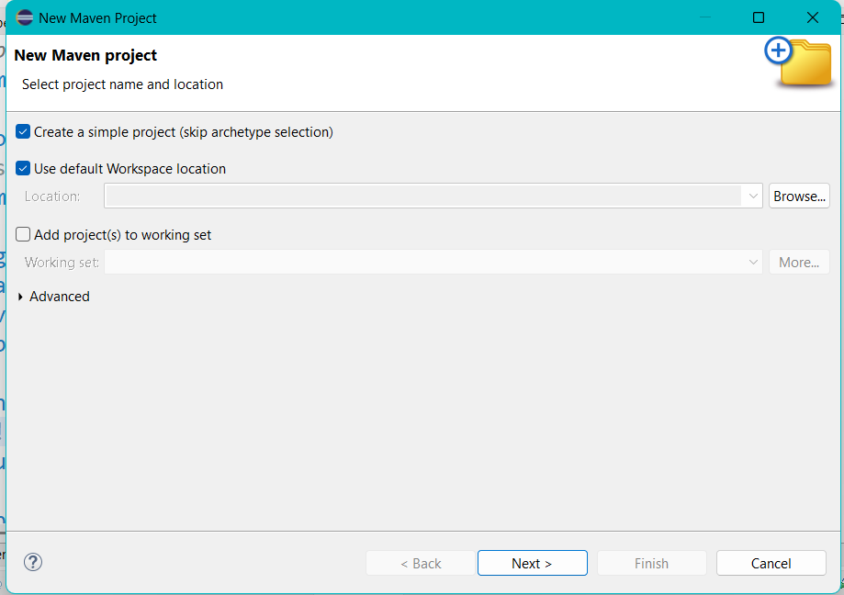

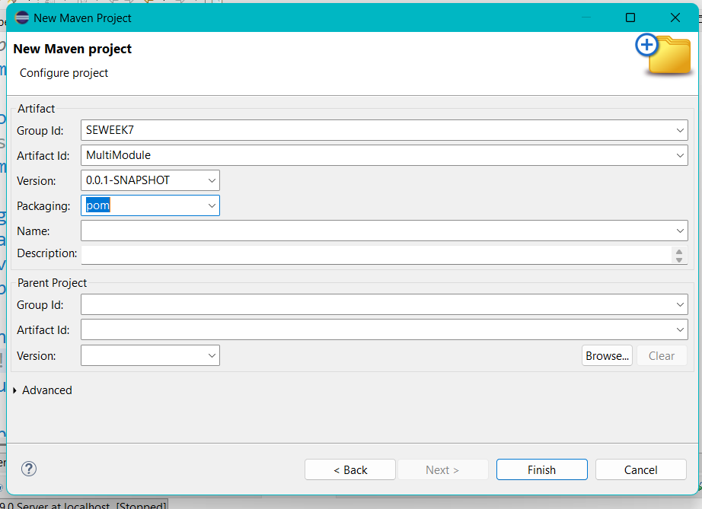

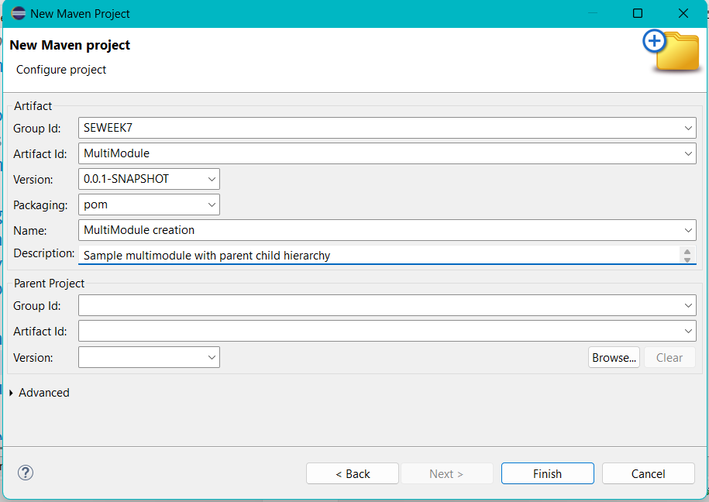

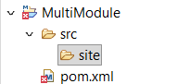

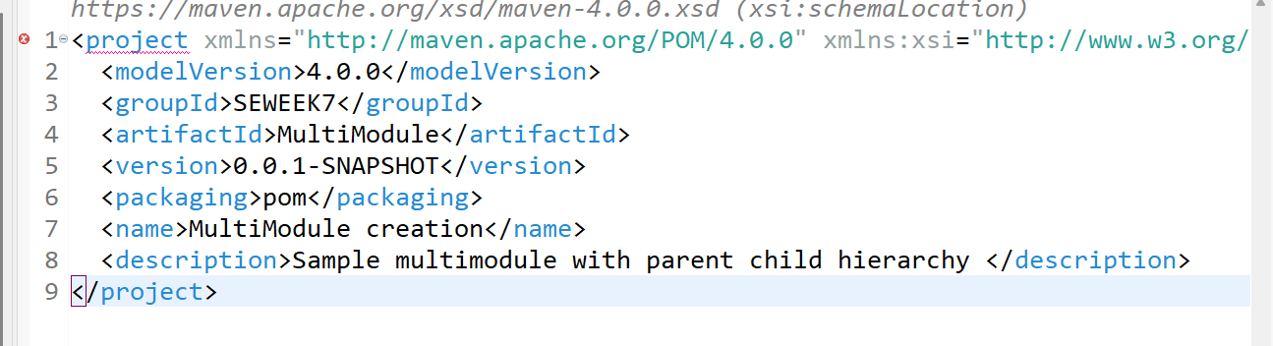

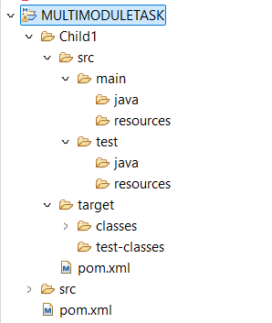

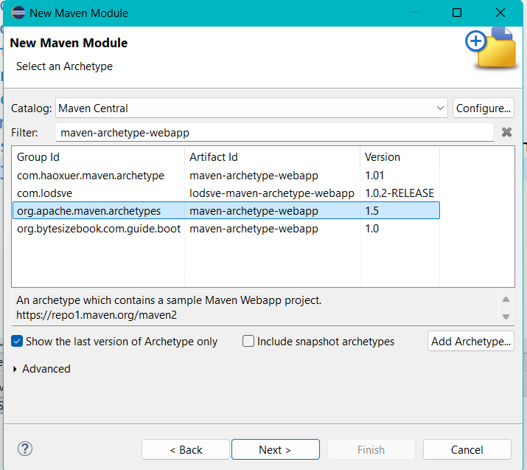

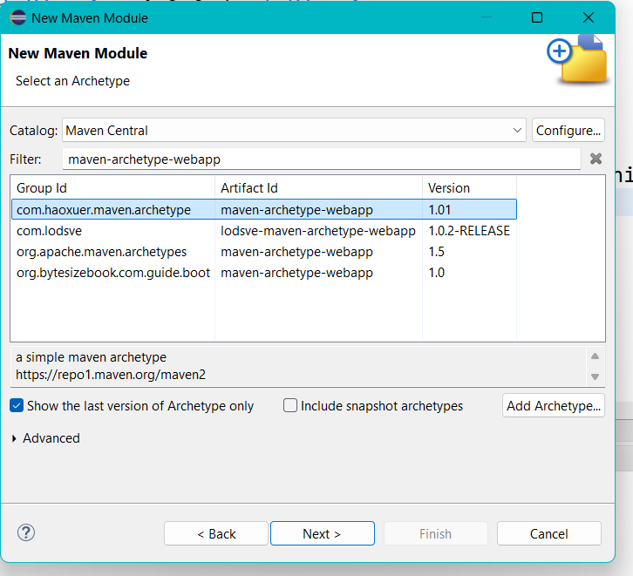

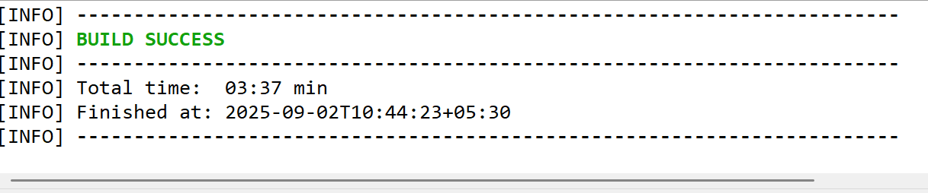

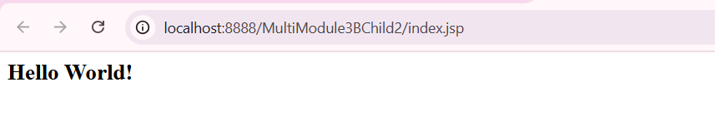

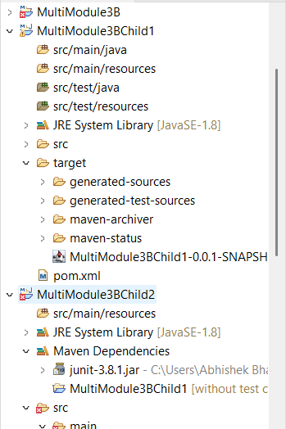

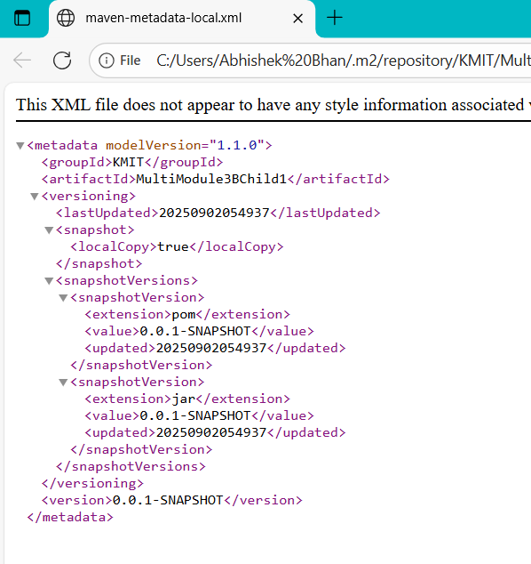

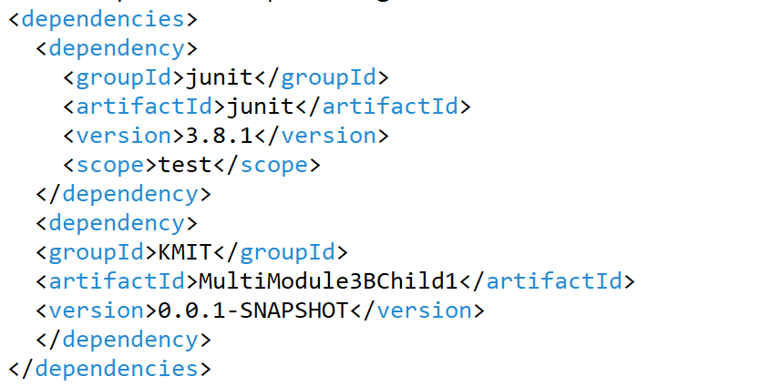

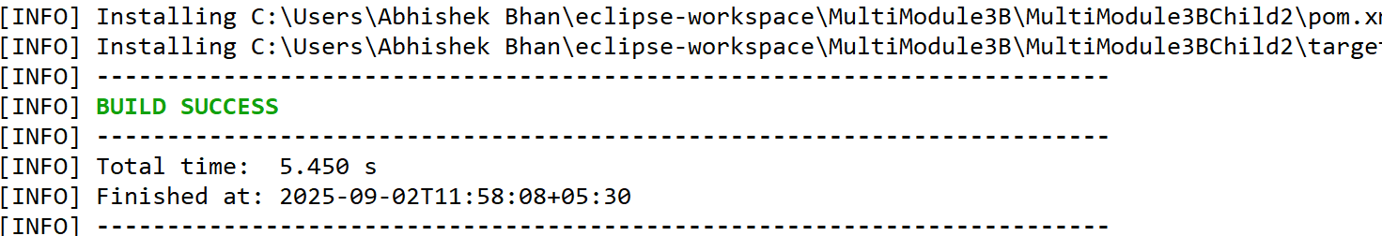

TASK 2

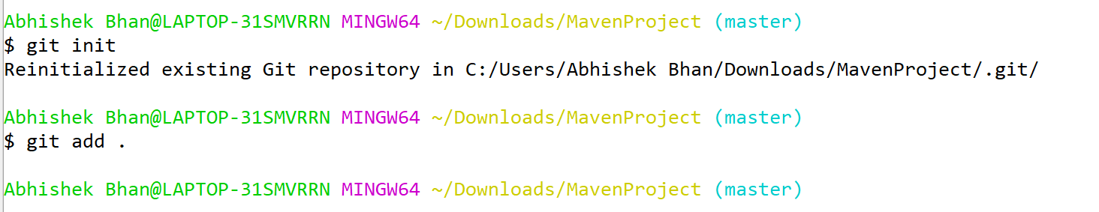

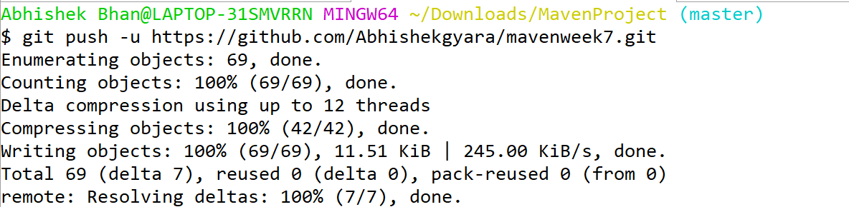

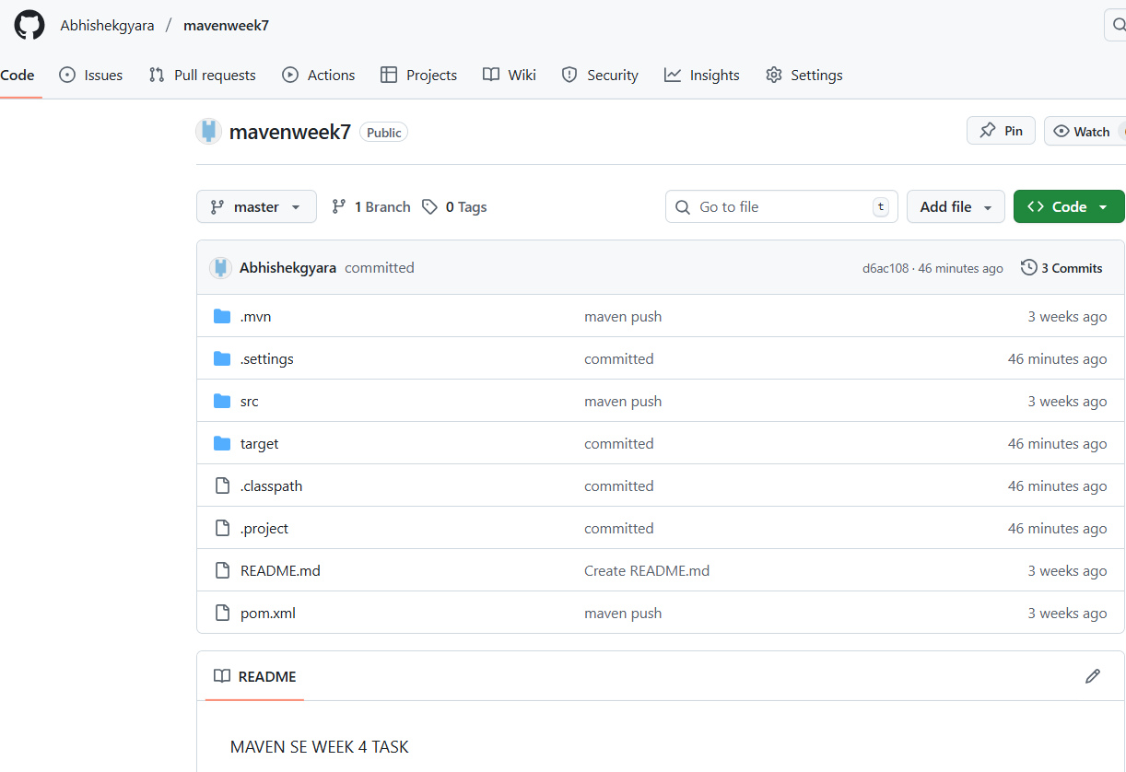

**Scenario-Based Questions:**

1. If my error is about:

*Failed to execute goal org.apache.maven.plugins:maven-compiler-plugin:3.8.1:compile*

*[ERROR] -> [Help 1]*

*[ERROR] To see the full stack trace of the errors, re-run Maven with the -X switch.*

How can I resolve it using maven terminal?

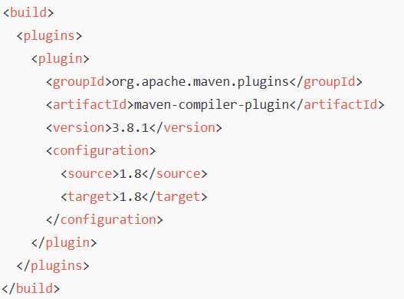

1. A dependency you added is not recognized by the compiler. What steps would you take to confirm it is available in **.m2** and listed in dependency tree?



1. A teammate sends a **.patch** file for a bug fix. How would you apply it and include it in your Maven build?



1. You have multiple **JUnit** test failures and want to rerun only failed tests. How would you approach this?
2. Your Maven build fails due to “Unsupported class version error.” What plugin and configuration would you review?

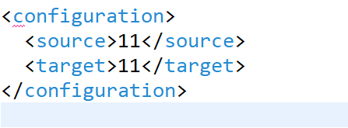

1. You need to change your Javaapplication from a **WAR** to a standalone **JAR**. What pom.xml changes are needed?

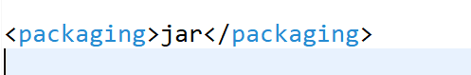

1. You are required to change the default build output directory from **target/** to **build_output/**. How would you configure it?

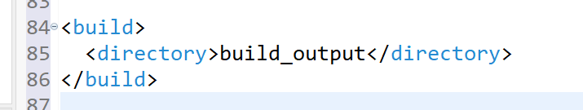

1. You want to skip tests during the Maven build. What command would you use?



1. How do you build a Java project using Maven, and what files are generated in the **target/** folder after running mvn clean install?



1. How does Maven resolve dependency conflicts when two libraries use different versions of the same dependency, and how can you view and manage the **dependency tree**?

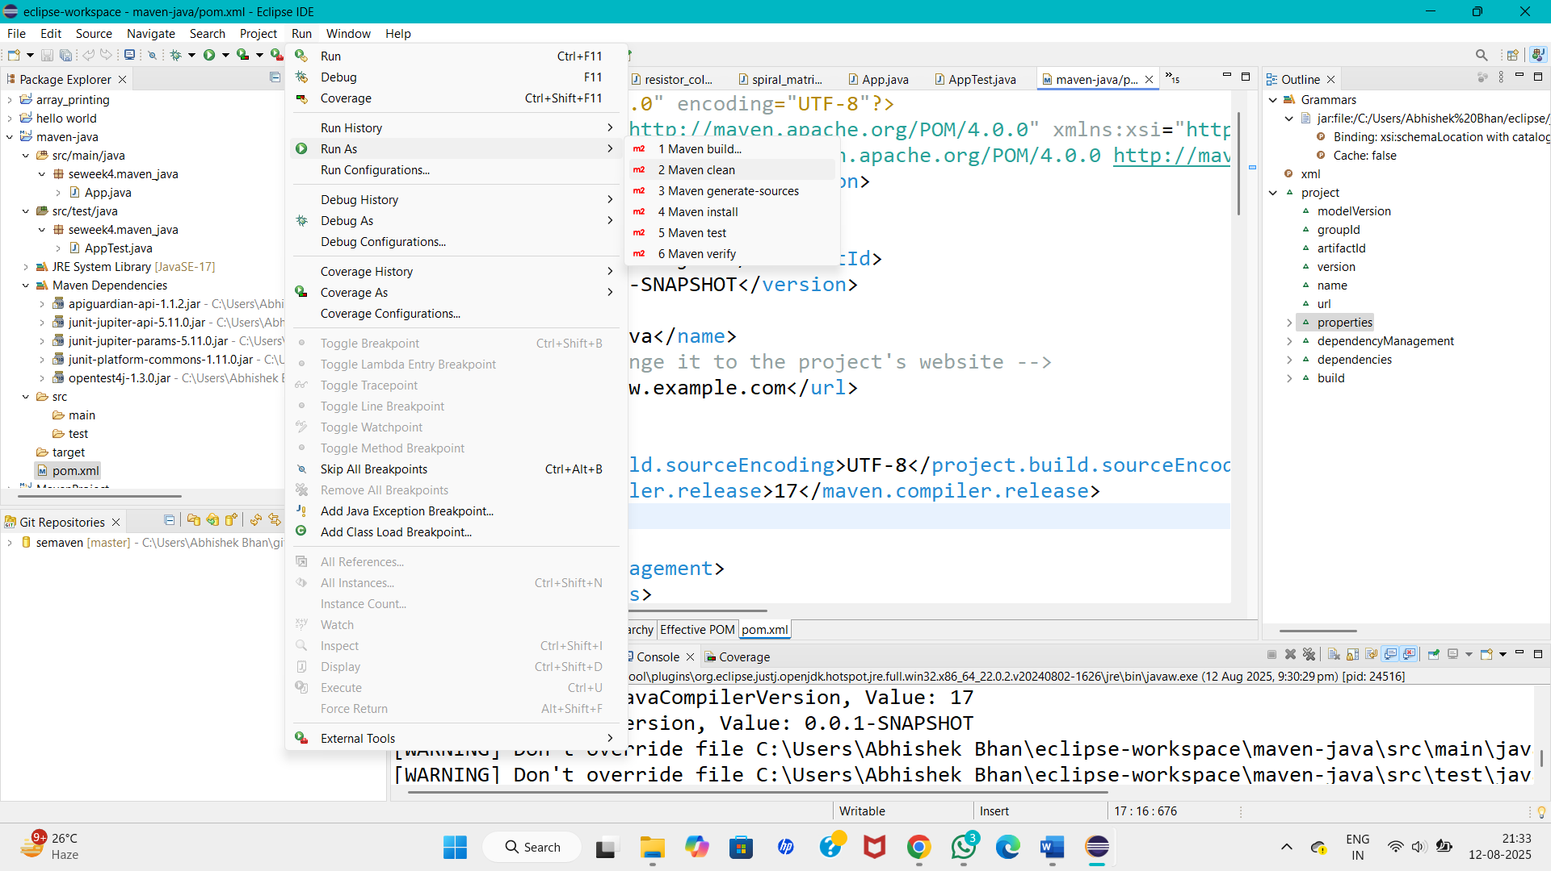

1. How do you write and run a JUnit test in a Maven project, and where are the compiled test classes and reports stored after running **mvn test**?



1. How can you create an executable **JAR** with a main method using Maven, and which **plugin** helps configure this behavior?

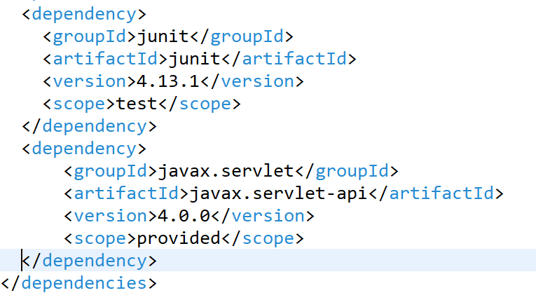

1. How do you install and use a custom third-party JAR file in your Maven project, and how can you confirm it’s included in the build and **classpath**?



1. How do you create a Maven web project that packages into a WAR file, and what is the standard folder structure for such a project?

mvn install:install-file \

-Dfile=custom-lib.jar \

-DgroupId=com.example \

-DartifactId=custom-lib \

-Dversion=1.0 \

-Dpackaging=jar

1. What command do you use to build a WAR file in Maven, where is it generated, and how can you deploy it to a server like **Apache Tomcat**?



1. How do you add JSTL and **servlet-api dependencies** in a Maven web project, and why should the servlet API use provided scope instead of compile?



1. How do you set up a multi-module Maven web project with separate modules for core logic and web interface, and how are these modules built and connected?

