Table of Contents

Sr.  No. |  | Particulars | Page No.
1. |  | Introduction | 15
 | 1.1 | Introduction to the project | 15
 | 1.2 | Objective of the Project | 16
 | 1.3 | Limitations of Existing System | 17
 | 1.4 | Proposed System | 18
 | 1.5 | Project Feasibility Analysis | 19
 |  | Economic Feasibility | 19
 |  | Technical Feasibility | 20
 |  | Operational Feasibility | 21
 | 1.6 | Project Management Approach- Software Process Model | 22
 | 1.7 | Project Timeline- Gantt Chart/Timeline Chart | 23
2. |  | Project Analysis- Software Requirement Specification (SRS) | 24
 | 2.1 | Purpose of the Project | 24
 | 2.2 | Scope of the Project | 25
 | 2.3 | Functional Requirements | 26
 | 2.4 | Non Functional Requirements | 28
 | 2.5 | Hardware Requirements | 29
 | 2.6 | Software Requirements | 31
 | 2.7 | Stakeholders of the System | 33
3. |  | Requirement Models | 36
 | 3.1 | Use case Diagram | 36
 | 3.2 | Context Level Diagram | 38
 | 3.3 | Data Flow Diagram | 40
 | 3.4 | Entity Relationship Diagram | 42
 | 3.5 | Activity Diagram | 43
 |  | Sequence Diagram | 45
 | 3.6 | Any UMLs (If Required) | 47
 |  | Class Diagram | 48
 | 3.7 | Flow charts (If any) | 49
 | 3.8 | Project Flow/Architecture | 51
 | 3.9 | Database Schema | 53
4. |  | Project Development / Implementation | 55
 | 4.1 | User Interface Designs (With Description) | 55
 | 4.2 | Any Configuration Designs | 58
 | 4.3 | Output Screen Designs / Report Screenshots Images | 59

5. |  | Project Testing | 69
 | 5.1 | Software Testing | 69
 | 5.2 | BUG FIXES AND IMPROVEMENTS | 72
 | 5.3 | IMPROVEMENT IMPLEMENTED | 74
 | 5.4 | Test Cases | 76
 |  | Testing Report | 79
6. |  | Limitations | 80
7. |  | Future Enhancements | 82
8. |  | Conclusion | 85
9. |  | Bibliography | 87

INTRODUCTION

Introduction to the Project

Educational institutions today manage a wide range of student activities beyond academics, including clubs, committees, cultural events, technical societies, and community engagement programs. These activities play an important role in developing leadership, teamwork, communication skills, and professional growth among students. However, the management of such activities is often dependent on disconnected communication channels and manual administrative procedures.
In many colleges, information regarding committee recruitment, event participation, official announcements, and organizational documents is distributed through notice boards, emails, messaging groups, and paper-based forms. While these methods have been used for years, they frequently create communication delays, inconsistent information sharing, and difficulties in maintaining records. Students may miss important opportunities, while committee heads and administrators spend considerable time handling applications and maintaining documentation manually.
CampusConnect has been developed to address these challenges by providing a centralized digital platform for managing student organizations and campus activities. The system acts as a bridge between students, committee leaders, faculty coordinators, and administrators by bringing all essential operations into a single web-based environment.
The platform allows students to explore available committees, submit applications online, monitor their recruitment progress, access official reports, and stay informed through real-time announcements. Committee heads can efficiently manage recruitment activities, evaluate applications, and maintain organization-related documents. Administrators are provided with tools to oversee campus operations, manage users, and ensure smooth communication across the institution.

.
By integrating modern web technologies and role-based access control mechanisms, CampusConnect creates a structured and transparent ecosystem that improves operational efficiency while enhancing student participation in campus life.

Objective of the Project

The primary goal of CampusConnect is to establish a unified digital environment that simplifies committee management, improves communication, and supports efficient collaboration among members of an educational institution.
The major objectives of the system are as follows:
- To Centralize Campus Information
The system provides a single platform where students can access announcements, committee information, reports, and recruitment opportunities without relying on multiple communication channels.
- To Modernize Committee Recruitment
CampusConnect replaces traditional application methods with a digital recruitment workflow that enables students to apply online and monitor their progress throughout the selection process.
- To Improve Administrative Efficiency
The project reduces repetitive administrative tasks by automating application management, document sharing, and committee-related operations.
- To Ensure Secure Access Control
Different categories of users are granted access according to their responsibilities, ensuring that sensitive information remains protected and accessible only to authorized individuals
- To Promote Transparency
Students receive clear visibility regarding available opportunities, application status updates, and recruitment outcomes, thereby increasing trust in the selection process.

- To Encourage Student Participation
By making information easily accessible and recruitment procedures more convenient, the platform encourages greater involvement in extracurricular activities and student organizations.
`

Limitations of Existing System

The management of college committees, and student activities in many educational institutions still relies on conventional methods such as physical notices, email communication, spreadsheets, paper forms, and unofficial messaging groups. Although these methods are widely used, they present several operational and administrative challenges.
One of the major limitations of the existing system is the absence of a centralized communication platform. Important announcements related to committee recruitments, events, meetings, and deadlines are often distributed through multiple channels. As a result, students may miss critical information, leading to confusion and reduced participation in campus activities.
Another significant issue is the manual recruitment process followed by many student organizations. Applications are commonly collected through paper forms or external platforms, making it difficult for committee heads to organize, review, and track applicants efficiently. The lack of a structured workflow increases administrative effort and may result in delays during candidate selection.
Document management presents another challenge. Reports, event records, meeting minutes, and official committee documents are frequently stored across different locations, making retrieval and sharing difficult. This scattered approach increases the risk of data loss and creates inefficiencies in information management.
Furthermore, traditional systems generally lack role-based access control mechanisms. Students, committee heads, faculty coordinators, and administrators often access information through the same communication channels without clearly defined permissions. This may lead to unauthorized access, information overload, and security concerns.

The absence of an integrated digital platform also restricts data analysis and reporting capabilities. Without centralized records, it becomes difficult for administrators to evaluate student participation, monitor recruitment trends, and generate meaningful insights for future planning.
Therefore, the limitations of the existing system highlight the need for a centralized, secure, and automated platform such as CampusConnect, which streamlines communication, recruitment management, document sharing, and administrative operations within a unified digital environment.

Proposed System

The proposed system, CampusConnect, is a web-based platform developed to simplify and digitize the management of college committees, clubs, and student activities. The system provides a centralized environment where students, committee heads, faculty coordinators, and administrators can perform their respective tasks efficiently through role-based access.
Students can explore available committees, apply online, track their application status, and access important announcements and documents. Committee heads can review applications, manage recruitment processes, and maintain committee records. Administrators can oversee the entire system, publish announcements, and manage users and organizations.
The platform also includes secure document management, online recruitment workflows, and centralized communication features. By automating these processes, CampusConnect reduces manual work, improves transparency, enhances communication, and promotes greater student participation in campus activities.
Committee Heads are provided with dedicated dashboards that enable them to review applications, evaluate candidates, manage recruitment rounds, and maintain records of committee members. This digital workflow significantly reduces the manual effort required for handling large numbers of applications and improves overall recruitment efficiency.
The system is developed using modern web technologies including React.js, Node.js, Express.js, MongoDB, and Cloudinary, providing a responsive, scalable, and secure architecture capable of supporting a large number of users simultaneously.

By integrating communication, recruitment management, document sharing, and administrative operations into a single platform, CampusConnect improves efficiency, enhances transparency, reduces paperwork, and promotes greater student participation in campus activities.
Advantages of Proposed System
- Centralized communication platform
- Online committee recruitment process
- Secure role-based access control
- Easy document sharing and management
- Improved transparency and efficiency
- Reduced paperwork and administrative workload
- Better student engagement and participation

Project Feasibility Analysis

A feasibility analysis is an important step in the software development process that helps determine whether a project can be successfully developed and implemented within the available resources and constraints. For the CampusConnect project, a detailed feasibility study was conducted to evaluate its practicality, cost-effectiveness, and usability within a college environment.
The analysis indicates that the proposed system is feasible from technical, economic, and operational perspectives.

Technical Feasibility
Technical feasibility examines whether the required technology, tools, and resources are available to develop and maintain the proposed system.

CampusConnect is developed using modern web technologies such as React.js for the frontend, Node.js and Express.js for backend services, MongoDB for database management, and Cloudinary for document storage. These technologies are widely used in the software industry and provide excellent support for building scalable and secure web applications.
The development tools required for the project are freely available and can be executed on standard computer systems without the need for specialized hardware. The selected technology stack also supports future enhancements, making the system flexible and easy to maintain.
Therefore, the project is technically feasible as the required technologies, infrastructure, and development resources are readily available.

Economic Feasibility
Economic feasibility evaluates whether the benefits of the proposed system justify the cost of its development and implementation.
CampusConnect is built using open-source technologies, which significantly reduces software licensing expenses. The development environment, frameworks, and database used in the project are available free of cost. In addition, cloud services such as Cloudinary offer free storage plans suitable for educational projects.
The implementation of CampusConnect can also reduce operational costs by minimizing paperwork, manual record maintenance, and repetitive administrative tasks. Since most campus activities can be managed digitally through the platform, institutions can save both time and resources.
As the development and maintenance costs are relatively low compared to the benefits provided, the project is considered economically feasible.

Operational Feasibility
Operational feasibility determines whether the proposed system can be effectively used by its intended users.

CampusConnect is designed with a simple, interactive, and user-friendly interface that can be easily used by students, committee heads, faculty coordinators, and administrators. The system automates several routine tasks such as application submission, recruitment management, document distribution, and announcement broadcasting.
The platform improves communication among different stakeholders and reduces dependency on traditional methods such as notice boards and paper forms. Since users can access the system through a web browser, no special training or technical expertise is required.
The proposed system integrates smoothly into existing college operations and provides a more organized approach to managing campus activities. Therefore, the project is operationally feasible.

Schedule Feasibility
Schedule feasibility evaluates whether the project can be completed within the available time frame.
The development of CampusConnect follows a structured software development approach consisting of requirement analysis, system design, implementation, testing, deployment, and documentation. Since the project utilizes modern development frameworks and readily available tools, it can be completed within the planned academic project duration.
Regular testing and incremental development further ensure that project milestones are achieved on time. Hence, the project is considered schedule feasible.

Conclusion
Based on the technical, economic, operational, and schedule feasibility studies, CampusConnect is a practical and viable solution for managing campus communication, committee recruitment, and document sharing. The system can be implemented successfully with the available resources while providing significant benefits to students, committee heads, faculty members, and college administrators. It offers an efficient, secure, and scalable platform that improves transparency, reduces administrative workload, and enhances overall campus management.

Project Management Approach – Software Process Model

The development of CampusConnect followed the Agile Software Development Model, which emphasizes iterative development, continuous feedback, and flexibility throughout the project lifecycle. This approach was selected because it allows developers to build the system in small functional modules while continuously testing and improving the application based on user requirements.
Unlike traditional software development models, Agile focuses on delivering working features in multiple stages rather than waiting until the entire project is completed. This methodology helped in identifying issues early, incorporating changes efficiently, and ensuring that the final system met the requirements of students, committee heads, faculty members, and administrators.
The development process of CampusConnect was divided into the following phases.
- Requirement Analysis
In this phase, the requirements of the system were gathered and analyzed. The major functionalities such as user authentication, committee management, recruitment workflow, announcement management, and document sharing were identified. User roles and system objectives were also defined.
- System Design
Based on the requirements, the system architecture, database structure, user interface designs, and workflow diagrams were prepared. The relationships between students, committees, applications, and administrators were carefully planned during this stage.
- Development
The application was developed incrementally by implementing different modules such as:
- User Authentication and Authorization
- Committee Management
- Recruitment Management

- Announcement System
- Document Repository
- Administrative Dashboard
Each module was developed, tested, and integrated into the system before moving to the next functionality.
- Testing
After implementation, various testing activities were performed to verify system functionality and reliability. Individual modules were tested, followed by integration testing to ensure smooth communication between different components of the application.
- Deployment
The completed system was deployed on a cloud platform and made accessible through a web browser. Regular monitoring and maintenance activities were carried out to fix issues, improve performance, and support future enhancements.
Advantages of Agile Model for CampusConnect
- Flexible and adaptable to changing requirements.
- Continuous testing improves software quality.
- Faster development through incremental releases.
- Easy identification and correction of errors.
- Better collaboration between developers and users.
- Supports future enhancements and scalability.

Project Timeline – Gantt Chart / Timeline

The development of CampusConnect was carried out in a structured and systematic manner over a period of ten weeks. The project began with requirement gathering and system analysis to understand the challenges associated with committee management and campus communication. After identifying the requirements, the database structure and user interface were designed to establish the foundation of the system.
The development phase involved the implementation of both frontend and backend components using the MERN stack. Core functionalities such as user authentication, role-based access control, committee management, application workflows, announcements, and document management were developed and integrated during this stage.
Once the implementation was completed, the system underwent comprehensive testing to identify and resolve errors, ensuring reliable performance and security. The final phase included deployment of the application and preparation of project documentation. The timeline helped in monitoring project progress, maintaining development efficiency, and ensuring that all objectives were achieved within the planned schedule
.

PROJECT ANALYSIS – SOFTWARE REQUIREMENT SPECIFICATION (SRS)

Purpose of the Project
The primary purpose of CampusConnect is to provide a centralized and integrated digital platform for managing committee activities, student recruitment processes, institutional announcements, and document sharing within a college environment. The system is designed to eliminate the inefficiencies associated with traditional communication and management methods by providing a single point of access for students, committee heads, faculty coordinators, and administrators.
In many educational institutions, committee recruitment and communication activities are conducted through multiple disconnected channels such as notice boards, emails, spreadsheets, social media groups, and paper-based forms. These approaches often result in communication gaps, delayed responses, lack of transparency, and difficulties in maintaining records. Students may miss important announcements, while committee heads and administrators spend considerable time managing applications and organizing documents manually.
CampusConnect aims to address these challenges by creating a digital ecosystem that automates and simplifies committee management processes. The system enables students to discover available committees and clubs, submit applications online, monitor recruitment progress, access institutional documents, and receive timely notifications regarding important events and opportunities.
From an administrative perspective, the platform assists committee heads and faculty coordinators in managing applications, conducting selection procedures, publishing announcements, and maintaining committee records. The system provides centralized control and structured workflows that improve operational efficiency and reduce manual effort.

The project also serves as a practical implementation of modern web technologies and software engineering principles. It demonstrates the use of full-stack web development, role-based access control, database management, cloud storage integration, and responsive user interface design to solve real-world problems within an educational institution.
Furthermore, CampusConnect promotes transparency, accountability, and student engagement by ensuring that recruitment activities, announcements, and organizational information are accessible through a secure and organized platform. The system contributes to the digital transformation of campus operations and supports the institution's goal of creating a more connected and efficient academic environment.

Scope of the Project

The scope of CampusConnect encompasses the digital management of committees, clubs, student recruitment activities, announcements, and document repositories within an educational institution.
The platform provides a centralized environment where students, committee heads, faculty coordinators, and administrators can interact and perform their tasks efficiently. Students can browse available organizations, view committee information, submit applications, monitor selection processes, and access relevant documents.
Committee heads can evaluate applications, manage recruitment workflows, maintain committee records, and publish committee-related information. Faculty coordinators can supervise activities, monitor recruitment procedures, and ensure compliance with institutional policies. Administrators have complete control over system operations, including user management, committee creation, announcement publishing, and system monitoring.

The scope of the project extends to:
- Student registration and authentication
- Committee and club management

- Online recruitment workflows
- Application tracking and status monitoring
- Announcement broadcasting
- Document upload and download facilities
- Role-based access control
- Administrative monitoring and reporting
The system is scalable and can be expanded in the future to support additional features such as:
- Event management
- Attendance tracking
- Feedback collection
- Certificate generation
- Mobile application integration
- Alumni networking
- Placement and internship management
Thus, CampusConnect provides a strong foundation for the digital transformation of campus administration and student engagement activities.

Functional Requirements

Functional requirements define the specific functionalities and services that CampusConnect must provide to its users.

    - User Registration and Login
The system shall provide secure user registration and authentication facilities.

Features include:
- Student account creation
- Secure login using roll number and password
- Password validation
- Session management
- Secure logout functionality
The system must ensure that only authorized users can access the platform
    - Role-Based Access Control
CampusConnect shall implement role-based access control to manage permissions for different user categories.
The supported roles include:

Student
- View committees
- Submit applications
- Track application status
- Download documents
- View announcements

Committee Head
- Review applications
- Manage recruitment workflows
- Upload reports
- Maintain committee records

Faculty Coordinator
- Monitor committee activities
- Approve important actions
- Supervise recruitment processes

Administrator
- Manage users
- Manage committees
- Publish announcements
- Upload documents
- Monitor overall system activities
reporting module must allow users to select severity levels such as low, medium, or high based on damage intensity.

    - Committee Management
The system shall maintain information regarding all committees and clubs operating within the institution.
The system shall support:
- Committee creation
- Committee updates
- Faculty coordinator assignment
- Student head assignment
- Seat capacity management
- Committee status monitoring
Students should be able to view detailed information about each committee before applying.

    - Online Recruitment Workflow
The recruitment process shall be completely digital. The system shall:
- Accept online applications
- Store applicant information
- Allow review of applications
- Update application status
- Notify students regarding recruitment progress
    - Announcement Management
The system shall provide a centralized announcement module.
Features:
- Create announcements
- Edit announcements
- Delete announcements
- Publish important notices
- Display notifications on user dashboards
Examples include:
- Recruitment openings
- Event schedules
- Meeting notifications
- Result declarations
    - Document Management
The system shall provide secure document storage and distribution facilities.

Authorized users shall be able to:
- Upload PDF reports
- Upload guidelines
- Upload committee documents
- Categorize documents
Students shall be able to:
- Browse available documents
- Download reports
- Access committee resources
Cloudinary integration shall be used for secure document storage.
    - Dashboard Management
The system shall provide personalized dashboards for each role.

Student Dashboard
Displays:
- Available committees
- Application status
- Announcements
- Reports and documents

Committee Head Dashboard
Displays:
- Applicant list
- Recruitment progress
- Committee statistics

- Uploaded reports

Admin Dashboard
Displays:
- User statistics
- Committee statistics
- Recruitment analytics
- System monitoring tool

Non-Functional Requirements

Non-functional requirements define system quality attributes such as performance, security, usability, scalability, and reliability. These requirements ensure that the system operates efficiently and provides a satisfactory user experience.
    - Performance Requirements
The system should process user requests efficiently and maintain acceptable response times even when multiple users access the platform simultaneously.
    - Security Requirements
CampusConnect shall implement secure authentication and authorization mechanisms. Sensitive information shall be protected from unauthorized access through role-based permissions.
    - Usability Requirements
The interface should be simple, responsive, and easy to navigate for users with varying levels of technical expertise.

    - Scalability Requirements
The architecture should support future growth in users, committees, documents, and applications.
    - Reliability Requirements
The application should operate continuously without unexpected failures and maintain data consistency.
- Portability Requirements
CampusConnect should function across different operating systems and devices, including desktops, laptops, tablets, and smartphones.

    - Maintainability Requirements
The system should be easy to update, modify, and extend with new functionalities.

Hardware Requirements

The successful development, testing, deployment, and operation of CampusConnect require adequate hardware resources. Since the application is a web-based system developed using the MERN stack, it does not require high-end hardware and can operate efficiently on standard computing devices.

The hardware requirements are categorized into development requirements and user-side requirements.

Development Hardware Requirements

The following hardware configuration was used for the development and testing of the project:
- Processor: Minimum Intel Core i3 or equivalent processor is required for development tasks. For smoother performance during frontend rendering, database operations, and server execution, Intel Core i5 or higher is recommended.
- Memory (RAM): A minimum of 4 GB RAM is required to run development tools, browsers, and database services simultaneously. However, 8 GB RAM or higher is recommended to ensure faster compilation, smooth application testing, and efficient multitasking.
- Storage: At least 256 GB storage is recommended. Solid State Drive (SSD) storage is preferred as it improves software loading speed, database response time, and overall system performance.
- Display: A standard monitor with minimum resolution of 1366 × 768 pixels is required. Higher resolution displays provide better visibility during user interface development and debugging.
- Internet Connectivity: A stable broadband internet connection is necessary for cloud service integration, application deployment, testing, and map service usage.
Server Hardware Requirements

The CampusConnect system requires a reliable server environment to host the application, manage user requests, store data, and ensure smooth operation. Since the project is deployed using cloud-based services, the server infrastructure provides scalability, security, and high availability:
- High-performance cloud server with scalable processing power
- Adequate memory allocation for database operations
- Secure storage for report data and images
- Load balancing support for handling multiple users

The hardware requirements of CampusConnect are moderate and cost-effective. The system can be developed, deployed, and accessed using commonly available computing resources, making it a practical solution for colleges and educational institutions seeking to digitize committee management and campus communication processes.

Software Requirements

Software requirements refer to the various software tools, frameworks, libraries, and platforms required for the development, testing, deployment, and execution of the CampusConnect system. The project has been developed using modern web technologies that provide scalability, security, responsiveness, and ease of maintenance.
Frontend Software Requirements

The frontend of the CampusConnect system is developed using modern web technologies to provide an interactive and responsive user interface.

React.js Library:
React.js is an open-source JavaScript library used for building dynamic and interactive user interfaces. It enables the development of reusable components and provides a fast and responsive user experience through its virtual DOM architecture.

Tailwind CSS:
Tailwind CSS is a utility-first CSS framework used for designing responsive and visually appealing user interface.

Backend software Requirements

The backend handles data processing, authentication, and database management.
- Node.js Runtime Environment:
Node.js is used for server-side development. It enables asynchronous data processing, faster request handling, and scalable API development.

Authentication Libraries:
Secure authentication mechanisms are implemented to protect user data and prevent unauthorized access.

Database Requirements

MongoDB Database:
MongoDB is a NoSQL document-oriented database used to store application data.
In CampusConnect, MongoDB stores:
- User information
- Committee details
- Student applications
- Announcements
- Reports and documents metadata

Mongoose ORM:
Mongoose is used to define database schemas and simplify database interactions.

Cloud Storage Requirements

Cloudinary:
Cloudinary is a cloud-based storage service used for storing and managing reports and documents uploaded to the system.

Deployment and Hosting Requirements

Vercel Hosting Platform:
The CampusConnect application is deployed using Vercel, which supports seamless Next.js deployment, automatic scaling, and fast content delivery.

Web Browsers:
The system supports modern browsers such as Google Chrome, Microsoft Edge, Mozilla Firefox, and Safari.

Development Tools

- Visual Studio Code (Code Editor)
- Git and GitHub (Version Control)
- Postman (API Testing)
- Node Package Manager (NPM)

Stakeholders of the System

Stakeholders are individuals, groups, or organizations that directly or indirectly interact with the system and are affected by its operation. In the CampusConnect project, multiple stakeholders play important roles in ensuring the successful functioning of the platform. Each stakeholder has specific responsibilities and expectations from the system.

Students
Students are the primary beneficiaries of the CampusConnect platform. They use the system to stay informed about various committees, clubs, recruitment opportunities, and institutional announcements. Through the platform, students can actively participate in campus activities and engage with different student organizations.
The system helps students by providing easy access to information, reducing communication gaps, and ensuring transparency throughout committee recruitment processes. Students can access important resources, updates, and opportunities from a single platform without relying on multiple communication channels.

Committee Heads
Committee Heads are responsible for leading and managing various student organizations within the institution. They play a significant role in organizing activities, coordinating members, and ensuring the smooth functioning of their respective committees.
CampusConnect assists Committee Heads by providing a structured environment where they can manage committee-related activities efficiently. The system helps them maintain better communication with students, monitor participation, and organize organizational information in a systematic manner.

Faculty Coordinators
Faculty Coordinators act as mentors and supervisors for student committees and clubs. They provide guidance, monitor committee activities, and ensure that organizational operations are conducted according to institutional policies and academic standards.
Through CampusConnect, faculty coordinators can maintain oversight of committee activities and ensure that communication between students and organizational leadership remains effective. The system supports their role by providing centralized access to committee-related information and updates.

College Administration
The college administration is responsible for maintaining discipline, transparency, and efficient management of institutional activities. Administrative authorities require accurate information regarding student participation, committee operations, and organizational performance.
CampusConnect provides the administration with a centralized platform for monitoring activities across different committees and student organizations. The system improves institutional communication and helps administrators maintain organized records of various campus activities.

Student Organizations and Committee
Student organizations and committees themselves are important stakeholders of the system. These groups depend on efficient communication, proper record management, and organized recruitment processes to achieve their objectives.
CampusConnect supports these organizations by providing a common digital platform that improves coordination, increases visibility among students, and simplifies the management of organizational activities.

Educational Institution
The educational institution as a whole is a major stakeholder because the success of the platform contributes to the overall development of campus operations. An efficient management system enhances communication, encourages student participation, and supports the institution's efforts toward digital transformation.
By implementing CampusConnect, the institution benefits from improved operational efficiency, reduced administrative burden, and a more connected academic environment.

    - Stakeholder Importance
The successful operation of CampusConnect depends on the active involvement of various stakeholders, including students, committee heads, faculty coordinators, college administrators, student organizations, and the educational institution. Each stakeholder contributes to the functioning of the platform and benefits from the improved communication, transparency, and efficiency provided by the system. This collaborative approach helps create a well-organized and digitally connected campus environment.

REQUIREMENT MODELS

Requirement models are graphical and conceptual representations used to describe system functionality, data flow, system behavior, and relationships between different system components. These models help developers, stakeholders, and users understand how the system operates before implementation. Requirement models reduce development errors, improve communication, and ensure that system design meets user requirements effectively.

Use Case Diagram

The Use Case Diagram provides a graphical representation of the interactions between various users and the CampusConnect system. It identifies the primary actors of the system, including Students, Committee Heads, Faculty Coordinators, and Administrators, and illustrates the services available to each of them.
Through the Use Case Diagram, students can perform activities such as registration, login, viewing committees, applying for recruitment, tracking application status, accessing announcements, and downloading reports. Committee Heads can review applications, manage recruitment processes, and maintain committee information. Faculty Coordinators can supervise organizational activities, while Administrators can manage users, committees, announcements, and overall system operations.
The diagram helps in understanding the functional scope of the application and provides a clear overview of user-system interactions before development begins.

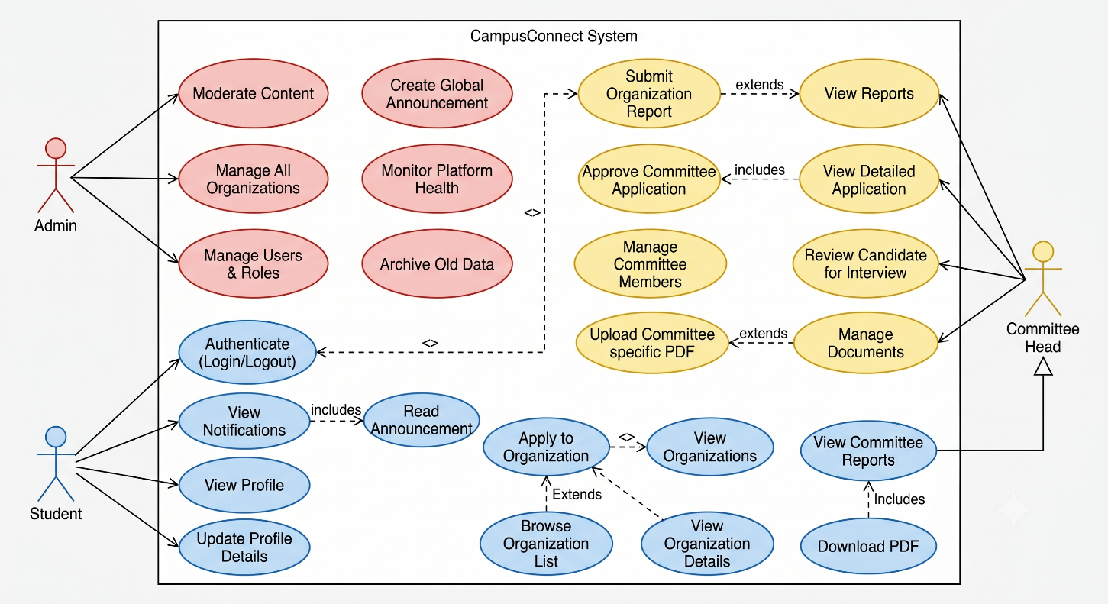

Context Level Diagram

The Context Level Diagram represents the highest level view of the CampusConnect system. It treats the entire application as a single process and illustrates the interaction between the system and external entities.
The external entities include Students, Committee Heads, Faculty Coordinators, and Administrators. These entities exchange information with the system through various inputs and outputs. Students submit applications and receive notifications, while committee heads and administrators provide organizational information, recruitment decisions, and announcements.
This diagram helps define the boundaries of the system and provides a clear understanding of how information flows between users and the platform.

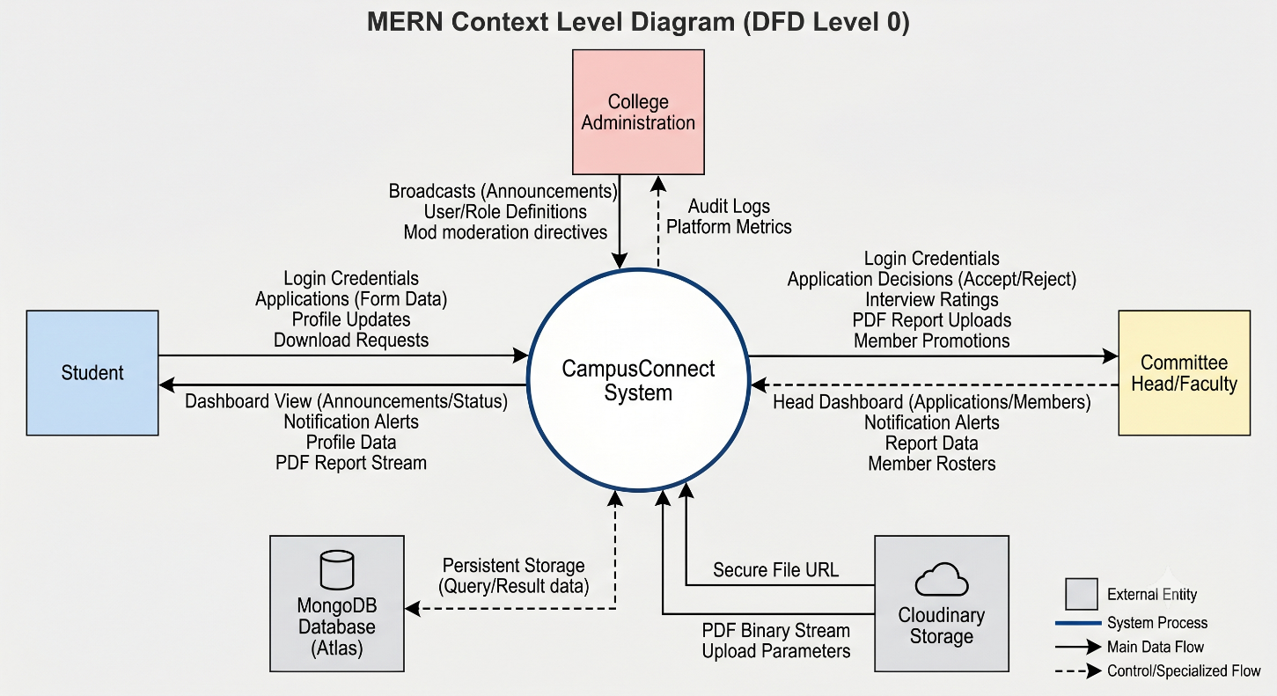

Data Flow Diagram (DFD)

The Data Flow Diagram illustrates how data is processed and transferred throughout the CampusConnect system. It describes the movement of information between users, processes, databases, and system modules.

The DFD demonstrates how students submit applications, how committee heads review and process those applications, and how recruitment results are communicated back to students. It also illustrates the flow of announcements, reports, and documents within the system.

By providing a visual representation of data movement, the DFD helps identify system processes, data stores, and interactions among various modules. It also assists developers in understanding the logical structure of the application and ensures efficient information management.

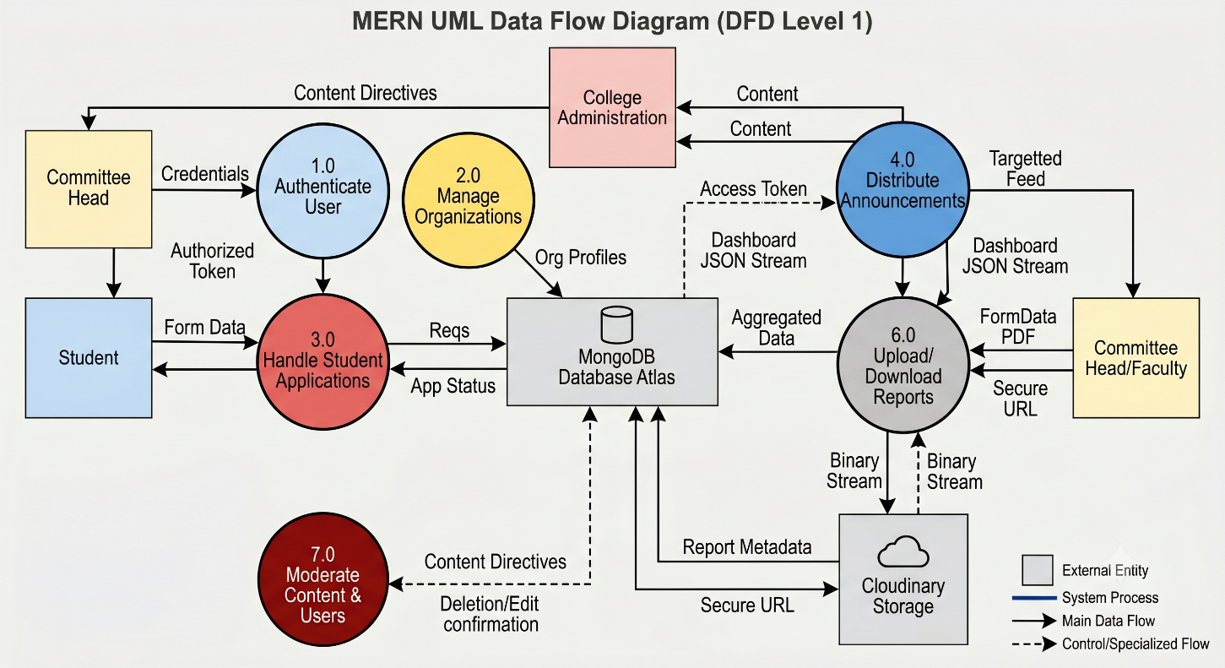

Entity Relationship Diagram (ERD)

The Entity Relationship Diagram is used to model the database structure of CampusConnect. It identifies the entities involved in the system and defines the relationships between them.

The major entities include Users, Committees, Applications, Announcements, Documents, and Recruitment Records. These entities are connected through relationships that define how information is stored and accessed within the database.

For example, a student may submit multiple applications, while a committee may receive applications from multiple students. Similarly, administrators can publish announcements and manage committee information.

The ER Diagram serves as the foundation for database design and helps ensure data consistency, integrity, and efficient storage of information.

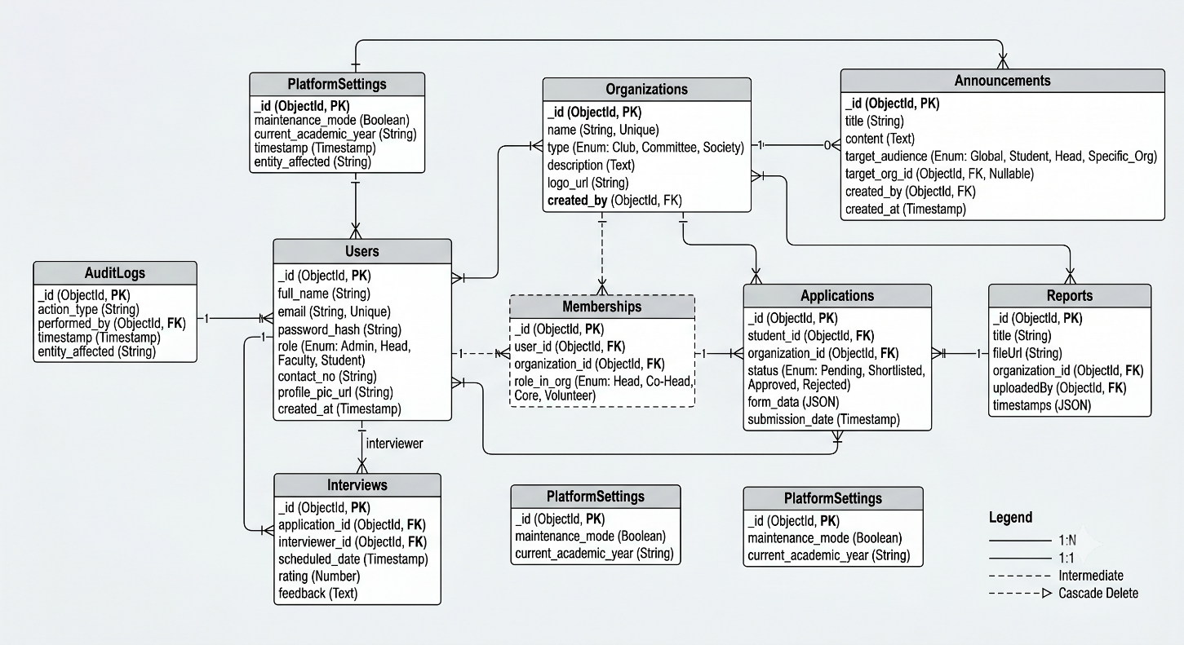

Activity Diagram

The Activity Diagram represents the workflow of various operations performed within the CampusConnect system. It illustrates the sequence of activities involved in completing a particular task and highlights decision points within the workflow.
For example, the diagram may describe the process of committee recruitment, beginning with student registration and application submission, followed by application review, shortlisting, selection, and final confirmation. Similarly, activity diagrams can be created for announcement management and document uploading processes.
This diagram helps developers and stakeholders understand the operational flow of the system and identify opportunities for process optimization.

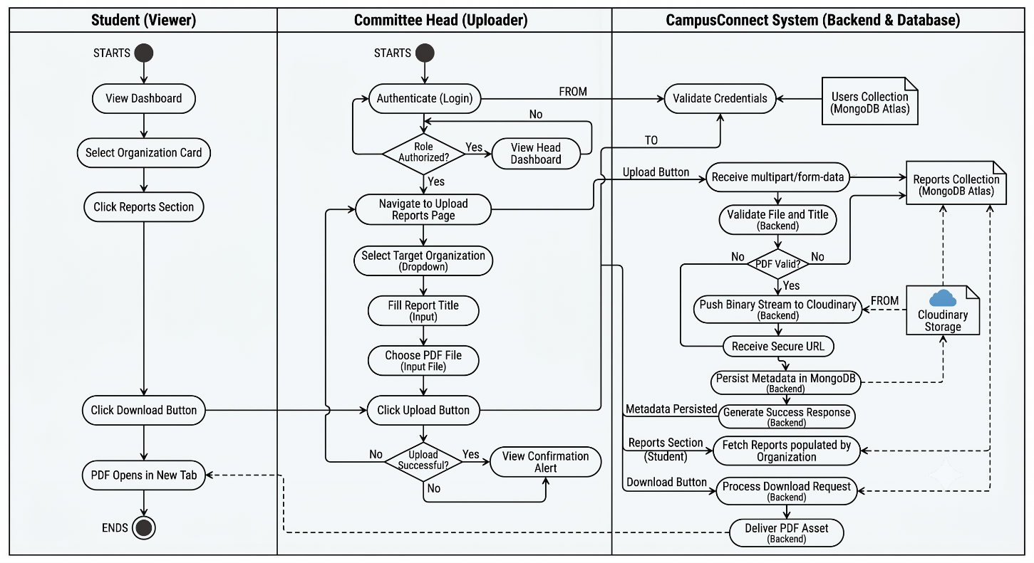

Sequence Diagram

The Sequence Diagram illustrates the chronological order of interactions between different components of the system. It focuses on how messages are exchanged between users, the frontend application, backend services, and the database during system operations.
For example, during the login process, the user submits credentials through the interface, the request is sent to the server, the database validates the information, and the response is returned to the user. Similar interactions occur during application submission, document retrieval, and announcement management.
The Sequence Diagram provides a dynamic view of the system and helps visualize communication between software components.

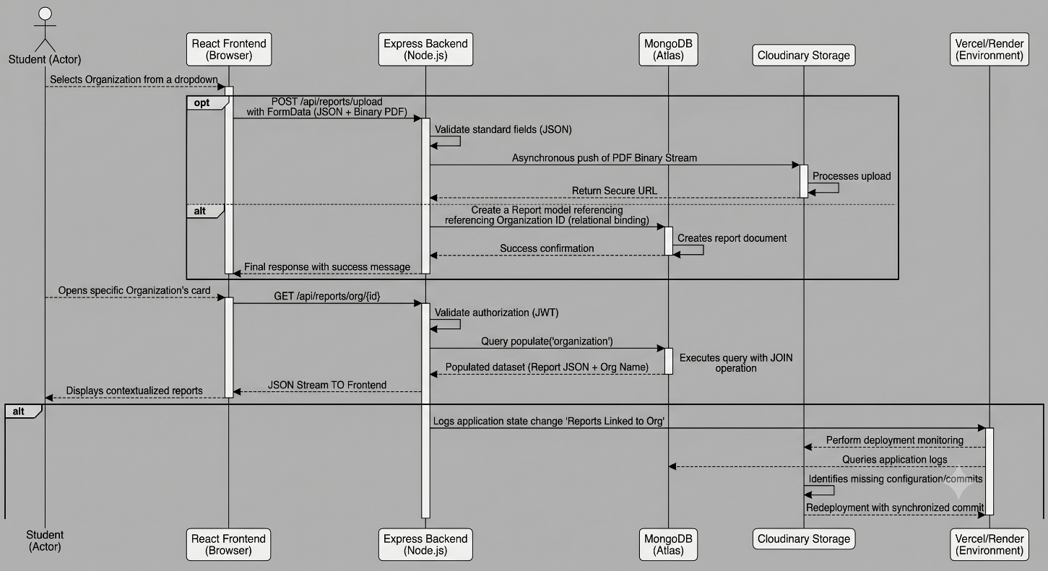

Additional UML Diagrams (If Required)

Apart from Use Case and Activity Diagrams, additional UML diagrams help provide deeper understanding of system structure and behavior. The CampusConnect system can include Class Diagrams to represent interaction flow and object-oriented design.

Class Diagram
The Class Diagram represents the object-oriented structure of CampusConnect. It identifies the classes used within the application, their attributes, methods, and relationships.
Classes such as User, Committee, Application, Announcement, and Document are represented along with their associated properties and operations. Relationships such as inheritance, association, and dependency are also illustrated.
The Class Diagram acts as a blueprint for software implementation and helps maintain consistency throughout the development process

Flowcharts

Flowcharts are graphical representations of system workflows and decision-making processes. They provide a step-by-step illustration of how different operations are performed within CampusConnect.
Flowcharts can be used to describe processes such as user authentication, application submission, recruitment management, and document uploading. Each step is represented using standardized symbols that simplify complex workflows and improve understanding.
These diagrams are useful for both developers and end-users as they provide a clear visual explanation of system functionality.

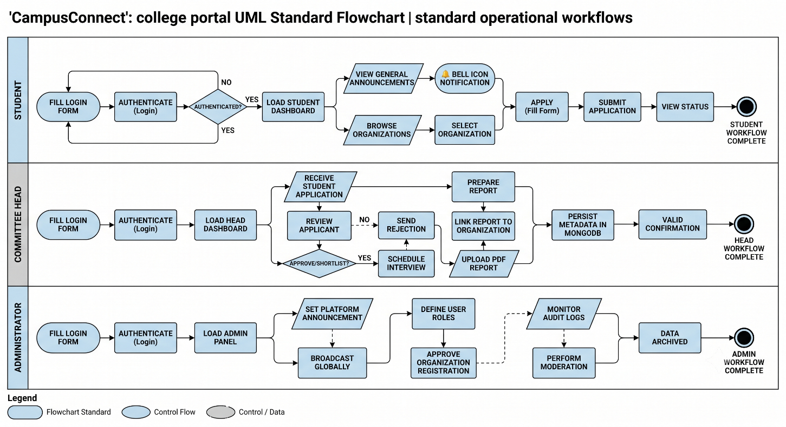

Project Flow / System Architecture

The Project Architecture illustrates the overall structure of the CampusConnect system and explains how different components interact with each other.
CampusConnect follows a three-tier architecture consisting of the Presentation Layer, Application Layer, and Data Layer. The Presentation Layer is developed using React.js and provides the user interface through which users interact with the system. The Application Layer consists of Node.js and Express.js services that process requests and implement business logic. The Data Layer includes MongoDB for data storage and Cloudinary for document management.
This architecture promotes modularity, scalability, security, and maintainability while ensuring efficient communication between all system components.

Database Schema

The Database Schema defines the logical structure of the database used by CampusConnect. It specifies the collections, fields, relationships, and constraints required to store and manage information efficiently.

The database stores user details, committee information, applications, announcements, documents, and recruitment records. Each collection is designed to maintain data integrity while supporting efficient retrieval and modification operations.

A well-structured database schema improves system performance, simplifies maintenance, and ensures reliable storage of institutional data.

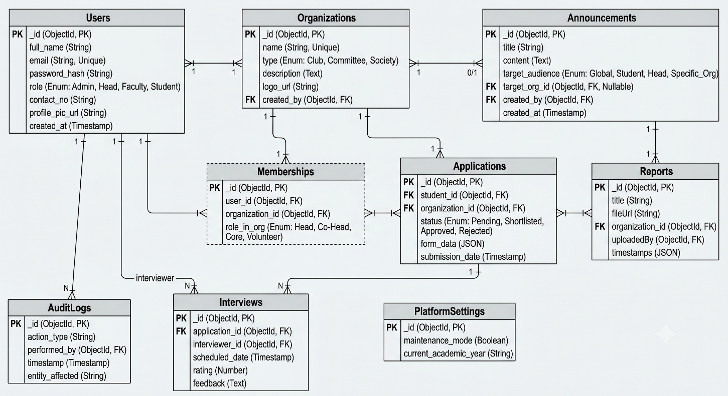

PROJECT DEVELOPMENT / IMPLEMENTATION

The Project Development and Implementation phase describes the actual construction of the CampusConnect system based on previously defined requirements and design models. This phase involves frontend development, backend integration, database connectivity, and deployment of the application. The CampusConnect system is developed using modern full-stack web technologies to ensure scalability, performance, and user-friendly interaction.
The implementation process was carried out in multiple stages, including user interface design, system configuration, module integration, and system testing. Each module was developed and integrated systematically to ensure smooth system functionality and maintain software quality standards.
This is the link the project is deployed at: https://c-sage-kappa.vercel.app/

User Interface Designs (With Description)

User Interface (UI) design plays a vital role in ensuring an effective and user-friendly interaction between users and the CampusConnect system. The interface has been developed using React.js and Tailwind CSS to provide a modern, responsive, and visually appealing experience. The design focuses on simplicity, accessibility, and smooth navigation across different modules of the system.

Home Page
The Home Page serves as the entry point of the CampusConnect platform. It introduces users to the system and highlights its purpose as a centralized platform for managing committees and clubs within the institution. The page provides role-based access options for Students, Committee Heads, and Faculty Coordinators.

The interface contains login functionality, registration options, and basic information regarding the services offered by the platform. The clean layout and responsive design ensure accessibility across different devices and screen sizes.

User Registration Interface
The Registration Interface allows new users to create accounts within the system. Users are required to provide essential information such as name, roll number, email address, password, and role details.
The interface includes validation mechanisms to ensure that user information is entered correctly. Error messages and confirmation notifications guide users throughout the registration process and improve overall usability.

User Login Interface
The Login Interface enables registered users to securely access the system using their roll number and password. The system validates user credentials and redirects users to their respective dashboards based on assigned roles.
The interface has been designed to be simple and secure while maintaining a professional appearance. Authentication mechanisms protect unauthorized access and ensure data security.

Student Dashboard Interface
The Student Dashboard serves as the primary workspace for students after successful login. It provides access to available committees, recruitment opportunities, announcements, and institutional documents.
Students can browse committee details, monitor recruitment updates, and track their application status through this interface. The dashboard presents information in an organized manner, allowing students to access important resources efficiently.

Committee Information Interface
The Committee Information Interface displays detailed information regarding available committees and clubs. Information such as committee name, faculty coordinator, student head, seat capacity, and recruitment status is presented clearly.
Students can review committee details before applying for recruitment. The interface also provides access to the application process and recruitment-related updates.

Committee Application Interface
The Committee Application Interface allows students to submit applications for committee recruitment. The form collects relevant information required for the selection process and validates user inputs before submission.
The interface simplifies the recruitment process by eliminating paper-based forms and enabling online application management. Submitted applications are stored securely and become available for review by committee heads.

Reports and Documents Interface
The Reports and Documents Interface provides centralized access to official documents uploaded by administrators and committee heads. Users can browse available reports and download them when required.
This module ensures organized document management and allows students to access important resources from a single location without relying on external communication channels.

Configuration Designs

Configuration Design describes the technical setup and integration of software components required for the proper functioning of CampusConnect. The application follows a client-server architecture where frontend services communicate with backend APIs and database services.

Frontend Configuration
The frontend of CampusConnect is developed using React.js and Tailwind CSS. The frontend is responsible for rendering user interfaces, handling user interactions, validating inputs, and communicating with backend services.
React Router is used for navigation between different pages and modules within the application. The responsive design ensures compatibility across desktops, laptops, tablets, and smartphones.

Backend Configuration
The backend is implemented using Node.js and Express.js. It processes user requests, implements business logic, manages authentication, and communicates with the database.
RESTful APIs are used to exchange data between the frontend and backend components. Middleware functions handle request validation, security, and access control.

Database Configuration
MongoDB is used as the primary database management system for storing user accounts, committee information, applications, announcements, and documents.
The database structure is designed to maintain data integrity and support efficient retrieval and modification of information. Collections are organized according to system modules to simplify management and scalability

Authentication Configuration
Secure authentication is implemented using JSON Web Tokens (JWT). Passwords are encrypted before storage, and authentication tokens are used to validate user sessions.
Role-based access control ensures that users can only access functionalities permitted for their assigned roles.

    - Deployment Configuration
The CampusConnect application is deployed on Vercel. The deployment configuration includes hosting setup, environment variables, API configuration, and automatic deployment mechanisms.

Output Screen Designs / Report Screenshots Images

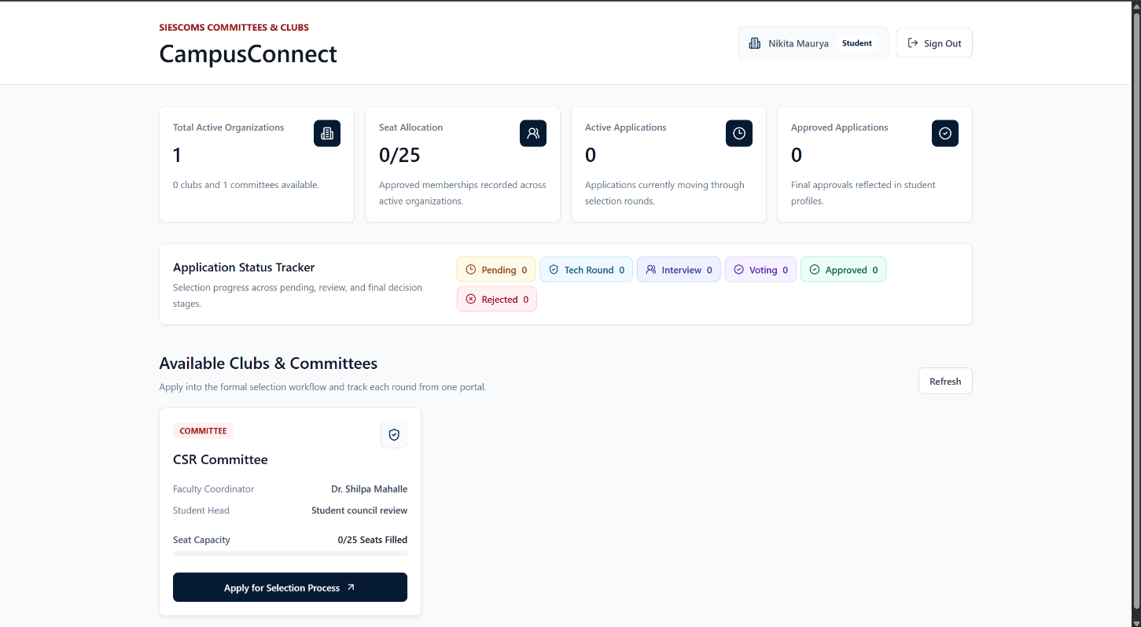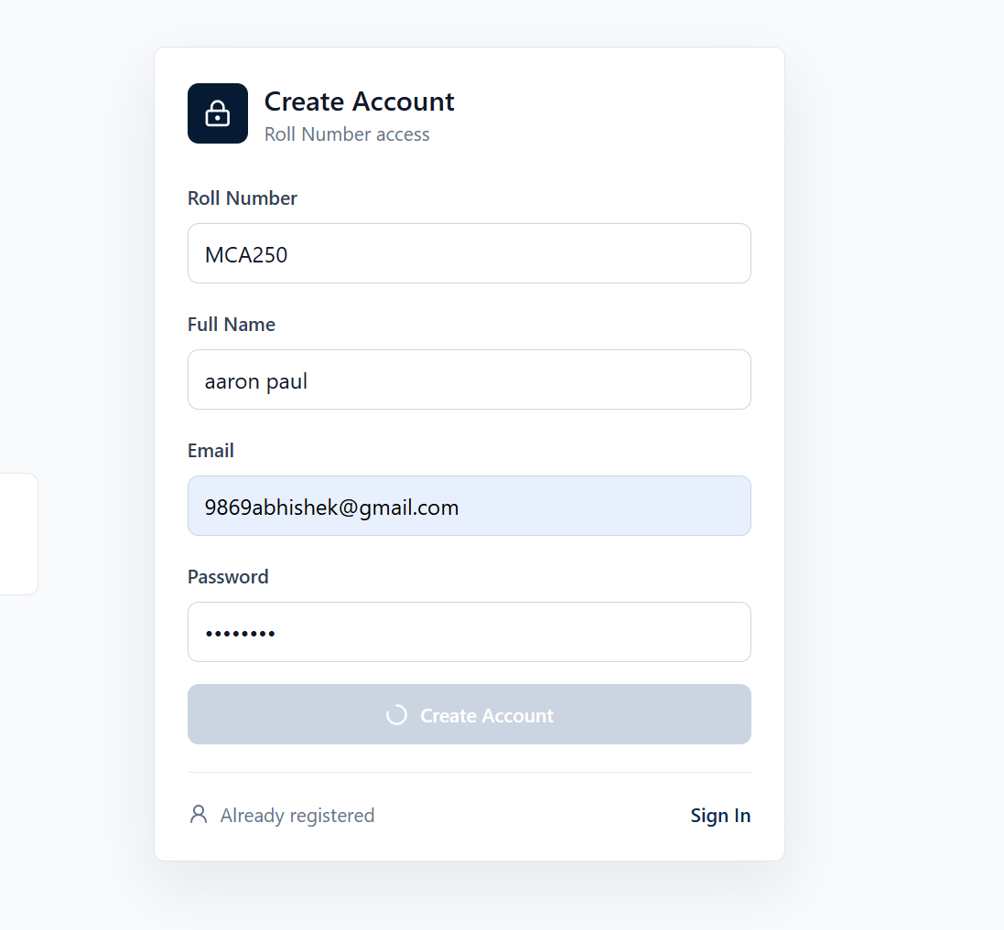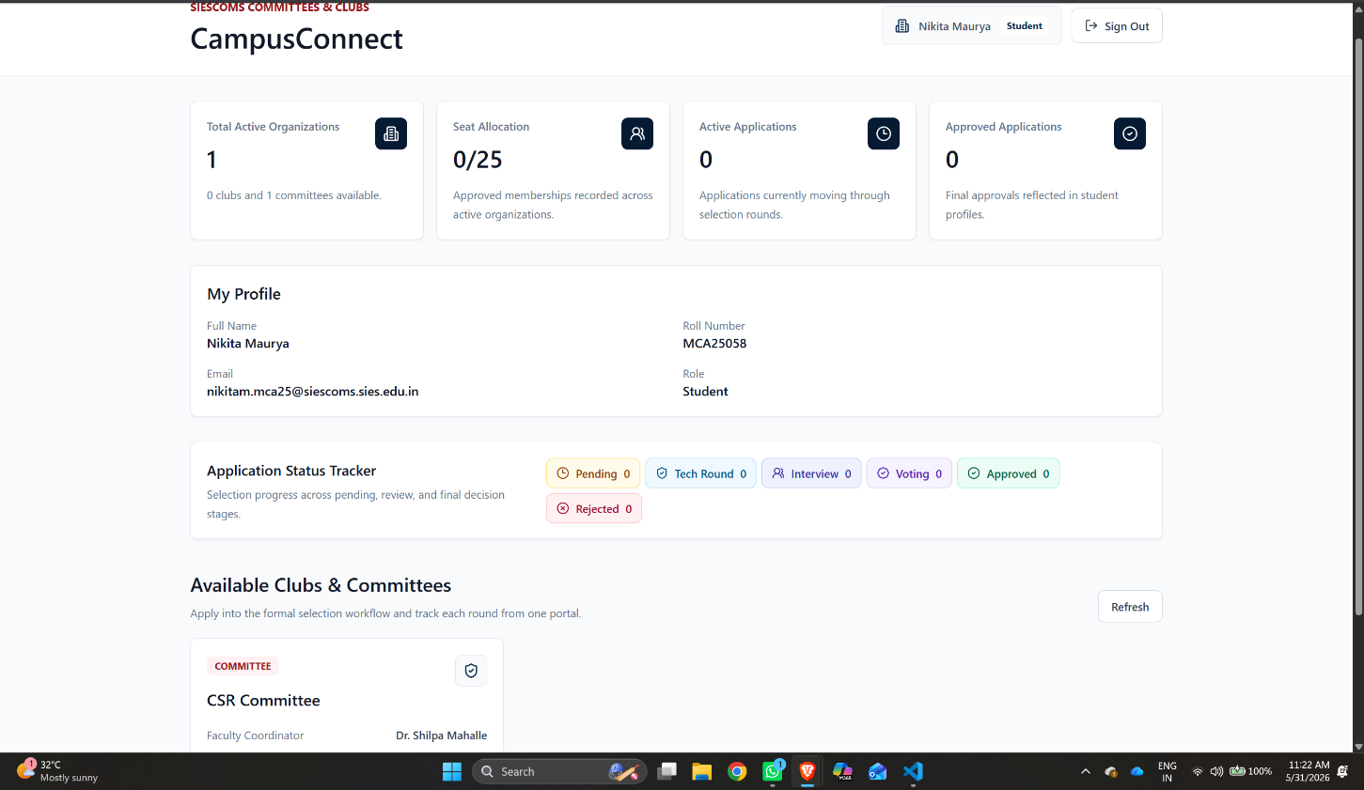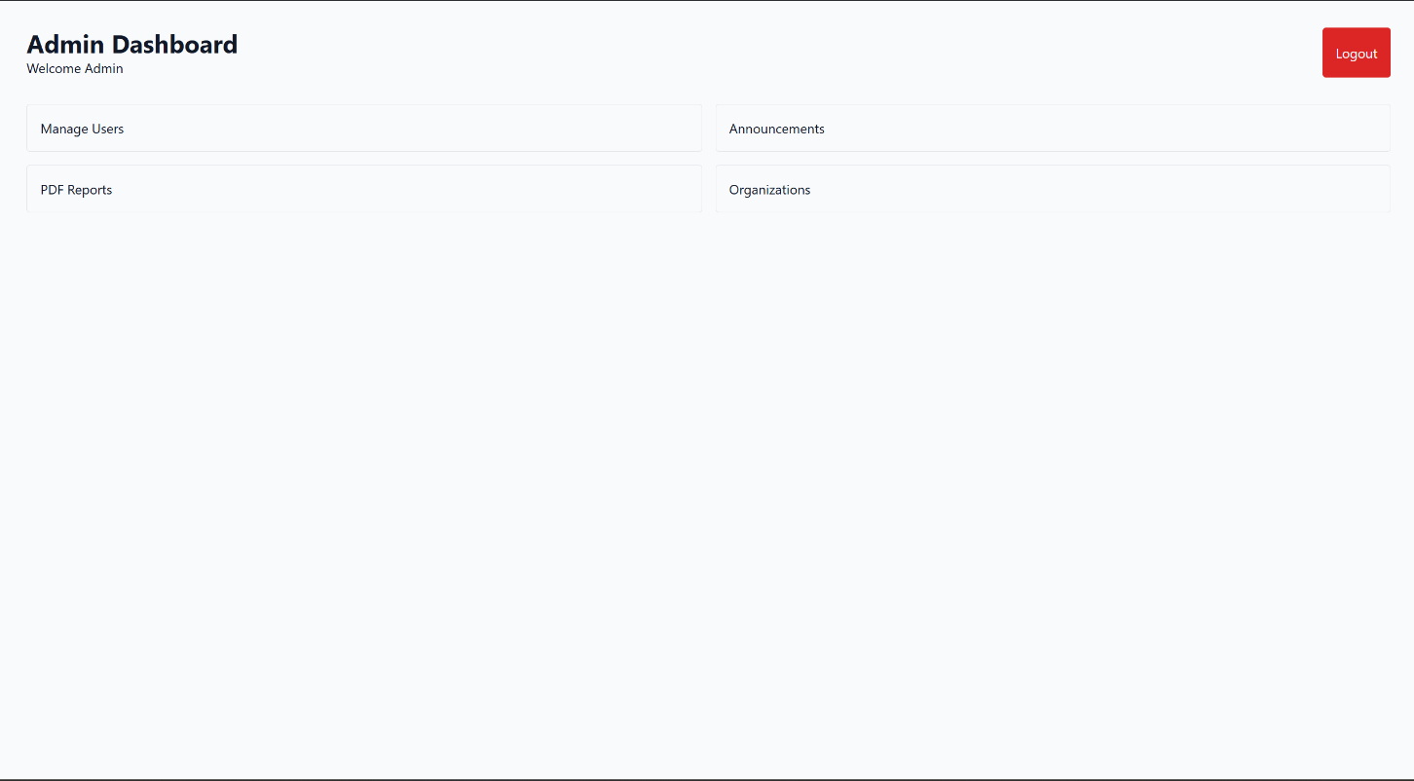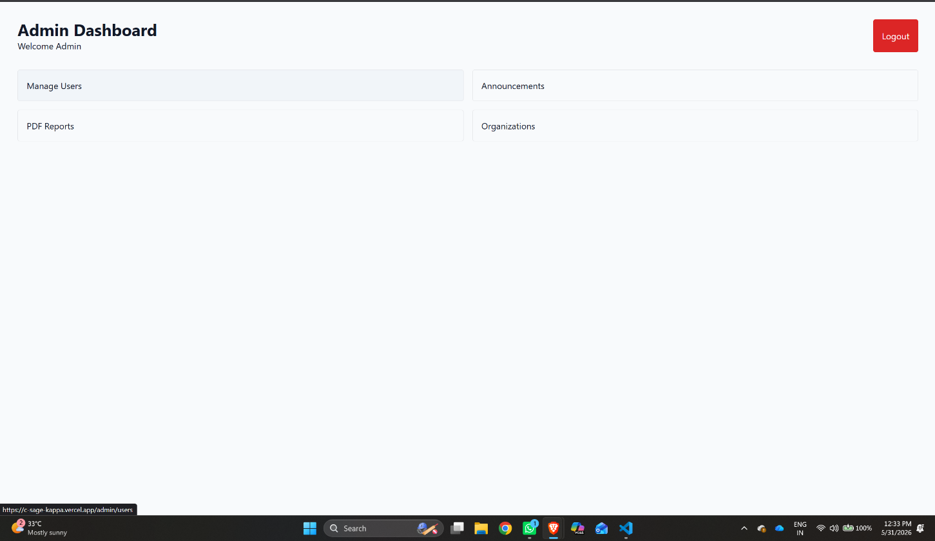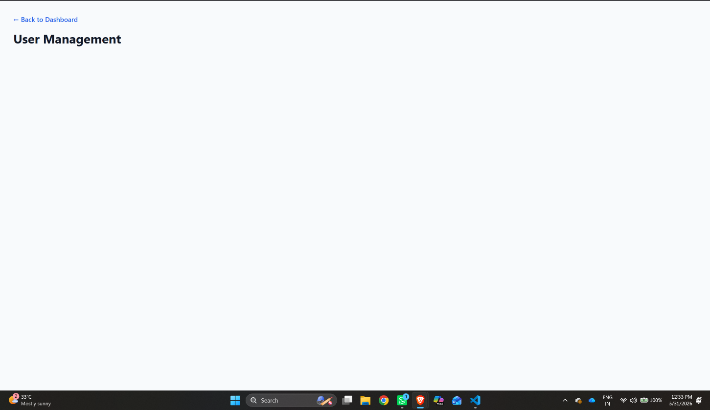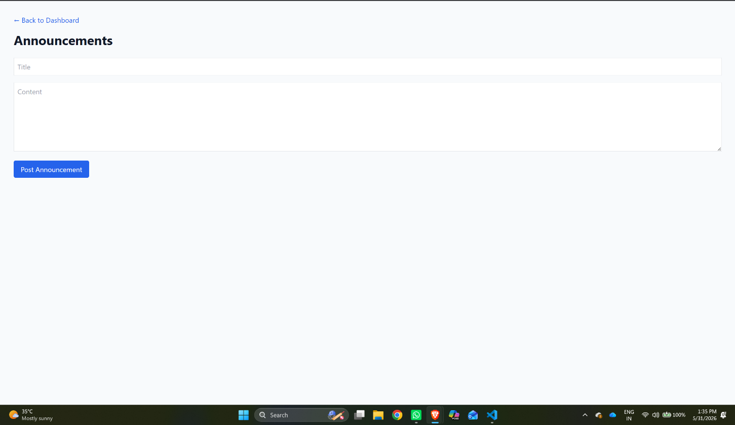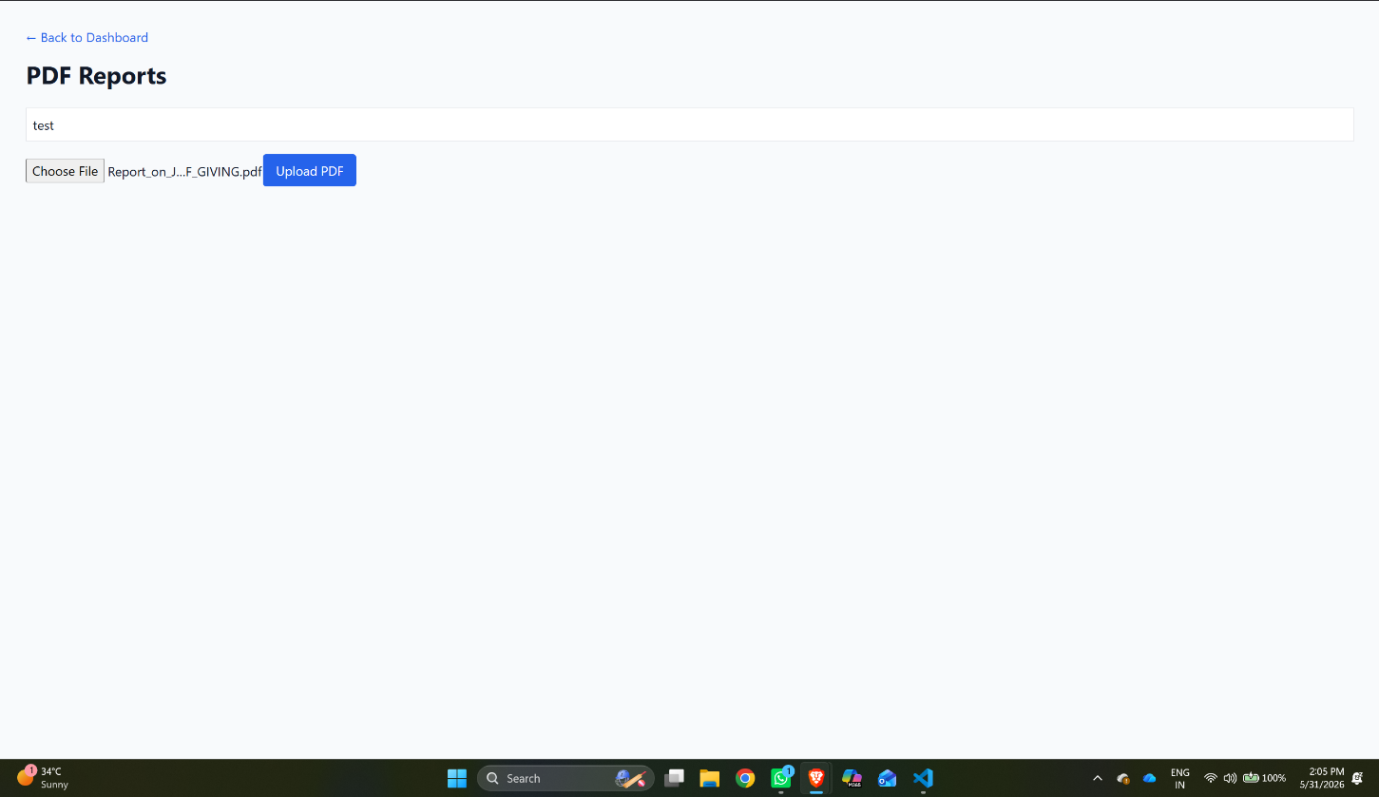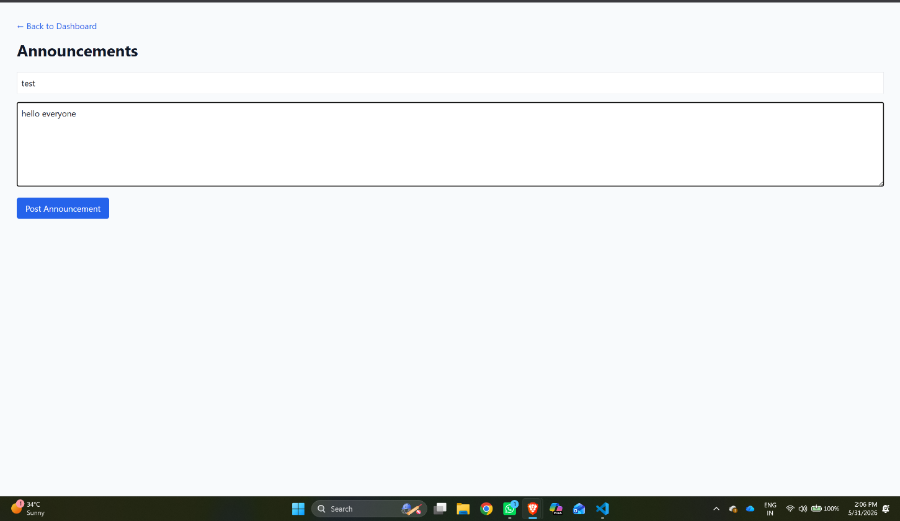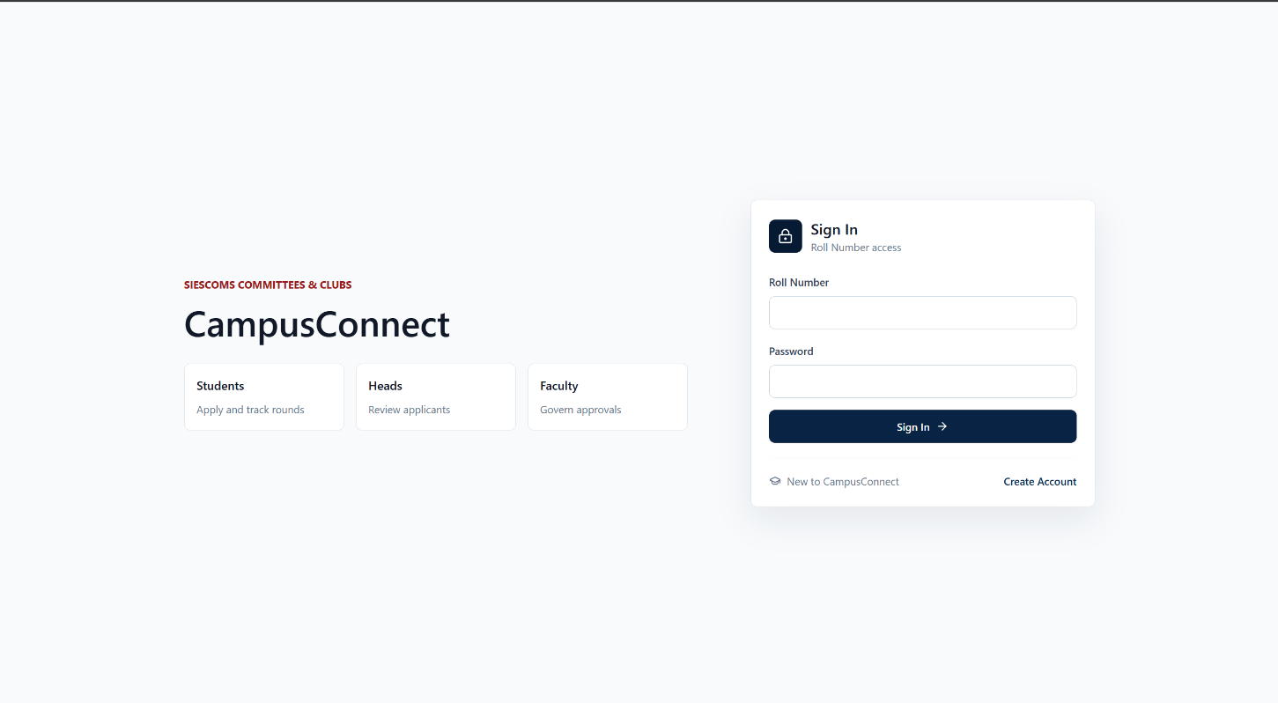

The Output Screen Designs section presents screenshots of the various interfaces implemented in CampusConnect. These screenshots demonstrate the successful implementation of system functionalities and provide visual evidence of project completion.

The screenshots include the Login Page, Student Dashboard, Committee Information Screen, Committee Application Interface, Reports and Documents Screen, and Administrative Dashboard. Each screen has been designed to support user requirements while maintaining consistency in layout and navigation.
The output screens illustrate how users interact with the platform, perform recruitment-related activities, access announcements, and manage documents. These screenshots also demonstrate the responsiveness and usability of the system across different modules.

PROJECT TESTING

Project Testing is one of the most important phases of software development as it ensures that the developed system functions according to the specified requirements. The primary objective of testing is to identify defects, verify functionality, improve software quality, and ensure that the system performs reliably under different conditions.
For the CampusConnect project, testing was conducted throughout the development process to validate system functionality, security, usability, and performance. Various modules such as user authentication, committee management, recruitment workflow, document management, and announcement management were tested individually and collectively to ensure smooth operation of the platform.
The testing process helped identify issues at an early stage, allowing corrective actions to be taken before deployment. Continuous testing contributed significantly to improving system stability and user experience.

Software Testing

Software testing in the CampusConnect system was conducted at multiple levels to ensure proper system functionality. The testing process included unit testing, integration testing, system testing, performance testing, and security testing.

Unit Testing
Unit testing was performed to verify individual modules of the CampusConnect application independently. Components such as user registration, login authentication, committee application submission, document upload functionality, and announcement management were tested separately.

Input validation mechanisms were checked to ensure that users entered valid information during registration and application submission. Error handling procedures were verified to confirm that meaningful messages were displayed whenever invalid data was provided.

Integration Testing
Integration testing was performed to verify communication between frontend interfaces, backend APIs, database services, and cloud storage components. The testing ensured that data entered through user interfaces was correctly processed by backend services and stored within the MongoDB database.
The integration testing process validated user authentication workflows, committee application processing, announcement publishing, and document management functionalities. Data consistency was verified throughout the application to ensure that information remained synchronized across all modules.

System Testing
System testing was conducted to evaluate the complete CampusConnect application under real-world operating conditions. The system was tested using multiple user accounts representing students, committee heads, faculty coordinators, and administrators.
Authentication and authorization testing verified that users could access only those functionalities permitted according to their assigned roles. Students were restricted from administrative functions, while administrators maintained full system control.
The testing process confirmed that all modules worked together seamlessly without system conflicts. Users were able to browse committees, submit applications, access reports, and receive announcements without interruptions.
Session management was also tested to ensure that users remained authenticated during active sessions and were securely logged out when required..

Performance Testing
Performance testing was conducted to evaluate system responsiveness and stability during normal and moderate usage conditions. The application was tested using multiple simultaneous requests to ensure consistent performance.
The testing results demonstrated that CampusConnect handled user requests efficiently without noticeable delays. Database operations remained within acceptable response times, ensuring smooth retrieval of committee information, announcements, and application records.

Security Testing
Security testing was conducted to verify data protection, authentication mechanisms, and access control features implemented within the CampusConnect platform.
Testing included verification of password encryption, session token validation, role-based authorization, and protection against unauthorized access attempts. Input validation procedures were examined to prevent invalid or malicious data submission.

BUG FIXES AND IMPROVEMENTS

Bug Fixes and Improvements Implemented
During the development and testing phases of the CampusConnect system, several functional and performance-related issues were identified and resolved to improve system stability, reliability, and user experience.
One of the primary issues encountered during development was related to user authentication and session management. Users occasionally experienced difficulties maintaining active sessions after page refresh operations. This issue was resolved by implementing improved JWT token handling and secure session validation mechanisms.
Another issue was observed in committee application processing, where incomplete form submissions occasionally resulted in unexpected validation errors. The problem was resolved by enhancing frontend validation checks and implementing additional server-side verification procedures.
Performance-related issues were also identified within dashboard modules where repeated API requests increased server workload. This was resolved through improved state management techniques and optimized API communication, significantly reducing unnecessary network requests.
Document upload functionality was enhanced by improving file validation procedures, handling upload errors more effectively, and providing clearer feedback messages to users.
Compatibility issues across different browsers and screen resolutions were identified and corrected through responsive design improvements and interface optimization.
Overall, the implemented bug fixes improved system stability, reduced runtime errors, enhanced user experience, and ensured consistent performance across different environments.

IMPROVEMENTS IMPLEMENTED

In addition to fixing identified issues, several enhancements were implemented to improve the overall quality and usability of the CampusConnect platform.
One of the major improvements involved enhancing the user interface to provide a cleaner and more intuitive experience. Dashboard layouts were reorganized to improve navigation and ensure that important information was easily accessible to users.
The committee recruitment workflow was optimized to simplify the application process for students while providing better management tools for committee heads. These improvements reduced administrative effort and improved transparency throughout the recruitment process.
Security enhancements were implemented through stronger authentication procedures, improved role-based access control mechanisms, and secure storage of user credentials.
Database performance was improved through optimization of query operations and efficient data retrieval techniques. These improvements reduced response times and enhanced overall application performance.
The reports and documents module was enhanced by integrating cloud-based storage solutions, enabling secure document management and easier access to resources.
Administrative functionalities were also expanded by improving committee management features, announcement distribution mechanisms, and document handling capabilities. These enhancements improved operational efficiency and simplified platform administration.
Code maintainability was improved through modular component design and structured API development. The implementation of reusable frontend components and standardized backend architecture simplified future maintenance and feature expansion.
Collectively, these improvements enhanced system performance, strengthened security measures, improved user experience, and ensured the scalability of the CampusConnect platform for future institutional requirements.

Test Cases

Test cases were designed to verify system functionality under different user scenarios. The following table summarizes major test cases used during system testing.

TC ID | Module | Test Scenario | Expected Outcome | Status
TC-01 | Auth | Enter valid Admin credentials on the Login page and submit. | System validates JWT token and securely routes the user to the Admin Dashboard. | Pass
TC-02 | Security | Log in as a Student and manually attempt to access /admin or /head URLs. | Access is denied (403 Forbidden) and the user is redirected safely to the home page. | Pass
TC-03 | Reports | Attempt to upload a PDF without selecting a target organization from the dropdown. | Frontend validation triggers; upload is blocked until an organization is selected. | Pass
TC-04 | Reports | Upload a valid PDF linked to an organization, then attempt to download it from the dashboard. | PDF binary streams to Cloudinary; database saves the relation; file downloads correctly. | Pass
TC-05 | UI / UX | Click the Bell Icon in the navbar when unread announcements exist in the database. | A relative-positioned dropdown opens without breaking UI, showing the correct unread count. | Pass
TC-06 | Workflow | Student submits a club application; Committee Head logs in and accepts it. | Application status updates dynamically from 'Pending' to 'Approved' on both dashboards. | Pass
TC-07 | Deploy | Verify the /api/announcements route functionality on the live Render server. | Returns HTTP 200 OK with JSON array. (Fixed locally after clearing stale Render build cache). | Pass
TC-08 | Server | Verify Express server startup on the UNIX/Linux deployment environment. | Server starts successfully without MODULE_NOT_FOUND crash. (Fixed file case-sensitivity mismatch). | Pass
TC-09 | Security | Attempt to access the portal or make an API request with an expired/invalid JWT token. | Request is rejected (401 Unauthorized); user is automatically logged out to the Login screen. | Pass
TC-10 | Applications | Student attempts to submit an application to the exact same committee twice. | System catches duplicate entry and displays a graceful "Already Applied" error message. | Pass
TC-11 | Reports | Attempt to upload a non-PDF file format (e.g., .jpeg or .docx) in the reports section. | Multer middleware rejects the file type; upload fails safely without crashing the backend. | Pass
TC-12 | Database | Admin deletes an Organization (e.g., a club is disbanded) from the admin panel. | Cascade delete triggers, automatically removing all related Reports and Application references. | Pass
TC-13 | UI / UX | View the Student Dashboard on a mobile viewport (e.g., iPhone 13 screen width). | CSS Grid layout collapses to a single column; navigation switches to a responsive hamburger menu. | Pass
TC-14 | Notifications | Click on an unread announcement inside the Bell Icon notification dropdown. | Announcement expands to show full text, and the red unread notification badge count decreases. | Pass
TC-15 | Moderation | Admin deletes an active global announcement from the centralized Admin panel. | Announcement is instantly removed from the database and vanishes from all student dashboards. | Pass
TC-16 | Performance | Load the Student Dashboard when 50+ PDF reports are linked to various organizations. | Data loads efficiently (under 1.5s) due to optimized Mongoose .populate() query chaining. | Pass
TC-17 | Deployment | Trigger a file upload when Cloudinary API keys are missing/incorrect in Render env vars. | System throws a safe HTTP 500 error on the frontend without leaking the server stack trace. | Pass
TC-18 | Backend | Simulate a MongoDB Atlas connection timeout or drop during server startup. | Application logs the error gracefully to the terminal console without causing a fatal server crash. | Pass

LIMITATIONS

Although CampusConnect provides an efficient and centralized platform for managing committee recruitment, announcements, and document sharing, certain limitations exist due to project scope, technical constraints, and available resources.

Internet Dependency
CampusConnect is a web-based application that requires a stable internet connection for accessing system functionalities. Users may experience difficulties accessing committee information, announcements, or documents in areas with poor network connectivity.

Limited Mobile Application Support
Currently, CampusConnect is available through a web browser and does not provide a dedicated mobile application. Although the system is responsive and can be accessed through smartphones, certain advanced mobile features are not available.

Manual Recruitment Process
The committee selection process still depends on manual review and decision-making by committee heads and faculty coordinators. The system assists in managing applications but does not automate candidate evaluation or selection.

Limited Notification Features
The current version provides basic communication and information-sharing facilities. Advanced real-time notifications through SMS, mobile push notifications, or instant alerts are not fully implemented.

Scalability Constraints
While the system is suitable for educational institutions and departmental committees, large-scale deployment across multiple campuses may require additional infrastructure, database optimization, and load-balancing mechanisms.

Role Based Dependency
Many administrative operations depend on authorized users such as administrators and committee heads. Delays in updating information or reviewing applications may affect the overall workflow of the system.

Despite these limitations, CampusConnect successfully achieves its objective of providing a centralized and organized platform for committee management and student participation
.

FUTURE ENHANCEMENTS

CampusConnect has been developed as a scalable and extensible platform. Several additional features can be incorporated in future versions to improve functionality, user experience, and institutional efficiency.

Dedicated Mobile Application
A mobile application can be developed for Android and iOS platforms to provide easier access to committee information, recruitment updates, and announcements. Mobile support would improve accessibility and user engagement.

Real Time Notification System
Future versions can integrate real-time notifications through email, SMS, and push notification services. This will allow students to receive immediate updates regarding recruitment rounds, announcements, and application status changes.

Advanced Analytics Dashboard
Analytical dashboards can be introduced to provide detailed insights into student participation, committee performance, recruitment statistics, and organizational activities. These reports can assist administrators in making data-driven decisions.

Automated Recruitment Assistance
Artificial Intelligence and machine learning techniques can be integrated to assist committee heads in screening applications, shortlisting candidates, and analyzing recruitment trends. This would reduce manual effort and improve efficiency.

Multi College Support
Future enhancements may allow the system to support multiple colleges and departments through a single platform. This would make CampusConnect suitable for larger educational organizations.

Calendar and Event Management
An integrated event management module can be added to allow committees to schedule events, workshops, seminars, and meetings. Students could register and receive reminders directly through the platform.

Enhanced Communication Features
Future versions may include discussion forums, chat systems, and direct messaging features to improve communication between students, committee members, faculty coordinators, and administrators.

Cloud Based Reporting and Analytics
Additional cloud services can be integrated to generate advanced reports, maintain historical records, and support long-term analysis of committee activities and student engagement.

Overall, these enhancements will further improve the efficiency, scalability, and usability of CampusConnect, making it a comprehensive digital platform for managing campus committees and student activities.

CONCLUSION

The CampusConnect project has been successfully designed and developed as a comprehensive web-based platform for managing committees, clubs, and student participation activities within an educational institution. The primary objective of the project was to create a centralized system that simplifies committee recruitment, improves communication between students and committee authorities, and provides a structured approach for managing campus-related activities. The developed system successfully addresses many challenges associated with traditional committee management processes, such as manual application handling, scattered communication channels, inefficient document sharing, and lack of transparency in recruitment procedures..
CampusConnect provides an integrated platform where students can explore available committees and clubs, review recruitment opportunities, submit applications, access important announcements, and download institutional documents. Through a user-friendly interface, students are able to interact with the system efficiently while tracking their participation in various organizational activities. The platform eliminates the need for paper-based forms and manual communication methods, thereby reducing administrative workload and improving operational efficiency.
The system also provides dedicated functionalities for committee heads and faculty coordinators. These stakeholders can review student applications, manage recruitment workflows, publish announcements, upload important documents, and monitor committee activities through a centralized dashboard. This organized approach improves transparency in decision-making and ensures that recruitment processes are conducted in a systematic and fair manner. The implementation of role-based access control guarantees that each user can access only those functionalities that are relevant to their responsibilities within the system..

The project also provided valuable learning opportunities in the areas of software engineering, full-stack web development, database design, API development, cloud computing, and system testing. The implementation process strengthened practical knowledge of software development methodologies and exposed real-world challenges associated with designing and deploying modern web applications. The experience gained through the development of CampusConnect contributes significantly to professional and academic growth in the field of information technology.
Although the current version of CampusConnect successfully fulfills its intended objectives, the platform has the potential for future expansion and enhancement. Additional features such as mobile applications, advanced analytics, automated recruitment assistance, real-time notifications, event management systems, and enhanced communication modules can further improve the functionality and effectiveness of the platform. The existing architecture has been designed with scalability in mind, allowing future developments to be integrated efficiently.
In conclusion, CampusConnect successfully achieves its goal of providing a centralized, secure, and user-friendly platform for managing committees and clubs within an educational institution. The project enhances student engagement, simplifies recruitment activities, improves administrative efficiency, and promotes better communication among stakeholders. By leveraging modern web technologies and structured software engineering practices, CampusConnect demonstrates how digital solutions can transform traditional campus management processes and contribute to a more organized, transparent, and connected educational environment.

BIBLIOGRAPHY

The following references and resources were used during the development and documentation of the CampusConnect system:

Web Development Frameworks
- Next.js Official Documentation https://nextjs.org/docs
- React.js Official Documentation https://react.dev
- Node.js Official Documentation https://nodejs.org/docs
- Express.js Documentation https://expressjs.com/en/
- Tailwind CSS Documentation https://tailwindcss.com/docs

Database Technologies
- MongoDB Documentation https://www.mongodb.com/docs/
- MongoDB Atlas Documentation https://www.mongodb.com/products/platform/atlas-database

Authentication and Security
- NextAuth.js Documentation https://next-auth.js.org
- bcrypt.js Documentation
https://github.com/dcodeIO/bcrypt.js
- JSON Web Documentation
https://www.jwt.io/

Cloud Storage Services
- Cloudinary Documentation https://cloudinary.com/documentation

Development Tools
- Visual Studio Code Documentation https://code.visualstudio.com/docs
- GitHub Version Control Documentation
https://docs.github.com
- Postman Api Documentation
https://learning.postman.com/docs/getting-started/overview/

Deployment Tools
- Vercel Documentation https://vercel.com/docs

Software Engineering References
- Ian Sommerville – Software Engineering (10th Edition)
- Roger S. Pressman – Software Engineering: A Practitioner’s Approach
- Pankaj Jalote – Software Engineering: A Precise Approach

Testing and Security References
- OWASP Security Testing Guidelines https://owasp.org
- Web Content Accessibility Guidelines (WCAG 2.1) https://www.w3.org/TR/WCAG21
- Mozilla Developer Network (MDN Web Docs)
https://developer.mozilla.org/en-US/

Academic and Technical References
- W3Schools Web Development Tutorials https://www.w3schools.com/
- GeeksforGeeks Web Development Resources
https://www.geeksforgeeks.org/

