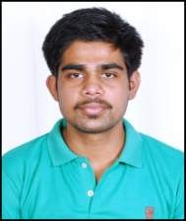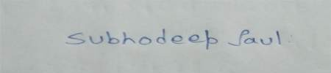CURRICULUM VITAE
NAME : SUBHODEEP PAUL
DATE OF BIRTH : 4/10/1999
MOTHERS NAME : KAKALI PAUL
FATHERS NAME : LATE ASIT PAUL
ADDRESS : 12/1, JAN MD GHAT ROAD NAIHATI
DISTRICT : NORTH 24 PGS
PIN : 743165
E-MAIL-ID : paulsubhodeep72@gmail.com
MOBILE NO : 8240171933

ACADEMIC QUALIFICATIONS
EXAMINATION | UNIVERSITY/ COUNCIL /  BOARD | NAME OF THE INSTITUTION | YEAR OF PASSING | % OF MARKS
MADHYAMIK | W.B.B.S.E | NAIHATI NARENDRA  VIDYANIKETAN | 2015 | 82%
H.S | W.B.C.H.S.E. | NAIHATI NARENDRA  VIDYANIKETAN | 2017 | 75.6%
GRADUATION (B.SC ZOOLOGY HONS.) | WEST BENGAL STATE UNIVERSITY | RAMAKRISHNA MISSION VIVEKANANDA CENTENARY  COLLEGE RAHARA | 2020 | 64.5%
DIPLOMA IN MEDICAL LAB TECHNOLOGY (D.M.L.T) | INDIAN MEDICAL ASSOCIATION | DR.LAL PATH LAB FOUNDATION | EXAM COMPLETED WAITING FOR RESULT | -

Experience: Worked in Dr Lal PathLab Barrackpore as a intern in Clinical pathology, Hematology, Biochemistry department, and also phlebotomy department.

OTHER QUALIFICATION : BASIC COMPUTER APPLICATION FROM SOFTPRO COMPUTER INSTITUTE
LANGUAGES KNOWN : BENGALI, ENGLISH & HINDI INTEREST : GARDENING
SIGNATURE:

