ISHTIYAQ AHMAD NAJAR S/O AB AHAD NAJAR

Career objects:
Cherwan Kangan, Ganderbal Jammu & Kashmir,191202
Email id:saifpro009@gmail.com
Mobile: 9622000215

To be apart of an organization that promises growth both in form of knowledge and profession By utilizing my academics and professional knowledge and to pursue a carrier in a competitive Organization with total global repute, holding a responsible position that would enhance my professional capabilities and enable me to carve a winning edge for the organization.

Strength:
- A constant desire to upgrade my professional and interpersonal skill base
- Friendly, positive and innovative.
- An able team member capable of working flexible hours

Education Qualification:
- Matriculation from JKBOSE,SRINAGAR
- Intermediate (science) from JKBOSE,SRINAGAR

Academic Qualification:
  - One year diploma in IT
  - Two year diploma in Medical Lab Technology

Computer Knowledge:
  - Computer fundamentals Photoshop Power Point
  - Good knowledge about internet browsers mails

Work Experience:
- 2 year experience in Medical Lab Technology
- Two year experience in data entry

Language Known:
- English : Speak Read Write
- Urdu : Speak Read Write

Personal Profile:
- Date of Birth : 09 NOV 1995
- Gender : Male
- Nationality : Indian
- Martial status : Unmarried
- Fathers Name : Ab Ahad Najar
- Interests : internet surfing, listening music, reading books, making new friends
- Current Address : Cherwan Kangan, Ganderbal Jammu & Kashmir,191202
- Aadhar No : 4756-1791-8412
- Passport No : N6688988
Declaration:

I hereby declare that the above mentioned information is correct and best of
my knowledge.

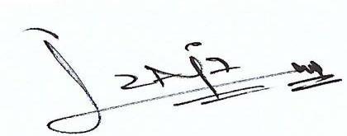
ISHTIYAQ AHMAD NAJAR

