**Analyzing the docking results**

> open receptor pdbqt file from vinadocking file >

Load your receptor.

> analyze > docking > open autock vina results > load your “ out file ligand” which is best result given by outfile

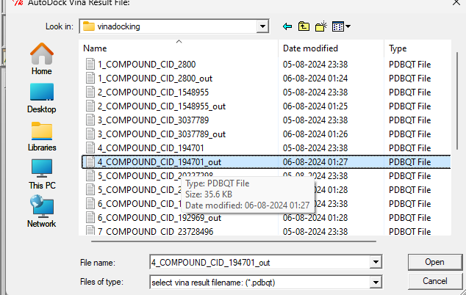

>Select “multiple confirmation” .

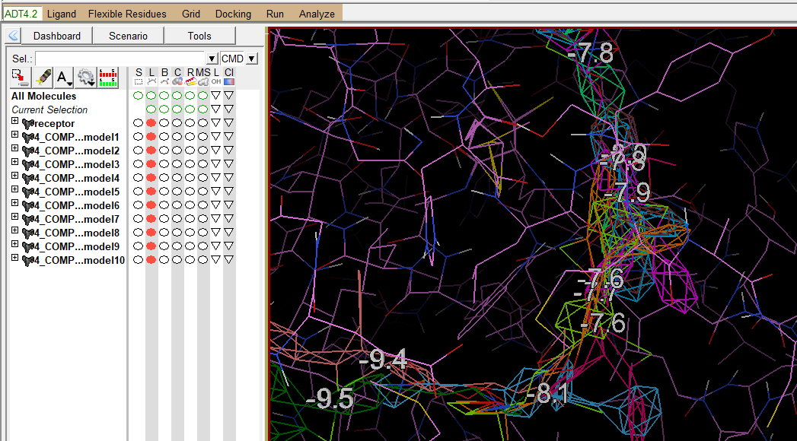

1. 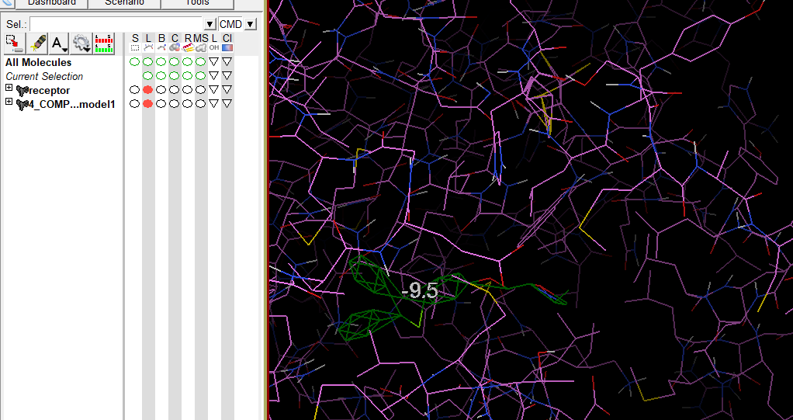 best model i.e.1st model

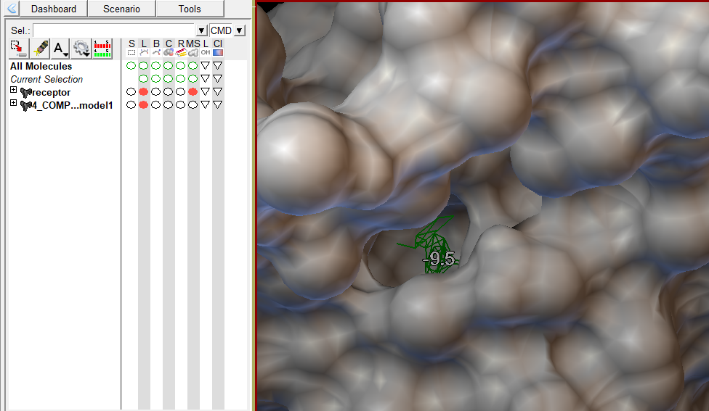

**the receptor molecule** from autodock and save the analysed ligand and save the “**best1.pdbqt**” for the biovia ds.

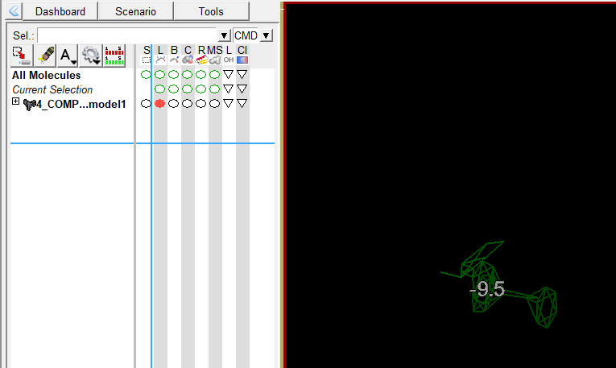

 ligands which will save as **best2.pdbqt** and **best3.pdbqt**



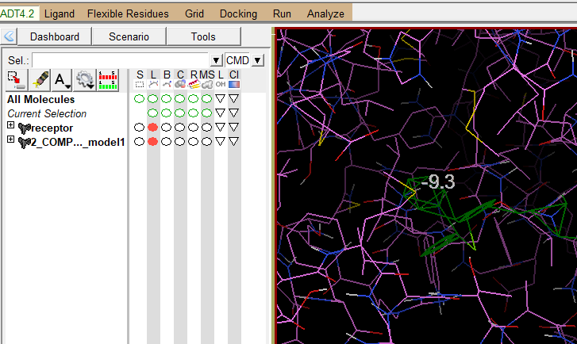 **best3.pdbqt**

:- so total 3 best file I generated



**Open discovery studio**

* 1. Open best 1 from vinadocking > open receptor.pdbqt in ds

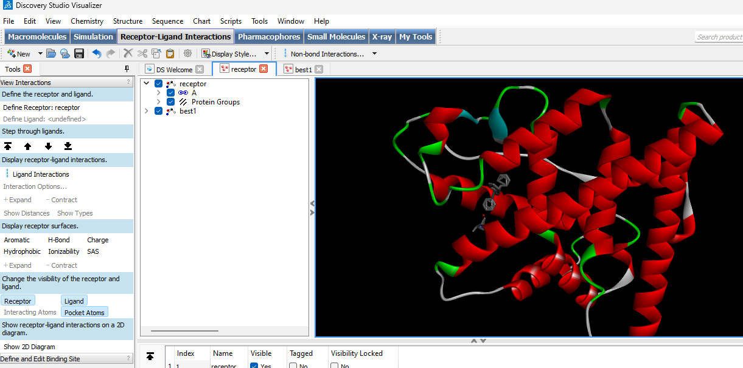

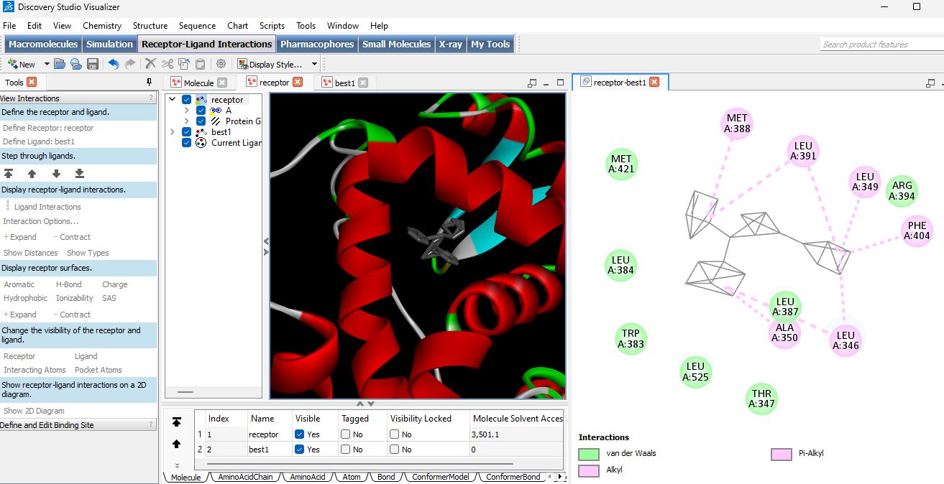

* 1. 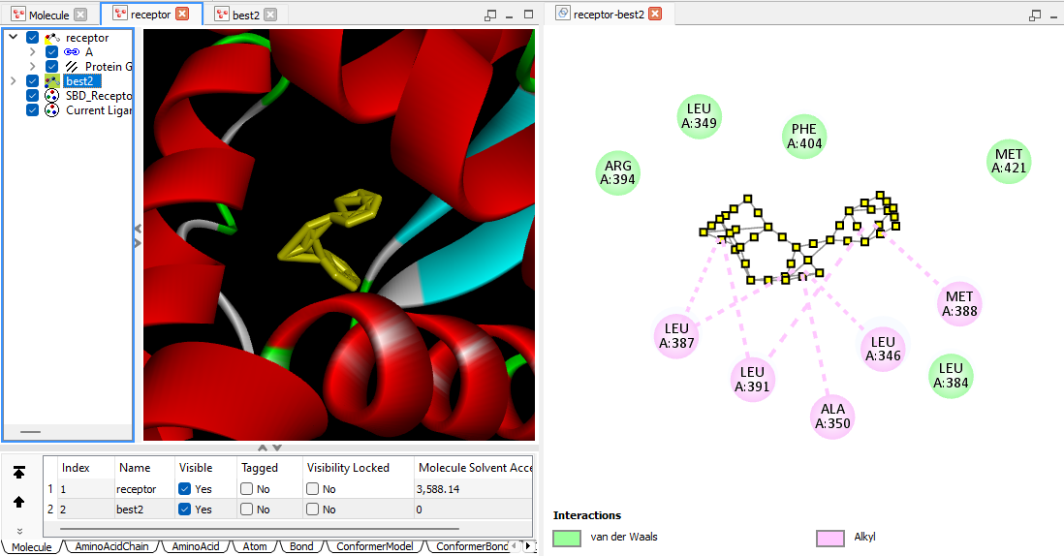Open best 2 from vinadocking > open receptor.pdbqt in ds
  2. 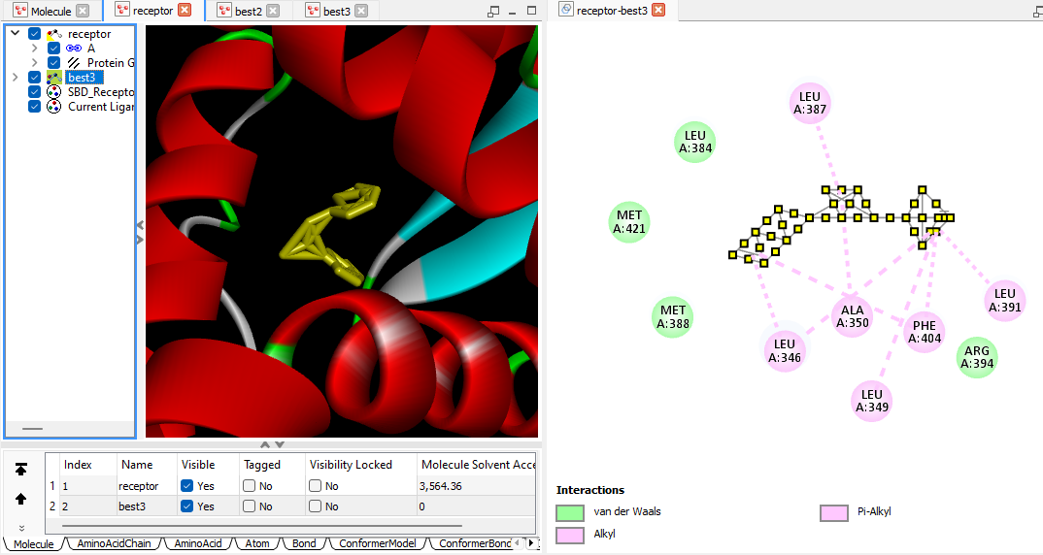Open best 3 from vinadocking > open receptor.pdbqt in ds

**Observation table:**

**Confirmer 1:**

|  |  |  |  |
| --- | --- | --- | --- |
| Sr.no | Ven dar waal | Pi alkyl | alkyl |
| 1. | MET A:421 | ALA A:350 | MET A:388 |
| 2. | LEU A:384 | LEU A:346 | LEU A:391 |
| 3. | TRP A:383 |  | LEU A:349 |
| 4. | LEU A:525 |  | PHE A:404 |
| 5. | THR A:347 |  |  |
| 6. | LEU A:387 |  |  |
| 7. | ARG A:394 |  |  |

**Confirmer 2:**

|  |  |  |  |
| --- | --- | --- | --- |
| Sr.no | Ven dar waal | Pi alkyl | alkyl |
| 1. | ARG A:394 | NA | MET A:388 |
| 2. | LEU A:349 | NA | LEU A:387 |
| 3. | PHE A:404 |  | LEU A:391 |
| 4. | MET A:421 |  | ALA A:350 |
| 5. | LEU A:384 |  | LEU A:346 |

**Confirmer 3:**

|  |  |  |  |
| --- | --- | --- | --- |
| Sr.no | Ven dar waal | Pi alkyl | alkyl |
| 1. | ARG A:394 | LEU A:346 | PHE A:404 |
| 2. | LEU A:384 | LEU A:349 | LEU A:387 |
| 3. | MET A:388 |  | LEU A:391 |
| 4. | MET A:421 |  | ALA A:350 |

**Interpretation**

Common Interactions Across Conformers:

* van der Waals Interactions:

ARG A:394, LEU A:384, MET A:421 consistently appear in van der Waals interactions across all three conformers. This suggests these residues play a significant role in stabilizing the ligand through van der Waals forces.

* Pi-Alkyl Interactions:

LEU A:346, LEU A:349 are involved in Pi-alkyl interactions in multiple conformers, indicating their importance in stabilizing the ligand through aromatic interactions.

* Alkyl Interactions:MET A:388, LEU A:387, LEU A:391 appear frequently in alkyl interactions, signifying their role in hydrophobic stabilization of the ligand.

Specific Observations for Each Conformer:

* Conformer 1:

Shows a diverse range of interactions with multiple residues, indicating a well-stabilized ligand through various interaction types.

Notable residues include MET A:421, LEU A:384, TRP A:383, LEU A:525, THR A:347, LEU A:387, ARG A:394.

* Conformer 2:

Exhibits fewer residues involved in interactions compared to Conformer 1, suggesting a potentially different binding pose or slightly less stabilized interaction profile.

Key residues include ARG A:394, LEU A:349, PHE A:404, MET A:421, LEU A:384.

* Conformer 3:

Similar to Conformer 2 in terms of interaction variety but with slight differences in specific residue involvement.

Important residues include ARG A:394, LEU A:384, MET A:388, MET A:421.

**Conclusion:**

Consistent Residues: The residues ARG A:394, LEU A:384, MET A:421 play a crucial role in the interaction of the ligand with the estrogen receptor alpha across different conformers. Their frequent involvement indicates they are likely key interaction points for the ligand binding.

Interaction Types: The presence of van der Waals, Pi-alkyl, and alkyl interactions in each conformer demonstrates the multifaceted nature of ligand stabilization within the binding site, with hydrophobic interactions being predominant.

Conformer Stability: Conformer 1 appears to have the most diverse interaction profile, which might suggest a more stable binding conformation compared to Conformers 2 and 3. However, experimental validation would be required to confirm this hypothesis.