**Experiment_6.2**

**Bidirectional *Chat Program***

***#Chat Client->***

import socket #for sockets

import sys #for exit

s = socket.socket(socket.AF_INET, socket.SOCK_DGRAM)

host = 'localhost';

port = 8888;

while(1) :

msg = input('Enter message to send : ')

#Set the whole string

s.sendto(msg.encode(), (host, port))

# receive data from client (data, addr)

d = s.recvfrom(1024)

reply = d[0]

addr = d[1]

print ('Server reply : ' + str(reply.decode()))

s.close()

***#Output***

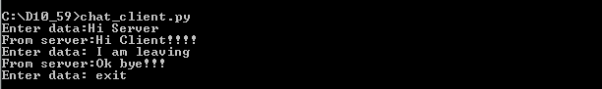

***#Chat Server->***

import socket

HOST = ' '

PORT = 8888

s = socket.socket(socket.AF_INET, socket.SOCK_DGRAM)

s.bind((HOST, PORT))

Print (“Connection From Client :”,HOST)

while 1:

d = s.recvfrom(1024)

data = d[0]

addr = d[1]

if not data:

break

print("From Client : ",str(data.decode()))

reply = input("Enter Response :")

s.sendto(reply.encode() , addr)

s.close()

***#Output***

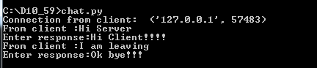

**Experiment_6.1**

**File Transfer *Program***

***#File transfer Server->***

import socket

host='localhost'

port=5000

s=socket.socket()

s.bind((host,port))

s.listen(1)

c,addr=s.accept()

print("Connected to client -> ",str(addr))

fname=c.recv(1024)

fname=str(fname.decode())

fname=fname.lower()

print("Requested for -> "+fname)

try:

f=open(fname,'rb')

content=f.read()

c.send(content)

print("File "+fname+" Sucessfully sent to ",str(addr))

f.close()

except FileNotFoundError:

c.send(b'File '+fname+' is not present')

c.close()

***#Output***

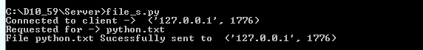

***#File transfer Client->***

import socket

host='localhost'

port=5000

s=socket.socket()

s.connect((host,port))

print("Connected to Server !!!!!")

filename=input("Enter the name of file -> ")

s.send(filename.encode())

content=s.recv(1024)

print("Sucessfully Received from server ")

print("The contents of file is ->\n")

print(content.decode())

***#Output***

