HR ANALYTICS
Employee Workforce, Experience & Training Analysis
Excel • Python • Power BI

Project Overview
This project analyzes workforce structure, employee experience, performance, and training information using a cleaned HR dataset. Excel was used for initial data preparation, Python was used for exploratory analysis and visualizations, and Power BI was used to build an interactive three-page dashboard.

Prepared as a Data Analytics portfolio project

Table of Contents
1. Executive Summary
2. Introduction
3. Problem Statement
4. Project Objectives
5. Dataset Description
6. Tools and Technologies
7. Project Methodology
8. Data Cleaning and Preparation
9. Python Exploratory Data Analysis
10. Workforce Analysis
11. Employee Experience Analysis
12. Training and Development Analysis
13. Power BI Dashboard
14. Key Findings
15. Recommendations
16. Conclusion
17. Future Scope
18. Project Structure

1. Executive Summary
The HR Analytics project was developed to turn employee, performance, experience, and training data into practical management insights. The final analytical dataset contains 2,845 employee records and 25 fields. The analysis was completed through a three-stage workflow: Excel for initial preparation, Python for data validation and exploratory analysis, and Power BI for interactive reporting.
Metric | Result
Total employees | 2,845
Active employees | 2,458 (86.40%)
Terminated employees | 387 (13.60%)
Average engagement | 2.94
Average satisfaction | 3.03
Average work-life balance | 2.99
Average employee rating | 2.97
Total training cost | Rs. 1,591,203
Average training cost | Rs. 559.30
Average training duration | 2.97 days

Overall analytical picture
Production is the largest department with 1,910 employees. Average engagement ranges from 2.91 in Production to 3.38 in the Executive Office. Training is almost evenly split between internal and external delivery, while the four training outcomes are distributed across Completed, Incomplete, Passed and Failed categories.

2. Introduction
Human resources data can contain information about employee status, department, performance, engagement, satisfaction, work-life balance and training. When these fields are analyzed together, an organization can understand its workforce structure and identify areas that require further attention.
This project focuses on descriptive and exploratory analytics rather than predicting employee behavior. The purpose is to present the available data clearly, identify measurable patterns, and provide a dashboard that allows users to filter and explore the information.

3. Problem Statement
The raw HR dataset contains many employee-level fields that are difficult to interpret quickly in spreadsheet form. The project therefore addresses the need to clean the data, summarize important HR indicators, visualize patterns, and present the results in an interactive Power BI dashboard.

4. Project Objectives
- Prepare a reliable HR dataset for analysis.
- Validate duplicates, missing values and date fields.
- Analyze employee status and department distribution.
- Study performance-score distribution and department-level patterns.
- Analyze engagement, satisfaction and work-life balance scores.
- Analyze training programs, outcomes, cost and duration.
- Create Python visualizations for exploratory analysis.
- Build a three-page Power BI dashboard for interactive analysis.
- Summarize the main findings in a professional report.

5. Dataset Description
The cleaned analytical dataset contains 2,845 rows and 25 columns. It includes employee identifiers, employment information, department, performance, employee experience scores, training details and age. Business Unit and State were removed during the project preparation to keep the final analytical model focused.
Category | Representative fields
Employee information | employee_id, title, employee_type, employee_classification_type
Employment | employee_status, department_type, division, payzone
Demographics | dob, gender_code, maritaldesc, age
Performance | performance_score, current_employee_rating
Experience | engagement_score, satisfaction_score, work_life_balance_score
Training | training_program_name, training_type, training_outcome
Training measures | training_duration_days, training_cost_in_Rupees
Dates | start_date, survey_date, training_date

6. Tools and Technologies
Tool | Purpose
Microsoft Excel | Initial data preparation and dataset review
Python | Data cleaning validation, exploratory analysis and chart generation
Pandas | Tabular data processing and aggregation
Matplotlib / Seaborn | Exploratory data visualizations
Power BI | Interactive dashboard, KPI cards, slicers and analytical visuals
DAX | Power BI measures and calculated analytical metrics

7. Project Methodology
The project follows the workflow below:
1. Excel preparation — review the downloaded HR data and prepare the working dataset.
2. Python loading — load the cleaned Excel data and inspect rows, columns and data types.
3. Python cleaning — check duplicate rows, duplicate employee IDs, missing values and date formats.
4. Exploratory analysis — calculate employee, department, performance, experience and training summaries.
5. Visualization — generate charts for the main analytical questions.
6. Power BI modeling — import the cleaned data, set date types and create DAX measures.
7. Dashboard — organize the analysis into Workforce Overview, Employee Experience and Training & Development pages.
8. Reporting — document the process, findings and recommendations.

8. Data Cleaning and Preparation
Python was used to validate the final analytical dataset after the Excel preparation stage. The cleaning script checked the structure of the data, duplicate records, duplicate employee IDs, missing values and date fields.
Validation check | Result
Rows after cleaning | 2,845
Columns after cleaning | 25
Duplicate rows | 0
Duplicate employee IDs | 0
Missing values | 0 across the final 25 columns
Date fields | Converted and validated as date/time fields

Data quality result
The Python cleaning process produced HR_Analytics_Python_Cleaned.xlsx with 2,845 rows and 25 columns. No duplicate rows, duplicate employee IDs or missing values were reported in the final cleaned dataset.

9. Python Exploratory Data Analysis
Python was used not only for checking the dataset but also as a real analytical stage of the project. The scripts generated summary tables and visualizations for workforce status, department distribution, performance, employee experience, training and correlations.

Department Distribution
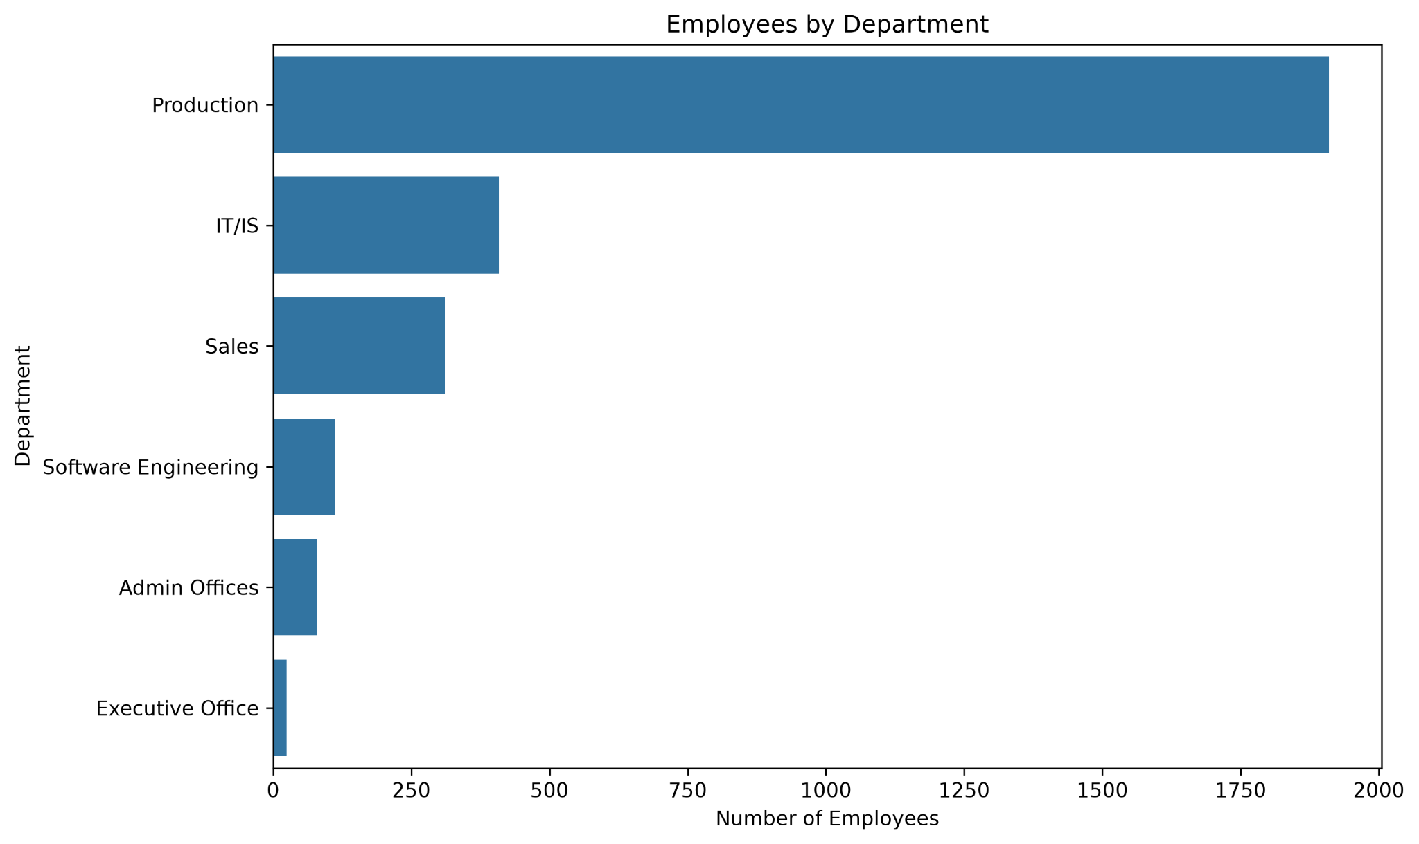
Production contains 1,910 employees, followed by IT/IS with 409 and Sales with 311.

Employee Status
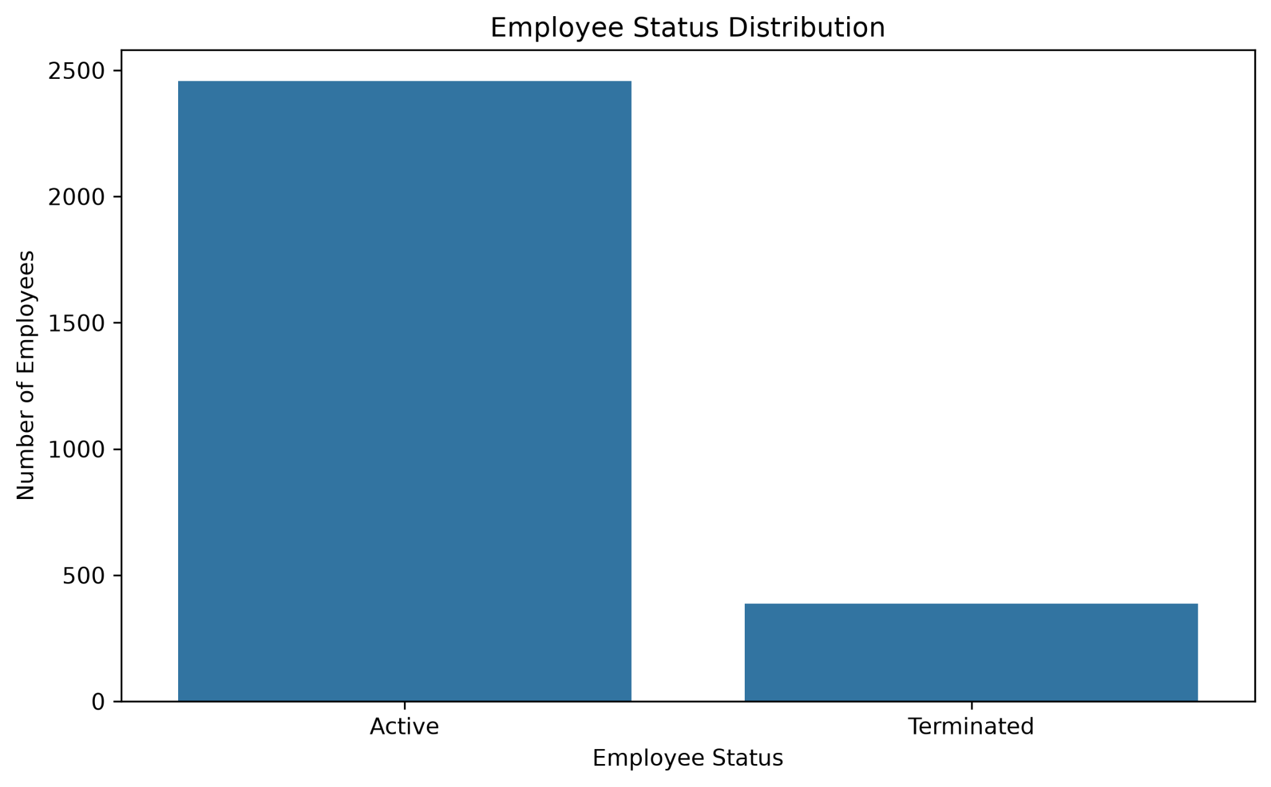
The dataset contains 2,458 active employees and 387 terminated employees.

Performance Distribution
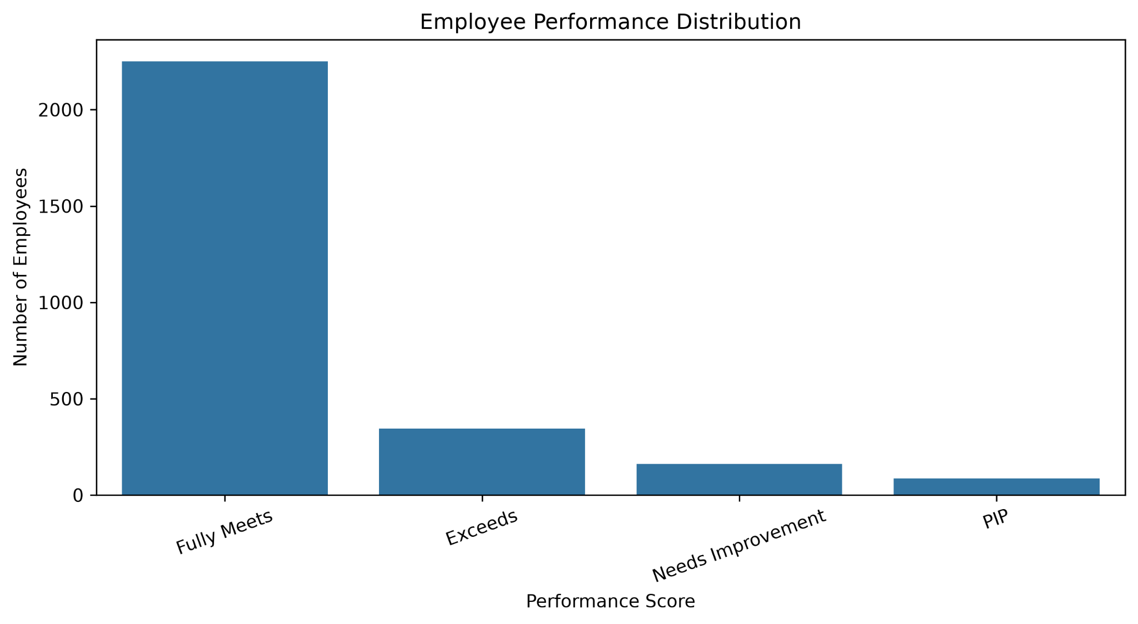
Fully Meets is the largest performance category with 2,251 employees.

Average Engagement by Department
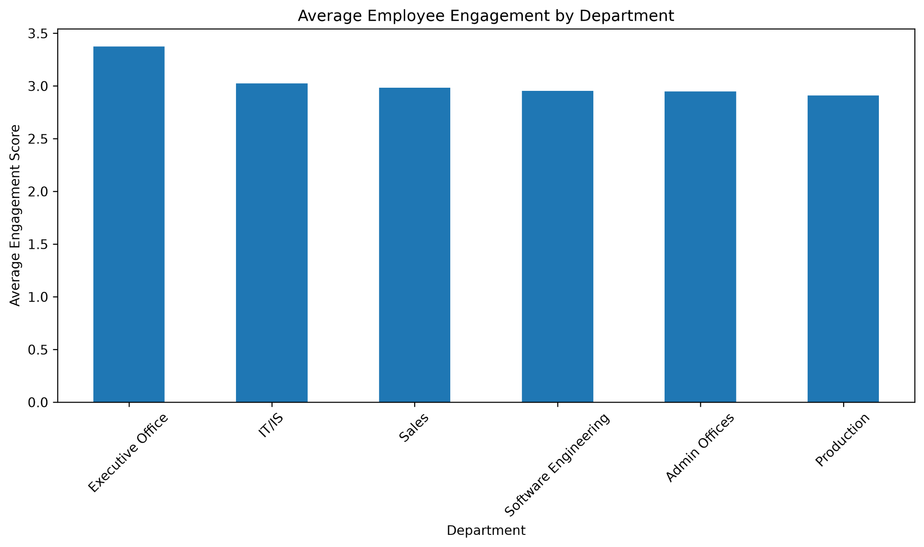
Average engagement ranges from 2.91 in Production to 3.38 in the Executive Office.

Department vs Employee Status
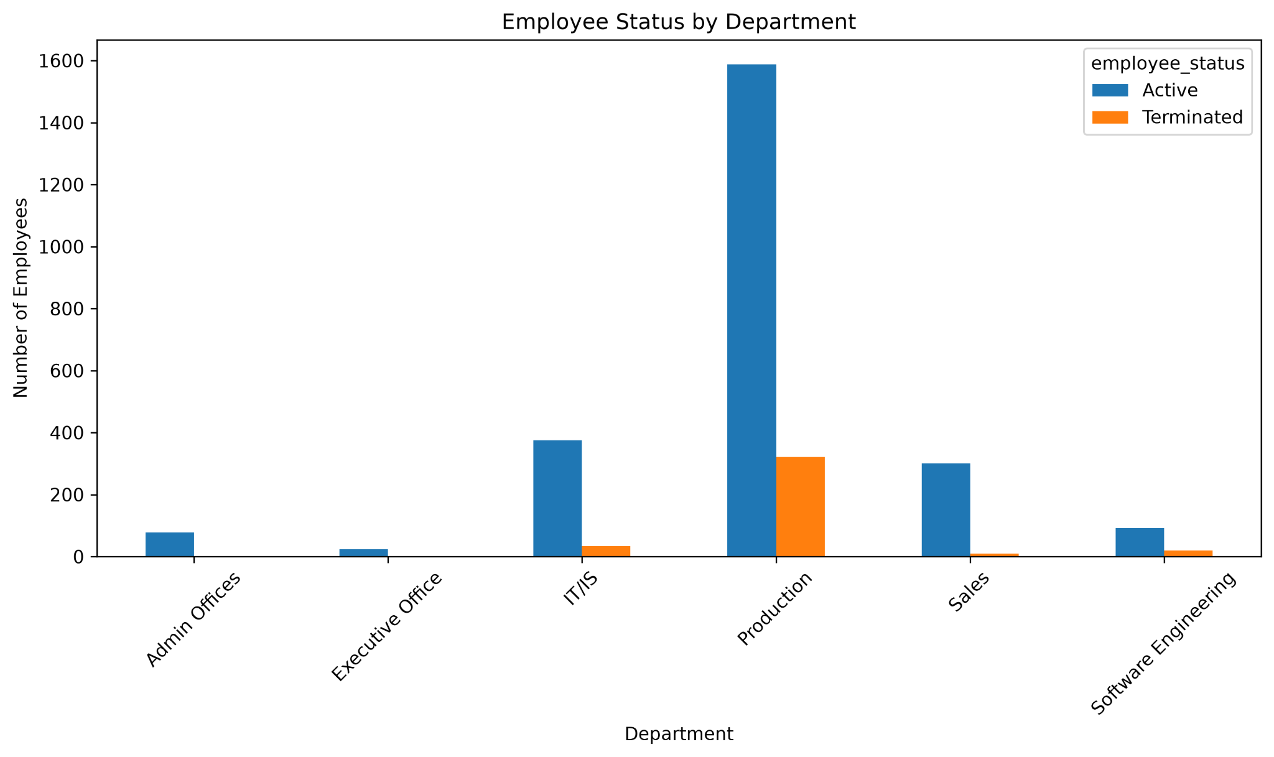
The chart compares active and terminated employees across departments.

Engagement Distribution
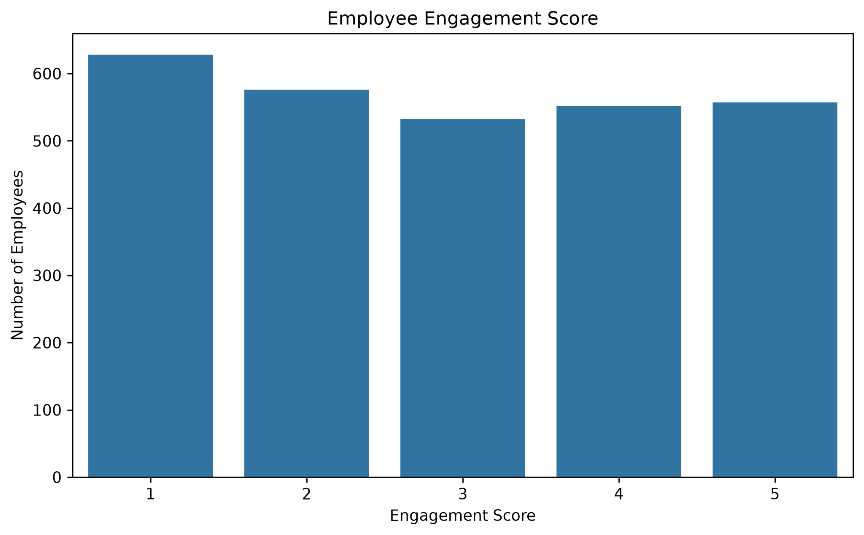
The distribution shows how engagement scores are spread across employees.

Satisfaction Distribution
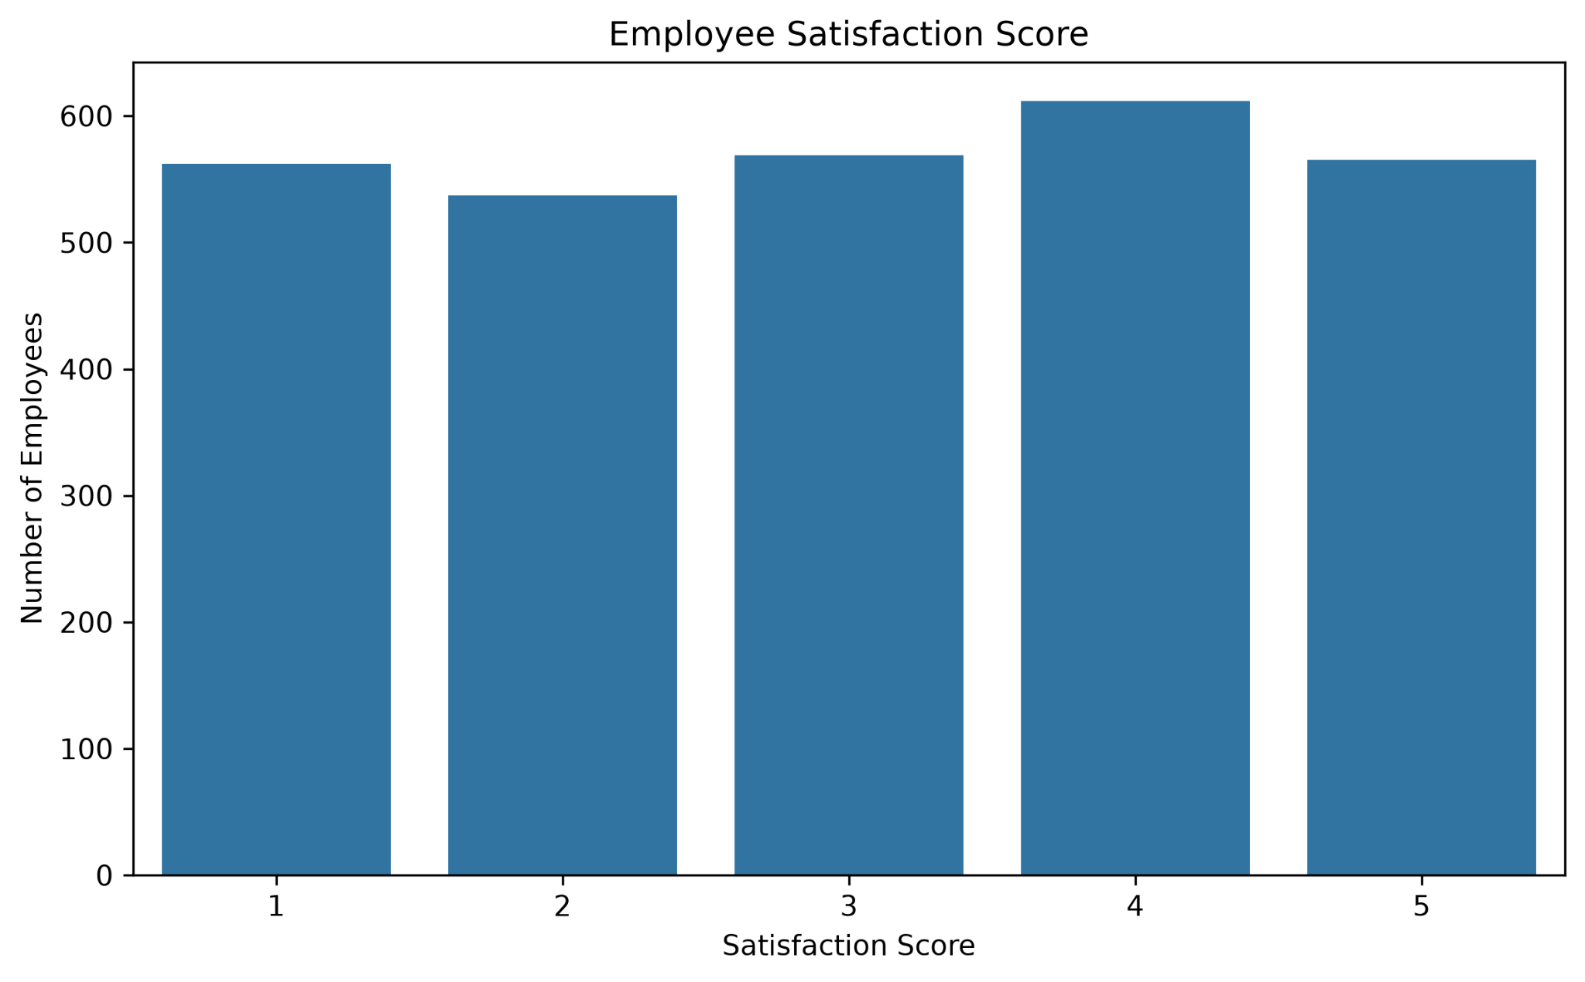
The distribution shows the employee satisfaction-score pattern.

Satisfaction vs Engagement
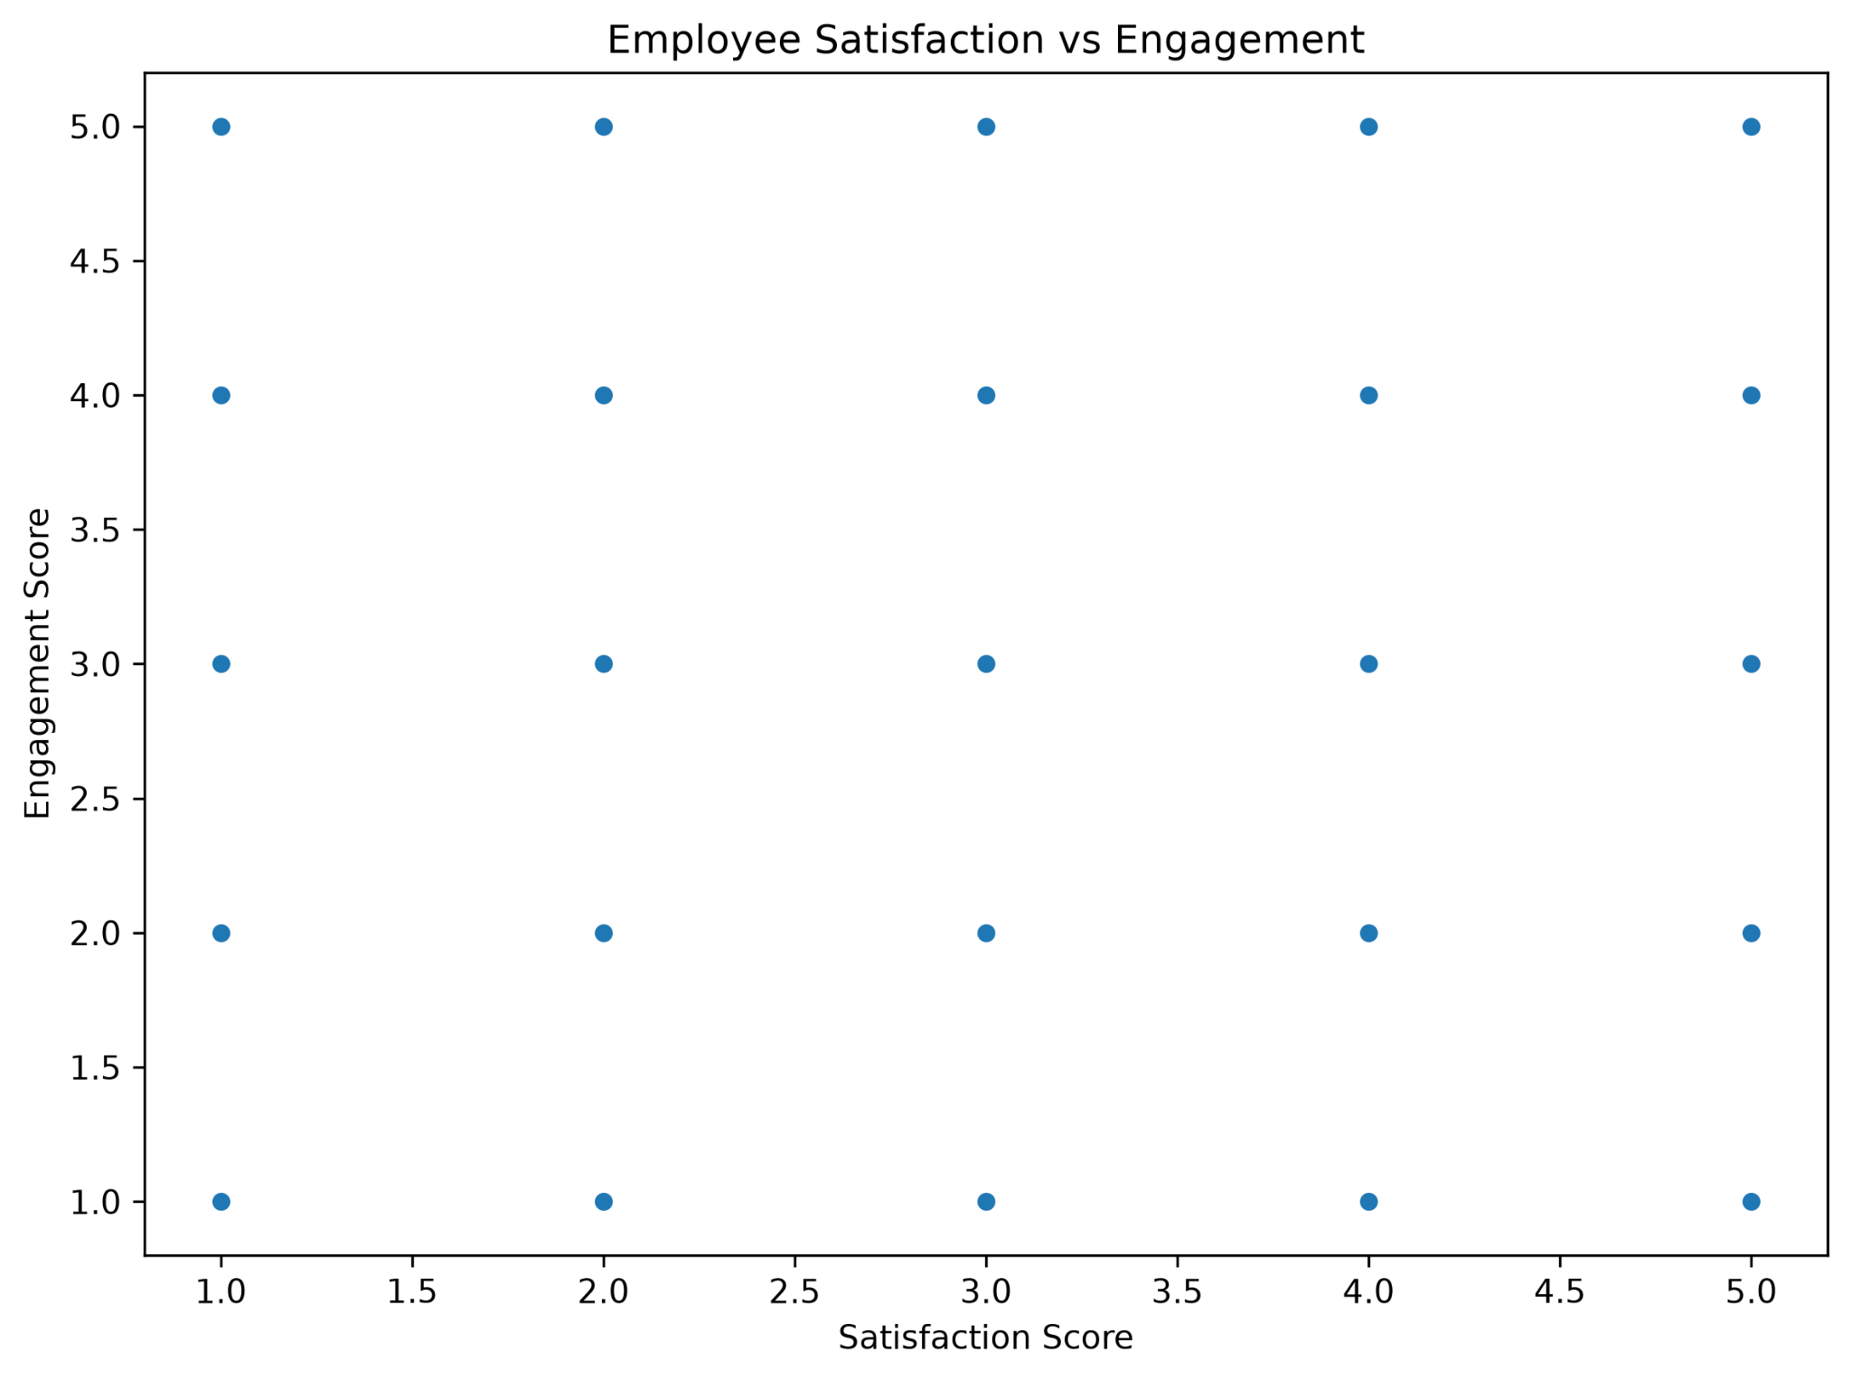
The Python analysis found an approximately zero correlation between satisfaction and engagement.

Correlation Heatmap
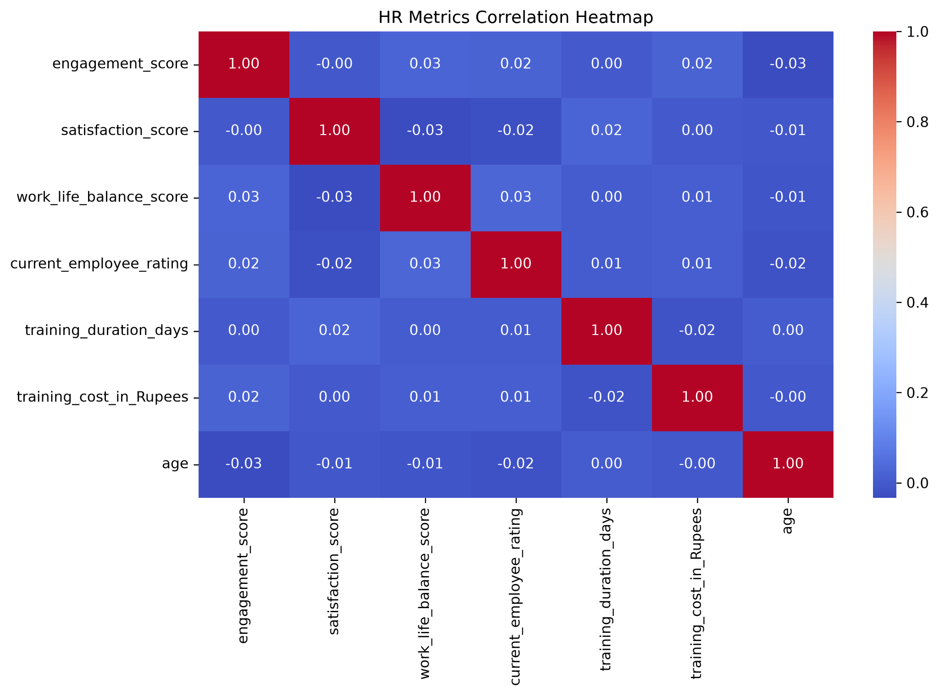
The main numeric HR variables show mostly weak linear relationships in this dataset.

Age Distribution
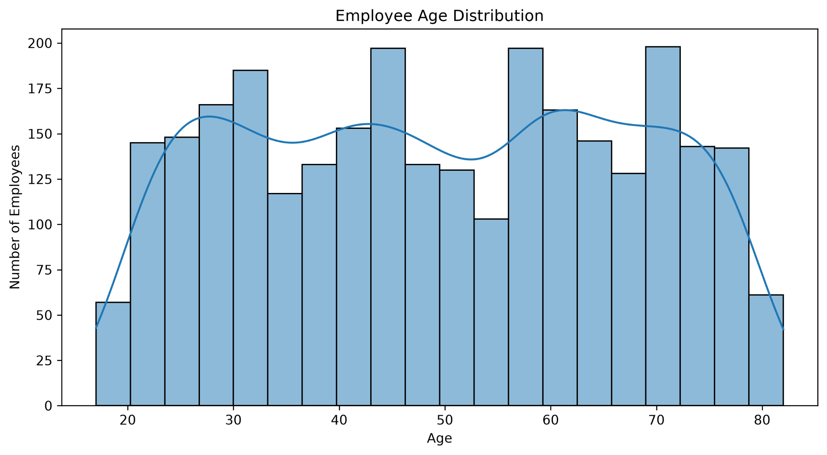
Employee age ranges from 17 to 82 years, with a mean age of approximately 49.45 years.

10. Workforce Analysis
The workforce analysis focuses on employee status, department size and performance distribution. These measures provide a high-level view of the organizational workforce.
Department | Employees | Termination %
Production | 1,910 | 16.86%
IT/IS | 409 | 8.31%
Sales | 311 | 3.22%
Software Engineering | 112 | 17.86%
Admin Offices | 79 | 1.27%
Executive Office | 24 | 0.00%

Production is the largest department. The department-level termination percentages vary across the six departments in the dataset. Software Engineering has 20 terminated employees out of 112 employees, while Production has 322 terminated employees out of 1,910.

11. Employee Experience Analysis
Measure | Average
Engagement | 2.94
Satisfaction | 3.03
Work-Life Balance | 2.99
Employee Rating | 2.97

Department-level engagement is highest in the Executive Office at 3.38 and lowest in Production at 2.91. The satisfaction-versus-engagement analysis shows an approximately zero linear correlation in this dataset, so the project does not treat one measure as a cause of the other.
Department-level average engagement used in the employee experience analysis.

12. Training and Development Analysis
Training program | Participants | Total cost (Rs.)
Communication Skills | 633 | 344,558
Project Management | 585 | 329,318
Leadership Development | 544 | 305,416
Technical Skills | 543 | 304,157
Customer Service | 540 | 307,754

Training outcome | Count | Share
Completed | 737 | 25.91%
Incomplete | 731 | 25.69%
Passed | 709 | 24.92%
Failed | 668 | 23.48%

Training type | Count | Share
External | 1,424 | 50.05%
Internal | 1,421 | 49.95%

The total training cost is Rs. 1,591,203 and the average training cost is Rs. 559.30. Average training duration is 2.97 days. Communication Skills has the highest total training cost because it has the largest participant count.

Training Programs
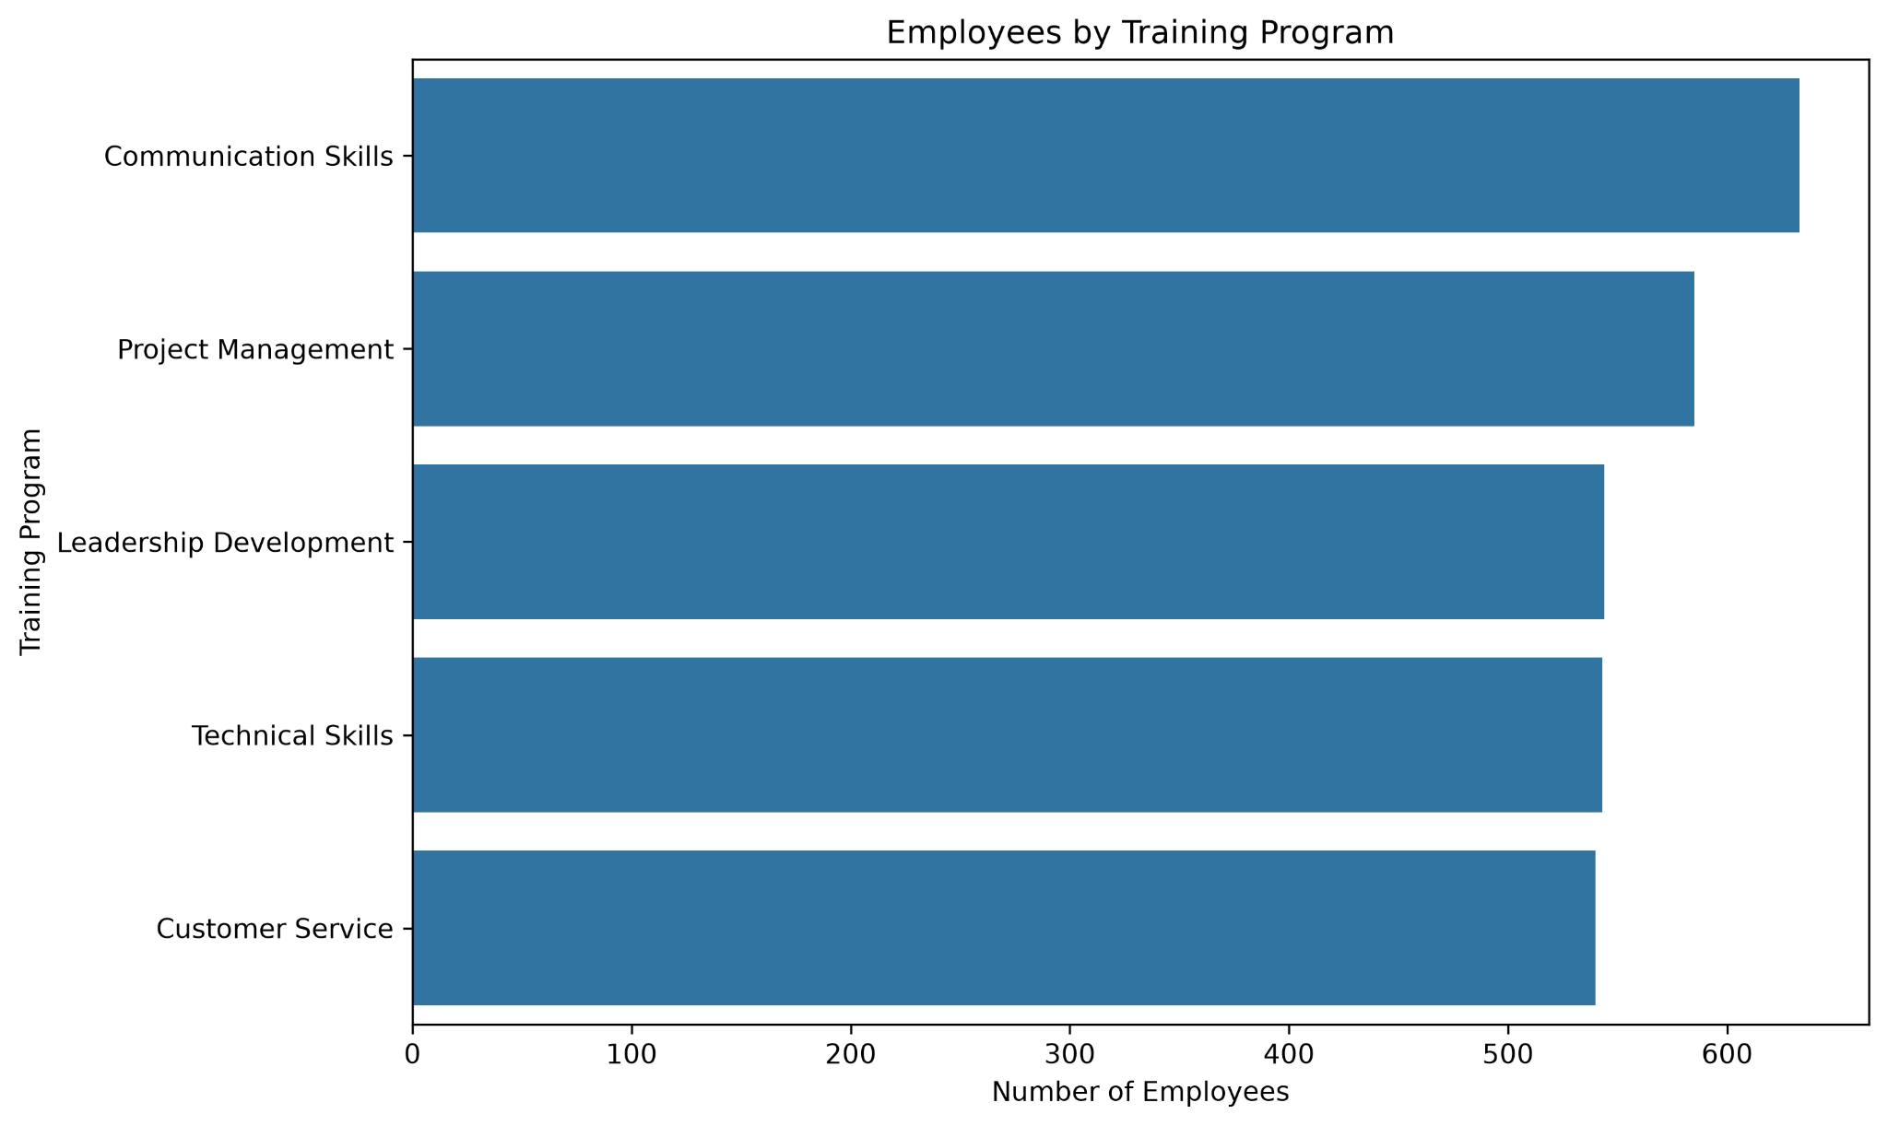
Distribution of employees across the five training programs.

Training Outcomes
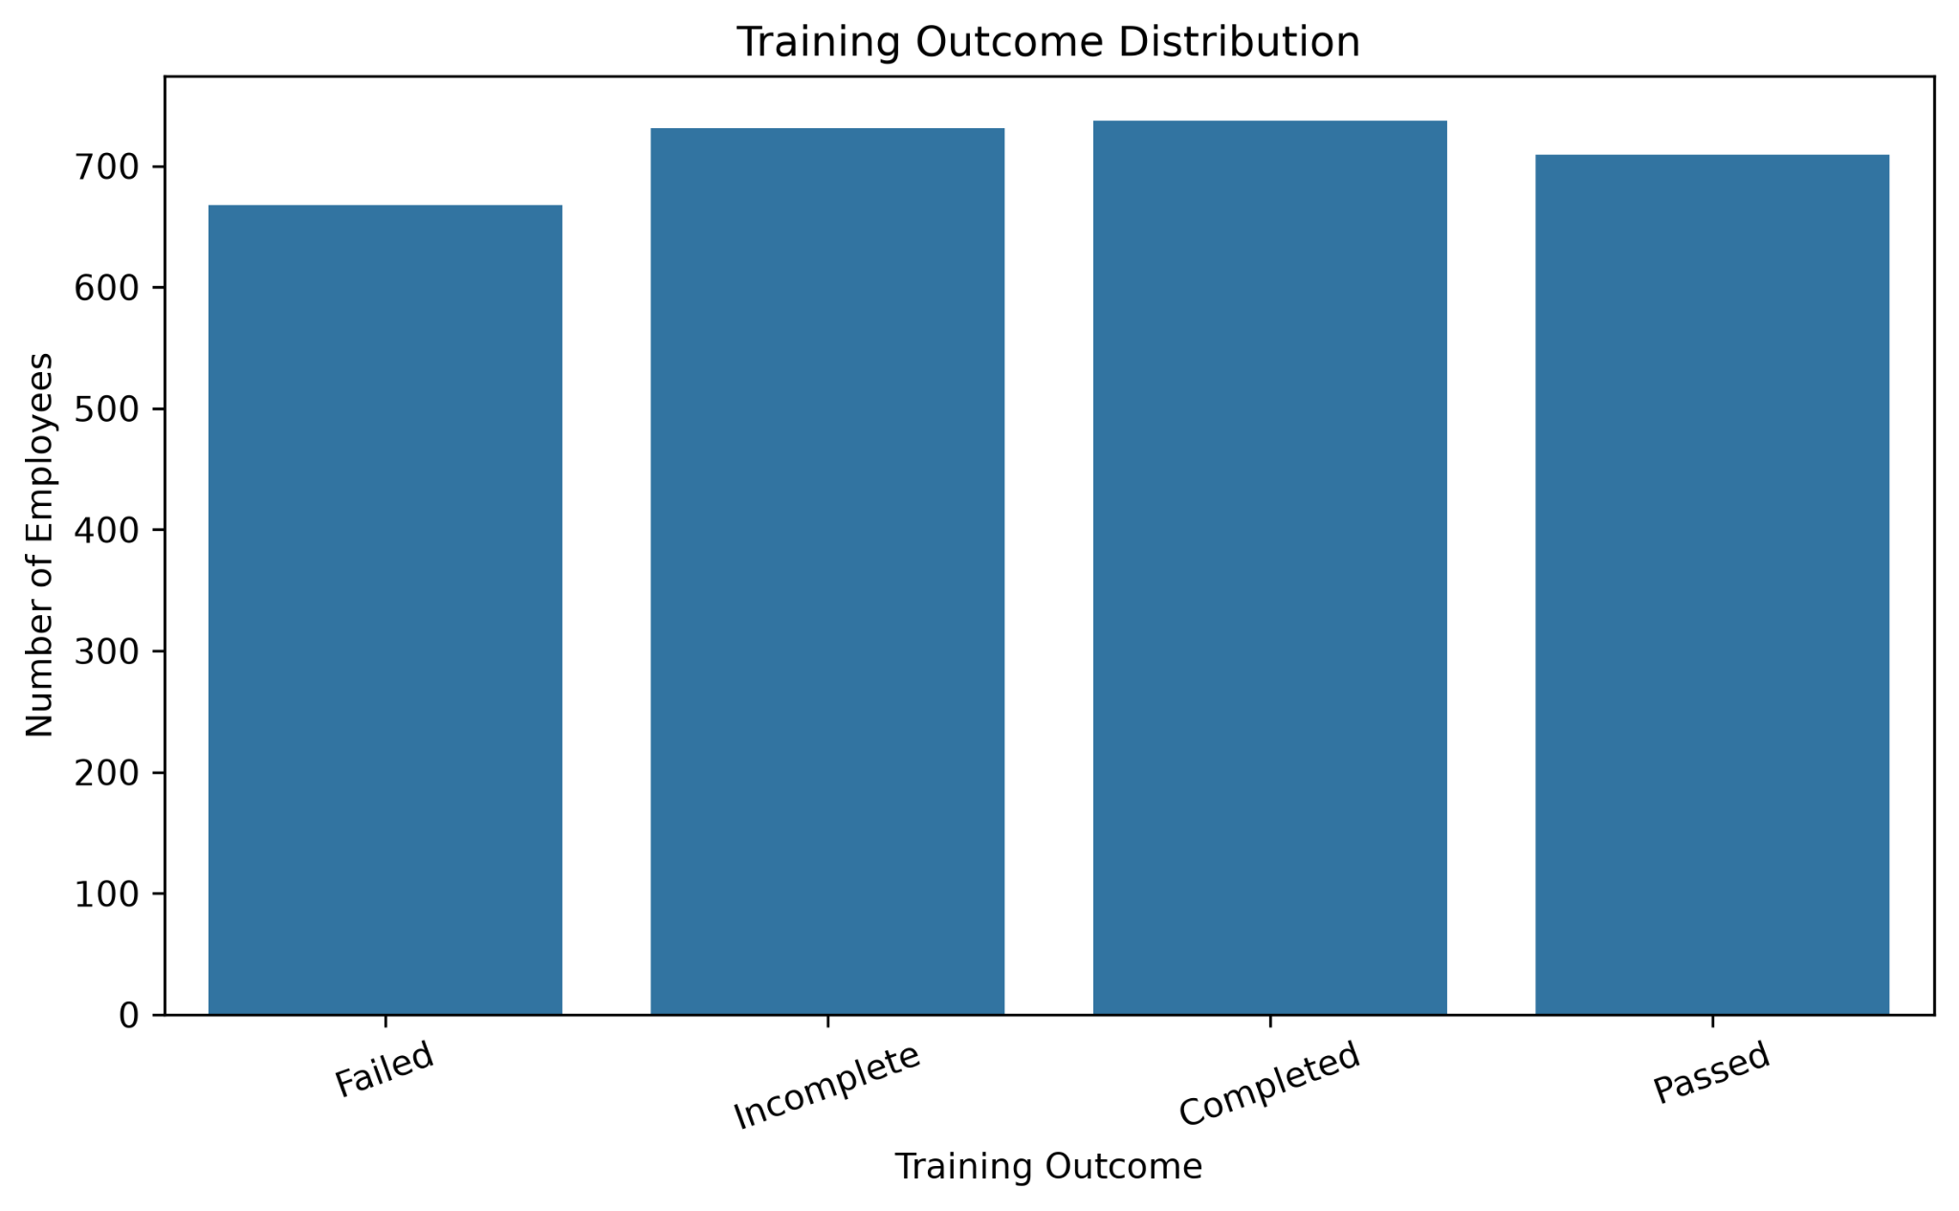
Training outcomes across Completed, Incomplete, Passed and Failed categories.

Training Cost by Program
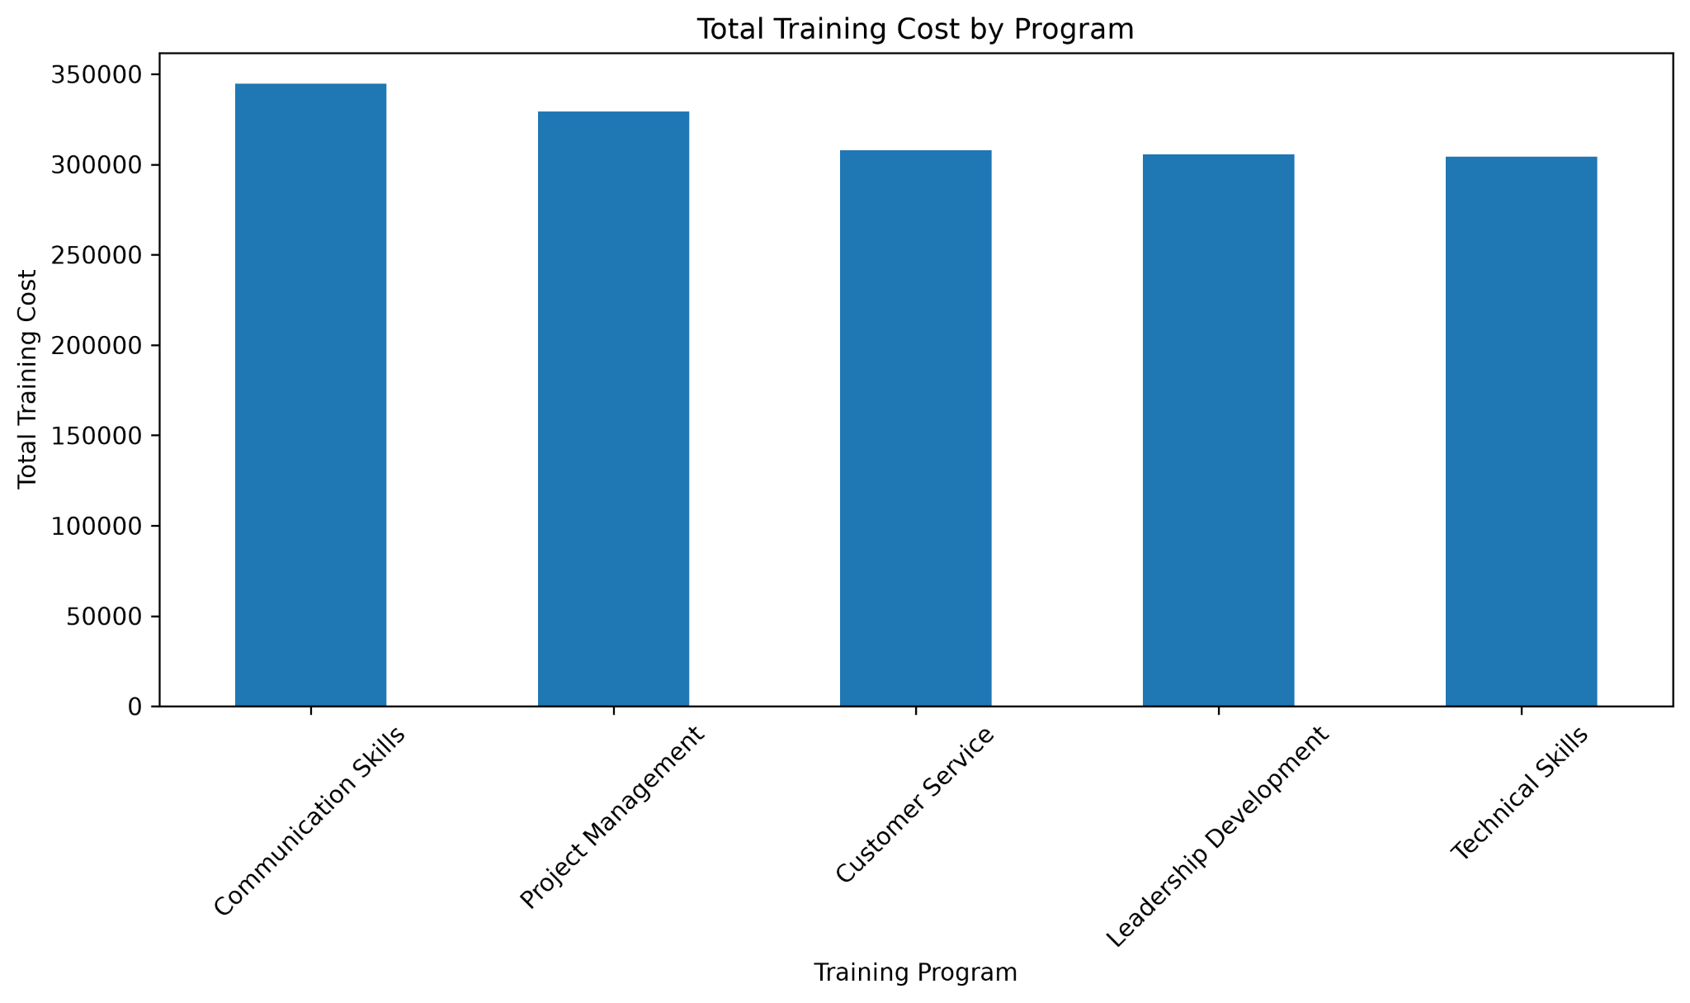
Total training cost by training program.

13. Power BI Dashboard
The Power BI dashboard is organized into three pages so that related HR questions are grouped together without repeating the same visuals unnecessarily.
Page | Purpose | Main elements
01 Workforce Overview | Workforce size, status, department and performance | KPI cards, slicers, department chart, status donut, performance chart, termination analysis
02 Employee Experience | Engagement, satisfaction, work-life balance and rating | Four KPI cards, department engagement, satisfaction vs engagement, work-life balance, slicers
03 Training & Development | Training participation, cost, duration and outcomes | Training KPIs, program analysis, cost analysis, outcomes and internal/external split

Power BI Employee Experience Page
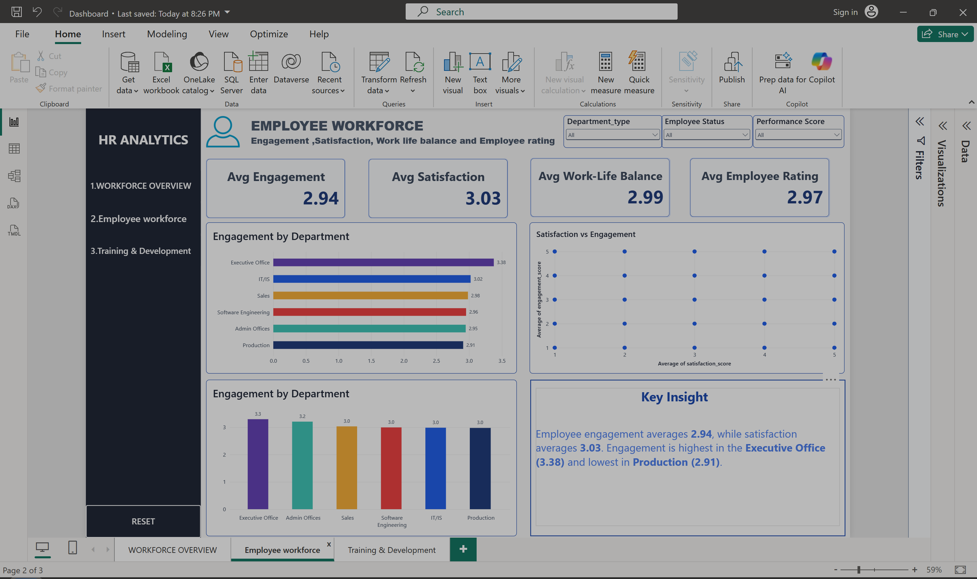
Power BI Employee Experience page during dashboard development, showing KPI cards, slicers and analytical visuals.

Power BI Workforce Overview Page
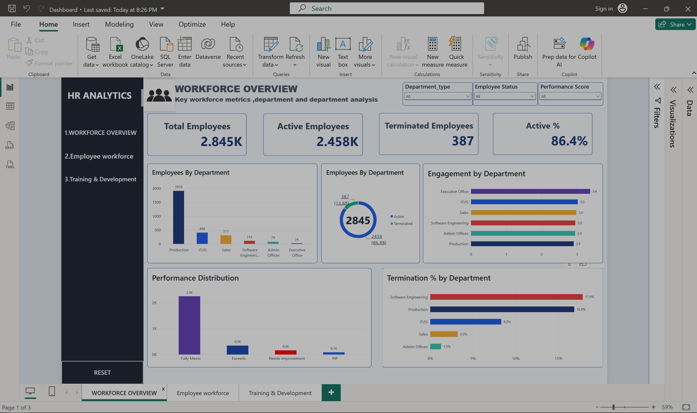

Power BI Training & Development Page
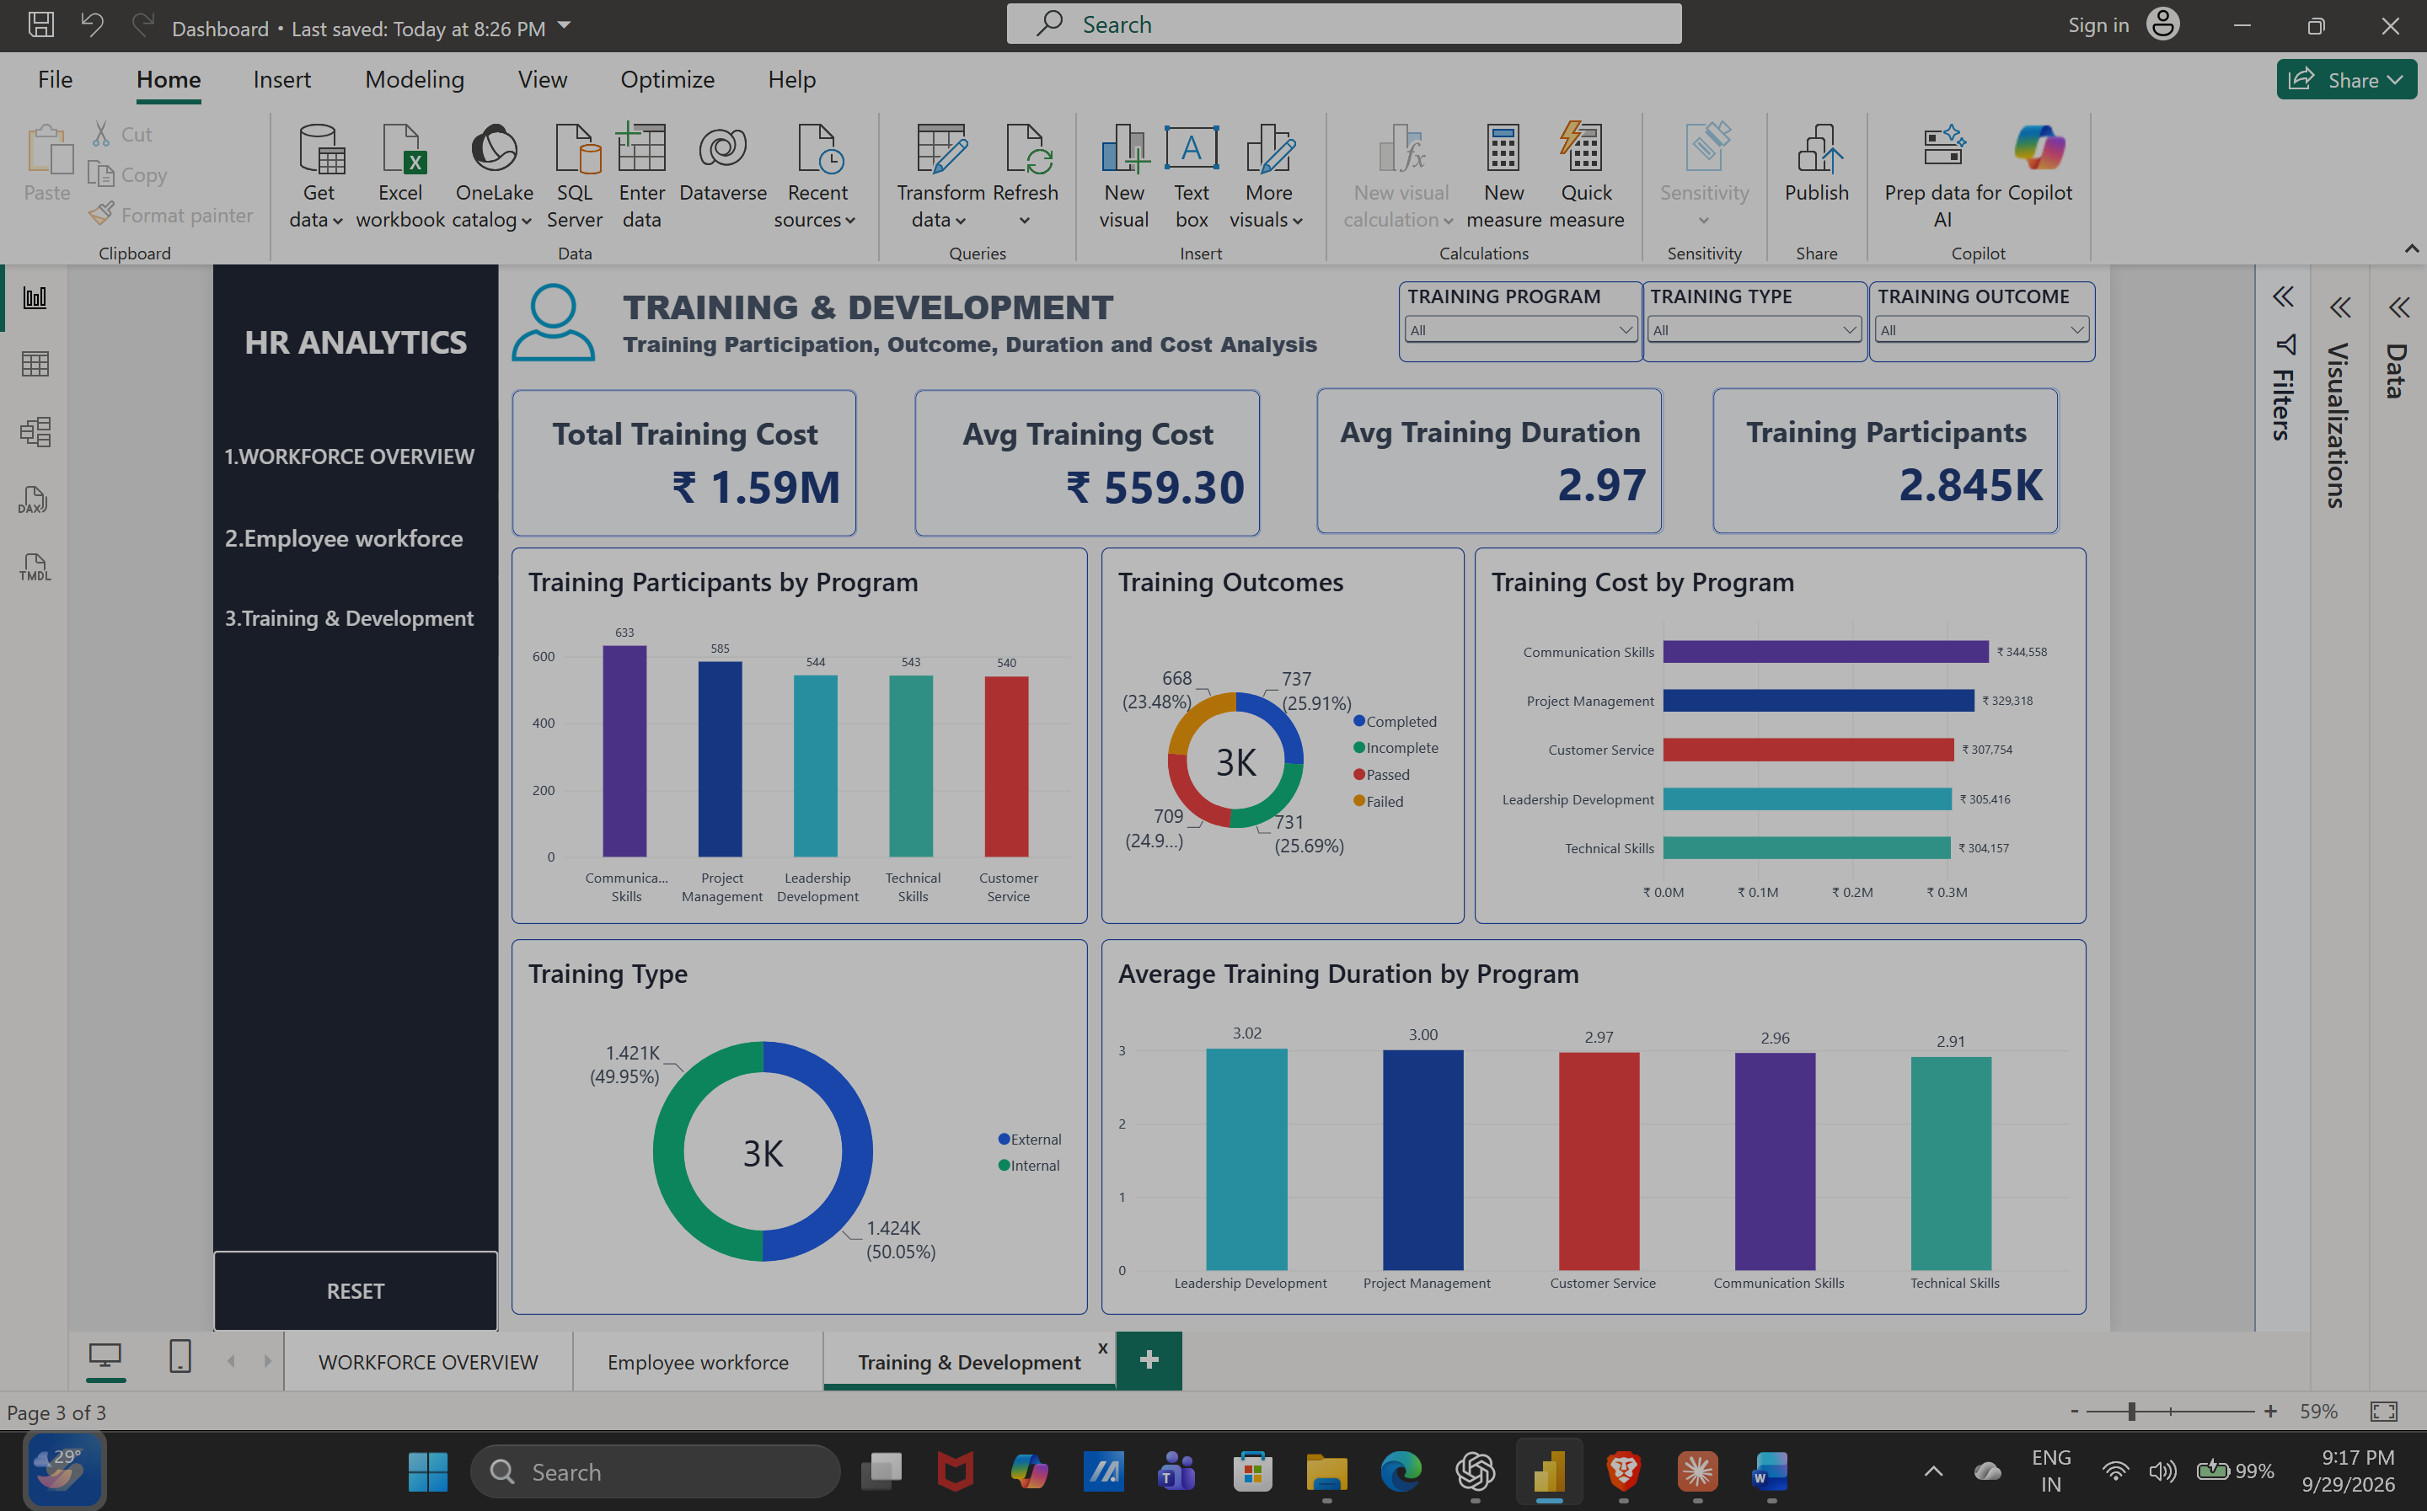

Updated Employee Experience page with the Satisfaction vs Engagement visual configured using average scores.
Dashboard design
The dashboard uses a dark navy navigation sidebar with a light analytical canvas. Slicers are used for Department, Employee Status and Performance so the user can interactively filter the report.

14. Key Findings
- The dataset contains 2,845 employees, with 2,458 active and 387 terminated records.
- Production is the largest department with 1,910 employees.
- Production has 322 terminated employees; Software Engineering has 20 terminated employees out of 112.
- The largest performance category is Fully Meets with 2,251 employees.
- Average engagement is 2.94, average satisfaction is 3.03, average work-life balance is 2.99, and average employee rating is 2.97.
- Average engagement differs by department, ranging from 2.91 in Production to 3.38 in the Executive Office.
- Total training expenditure in the dataset is Rs. 1,591,203.
- External and internal training participation is almost evenly divided: 1,424 external and 1,421 internal.
- Training outcomes are distributed across four categories, with Completed at 737 and Failed at 668.
- The satisfaction-engagement correlation is approximately 0.00, indicating no meaningful linear relationship in this dataset.

15. Recommendations
The following recommendations are based on the descriptive patterns observed in the project:
- Monitor department-level employee status trends regularly, especially where termination percentages are comparatively higher in the dataset.
- Review engagement patterns in departments with lower average engagement and investigate the underlying employee experience factors.
- Use performance and employee-experience metrics together when conducting HR reviews rather than relying on a single indicator.
- Track training outcomes by program and type to identify programs with comparatively higher incomplete or failed counts.
- Compare training cost with participation and outcome measures when evaluating future training plans.
- Use the Power BI slicers to examine whether the observed patterns change for different departments, employee statuses or performance groups.

16. Conclusion
This HR Analytics project demonstrates a complete data analytics workflow from data preparation to reporting. Excel supported the initial preparation, Python provided reproducible cleaning and exploratory analysis, and Power BI transformed the results into an interactive dashboard.
The project provides a clear view of workforce size, employee status, departmental distribution, performance, employee experience and training. The report and dashboard together make the analysis easier to understand and provide a reusable foundation for further HR analytics.

17. Future Scope
- Add a dedicated time-series analysis if multiple reporting periods become available.
- Add deeper analysis of training outcomes by department and performance group.
- Create more detailed demographic analysis where appropriate and supported by the project requirements.
- Add automated refresh and publishing through Power BI Service when an appropriate organizational account is available.
- Develop predictive models in a future project if a clearly defined target variable and suitable historical data are available.

18. Project Structure
HR_Analytics_Project/
│
├── data/
│ ├── HR_Analytics_Cleaned.xlsx
│ └── HR_Analytics_Python_Cleaned.xlsx
│
├── python/
│ ├── 01_data_loading.py
│ ├── 02_data_cleaning.py
│ ├── 03_eplatory_data_analytics.py
│ ├── 04_employee_analysis.py
│ ├── 05_training_analysis.py
│ ├── 06_visualizations.py
│ └── insights.py
│
├── visualizations/
│ ├── employee_status.png
│ ├── department_distribution.png
│ ├── performance_distribution.png
│ ├── engagement_distribution.png
│ ├── satisfaction_distribution.png
│ ├── satisfaction_vs_engagement.png
│ ├── correlation_heatmap.png
│ ├── training_programs.png
│ ├── training_outcome.png
│ └── training_cost_by_program.png
│
└── Power BI Dashboard

Final project workflow
Excel → Python → Power BI Dashboard → Word Report

