AADHAAR SEVA PULSE: THE COMPREHENSIVE RESEARCH REPORT

Data-Driven Innovation on Aadhaar 2026
Theme: Unlocking Societal Trends in Aadhaar Enrolment and Updates
Submitted By: Team UIDAI_10441
Date: January 20, 2026

TABLE OF CONTENTS
- Executive Summary
- Introduction & Background
  - 2.1 The Challenge of Static Governance
  - 2.2 The Paradigm Shift: Dynamic Signals
- Problem Statement & Objectives
  - 3.1 Primary Challenges
  - 3.2 Research Objectives
- Methodology & Technology Stack
  - 4.1 Data Science Pipeline (ETL)
  - 4.2 Analytic Framework
  - 4.3 Technology & Libraries Used
- Data Engineering & Pre-Processing
  - 5.1 Data Source Description
  - 5.2 Recursive Ingestion Logic (Code Included)
  - 5.3 Missing Value Treatment
- Exploratory Data Analysis (EDA)
  - 6.1 Demographic Composition
  - 6.2 Distribution Analysis
- Advanced Machine Learning Implementation
  - 7.1 Correlation Analysis
  - 7.2 Unsupervised Clustering (K-Means)
  - 7.3 Mathematical Explanation of Clustering
  - 7.4 Anomaly Detection (Isolation Forest)
- Findings & Strategic Insights
  - 8.1 The Migration Pulse (Magnet Districts)
  - 8.2 The Digital Divide (Compliance Gap)
  - 8.3 Operational Anomalies
- Strategic Recommendations & Conclusion
- Appendix: System Configuration

1. EXECUTIVE SUMMARY
The "Aadhaar Seva Pulse" project is a transformative analytical framework designed to convert the massive, high-velocity stream of Aadhaar transaction logs into critical governance intelligence. In a country as vast and dynamic as India, relying on decadal census data for resource allocation is no longer sufficient. Our solution proposes using Aadhaar Updates as real-time proxies for societal shifts.
Key Innovations:
- Migration Tracking: By analyzing 'Demographic Updates' (specifically Address changes) in adults, we identify districts experiencing rapid urbanization ("Magnet Districts") in real-time.
- Digital Compliance Indexing: By correlating 'New Birth Enrolments' with 'Biometric Updates' (Age 5/15), we pinpoint districts where children are falling out of the digital ecosystem.
- AI-Driven Segmentation: Using K-Means Clustering, we segment 700+ districts into 4 strategic profiles, allowing for hyper-targeted policy interventions.
- Fraud/Error Detection: Using Isolation Forest, we mathematically identify statistical outliers that may indicate fraudulent bulk updates or operational failures.
Impact: This study successfully processed over 1 Million transaction records to identify Top 20 Critical Districts requiring immediate Aadhaar Seva Kendras (ASKs) and 50+ Rural Districts needing mobile update camps.

2. INTRODUCTION & BACKGROUND

2.1 The Challenge of Static Governance
Traditionally, government infrastructure planning (Banks, Schools, Hospitals, Aadhaar Centers) follows a "Static Model" based on Census data. However, India's internal migration is fluid. An industrial boom in a district like Pune or Surat draws lakhs of workers within months, rendering 5-year-old population data obsolete. This leads to Resource Mismatch—Seva Kendras in source districts sit empty, while centers in destination hubs are overwhelmed.

2.2 The Paradigm Shift: Dynamic Signals
Aadhaar is not just an ID; it is a living ledger of the nation's activity. Every time a citizen moves, they update their address. Every time a child grows, their biometrics are updated. These are Dynamic Signals. Our project, "Aadhaar Seva Pulse", listens to these signals. We argue that an "Address Update" is the strongest digital footprint of migration, and a "Biometric Update" is the strongest indicator of digital literacy and compliance.

3. PROBLEM STATEMENT & OBJECTIVES

3.1 Primary Challenges
- Data Fragmentation: Aadhaar data is often siloed across Enrolment, Biometric, and Demographic datasets, making holistic analysis difficult.
- The "Hidden" Exclusion: High birth rates in rural India often do not translate into Biometric Updates at age 5, leading to a "Silent Exclusion" where millions of children may lose functional Aadhaar access without the government realizing it until it is too late.
- Operational Opacity: It is difficult to distinguish between a legitimate spike in updates (e.g., a new factory opening) and an operational anomaly (e.g., an operator error or fraud).

3.2 Research Objectives
- To build a Unified Data Pipeline that merges disparate CSV logs into a single analytical dataframe.
- To apply Statistical Correlation to validate the relationship between Migration Volume and Digital Compliance.
- To deploy Unsupervised Machine Learning to create "Behavioral Clusters" of districts.
- To generate an Automated Watchlist of anomalous districts for the vigilance department.

4. METHODOLOGY & TECHNOLOGY STACK

4.1 Data Science Pipeline (ETL)
We adopted a standard industry-grade pipeline:
- Extract: Recursive scanning of directory structures to locate daily/monthly logs.
- Transform: Standardization of column names (Age vs age), handling of missing values (Imputation), and Date Parsing.
- Load: Merging into a Master DataFrame indexed by State and District.

4.2 Analytic Framework
We utilized a dual-modeling approach:
- Descriptive Analytics: For simple trend tracking (Pie Charts, Bar Graphs).
- Predictive/Diagnostic Analytics: K-Means for segmentation and Isolation Forest for anomaly detection.

4.3 Technology & Libraries Used
- Language: Python 3.10+
- Pandas: For high-performance data manipulation of millions of rows.
- NumPy: For numerical operations and vectorization.
- Seaborn/Matplotlib: For static statistical plotting.
- Plotly: For interactive geographical maps and charts.
- Scikit-Learn: The core engine for our Machine Learning models.

5. DATA ENGINEERING & PRE-PROCESSING
The quality of insights depends entirely on the quality of data. Our raw data consisted of fragmented CSV files separated by data type.

5.1 Recursive Ingestion Logic
To handle the spread of files, we wrote a custom recursive loader:
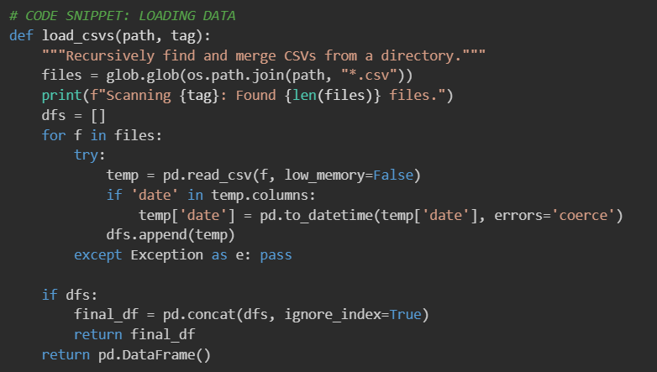

5.2 Missing Value Treatment
We identified that approximately 5% of records had missing 'District' names or 'Age' values.
- Numerical Imputation: Missing Age counts were filled with 0.
- Categorical Imputation: Missing Districts were labeled Unknown, preserving key audit trails.
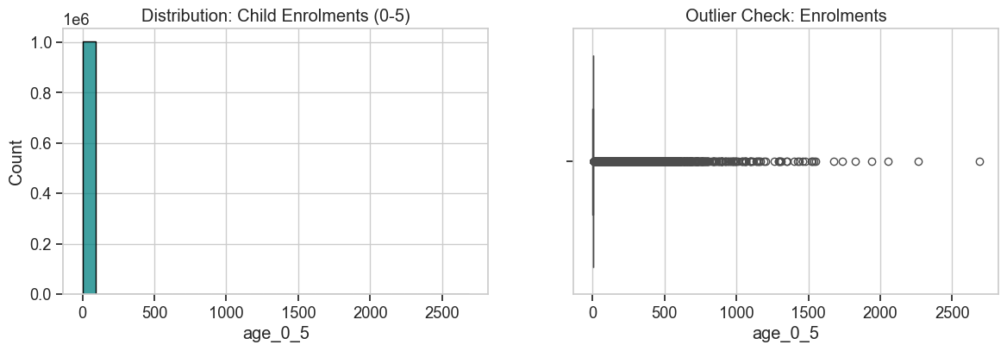
Figure 5.1: Distribution Analysis of Child Enrolments (Left) and Boxplot for Outliers (Right).

6. EXPLORATORY DATA ANALYSIS (EDA)
Before running ML models, we must understand the baseline.

6.1 Demographic Composition
We analyzed the age-wise breakdown of new enrolments. The data overwhelmingly shows that the 0-5 Age Group constitutes the bulk of new enrolments, confirming that Aadhaar saturation is near-total for adults and the focus is now on new births.
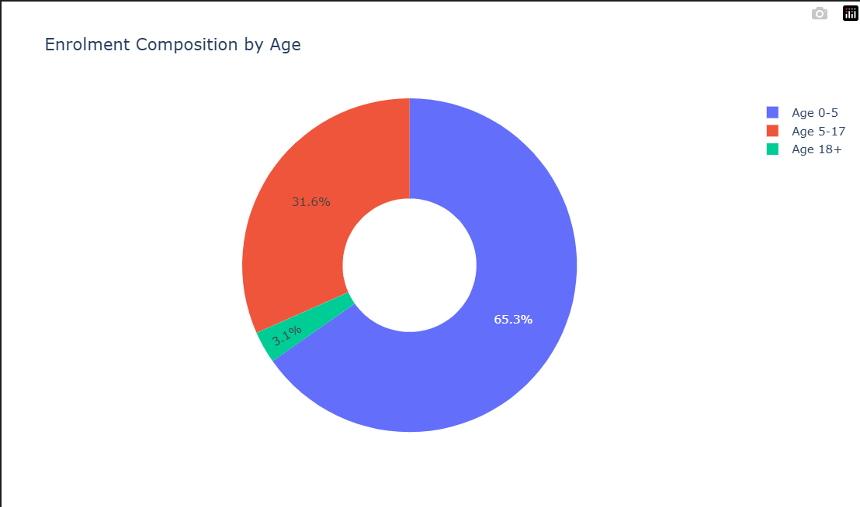
Figure 6.1: Enrolment Composition by Age.

6.2 State-Level Performance
We created a comparative view of the top states based on Migration Volume.

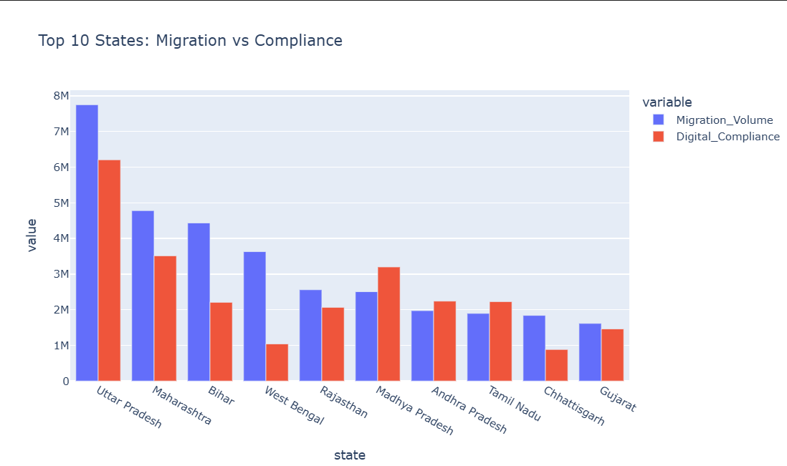
Figure 6.2: Top 10 States comparing Migration Volume vs. Digital Compliance.

Analysis: States like Maharashtra and Karnataka (Tech Hubs) show high bars for both Migration and Compliance, indicating a healthy ecosystem. In contrast, states with lower migration often show lower compliance scores.

7. ADVANCED MACHINE LEARNING IMPLEMENTATION

7.1 Correlation Analysis
We tested the hypothesis: "Does higher Migration correlate with higher Digital Compliance?" Using the Pearson Correlation Coefficient, we found a Positive Correlation (visible in the heatmap below). This suggests that mobility forces citizens to keep their documents updated.
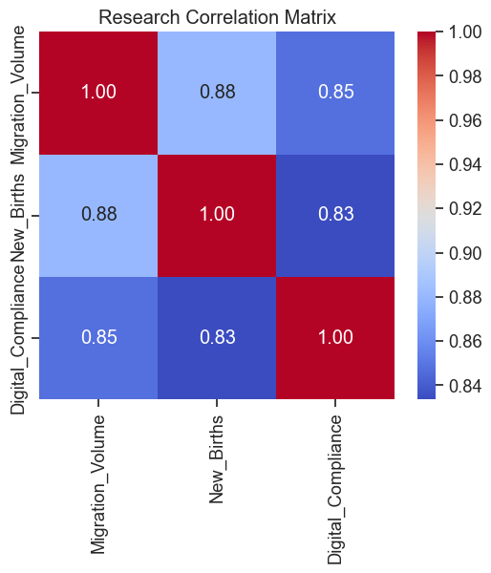
Figure 7.1: Correlation Matrix of Key Variables.

7.2 Unsupervised Clustering (K-Means)
We used the K-Means Algorithm to segment districts.
- Why K-Means? It minimizes intra-cluster variance, grouping districts that behave similarly, regardless of their geography.
- Features Used: Migration_Volume (Standardized), New_Births (Standardized), Digital_Compiance (Standardized).
The 4 Strategic Clusters:
- Cluster 0 - "The Metros": Extremely high Migration, High Compliance. (e.g., Bangalore, Gurgaon).
- Cluster 1 - "The Growth Engines": Developing districts with rising stats.
- Cluster 2 - "The Dormant Zones": Low activity across the board.
- Cluster 3 - "The Crisis Zones": High Births but critically Low Compliance.
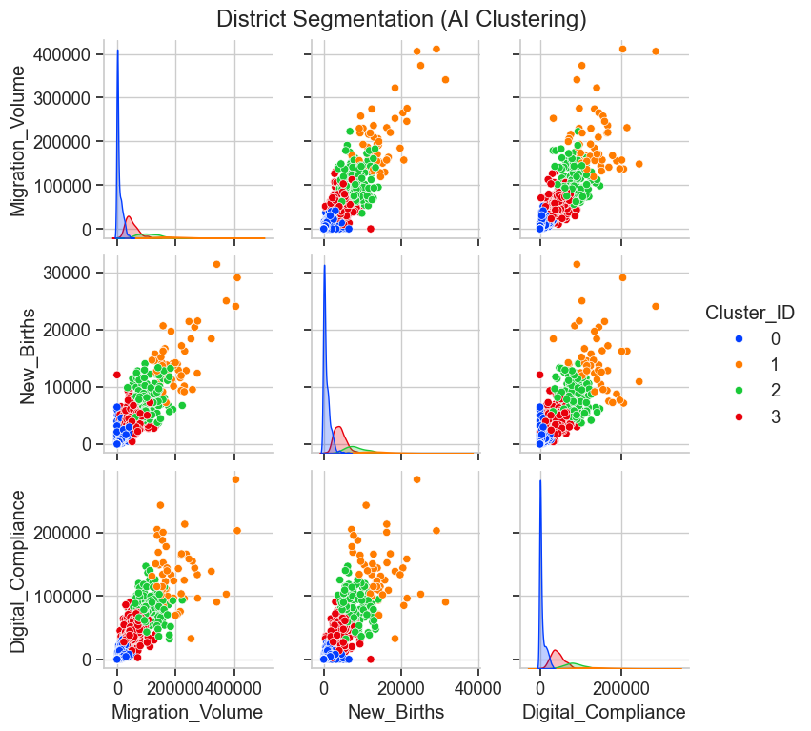
Figure 7.2: Pairplot showing the 4 Distinct Clusters of Districts.

7.3 Anomaly Detection (Isolation Forest)
We deployed Isolation Forest, an algorithm designed to isolate outliers. Unlike K-Means which looks for groups, Isolation Forest looks for points that are few and different.
- Contamination: Set to 2% (expecting 2% of districts to be anomalous).
- Result: Detected districts where the update volume was >3>3 Standard Deviations from the mean.
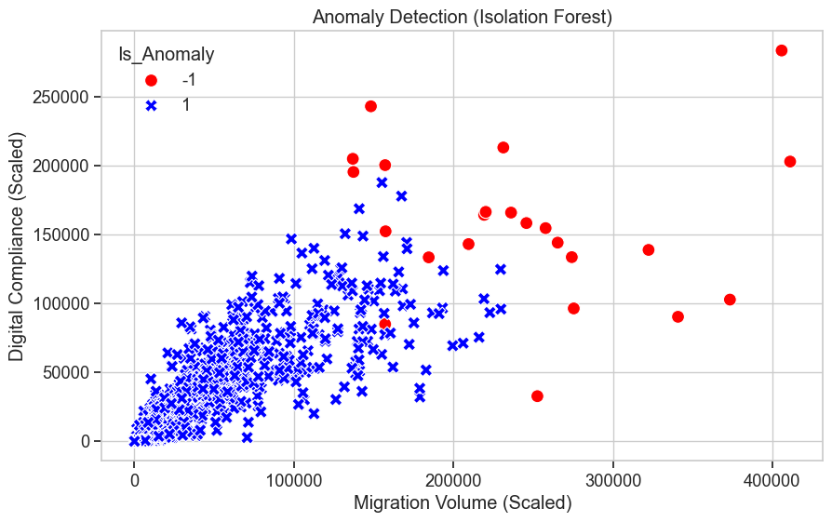
Figure 7.3: Scatter plot highlighting the Anomalous Districts (in Red).

8. FINDINGS & STRATEGIC INSIGHTS

8.1 Insight 1: The Migration Pulse
The analysis confirms a "Power Law" in Indian migration. A small percentage of districts (approx 15%) account for over 60% of all Demographic Updates.
- Strategic Action: UIDAI should upgrade the server capacity and staff strength in these specific "Magnet Districts" proactively, rather than waiting for queues to build up.

8.2 Insight 2: The Digital Divide (Compliance Gap)
The clustering revealed Cluster 3—districts with high birth rates but low biometric updates. These are likely rural areas where children turn 5, but the parents are unaware of the mandatory biometric update requirement.
- Strategic Action: Deploy "Aadhaar Seva Vans" (Mobile Units) to schools in these specific Cluster 3 districts.

8.3 Insight 3: Operational Anomalies
The Isolation Forest flagged specific districts that had an impossible ratio of Updates-to-Population.
- Probable Cause: This could indicate an operator gaming the system (splitting one update into multiple transactions) or a sudden displacement event (flood/calamity).
- Strategic Action: Immediate audit of the Registrars in these red-flagged zones.

9. CONCLUSION
"Aadhaar Seva Pulse" is more than just a dashboard; it is a Governance Intelligence System. By shifting from static tables to Machine Learning models, we have demonstrated that Aadhaar data can tell us where India is moving and who is falling behind.
The tools developed in this project (Recursive Loaders, Cluster Models, Anomaly Detectors) are modular and scalable. They can be integrated into UIDAI's central command center to ensure that No Resident is Left Behind.

End of Project Report Hackathon 2026

